Supplementary Figures

Sex-divergent microRNA–mRNA regulatory networks in the dorsolateral prefrontal cortex in major depressive disorder

Lluis Miquel-Rio¹, Judith Jericó-Escolar¹, Verónica Paz¹, Esther Ruiz-Bronchal¹, Luis F Callado², J Javier Meana², Muriel Vicent-Gil³, Maria J Portella³, Javier de Diego-Adeliño³, Gustavo Turecki⁴, Cristina Fornaguera⁵, Eduard Vieta⁶, and Analia Bortolozzi¹*
¹ Institute of Biomedical Research of Barcelona (IIBB), Spanish National Research Council (CSIC), 08036 Barcelona, Spain; Translational Research Programme for Brain Disorders, Institut d’Investigacions Biomèdiques August Pi i Sunyer (IDIBAPS), Barcelona, Spain; Biomedical Research Networking Center for Mental Health (CIBERSAM), Institute of Health Carlos III (ISCIII), Madrid, Spain
² Department of Pharmacology, University of the Basque Country EHU, E-48940 Leioa, Bizkaia, Spain; Biobizkaia Health Research Institute, Barakaldo, Spain; Biomedical Research Networking Center for Mental Health (CIBERSAM), Institute of Health Carlos III (ISCIII), Madrid, Spain
³ Mental Health Research Group, Institut de Recerca Sant Pau (IR Sant Pau), Barcelona, Spain; Department of Psychiatry and Legal Medicine, Universitat Autònoma de Barcelona (UAB), Spain; Department of Psychiatry, Hospital de la Santa Creu i Sant Pau (HSCSP), Barcelona, Spain; Biomedical Research Network Research Center on Mental Health (CIBERSAM), Madrid, Spain
⁴ Department of Psychiatry, McGill Group for Suicide Studies, Douglas Mental Health University Institute, McGill University, Montreal, QC, Canada
⁵ Grup d'Enginyeria de Materials (GEMAT), Institut Químic de Sarrià (IQS), Universitat Ramon Llull (URL), Barcelona, Spain; Institució Catalana de Recerca i Estudis Avançats (ICREA), Barcelona, Spain
⁶ Bipolar and Depressive Disorders Unit, Hospital Clinic de Barcelona, Barcelona, Spain; Translational Research Programme for Brain Disorders, Institut d'Investigacions Biomèdiques August Pi I Sunyer (IDIBAPS), Barcelona, Spain; Department of Medicine, Faculty of Medicine and Health Sciences, Institute of Neurosciences (UBNeuro), University of Barcelona (UB), Barcelona, Spain; Biomedical Research Networking Center for Mental Health (CIBERSAM), Institute of Health Carlos III (ISCIII), Madrid, Spain

*Correspondence: Dra. Analia Bortolozzi, Department of Neuroscience and Experimental Therapeutics (IIBB-CSIC), Rosselló161, 08036 Barcelona, Spain, e-mail: analia.bortolozzi@iibb.csic.es

Supplementary Figure 1. Quality control and read mapping of the small RNA sequencing data. Small RNA sequencing of dlPFC samples from the discovery cohort (17 MDD-S and 17 control subjects). C, control; D, MDD-S; numbers correspond to the pair ID (Supplementary Table 1). a Percentage of reads with median Phred quality scores of 20-30 and 30-40 in each sample. b Number of raw reads (millions) per sample used as input for UMI deduplication. c Percentage of reads assigned to each RNA biotype among UMI-deduplicated reads that did not map to small RNA databases and were mapped to the human genome (GRCh38; Ensembl release 110 annotation). Box plots show the median and the 25th-75th percentiles; whiskers indicate minimum and maximum values; dots represent individual samples. d Read-length distribution after trimming of adapters and UMIs in each sample (15-44 nt shown). The peak at ~22 nt corresponds to miRNAs, and the peak at ~32 nt to potential piRNAs and tRNA-derived fragments. IR RNA, retained intron; lncRNA, long non-coding RNA; misc_RNA, miscellaneous RNA; mt-rRNA, mitochondrial ribosomal RNA; mt-tRNA, mitochondrial transfer RNA; NMD-RNA, transcripts subject to nonsense-mediated decay; NSD-RNA, transcripts subject to non-stop decay; PP-RNA, pseudogene transcripts; rRNA, ribosomal RNA; scaRNA, small Cajal body-specific RNA; scRNA, small cytoplasmic RNA; snoRNA, small nucleolar RNA; snRNA, small nuclear RNA; sRNA, small RNA. Source data are provided as a Source Data file.

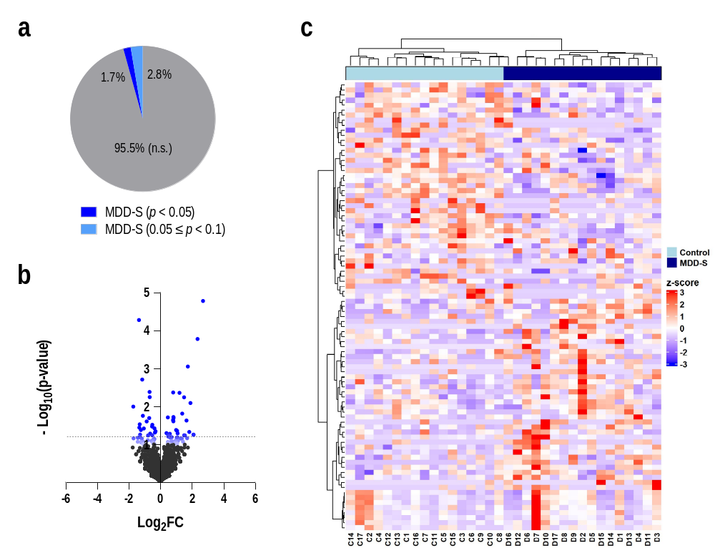

Supplementary Figure 2. miRNA differential expression in the discovery cohort with both sexes combined. Small RNA sequencing of the dlPFC of 17 MDD-S and 17 control subjects. a Proportion of annotated miRNAs (n = 1,972) that were differentially expressed (p < 0.05; 34 miRNAs, 1.7%) or marginally significant (0.05 ≤ p < 0.1; 55 miRNAs, 2.8%) in MDD-S vs. control subjects. b Volcano plot of log₂ fold change and -log₁₀ p-value for each miRNA. Dark blue, p < 0.05; light blue, 0.05 ≤ p < 0.1. The dashed line indicates nominal p = 0.05. c Heatmap of the 34 DEmiRs and 55 miRNAs with p < 0.1. Values are row-scaled z-scores of log₂-(TMM-normalized CPM + 1). miRNAs and samples were clustered by hierarchical clustering (1 - Pearson correlation distance, Ward’s linkage; ComplexHeatmap, R). C, control; D, MDD-S; numbers correspond to the pair ID (Supplementary Table 1). Differential expression was assessed with DESeq2, including case-control pair and diagnosis in the model; p-values are nominal (uncorrected). DEmiRs were defined as p < 0.05. Source data are provided as a Source Data file.

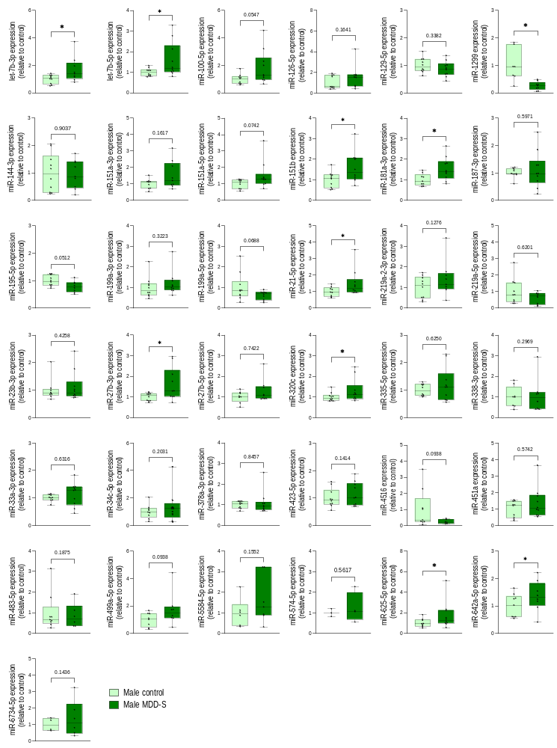

Supplementary Figure 3. RT-qPCR technical validation of candidate miRNAs in males of the discovery cohort. Expression of the 37 candidate miRNAs selected from the sequencing data, measured by RT-qPCR (miRCURY LNA miRNA PCR Panel; QIAGEN) in the dlPFC of 10 male MDD-S/control pairs. Relative expression was calculated as 2^{-ΔCt}, with ΔCt relative to the geometric mean of miR-9-3p, miR-103a-3p and miR-30e-5p, and expressed relative to the mean of the control group. Box plots show the median and the 25th-75th percentiles; whiskers indicate minimum and maximum values; dots represent individual subjects. The number of subjects varies between miRNAs because samples in which the miRNA was not detected (Ct > 37) were excluded. Values lacking a matched counterpart (e.g., because the paired sample was excluded) are shown but were not included in paired tests. Groups were compared with a paired Student’s t-test or a Wilcoxon matched-pairs signed-rank test according to the normality of each groups (Shapiro-Wilk). For miRNAs with fewer than three complete pairs (miR-574-5p and miR-6734-5p), unpaired t-tests were used instead. *p < 0.05, **p < 0.01; exact p-values are shown for p ≥ 0.05. P-values are nominal (uncorrected). Source data are provided as a Source Data file.

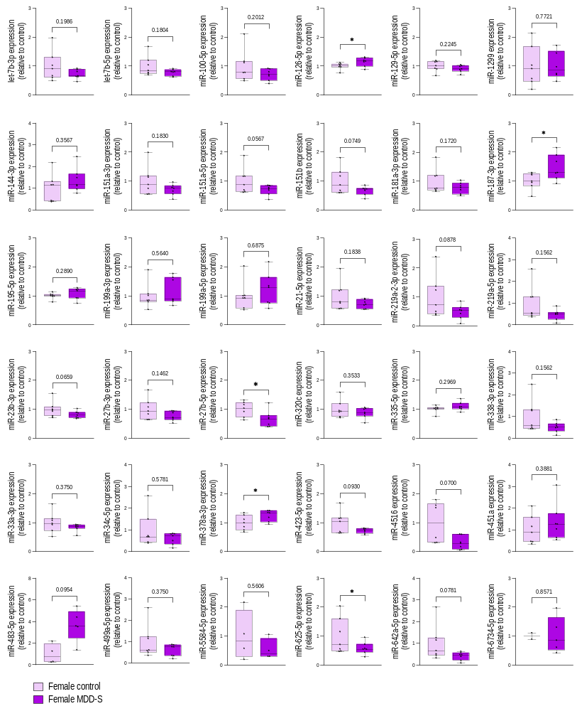

Supplementary Figure 4. RT-qPCR technical validation of candidate miRNAs in females of the discovery cohort. Expression of the 37 candidate miRNAs selected from the sequencing data, measured by RT-qPCR (miRCURY LNA miRNA PCR Panel; QIAGEN) in the dlPFC of 7 female MDD-S/control pairs. Relative expression was calculated as 2^{-ΔCt}, with ΔCt relative to the geometric mean of miR-9-3p, miR-103a-3p and miR-30e-5p, and expressed relative to the mean of the control group. Box plots show the median and the 25th-75th percentiles; whiskers indicate minimum and maximum values; dots represent individual subjects. The number of subjects varies between miRNAs because samples in which the miRNA was not detected (Ct > 37) were excluded. Values lacking a matched counterpart (e.g., because the paired sample was excluded) are shown but were not included in paired tests. Groups were compared with a paired Student’s t-test or a Wilcoxon matched-pairs signed-rank test according to the normality of each groups (Shapiro-Wilk). For miRNAs with fewer than three complete pairs (miR-574-5p, miR-5584-5p and miR-6734-5p), unpaired t-tests were used instead. *p < 0.05, **p < 0.01; exact p-values are shown for p ≥ 0.05. P-values are nominal (uncorrected). Source data are provided as a Source Data file.

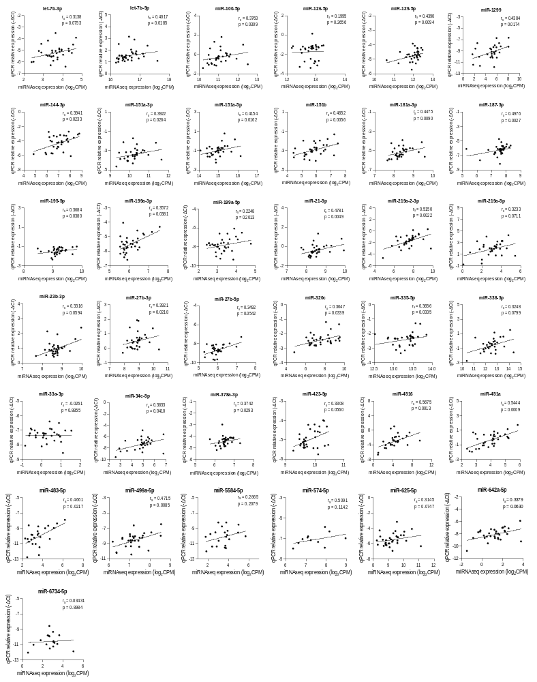

Supplementary Figure 5. Correlation between sequencing and RT-qPCR measurements of candidate miRNAs. Expression of the 37 candidate miRNAs in the discovery cohort (17 MDD-S and 17 control subjects; both sexes and diagnostic groups combined), measured by small RNA sequencing (log₂-TMM-normalized CPM + 1) and by RT-qPCR in the technical validation (−ΔCt relative to the geometric mean of miR-9-3p, miR-103a-3p, and miR-30e-5p). Each dot represents one subject. The number of subjects varies between miRNAs because samples without an RT-qPCR value were excluded. Correlations were assessed with Spearman’s rank correlation coefficient (rs); p-values are nominal (two-sided). Regression lines are shown for visualization only. Source data are provided as a Source Data file.

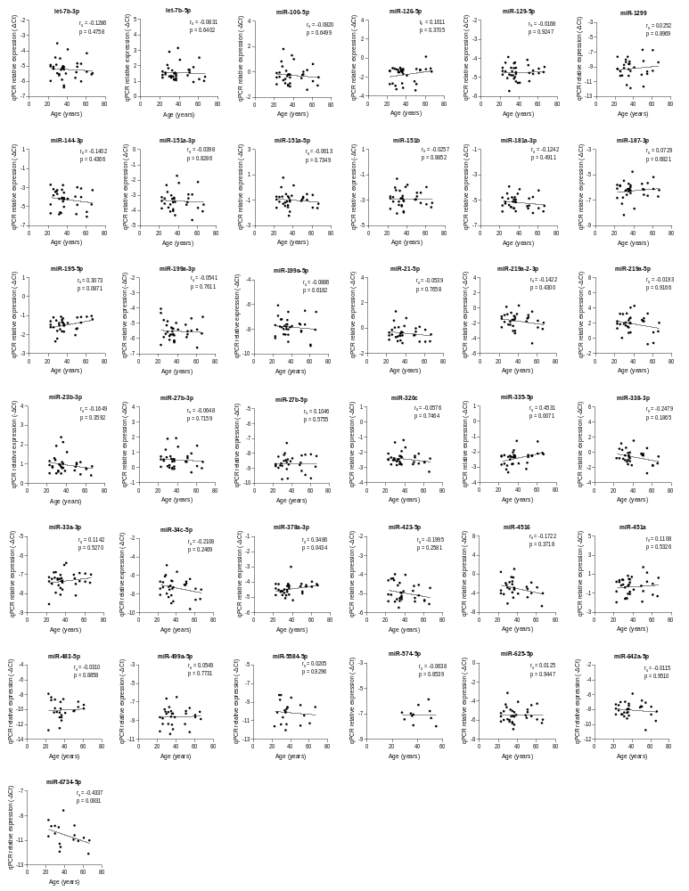

Supplementary Figure 6. Correlation between miRNA expression and age at death. RT-qPCR levels (−ΔCt) of the 37 candidate miRNAs in the technical validation, plotted against age at death in the discovery cohort (17 MDD-S and 17 control subjects; both sexes and diagnostic groups combined). Each dot represents one subject. Correlations were assessed with Spearman’s rank correlation coefficient (rs); p-values are nominal (two-sided). Regression lines are shown for visualization only. Source data are provided as a Source Data file.

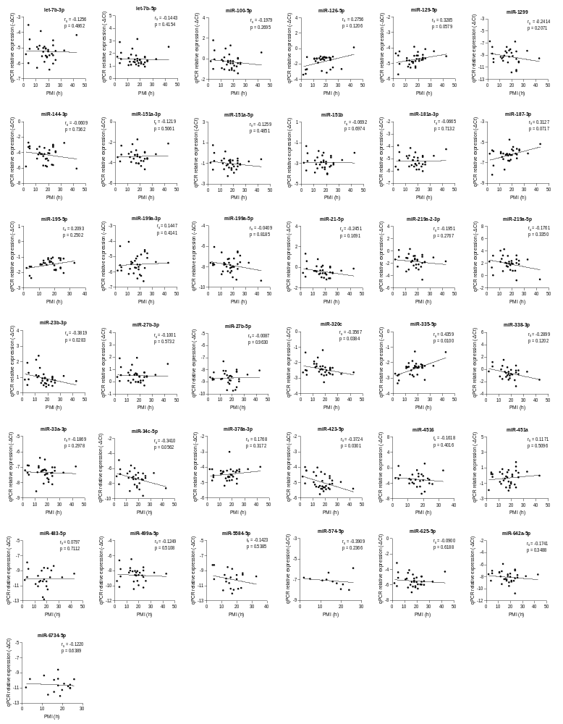
Supplementary Figure 7. Correlation between miRNA expression and postmortem interval. RT-qPCR levels (−ΔCt) of the 37 candidate miRNAs in the technical validation plotted against postmortem interval (PMI, hours) in the discovery cohort (17 MDD-S and 17 control subjects; both sexes and diagnostic groups combined). Each dot represents one subject. Correlations were assessed with Spearman’s rank correlation coefficient (rs); p-values are nominal (two-sided). Regression lines are shown for visualization only. Source data are provided as a Source Data file.
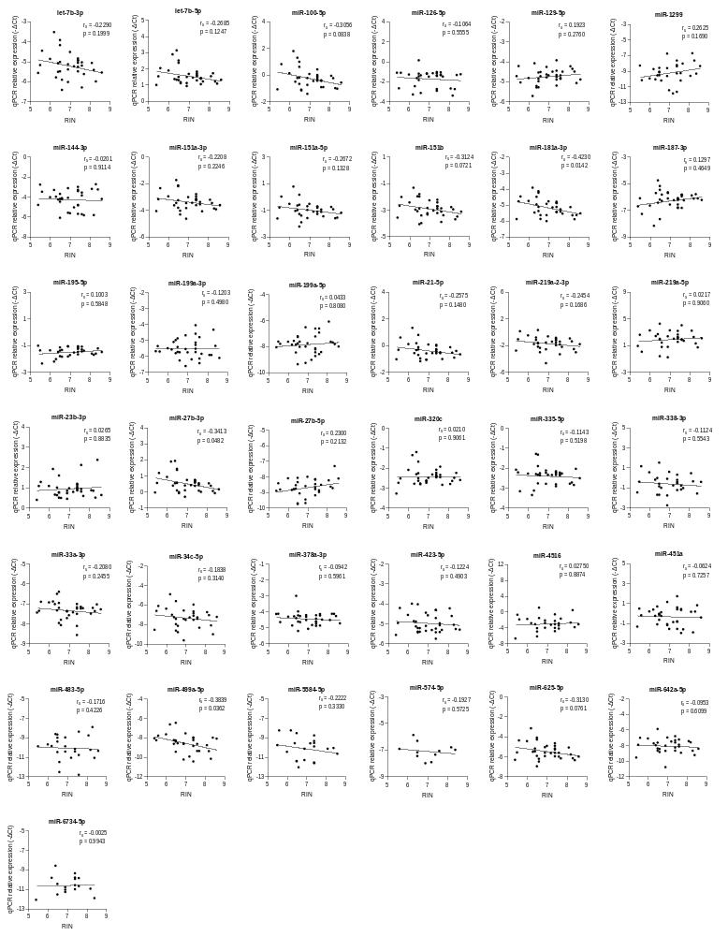

Supplementary Figure 8. Correlation between miRNA expression and RNA integrity number. RT-qPCR levels (−ΔCt) of the 37 candidate miRNAs in the technical validation plotted against RNA integrity number (RIN) in the discovery cohort (17 MDD-S and 17 control subjects; both sexes and diagnostic groups combined). Each dot represents one subject. Correlations were assessed with Spearman’s rank correlation coefficient (rs); p-values are nominal (two-sided). Regression lines are shown for visualization only. Source data are provided as a Source Data file.

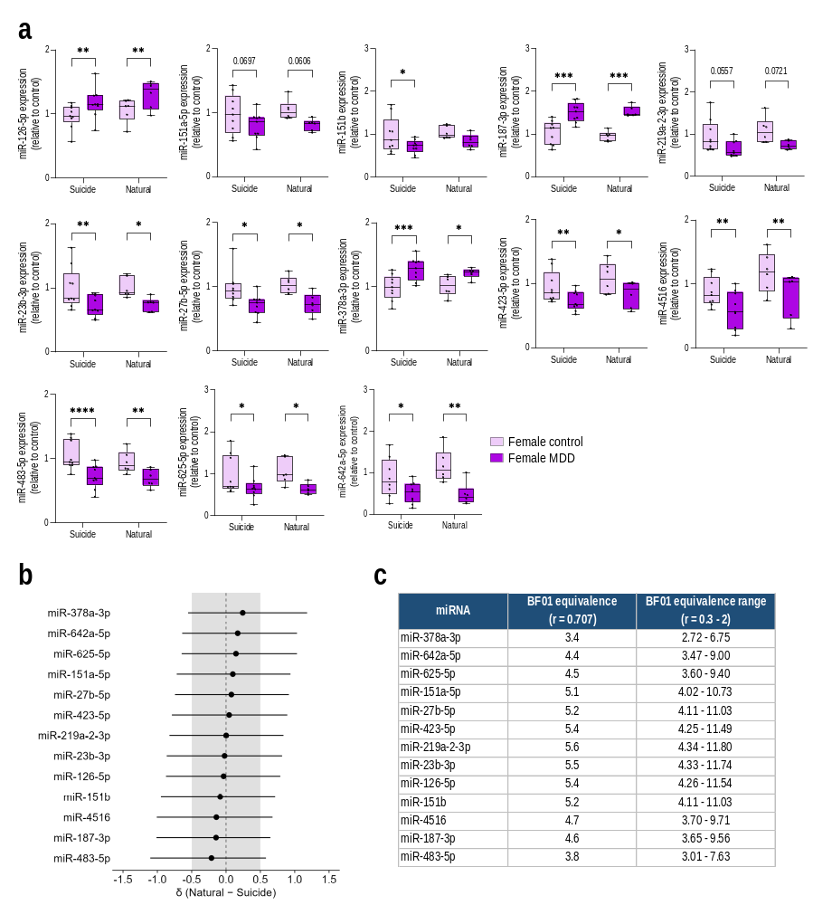

Supplementary Figure 9. miRNA changes in females with MDD do not differ by cause of death. a RT-qPCR levels of the 13 female DEmiRs in the extended cohort, shown separately for MDD subjects who died by suicide (MDD-S; 9 pairs) or from natural causes (MDD-N; 6 pairs) and their matched controls. Relative expression was calculated as 2^{-ΔCt}, with ΔCt relative to the geometric mean of miR-9-3p, miR-103a-3p, miR-30e-5p and RNU6, and expressed relative to the mean of all female controls.Box plots show the median and the 25th-75th percentiles; whiskers indicate minimum and maximum values; dots represent individual subjects. Data were analyzed by two-way repeated-measures ANOVA (diagnosis within pairs × mode of death between pairs). MDD and control subjects were compared within each mode of death with uncorrected Fisher’s LSD tests. *p < 0.05, **p < 0.01, ***p < 0.001, ****p < 0.0001; exact p values are shown for 0.05 ≤ p < 0.10. b Standardized difference (δ) in expression relative to matched controls between MDD-N and MDD-S, estimated by Bayesian two-sample t-tests (posterior median and 95% credible interval). The shaded area indicates the equivalence interval (-0.5 < δ < 0.5). c Bayes factors in favor of the null hypothesis (BF₀₁) obtained with the default Cauchy prior (r = 0.707), together with the range obtained across prior widths of r = 0.3-2 (robustness analysis). BF₀₁ values of 3-10 indicate moderate evidence for the null hypothesis. Source data are provided as a Source Data file.

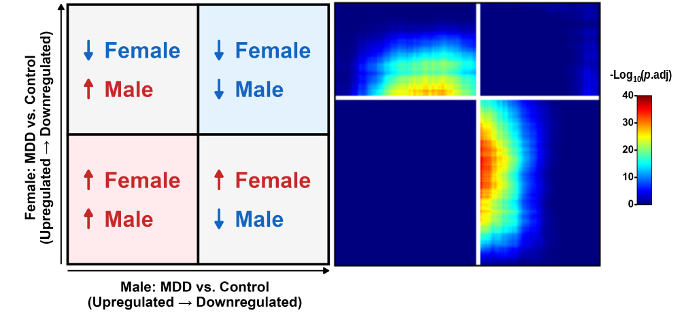

Supplementary Figure 10. Opposite transcriptomic changes in males and females with MDD-S in an independent cohort. Rank-rank hypergeometric overlap (RRHO2) of genome-wide differential expression (MDD-S vs. control) in males (x-axis) and females (y-axis) in the dlPFC. RNA-seq dataset of Labonté et al.²² (GEO: GSE102556; 13 MDD-S and 13 control males; 13 MDD-S and 9 control females). Genes (n = 15,700 common to both sexes) were ranked from most upregulated to most downregulated in MDD by -log₁₀-(p-value) × sign(log₂FC). Color indicates the -log₁₀ Benjamini-Hochberg-adjusted hypergeometric p of the overlap (scale capped at 60). The schematic indicates the direction of change represented by each quadrant. Spearman ρ = -0.102, p = 1.77x10⁻³⁷. Source data are provided as a Source Data file.

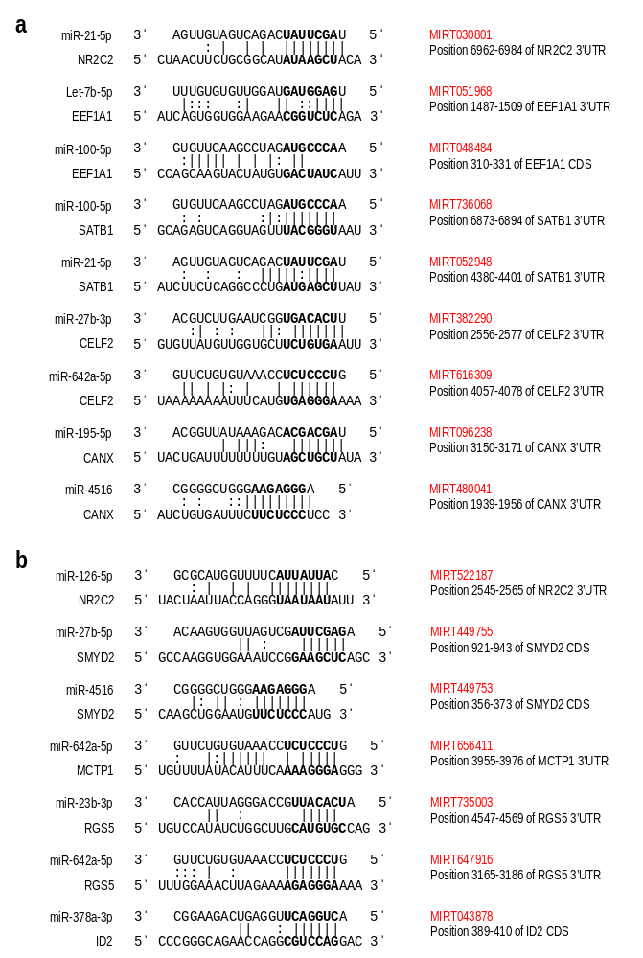

Supplementary Figure 11. Binding sites of DEmiRs in RT-qPCR-validated target mRNAs. Schematic representation of the duplexes formed between DEmiRs and their RT-qPCR-validated target mRNAs in males (a) and females (b). miRNA sequences are shown 3′→5′ (top) and target sequences 5′→3′ (bottom). The miRNA seed region (nucleotides 2–8) and the complementary target sequence are shown in bold. Vertical lines indicate Watson–Crick pairs, and colons indicate G:U wobble pairs. For each interaction, the miRTarBase identifier (red) and the position of the binding site in the 3′UTR or coding sequence (CDS) of the target transcript are shown. Duplexes and binding-site positions were retrieved from miRTarBase or from the original publications cited therein. Source data are provided as a Source Data file.

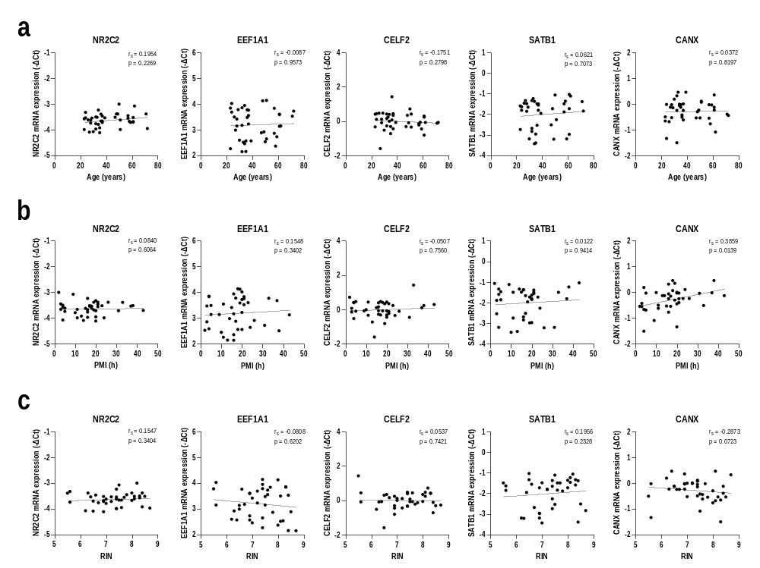

Supplementary Figure 12. Correlation between target mRNA expression and age, PMI, and RIN in males. RT-qPCR levels (-ΔCt relative to the geometric mean of ACTB and RPL13A) of the target mRNAs validated in males (NR2C2, EEF1A1, CELF2, SATB1, and CANX), plotted against age at death (a), postmortem interval (PMI, hours) (b), and RNA integrity number (RIN) (c) in the extended cohort (20 MDD-S and 20 control males; diagnostic groups combined). Each dot represents one subject. Correlations were assessed with Spearman’s rank correlation coefficient (rs); p-values are nominal (two-sided). Regression lines are shown for visualization only. Source data are provided as a Source Data file.

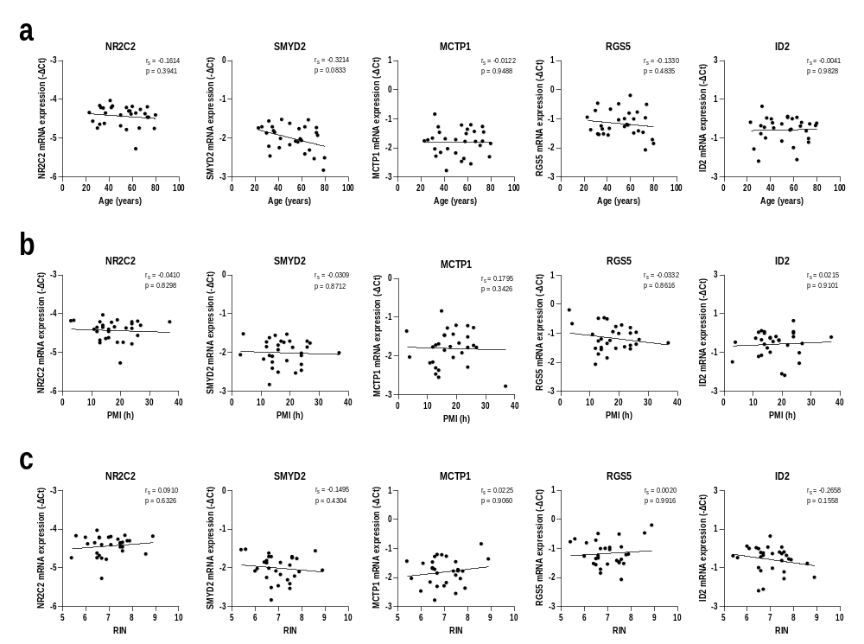

Supplementary Figure 13. Correlation between target mRNA expression and age, PMI, and RIN in females. RT-qPCR levels (-ΔCt relative to the geometric mean of ACTB and RPL13A) of the target mRNAs validated in females (NR2C2, SMYD2, MCTP1, RGS5, and ID2) plotted against age at death (a), postmortem interval (PMI, hours) (b), and RNA integrity number (RIN) (c) in the extended cohort (15 MDD-S/N and 15 control females; diagnostic groups combined). Each dot represents one subject. Correlations were assessed with Spearman’s rank correlation coefficient (rs); p-values are nominal (two-sided). Regression lines are shown for visualization only. Source data are provided as a Source Data file.

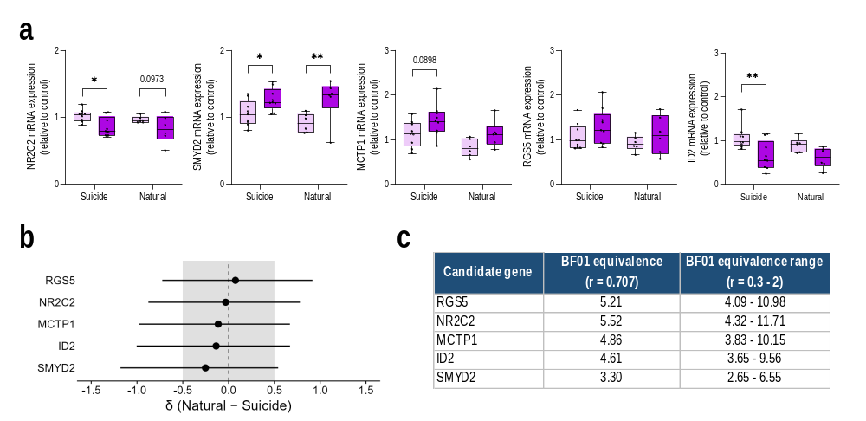

Supplementary Figure 14. Target mRNA changes in females with MDD by cause of death. a RT-qPCR levels of the target mRNAs validated in females in the extended cohort, shown separately for MDD subjects who died by suicide (MDD-S; 9 pairs) or from natural causes (MDD-N; 6 pairs) and their matched controls. Relative expression was calculated as 2^{-ΔCt}, with ΔCt relative to the geometric mean of ACTB and RPL13A, and expressed relative to the mean of all female controls. Box plots show the median and the 25th-75th percentiles; whiskers indicate minimum and maximum values; dots represent individual subjects. Data were analyzed by two-way repeated-measures ANOVA (diagnosis within pairs × mode of death between pairs. MDD and control subjects were compared within each mode of death with uncorrected Fisher’s LSD tests.*p < 0.05, **p < 0.01; exact p-values are shown for 0.05 ≤ p < 0.10. b Standardized difference (δ) in expression relative to matched controls between MDD-N and MDD-S, estimated by Bayesian two-sample t-tests (posterior median and 95% credible interval). The shaded area indicates the equivalence interval (-0.5 < δ < 0.5). Black, moderate evidence for equivalence (BF₀₁ ≥ 3); grey, anecdotal evidence (1 ≤ BF₀₁ < 3). c Bayes factors in favor of equivalence (BF₀₁) obtained with the default Cauchy prior (r = 0.707), and the range obtained across prior widths of r = 0.3-2 (robustness analysis). Source data are provided as a Source Data file.

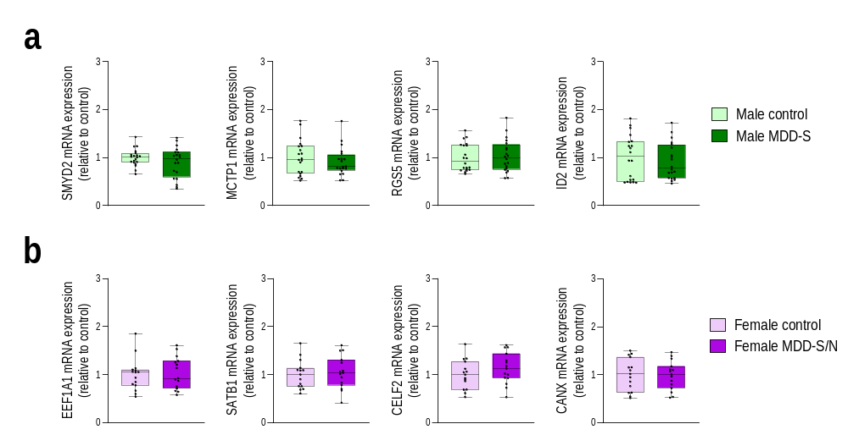

Supplementary Figure 15. Expression of sex-specific target mRNAs in the opposite sex. RT-qPCR levels in the extended cohort of target mRNAs altered in only one sex, measured in the other sex. a Target mRNAs altered in females (SMYD2, MCTP1, RGS5, and ID2), measured in 20 male MDD-S/control pairs. b Target mRNAs altered in males (EEF1A1, SATB1, CELF2, and CANX), measured in 15 female MDD-S/N/control pairs. Relative expression was calculated as 2^{-ΔCt}, with ΔCt relative to the geometric mean of ACTB and RPL13A, and expressed relative to the mean of the control group of each sex. Box plots show the median and the 25th-75th percentiles; whiskers indicate minimum and maximum values; dots represent individual subjects. Groups were compared with a paired Student’s t-test or a Wilcoxon matched-pairs signed-rank test according to the normality of each groups (Shapiro-Wilk); none of the comparisons was significant p ≥ 0.10. Source data are provided as a Source Data file.

