Supplementary Material

Detecting chlorophylls and carotenoids utilizing a novel chromatographic method designed for HPLC-PDA-MS analyses and application to environmental and cultured algae and cyanobacteria

[Zacharias J. Smith¹, David E. Berthold², Katherine M. Gaffney³, H. Dail Laughinghouse², Cathleen Hapeman¹]

1. USDA Agricultural Research Service, Hydrology and Remote Sensing Laboratory, 10300 Baltimore Ave, Beltsville, MD, 20705
2. Agronomy Department, Fort Lauderdale Research and Education Center, Institute of Food and Agricultural Sciences, University of Florida, 3205 College Avenue, Davie, FL 33314
3. School of Environment and Natural Resources, College of Food, Agricultural, and Environmental Sciences, Ohio State University, 2021 Coffey Road, Columbus, OH 43210

*Corresponding author: Zacharias J. Smith (Zach.Smith@usda.gov)

Supplemental Text 1: Multi-residue Analyses of Pigment Standards
Due to software limitations on the Waters system only five standards could be injected at the same time, while the standards suite could not be mixed as the dilution would push them outside of the detectable range. To get around this limitation for generating a chromatogram with all standards (Figure 2A), five standards were injected at a time with flow rate set at 0.1 mL/min utilizing the ‘cold-trapping’ property of the method, starting with the most well retained of the analytes progressing to the least retained (lowest capacity factor). After six ‘batches’ of injections the standard chromatographic method was started, with the total analyte loading time taking ~10 minutes. Limitations in software control meant that each of the 26 standards could not be injected at the same time but were injected in stages and ‘solvent-trapped’ on the column, using low flow rates and injecting high capacity factor samples first to minimize peak broadening. This modification gave similar, but not identical, results to a standard injection. Additional chromatograms showing the true resolution for closely eluting compounds separations are below. The most substantial differences were that aphanizophyll, diatoxanthin, and myxoxanthophyll were baseline separated (Figure A.1), peridinin elutes earlier than fucoxanthin at 13 min and was baseline resolved from fucoxanthin at 14 minutes (Figure A.2), prasinoxanthin and neoxanthin were baseline resolved with prasinoxanthin eluting first (Figure A.3), and chlorophyll a and myxoxanthophyll were baseline separated in natural samples and cyanobacterial cultures (Figure 2C).

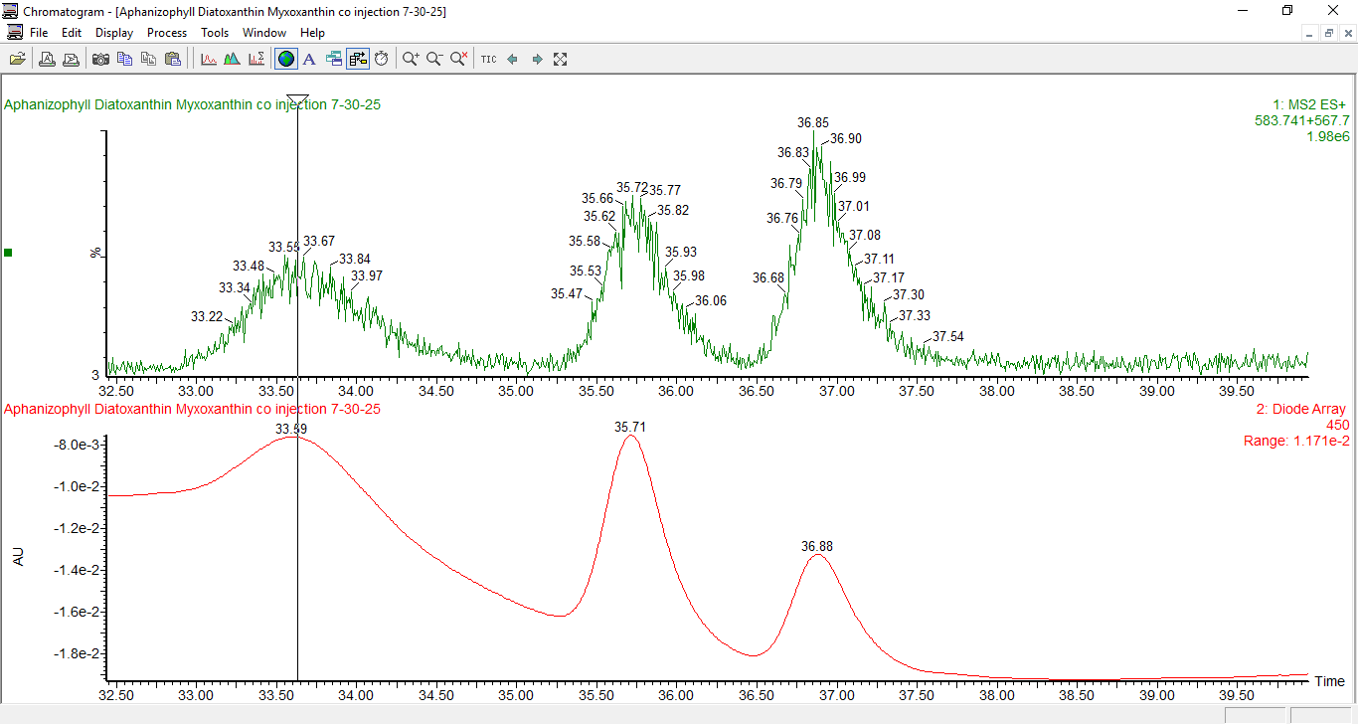
Figure A.1. Demonstration of the separation that can be achieved for aphanizophyll, diatoxanthin, and myxoxanthophyll.

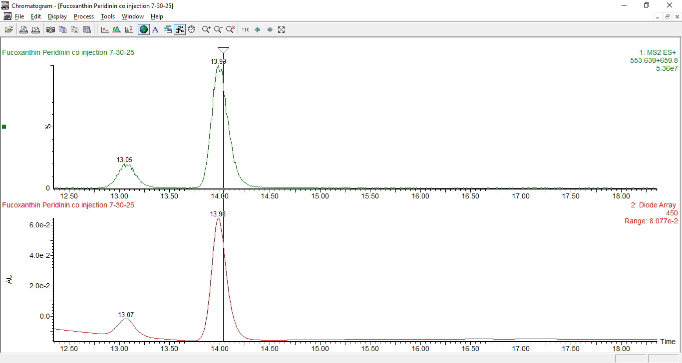
Figure A.2. Demonstration of the separation of fucoxanthin and peridinin, with peridinin eluting prior to fucoxanthin rather than after as shown in Figure 2A.

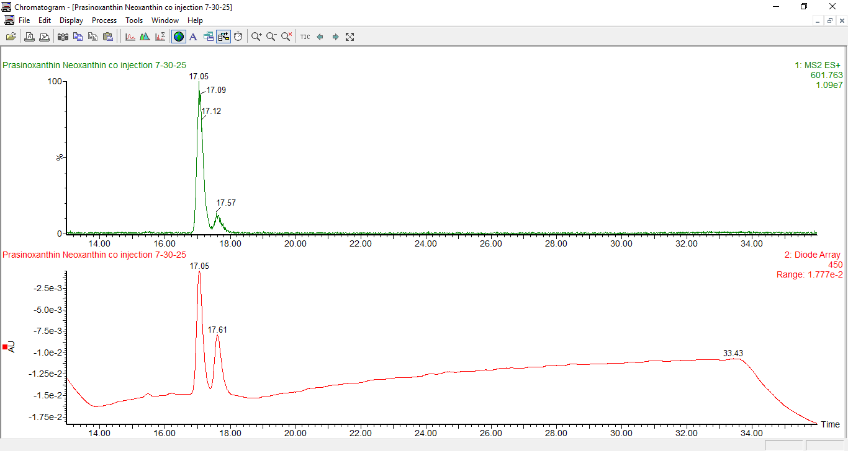
Figure A.3. Demonstration of the separation between the constitutional isomers prasinoxanthin and neoxanthin.

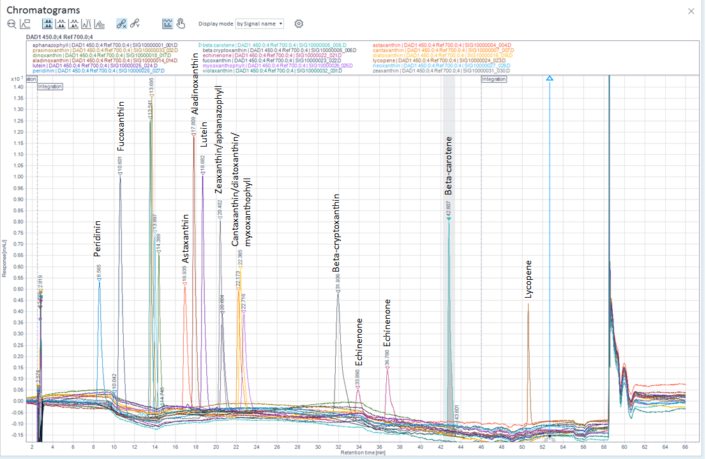
Figure A.4. Representative separation of carotenoids using the Agilent HPLC system. Shown are individual injections of standards overlaid. Resolution may be slightly different when co-injected.

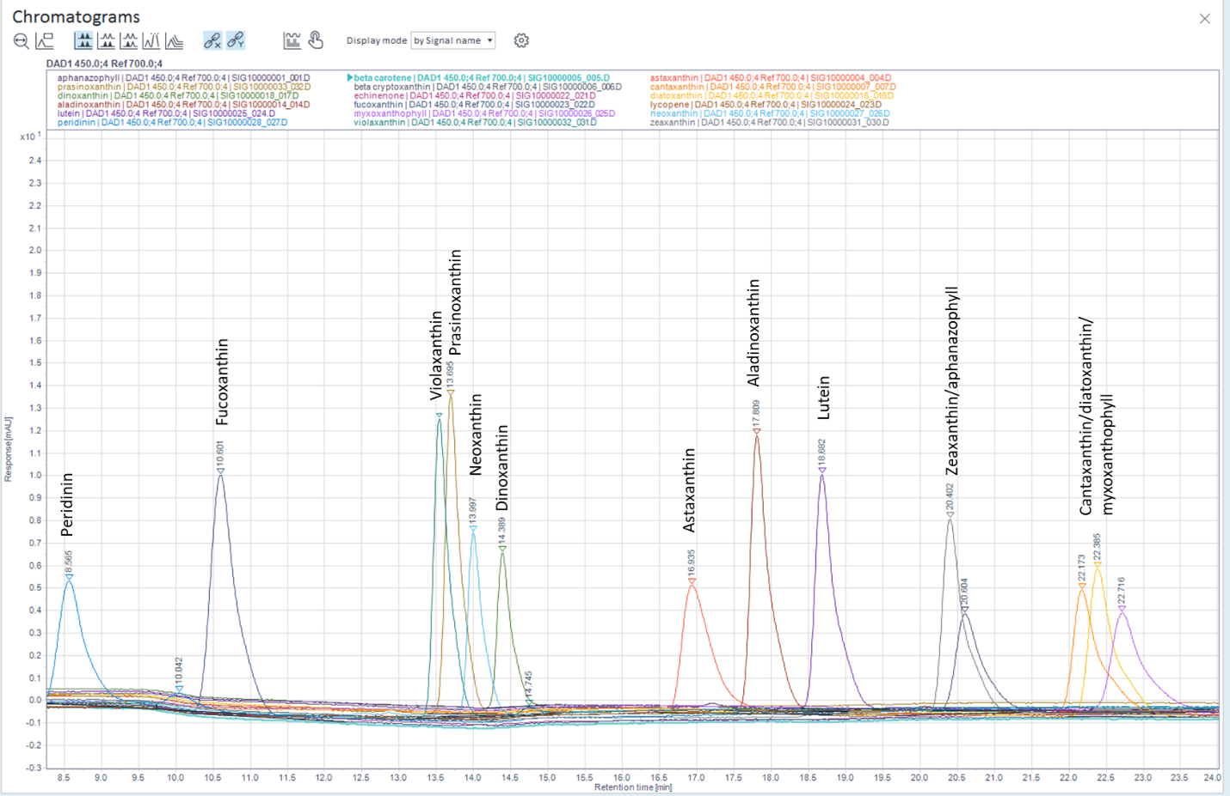
Figure A.5. Separation of carotenoids using the Agilent HPLC system in from Figure A.4 zoomed in on 8-25 minutes.

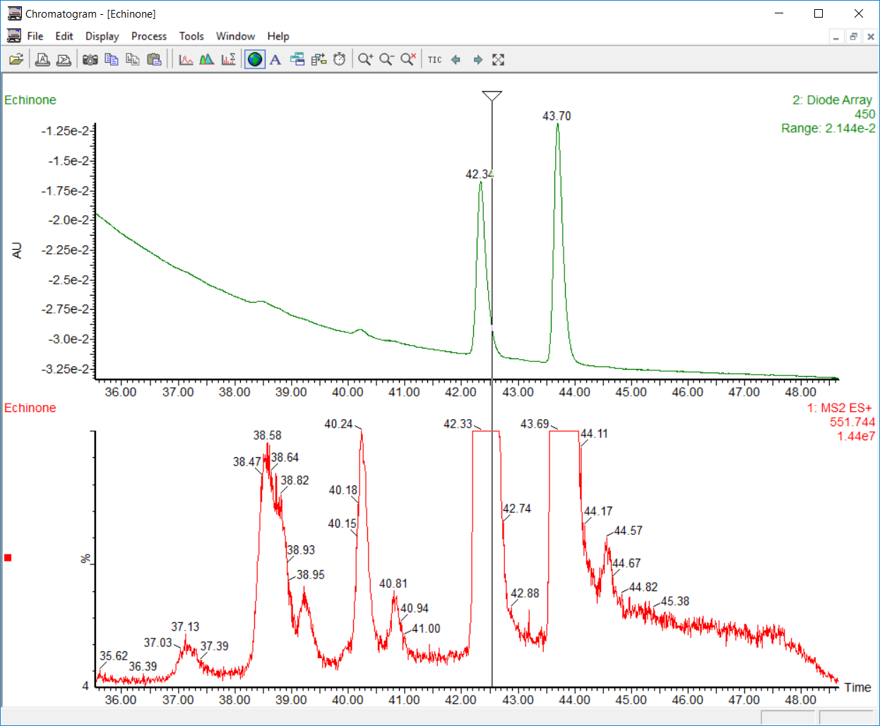
Figure A.6. Chromatogram of DHI echinenone standard showing the numerous isomers detected and separated by the methodology. 11-hydroxy echinenone was also detected in this standard, co-eluting with the two primary echinenone peaks. This method is the first to report that ‘echinenone’ is found as a pair of isomers in nature rather than a single compound.

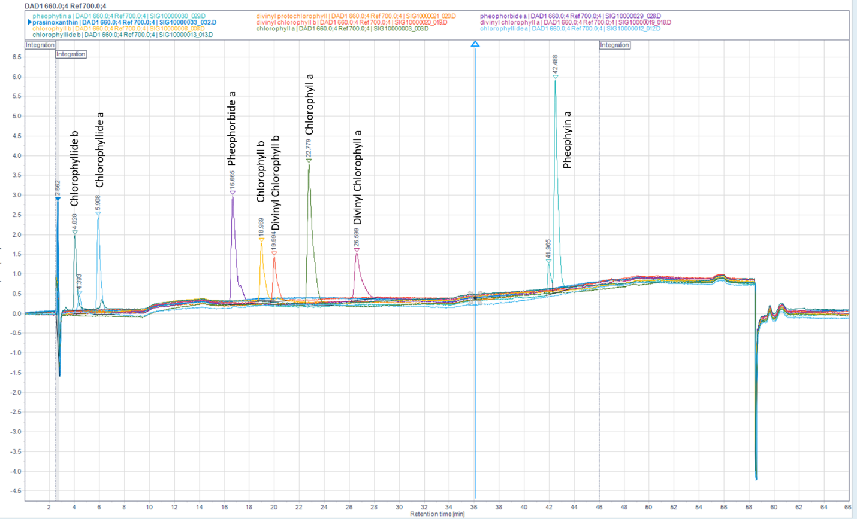
Figure A.7. Representative separation of chlorophylls using the Agilent HPLC system. C-chlorophylls separation is shown in Figure A.8.

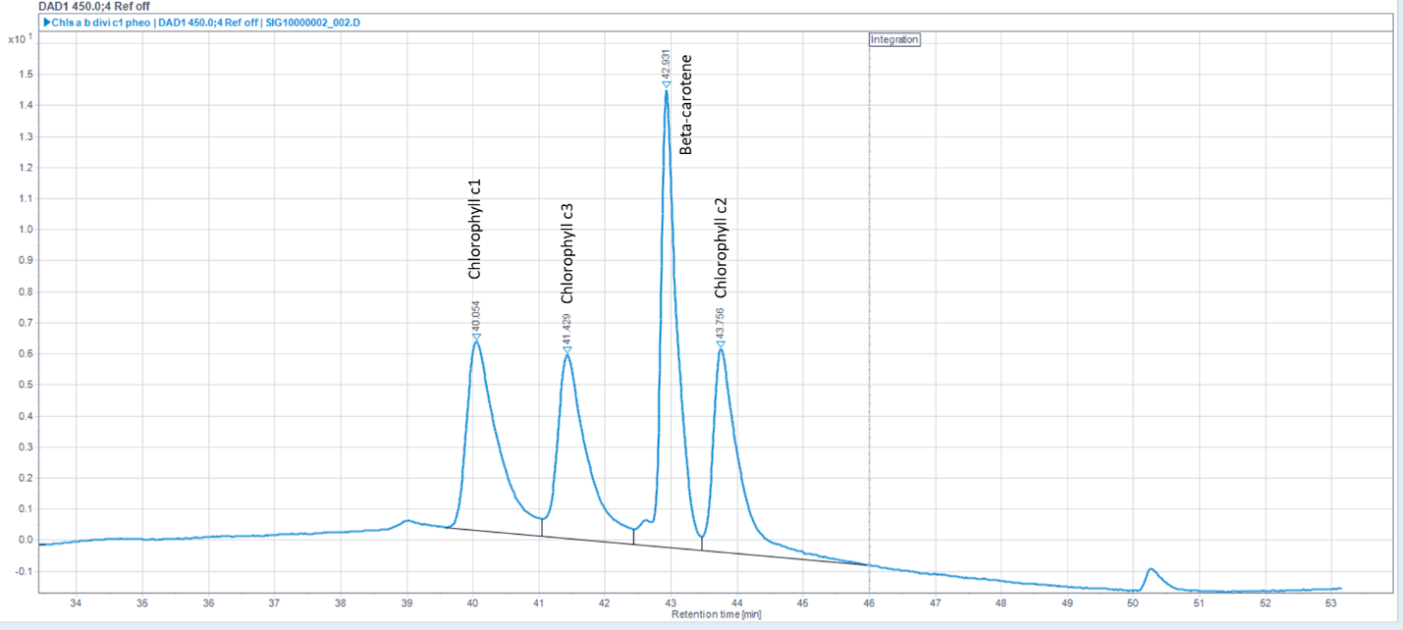
Figure A.8. Representative separation of c-chlorophylls and beta carotene using the Agilent HPLC system when co-injecting each of the four standards demonstrating baseline resolution. Pheophytin a was also injected in this sample and elutes during this retention time window, but was a poor absorber at 450 nm and therefore did not interfere with this set of compounds in this chromatogram.

Supplemental Text 2: Column Selection and Chemistry
There are several advantages in the separation described in this paper over historical methodology and many of the advantages derive from the C30 column phase. The YMC Carotenoid column was specially designed for analyses of carotenoids, which are relatively long carbon chains (~20-30𝐴̊) of varying levels of hydrophobicity (Sander et al. 1994). This column was designed with specific silica particle pore sizes for optimal peak shape, polymeric stationary phase binding which had been demonstrated to be critical for good carotenoid separation (Epler et al. 1992; Lesellier et al. 1993; Van Heukelem and Thomas 2001), and was not endcapped. These properties contributed toward the YMC Carotenoid column also being able to achieve good separation of chlorophylls, where minor changes on large molecular scaffolds must be used to differentiate the various chlorophyll analogs chromatographically (Figure 1). Achieving baseline resolution therefore requires highly specialized column technology to separate many closely eluting analytes, where pigment mixtures may contain compounds with a wide range of hydrophobicity. We hypothesize that the lack of endcapping is a major component of the improved selectivity of this column phase for the chlorophylls, taking advantage of small differences in polarity between tightly eluting chlorophyll analytes.

Supplemental Text 3: Solvent and Temperature Influences on Separation
Using the Agilent HPLC system the c-chlorophyll separation was extremely sensitive to batch-to-batch variability of the A solvent, and testing was required to confirm the separation could still be achieved. We hypothesize that the separation was lost due to the ammonium hydroxide additive and the amount of water present in the chromatography solvent, as this additive adds a small amount of water into the system. The amount of water in the mobile phase was extremely influential on the overall separation and even a small difference in accuracy during solvent preparation may have impacted the resolution of the c-chlorophylls. Using an ammonium formate salt could reduce variability, but the missing water could require modification of the gradient, and use of salt in the LC increases the chances of introducing particles into the chromatographic system.
On the Waters UPLC system, the resolution between the c1, c2, c3, and beta carotene improved and the influence on solvent batch variability became insignificant (Figures 1A and A.8). However, c2 was found to tail excessively and therefore lycopene began co-eluting with c2. Initial testing of chlorophyll c2 with the Waters UPLC system did not find excessive tailing, but after fully initiating method development temperatures in the room were significantly colder than 30 °C (temperatures were between 15-20 °C during analysis), and we suspect that this temperature change negatively impacted the peak shape. It is notable that the elution order of the c-chlorophylls and beta-carotene changed between the two HPLC systems – the order of elution on the Agilent system was c1, c3, beta-carotene, c2, while on the Waters system the order of elution was beta-carotene, c1, c3, c2 (Figure A.8).

Supplemental Text 4: Chromatographic Run Time and Recommendations for Modification of the Separation Method
This method was not designed for high-throughput analysis and therefore may not be ideal for routine monitoring. Between standards and quality controls and the 66-minute analysis time, plus injector loading for high volume injections, it may only be possible to analyze 15-20 samples in 24h. We designed this method to provide as much information about the pigments present in a sample as possible, and therefore the gradient runs relatively slowly, including with isocratic hold starting at 15 min that is primarily present to separate c-chlorophylls and carotenoids eluting 20-40+ minutes later.
However, it is quite feasible to keep the solvent and column framework in place and modify the gradient to increase the throughput if certain carotenoids or pigments do not require quantification, or if the MS detector is to separate co-eluting compounds by molecular weight. An increase in flow rate would increase throughput and, most likely, loss of theoretical plates would minimally impact resolution and not impede separation for the majority of compounds; we selected to keep the ‘lower’ flow rate to ensure a good evaporation rate in the source, and by extension sensitivity, in the electrospray ionization source, where we accepted the tradeoff being a loss in analysis speed. The rate at which 100% ethyl acetate is reached in the gradient could be increased, which would shorten retention times drastically, with many critical analytes (such as the chlorophylls a and b) having capacity factors so different that the separation would still be perfectly acceptable even with very aggressively ramped gradients. It is imperative that all methods reach 100% ethyl acetate and hold for at least 10 minutes to elute all late eluting carotenoids off of the column between samples.

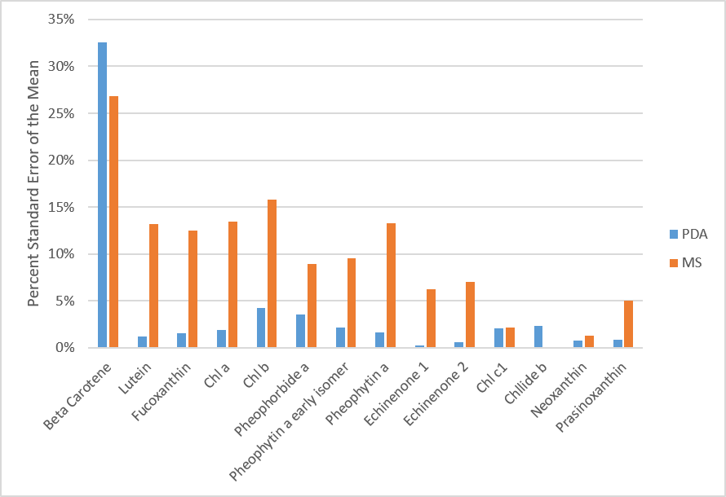
Figure A.9. Standard errors of the mean for the standards used to quantify pigments in Cladophora.

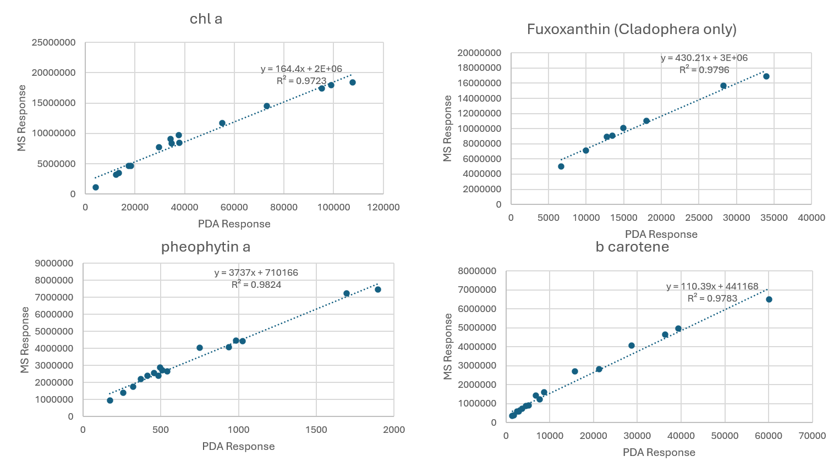
Figure A.10. Linear relationships between MS and PDA responses in the cyanobacterial cultures and Cladophora samples analyzed for pigments.

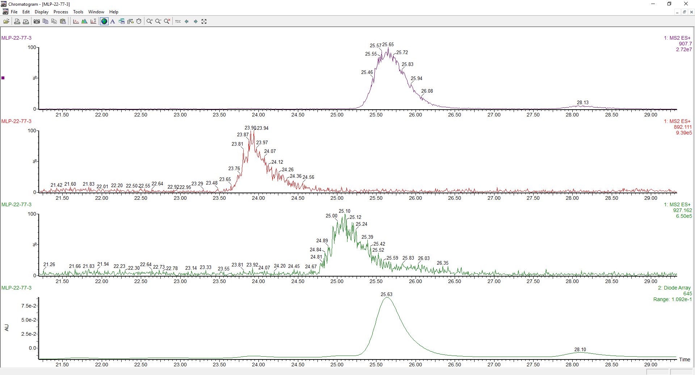
Figure A.11. Extracted ion chromatograms of chlorophyll b (purple), putative chlorophyll (red), putative hydroxychlorophyll b (green), and the PDA trace at 645 (bottom green) from the MLP-22-77-3 extract.
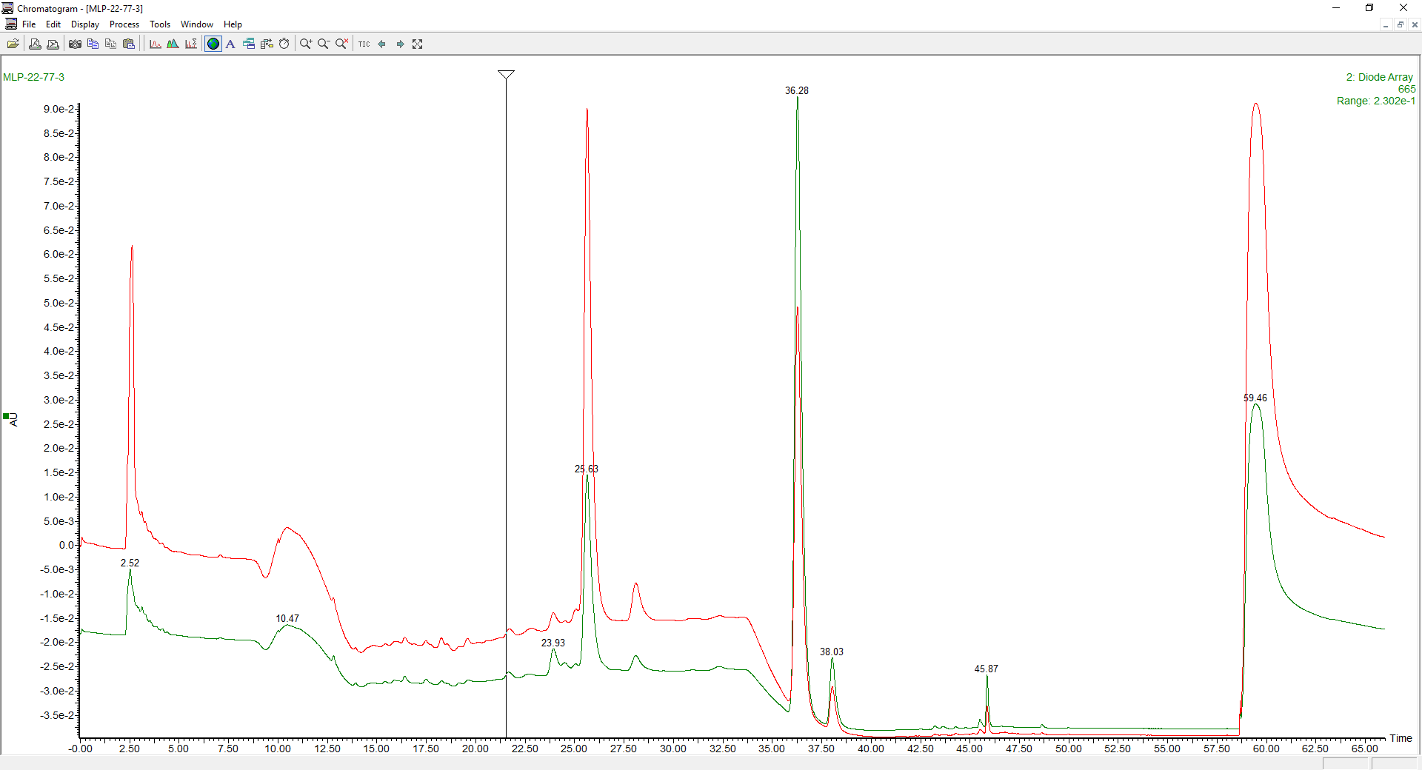
Figure A.12. Overlaid spectra of MLP-22-77-3 at 665 nm (green) and 645 nm (red). It is notable how the chlorophyll b peak height (25.63 min) decreases significantly at 665 nm, while it increases alongside the co-eluting putative hydroxychlorophyll b at 645 nm. The intensity of the other putative chlorophyll, eluting at 22.93, remains relatively unchanged.

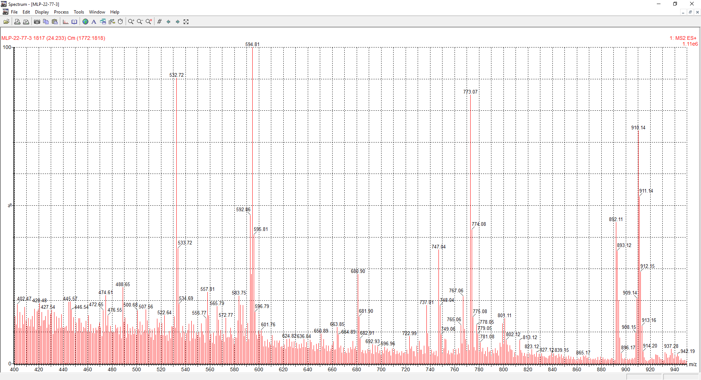
Figure A.13. Mass spectra of unknown chlorophyll with putative [M+H]⁺ of ~891 AMU, from original sample shown in Figure 2B.
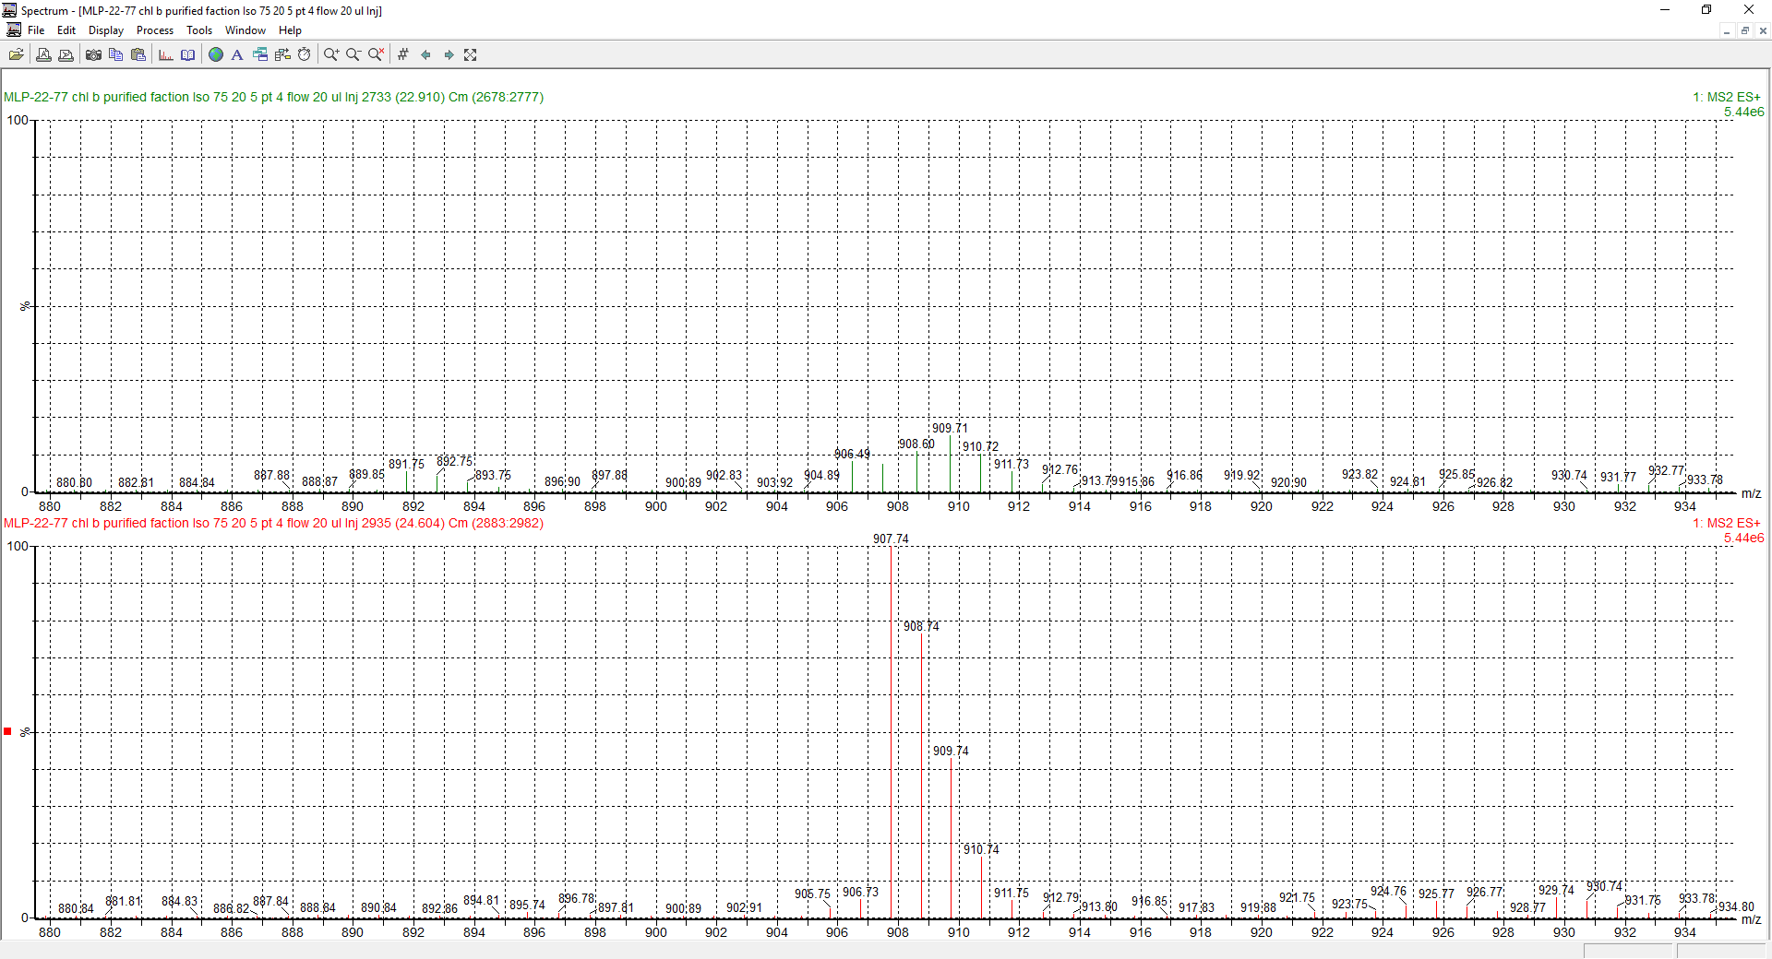
Figure A.14. Mass spectra of unknown chlorophyll with putative [M+H]⁺ of ~891 AMU (top panel), and chlorophyll b (bottom panel). While there are some molecular weights of chlorophyll b that are present in the unknown chlorophyll, the isotope pattern is not the same as chlorophyll b, suggesting the unknown is not an isomer or allomer of chlorophyll b.

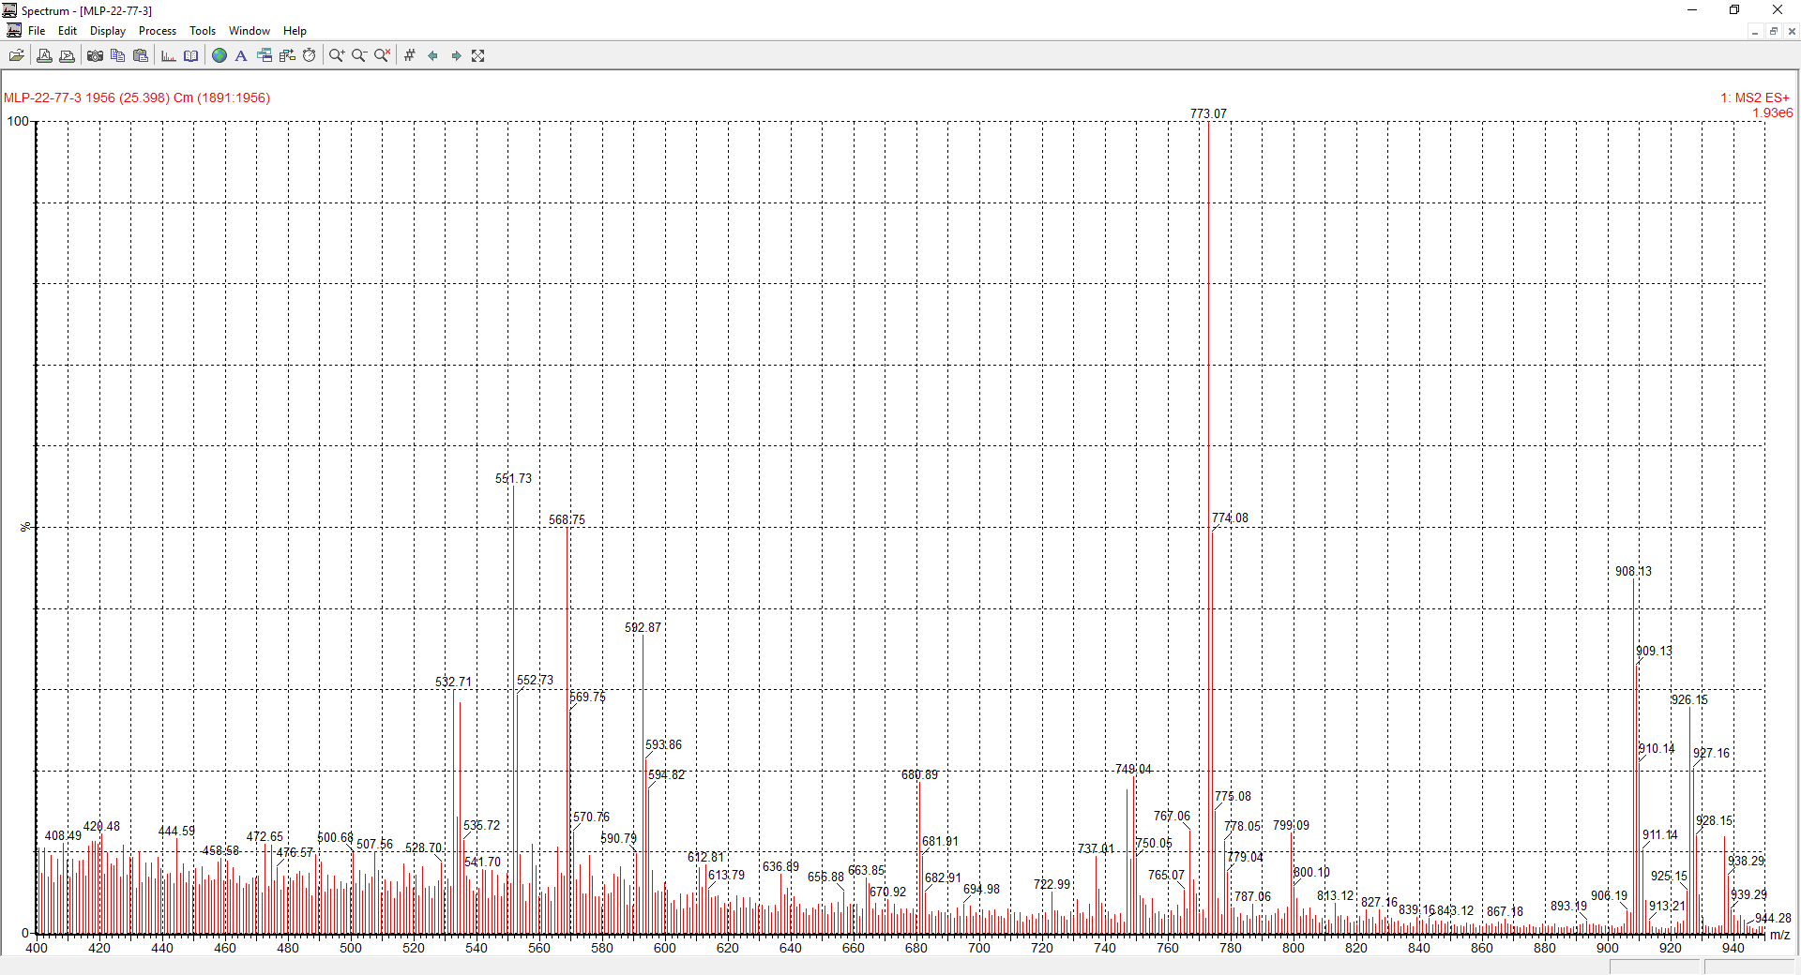
Figure A.15. Mass spectra of unknown chlorophyll with putative [M+H]⁺ of ~926 AMU, from original sample shown in Figure 2B.
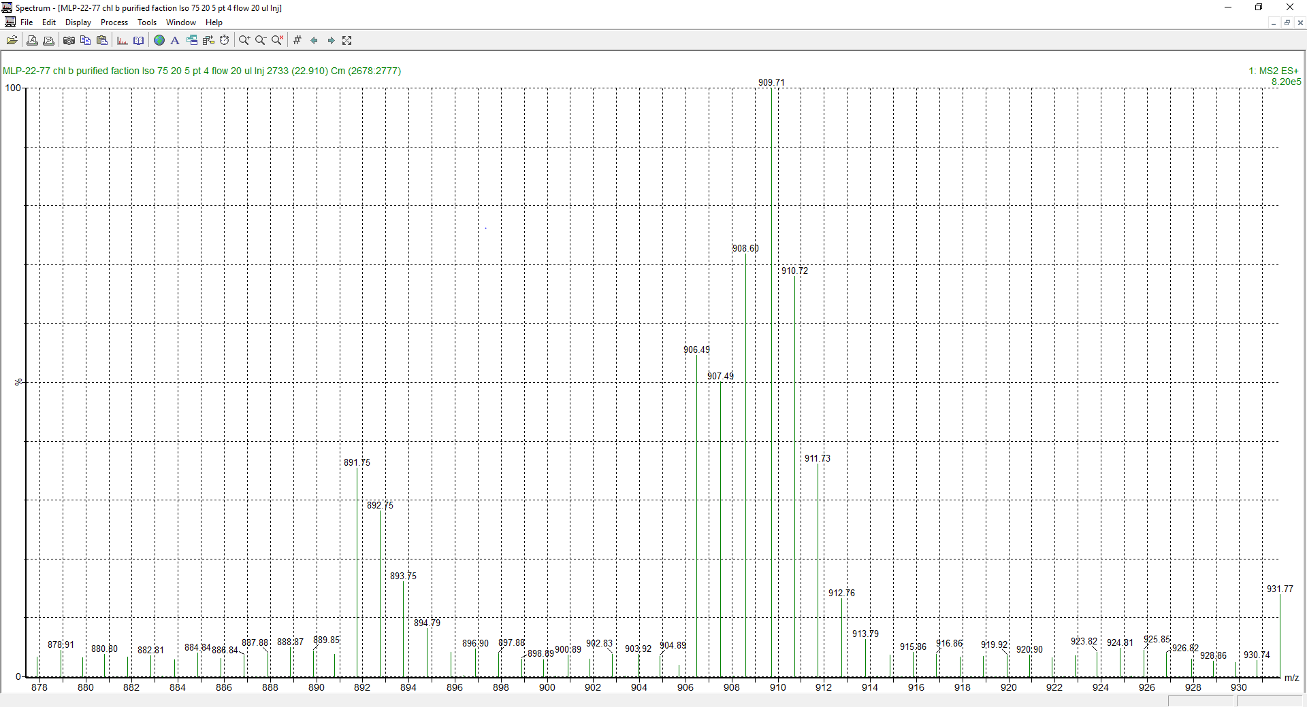 Figure A.16. Mass spectra of unknown chlorophyll with putative [M+H]⁺ of ~891 AMU, partially purified from MLP-22-77-3, highlighting the molecular weights of the unknown and 907-908 region of Chl b.

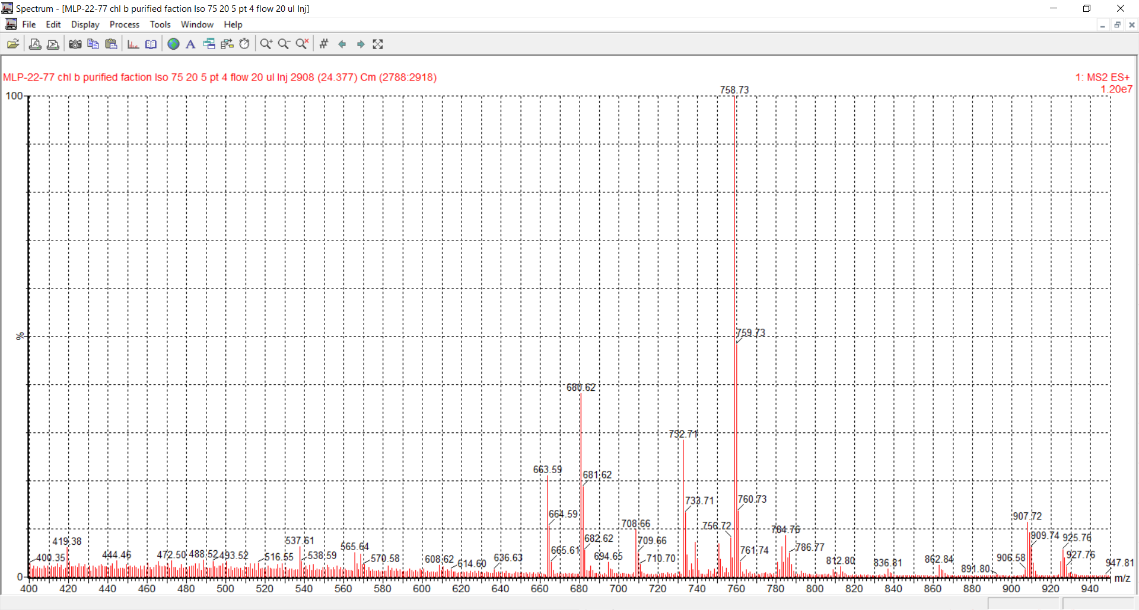
Figure A.17. Mass spectra of unknown chlorophyll with putative [M+H]⁺ of ~926 AMU, partially purified from MLP-22-77-3, highlighting the molecular weights of the unknown and 907-908 region of Chl b.

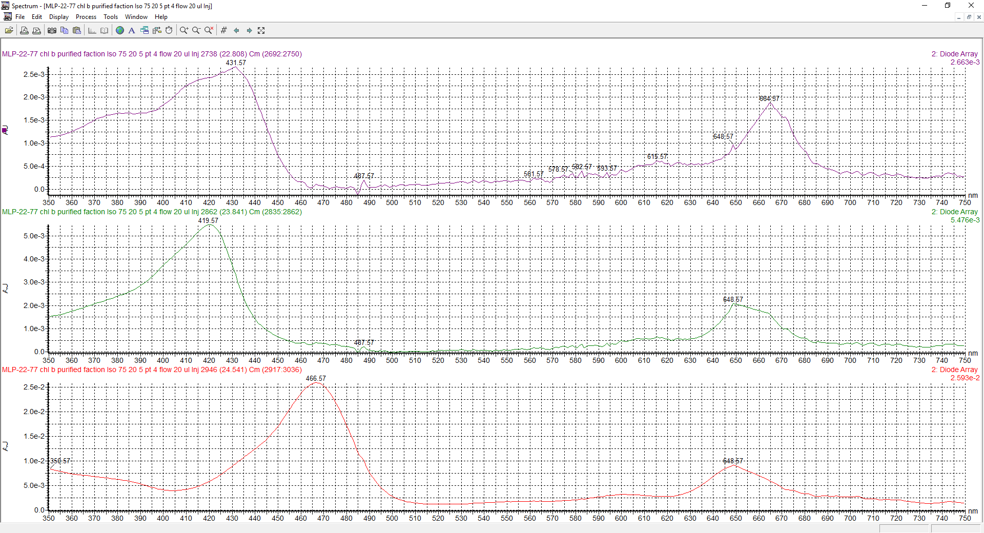
Figure A.18. PDA spectra of chlorophyll b (red), unknown putative hydroxychlorophyll with [M+H]⁺ of ~926 AMU (green), and putative chlorophyll [M+H]⁺ of ~891 AMU (purple), partially purified from MLP-22-77-3. The spectra suggest the green compound is related to chl b, while the purple compound may be more similar to chl a. These spectra should not be over-interpreted because the wavelengths around 660 nm are imputed rather than measured due to the deuterium lamp in the detector.

Figure A.18. Concentrations of various pigments in Cladophora analyzed by this method in ug/g.

Supplemental Text 5: Evidence for Novel Chlorophylls in Caulerpa and Planktothricoides
1. No carryover was ever identified in any standard or sample, and the spectra and chromatograms are so unique and the instrument highly sensitive that we would have identified instrument carryover that would have transferred these chlorophylls between samples; 2. These two samples were analyzed nearly four hours apart, and the chlorophylls were not seen in the intervening samples; 3. Caulerpa contained many early eluting compounds, and numerous pigments throughout, that it would have been extremely obvious if carryover occurred into the Planktothricoides injection; 4. The only feasible way these peaks could have appeared in Caulerpa from contamination would have been Planktothricoides contamination of Caulerpa during grinding into powder or during extraction, but the contamination would have had to be enormous (20%+), involving catastrophic sample handling, to explain the peak sizes we observed

