Supplementary Figure S1 Headlines Cirrus
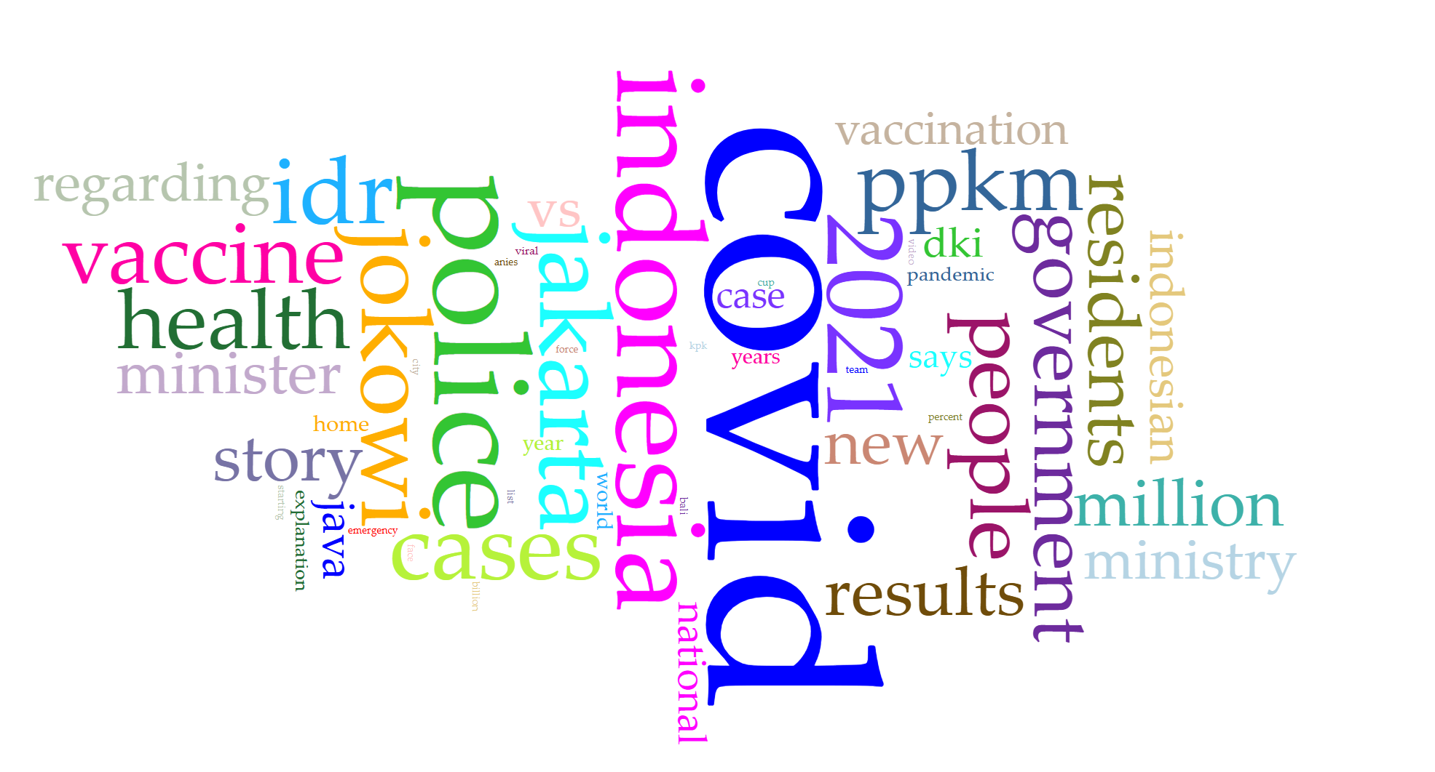
Supplementary Figure S1. Supplied Voyant word cloud for the collection labelled Headlines. The image displays covid alongside political, geographical, institutional and preventive vocabulary. Type size indicates visual prominence within this export; it is not used to calculate numerical ranks, frame prevalence or cross-corpus differences. English labels are reproduced as supplied; original-language mapping and processing settings are unverified.

Supplementary Figure S2 News Cirrus
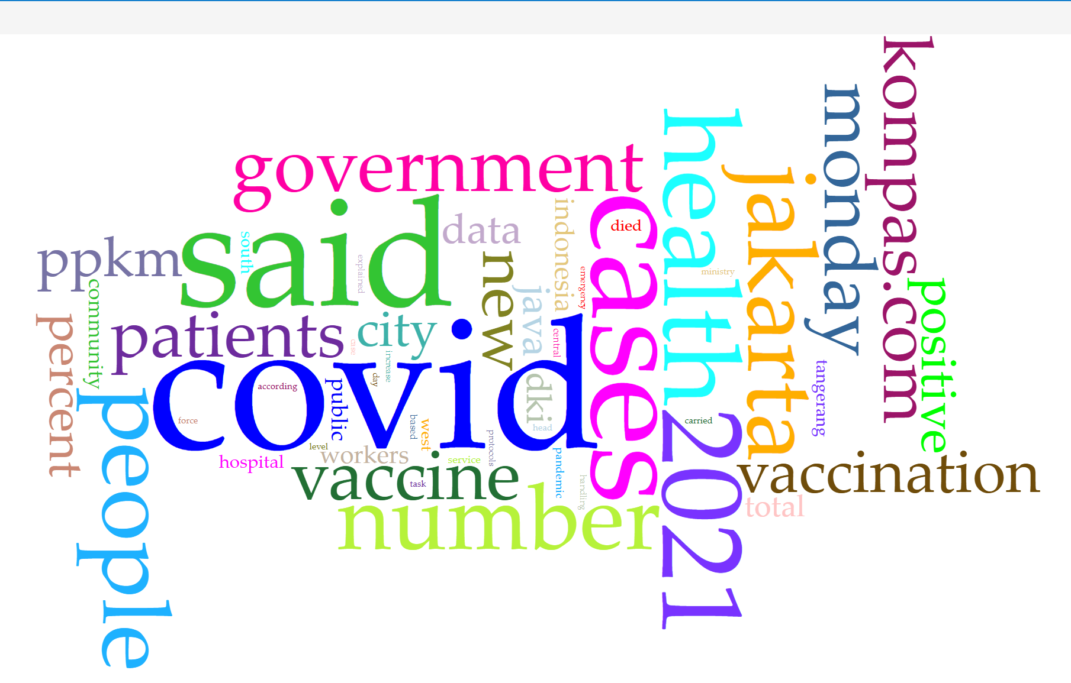
Supplementary Figure S2. Supplied Voyant word cloud for the collection labelled News. Disease and prevention vocabulary appears alongside attribution, date and publication-related forms, including said, monday, 2021 and kompas.com. The presence of these forms motivates inspection of source aggregation and preprocessing. Cloud geometry does not establish emotion, moral attribution or audience response.

Supplementary Figure S3 Headlines Trends
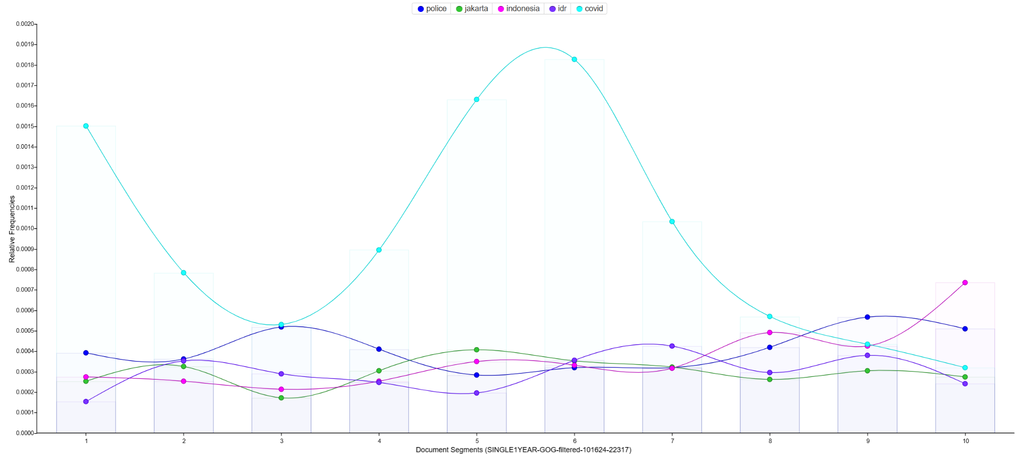
Supplementary Figure S3. The supplied chart displays relative frequencies of police, jakarta, indonesia, idr and covid across ten segments of a single document, as labelled on the horizontal axis. Segment numbers are textual positions, not verified calendar intervals. The smoothing does not establish values between positions. The selected terms and segmentation differ from the News chart and from the headline StreamGraph.

Supplementary Figure S4 News Trends
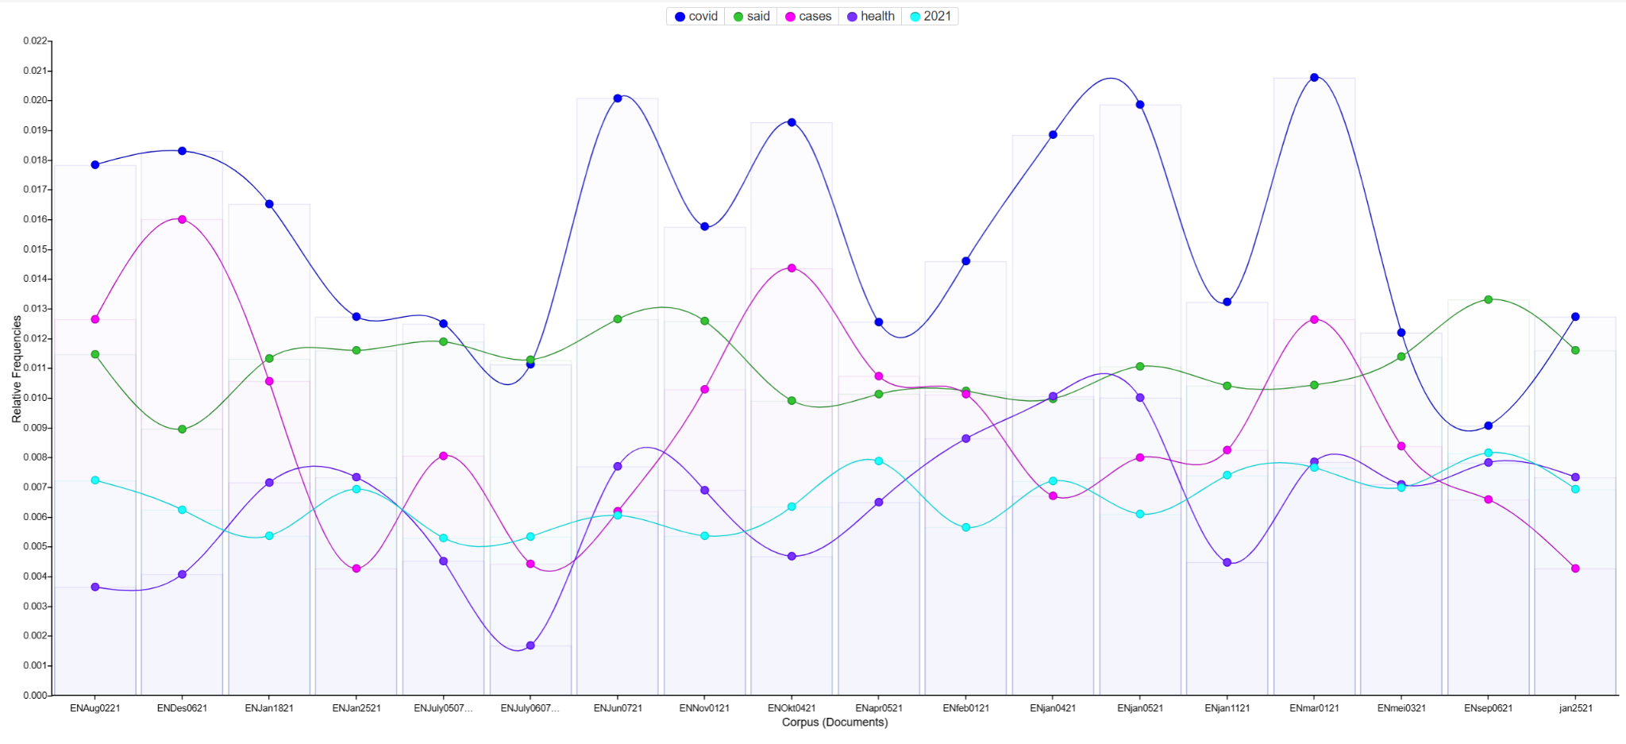
Supplementary Figure S4. The supplied chart displays relative frequencies of covid, said, cases, health and 2021 across 18 labelled documents. Their displayed order is non-chronological. The graph therefore describes document-level variation as supplied; it does not establish a monthly or daily trajectory. Document lengths, source membership and date mapping require verification before comparison.

Supplementary Figure S5 Headlines StreamGraph
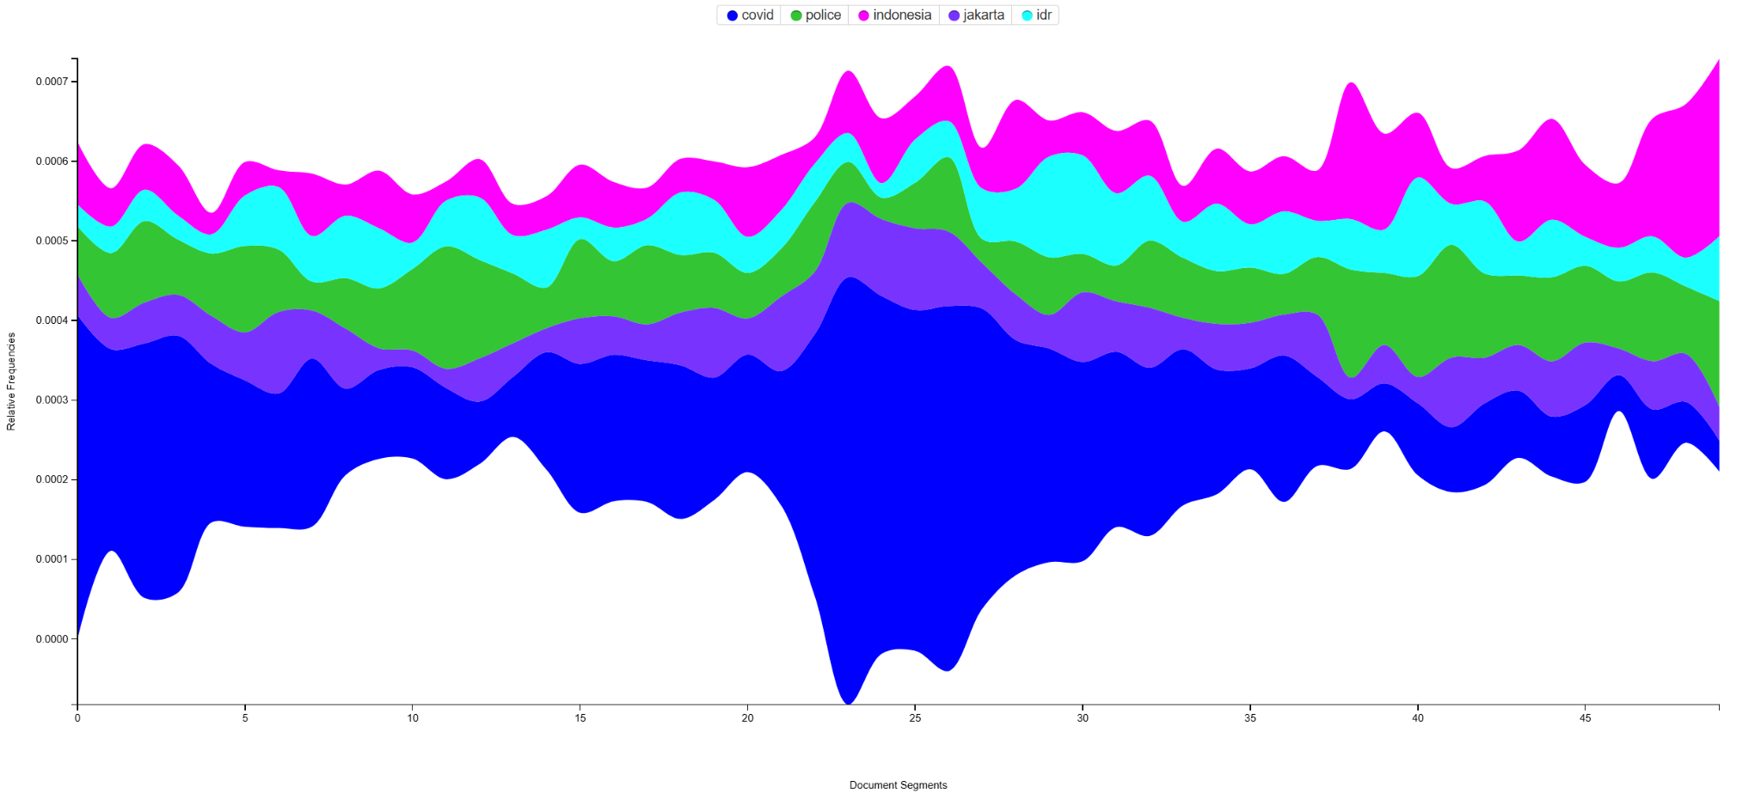
Supplementary Figure S5. The supplied graph displays selected terms across document segments, with a finer resolution than the ten-segment Headlines Trends export. Band thickness represents the displayed lexical distribution; vertical placement follows the stream layout. Positions below zero are not negative term frequencies. No mapping from segments to calendar dates or epidemic events is established.

Supplementary Figure S6 News StreamGraph
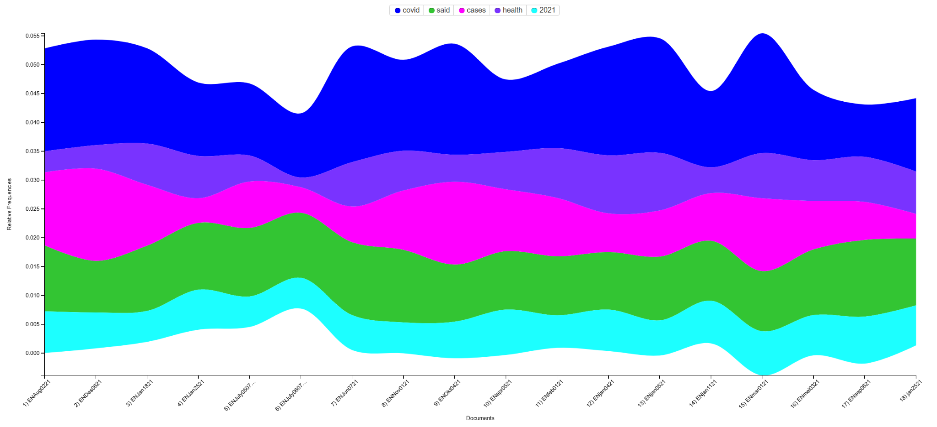
Supplementary Figure S6. The supplied graph displays the selected terms covid, said, cases, health and 2021 across 18 labelled documents in the displayed order. That order is not chronological. Band thickness, rather than its upper boundary alone, describes a term's displayed distribution; vertical displacement is a layout feature. No epidemiological event association or temporal causal claim is inferred.

Supplementary Figure S7 Headlines Links
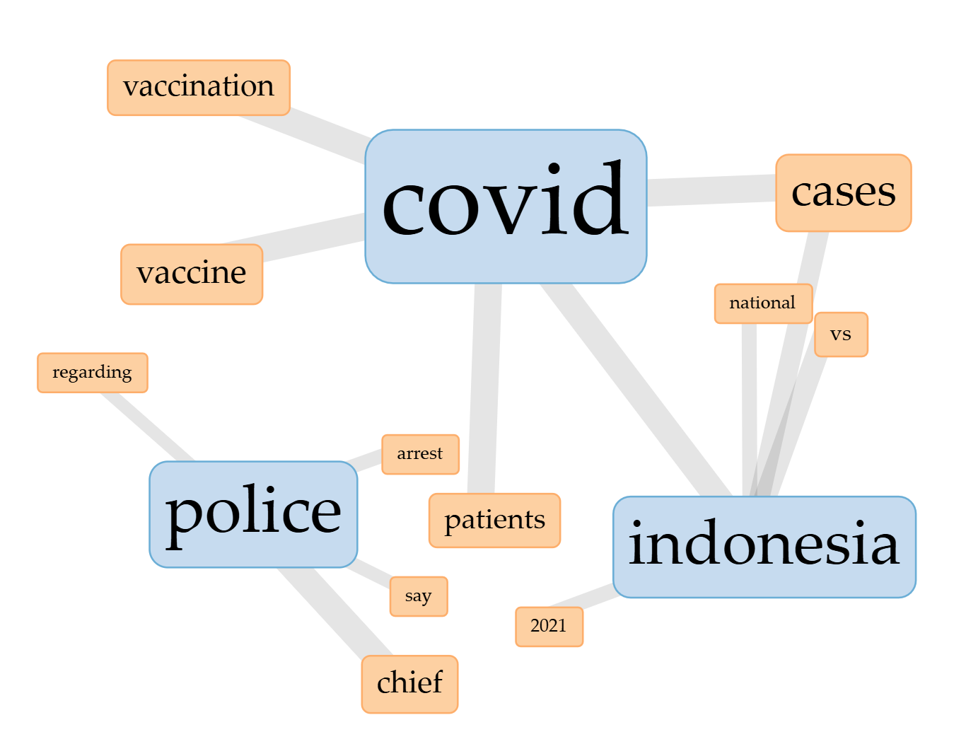
Supplementary Figure S7. Supplied lexical connection display. The covid neighbourhood includes vaccine, vaccination, cases, patients and indonesia; a separate police neighbourhood includes arrest and chief. The image does not specify the complete selection rule, co-occurrence window or numerical weights. Edges are not causal relationships, and the police neighbourhood cannot be assigned to pandemic enforcement without original passages.

Supplementary Figure S8 News Links
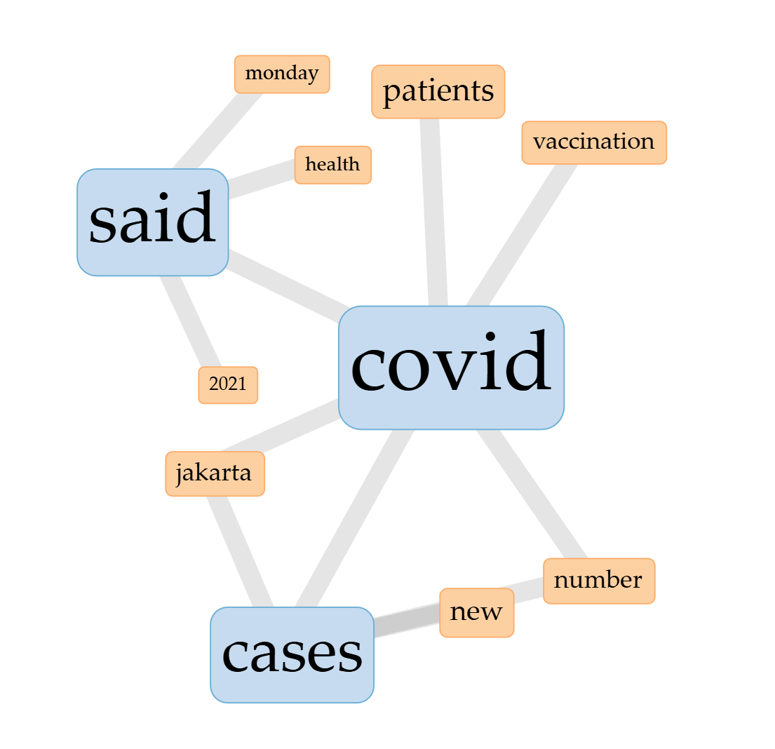
Supplementary Figure S8. Supplied lexical connection display including covid, cases and said. Visible links connect disease, patient, vaccination, numerical and attribution-related terms. The settings needed to reproduce the layout and edge values are not supplied. The graphic does not by itself establish semantic equivalence, moral judgement, statistical significance or audience effects.

