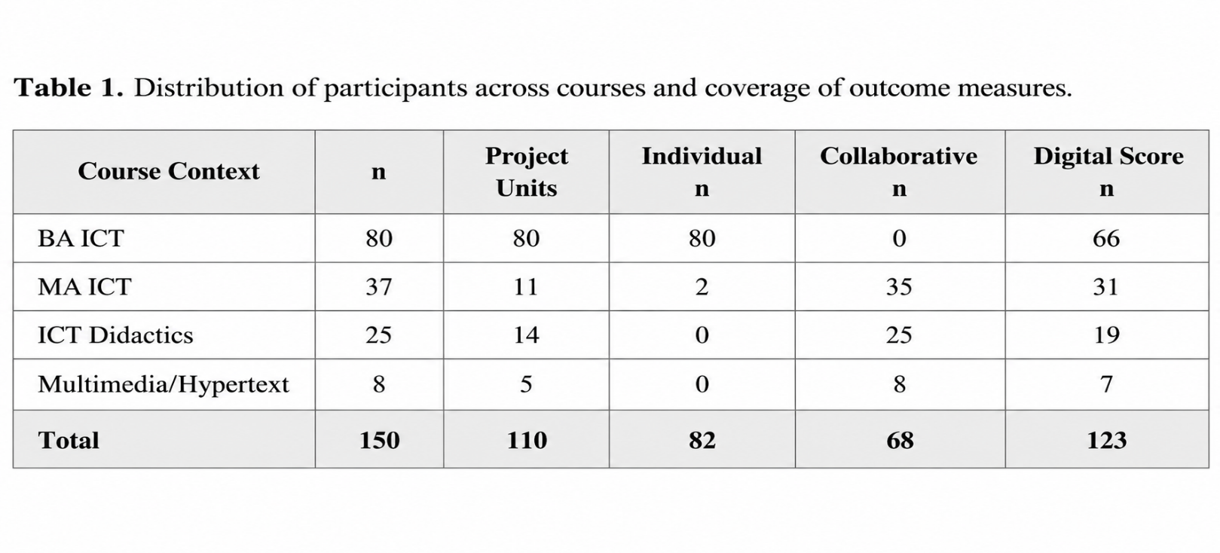
Calculation of the digital score required at least 17 substantive responses across the 22 questionnaire items. The primary digital analysis included 122 respondents with complete covariate information. Course designations correspond to the four administratively defined educational contexts, while the comparison between the 122 included respondents and the 28 excluded respondents is provided in Appendix A (Supplementary File S1: Statistical Tables).
Table 1. Distribution of Participants Across Courses and Coverage of Outcome Measures.

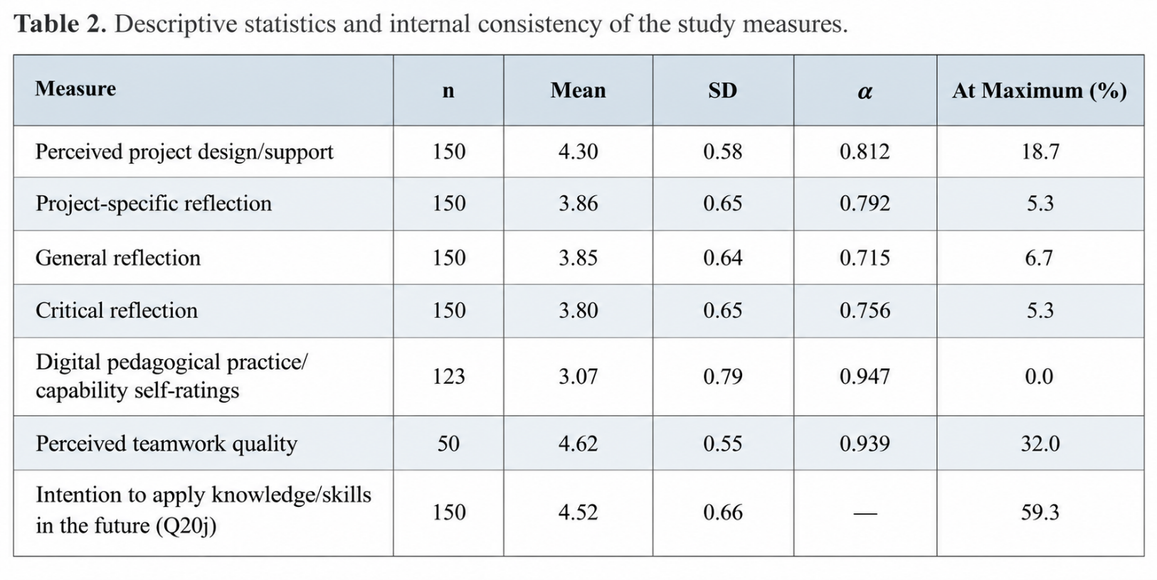
All measures were evaluated on a five-point scale ranging from 1 to 5. Cronbach’s alpha (α) was calculated using respondents with complete item-level data, comprising 89 participants for the digital pedagogical measure and the sample sizes reported in Table 2 for the remaining measures. Appendix A (Supplementary File S1: Statistical Tables) provides the supporting statistical results, including cluster-bootstrap confidence intervals for Cronbach’s alpha, detailed definitions of the composite scores, and distributions of individual questionnaire items.
Table 2. Descriptive Statistics and Internal Consistency of the Study Measures.

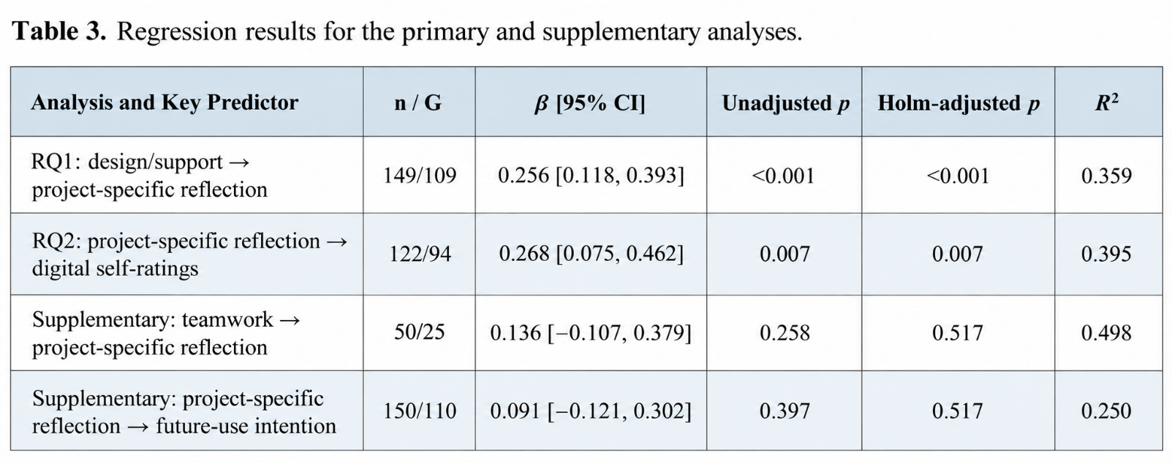
G represents the number of administrative project units, while β indicates a standardised regression association. The arrows identify the direction of the regression relationships and should not be interpreted as evidence of causality. Confidence intervals were calculated using the CR1 cluster-robust estimator and the t(G − 1) distribution, with degrees of freedom of 108, 93, 24, and 109 for the four models, respectively. The Holm correction was applied to two separate families of hypothesis tests, comprising the two primary analyses and the two supplementary analyses. The RQ1 and RQ2 models incorporated perceived project design/support, general and critical reflection as separate measures, four reported experience variables (Q8a–d), practical teaching experience (Q5), and course indicators. Project-specific reflection was additionally included as a predictor in the RQ2 model. The supplementary teamwork model adjusted for perceived design/support, general reflection, critical reflection, and course membership. The future-use intention model included project-specific reflection, perceived design/support, general and critical reflection, Q8a–d, and course indicators. The residual degrees of freedom, calculated as n − k, were 137, 109, 43, and 138 for the respective models. Complete regression coefficient estimates for the primary and supplementary analyses are provided in Appendix A (Supplementary File S1: Statistical Tables).

Table 3. Key Regression Coefficients from the Primary and Supplementary Analyses.

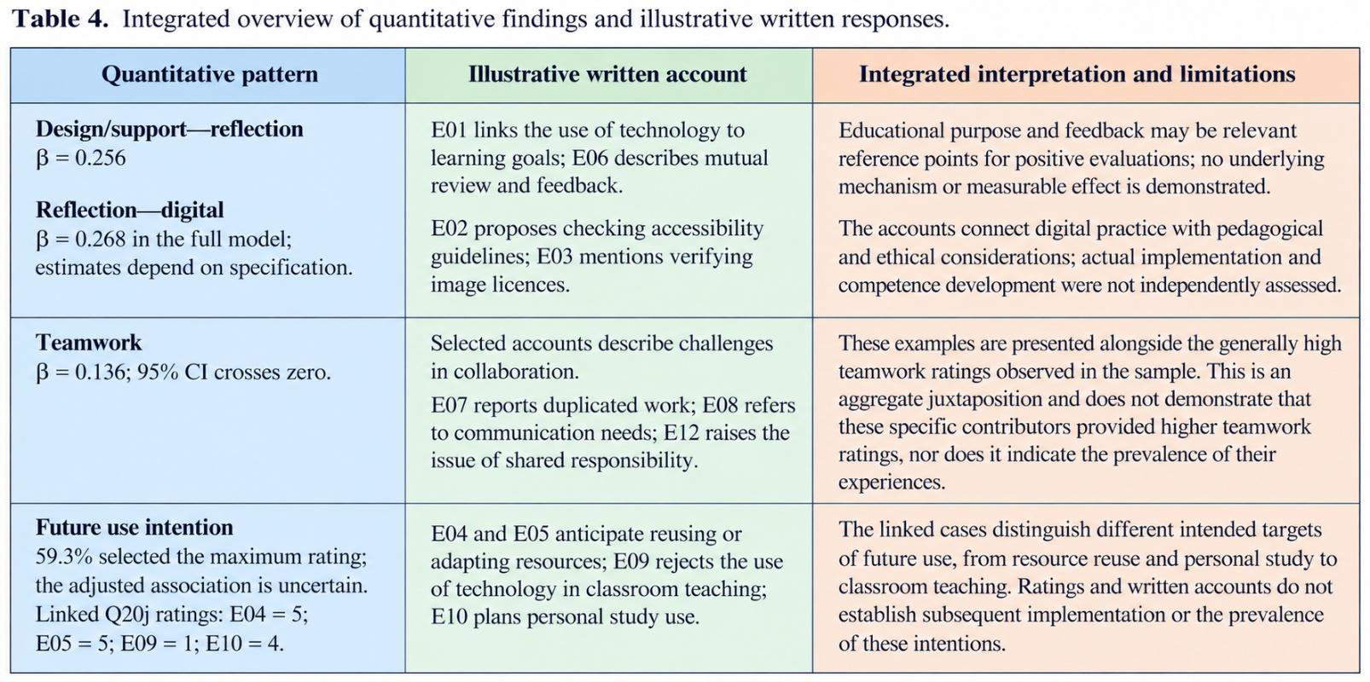
The excerpt labels do not represent participant identifiers. All 12 original excerpts are linked to their respective contributors’ Q20j ratings, which are measured on a five-point scale (1–5). These excerpts were selected prior to conducting the linkage diagnostic. A further six excerpts illustrate distinctions within the coding process and are not included in the joint display. The illustrative presentation does not provide a basis for determining category frequencies or explaining any regression coefficient. The retrospective reconciliation process maintains the eligibility criteria established for the manuscript.

Table 4. Integrated Presentation of Quantitative Findings and Supporting Illustrative Written Responses.

