SUPPLEMENTARY FIGURES AND FIGURE LEGENDS
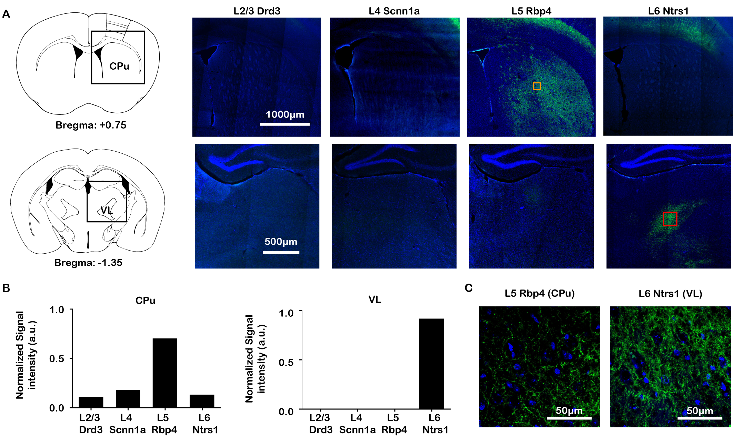
Supplementary Figure 1: M1 L5 projects to CPu while M1 L6 projects to VL as revealed by ChR2 expression only in Rbp4 L5 and Ntsr1 L6 Cre-lines, respectively. (A) Representative fluorescence images of the CPu and VL from the four layer-specific Cre-lines shows robust ChR2-EYFP expression only from Rbp4 L5 Cre-line in CPu and only from Ntsr1 L6 Cre-line in VL. (B) Normalized signal intensity in CPu and VL demonstrates Rbp4 L5 and Ntsr1 L6 Cre-lines have the strongest expression in CPu and VL, respectively. (C) The merge representative confocal image of ChR2-EYFP and stained nuclear marker DAPI demonstrates that the CPu and VL expression are projections from M1 L5 and L6, respectively, but not neurons.

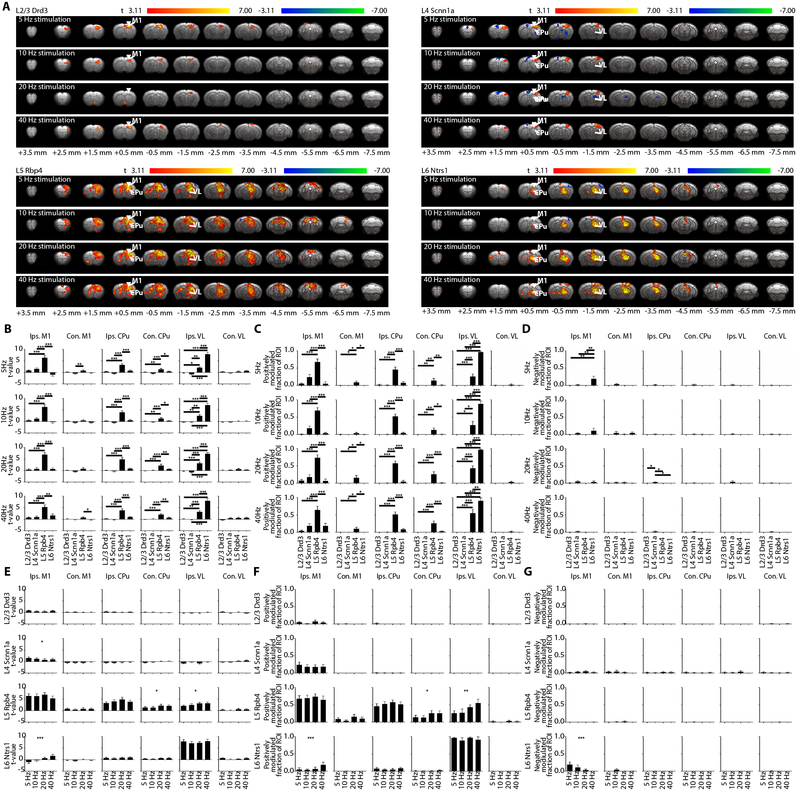
Supplementary Figure 2: Layer-specific and frequency-specific M1 stimulations evoked distinct brain-wide ofMRI responses. (A) Group-level activation maps during L2/3, L4, L5, and L6 M1 stimulation at 5 Hz, 10 Hz, 20 Hz and 40 Hz (n = 12 animals per Cre-line, total N = 48 animals; p < 0.001, FDR-corrected). Inverted white triangle indicates site of stimulation; warm and cool colors indicate positive and negative t-scores, respectively. Abbreviations: primary motor cortex (M1), caudate putamen (CPu), ventrolateral thalamic nucleus (VL). (B – D) Average t-values (B), fraction of ROI positively (C) and negatively (D) modulated were extracted. Note the same ROIs were used in Figure 2B. In general, L2/3 stimulation activated only ipsilateral M1. L4 stimulation activated ipsilateral M1, while small negative responses were observed in contralateral M1, ipsilateral CPu and ipsilateral VL. L5 stimulation evoked robust ipsilateral M1, bilateral CPu and ipsilateral VL activations. L6 stimulation evoked negative ipsilateral M1 response, positive ipsilateral CPu response and robust VL activations. L5 stimulation evoked the strongest responses in ipsilateral M1 and bilateral CPu compared to L2/3, L4 and L6 stimulations. For ipsilateral VL, L6 stimulation evoked the strongest activations, while L5 stimulation evoked stronger activations compared to L2/3 and L4 stimulations. One-way ANOVA followed by Bonferroni’s post hoc test was used (*p < 0.05, **p < 0.01 and ***p < 0.001; error bars indicate ±SEM). (E – G) Average t-values (E), fraction of ROI positively (F) and negatively (G) modulated were extracted to compare ofMRI responses between different frequencies (5 Hz, 10 Hz, 20 Hz and 40 Hz). The extracted t-values had a decreasing trend with frequency in ipsilateral M1 during L4 stimulation, while both the extracted t-values and fraction of ROI positively modulated had an increasing trend with frequency in contralateral CPu and ipsilateral VL during L5 stimulation. For L6 stimulation, ipsilateral M1 responses had increasing trends with increasing stimulation frequency for t-values and fraction of ROI positively modulated, while a decreasing trend with frequency was observed for fraction of ROI negatively modulated. One-way ANOVA followed by trend analysis was applied (*p < 0.05, **p < 0.01 and ***p < 0.001; error bars indicate ±SEM).

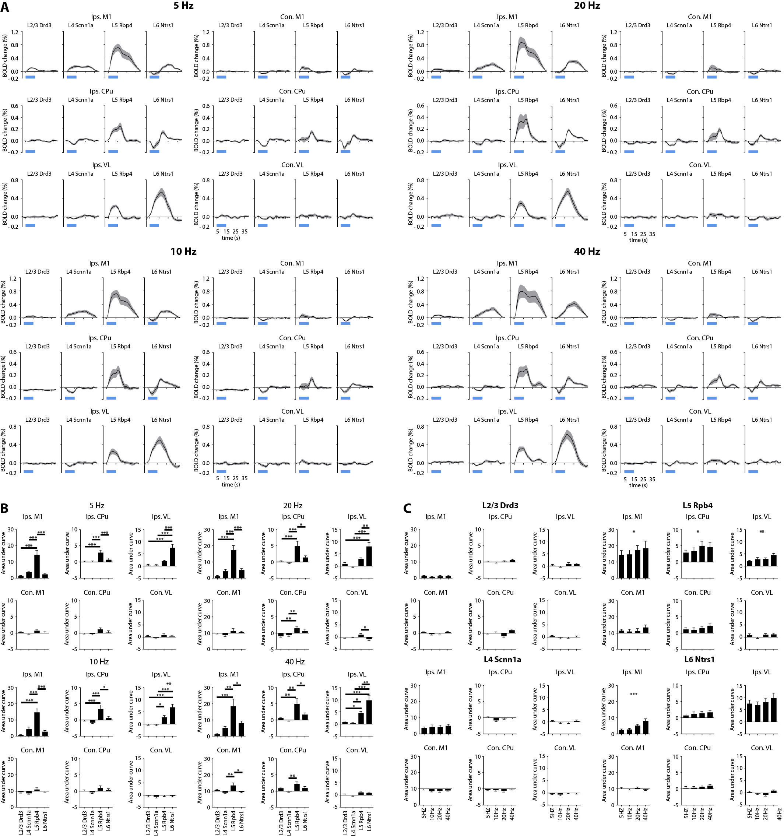
Supplementary Figure 3: Distinct ofMRI temporal dynamics of the BOLD signal across the brain evoked by layer-specific and frequency-specific M1 stimulation. (A) BOLD signal profiles extracted from the same ROIs used for quantifying activation maps in Figure 2B. Abbreviations: primary motor cortex (M1), caudate putamen (CPu), ventrolateral thalamic nucleus (VL). (B) Area under the curve (AUC) were calculated for the comparison of the extracted BOLD signal. In general, L5 stimulation evoked the strongest responses in ipsilateral M1 and ipsilateral CPu compared to L2/3, L4 and L6 stimulations; while L6 stimulation evoked the strongest ipsilateral VL activations. These results were in line with Figure 2 and 3 disregarding different stimulation frequency. One-way ANOVA followed by Bonferroni’s post hoc test was used (n = 12 animals per Cre-line, total N = 48 animals; *p < 0.05, **p < 0.01 and ***p < 0.001; error bars indicate ±SEM). (C) Similarly, AUC were calculated for the comparison of the extracted BOLD signal between different frequencies. AUC had an increasing trend in ipsilateral M1 during L5 and L6 stimulation, as well as ipsilateral CPu and VL during L5 stimulation. One-way ANOVA followed by trend analysis was applied (*p < 0.05, **p < 0.01 and ***p < 0.001; error bars indicate ±SEM).

Supplementary Figure 4: No evoked fMRI responses were observed in a naïve animal. Activation map and extracted BOLD signal from a naïve animal (n = 1) during optogenetic stimulation of L5 did not evoke fMRI responses. These results indicate that the observed responses were a direct consequence of ChR2 stimulation rather than heat induced artifacts or undesired light-induced activations.

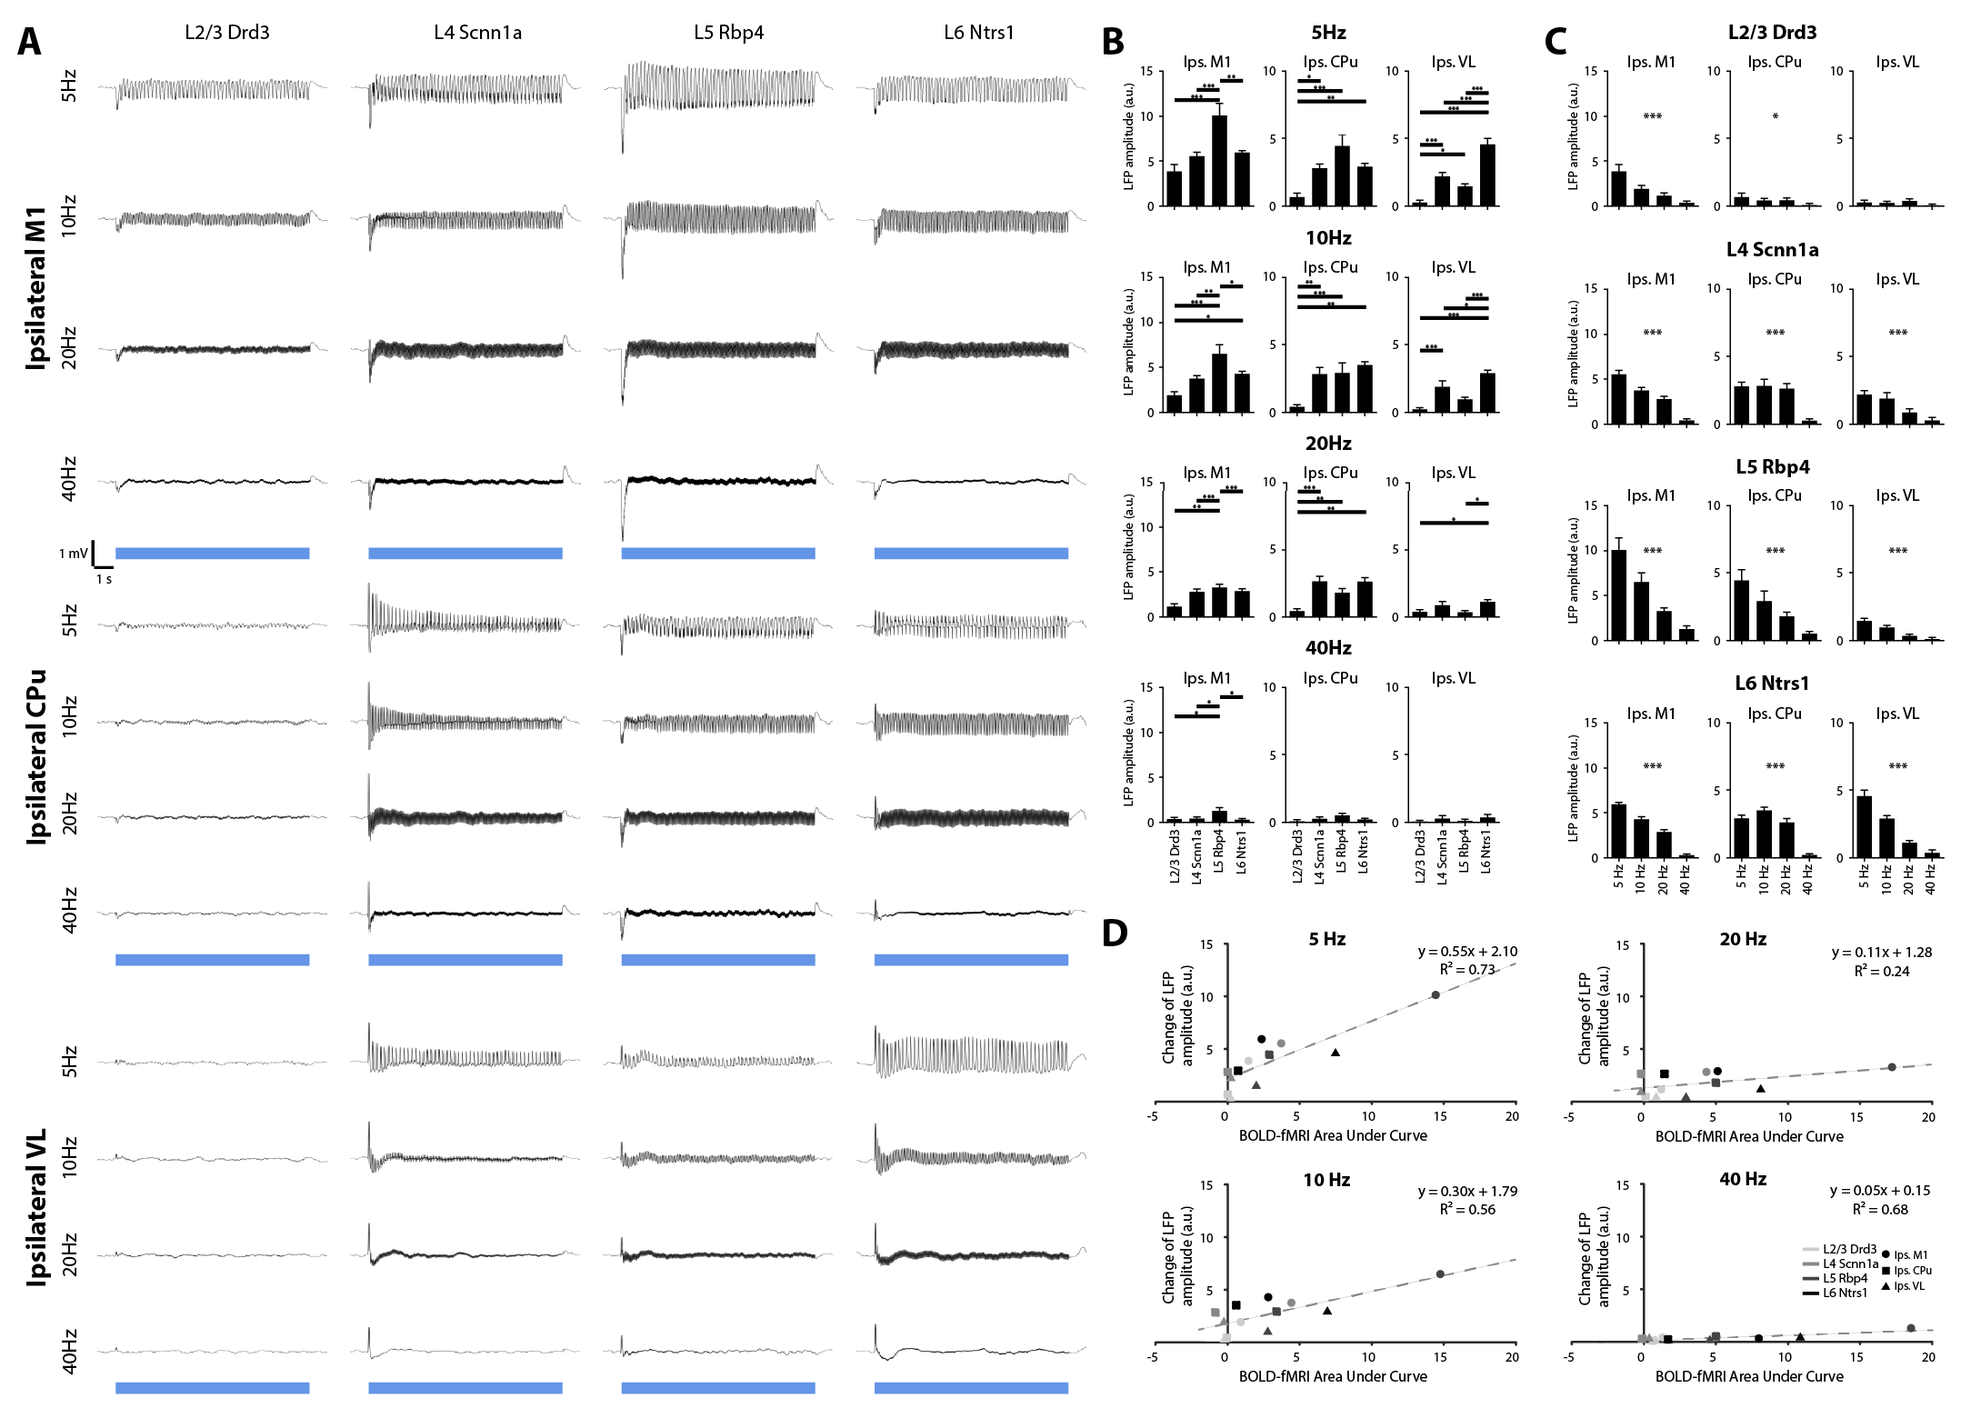
Supplementary Figure 5: LFP recordings reveal activations in M1 for all layer-specific and frequency-specific stimulations, and in CPu and VL for only L4, L5 and L6 stimulations, which correlates with fMRI activations. (A) Average LFP traces (n = 4 animals per Cre-line, total N = 16 animals) from ipsilateral M1, VL and CPu layer-specific M1 stimulation at 5 Hz, 10 Hz, 20 Hz and 40 Hz shows robust activation in M1 for all Cre-lines, and in CPu and VL for Scnn1a L4, Rbp4 L5 and Ntsr1 L6 Cre-lines. (B) Change in LFP amplitude during stimulation was calculated to quantify the LFP traces. L5 stimulation evoked the strongest change in LFP amplitude in ipsilateral M1 compared to L2/3, L4 and L6 stimulations at all stimulation frequencies. L2/3 stimulation at 5 Hz, 10 Hz and 20 Hz evoked the weakest LFP amplitude change in ipsilateral CPu. For ipsilateral VL, L6 stimulation at 5 Hz, 10 Hz, and 20 Hz evoked the strongest change in LFP amplitude. These LFP results corroborate with our fMRI results. One-way ANOVA followed by Bonferroni’s post hoc test was used (*p < 0.05, **p < 0.01 and ***p < 0.001; error bars indicate ±SEM). (C) Similarly, change in LFP amplitude were calculated for the comparison between different stimulation frequencies. Change in LFP amplitude had a decreasing trend in ipsilateral M1, CPu and VL with stimulation frequency except ipsilateral VL during L2/3 stimulation. One-way ANOVA followed by trend analysis was applied (*p < 0.05, **p < 0.01 and ***p < 0.001; error bars indicate ±SEM). (D) Scatter plot of change in LFP amplitude against BOLD-fMRI area under the curve in ipsilateral M1, CPu and VL for all Cre-lines shows that our LFP and fMRI results are correlated.

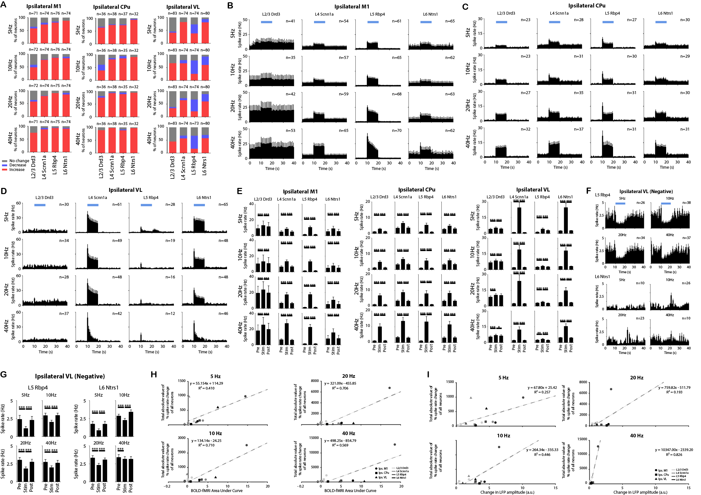
Supplementary Figure 6: Distinct spike responses and dynamics of the ipsilateral M1, CPu and VL evoked by layer-specific and frequency-specific M1 stimulation correlating with LFP and fMRI results. (A) Quantification of significant changes in firing rate across recorded units in ipsilateral M1 (left), CPu (middle) and VL (right). For each unit, paired student t-test was applied and results with p < 0.05 were considered significant (n = 4 animals per Cre-line, total N = 16 animals). Red, blue and gray indicate units with significant increase, significant decrease and no significant change, respectively, during stimulation. (B – D) Mean peri-event time histograms across all units with significant increased firing rates in the ipsilateral M1 (B), CPu (C) and VL (D) during 5Hz, 10Hz, 20Hz and 40Hz stimulation at L2/3, L4, L5 and L6 of ipsilateral M1. (E) Average firing rates of units with significant increase before, during, and after stimulation in ipsilateral M1 (left), CPu (middle) and VL (right) (10 s periods, one-way ANOVA followed by Bonferroni’s post hoc test; *p < 0.05, **p < 0.01 and ***p < 0.001). (F) Mean peri-event time histograms across all units with significant decreased firing rates in ipsilateral VL during 5Hz, 10Hz, 20Hz and 40Hz stimulation at L5 and L6 of ipsilateral M1. (G) Average firing rates of units with significant decrease before, during, and after stimulation (10 s periods, one-way ANOVA followed by Bonferroni’s post hoc test; *p < 0.05, **p < 0.01 and ***p < 0.001). (H – I) Scatter plots of total absolute value of % spike rate change of all neurons against BOLD-fMRI area under the curve (H) and against change in LFP amplitude (I) in ipsilateral M1, CPu and VL for all Cre-lines show that spike rate, fMRI and LFP results are correlated. All error bars represent ±SEM.

Supplementary Figure 7: No evoked LFP responses were observed in a naïve animal. LFP signal from a naïve animal (n = 1) during optogenetic stimulation of L5 did not evoke LFP responses. These results indicate that the observed responses were a direct consequence of ChR2 stimulation and not photovoltaic induced artifacts or undesired light-induced activations.

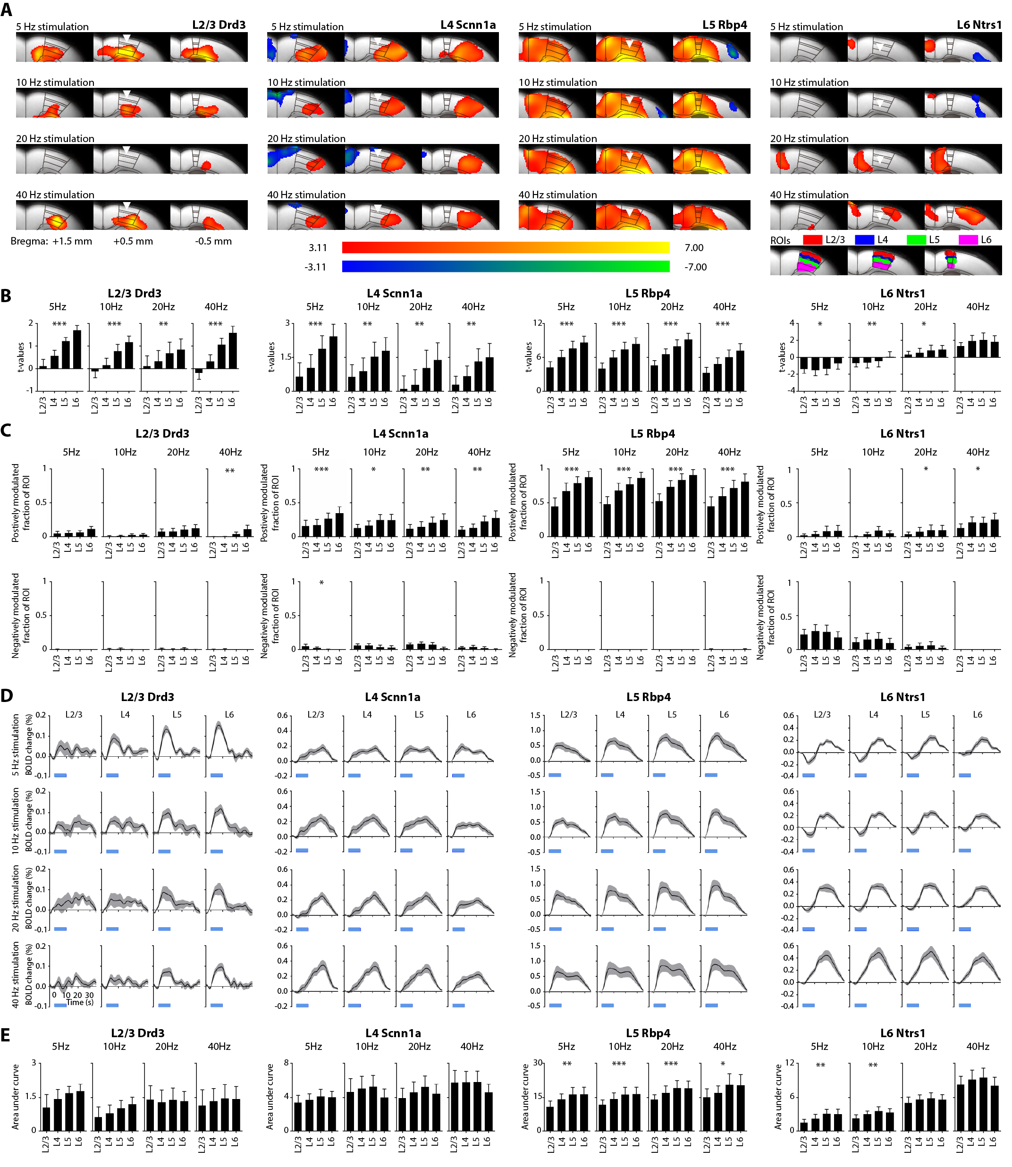
Supplementary Figure 8: Distinct mesoscale laminar ofMRI responses evoked by layer-specific stimulation at 5 Hz, 10 Hz, 20 Hz and 40 Hz exhibit a similar increasing trend along the M1 cortical depth. (A) Group-level M1 local activation maps during L2/3, L4, L5, and L6 M1 stimulation at 5 Hz, 10 Hz, 20 Hz and 40 Hz (n=12 animals per Cre-line, total N = 48 animals; p < 0.001, FDR-corrected). Distinct mesoscale laminar fMRI responses were observed. Inverted triangle indicate site of stimulation; warm and cool colors indicate positive and negative t-scores, respectively. ROIs (bottom right) defined based on the mouse brain atlas to quantify the layer-specific activations at the local ipsilateral M1. (B) Extracted t-values for the comparison of ofMRI responses across different layers. Although all fMRI responses were distinct, they exhibit an increasing trend along the cortical depth for all layer-specific stimulations, besides L6 40 Hz stimulation. (C) Extracted fraction of ROI positively (top) and negatively (bottom) modulated for the comparison of ofMRI responses across different layers. Fraction of ROI positively modulated exhibit an increasing trend along the cortical depth during 40 Hz L2/3 stimulation, all L4 stimulations, all L5 stimulations, and 20 Hz and 40 Hz L6 stimulations. On the other hand, fraction of ROI negatively modulated exhibit a decreasing trend along the cortical depth during 5 Hz L4 stimulation. (D) BOLD signal profiles extracted from the ROIs. These BOLD signal profiles also appears to exhibit an increasing trend along the cortical depth. (E) Area under the curve (AUC) was calculated form the extracted BOLD profiles for the comparison across different layers. AUC exhibit an increasing trend along the cortical depth during all L5 stimulations, and 5 Hz and 10 Hz L6 stimulations. One-way ANOVA followed by trend analysis was applied (*p < 0.05, **p < 0.01 and ***p < 0.001). Error bars indicate ±SEM.

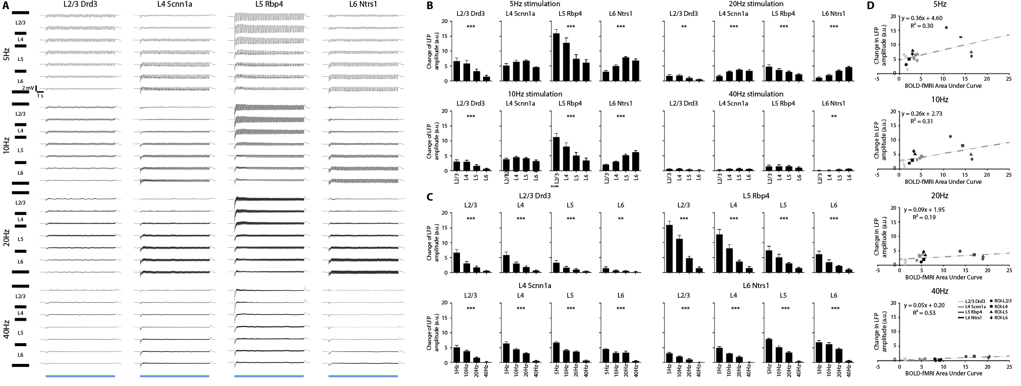
Supplementary Figure 9: Laminar LFP recordings along M1 cortical depth reveal layer-specific activations at respective layer-specific stimulations at 5 Hz, 10 Hz, 20 Hz and 40 Hz, which correlates with laminar fMRI responses. (A) Average LFP traces (n = 4 animals per Cre-line, total N = 16 animals) of ipsilateral M1 along cortical depth at 5 Hz, 10 Hz, 20 Hz and 40 Hz layer-specific optogenetic stimulation. (B) Change in LFP amplitude during stimulation was calculated to quantify the LFP traces. The change in LFP amplitude decreased along the cortical depth during L2/3 and L5 stimulations at 5 Hz, 10 Hz and 20 Hz, while the amplitude increased along the cortical depth during 20 Hz L4 stimulation and all L6 stimulations. One-way ANOVA followed by trend analysis was applied (*p < 0.05, **p < 0.01 and ***p < 0.001). (C) The change in LFP amplitude had a decreasing trend with frequency during all layer-specific stimulations (D) Scatter plots of change in LFP amplitude against BOLD-fMRI area under the curve along the cortical depth in ipsilateral M1 for all Cre-lines at all stimulation frequencies show that our LFP and fMRI results are correlated. Error bars indicate ±SEM.

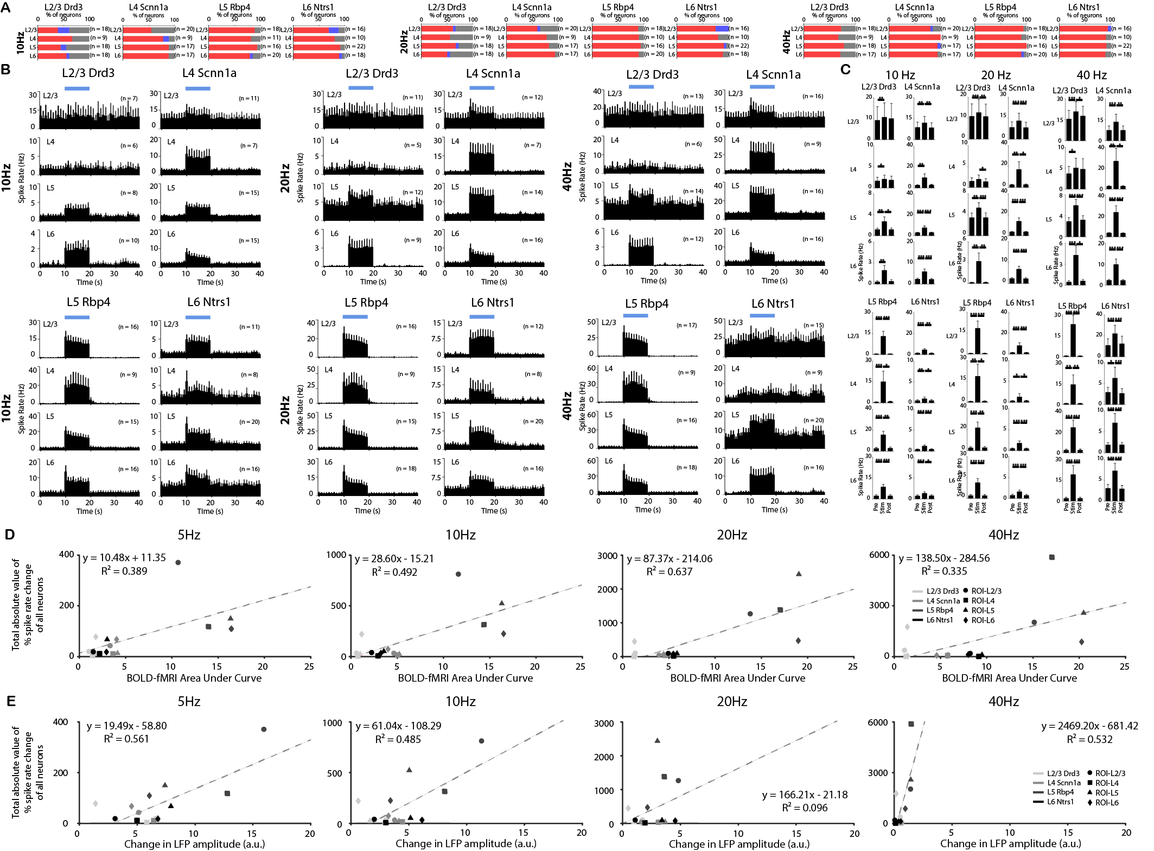
Supplementary Figure 10: Distinct laminar spiking dynamics evoked by layer-specific M1 stimulation at 5 Hz, 10 Hz, 20 Hz and 40 Hz correlating with laminar fMRI and LFP responses. (A) Quantification of significant changes in firing rate across recorded units at 10 Hz, 20 Hz and 40 Hz. For each unit, paired student t-test was applied and results with p < 0.05 were considered significant (n = 4 animals per Cre-line, total N = 16 animals). Red, blue and gray indicate units with significant increase, significant decrease and no significant change, respectively, during stimulation. Over half of the recording units were modulated by the selective stimulation of each layer. Furthermore, nearly all modulated units exhibited a significant increase in firing rate. (B) Mean peri-event time histograms across all units with significant increased firing rates along ipsilateral M1 cortical depth during L2/3, L4, L5 and L6 M1 stimulation at 10 Hz, 20 Hz and 40 Hz. Interestingly, robust increase in spike rates was observed in L6 during L2/3 stimulation. (C) Average firing rates of units with significant increase before, during, and after stimulation at 10 Hz, 20 Hz and 40 Hz stimulation (10 s periods, one-way ANOVA followed by Bonferroni’s post hoc test; *p < 0.05, **p < 0.01 and ***p < 0.001; error bars indicate ±SEM). In general, the spike rates significantly increased in all layers during all layer-specific stimulation. (D – E) Scatter plots of total absolute value of % spike rate change of all neuron against BOLD-fMRI area under the curve (D) and against change in LFP amplitude (E) along the cortical depth for all Cre-lines show that spike rate, fMRI and LFP results along the cortical depth are correlated. Error bars represent ±SEM.

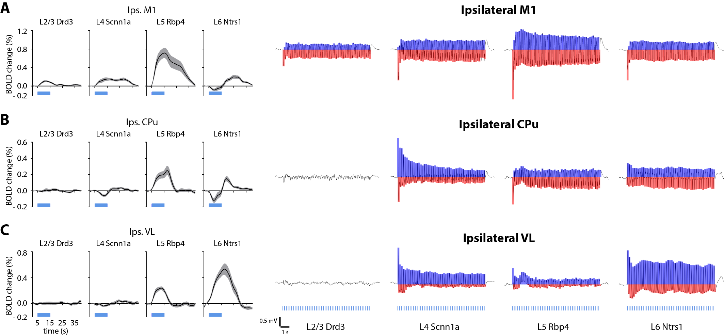
Supplementary Figure 11: Region specific positive and negative peaks of the LFP response are associated to distinct fMRI responses across different brain regions. (A) For ipsilateral M1, predominantly negative peaks of the LFP were observed during all stimulations. Note that blue indicates positive peaks while red indicates negative peaks. (B) For ipsilateral CPu, negative and positive BOLD responses were observed during L5 and L5 stimulation, respectively. In the same region, predominantly positive and negative peaks of the LFP were observed during L4 and L5 stimulations, respectively. For L6 stimulation, BOLD responses transitioned from negative to positive, while LFP responses transitioned from predominantly positive peaks to negative peaks. (C) For ipsilateral VL, predominantly positive peaks of the LFP were observed during L4, L5 and L6 stimulations.

SUPPLEMENTARY TABLES AND TABLE LEGENDS
Supplementary Table 1. Over half of the recorded units were modulated by all stimulations. Table displays the percentage of modulated units among all recorded units.
Ipsilateral M1 | L2/3 Drd3 | L4 Scnn1a | L5 Rbp4 | L6 Ntrs1
5 Hz | 64.80% | 79.70% | 84.20% | 87.8%
10 Hz | 58.30% | 78.40% | 86.80% | 89.2%
20 Hz | 63.90% | 81.10% | 90.70% | 91.9%
40 Hz | 74.60% | 93.20% | 94.70% | 93.2%

Ipsilateral CPu | L2/3 Drd3 | L4 Scnn1a | L5 Rbp4 | L6 Ntrs1
5 Hz | 69.4% | 76.3% | 75.7% | 96.9%
10 Hz | 66.7% | 86.8% | 94.3% | 90.6%
20 Hz | 80.6% | 94.7% | 94.3% | 93.8%
40 Hz | 88.9% | 97.4% | 91.4% | 96.9%

Ipsilateral VL | L2/3 Drd3 | L4 Scnn1a | L5 Rbp4 | L6 Ntrs1
5 Hz | 45.8% | 82.4% | 73.0% | 93.8%
10 Hz | 45.8% | 78.4% | 77.0% | 92.5%
20 Hz | 38.6% | 73.0% | 67.6% | 88.8%
40 Hz | 44.6% | 67.6% | 67.1% | 70.0%

Supplementary Table 2. In most cases, almost all the modulated units exhibited an increase in firing rate except for ipsilateral VL during L5 and L6 stimulations. Table displays the percentage of units with significant increase in firing rate among all modulated units.
Ipsilateral M1 | L2/3 Drd3 | L4 Scnn1a | L5 Rbp4 | L6 Ntrs1
5 Hz | 89.1% | 91.5% | 95.3% | 100%
10 Hz | 83.3% | 98.3% | 98.5% | 93.9%
20 Hz | 91.3% | 98.3% | 100% | 92.6%
40 Hz | 100% | 94.2% | 98.6% | 97.1%

Ipsilateral CPu | L2/3 Drd3 | L4 Scnn1a | L5 Rbp4 | L6 Ntrs1
5 Hz | 92.0% | 96.6% | 96.4% | 96.8%
10 Hz | 95.8% | 93.9% | 90.9% | 100%
20 Hz | 93.1% | 92.2% | 93.9% | 100%
40 Hz | 100% | 100% | 96.9% | 100%

Ipsilateral VL | L2/3 Drd3 | L4 Scnn1a | L5 Rbp4 | L6 Ntrs1
5 Hz | 78.9% | 100% | 51.9%, | 86.7%
10 Hz | 89.5% | 84.5% | 33.3% | 64.9%
20 Hz | 87.5% | 88.9% | 32.0% | 67.6%
40 Hz | 100% | 84.0% | 24.5% | 82.1%

Supplementary Table 3. Little modulated units exhibited a significant decrease in firing rate besides ipsilateral VL during L5 and L6 stimulations. Table displays the percentage of units with significant decrease in firing rate among all modulated units.
Ipsilateral M1 | L2/3 Drd3 | L4 Scnn1a | L5 Rbp4 | L6 Ntrs1
5 Hz | 10.9% | 8.5% | 4.7% | 0%
10 Hz | 16.7% | 1.7% | 1.5% | 6.1%
20 Hz | 8.7% | 1.7% | 0% | 7.4%
40 Hz | 0% | 5.8% | 1.4% | 2.9%

Ipsilateral CPu | L2/3 Drd3 | L4 Scnn1a | L5 Rbp4 | L6 Ntrs1
5 Hz | 8.0% | 3.4% | 3.6% | 3.2%
10 Hz | 4.2% | 6.1% | 9.1% | 0%
20 Hz | 6.9% | 2.8% | 6.1% | 0%
40 Hz | 0% | 0% | 3.1% | 0%

Ipsilateral VL | L2/3 Drd3 | L4 Scnn1a | L5 Rbp4 | L6 Ntrs1
5 Hz | 21.1% | 0% | 48.1% | 13.3%
10 Hz | 10.5% | 15.5% | 66.7% | 35.1%
20 Hz | 12.5% | 11.1% | 68.0% | 32.4%
40 Hz | 0% | 16.0% | 24.5% | 17.9%

Supplementary Table 4. Over half of all the recorded units in M1 along the cortical depth were modulated by all stimulations. Table displays the percentage of modulated units among all recorded units.
5 Hz | L2/3 Drd3 | L4 Scnn1a | L5 Rbp4 | L6 Ntrs1
L2/3 | 66.7% | 65% | 83.33% | 81.3%
L4 | 66.7% | 88.9% | 90.9% | 70%
L5 | 55.6% | 76.5% | 87.5% | 95.5%
L6 | 64.7% | 94.1% | 85% | 94.4%

10 Hz | L2/3 Drd3 | L4 Scnn1a | L5 Rbp4 | L6 Ntrs1
L2/3 | 61.11% | 55% | 88.9% | 87.5%
L4 | 66.7% | 88.9% | 81.8% | 80%
L5 | 55.6% | 88.2% | 93.8% | 90.9%
L6 | 61.1% | 88.2% | 85% | 94.4%

20 Hz | L2/3 Drd3 | L4 Scnn1a | L5 Rbp4 | L6 Ntrs1
L2/3 | 66.7% | 65% | 88.9% | 100%
L4 | 55.6% | 77.8% | 90% | 80%
L5 | 72.2% | 82.4% | 93.8% | 95.5%
L6 | 55.6% | 94.1% | 90% | 88.9%

40 Hz | L2/3 Drd3 | L4 Scnn1a | L5 Rbp4 | L6 Ntrs1
L2/3 | 72.2% | 85% | 94.4% | 100%
L4 | 66.7% | 100% | 90% | 90%
L5 | 77.8% | 100% | 100% | 90.9%
L6 | 70.6% | 94.1% | 95% | 88.9%

Supplementary Table 5. Nearly all modulated units exhibited a significant increase in firing rate of the ipsilateral M1 along the cortical depth. Table displays the percentage of units with significant increase in firing rate among all modulated units.
5 Hz | L2/3 Drd3 | L4 Scnn1a | L5 Rbp4 | L6 Ntrs1
L2/3 | 83.3% | 100% | 100% | 100%
L4 | 83.3% | 62.5% | 80% | 100%
L5 | 100% | 100% | 100% | 100%
L6 | 100% | 100% | 94.1% | 100%

10 Hz | L2/3 Drd3 | L4 Scnn1a | L5 Rbp4 | L6 Ntrs1
L2/3 | 63.6% | 100% | 100% | 78.6%
L4 | 100% | 87.5% | 100% | 100%
L5 | 80% | 100% | 100% | 100%
L6 | 90.9% | 100% | 94.1%, | 94.1%

20 Hz | L2/3 Drd3 | L4 Scnn1a | L5 Rbp4 | L6 Ntrs1
L2/3 | 91.7% | 92.3% | 100% | 75%
L4 | 100% | 100% | 100% | 100%
L5 | 92.3% | 100% | 100% | 95.2%
L6 | 90% | 100% | 100% | 100%

40 Hz | L2/3 Drd3 | L4 Scnn1a | L5 Rbp4 | L6 Ntrs1
L2/3 | 100% | 94.1% | 100% | 93.8%
L4 | 100% | 100% | 100% | 100%
L5 | 100% | 94.1% | 100% | 100%
L6 | 100% | 100% | 94.7% | 100%

Supplementary Table 6. Little modulated units exhibited a significant decrease in firing rate of the ipsilateral M1 along the cortical depth. Table displays the percentage of units with significant decrease in firing rate among all modulated units.
5 Hz | L2/3 Drd3 | L4 Scnn1a | L5 Rbp4 | L6 Ntrs1
L2/3 | 16.7% | 0% | 0% | 0%
L4 | 16.7% | 37.5% | 20% | 0%
L5 | 0% | 0% | 0% | 0%
L6 | 0% | 0% | 5.9% | 0%

10 Hz | L2/3 Drd3 | L4 Scnn1a | L5 Rbp4 | L6 Ntrs1
L2/3 | 36.4% | 0% | 0% | 21.4%
L4 | 0% | 12.5% | 0% | 0%
L5 | 20% | 0% | 0% | 0%
L6 | 9.1% | 0% | 5.9%, | 5.9%

20 Hz | L2/3 Drd3 | L4 Scnn1a | L5 Rbp4 | L6 Ntrs1
L2/3 | 8.3% | 7.7% | 0% | 25%
L4 | 0% | 0% | 0% | 0%
L5 | 7.7% | 0% | 0% | 4.8%
L6 | 10% | 0% | 0% | 0%

40 Hz | L2/3 Drd3 | L4 Scnn1a | L5 Rbp4 | L6 Ntrs1
L2/3 | 0% | 5.9% | 0% | 6.2%
L4 | 0% | 0% | 0% | 0%
L5 | 0% | 5.9% | 0% | 0%
L6 | 0% | 0% | 5.3% | 0%

Supplementary Table 7. Summary of R² values showing different spike quantities correlates with fMRI responses in ipsilateral M1, CPu, and VL. Table displays R² values obtained from scatter plots of percentage of positively modulated neurons (1st row), percentage of negatively modulated neurons (2nd row), percentage of modulated neurons (3rd row), average percentage spike rate change of positively modulated neurons, (4th row), average percentage spike rate change of negatively modulated neurons (5th row), average percentage spike rate change of all modulated neurons (6th row), average absolute value of percentage spike rate change of all modulated neurons (7th row), average percentage spike rate change of all neurons (8th row), average absolute value of percentage spike rate change of all neurons (9th row), total percentage spike rate change of positively modulated neurons (10th row), total percentage spike rate change of negatively modulated neurons (11th row), total percentage spike rate change of all modulated neurons (12th row), total absolute value of percentage spike rate change of all modulated neurons (13th row), total percentage spike rate change of all neurons (14th row), and total absolute value of percentage spike rate change of all neurons (15th row) against BOLD-fMRI area under the curve during 5 Hz, 10 Hz, 20 Hz and 40 Hz stimulation (different columns). Total change in spike rate against BOLD-fMRI area under the curve yields the highest average R² value across stimulation frequency.

R² | 5Hz | 10Hz |  | 20Hz |  | 40Hz |  | Mean |  | SD
% pos. modulated neurons | 0.067 |  | 0.055 |  | 0.062 |  | 0.014 |  | 0.050 |  | 0.024
% neg. modulated neurons | 0.004 |  | 8.00E-06 |  | 4.00E-05 |  | 0.004 |  | 0.002 |  | 0.002
% modulated neurons | 0.134 |  | 0.152 |  | 0.125 |  | 0.053 |  | 0.116 |  | 0.043
average % spike rate change of pos. modulated neurons | 0.335 |  | 0.565 |  | 0.606 |  | 0.363 |  | 0.467 |  | 0.138
average % spike rate change of neg. modulated neurons | 0.384 |  | 0.034 |  | 0.049 |  | 0.529 |  | 0.249 |  | 0.247
average % spike rate change of all modulated neurons | 0.352 |  | 0.632 |  | 0.658 |  | 0.541 |  | 0.546 |  | 0.139
average absolute value of % spike rate change of all modulated neurons | 0.354 |  | 0.630 |  | 0.658 |  | 0.541 |  | 0.546 |  | 0.137
average % spike rate change of all neurons | 0.386 |  | 0.678 |  | 0.683 |  | 0.538 |  | 0.571 |  | 0.141
average absolute value of % spike rate change of all neurons | 0.393 |  | 0.684 |  | 0.685 |  | 0.539 |  | 0.575 |  | 0.140
total % spike rate change of pos. modulated neurons | 0.395 |  | 0.691 |  | 0.689 |  | 0.550 |  | 0.581 |  | 0.141
total % spike rate change of neg. modulated neurons | 0.010 |  | 0.003 |  | 0.113 |  | 0.099 |  | 0.056 |  | 0.058
total % spike rate change of all modulated neurons | 0.393 |  | 0.688 |  | 0.645 |  | 0.514 |  | 0.560 |  | 0.134
total absolute value of % spike rate change of all modulated neurons | 0.398 |  | 0.694 |  | 0.649 |  | 0.515 |  | 0.564 |  | 0.134
total % spike rate change of all neurons | 0.406 |  | 0.704 |  | 0.704 |  | 0.568 |  | 0.596 |  | 0.142
total absolute value of % spike rate change of all neurons | 0.410 |  | 0.710 |  | 0.706 |  | 0.569 |  | 0.599 |  | 0.142

Supplementary Table 8. Summary of R² values showing different spike quantities correlates with LFP responses in ipsilateral M1, CPu, and VL. Table displays R² values obtained from scatter plots of percentage of positively modulated neurons (1st row), percentage of negatively modulated neurons (2nd row), percentage of modulated neurons (3rd row), average percentage spike rate change of positively modulated neurons, (4th row), average percentage spike rate change of negatively modulated neurons (5th row), average percentage spike rate change of all modulated neurons (6th row), average absolute value of percentage spike rate change of all modulated neurons (7th row), average percentage spike rate change of all neurons (8th row), average absolute value of percentage spike rate change of all neurons (9th row), total percentage spike rate change of positively modulated neurons (10th row), total percentage spike rate change of negatively modulated neurons (11th row), total percentage spike rate change of all modulated neurons (12th row), total absolute value of percentage spike rate change of all modulated neurons (13th row), total percentage spike rate change of all neurons (14th row), and total absolute value of percentage spike rate change of all neurons (15th row) against change in LFP amplitude during 5 Hz, 10 Hz, 20 Hz and 40 Hz stimulation (different columns). Net change in spike rate against change in LFP amplitude the curve yields the highest average R² value across stimulation frequency.

R² | 5Hz | 10Hz |  | 20Hz |  | 40Hz |  | Mean |  | SD
% pos. modulated neurons | 0.270 |  | 0.494 |  | 0.644 |  | 0.144 |  | 0.388 |  | 0.224
% neg. modulated neurons | 0.044 |  | 0.182 |  | 0.285 |  | 0.048 |  | 0.140 |  | 0.116
% modulated neurons | 0.260 |  | 0.412 |  | 0.470 |  | 0.153 |  | 0.324 |  | 0.144
average % spike rate change of pos. modulated neurons | 0.175 |  | 0.281 |  | 0.130 |  | 0.682 |  | 0.317 |  | 0.251
average % spike rate change of neg. modulated neurons | 0.130 |  | 0.253 |  | 0.251 |  | 0.564 |  | 0.300 |  | 0.185
average % spike rate change of all modulated neurons | 0.209 |  | 0.365 |  | 0.165 |  | 0.776 |  | 0.379 |  | 0.278
average absolute value of % spike rate change of all modulated neurons | 0.205 |  | 0.359 |  | 0.163 |  | 0.775 |  | 0.376 |  | 0.279
average % spike rate change of all neurons | 0.261 |  | 0.428 |  | 0.187 |  | 0.806 |  | 0.421 |  | 0.276
average absolute value of % spike rate change of all neurons | 0.258 |  | 0.423 |  | 0.184 |  | 0.805 |  | 0.418 |  | 0.277
total % spike rate change of pos. modulated neurons | 0.237 |  | 0.421 |  | 0.181 |  | 0.801 |  | 0.410 |  | 0.280
total % spike rate change of neg. modulated neurons | 0.029 |  | 0.085 |  | 0.210 |  | 0.271 |  | 0.149 |  | 0.111
total % spike rate change of all modulated neurons | 0.238 |  | 0.423 |  | 0.161 |  | 0.781 |  | 0.401 |  | 0.276
total absolute value of % spike rate change of all modulated neurons | 0.235 |  | 0.418 |  | 0.157 |  | 0.780 |  | 0.398 |  | 0.277
total % spike rate change of all neurons | 0.261 |  | 0.451 |  | 0.196 |  | 0.826 |  | 0.434 |  | 0.283
total absolute value of % spike rate change of all neurons | 0.257 |  | 0.446 |  | 0.193 |  | 0.826 |  | 0.431 |  | 0.285

Supplementary Table 9. Summary of R² values showing different laminar spike quantities correlates with laminar fMRI responses in ipsilateral M1. Table displays R² values obtained from scatter plots of percentage of positively modulated neurons (1st row), percentage of negatively modulated neurons (2nd row), percentage of modulated neurons (3rd row), average percentage spike rate change of positively modulated neurons, (4th row), average percentage spike rate change of negatively modulated neurons (5th row), average percentage spike rate change of all modulated neurons (6th row), average absolute value of percentage spike rate change of all modulated neurons (7th row), average percentage spike rate change of all neurons (8th row), average absolute value of percentage spike rate change of all neurons (9th row), total percentage spike rate change of positively modulated neurons (10th row), total percentage spike rate change of negatively modulated neurons (11th row), total percentage spike rate change of all modulated neurons (12th row), total absolute value of percentage spike rate change of all modulated neurons (13th row), total percentage spike rate change of all neurons (14th row), and total absolute value of percentage spike rate change of all neurons (15th row) against BOLD-fMRI area under the curve during 5 Hz, 10 Hz, 20 Hz and 40 Hz stimulation (different columns). Total change in spike rate against BOLD-fMRI area under the curve yields the highest average R² value across stimulation frequency.

R² | 5Hz | 10Hz |  | 20Hz |  | 40Hz |  | Mean |  | SD
% pos. modulated neurons | 0.117 |  | 0.288 |  | 0.468 |  | 0.395 |  | 0.317 |  | 0.152
% neg. modulated neurons | 0.004 |  | 0.148 |  | 0.084 |  | 0.014 |  | 0.063 |  | 0.067
% modulated neurons | 0.193 |  | 0.216 |  | 0.336 |  | 0.381 |  | 0.282 |  | 0.091
average % spike rate change of pos. modulated neurons | 0.449 |  | 0.479 |  | 0.579 |  | 0.215 |  | 0.431 |  | 0.154
average % spike rate change of neg. modulated neurons | 0.787 |  | 0.003 |  | 0.658 |  | 0.022 |  | 0.368 |  | 0.413
average % spike rate change of all modulated neurons | 0.410 |  | 0.499 |  | 0.591 |  | 0.214 |  | 0.429 |  | 0.161
average absolute value of % spike rate change of all modulated neurons | 0.414 |  | 0.498 |  | 0.580 |  | 0.213 |  | 0.426 |  | 0.157
average % spike rate change of all neurons | 0.434 |  | 0.529 |  | 0.628 |  | 0.246 |  | 0.459 |  | 0.163
average absolute value of % spike rate change of all neurons | 0.437 |  | 0.529 |  | 0.628 |  | 0.246 |  | 0.460 |  | 0.163
total % spike rate change of pos. modulated neurons | 0.387 |  | 0.493 |  | 0.637 |  | 0.335 |  | 0.463 |  | 0.133
total % spike rate change of neg. modulated neurons | 0.442 |  | 0.151 |  | 0.000 |  | 0.022 |  | 0.154 |  | 0.203
total % spike rate change of all modulated neurons | 0.385 |  | 0.493 |  | 0.637 |  | 0.335 |  | 0.463 |  | 0.134
total absolute value of % spike rate change of all modulated neurons | 0.389 |  | 0.493 |  | 0.636 |  | 0.335 |  | 0.463 |  | 0.133
total % spike rate change of all neurons | 0.385 |  | 0.493 |  | 0.637 |  | 0.335 |  | 0.463 |  | 0.134
total absolute value of % spike rate change of all neurons | 0.389 |  | 0.492 |  | 0.637 |  | 0.335 |  | 0.463 |  | 0.133

Supplementary Table 10. Summary of R² values showing different laminar spike quantities correlates with laminar LFP responses in ipsilateral M1. Table displays R² values obtained from scatter plots of percentage of positively modulated neurons (1st row), percentage of negatively modulated neurons (2nd row), percentage of modulated neurons (3rd row), average percentage spike rate change of positively modulated neurons, (4th row), average percentage spike rate change of negatively modulated neurons (5th row), average percentage spike rate change of all modulated neurons (6th row), average absolute value of percentage spike rate change of all modulated neurons (7th row), average percentage spike rate change of all neurons (8th row), average absolute value of percentage spike rate change of all neurons (9th row), total percentage spike rate change of positively modulated neurons (10th row), total percentage spike rate change of negatively modulated neurons (11th row), total percentage spike rate change of all modulated neurons (12th row), total absolute value of percentage spike rate change of all modulated neurons (13th row), total percentage spike rate change of all neurons (14th row), and total absolute value of percentage spike rate change of all neurons (15th row) against change in LFP amplitude during 5 Hz, 10 Hz, 20 Hz and 40 Hz stimulation (different columns). Total change in spike rate against change in LFP amplitude yields the highest average R² value across stimulation frequency.

R² | 5Hz | 10Hz |  | 20Hz |  | 40Hz |  | Mean |  | SD
% pos. modulated neurons | 0.065 |  | 0.320 |  | 0.581 |  | 0.128 |  | 0.274 |  | 0.232
% neg. modulated neurons | 0.035 |  | 0.152 |  | 0.271 |  | 0.050 |  | 0.127 |  | 0.109
% modulated neurons | 0.192 |  | 0.248 |  | 0.311 |  | 0.082 |  | 0.208 |  | 0.097
average % spike rate change of pos. modulated neurons | 0.622 |  | 0.420 |  | 0.074 |  | 0.382 |  | 0.375 |  | 0.226
average % spike rate change of neg. modulated neurons | 0.652 |  | 0.356 |  | 0.087 |  | 0.268 |  | 0.341 |  | 0.236
average % spike rate change of all modulated neurons | 0.577 |  | 0.452 |  | 0.082 |  | 0.381 |  | 0.373 |  | 0.210
average absolute value of % spike rate change of all modulated neurons | 0.581 |  | 0.451 |  | 0.076 |  | 0.381 |  | 0.372 |  | 0.214
average % spike rate change of all neurons | 0.633 |  | 0.522 |  | 0.109 |  | 0.422 |  | 0.422 |  | 0.225
average absolute value of % spike rate change of all neurons | 0.637 |  | 0.522 |  | 0.109 |  | 0.422 |  | 0.422 |  | 0.227
total % spike rate change of pos. modulated neurons | 0.559 |  | 0.486 |  | 0.096 |  | 0.532 |  | 0.418 |  | 0.217
total % spike rate change of neg. modulated neurons | 0.906 |  | 0.152 |  | 0.152 |  | 0.268 |  | 0.370 |  | 0.362
total % spike rate change of all modulated neurons | 0.555 |  | 0.486 |  | 0.096 |  | 0.532 |  | 0.417 |  | 0.216
total absolute value of % spike rate change of all modulated neurons | 0.559 |  | 0.486 |  | 0.096 |  | 0.532 |  | 0.418 |  | 0.217
total % spike rate change of all neurons | 0.558 |  | 0.486 |  | 0.096 |  | 0.532 |  | 0.418 |  | 0.217
total absolute value of % spike rate change of all neurons | 0.561 |  | 0.485 |  | 0.096 |  | 0.532 |  | 0.419 |  | 0.217

