Supplementary information
for

Wafer-scale van der Waals Dielectrics of Inorganic Molecular Crystals

Kailang Liu¹, Bao Jin¹, Wei Han¹, Xiang Chen², Penglai Gong³, Li Huang³, Yinghe Zhao¹, Liang Li⁴, Sanjun Yang¹, Xiaozong Hu⁵, Junyuan Duan¹, Lixin Liu¹, Fuwei Zhuge¹, and Tianyou Zhai¹*

- State Key Laboratory of Materials Processing and Die & Mould Technology, School of Materials Science and Engineering, Huazhong University of Science and Technology, Wuhan, China
- Nano and Heterogeneous Materials Center, School of Materials Science and Engineering, Nanjing University of Science and Technology, Nanjing, China.
- Department of Physics, Southern University of Science and Technology, Shenzhen, China.
- Institutes of Physical Science and Information Technology, Anhui University, Hefei, China.
- Green Catalysis Center, College of Chemistry, Zhengzhou University, Zhengzhou, China
*To whom correspondence should be addressed: zhaity@hust.edu.cn

We grind the Sb₂O₃ powder before its uploading into the STED system, as demonstrated in Figure S1. The evaporation temperature is automatically controlled according to the deposition rate settings. To test the evaporation temperature, we carried out the TGA of Sb₂O₃ powder and the evaporation temperature is measured to be (490℃) at ambient pressure. We anticipate that the evaporation temperature in our STED system should be much lower for its high vacuum.
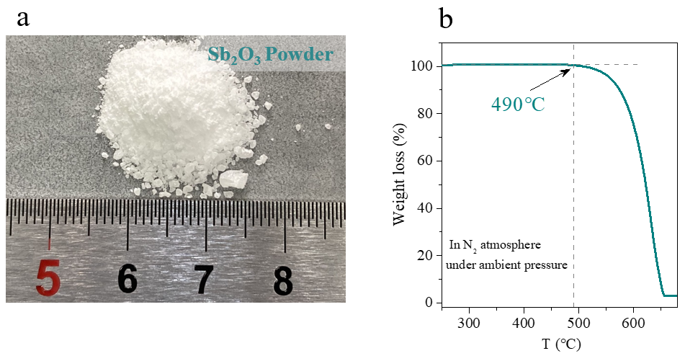Figure S1: a, High-purity Sb₂O₃ powder. b, its thermogravimetric analysis under ambient pressure in N₂ atmosphere.

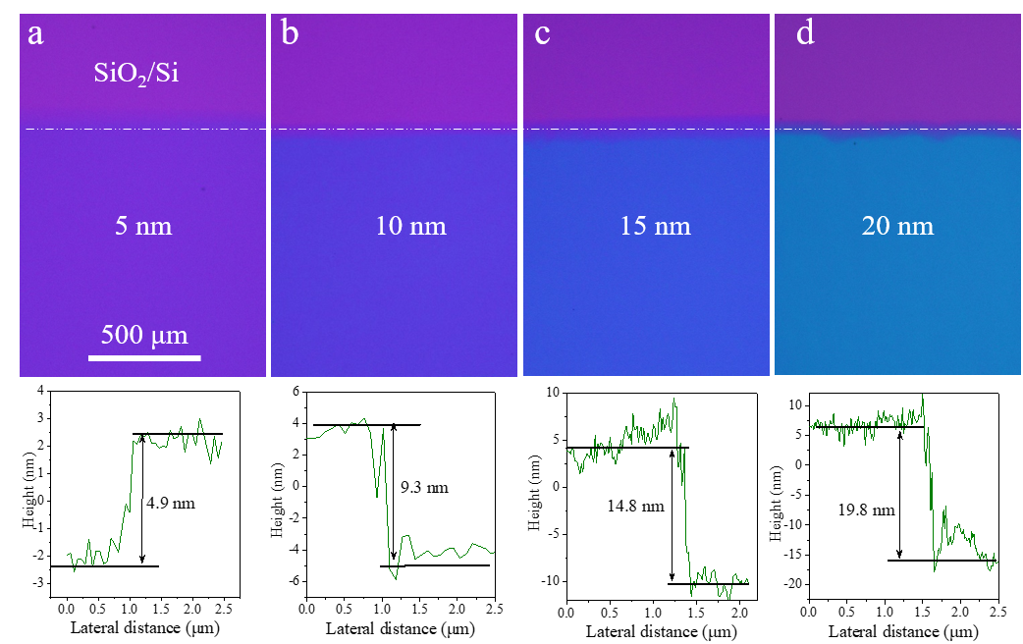
Figure S2: Optical images of Sb₂O₃ film with precisely controlled thickness deposited on SiO₂/Si substrate and their corresponding AFM profiles for thickness measurement. The bare parts on substrates are covered by a piece of PDMS during the deposition, which is peeled off before taking these images for clear contrasts.

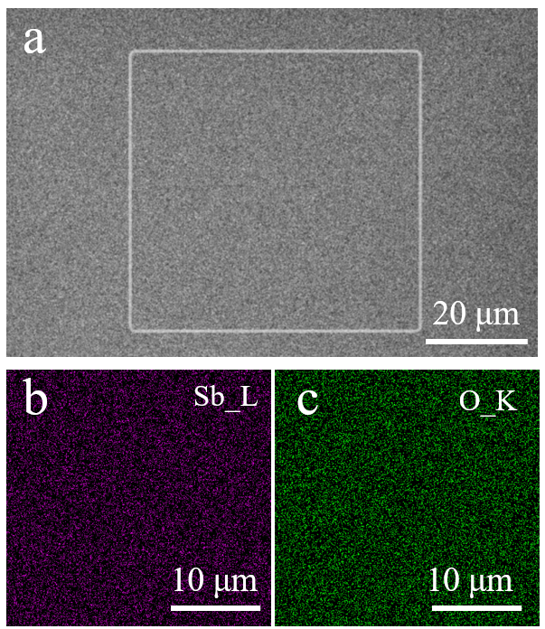
Figure S3: SEM image of Sb₂O₃ film and the elemental maps of Sb and O. a, SEM image of Sb₂O₃ deposited on SiO₂/Si substrate. b and c are respectively the EDX elemental maps of Sb and O, acquired from the square indicated in a.
First-principle calculations
The first-principles calculations were performed in the Vienna ab initio simulation package (VASP) ^{[1]} with a plane-wave basis set. The projector-augmented-wave method (PAW) ^{[2]} describes the interactions between core and valence electrons and the generalized gradient approximation (GGA) of Perdew-Burke-Ernzerh (PBE) ^{[3]} deals with the exchange-correlation interaction. The optb88-vdW method^{[4]} was adopted in describing the van der Waals interactions (vdW) interaction. The cutoff energy is set to be 500 eV. The screened-exchange HSE06^{[5]} functional is used to get more accurate electronic properties based on the optimized geometries.

For density of states calculation of Sb₂O₃, A k-point sampling gird of 4×4×4 was employed to sample the first Brillouin zone. The lattice parameters of bulk Sb₂O₃ were fully optimized with the inclusion of atom relaxation, yielding a = 11.14 Å, in line with the experimental data (11.10) ^{[6]}. Our calculated lattice constants were less than the other theoretical results (11.54 Å) ^{[7, 8]} because they neglected the vdW forces among discrete Sb₂O₃ molecular units. Based on the optimized structures, the density of states (DOS) of bulk and 5-slab Sb₂O₃ were obtained by the HSE06 method. It showed that both of them display a similar profile and band-gap of 4.065 eV, in agreement with our experimental data (4.0 eV). The thickness-independent band-gap further ensured of the pristine vdW interaction among those Sb₂O₃ molecular units.

The band alignment between Sb₂O₃ and MoS₂ was predicted by the HSE06 functional. The 5-slab Sb₂O₃ was built to extract its energy level of valance band maximum (VBM) and conductive band minimum (CBM) relative to the vacuum level. They were -7.23 eV and -3.16 eV for the VBM and CBM, respectively. For MoS₂, we used the data from the Ref. [9]

For the calculations of vacancy formation energy, we define the vacancy formation energy as E_{f}=E_{m}-E_{fr}-E_{opt}, where E_{m} is the energy of pristine Sb₂O₃ molecule, E_{fr} stands for the energy of free O, Sb or O₂, respectively corresponding to the three types of vacancies, and E_{opt} stands for the optimized energy of the defected molecules in the corresponding types.

To calculate the adsorption of H₂O and O₂ onto Sb₂O₃ molecule, we define the adsorption energy as E_{a}=E_{gas/Sb2O3}-E_{m}-E_{gas}, where E_{a} is the adsorption energy, E_{gas/Sb2O3} is the total energy of gas adsorbed on Sb₂O₃ molecule and E_{m}, E_{gas} are respectively the energy of pristine Sb₂O₃ and gas molecule. Typical adsorption types of H₂O and O₂ were taken into consideration.

Table S1: The peak positions of Sb₂O₃ Raman spectrum and their vibration modes, all of which belong to the intra-molecular modes.
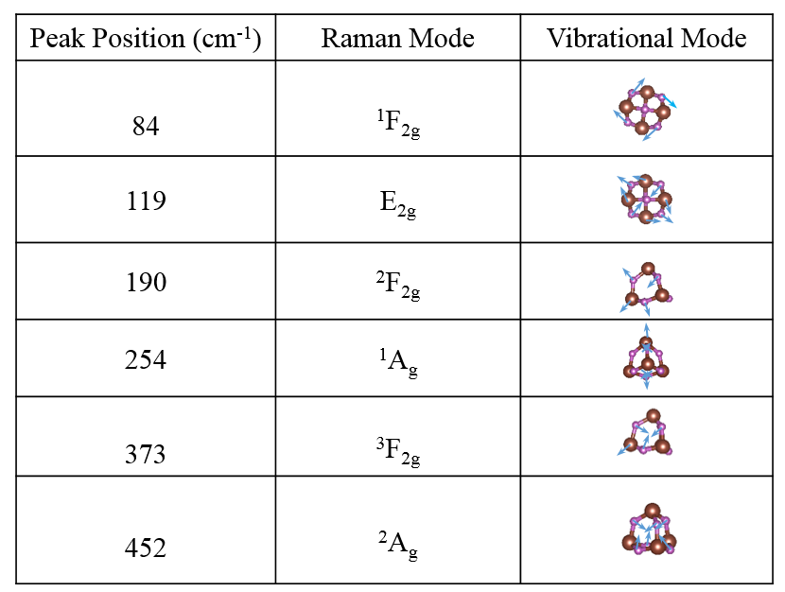
Table S2: The formation energy of O vacancy, Sb vacancy and O-O vacancy in a Sb₂O₃ molecule obtained by first-principle calculations.
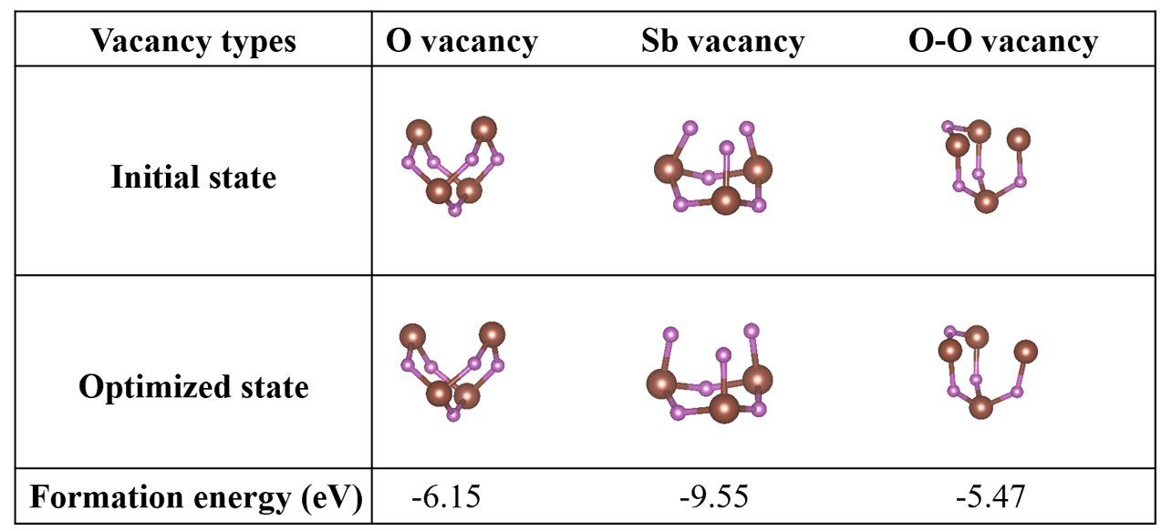

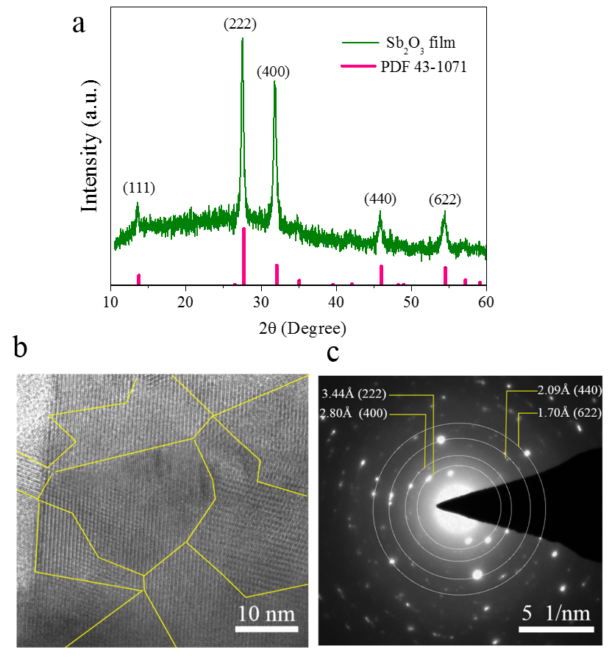
Figure S4: The polycrystalline structure of our Sb₂O₃ film. a, typical XRD pattern of Sb₂O₃ film of 40 nm, suggesting its polycrystalline structure. b, HRTEM image of Sb₂O₃ fim, showing the typical grain size of our Sb₂O₃ fim. c, Selected area electron diffraction of Sb₂O₃, confirming its polycrystalline structure.

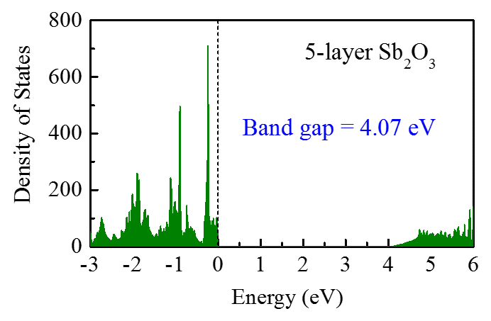
Figure S5: The density of states of Sb₂O₃ film with 5 molecular layers and its bandgap.

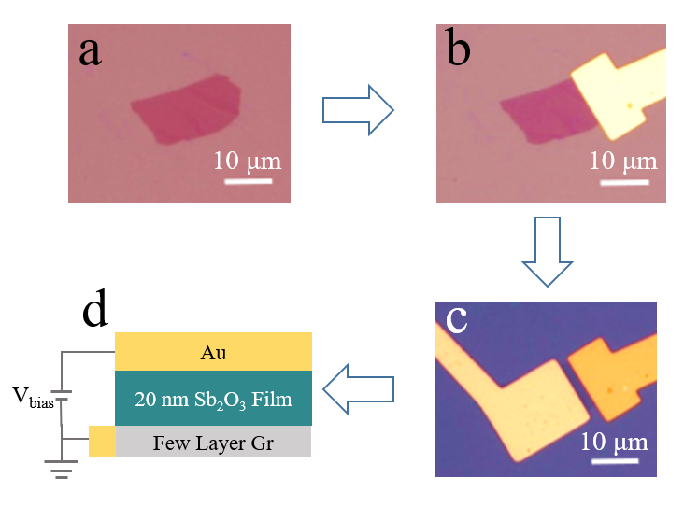
Figure S6: The process flow of device fabrication for Sb₂O₃ breakdown measurement. a, Few-layer graphene flake is exfoliated onto SiO₂/Si substrate. b, Bottom electrode is defined and fabricated. c, 20 nm Sb₂O₃ is deposited and top electrode is fabricated. d, Schematic figure of the device for breakdown measurement.

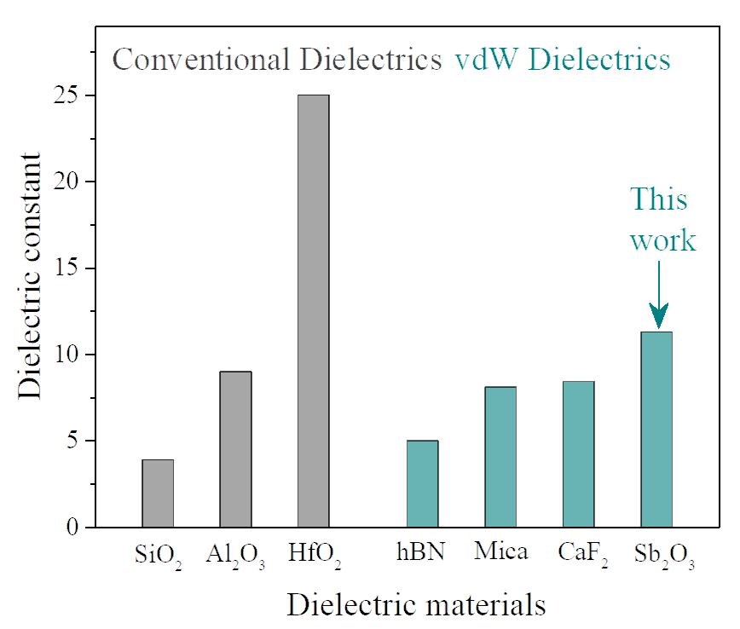
Figure S7: Dielectric constants of conventional dielectric oxides and the reported vdW (quasi-vdW) dielectrics.

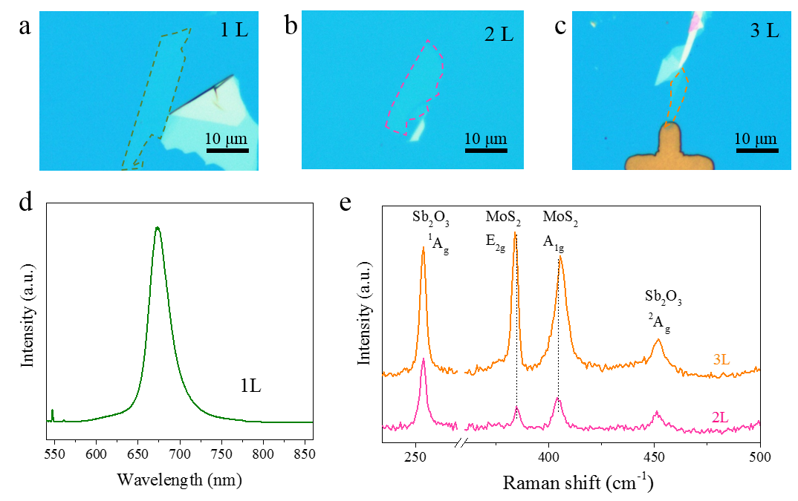
Figure S8: Confirming the layer number of MoS₂ via optical approaches. a, b, and c are respectively the as-exfoliated monolayer, bilayer and trilayer MoS₂ on Sb₂O₃ substrate. d, photoluminescence spectrum of monolayer MoS₂. e, Raman spectra of bilayer and trilayer MoS₂ on Sb₂O₃ substrate.

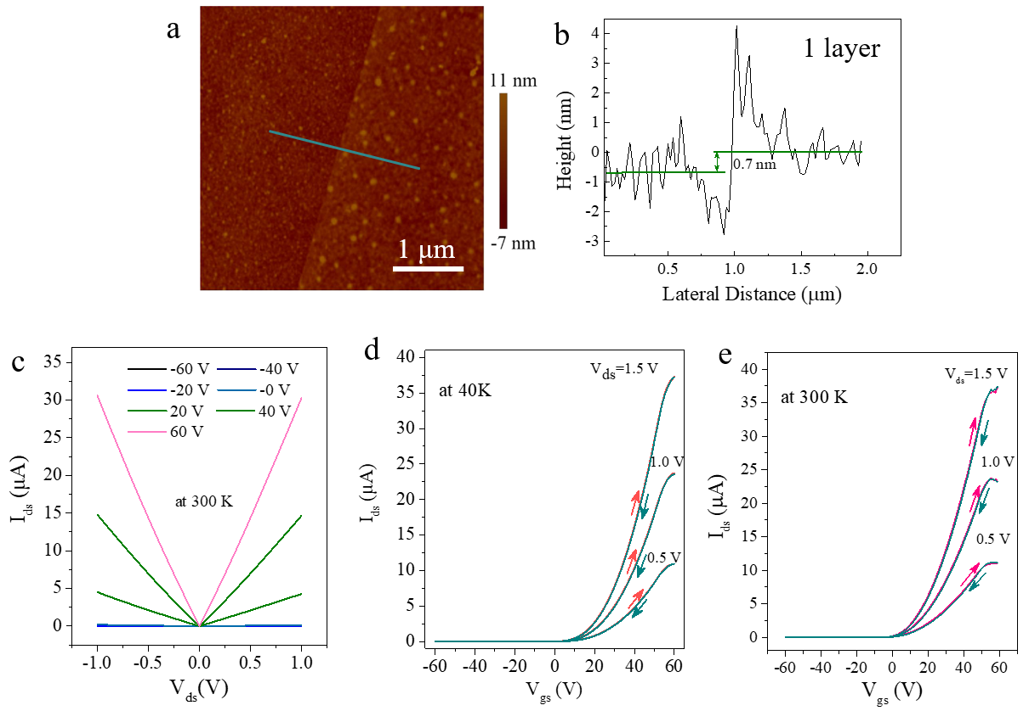
Figure S9: Electrical performance of monolayer MoS₂/Sb₂O₃ FET. a, AFM image of the monolayer MoS₂ on Sb₂O₃. b, height profile at the position indicated in a. c Output curves of monolayer MoS₂ FET measured at 300 K. d and e, Transfer characteristic curves of monolayer MoS₂/Sb₂O₃ FET with different bias voltage V_{ds} measured at 40 K and 300 K respectively.

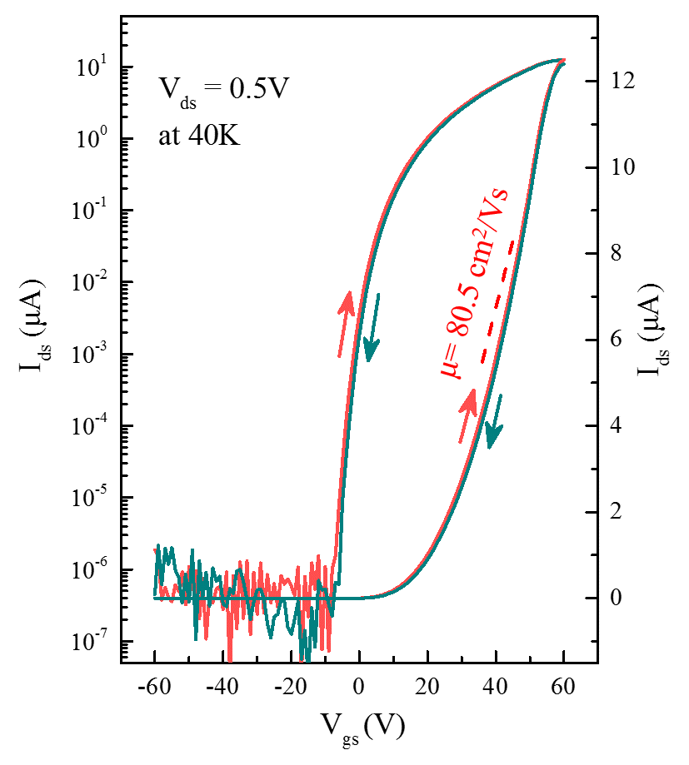
Figure S10: Transfer characteristic curve of another monolayer MoS₂/Sb₂O₃ FET, displaying similar electron mobility and on/off ratio.

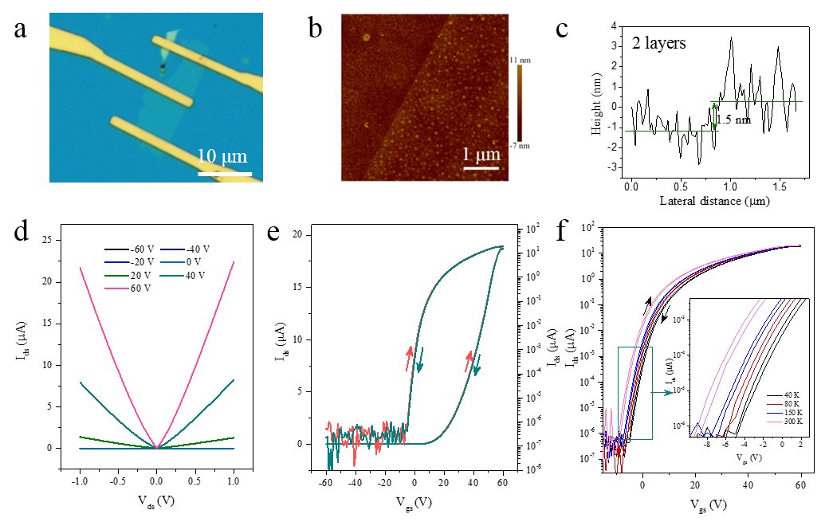Figure S11: Electrical performance of bilayer MoS₂/Sb₂O₃ FET. a, Optical image of bilayer MoS₂/Sb₂O₃ FET. b, AFM image of channel bilayer MoS₂. c, the profile from b confirms the thickness of MoS₂. d, the output curves of bilayer MoS₂/Sb₂O₃ FET at 40 K. e, the transfer characteristic curves of bilayer MoS₂/Sb₂O₃ FET. f, the temperature-dependent transfer characteristic curves of bilayer MoS₂/Sb₂O₃ FET and the corresponding hysteresis is highlighted (inset).

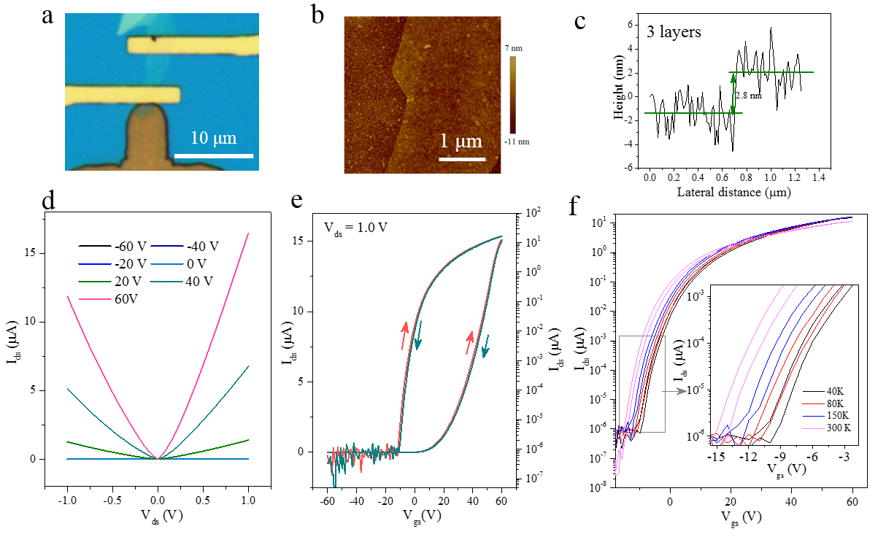
Figure S12: Electrical performance of trilayer MoS₂/Sb₂O₃ FET. a, Optical image of trilayer MoS₂/Sb₂O₃ FET. b, AFM image of channel trilayer MoS₂. c, the profile from b confirms the trilayer MoS₂. d, the output curves of trilayer MoS₂/Sb₂O₃ FET at 40 K. e, the transfer characteristic curves of trilayer MoS₂/Sb₂O₃ FET. f, the temperature-dependent transfer characteristic curves of trilayer MoS₂/Sb₂O₃ FET and the corresponding hysteresis is highlighted (inset).

Table S3: Typical gas adsorption onto a Sb₂O₃ molecule.
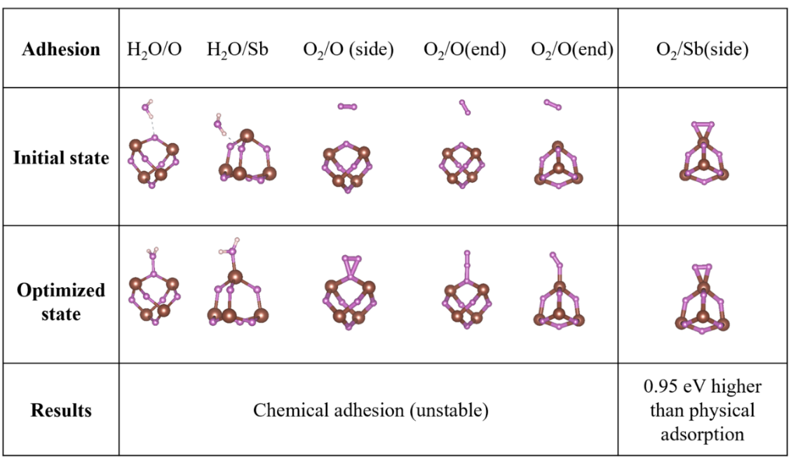
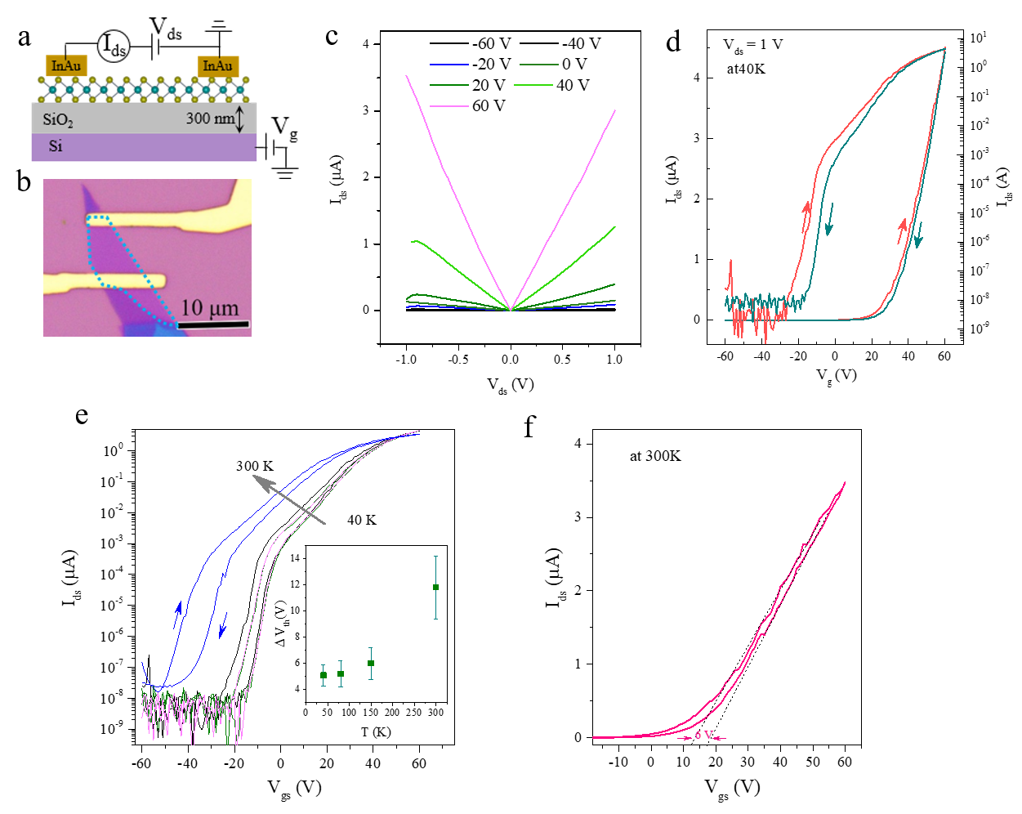
Figure S13: Electrical performance of monolayer MoS₂/SiO₂ FET. a, Schematic figure of monolayer MoS₂/SiO₂ FET. b, Optical image of monolayer MoS₂/SiO₂ FET. c, Output curves of monolayer MoS₂/SiO₂ FET measured at 40 K. d transfer characteristic curves of at 40 K. e, the temperature-dependent transfer characteristic curves of monolayer MoS₂/Sb₂O₃ FET. Inset: the variation of onset voltage ΔV_{on} at various temperature. e,the transfer characteristic curves at 300 K, from which we extract the threshold voltage variation Vth at 300 K.
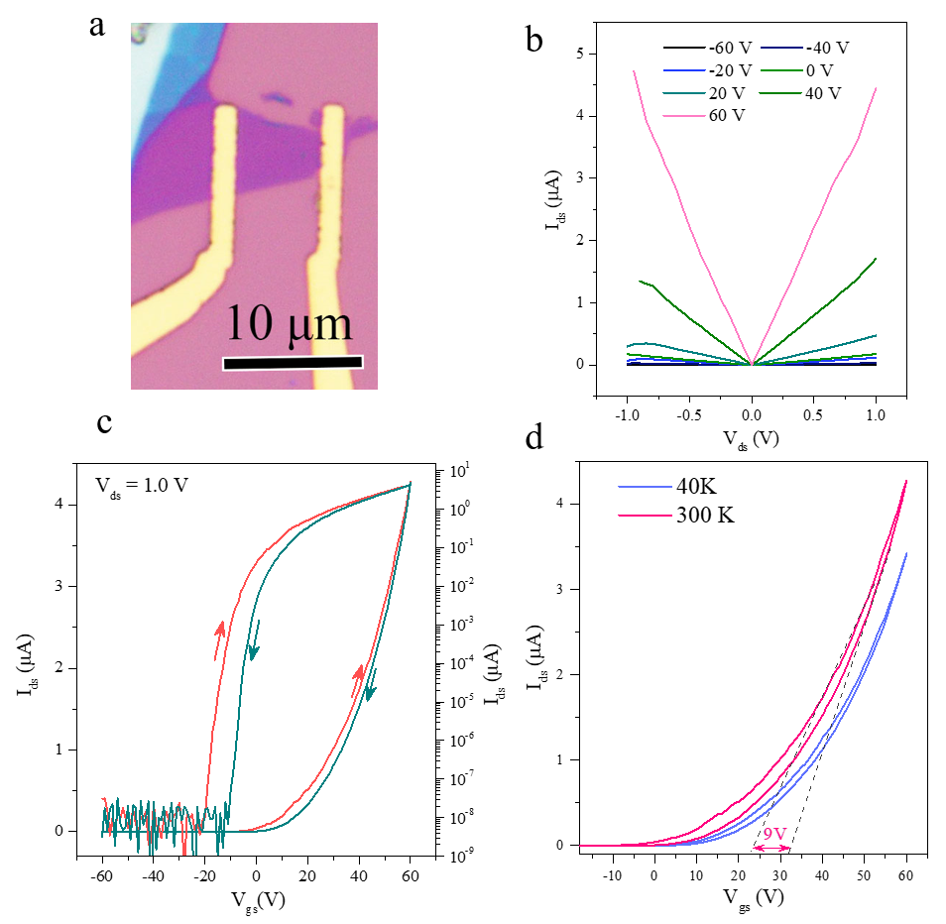Figure S14: Electrical performance of bilayer MoS₂/SiO₂ FET. a, Optical image of bilayer MoS₂/SiO₂ FET. b, The output curves of bilayer MoS₂/SiO₂ FET measured at 40 K. c, the transfer characteristic curves of at 40 K. d, the transfer characteristic curves at 40 K and 300 K for the extraction of ΔV_{th}.

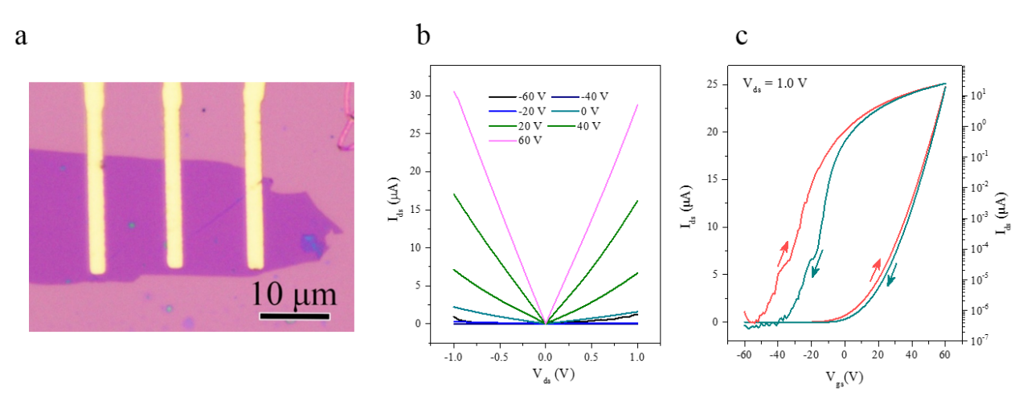Figure S15: Electrical performance of trilayer MoS₂/SiO₂ FET. a, Optical image of trilayer MoS₂/SiO₂ FET. b, The output curves of trilayer MoS₂/SiO₂ FET measured at 40 K. c, its transfer characteristic curves of at 40 K.

Reference
- Hafner, J., Ab‐initio simulations of materials using VASP: Density‐functional theory and beyond. J. Comput. Chem. 29 , 2044-2078 (2008).
- Blöchl, P. E., Projector augmented-wave method. Phys. Rev. B 50, 17953-17979 (1994).
- Perdew, J. P.; Burke, K.; Ernzerhof, M., Generalized gradient approximation made simple. Phys. Rev. Lett. 77, 3865-3868 (1996).
- Klimeš, J.; Bowler, D. R.; Michaelides, A., Van der Waals density functionals applied to solids. Phys. Rev. B 83, 19513 (2011).
- Heyd, J.; Scuseria, G. E.; Ernzerhof, M., Hybrid functionals based on a screened Coulomb potential. J. Chem. Phys. 118 , 8207-8215 (2003)
- Sheng, P.; Abeles, B.; Arie, Y., Hopping Conductivity in Granular Metals. Phys. Rev. Lett. 31, 44-47 (1973).
- Carey, J. J.; Allen, J. P.; Scanlon, D. O.; Watson, G. W., The electronic structure of the antimony chalcogenide series: Prospects for optoelectronic applications. J. Solid State Chem. 213, 116-125 (2014).
- Matsumoto, A.; Koyama, Y.; Togo, A.; Choi, M.; Tanaka, I., Electronic structures of dynamically stable As₂O₃, Sb₂O₃, and Bi₂O₃ crystal polymorphs. Phys. Rev. B 83, 214110 (2011).
- Liu, Y., Stradins, P. & Wei, S.-H. Van der Waals metal–semiconductor junction: weak Fermi level pinning enables effective tuning of Schottky barrier. Sci. Adv. 2, e1600069 (2016).

