Supporting Information

Ultrastructure and function of setae of a planktonic diatom, Chaetoceros coarctatus

Yuka Owari¹ • Yuya Oaki¹ • Fumi Nakamura¹ • Hiroyuki Tsuda¹ • Shinji Shimode² • Hiroaki Imai¹*

Address
1: Department of Applied Chemistry, Faculty of Science and Technology, Keio University, 3-14-1 Hiyoshi, Kohoku-ku, Yokohama 223-8522, Japan /E-mail*: hiroaki@applc.keio.ac.jp
2: Manazuru Marine Center for Environmental Research and Education, Graduate School of Environment and Information Sciences, Yokohama National University, 61 Iwa, Manazuru 259-0202, Japan.

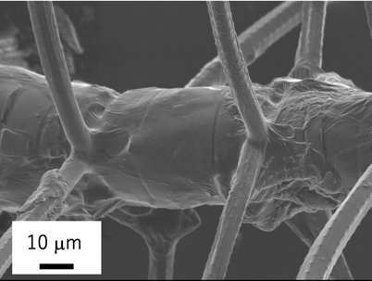

(a)

Fig. S1 A SEM image of an intercalary cellular injection of a C. coarctatus colony. Four setae extend from the four sides of a cell.
(b)

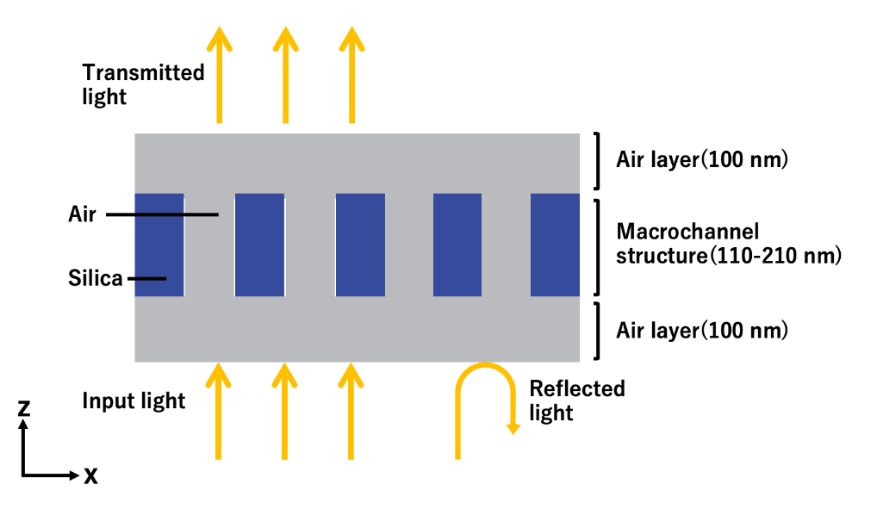

Fig. S2 A schematic model for the 3D finite-difference time-domain (3D-FDTD) method using a software “RSoft-FullWAVE.” A three-dimension system with periodic boundary conditions in the x and y directions, was used for a nanohole structure consisting of silica (n: 1.470 for wavelength 400 nm, n: 1.452 for wavelength 900 nm) and air (n: 1.00). A broadband (400–900 nm) plane wave source polarized along the x-axis or y-axis was incident from within the air region. Considering the unpolarized nature of the sunlight, the transmission spectrum is averaged among incident electric field polarized along x-axis and y-axis. The thickness of the silica layer varied from 150 to 250 nm to verify the effect of the thickness of the silica plate. The difference in transmittance between the silica plates with and without pores was then examined with a plate thickness 150 nm.

