Supplementary Information

Direct growth of copper oxide nanocubes on graphitic carbon nitrides for aqueous carbon dioxide photoreduction

Byeonghoon Choi,^{1,3} Chan Kyu Lim,^{1,3} Minjun Kim,¹ Bumjin Park,¹ Won-Woo Park,² Oh-Hoon Kwon,² Hee-Seung Lee¹ & Hyunjoon Song¹*
¹Department of Chemistry, Korea Advanced Institute of Science and Technology (KAIST), 291 Daehak-ro, Yuseong-gu, Daejeon 34141, Republic of Korea.
²Department of Chemistry, Ulsan National Institute of Science and Technology, Ulsan 44919, Republic of Korea.
³These authors contributed equally: Byunghoon Choi, Chan Kyu Lim
*email: hsong@kaist.ac.kr

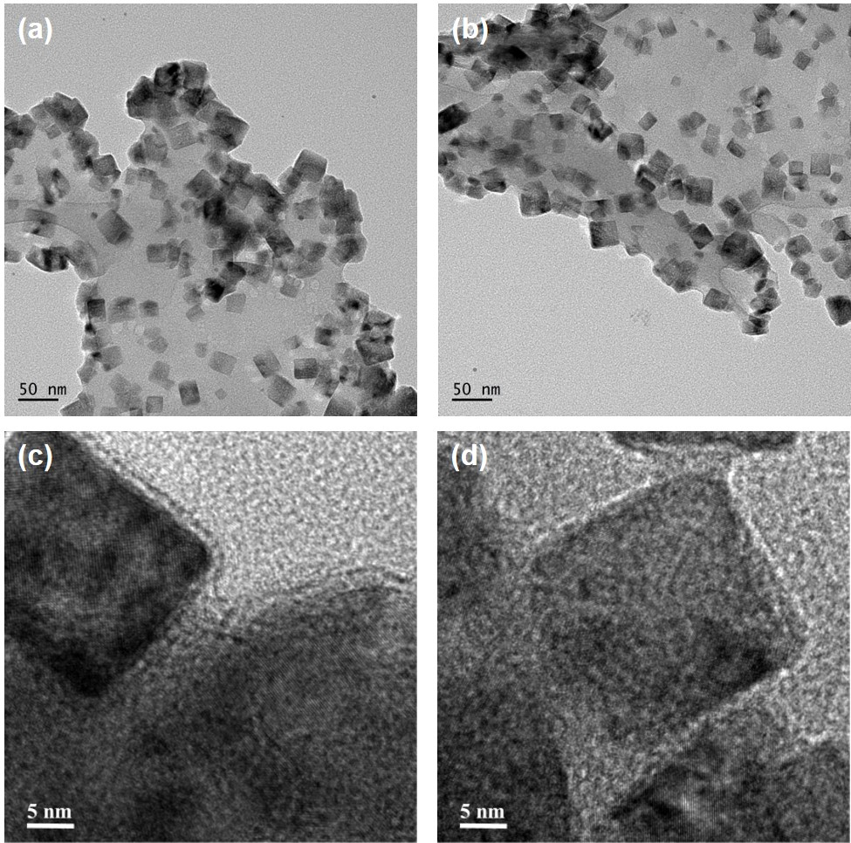
Supplementary Figure 1. TEM and HRTEM images of g-C₃N₄/Cu₂O.
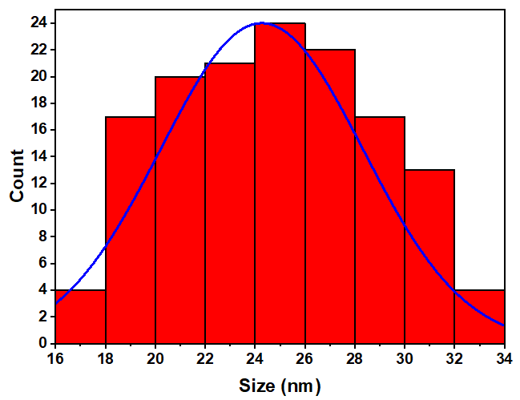
Supplementary Figure 2. The histogram for the edge sizes of the Cu₂O nanocubes formed on the g-C₃N₄ surface.
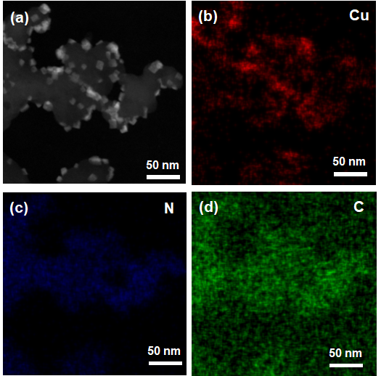
Supplementary Figure 3. Elemental analysis. (a) HAADF image and (b-d) elemental mapping of g-C₃N₄/Cu₂O.
Supplementary Table 1. Comparison of photocatalytic CO₂RR performances under the specified reaction conditions without sacrificial reagents.
Catalyst | Light source | Reaction medium | Product  (Selectivity) | Activity | Ref
g-C₃N₄/Cu₂O | 300 W  Xe lamp | Saturated CO₂ in water | CH₄  (98%) | 5400 μmol g_{cat}⁻¹h⁻¹  QE = 3.7% | this work
ZnO-Cu₂O | 300 W  Xe lamp | Saturated CO₂ in water | CH₄  (99%) | 1080 μmol g_{cat}⁻¹h⁻¹  QE = 1.5% | Song et al.¹
S-doped CoO/Co₃O₄ | 300 W  Xe lamp | Saturated CO₂ in water | CH₄  (98%) | 10000 μmol g_{cat}⁻¹h⁻¹ QE = 2.3% | Song et al.²
3DOM CdSQD/NC | 300 W  Xe lamp  420 nm ≤ λ | Saturated CO₂ in water | CO | 10 μmol g_{cat}⁻¹h⁻¹  4280 μmol g_{cat}⁻¹h⁻¹  (with TEOA) | Wang et al.³
Co₂N/BiOBr | 300 W  Xe lamp | Saturated CO₂ in water | CO | 67.8 μmol g_{cat}⁻¹h⁻¹ | Liu et al.⁴
Bi₁₂O₁₇Cl₂ | 300 W  Xe lamp | Saturated CO₂ in water | CO | 48.6 μmol g_{cat}⁻¹h⁻¹  QE = 0.14% | Liu et al.⁵
V_{Bi}-BiOBr UNs | 300 W  Xe lamp | Saturated CO₂ in water | CO | 20.1 μmol g_{cat}⁻¹h⁻¹ | Xia et al.⁶
(Au/Cu 1:2)  TiO₂ | 0.21 Wcm⁻²  Xe lamp  400 nm ≤ λ | Saturated CO₂ in water | CH₄ | 2200 μmol g_{cat}⁻¹h⁻¹ | Garcia et al.⁷
PCN-224(Cu)/TiO₂ | 300 W  Xe lamp  300 nm ≤ λ | Saturated CO₂ in water | CO | 37.21 μmol g_{cat}⁻¹h⁻¹ | Wang et al.⁸
3D-SiC/2D-MoS₂ | 300 W  Xe lamp  420 nm ≤ λ | CO₂ and H₂O vapor | CH₄ | 323 μmol g_{cat}⁻¹h⁻¹  QE = 1.75% | Li et al.⁹
Graphene wrapped Pt/TiO₂ | 300 W  Xe lamp | CO₂ and H₂O vapor | CH₄  (99%) | 41.3 μmol g_{cat}⁻¹h⁻¹  QE = 1.93% | Zhao et al.¹⁰
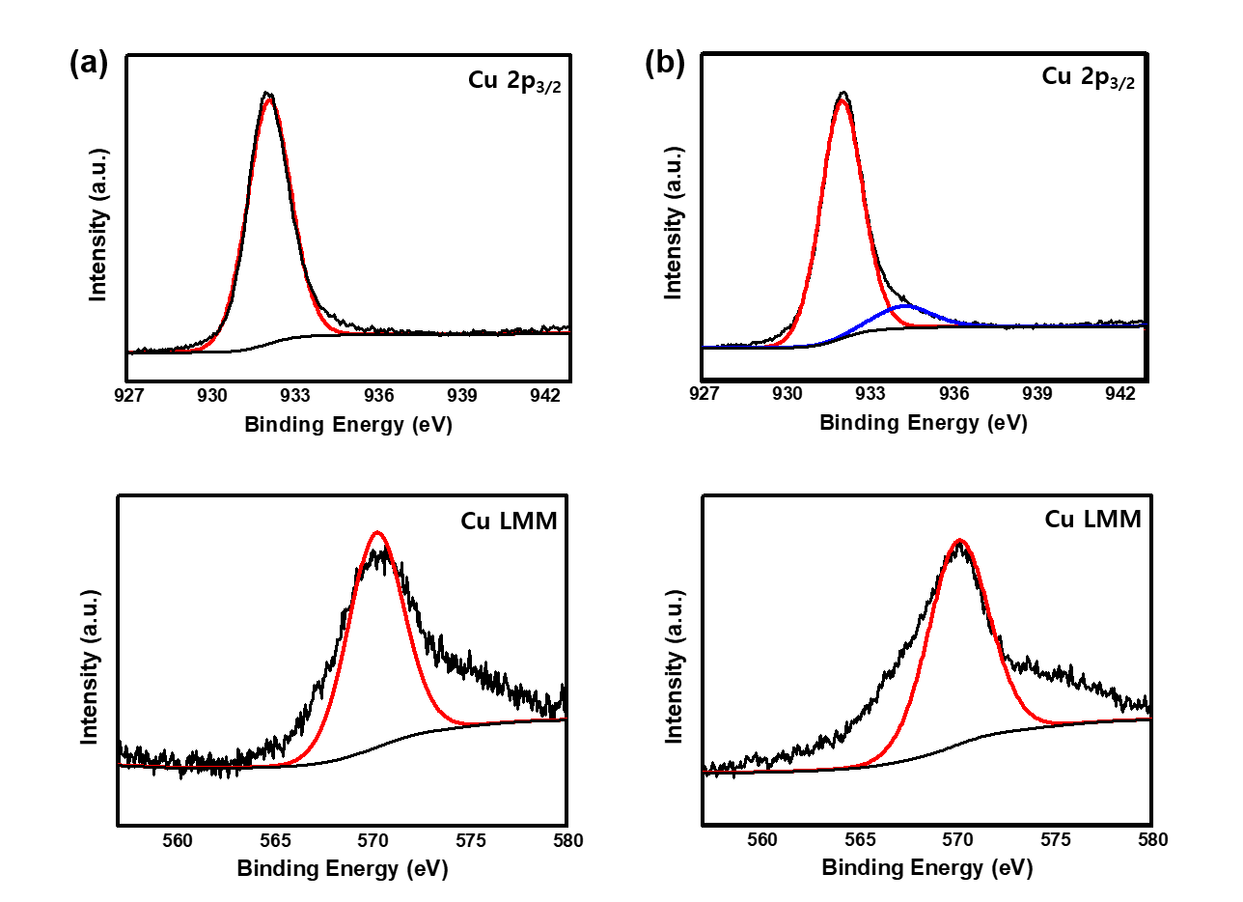
Supplementary Figure 4. XPS spectra of g-C₃N₄/Cu₂O. The spectra in Cu 2p_{3/2} and Cu LMM regions (a) before and (b) after three repetitive photocatalytic reaction cycles.

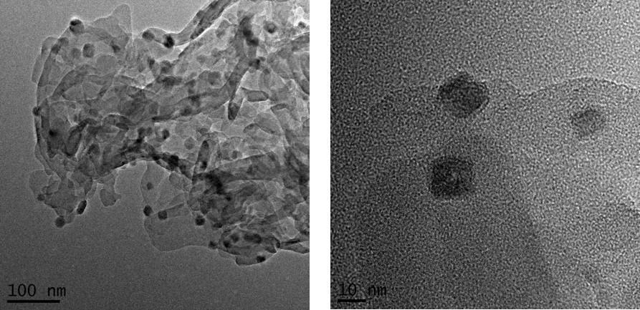
Supplementary Figure 5. TEM images of g-C₃N₄/Cu₂O after three repetitive photocatalytic reactions.
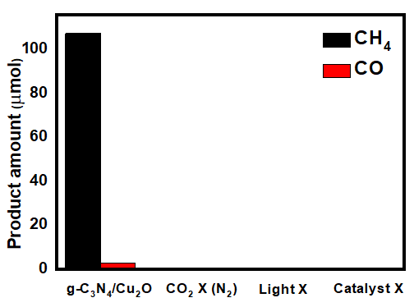
Supplementary Figure 6. Control experiments. Photocatalytic CO₂RR without CO₂, light irradiation, and the catalyst.

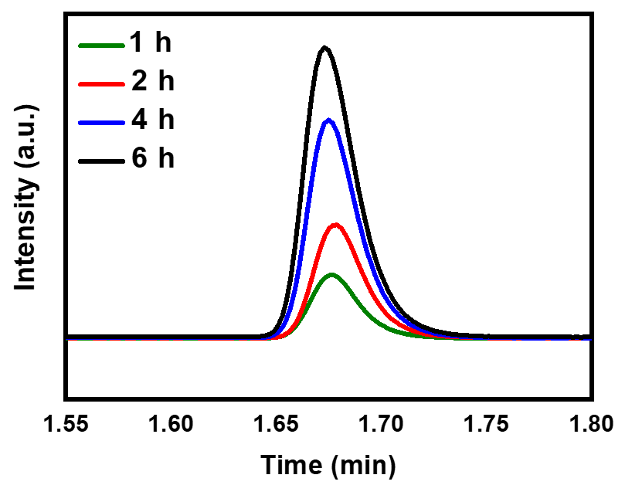
Supplementary Figure 7. Photocatalytic CO₂RR with isotopes. GC-MS analysis of ¹³CH₄ evolved as the irradiation time from the photocatalytic reduction of ¹³CO₂ with the g-C₃N₄/Cu₂O catalyst.
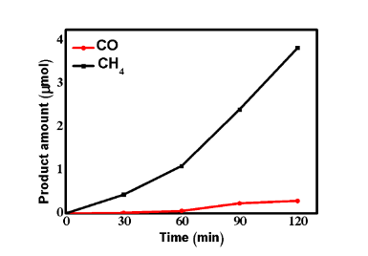
Supplementary Figure 8. Activity using visible light. Photocatalytic production of CH₄ and CO by the irradiation of visible light (λ > 420 nm) using a cut-off filter as a function of irradiation time.
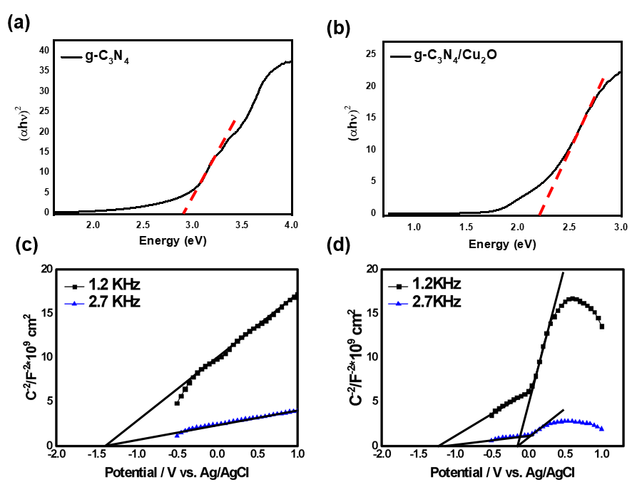
Supplementary Figure 9. Band energy analysis. Tauc plots for (a) g-C₃N₄ and (b) Cu₂O. Mott-Schottky plots for (c) g-C₃N₄ and (d) g-C₃N₄/Cu₂O.
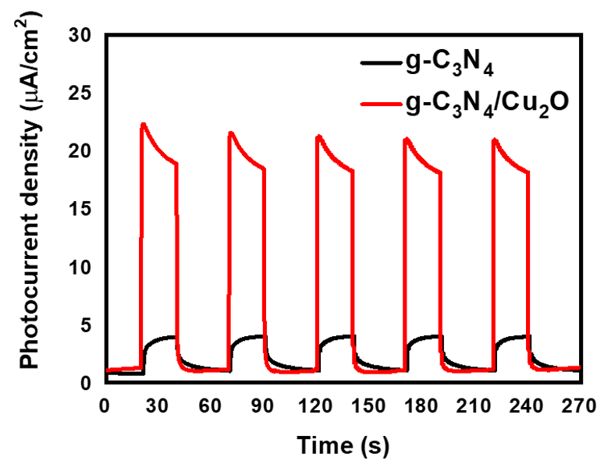
Supplementary Figure 10. Photoresponses by visible light. Current-time response curves at the visible region of g-C₃N₄ (black line) and g-C₃N₄-Cu₂O (red line) in 0.1 M phosphate buffer solution.

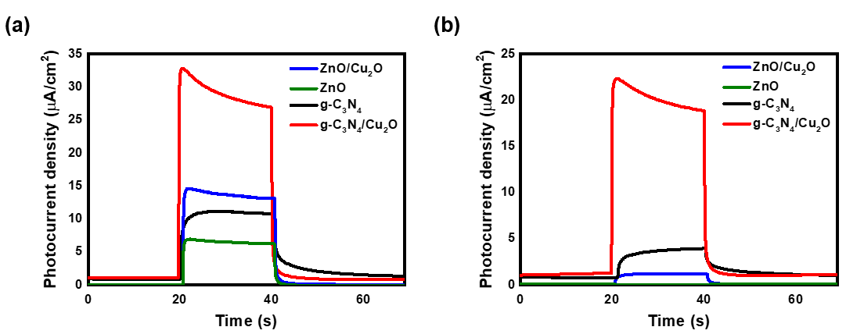
Supplementary Figure 11. Comparison of photoresponses. Current-time response curves of ZnO-Cu₂O (black), ZnO (red), g-C₃N₄ (blue), and g-C₃N₄-Cu₂O (green) in a 0.1 M phosphate buffer solution by the irradiation in the (a) full-wavelength and (b) visible (λ ≥ 420 nm) regions.

Supplementary Table S2. TCSPC analysis. Fit parameters of TCSPC kinetic profiles in Figure 4d.
 | A₁ (counts) | τ₁  (ns) | A₂ (counts) | τ₂  (ns) | A₃ (counts) | τ₃  (ns) | τ_{ave}  (ns)
g-C₃N₄ | 3760  [±60] | 18.6  [±0.2] | 38400  [±300] | 4.42  [±0.03] | 70100  [±1000] | 1.23  [±0.02] | 2.91  [±0.04]
g-C₃N₄/ Cu₂O | 2350  [±50] | 15.1  [±0.2] | 30200  [±400] | 3.33  [±0.03] | 70600  [±1300] | 0.82  [±0.01] | 1.88  [±0.03]

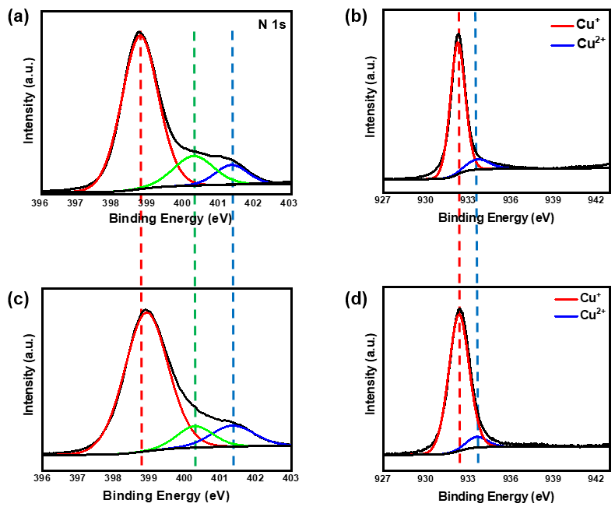
Supplementary Figure 12. XPS spectra. (a) g-C₃N₄ in the N 1s region, (b) Cu₂O in the Cu 2p_{3/2} region, and g-C₃N₄/Cu₂O in the (c) N 1s and (d) Cu 2p_{3/2} regions.

Supplementary references
1. Bae, K.-L., Kim, J., Lim, C. K., Nam, K. M. & Song, H. Colloidal zinc oxide-copper(I) oxide nanocatalysts for selective aqueous photocatalytic carbon dioxide conversion into methane. Nat. Commun. 8, 1156 (2017).
2. Choi, J. Y. et al. Surface activation of cobalt oxide nanoparticles for photocatalytic carbon dioxide reduction to methane. J. Mater. Chem. A 7, 15068-15072 (2019).
3. Wang, F. et al. Ordered macroporous carbonous frameworks implanted with CdS quantum dots for efficient photocatalytic CO₂ reduction. Adv. Mater. 33, 2102690 (2021).
4. Di, J. et al. Cobalt nitride as a novel cocatalyst to boost photocatalytic CO₂ reduction. Nano Energy 79, 105429 (2021).
5. Di, J. et al. Defect-rich Bi₁₂O₁₇Cl₂ nanotubes self-accelerating charge separation for boosting photocatalytic CO₂ reduction. Angew. Chem. Int. Ed. 57, 14847-14851 (2018).
6. Di, J. et al. Bismuth vacancy-tuned bismuth oxybromide ultrathin nanosheets toward photocatalytic CO₂ reduction. ACS Appl. Mater. Interfaces 11, 30786-30792 (2019).
7. Neaţu, Ş., Maciá-Agulló, J. A., Concepción, P. & Garcia, H. Gold–copper nanoalloys supported on TiO₂ as photocatalysts for CO₂ reduction by water. J. Am. Chem. Soc. 136, 15969-15976 (2014).
8. Wang, L., Jin, P., Huang, J., She, H. & Wang, Q. Integration of copper(II)-porphyrin zirconium metal–organic framework and titanium dioxide to construct Z-scheme system for highly improved photocatalytic CO₂ reduction. ACS Sustain. Chem. Eng. 7, 15660-15670 (2019).
9. Wang, Y. et al. Visible-light driven overall conversion of CO₂ and H₂O to CH₄ and O₂ on 3D-SiC@2D-MoS₂ heterostructure. J. Am. Chem. Soc. 140, 14595-14598 (2018).
10. Zhao, Y. et al. Graphene-wrapped Pt/TiO₂ photocatalysts with enhanced photogenerated charges separation and reactant adsorption for high selective photoreduction of CO₂ to CH₄. Appl. Catal. B 226, 360-372 (2018).

