Supporting information
From waste to waste: Iron blast furnace slag for heavy metal ions removal from aqueous system
Sabah M. Abdelbasir*, M.A. Abdel Khalek
Central Metallurgical Research and Development Institute, P.O. Box: 87, Helwan, 11421, Cairo, Egypt

*Corresponding author. Tel.: +202 27142011; fax: +202 27142451.
E-mail address: sfoda20@hotmail.com
ORCID/ 0000-0003-2698-2041

Slag characterization
Chemical composition of BFS was determined using X-ray Fluorescence (XRF, Axios Advanced WDXRFP analytical, Netherland). The detection limit for each element reported as metal oxides. The mineral composition was investigated using X-ray diffraction (Bruker D8 Advance diffractometer, Germany), with Cu-Kὰ radiation (40 kV, 40 mA) (λ = 1.5406 Å in a 2θ range of 10 - 70°). Microscopic structural investigation of BFS components was performed by field emission scanning electron microscope (FESEM, QUANTA FEG 250 manufacturers, Holland) with an EDX unit (JEOL, JSM-4510, Germany).
The surface area was determined by the nitrogen adsorption technique (Brunauer-Emmett-Teller (BET) isotherm) at 77 K using a Quantachrome instrument (Nova Series, UK) of degassed samples at 100°C for 5h. A thermostatic shaker model (GFL3017, Germany) was used for shaking during experimentations with a constant rate. The adsorbents were separated using a centrifuge (Sigma, Germany) at a speed of 8000 rpm to achieve complete separation.

Table S1. Surface structure of BFS under N₂
Specific surface area (m² g⁻¹) | pore volume  (cc/g) | average pore size  (nm)
19.315 | 0.018 | 3.144

Table S2. Physical and chemical properties of the studied metals (Nightingale 1959) (Volkov et al. 1997)
Element | Atomic mass  (g/mol) | Atomic radius  (Å) | Ionic radius  (Å) | Hydration Energy  (KJ mol^{–1}) | Charge density* | Hydrated ionic radius  (Å) | Solubility product constants of metal hydroxide (25°C)
Co | 58.93 | 1.67 | 0.65 | –1996 | 2.7778 | 2.10 | 1.3 ×10⁻¹⁵
Pb | 207.20 | 1.81 | 1.32 | –1480 | 1.6667 | 4.01 | 1.43×10⁻²⁰
* Charge density = charge / ionic radius

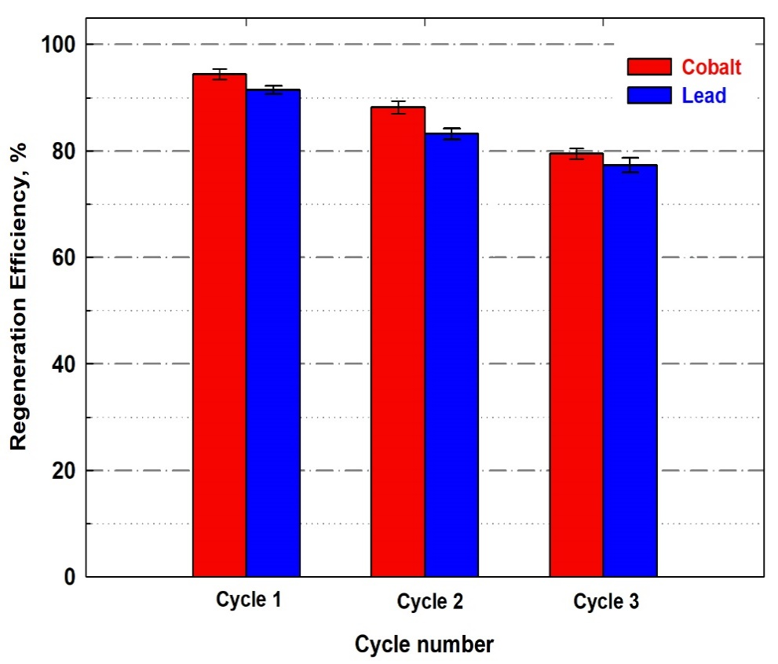
Fig. S1. Reusability performance of BFS for Co²⁺ and Pb²⁺ ions removal.

Table S3. Comparison of Pb²⁺ and Co²⁺ removal from wastewater using different slag adsorbents.
Adsorbent | Adsorption capacity (mg g⁻¹) or % Removal |  | Adsorption isotherm | Kinetic model | References
Adsorbent | Pb²⁺ | Co²⁺ | Adsorption isotherm | Kinetic model | References
Steel slag | 32.3 |  | Langmuir | *NR | (Feng et al. 2004)
Iron slag | 95.2 |  | Langmuir | *NR | (Feng et al. 2004)
Iron oxide-coated sludge | 42.4 |  | Langmuir | PSO | (Phuengprasop et al. 2011)
Oxalated blast-furnace slag |  | 576 | Sips | PSO | (Le et al. 2021)
Granulated blast-furnace slag | 97% |  | Freundlich | *NR | (Dimitrova and Mehandgiev 1998)
Bentonite-Steel Slag Composite | 29.8 |  | Langmuir and Brunauer Emmett Teller (BET) | PSO | (Zhan et al. 2019)
Basic oxygen furnace slag (BOFs) | 98.3 |  | Freundlich | PSO | (Xue et al. 2020)
Electric induction furnace slag | 34% |  | *NR | *NR | (Mercado-Borrayo et al. 2020)
Blast furnace slag (non-modified) | 30.2 | 43.8 | Freundlich | Avrami | This work
*NR: not reported by the author.

Supporting references

Dimitrova S v., Mehandgiev DR (1998) Lead removal from aqueous solutions by granulated blast-furnace slag. Water Research 32:3289–3292. https://doi.org/10.1016/S0043-1354(98)00119-5
Feng D, van Deventer JSJ, Aldrich C (2004) Removal of pollutants from acid mine wastewater using metallurgical by-product slags. Separation and Purification Technology 40:61–67. https://doi.org/10.1016/J.SEPPUR.2004.01.003
Le QTN, Vivas EL, Cho K (2021) Oxalated blast-furnace slag for the removal of Cobalt(II) ions from aqueous solutions. Journal of Industrial and Engineering Chemistry 95:57–65. https://doi.org/10.1016/J.JIEC.2020.12.003
Mercado-Borrayo BM, Contreras R, Sánchez A, et al (2020) Optimisation of the removal conditions for heavy metals from water: A comparison between steel furnace slag and CeO2 nanoparticles. Arabian Journal of Chemistry 13:1712–1719. https://doi.org/10.1016/j.arabjc.2018.01.008
Nightingale ER (1959) Phenomenological Theory of Ion Solvation. Effective Radii of Hydrated Ions. The Journal of physical chemistry 63:1381–1387. https://doi.org/10.1021/J150579A011
Phuengprasop T, Sittiwong J, Unob F (2011) Removal of heavy metal ions by iron oxide coated sewage sludge. Journal of hazardous materials 186:502–507. https://doi.org/10.1016/J.JHAZMAT.2010.11.065
Volkov AG, Paula S, Deamer DW (1997) Two mechanisms of permeation of small neutral molecules and hydrated ions across phospholipid bilayers. Bioelectrochemistry and Bioenergetics 42:153–160. https://doi.org/10.1016/S0302-4598(96)05097-0
Xue YJ, Hu ZH, Niu YY (2020) Single and coadsorption of copper, cadmium, lead and zinc onto basic oxygen furnace slag. Desalination and Water Treatment 179:242–251. https://doi.org/10.5004/DWT.2020.24868
Zhan X, Xiao L, Liang B (2019) Removal of Pb(II) from Acid Mine Drainage with Bentonite-Steel Slag Composite Particles. Sustainability 2019, Vol 11, Page 4476 11:4476. https://doi.org/10.3390/SU11164476

