Nº | Group name | TL | Biomass (t/km²) | P/B (/year) | Q/B (/year) | Ecotrophic Efficiency
1 | Bottlenose dolphins | 4.09 | 0.003 | 0.07 | 23.20 | 0.75
2 | Striped dolphins | 4.15 | 0.01 | 0.04 | 32.50 | 0.40
3 | Short-beaked common dolphin | 4.34 | 0.001 | 0.09 | 31.20 | 0.52
4 | Fin whale | 3.53 | 0.01 | 0.03 | 7.20 | 0.29
5 | Deep sea-cetacean feeders | 4.51 | 0.01 | 0.07 | 16.90 | 0.74
6 | Monk seals | 4.49 | 0.00002 | 0.08 | 27.30 | 0.00
7 | Endangered and pelagic seabirds | 4.04 | 0.0001 | 0.40 | 3.95 | 0.25
8 | Gulls and cormorants | 3.64 | 0.0002 | 0.31 | 3.07 | 0.02
9 | Terns | 3.17 | 0.00001 | 0.28 | 2.84 | 0.00
10 | Loggerhead turtles | 3.29 | 0.002 | 0.20 | 2.50 | 0.27
11 | Pelagic sharks | 4.54 | 0.01 | 0.12 | 1.80 | 0.46
12 | Non-commercial large pelagic fishes | 3.08 | 0.09 | 0.11 | 1.70 | 0.36
13 | Bluefin tuna | 3.99 | 0.10 | 0.34 | 2.10 | 0.93
14 | Swordfish | 4.09 | 0.04 | 0.45 | 2.70 | 0.93
15 | Other large pelagic fishes | 4.02 | 0.04 | 0.55 | 3.70 | 0.91
16 | Mackerels | 3.50 | 0.06 | 0.80 | 6.00 | 0.90
17 | Horse mackerels | 3.40 | 0.23 | 0.90 | 6.20 | 0.71
18 | Other medium pelagic fishes | 3.96 | 0.03 | 1.50 | 4.70 | 0.97
19 | European sardine juv. | 2.25 | 0.06 | 1.70 | 21.86 | 0.89
20 | European sardine adult | 3.07 | 0.60 | 1.30 | 8.40 | 0.66
21 | European anchovy juv. | 2.25 | 0.05 | 1.90 | 20.32 | 0.61
22 | European anchovy adult | 2.90 | 0.25 | 1.50 | 9.14 | 0.78
23 | Round sardinella | 2.91 | 0.05 | 1.00 | 7.50 | 0.97
24 | Other small pelagic fish | 3.09 | 0.94 | 1.50 | 8.50 | 0.68
25 | Benthopelagic fishes | 3.26 | 0.05 | 1.80 | 7.70 | 0.90
26 | No commercial meso (bathy) pelagic fishes | 3.41 | 0.27 | 2.00 | 7.90 | 0.90
27 | Anglerfish | 3.80 | 0.02 | 0.50 | 4.00 | 0.46
28 | European conger | 4.20 | 0.01 | 0.70 | 3.90 | 0.85
29 | European hake juv. | 3.61 | 0.06 | 1.10 | 6.00 | 0.95
30 | European hake adult | 3.94 | 0.38 | 0.70 | 2.33 | 0.24
31 | Other commercial large demersal fish | 4.28 | 0.003 | 0.40 | 6.50 | 0.83
32 | Poor cod | 3.55 | 0.01 | 1.00 | 7.90 | 0.86
33 | Blue whiting | 3.57 | 0.06 | 1.10 | 6.10 | 0.94
34 | Common pandora | 3.22 | 0.01 | 0.70 | 5.50 | 0.79
35 | Sparidae+ | 3.07 | 0.16 | 1.00 | 7.90 | 0.99
36 | White seabream | 3.00 | 0.003 | 0.70 | 5.20 | 0.93
37 | Common two-banded seabream | 3.24 | 0.005 | 0.90 | 5.60 | 0.88
38 | Common dentex | 4.17 | 0.01 | 0.50 | 3.80 | 0.95
39 | Red scorpionfish | 4.14 | 0.002 | 0.70 | 11.70 | 0.58
40 | Scorpaenidae+ | 3.34 | 0.03 | 0.80 | 7.30 | 0.88
41 | Groupers | 3.52 | 0.02 | 0.45 | 3.80 | 0.99
42 | Brown meagre | 3.69 | 0.0004 | 0.60 | 5.00 | 0.94
43 | Labridae and serranidae+ | 3.27 | 0.04 | 1.10 | 7.80 | 0.96
44 | Flatfishes | 3.09 | 0.04 | 0.90 | 7.40 | 0.95
45 | Other commercial medium demersal fish | 3.37 | 0.04 | 0.70 | 4.50 | 0.84
46 | No commercial medium demersal fish | 3.87 | 0.06 | 0.70 | 6.60 | 0.86
47 | Salema | 2.00 | 0.01 | 0.70 | 6.00 | 0.60
48 | Mugilidae | 2.20 | 0.02 | 0.70 | 6.00 | 0.89
49 | Transparent gobies | 3.51 | 0.42 | 2.00 | 15.90 | 0.03
50 | Red mullet | 3.19 | 0.01 | 0.93 | 7.30 | 0.87
51 | Surmullet | 3.01 | 0.01 | 1.40 | 6.50 | 0.92
52 | Commercial small demersal fish | 2.20 | 0.005 | 1.50 | 8.50 | 0.89
53 | No commercial small demersal fish | 3.43 | 0.23 | 1.50 | 10.60 | 0.93
54 | Bathydemersal (deep sea) fish | 3.43 | 0.08 | 1.50 | 10.30 | 0.96
55 | Small-spotted catshark | 4.20 | 0.01 | 0.65 | 6.20 | 0.24
56 | Blackmouth catshark | 3.85 | 0.01 | 0.50 | 6.00 | 0.37
57 | Other small demersal sharks | 3.61 | 0.09 | 0.40 | 3.90 | 0.19
58 | Rays and skates | 3.57 | 0.09 | 0.40 | 3.60 | 0.39
59 | Torpedos | 4.15 | 0.001 | 0.40 | 4.70 | 0.90
60 | Coastal benthic cephalopods | 3.47 | 0.05 | 1.50 | 7.30 | 0.97
61 | Benthopelagic cephalopods | 3.90 | 0.06 | 2.30 | 16.60 | 0.97
62 | Mesopelagic cephalopods | 3.65 | 0.03 | 2.30 | 16.60 | 0.97
63 | Other benthic cephalopods | 3.55 | 0.08 | 1.50 | 7.30 | 0.96
64 | Bivalves | 2.00 | 0.08 | 1.42 | 7.10 | 0.96
65 | Gastropods | 2.00 | 0.12 | 1.46 | 7.30 | 0.99
66 | Deep-water rose shrimp | 2.95 | 0.003 | 2.22 | 28.90 | 0.96
67 | Blue and red shrimp | 3.22 | 0.003 | 2.50 | 28.90 | 0.70
68 | Giant red shrimp | 3.34 | 0.003 | 2.50 | 28.90 | 0.30
69 | Other commercial shrimps | 3.16 | 0.002 | 2.50 | 28.90 | 0.70
70 | No commercial shrimps | 2.90 | 0.13 | 3.54 | 28.90 | 0.93
71 | Norway lobster | 3.33 | 0.005 | 1.30 | 8.60 | 0.24
72 | European lobster | 3.24 | 0.004 | 0.87 | 5.80 | 0.54
73 | Other commercial decapods | 2.72 | 0.01 | 2.30 | 7.00 | 0.99
74 | Non-commercial decapods | 2.95 | 0.12 | 2.67 | 17.80 | 0.98
75 | Purple sea urchin | 2.00 | 0.0002 | 0.75 | 3.70 | 0.94
76 | Other sea urchins | 2.00 | 0.08 | 0.71 | 3.70 | 0.86
77 | Sea cucumbers | 2.00 | 0.03 | 0.80 | 3.70 | 0.81
78 | Other macro-benthos | 2.06 | 1.30 | 3.00 | 9.00 | 0.99
79 | Jellyfish | 3.43 | 0.004 | 3.20 | 15.50 | 0.96
80 | Salps and other gelatinous zooplankton | 2.04 | 0.01 | 3.00 | 10.60 | 0.91
81 | Red coral | 2.63 | 0.07 | 0.23 | 1.20 | 0.01
82 | Other corals and gorgonians | 2.01 | 0.15 | 0.23 | 1.20 | 0.11
83 | Macro zooplankton | 2.53 | 30.00 | 5.25 | 15.00 | 0.17
84 | Meso and micro zooplankton | 2.00 | 46.74 | 8.00 | 20.00 | 0.64
85 | Suprabenthos | 2.00 | 0.14 | 18.00 | 45.00 | 0.96
86 | Mediterranean seagrass | 1.00 | 0.03 | 1.83 | - | 0.02
87 | Other seagrasses | 1.00 | 0.01 | 5.52 | - | 0.01
88 | Erected algae | 1.00 | 0.01 | 2.50 | - | 0.96
89 | Seaweeds | 1.00 | 0.02 | 2.50 | - | 0.99
90 | Small phytoplankton | 1.00 | 0.51 | 209.38 | - | 0.97
91 | Large phytoplankton | 1.00 | 4.59 | 165.13 | - | 0.92
92 | Detritus | 1.00 | 288.13 | - | - | 0.60
93 | Discards | 1.00 | 0.07 | - | - | 0.15
Table 1 Functional groups and balanced parameters of the Western Mediterranean Sea Ecopath model. In grey parameters estimated by the model.

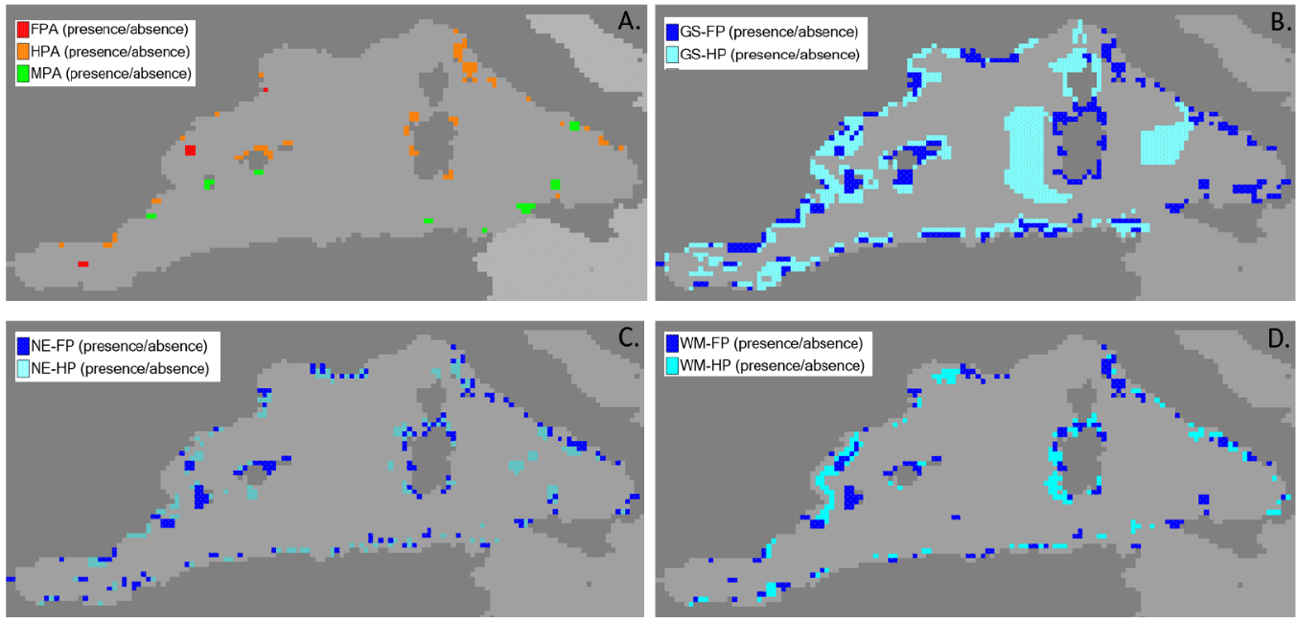
Figure 1 Configurations of MPAs with Fully Protected Areas (FPAs) and Highly Protected Areas (HPAs): a) Status Quo; b) Global Sustainability, c) National Enterprise, and d) World Markets.

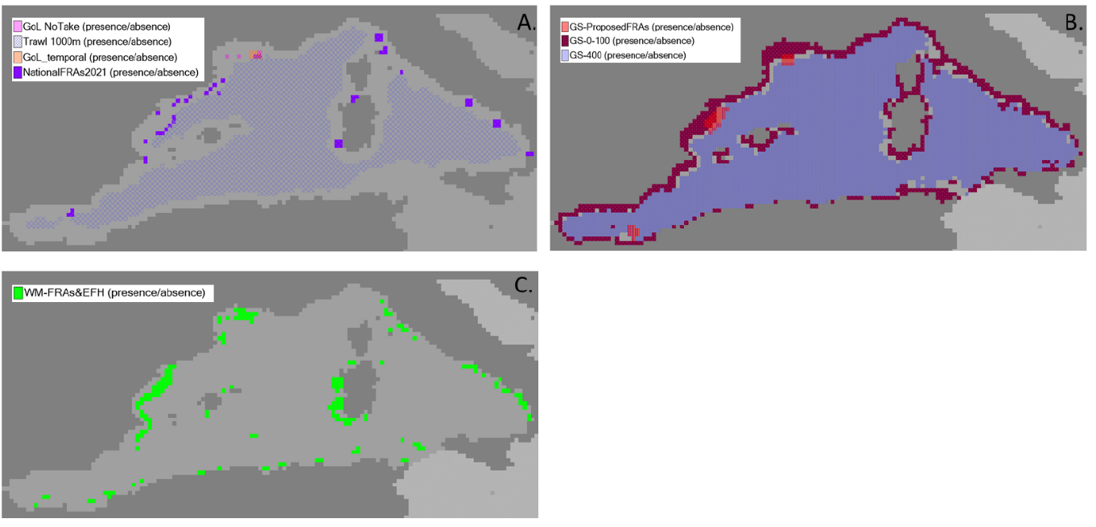
Figure 2 Configurations of Fisheries Closures: a) Status Quo; b) Global Sustainability, c) World Markets. The National Enterprise scenario does not include additional FCs after the 2021.
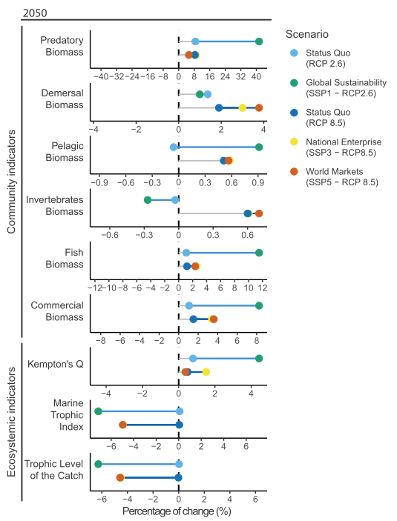
Figure 3 Community and ecosystem indicators percentage of changes between 2047-2050 and 2019-2023 averages.

