Supplementary Information

Breaking the Equilibrium Yield Limit of Methane Aromatization Using Tandem Chemical Looping Catalysis
Ibrahim Sultan^{a,#}, Baitang Jin^{a,#}, Zhenhua Xie^{b,c}, Md Emdadul Haque^{d}, Ashley Caiola^{d}, Jianli Hu^{d}, Debangsu Bhattacharyya^{d}, Luke Nealª, Jingguang G. Chen^{b,c,*}, Fanxing Li^{a,*}
ª Department of Chemical and Biomolecular Engineering, North Carolina State University, 911 Partners Way, Raleigh, NC 27695, USA; ^{b} Department of Chemical Engineering, Columbia University, New York, NY 10027, USA; ^{c} Chemistry Division, Brookhaven National Laboratory, Upton, NY 11973, USA; ^{d} Department of Chemical and Biomedical Engineering, West Virginia University, Morgantown, WV 26506, USA
# These authors contributed equally. * Corresponding authors: fli5@ncsu.edu (F.L.); jgchen@columbia.edu (J.G.C.)

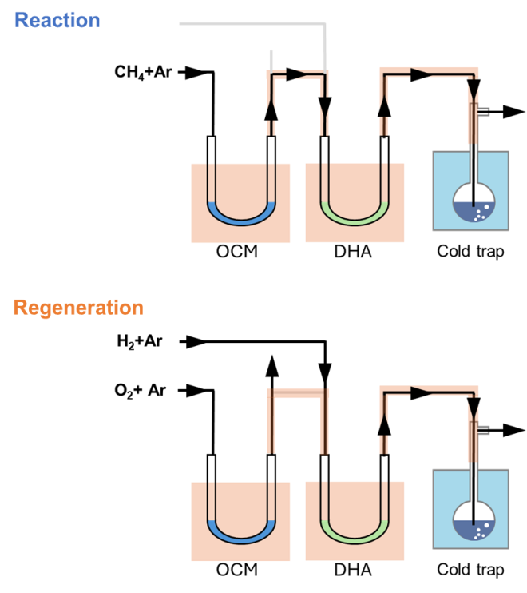
Figure S1. CL-OCM+DHA reaction and regeneration setup

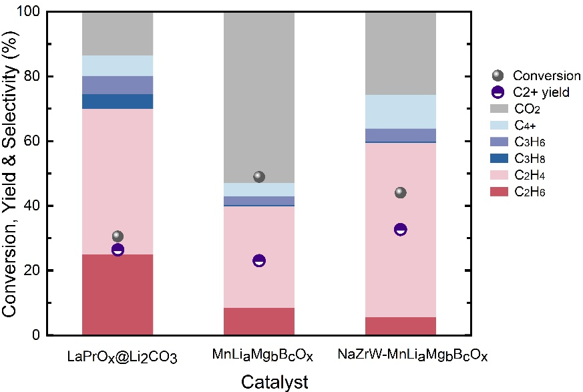
Figure S2. Chemical Looping OCM performance for different redox-oxide formulations (LaPrO_{x}@Li₂CO₃ at 725 °C; MnLi_{a}Mg_{b}B_{c}O_{x} and NaZrW-MnLi_{a}Mg_{b}B_{c}O_{x} at 840 °C; conditions in Table S1)
Table S1. Experimental conditions for the data shown in Figs. 1f, 2, 5b, S2 and S10 of the main text and SI.
Data set | CL-OCM bed (catalyst, mass, T) | DHA bed (catalyst, mass, T) | Reaction step (feed, duration) | Ar purge | Regeneration step (duration; gas to each bed) | Cycles
Fig. 1f, LC-LP | 2 g LaPrO_{x}@Li₂CO₃, 725 °C | 0.1 g HGaAlMFI, 550 °C | 80% CH₄/Ar, 5 min | 5 min | 5 min; 20% O₂/Ar to CL-OCM bed, 20% H₂/Ar to DHA bed | 5 (averaged)
Fig. 1f, MLMB | 0.43 g MLMB, 840 °C | 0.1 g HGaAlMFI, 550 °C | 80% CH₄/Ar, 15 s | 10 min | 30 min; 20% O₂/Ar to CL-OCM bed, 20% H₂/Ar to DHA bed | 5 (averaged)
Fig. 1f, NZW-MLMB | 0.43 g MLMB + 0.215 g NaZrWO_{x}, 840 °C | 0.1 g HGaAlMFI, 550 °C | 80% CH₄/Ar, 15 s | 10 min | 30 min; 20% O₂/Ar to CL-OCM bed, 20% H₂/Ar to DHA bed | 5 (averaged)
Fig. 2a | 2 g LaPrO_{x}@Li₂CO₃, 700 °C | 0.1 g HGaAlMFI, 550 °C | 80% CH₄/Ar, 5 min | 5 min | 5 min; 20% O₂/Ar to both beds | 5 (individual cycles)
Fig. 2b (CL-OCM only) | 2 g LaPrO_{x}@Li₂CO₃, 700 °C | – | 80% CH₄/Ar, 5 min | 5 min | 5 min; 20% O₂/Ar | 5 (individual cycles)
Fig. 2c (C₂H₄-DHA only) | – | 0.1 g HGaAlMFI, 550 °C | 10 mL/min C₂H₄ + 0–10 mL/min H₂O(g), Ar balance | – | – | –
Fig. 2d | 2 g LaPrO_{x}@Li₂CO₃, 700 °C | 0.1 g HGaAlMFI, 550 °C | 80% CH₄/Ar, 5 min | 5 min | 5 min; 20% O₂/Ar to CL-OCM bed, 20% H₂/Ar to DHA bed | 5 (individual cycles)
Fig. 5b | 0.43 g MLMB + 0.215 g NaZrWO_{x}, 840 °C | 0.1 g HGaAlMFI, 550 °C | 80% CH₄/Ar, 15 s | 10 min | 3 min; 20% O₂/Ar to CL-OCM bed, 20% H₂/Ar to DHA bed | 20 (individual cycles)
Fig. S2 (CL-OCM only) | As the Fig. 1f rows | – | As Fig. 1f rows | As Fig. 1f rows | As Fig. 1f rows; 20% O₂/Ar only | 5 (averaged)
Fig. S10 | 2 g LaPrO_{x}@Li₂CO₃, 725 °C | 0.1 g HGaAlMFI, 550 °C | 80% CH₄/Ar, 3 min | 21 min | 15 min; 20% O₂/Ar to CL-OCM bed, 20% H₂/Ar to DHA bed | 50 (~50 h)
All experiments were run at 1 bar with a total flow rate of 25 mL/min; a second Ar purge followed each regeneration step. 80% CH₄/Ar = 80 vol% CH₄/20 vol% Ar; 20% O₂/Ar = 20 vol% O₂/80 vol% Ar; 20% H₂/Ar = 20 vol% H₂/80 vol% Ar. LaPrO_{x}@Li₂CO₃ = 5 wt% Li₂CO₃/LaPrO_{x} (LC-LP in Fig. 1f); MLMB = MnLi_{a}Mg_{b}B_{c}O_{x}; NZW = NaZrWO_{x}.

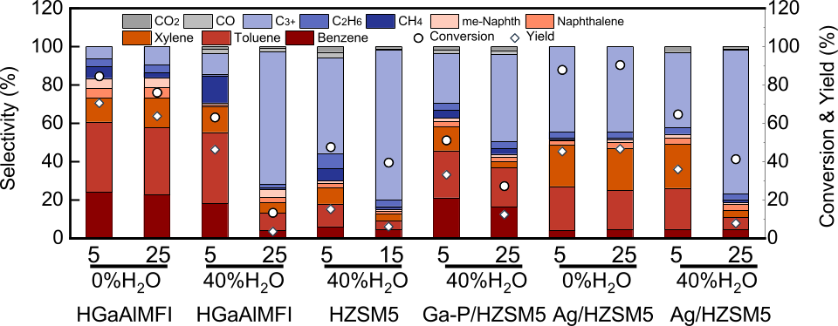
Figure S3. DHA performance of different catalysts. The number is the time (min)/ flow rate: 10 sccm C₂H₄ + 0–10 sccm H₂O + 15–5 sccm Ar, catalyst loading: 0.1 g HGaAlMFI, or 0.5 g HZSM5, or 0.1 g Ga-P/ZSM5, or 0.1 g Ag/ZSM5.
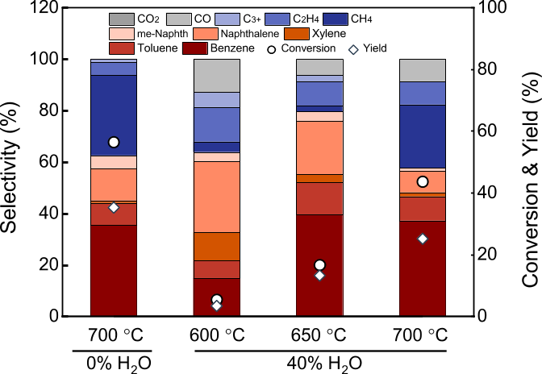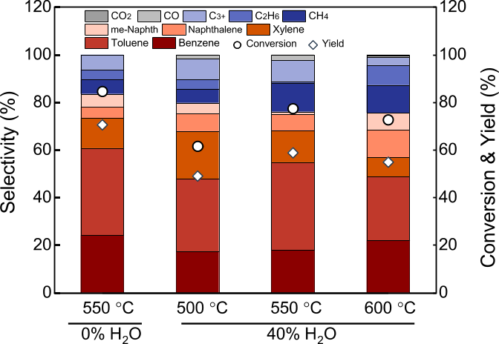
Figure S4 (a)C₂H₆ DHA performance: 10 sccm C₂H₆+ 0-10 sccm H₂O(g) +15-5 sccm Ar for 0 or 40%H₂O, catalyst loading: 0.8 g HGaAlMFI, 5min (b) C₂H₄ DHA performance: 10 sccm C₂H₄+ 0-10 sccm H₂O(g) +15-5 sccm Ar for 0 or 40%H₂O, catalyst loading: 0.1 g HGaAlMFI, 5min

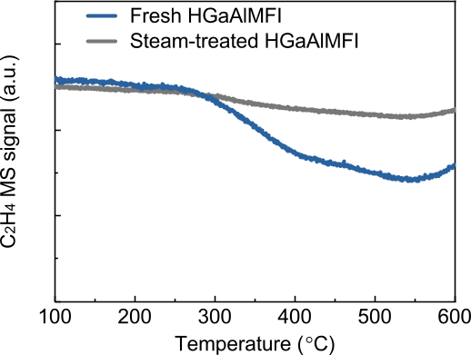
Figure S5. C₂H₄-TPSR of fresh and steam-treated HGaAlMFI.

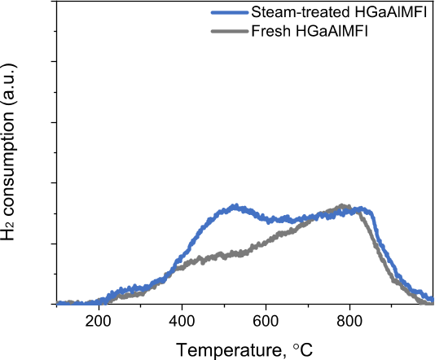
Figure S6. H₂-TPR results of fresh and steam-treated HGaAlMFI.
Figure S7. The Fourier-transformed EXAFS spectra of Ga K-edge and corresponding fitting plots in R space (a) and k space (b) over the HGaAlMFI catalyst under different conditions without steam treatment. Notes: k¹k²k³-weighted EXAFS fitting ranges—N₂@25°C: ∆k=2.6-12 Å⁻¹ and ∆R=1.0-2.8 Å; others: ∆k=2.6-12 Å⁻¹ and ∆R=1.0-2.5 Å.
Figure S8. The Fourier-transformed EXAFS spectra of Ga K-edge and corresponding fitting plots in R space (a) and k space (b) over the HGaAlMFI catalyst under different conditions with steam treatment. Notes: k¹k²k³-weighted EXAFS fitting ranges—N₂+H₂O@25°C: ∆k=2.6-12 Å⁻¹ and ∆R=1.0-2.8 Å; others: ∆k=2.6-12 Å⁻¹ and ∆R=1.0-2.5 Å.
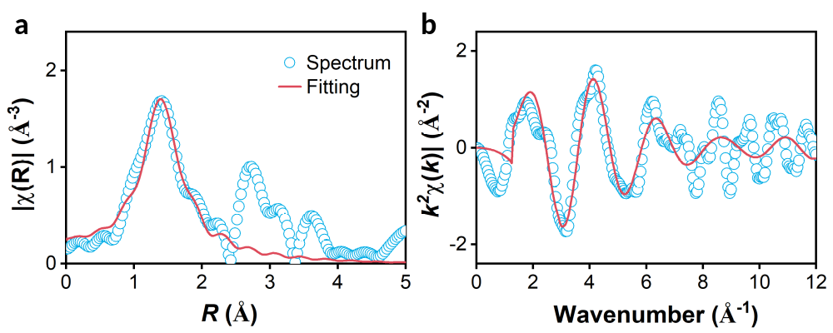
Figure S9. The Fourier-transformed EXAFS spectra of Ga K-edge and corresponding fitting plots in R space over Ga₂O₃. Notes: k¹k²k³-weighted EXAFS fitting ranges—∆k=2.6-11 Å⁻¹ and ∆R=1.0-2.4 Å.
EXAFS fitting results. Without steam pretreatment, heating fresh HGaAlMFI to 550 °C in N₂ decreased the coordination number of the shorter Ga–-O* shell from ~5.0 to ~3.3 (bond distance ~1.76 Å), with a slight increase in the longer Ga–-O** distance (~1.95 Å, CN ~0.6), consistent with reduction of extra-framework Ga–-O species and migration into the zeolite framework. Exposure to C₂H₄ raised CN(Ga–-O*) slightly to ~3.7 and lowered CN(Ga–O**) to ~0.4; subsequent H₂ treatment followed by a second C₂H₄ exposure lowered CN(Ga–O*) to ~3.0, indicating further reduction of Ga (Table S2, Figure S7). With steam pretreatment, the same sequence gave higher Ga–O coordination numbers throughout (Table S3, Figure S8), and after H₂ regeneration and renewed C₂H₄ exposure CN(Ga–O**) rose to ~0.8 with reappearance of the Ga–(O)–Ga contribution. Fitting results for the Ga₂O₃ reference are given in Table S4 and Figure S9.
Table S2. Fitting results of the in situ Ga K-edge FT-EXAFS spectra over the HGaAlMFI catalyst under different conditions without steam treatment.
Samples | Shell | CN | Bond length (Å) | σ² (Å²) | E₀ shift (eV) | R factor
N₂@25°C | Ga-O | 5.0±0.2 | 1.80±0.00 | 0.0047 | -1.03 | 0.015
N₂@25°C | Ga-(O)-Ga | 1.2±0.5 | 2.92±0.02 | 0.0047 | -1.03 | 0.015
N₂@550°C | Ga-O* | 3.3±0.4 | 1.76±0.01 | 0.0039 | -1.92 | 0.015
N₂@550°C | Ga-O** | 0.57±0.46 | 1.95±0.09 | 0.0039 | -1.92 | 0.015
C₂H₄@550°C | Ga-O* | 3.7±0.2 | 1.76±0.01 | 0.0054 | -2.15 | 0.015
C₂H₄@550°C | Ga-O** | 0.36±0.27 | 2.00±0.08 | 0.0054 | -2.15 | 0.015
H₂@550°C | Ga-O* | 3.0±0.2 | 1.77±0.01 | 0.0037 | 2.26 | 0.015
H₂@550°C | Ga-O** | 0.46±0.30 | 2.01±0.07 | 0.0037 | 2.26 | 0.015
C₂H₄@550°C_a | Ga-O* | 2.9±0.3 | 1.77±0.01 | 0.0041 | 2.32 | 0.015
C₂H₄@550°C_a | Ga-O** | 0.52±0.42 | 2.03±0.08 | 0.0041 | 2.32 | 0.015
Notes: CN―average coordination number (normalized to all the Ga absorbers) around the absorbing center atom; σ²―mean square variation in path length; R-factor―quality of fitting. Ga-O* and Ga-O** referred to the shorter and longer Ga-O bonds, respectively; k¹k²k³-weighted EXAFS fitting ranges—N₂@25°C: ∆k=2.6-12 Å⁻¹ and ∆R=1.0-2.8 Å; others: ∆k=2.6-12 Å⁻¹ and ∆R=1.0-2.5 Å.

Table S3. Fitting results of the in situ Ga K-edge FT-EXAFS spectra over the HGaAlMFI catalyst under different conditions with steam treatment.
Samples | Shell | CN | Bond length (Å) | σ² (Å²) | E₀ shift (eV) | R factor
N₂@25°C | Ga-O | 5.1±0.2 | 1.80±0.00 | 0.0039 | -0.49 | 0.014
N₂@25°C | Ga-(O)-Ga | 1.2±0.3 | 2.91±0.02 | 0.0039 | -0.49 | 0.014
N₂@550°C | Ga-O* | 3.9±0.3 | 1.77±0.01 | 0.0055 | -1.23 | 0.014
N₂@550°C | Ga-O** | 0.57±0.36 | 2.03±0.06 | 0.0039 | -1.23 | 0.014
C₂H₄@550°C | Ga-O* | 4.0±0.5 | 1.77±0.01 | 0.0061 | -1.27 | 0.014
C₂H₄@550°C | Ga-O** | 0.45±0.60 | 2.06±0.10 | 0.0039 | -1.27 | 0.014
H₂@550°C | Ga-O* | 3.4±0.4 | 1.78±0.01 | 0.0055 | 1.83 | 0.014
H₂@550°C | Ga-O** | 0.36±0.48 | 2.08±0.11 | 0.0039 | 1.83 | 0.014
C₂H₄@550°C_a | Ga-O* | 3.5±0.3 | 1.78±0.01 | 0.0055 | 5.55 | 0.014
C₂H₄@550°C_a | Ga-O** | 0.80±0.38 | 2.05±0.08 | 0.0039 | 5.55 | 0.014
Notes: CN―average coordination number (normalized to all the Ga absorbers) around the absorbing center atom; σ²―mean square variation in path length; R-factor―quality of fitting. Ga-O* and Ga-O** referred to the shorter and longer Ga-O bonds, respectively; k¹k²k³-weighted EXAFS fitting ranges—N₂+H₂O: ∆k=2.6-12 Å⁻¹ and ∆R=1.0-2.8 Å; others: ∆k=2.6-12 Å⁻¹ and ∆R=1.0-2.5 Å.
Table S4. Fitting results of the in situ Ga K-edge FT-EXAFS spectra over Ga₂O₃.
Samples | Shell | CN | Bond length (Å) | σ² (Å²) | E₀ shift (eV) | R factor
Ga₂O₃ | Ga-O* | 3.6±0.5 | 1.87±0.02 | 0.0019 | 6.09 | 0.017
Ga₂O₃ | Ga-O** | 2.4±0.5 | 2.04±0.04 | 0.0019 | 6.09 | 0.017
Notes: CN―average coordination number (normalized to all the Ga absorbers) around the absorbing center atom; σ²―mean square variation in path length; R-factor―quality of fitting. Ga-O* and Ga-O** referred to the shorter and longer Ga-O bonds, respectively; k¹k²k³-weighted EXAFS fitting ranges—∆k=2.6-11 Å⁻¹ and ∆R=1.0-2.4 Å.

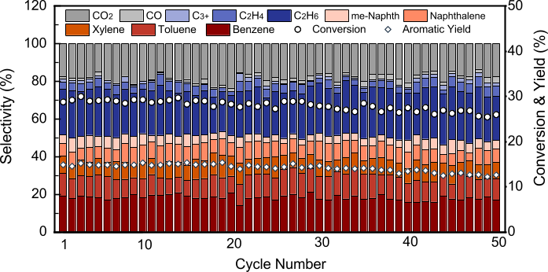
Figure S10. Long-term stability test of the OCM+DHA reaction setup: OCM: 2 g LaPrO_{x}@Li₂CO₃ catalyst at 725 °C, DHA catalyst: 0.1 g HGaAlMFI catalyst at 550 °C, flow rate= 25 mL/min; reduction: 3-min 80vol%CH₄/20vol%Ar, internal flush: 21-min Ar, regeneration: 15-min 20vol% O₂/80vol%Ar for OCM, 20vol% H₂/80vol%Ar for DHA.

S1 Process Modeling for TEA and LCA
An Aspen Plus process model has been developed to convert natural gas (NG) into value-added chemicals—specifically organic liquids—via an integrated Oxidative Coupling of Methane and Dehydroaromatization (OCM-DHA) process. The model considers benzene, toluene, xylene, and naphthalene as primary products, with an additional provision for producing non-separated organic liquids (i.e., Py Gas) as a combined product stream. In addition to a baseline system that does not mitigate CO₂ emissions, the system accounts for generated carbon dioxide (CO₂) through two cases:
- Capture: 80–90% of the generated CO₂ is captured using an amine-based system (Cansolv solvent). The remaining CO₂, along with other unreacted components, is recycled within the process.
- Methanation: The produced CO₂ undergoes methanation, where 90% is converted to CH₄ and recycled.
Modeling was further subdivided to address two technoeconomic scenarios:
- Complete Separation: Major products (Benzene, toluene, xylene, and naphthalene) are separated on site using distillation columns.
- Py Gas: The liquid hydrocarbon product was exported as a pyrolysis gasoline-type mixture.
Initial modeling assumes a plant capacity of 50 bbl/day of organic liquids, aligning with the expected capacity at “stranded” natural gas sites. To avoid the build-up of inert or unconverted gases, a purge stream is incorporated in both cases.
In all cases, NG (100% CH₄ at 25°C and 31 bar, per pipeline specifications) is depressurized to 2.5 bar and preheated before entering the reactor section. Pure methane was used due to the lack of experimental results on C₂₊ and other feed impurities, the low expected net effect of easier-to-convert C₂₊ and minor amounts of CO_{x} and nitrogen on the overall process results, and the likely variance of a real shale field gas composition from literature.
The core of the process involves an OCM-DHA reactor system, where three key reactions occur sequentially at 750°C and 2 bar. The stated reactor temperature and pressure are adopted as representative modeling conditions, with CH₄ conversion and product yields based on experimental results, while the estimated reactor cost is assumed to be insensitive to this choice. The process is modeled as separate OCM, DHA, and SHC reactors, utilizing three RSTOIC reactors in series. In the OCM reactor, methane was converted into ethane, ethylene, and hydrogen. Within the DHA reactor, ethane and ethylene were converted into products such as methane, ethane, ethylene, benzene, toluene, p-xylene, naphthalene, dimethyl naphthalene, coke, and carbon monoxide. In the selective hydrogen combustion (SHC) reactor, hydrogen was selectively consumed to improve aromatics yield and process efficiency. Table S5 lists the reactions used in the OCM-DHA process. After the SHC reactor, solids and coke are separated, and the gaseous stream is sent to a compression section. The OCM reactor achieves a single-pass methane conversion of 44.3%, with a carbon-based organic yield of 27.1%. The separated solids contain redox catalyst materials (MnO₂ and Mn₂O₃) along with coke, both of which are regenerated in the reactor. Here, air was introduced with 20% excess oxygen to ensure complete oxidation of Mn₂O₃ back to MnO₂ and full conversion of carbon to an equimolar mixture of CO and CO₂. The depleted air stream is vented from the system.
The gaseous product, after coke and solids separation, undergoes heat recovery, generating superheated steam, and is subsequently cooled to 25°C. It then passes through a four-stage compression system, with interstage liquid separators, to reach 32 bar. Following compression, the stream enters a cryogenic separation unit, cooled to -60°C using propane and ethylene refrigerants, to recover additional liquids for purification. Liquids collected from both the cryogenic separator and interstage separators were routed to the purification section, which consists of three distillation columns designed to isolate naphthalene, benzene, toluene, and p-xylene, each at around 99 mol% purity. The overhead gas from the cryogenic separator was processed differently in each case. In the Cansolv case, the gas entered the CO₂ capture unit based on the conventional Cansolv. In the Methanation Case, the gas undergoes methanation via the Sabatier reaction, where Ni/Al₂O₃ is used as the catalyst to convert CO₂ and H₂ to CH₄, which is then recycled back into the system. The Sabatier reactions are listed in Table S5, the equation (1) shows the reaction kinetics and parameters are listed in Table S6.⁴⁷ Throughout the process, heat integration strategies were applied to optimize energy consumption. Notably, superheated steam generated from reactor heat is used to drive the reboilers in the distillation columns. Detailed process flow diagrams for both cases are provided in Figure S11 – S13.
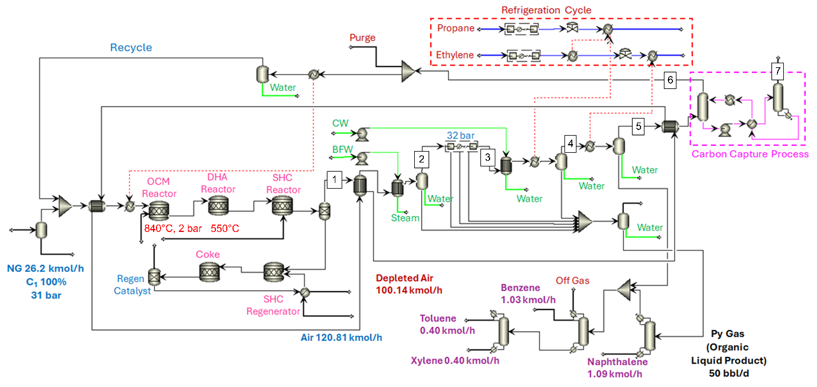
Figure S11. Capture Case utilizing an amine-based carbon capture (Cansolv) to remove CO₂ from the process stream.

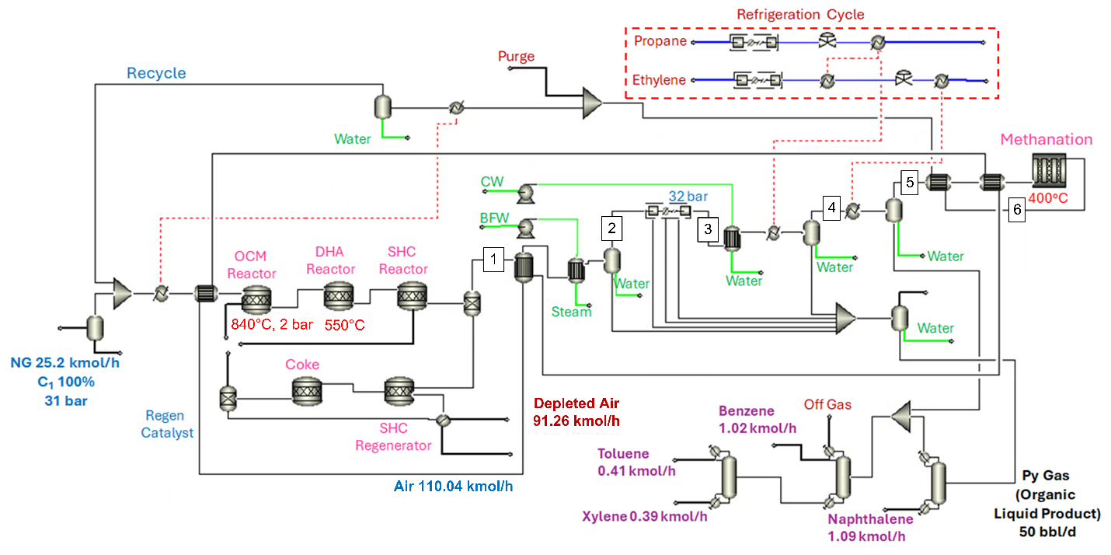
Figure S12. Methanation case using a methanation unit to convert CO₂ in the process stream.
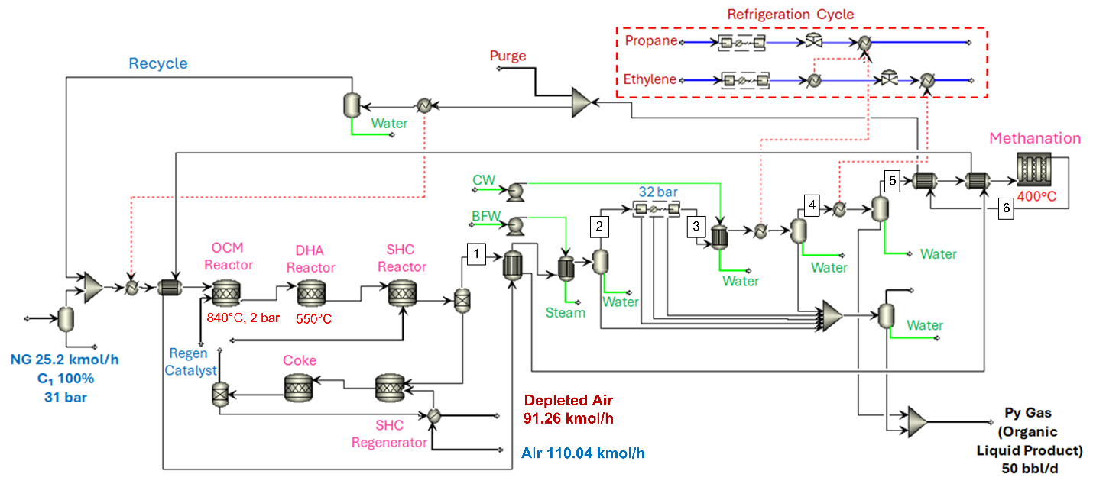
Figure S13. Methanation Case for Py Gas product.

Table S5. Stoichiometric Reactions used for OCM, DHA, SHC, and Methanation Steps.
Reaction Step | Reaction
OCM | 2CH₄ à C₂H₄ + 2H₂
OCM | 2CH₄ à C₂H₆ + H₂
OCM | CH₄ à CO + 2H₂
OCM | CH₄ + 8MnO₂ à CO₂ + 4Mn₂O₃ + 2H₂O
DHA | C₂H₄ + H₂ à 2CH₄
DHA | 3C₂H₄ à 2C₃H₆
DHA | 3C₂H₄ à C₆H₆ + 3H₂
DHA | 3.5C₂H₄ à C₇H₈ + 3H₂
DHA | 4C₂H₄ à C₈H₁₀ + 3H₂
DHA | 9C₂H₄ à 2C₉H₁₂ + 6H₂
DHA | 5C₂H₄ à C₁₀H₈ + 6H₂
DHA | 6C₂H₄ à C₁₂H₁₂ + 6H₂
DHA | C₂H₄ + 8MnO₂ à 2CO + 4Mn₂O₃ + 2H₂O
DHA | C₂H₄ à 2C_{(s)} + 2H₂
DHA | C₂H₆ à C₂H₄ + H₂
DHA | C₂H₆ + H₂ à 2CH₄
DHA | 3C₂H₆ à 2C₃H₆ + 3H₂
DHA | 3C₂H₆ à C₆H₆ + 6H₂
DHA | 7C₂H₆ à 2C₇H₈ + 13H₂
DHA | 4C₂H₆ à C₈H₁₀ + 7H₂
DHA | 9C₂H₆ à 2C₉H₁₂ + 15H₂
DHA | 5C₂H₆ à C₁₀H₈ + 11H₂
DHA | 6C₂H₆ à C₁₂H₁₂ + 12H₂
DHA | C₂H₆ + 10MnO₂ à 2CO + 5Mn₂O₃ + 3H₂O
DHA | C₂H₆ à 2C_{(s)} + 3H₂
SHC | H₂ + 2MnO₂ à H₂O + Mn₂O₃
Methanation | CO + 3H₂ ↔ CH₄ + H₂O
Methanation | CO₂ + H₂ ↔ CO + H₂O
Methanation | CO₂ + 4H₂ ↔ CH₄ + 2H₂O

$k_{j}=A_{j}exp(\frac{{-E}_{j}}{RT})$ (1)

Table S6. Parameters of Sabatier Reaction ⁴⁷
A₁ (mol.kPa^{0.5}/kg.s) | A₂ (mol.kPa^{0.5}/kg.s) | A₃ (mol/kPa.kg.s)
8.9×10⁸ | 3.42×10⁶ | 9.22×10⁻⁵
E₁ (kJ/mol) | E₂ (kJ/mol) | E₃ (kJ/mol)
122.4 | 93.1 | 104.8

The mass and energy balances for both cases are presented in Table S7. Key mass and energy balances for each case are detailed in Table S7, while the equipment sizing results are summarized in Table S8.

Table S7. Mass and Energy Balance for Capture and Methanation and Cases
Parameter | Capture, Complete Separation | Capture, Py Gas | Methanation,  Complete Separation | Methanation,  Py Gas
Mass In (kg/h) | 3885 | 3885 | 3579 | 3579
Mass Out (kg/h) | 3885 | 3885 | 3579 | 3579
Produced Water | 709 | 709 | 712 | 712
Electric Power (MJ/kg Aromatics) | 1.53 | 1.25 | 1.43 | 1.19
Heating Duty (MJ/kg Aromatics | 0.41 | 0.10 | 0.50 | 0
Cooling Duty (MJ/kg Aromatics | 7.93 | 7.11 | 7.90 | 7.08

Table S8. List of Major Equipment Sizing Results
Parameter | Capture Complete Separation | Methanation  Complete Separation
OCM-DHA Reactor
Number of Reactors | 5 | 5
Diameter (m) | 1.9 | 1.9
Length (m) | 3.4 | 3.4
Carbon Capture Process
Absorber (dia × height, m) | 0.25×1.0 | N/A
Stripper | 0.25×1.0 | N/A
Circulation Pump 1 | 0.21 | N/A
Methanation Reactor
Number of Tubes | N/A | 15
Tube Diameter (m) | N/A | 1.25
Tube Length (m) | N/A | 0.3
Refrigeration Compressor
Propane Compressor (4 stage, kW) | 6.04 | 6.14
Ethylene Compressor (5 stage, kW) | 30.75 | 31.75
Methane Compressor (4 stage, kW) | N/A | N/A
Nitrogen Compressor (4 stage, kW) | N/A | N/A
Column-1
Number of Stage | 28 | 28
Reflux Ratio | 0.26 | 0.28
Diameter (m) | 0.46 | 0.46
Height (m) | 20.27 | 20.27
Condenser Duty (kW) | 4.75 | 4.7
Reboiler Duty (kW) | 58.21 | 57.94
Column-2
Number of Stage | 30 | 30
Reflux Ratio | 4.01 | 4.03
Diameter (m) | 0.55 | 0.55
Height (m) | 14.25 | 14.25
Condenser Duty (kW) | 49.66 | 49.45
Reboiler Duty (kW) | 32.01 | 31.98
Column-3
Number of Stage | 36 | 36
Reflux Ratio | 3.65 | 3.65
Diameter (m) | 0.5 | 0.5
Height (m) | 15.75 | 15.75
Condenser Duty (kW) | 34.99 | 34.38
Reboiler Duty (kW) | 33.75 | 33.51
Other Compressor, Pump and Vessel
Main Compressor (5 stage, kW) | 53.29 | 53.29
BFW Pump (kW) | 0.62 | 0.62
CW Pump (kW) | 0.83 | 0.83
Flash Vessel 1 (dia × height, m) | 0.5×1.0  0.5×1.0  0.5×1.0  0.3×1.0  0.2×1.0
Flash Vessel 2(dia × height, m)
Flash Vessel 3(dia × height, m)
Flash Vessel 4(dia × height, m)
Flash Vessel 5(dia × height, m)

Reference Base Case
For the base case, the objective was to compare the process performance and TEA results with those of an industrial-scale non-oxidative direct methane dehydroaromatization (MDA) process. Since no commercially available methane DHA process currently exists, the base case was adopted from a study by Huang and Maravelias (2020),⁴⁸ which provides a comprehensive technical and economic evaluation for a reference plant. To facilitate a cost comparison between the OCM-DHA process and the reference base case, Huang et al.’s model was modified by retrofitting a post-combustion CO₂capture system to recover CO₂from the heating furnace flue gas. The modified process is shown in Figure S14. The reference plant was also rescaled from a capacity of 8,650 bbl/day liquids to approximately 50 bbl/day. The base case model utilizes NG feed of pipeline specification (25°C, 31 bar) to produce aromatics (benzene, toluene, naphthalene) and hydrogen. The process involves a catalytic conversion, compression system, cryogenic separation of the organic liquids, and a separation train for individual aromatics. The base case model performs an economic evaluation by determining net present value (NPV) with similar investment parameters listed in Table S9.

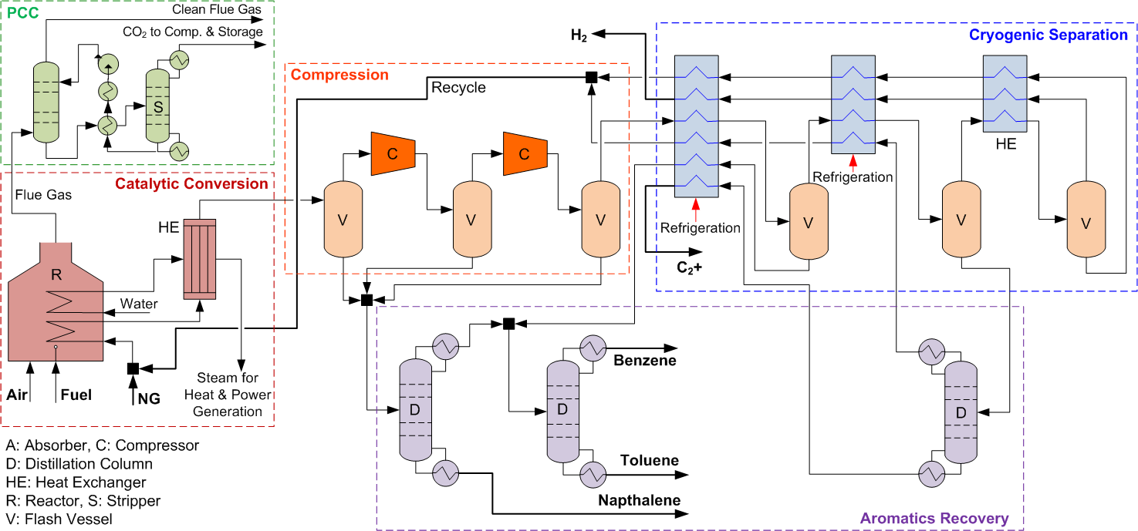
Figure S14. Process flow diagram for the reference base case.
S2 Techno-economic Analysis
A TEA was conducted for the developed case models—and compared against a reference base case model. For each scenario, both complete separation and non-separation process configurations were evaluated. In the complete separation cases, naphthalene, benzene, toluene, and xylene were considered as the final products, whereas pyrolysis gasoline (Py Gas) was treated as the final product in the non-separation cases. The investment parameters for the base and developed cases are summarized in Table S9. A process contingency ranging from 5–40% was applied to various equipment units, as detailed in Table S10, and a project contingency of 15% was included, following National Energy Technology Laboratory (NETL) guidelines.⁴⁹ Additional financial and economic parameters were sourced from the literature.⁵⁰ The prices of raw materials, products, and utilities used in the TEA are listed in Table S11. The natural gas (NG) price was obtained through internal collaboration with Jay Hewitt (Hewitt Energy Strategies) for the Appalachian Basin. An estimated price for Py Gas, accounting for the energy penalty due to lack of separation, was used in the model, with the estimation method described later in this section. Electricity prices reflect typical West Virginia rates, while prices for other products and refrigerants were sourced as indicated in Table S11.
Table S9. Parameters for the Economic Model
Parameter | Value | Parameter | Value
Project Contingency⁴⁹ | 15% | Working Capital | 5%/yr
Tax Rate | 21% | Plant Overhead | 50%
Desired Internal Rate of Return | 10%/yr | G & A Expense | 5%/yr
Salvage Value | 20% | O & M Escalation | 3%/yr
Project Capital Escalation | 1%/yr | No. of Periods for Analysis | 20
Product & Raw Material Escalation | 1%/yr | Operating hours per year | 8000 h
Utility Escalation | 1%/yr | Length of startup period | 20 weeks

Table S10. Process Contingency ⁴⁹
Parameter | Value
Separator | 5%
OCM-DHA Reactor | 40%
Methanation Reactor | 20%
Heat Exchanger | 5%
Compressor | 5%
Pump | 5%
Column | 5%

Table S11. Price of Raw Materials, Products and Utilities
Class | Description | Value | Reference
Raw Material | NG | 0.86 $/MCF | Estimate from Hewitt Energy Strategies
Product | Py Gas | 0.746 $/kg | Estimated Price
Product | Benzene | 0.86 $/kg | businessanalytiq.com/index/ (accessed July 1, 2025).
Product | Naphthalene | 0.64 $/kg | businessanalytiq.com/index/ (accessed July 1, 2025).
Product | Toluene | 1.03 $/kg | businessanalytiq.com/index/ (accessed July 1, 2025).
Product | Xylene | 0.83 $/kg | businessanalytiq.com/index/ (accessed July 1, 2025).
Utility | Electricity | 0.0724 $/kWh | eia.gov/electricity/sales_revenue_price/ (accessed on July 1, 2025).
Utility | Propane | 0.416 $/kg | businessanalytiq.com/index/ (accessed July 1, 2025).
Utility | Ethylene | 0.66 $/kg | businessanalytiq.com/index/ (accessed July 1, 2025).

The economic model was developed using Aspen Process Economic Analyzer (APEA) v14, utilizing 2022 equipment cost data. The equipment costs were adjusted to 2023 chemical engineering plant cost index (CEPCI) data. Based on CEPCI values, the cost difference between 2023 and 2025 is insignificant and was therefore not updated further. Four scenarios were generated and compared against the reference base case model: The Canslov Case with and without product separation, and the Methanation case with and without product separation. For the base case, the economic results reported by Huang and Maravelias (2020), based on a commercial-scale design, were scaled down to match the capacity of the developed model. CAPEX and OPEX were also adjusted using the 2023 CEPCI to ensure consistency with the current model.
Price Estimation for Py Gas
The price of the unseparated products (i.e. “Py Gas”) was estimated using Equations (2) and (3). The Py Gas price was calculated based on the component-wise composition obtained from the process model, using the individual market prices of each constituent (as listed in Table S11), from which the estimated separation costs were subtracted.Since the Py Gas is not separated at the plant and is sold as a mixed organic liquid stream, the estimation accounted for the energy penalty avoided by not performing product separation. These separation costs included the energy requirements for cooling in the condensers and heating in the reboilers of the distillation columns.
$Py Gas Price \left(\frac{\$}{kg}\right)=x_{B}.P_{B}+x_{N}.P_{N}+x_{T}.P_{T}+x_{X}.P_{X}-Q_{s}$ (2)
$Py Gas Price \left(\frac{\$}{kg}\right)=x_{B}.P_{B}+x_{N}.P_{N}+x_{T}.P_{T}+x_{X}.P_{X}$ (3)
Where, $x_{B}$, $x_{N}$, $x_{T}$ and $x_{X}$ are the mass fractions of Benzene, Naphthalene, Toluene, and Xylene, and $P_{B}$, $P_{N}$, $P_{T}$ and $P_{X}$ are the unit prices of Benzene, Naphthalene, Toluene and Xylene in kg/h. and $Q_{s}$ is the energy penalty for separation. Based on the process model, the total cooling and heating duties were 0.0706 MW and 0.105 MW, respectively. The cooling duty was met using cooling water, which includes associated pumping and treatment costs. The heating duty was supplied by high-pressure steam (HP steam), with its cost estimated using data from Turton et al. (2018).⁵¹ The calculated energy cost for separation amounted to $0.018/kg of Py Gas. Therefore, the final estimated price of Py Gas, accounting for the avoided separation energy penalty, is $0.746/kg.

Levelized Cost
The levelized cost for each case was calculated using Equation (4). For the complete separation cases, all products were converted to their benzene-equivalent based on energy content, and the lower heating value (LHV) of benzene was used in the calculation. In this equation, PC represents the plant capacity, $LHV_{C6H6}$ is the lower heating value of benzene, i is the discount rate, n is the plant lifetime in years, and the factor 8000 converts hourly production to annual output. The calculation incorporates both CAPEX and OPEX to determine the levelized cost.
$LC =\frac{\left( \frac{CAPEX×i{\left(1+i\right)}^{n}}{{\left(1+i\right)}^{n}-1}+OPEX\right)}{\left(PC\right)×LHV_{C6H6}×8000}$ (S4)

Economic Model Results
Table S12 presents the economic model results for a 50 bbl/d capacity across each case, compared to the base reference model. The detailed breakdowns of CAPEX and OPEX are shown in Tables S13 and S14, respectively. The detailed breakdown of capital expenditures (CAPEX), operating expenditures (OPEX), and overall economic performance for the evaluated configurations is illustrated in Figure S15. Although all cases and product scenarios yield negative net present values (NPVs) at 50 bbl/day capacity, each shows an improvement over the base case. The most favorable scenario is the Methanation-Py Gas case, with an NPV of -1.26 $MM at an internal rate of return (IRR) of 10%. However, the system achieves breakeven (NVP of 0) at a slightly lower IRR of 9.39%, the process reaches breakeven, indicating feasibility under more conservative return expectations. Major capital costs are driven by compressors associated with the compression train, refrigeration cycle, and recycle systems. For the economic analysis, an in-house cost estimate for the OCM-DHA reactor—modeled similarly to a CATOFIN reactor—was employed. On the operational expense side, the primary cost drivers are raw materials (natural gas) and operation and maintenance costs.
Table S12. Economic Model Results
Description | Base Case (Huang and Maravelias 2020)⁴⁸ | Capture Complete Separation | Capture,  Py Gas | Methanation,  Complete Separation | Methanation,  Py Gas
Total project Capital Cost ($MM) | 36.65 | 15.40 | 11.42 | 14.37 | 9.69
Total Operating Cost ($MM/yr) | 6.30 | 0.75 | 0.66 | 0.75 | 0.66
Total Revenue ($MM/yr) | 3.36 | 1.91 | 1.87 | 1.91 | 1.87
Levelized Cost ($/kg) | 3.950 | 0.977 | 0.858 | 0.921 | 0.774
NPV ($MM) | -13.16 | -6.13 | -2.55 | -4.99 | -1.26

Table S13. CAPEX Breakdown
Parameter | Capture, Complete Separation) | Capture. Py Gas) | Methanation,  Complete Separation | Methanation,  Py Gas
Separator ($MM) | 0.30 | 0.30 | 0.30 | 0.30
Reactor
OCM Reactor ($MM) | 0.70 | 0.70 | 0.70 | 0.70
Methanation Reactor ($MM) | 0 | 0 | 0.37 | 0.37
Heat Exchanger ($MM) | 1.75 | 1.75 | 1.62 | 1.62
Compressor ($MM) | 2.14 | 2.14 | 2.14 | 2.14
Columns ($MM) | 4.27 | 1.21 | 3.06 | 0
Pump ($MM) | 0.06 | 0.06 | 0.05 | 0.05
Project Contingency ($MM) | 2.31 | 1.91 | 2.16 | 1.45
Process Contingency ($MM) | 0.63 | 0.53 | 0.78 | 0.47
Design, Engineering, Procurement and Construction Materials ($MM) | 2.75 | 2.42 | 2.72 | 2.26
Contract Fee ($MM) | 0.18 | 0.14 | 0.17 | 0.11
G & A Overheads ($MM) | 0.31 | 0.26 | 0.30 | 0.22
Total ($MM) | 15.40 | 11.42 | 14.37 | 9.69

Table S14. OPEX Breakdown
Parameter | Capture Complete Separation) | Capture, Py Gas) | Methanation,  Complete Separation | Methanation,  Py Gas
Raw Material ($MM/yr) | 0.14 | 0.14 | 0.14 | 0.14
Catalyst ($MM/yr) | 0.12 | 0.12 | 0.13 | 0.13
O&M
Operator (24/7 shift cover with 1 operator per shift) ($MM/yr) | 0.16 | 0.16 | 0.16 | 0.16
Maintenance ($MM/yr) | 0.08 | 0.06 | 0.08 | 0.06
Overhead and G&A ($MM/yr) | 0.06 | 0.05 | 0.06 | 0.05
Utility
Electricity (kWh, $MM/yr) | 132.3, 0.08 | 108.21, 0.06 | 124.1, 0.07 | 103, 0.06
Refrigerants ($MM/yr) | 0.05 | 0.05 | 0.05 | 0.05
Cooling Water ($MM/yr) | 0.02 | 0.01 | 0.02 | 0.01
HP Steam ($MM/yr) | 0.04 | 0.01 | 0.04 | 0
Total ($MM/yr) | 0.75 | 0.66 | 0.75 | 0.66

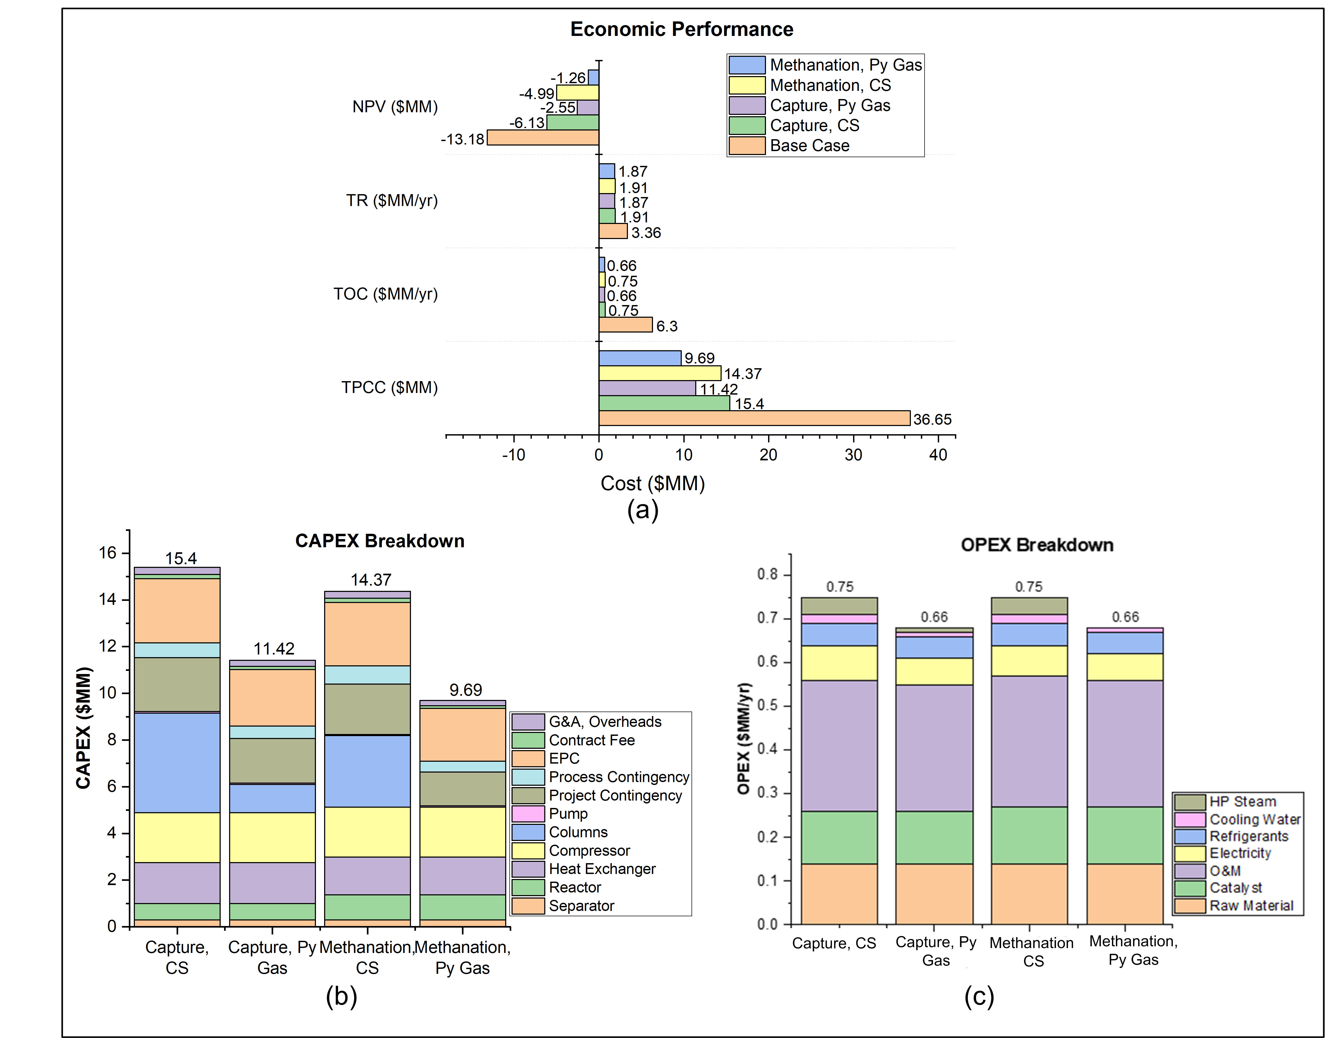
Figure S15. (a) Economic performance of the OCM-DHA process for different configurations; (b) CAPEX breakdown, and (c) OPEX breakdown.

Sensitivity Study 1: Reactor Pressure Variation
The developed process model, which considered a reactor pressure of 2 bar, resulted in negative NPVs for both cases. To evaluate the impact of operating pressure on economic performance, reactor pressure for the Methanation case varied from 2 bar to 5 bar (Fig S16). The analysis revealed that increasing the reactor pressure significantly reduces compression energy requirements without compromising separation efficiency. As a result, the economic performance improves, and the Methanation Py Gas scenario achieves a positive NPV of $0.34 million. Table S15 shows the sensitivity results for reactor pressure variation analysis.

Table S15. Economic Results of Reactor Pressure Variation
Parameter | Methanation- Complete Separation |  | Methanation, Py Gas
Parameter | Reactor Pressure 2 bar | Reactor Pressure 5 bar | Reactor Pressure 2 bar | Reactor Pressure 5 bar
Total project Capital Cost ($MM) | 14.37 | 13.87 | 9.69 | 9.19
Total Operating Cost ($MM/yr) | 0.75 | 0.68 | 0.66 | 0.60
Total Revenue ($MM/yr) | 1.91 | 1.91 | 1.87 | 1.87
NPV ($MM) | -4.99 | -2.81 | -1.26 | +0.34

Sensitivity Study 2: Plant Capacity Variation
A second analysis was conducted to assess the effect of plant capacity on the economic viability of the process. In this study, the capacity of Methanation (complete separation scenario) was varied from 50 to 100 bbl./d to identify the breakeven point. The results, shown in Figure S16b, indicate that the process reaches breakeven at a capacity of 78 bbl./d. Beyond this point, the plant becomes profitable, achieving an NPV of 3.25 $MM at 100 bbl./d. The analysis results are presented in Table S16.
Table S16. Economic Results of Plant Capacity Variation
Parameter | Methanation, Complete Separation
Parameter | 50 bbl./d | 75 bbl./d | 90 bbl./d | 100 bbl./d
Total project Capital Cost ($MM) | 14.37 | 15.57 | 15.97 | 17.25
Total Operating Cost ($MM/yr) | 0.75 | 0.88 | 0.97 | 1.02
Total Revenue ($MM/yr) | 1.91 | 2.88 | 3.45 | 3.84
NPV ($MM) | -4.99 | -0.67 | +2.16 | +3.25

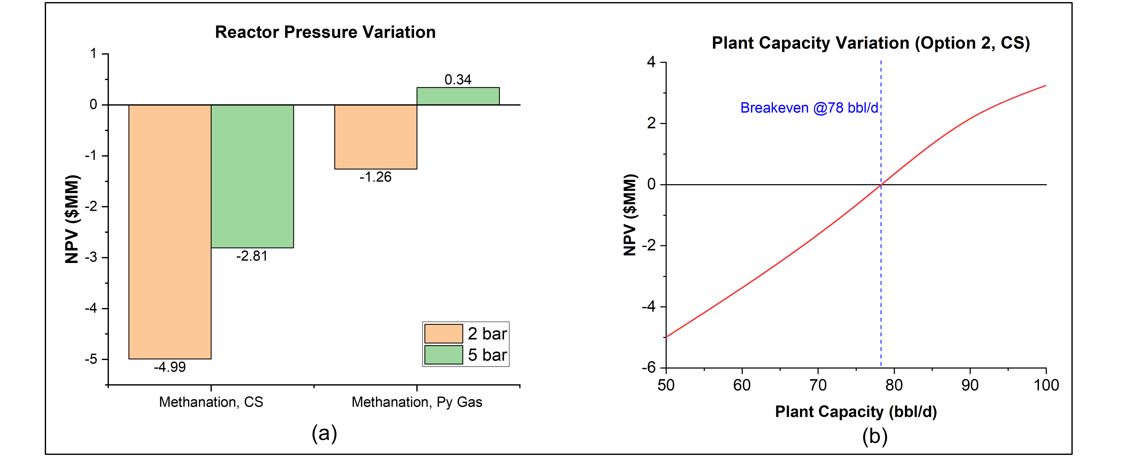
Figure S16. Sensitivity analysis results for: (a) Reactor pressure variation, and (b) Plant capacity.

Sensitivity Study 3: Different Raw Materials and Products Price
A third sensitivity analysis was conducted for the scaled-up model with a capacity of 100 bbl/d, evaluating the impact of varying raw material (natural gas) and product prices. Six case studies were considered, with pricing details provided in Table S17, based on historical data for natural gas, benzene, naphthalene, toluene, and xylene (Figure S17). The product prices for Price Case-5 and Price Case-6 were kept the same, while the NG price for Price Case-5 followed the NETL guideline, and Case-6 used a discounted NG price based on Price Case-5. The results (Tables S18–S23) indicate that all scenarios lead to an economically viable process. Among them, Price Case-4 under Methanation – Py Gas delivers the most favorable outcome, achieving an NPV of 14.80 $MM. The detailed economic cash flow and profitability results across the six evaluated price scenarios are detailed in Tables S18–S23.

Table S17. Price Scenario for Sensitivity Analysis
Description | Model Case | Price  Case-1 | Price  Case-2 | Price  Case-3 | Price  Case-4 | Price  Case-5 | Price  Case-6
NG ($/MCF) | 0.86 | 2.23 | 3.345 | 1.115 | 5.48 | 4.58 | 3.39
Benzene ($/kg) | 0.86 | 0.93 | 1.116 | 0.744 | 0.96 | 0.88 | 0.88
Naphthalene ($/kg) | 0.64 | 0.94 | 1.128 | 0.752 | 1.26 | 1.05 | 1.05
Toluene ($/kg) | 1.03 | 1.04 | 1.248 | 0.832 | 1.26 | 0.90 | 0.90
Xylene ($/kg) | 0.83 | 0.94 | 1.128 | 0.752 | 1.12 | 0.81 | 0.81

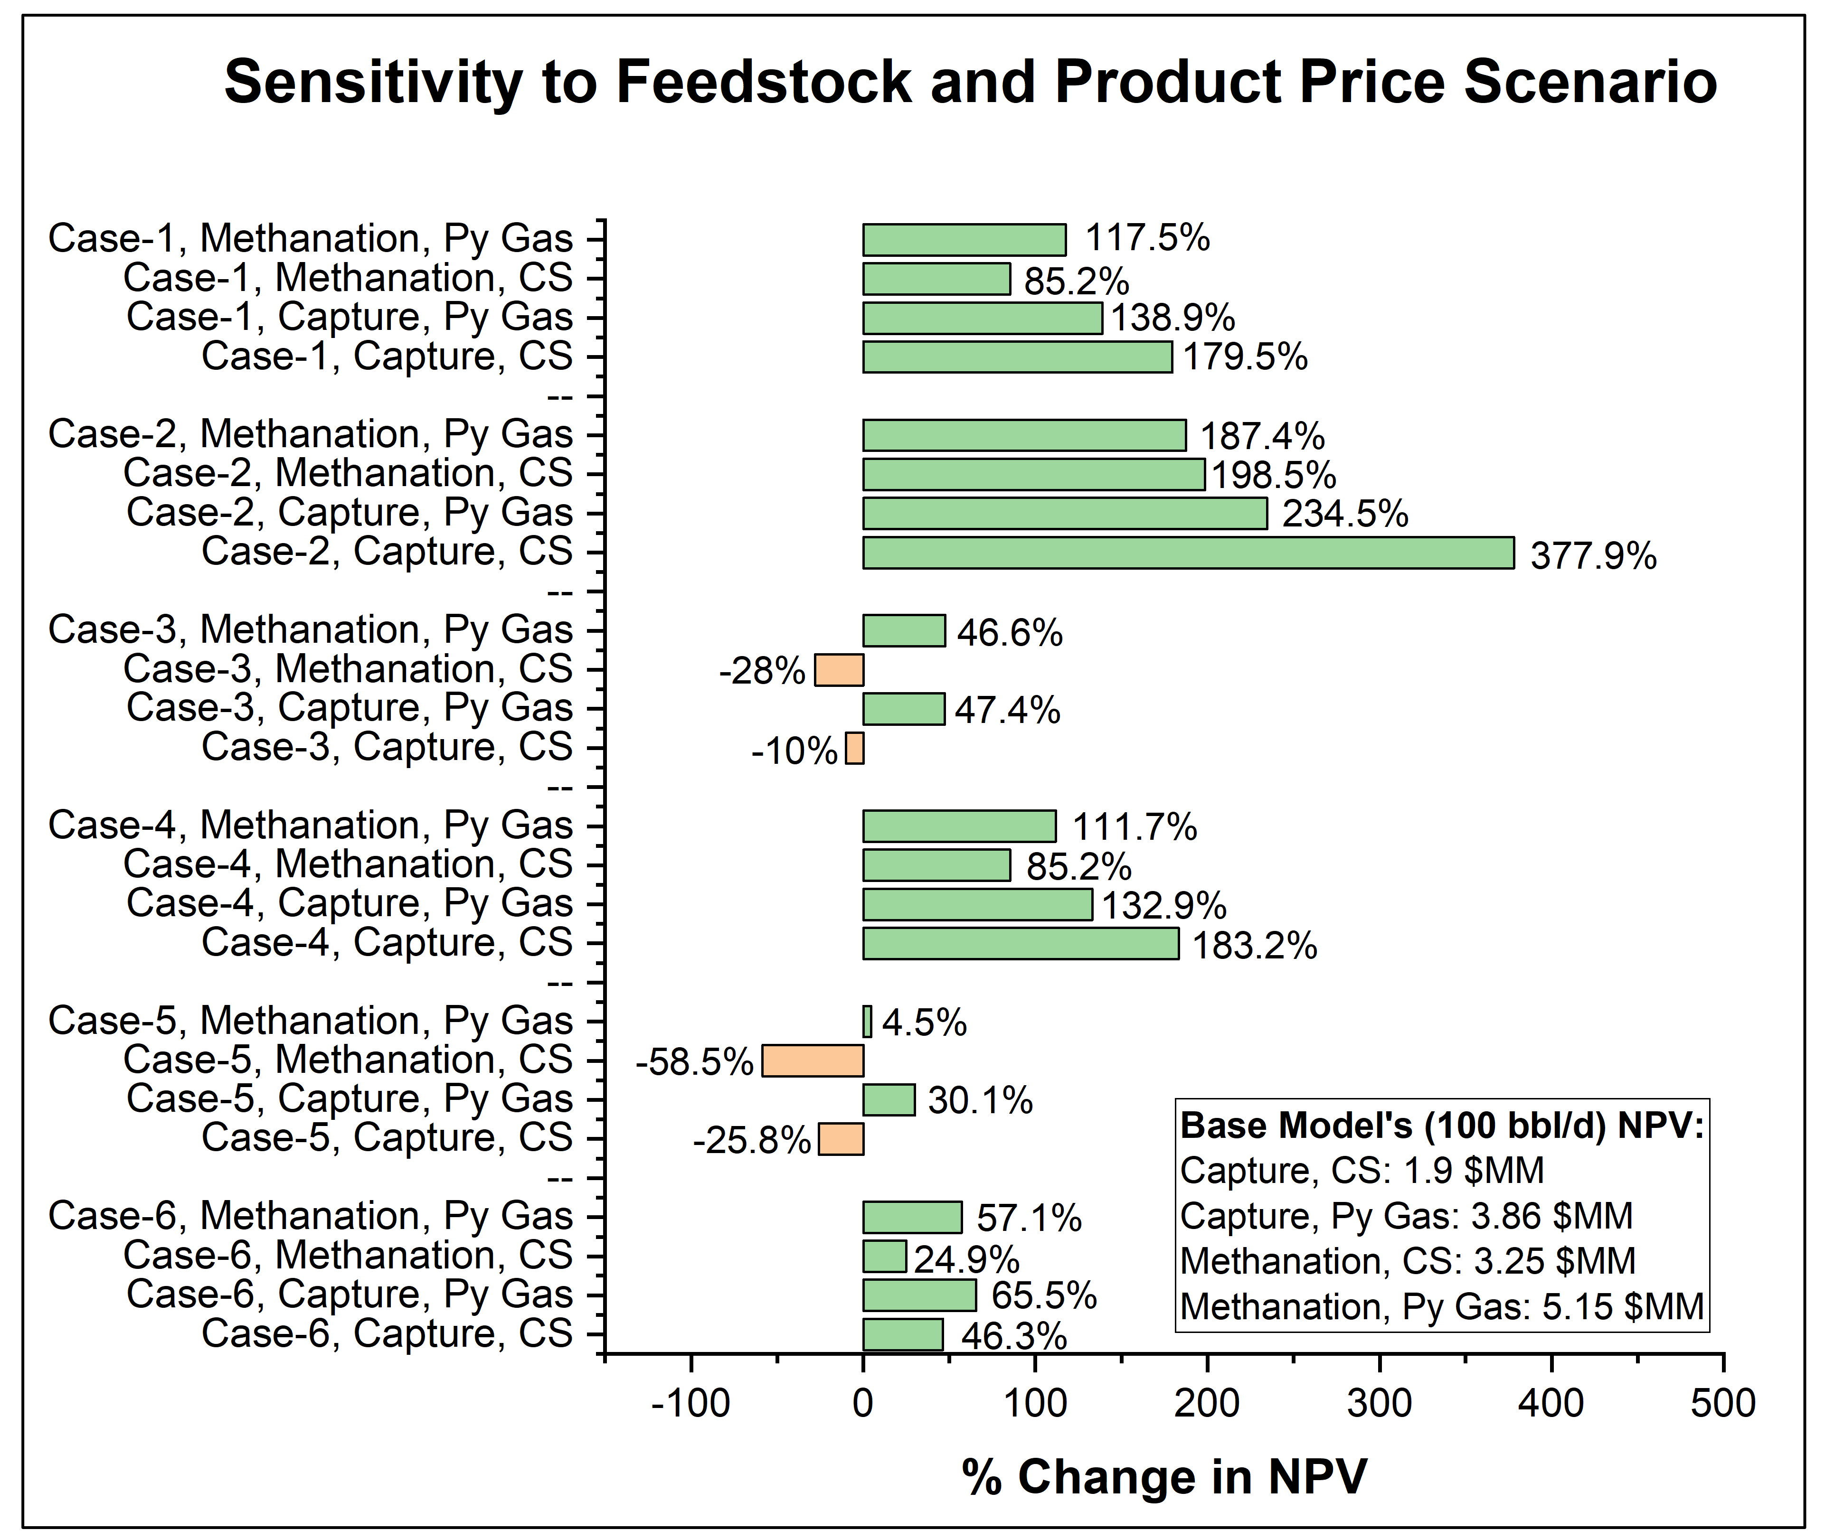
Figure S17. Sensitivity analysis results for different price scenarios.
Table S18. Price Case-1 Results for Price Sensitivity
Description | Capture, Complete Separation | Capture, Py Gas | Methanation,  Complete Separation | Methanation,  Py Gas
Total project Capital Cost ($MM) | 18.48 | 13.93 | 17.25 | 11.82
Total Operating Cost ($MM/yr) | 1.42 | 1.38 | 1.46 | 1.31
Total Revenue ($MM/yr) | 4.75 | 4.64 | 4.75 | 4.64
NPV ($MM) | +5.31 | +9.22 | +6.02 | +11.20

Table S19. Price Case-2 Results for Price Sensitivity
Description | Capture, Complete Separation | Capture, Py Gas | Methanation,  Complete Separation | Methanation,  Py Gas
Total project Capital Cost ($MM) | 18.48 | 13.93 | 17.25 | 11.82
Total Operating Cost ($MM/yr) | 1.76 | 1.73 | 1.81 | 1.68
Total Revenue ($MM/yr) | 5.70 | 5.58 | 5.70 | 5.58
NPV ($MM) | +9.08 | +12.91 | +9.70 | +14.80

Table S20. Price Case-3 Results for Price Sensitivity
Description | Capture, Complete Separation | Capture, Py Gas | Methanation,  Complete Separation | Methanation,  Py Gas
Total project Capital Cost ($MM) | 18.48 | 13.93 | 17.25 | 11.82
Total Operating Cost ($MM/yr) | 1.05 | 1.0 | 1.10 | 0.94
Total Revenue ($MM/yr) | 3.80 | 3.69 | 3.80 | 3.69
NPV ($MM) | +1.71 | +5.69 | +2.34 | +7.60

Table S21. Price Case-4 Results for Price Sensitivity
Description | Capture, Complete Separation | Capture, Py Gas | Methanation,  Complete Separation | Methanation,  Py Gas
Total project Capital Cost ($MM) | 18.48 | 13.93 | 17.25 | 11.82
Total Operating Cost ($MM/yr) | 2.50 | 2.42 | 2.49 | 2.39
Total Revenue ($MM/yr) | 5.83 | 5.72 | 5.83 | 5.72
NPV ($MM) | +5.38 | +8.99 | +6.02 | +10.90

Table S22. Price Case-5 Results for Price Sensitivity
Description | Capture, Complete Separation | Capture, Py Gas | Methanation,  Complete Separation | Methanation,  Py Gas
Total project Capital Cost ($MM) | 18.48 | 13.93 | 17.25 | 11.82
Total Operating Cost ($MM/yr) | 2.20 | 2.12 | 2.19 | 2.09
Total Revenue ($MM/yr) | 4.78 | 4.68 | 4.78 | 4.68
NPV ($MM) | +1.41 | +5.02 | +1.35 | +5.38

Table S23. Price Case-6 Results for Price Sensitivity
Description | Capture, Complete Separation | Capture, Py Gas | Methanation  Complete Separation | Methanation, Py Gas
Total project Capital Cost ($MM) | 18.48 | 13.93 | 17.25 | 11.82
Total Operating Cost ($MM/yr) | 1.82 | 1.74 | 1.80 | 1.70
Total Revenue ($MM/yr) | 4.78 | 4.68 | 4.78 | 4.68
NPV ($MM) | +2.78 | 6.39 | +4.06 | +8.09

Sensitivity 4: Economic Parameters Variation
A fourth sensitivity analysis was performed for the Methanation-Py Gas scenario at a capacity of 100 bbl/d. In this analysis, CAPEX, O&M cost, electricity cost, IRR, and NG cost were varied by ±25% and compared with the base model values summarized in Table S24. The first row of the table shows the "Base Model Value," which uses the product cost data from Table S11 (also referenced in Table S17) and serves as the baseline for all comparisons. The electricity price for this study was set at 0.0724 $/kWh. The base model assumes an IRR of 10%, which was varied between 7.5% and 12.5%. Results indicate that IRR has a strong influence on NPV, increasing it by approximately 72% to 8.87 $MM for 25% reduction of IRR. CAPEX also significantly impacts NPV, showing a ~55% increase in NPV when CAPEX is reduced by 25%. In comparison, electricity cost, O&M cost, and NG cost have a smaller impact on NPV than CAPEX and IRR. A direct side-by-side comparison of the key technical and economic performance indicators between the baseline case and the OCM-DHA process is compiled in Table S25 (with the overall TEA summary parameters detailed in Table S26)

Table S24. Sensitivity Results for Economic Parameters Variation
Description | TPCC ($MM) | TOC ($MM/yr) | TR ($MM/yr) | NPV ($MM)
Base Model Value | 11.82 | 1.33 | 3.73 | +5.15
+25% CAPEX | 14.70 | 1.31 | 3.73 | +2.96
-25% CAPEX | 8.89 | 1.20 | 3.73 | +7.97
+25% O&M Cost | 11.82 | 1.43 | 3.73 | +4.31
-25% O&M Cost | 11.82 | 1.20 | 3.73 | +5.93
+25% Electricity Cost | 11.82 | 1.33 | 3.73 | +5.03
-25% Electricity Cost | 11.82 | 1.31 | 3.73 | +5.27
+25% IRR | 11.82 | 1.33 | 3.73 | +1.69
-25% IRR | 11.82 | 1.33 | 3.73 | +8.87
+25% NG Cost | 11.82 | 1.50 | 3.73 | +3.91
-25% NG Cost | 11.82 | 1.13 | 3.73 | +6.43
TPCC: Total Project Capital Cost, TOC: Total Operating Cost, TR: Total Revenue

Table S25. Comparison of Key Performance Measures between the Base Case and OC-DHA Process
Values in MW (unless otherwise noted) | Reference Direct MDA Case | OCM-DHA
Inlet Flows
Natural Gas (Feed Stream) | 7.2 | 5.84
Outlet Flows
Benzene | 1.93 | 1.85
Toluene | 0.09 | 0.43
Naphthalene | 2.63 | 2.64
Hydrogen | 3.93 | 0.0
Xylene |  | 0.49
Heating Duty | 3.93 | 0
Cooling Duty | 1.62 | 0.73 (Capture)  0.72 (Methanation)
Electricity
Compression | 0.97 | 0.09 (Capture and Methanation)
Refrigeration | 1.65 | 0.04 (Capture and Methanation)
Generation (HRSG, Regen, etc.) | -1.11 | 0
Net Work Required | 1.51 | 0.13 (Capture and Methanation)
Fuel Credits
Hydrogen | 3.94 | 0.0
Fuel Gas | 0.15 | 0.0
Excess Heat (i.e., Exotherms) | 0.0 | 0.04
Capital Cost ($/bbl of aromatics/day) | 733,000 | 308,000 (Capture)  287,400 (Methanation
Cost for CO₂ capture ($/tonne) | 59.9 | 44.3 (Capture)  N/A (Methanation)
Breakeven Price for Benzene ($/kg) 95% CO₂ abated | 3.95 | 0.977 (Capture)  0.921 (Methanation)
Reduction in Cost of Benzene with Respect to Base Case | - | 75.3% (Capture)  76.7% (Methanation)

Table S26. Overall Summary for the TEA and Related Parameters for Capture and Methanation Cases
Parameter | Units | Value
Design Basis and Performance
CO₂ Source Conditions | °C
CO₂ Source Conditions | bar
CO₂ Source Conditions | ppmv CO₂
CO₂ Source Conditions | mol% H₂O
CO₂ Source Conditions | mol% N₂
CO₂ Source Conditions | mol% O₂
CO₂ Source Conditions | Other notable constituents/ pollutants
Auxiliary Load of Reactive Capture System | MWe | 0.04
Auxiliary Load of Balance of Plant Equipment | MW | 0.09
Electrical Auxiliary Boiler Load (if applicable) | MW | N/A
Heat Requirement (if applicable) | MWe | 0.07
Heat Source | -- | Electrical, Process Fluid
Capacity Factor (CF) of Energy Source | % | 100
Utilization Factor (UF) of System | % | 99
Air Inlet to Process | kg/h | N/A
CO₂ Capture Efficiency | % | 90
Gross CO₂ Capture Capacity  (CF & UF = 100%) | tonnes/yr | 245
Net CO₂ Capture Capacity  (CF & UF = 100%) | tonnes/yr | 220
Product Stream (Benzene, Naphthalene, Toluene, Xylene) | kg/h | 79.67 (Benzene), 139.7 (Naphthalene), 37.78 (Toluene), 41.41 (Xylene)
Product Stream (Benzene, Naphthalene, Toluene, Xylene) | % product | 99.5 wt% (98.5 wt% for Benzene only)
Product Stream (Benzene, Naphthalene, Toluene, Xylene) | Impurities | Water for Benzene,  Toluene for Naphthalene and Xylene,  Benzene for Toluene
Product Stream (Benzene, Naphthalene, Toluene, Xylene) | °C | 35
Product Stream (Benzene, Naphthalene, Toluene, Xylene) | bar | 2
Pressure Drop of CO₂ Source Across the Reactive Capture Unit | bar | 1
Water Consumption | kg/h | 213.6 (all other water is recirculated)
Initial Reactant/Sorbent/Catalyst Fill | tonne | 1.0 tonne HGaAlMFI Catalyst, 24.0 tonne MnLi_{a}Mg_{b}B_{c}O_{x} Catalyst
Make-up Rate | tonne/y | - tonne HGaAlMFI/yr,  8.0 tonne MnLi_{a}Mg_{b}B_{c}O_{x}/yr
Cycle Description and Time (if any) |  | N/A
Costs
Dollar Basis | Year | 2023
Capital Cost Accuracy | +/– % | +30/-20
Process and Project Contingencies | % | Process contingency 5-40%, project contingency 15%
Reactive Capture System Total Plant Cost | $ | 1.34 $MM
BOP Total Plant Cost | $ | 15.40 $MM (Cansolve) 14.37 $MM ( Methanation)
Initial Reactant/Sorbent/Catalyst Fill
Initial Cost | $ | 40,000 for HGaAlMFI, 240,000 for MnLiMgBO
Replacement Cost | $/yr | 120,000 (Average cost of replacement)
Unit Cost | $/tonne | 40,000 $/tonne HGaAlMFI, 10,000 $/tonne MnLi_{a}Mg_{b}B_{c}O_{x}
Reactant/Sorbent/Catalyst Waste Disposal | $/tonne | N/A
Reactant/Sorbent/Catalyst Waste Disposal | $/yr | N/A
Natural Gas (if applicable) | $/MMBtu | 0.83
Natural Gas (if applicable) | $/yr | 144,867.0
Electricity | $/MWh | 72.4
Electricity | $/yr | 85,316 (Capture)  71,878 (Methanation)
Other Consumables/Waste Disposal | $/yr | N/A
Fixed O&M | $/yr | 300,000 (Methanation and Capture)
Product cost | $/kg | 0.86 for Benzene, 0.64 for Naphthalene, 1.03 for Toluene, 0.83 for Xylene
Cost of net CO₂ Captured | $/tonne | 44.3 (Capture)

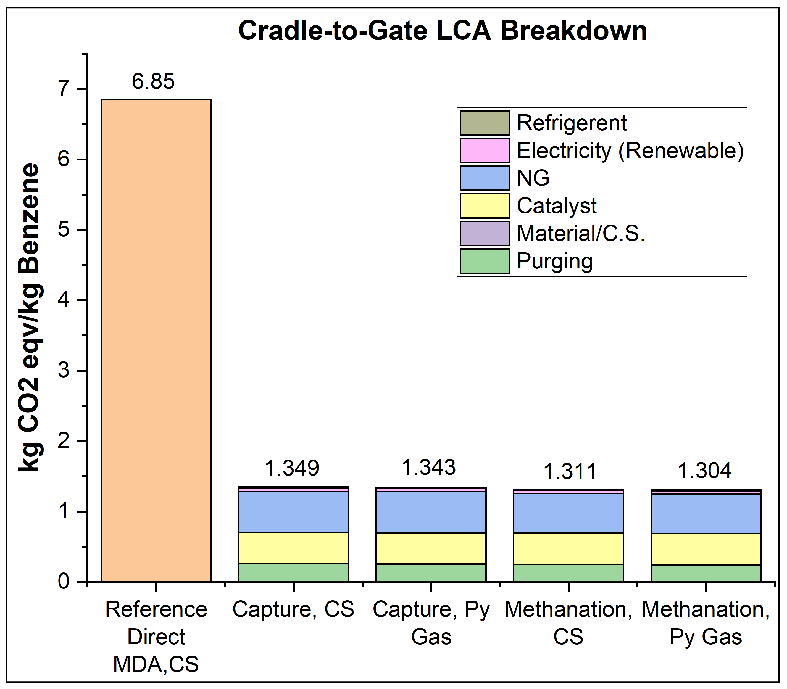
Figure S18. Impacts of OCM-DHA process for different configurations with breakdown.³⁹
S3 Life Cycle Analysis
A life cycle assessment (LCA) was conducted to evaluate the greenhouse gas (GHG) emissions associated with the OCM-DHA process, with the objective of assessing its environmental impact to inform future investment decisions and technology adoption strategies (Fig S18). A GHG-focused LCA model was developed for each case and compared against a base case. For this study, electricity is used for cooling duties in air coolers and water coolers. Electric heaters are utilized for heating duties. Vapor compression cycle is used for obtaining the refrigeration duty. Depending on the source of electricity,³⁹ the GHG emissions due to electricity consumption vary (Figure 6e). The cradle-to-gate and gate-to-gate LCA model was developed, and it excludes waste disposal, infrastructure development, and decommissioning. The cradle-to-gate assessment encompasses all unit operations from raw material extraction through the production and separation of organic liquid products, while the gate-to-gate assessment focuses solely on process plant operations. The process model encompasses the reactor section, compression train, separation train, and the respective CO₂ capture or conversion system. As shown in Figure S19, the system boundaries were clearly defined to ensure consistency across configurations. Key components in the LCA inventory listed in Table S27 include feedstock, catalysts, materials of construction (MOC), electricity consumption, utilities and direct purging from the process. Here, cooling duty is only considered as heating duty is balanced by heat integration of the process and same energy penalty was applied for Py Gas cases. The LCA was conducted based on a functional unit of 1 kg of benzene-equivalent product for a consistent basis to compare environmental impact categories. The analysis is restricted to greenhouse gas emissions and adheres to the standards outlined in ISO 14040. It was implemented using SimaPro v9.6.01, incorporating data from multiple databases including Ecoinvent 3, the NETL CO₂ Utilization (CO₂U) OpenLCA LCI database, and the TRACI 2.1 methodology developed by the U.S. Environmental Protection Agency (EPA) for impact assessment.
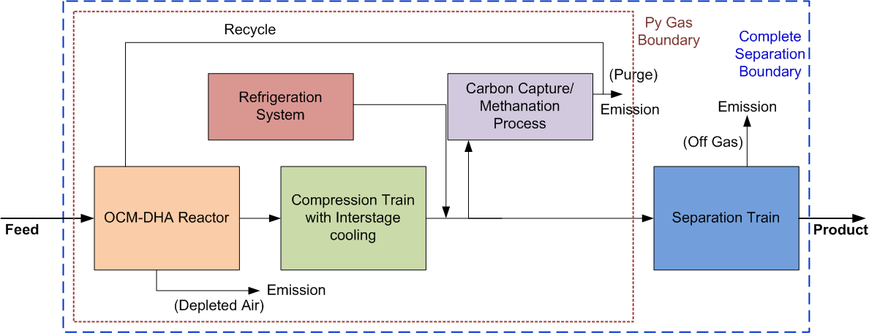
Figure S19. System boundaries for LCA model.

Figure S20 illustrates the GHG emissions for the OCM-DHA process for the Py Gas cases under the gate-to-gate system boundary. The cradle-to-gate and gate-to-gate LCA results for all process configurations are listed in Table S28. It should be noted that the cradle-to-gate GHG emissions for the Py Gas cases, along with comparison with the reference case⁴⁸, are presented in Figure 6 of the main manuscript. The discussion in this section focuses on gate-to-gate assessment results. In this analysis, it is assumed that the electricity is available from a solar based renewable-power generation facility. The reference case exhibits GHG emissions of 5.94 kg CO₂ eq/kg benzene, indicating a relatively high carbon intensity. In contrast, all cases of the OCM-DHA process demonstrate substantial reductions in emissions. The Cansolv-based CO₂ “Capture” case with complete separation gives 0.301 kg CO₂ eq/kg benzene (see Table S28). The methanation case that converts the CO₂ byproduct into methane achieves the lowest emissions with 0.283 kg CO₂ eq/kg benzene, a 95% reduction compared to the base case. In addition, Py Gas cases (Figure S20) for each configuration show improved performance. These findings underscore the significant potential of integrating CO₂ capture or conversion technologies in the OCM-DHA process to considerably reduce its carbon footprint, with the methanation case offering the most favorable environmental performance among the evaluated configurations.
Table S27. Key Parameters of the Process Model Used for LCA
Parameter | Complete Separation | Py Gas
Plant Capacity (bbl/d) | 50 | 50
NG Feed Flow (kg/h) | 420.32 (Capture)  404.28 (Methanation) | 420.32 (Capture)  404.28 (Methanation)
CO₂ equivalent emission (kg CO₂/kg Benzene) | 0.254 (Capture)  0.242 (Methanation) | 0.246 (Capture)  0.234 (Methanation)
Electricity (kWh/kg Benzene) | 0.442 (Capture)  0.414 (Methanation) | 0.361 (Capture)  0.344 (Methanation)
Material (kg metal/ kg Benzene) | 6.81×10⁻⁴ (Capture)  6.75×10⁻⁴ (Methanation) | 6.28×10⁻⁴ (Capture)  6.21×10⁻⁴ (Methanation)
OCM-DHA Catalyst (kg cat/kg Benzene) | 2.64×10⁻³ (Capture & Methanation) | 2.64×10⁻³ (Capture & Methanation)
Methanation Catalyst (Ni/Al₂O₃) (kg cat/kg Benzene) | 1.25×10⁻⁵ (Methanation) | 1.25×10⁻⁵ (Methanation)
Cansolv Solvent (kg/kg Benzene) | 1.89×10⁻⁵ (Capture) | 1.89×10⁻⁵ (Capture)
Refrigerant (kg/ kg Benzene) | Capture:  4.25×10⁻³ (kg C₃H₈/kg Benzene)  1.09×10⁻²(kg C₂H₄/kg Benzene)  Methanation:  4.25×10⁻³ (kg C₃H₈/kg Benzene)  1.09×10⁻²(kg C₂H₄/kg Benzene) | Capture:  4.25×10⁻³ (kg C₃H₈/kg Benzene)  1.09×10⁻²(kg C₂H₄/kg Benzene)  Methanation:  4.25×10⁻³ (kg C₃H₈/kg Benzene)  1.09×10⁻²(kg C₂H₄/kg Benzene)

Table S28. Impacts of OCM-DHA process for cradle-to-gate and gate-to-gate LCA
Case Description | Cradle-to-Gate  (kg CO₂ eq/kg benzene) | Gate-to-Gate  (kg CO₂ eq/kg benzene)
Capture, Complete Separation | 1.349 | 0.301
Capture, Py Gas | 1.343 | 0.295
Methanation, Complete Separation | 1.311 | 0.283
Methanation, Py Gas | 1.304 | 0.277
Sensitivity on Electricity Sources: Methanation, Py Gas
100% Renewable | 1.304 | 0.277
US grid (current) | 3.095 | 2.068
US grid (2050) | 2.995 | 1.968
Natural Gas CCS | 2.775 | 1.748

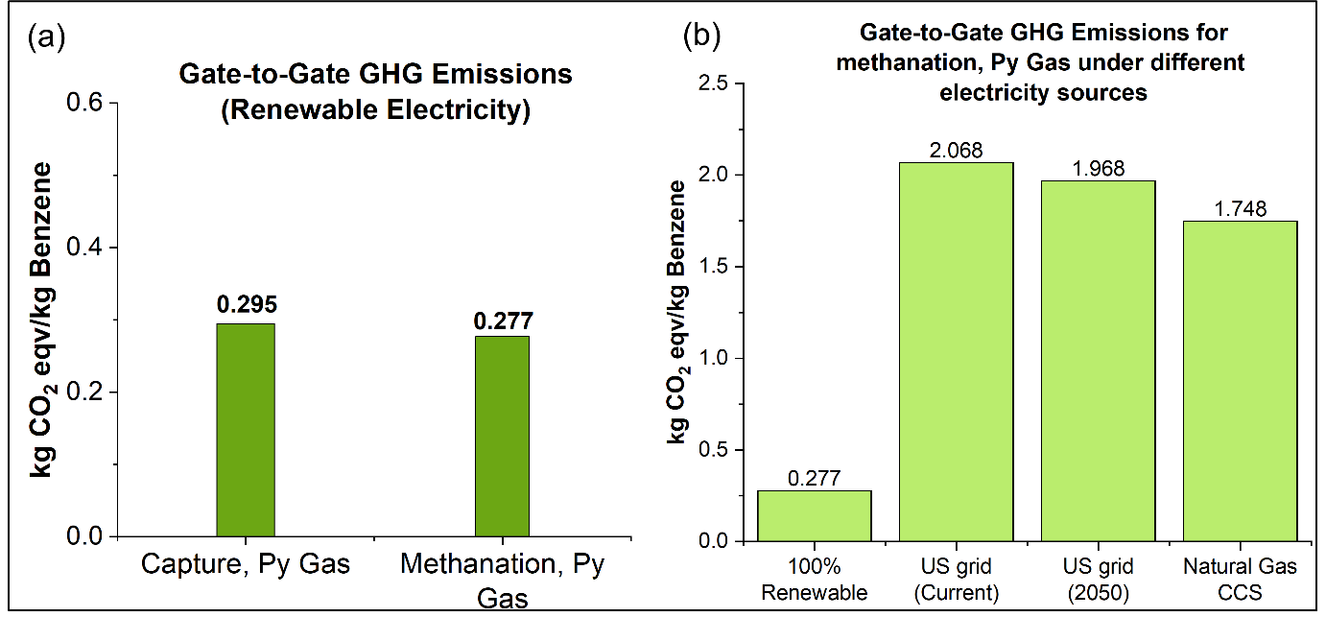
Figure S20. Gate-to-gate LCA: (a) Impacts of OCM-DHA process for different configurations, (b) sensitivity results to different electricity sources.
A sensitivity study was carried out for the Methanation–Py Gas case with four electricity sources: 100% renewables, the current US grid mix, the 2050 US grid mix, and 100% NG with CCS (Figure S20b). The highest emissions are associated with current U.S. grid mix electricity source, resulting in 2.068 kg CO₂ eq/kg benzene, followed closely by the 2050 U.S. grid mix at 1.968 kg CO₂ eq/kg benzene, and NG with CCS at 1.748 kg CO₂ eq/kg benzene. The lowest GHG emissions are observed with 100% renewable electricity, yielding only 0.277 kg CO₂ eq/kg benzene, highlighting the significant environmental benefits of using clean energy sources for electricity production. These results emphasize that the carbon intensity of the source for electricity supply has a strong impact on the overall GHG footprint of the OCM-DHA process, with renewable energy offering the most favorable outcome.
Figure S21 illustrates the contribution of key life cycle inventory (LCI) items to the total GHG emissions associated with the production of 1 kg of benzene in the OCM-DHA process. The largest contributor across all process cases is the purge of recycle gas, with emissions ranging from 0.240 to 0.254 kg CO₂-eq/kg benzene produced. In contrast, the impact from the use of renewable electricity is significantly lower, contributing between 0.041 and 0.047 kg CO₂-eq/kg benzene.
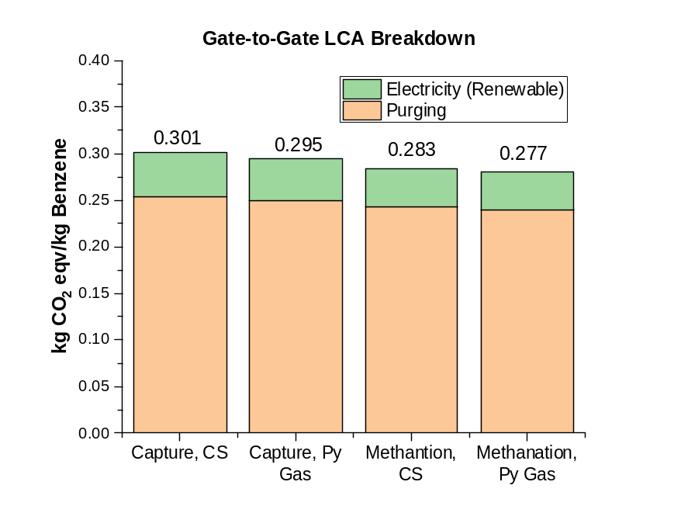
Figure S21. Gate-to-gate LCA breakdown results for OCM-DHA process.

Table S29. ICP-OES elemental analysis of the microwave-synthesized HGaAlMFI catalyst.
Ga (wt.%) | Si (wt.%) | Al (wt.%) | Si/Al (at.) | Si/Ga (at.) | Si/(Al+Ga) (at.)
2.4 | 34.1 | 1.9 | 17.2 | 35.3 | 11.6

References
39. Timothy J. Skone et al. Carbon Dioxide Utilization Life Cycle Analysis Guidance for the U.S. DOE Office of Fossil Energy. (2019).
47. Currie, R., Mottaghi-Tabar, S., Zhuang, Y. & Simakov, D. S. A. Design of an Air-Cooled Sabatier Reactor for Thermocatalytic Hydrogenation of CO2: Experimental Proof-of-Concept and Model-Based Feasibility Analysis. Ind. Eng. Chem. Res. 58, 12964–12980 (2019).
48. Huang, K. & Maravelias, C. T. Synthesis and Analysis of Nonoxidative Methane Aromatization Strategies. Energy Technology 8, 1900650 (2020).
49. Theis, J. Quality Guidelines for Energy System Studies: Cost Estimation Methodology for NETL Assessments of Power Plant Performance. https://netl.doe.gov/projects/files/QGESSCostEstMethodforNETLAssessmentsofPowerPlantPerformance_022621.pdf (2021).
50. Mevawala, C., Bai, X., Hu, J. & Bhattacharyya, D. Plant-wide modeling and techno-economic analysis of a direct non-oxidative methane dehydroaromatization process via conventional and microwave-assisted catalysis. Applied Energy 336, 120795 (2023).
51. Richard Turton, Joseph A. Shaeiwitz, Debangsu Bhattacharyya, & Wallace B. Whiting. Analysis, Synthesis, and Design of Chemical Processes. (Pearson, Hoboken, NJ, 2018).

