Supplementary Information.
Table S1. Bacterial strains used in this study.
Strain | Species | Clinical source
LCP | Cutibacterium acnes | Prosthesis
LCPb | Staphylococcus lugdunensis | Prosthesis
AVMS | Cutibacterium acnes | Prosthesis
ISR | Cutibacterium acnes | Prosthesis
LAR | Cutibacterium acnes | Prosthesis
PR | Cutibacterium acnes | Prosthesis
JC | Cutibacterium acnes | Prosthesis
ATCC 11827 | Cutibacterium acnes | Skin
546 | Staphylococcus lugdunensis | Blood
97s | Staphylococcus lugdunensis | Blood
21 | Staphylococcus lugdunensis | Catheter
633 | Staphylococcus lugdunensis | Blood
540 | Staphylococcus lugdunensis | Wound
645 | Staphylococcus lugdunensis | ND
644 | Staphylococcus lugdunensis | Prosthesis secretion
451 | Staphylococcus lugdunensis | Urine
632 | Staphylococcus lugdunensis | Blood
633 | Staphylococcus lugdunensis | Blood
541 | Staphylococcus lugdunensis | Blood
98s | Staphylococcus lugdunensis | Surgical site
468 | Staphylococcus lugdunensis | Blood
ATCC 43809 | Staphylococcus lugdunensis | Axillary lymph node
238 | Staphylococcus hominis | Blood
72 hp | Staphylococcus hominis | Blood
648 | Staphylococcus hominis | Blood
rf15 | Staphylococcus hominis | Blood
678 | Staphylococcus hominis | Blood
681 | Staphylococcus hominis | Blood
226 | Staphylococcus hominis | Blood
60 | Staphylococcus hominis | Blood
671 | Staphylococcus hominis | Blood
1001 | Staphylococcus hominis | Blood
1046 | Staphylococcus haemolyticus | Prosthesis
1047 | Staphylococcus warneri | Prosthesis
MD03 | Staphylococcus saprophyticus | Catheter
112 | Staphylococcus aureus | Catheter
ATCC 35984 | Staphylococcus epidermidis | Catheter
ND – Not determined.

Table S2: Primers used for qRT-PCR.
Primer name | Sequence
icaA Fw | 5’-TGATGACGCACCTTATTTCA-3’
icaA Rev | 5’-CACGTTTAATACTGCCAACC-3’
mgtE Fw | 5’-AAACGGACCGCTTGCTACTG-3’
mgtE Rev | 5’-AAGCGGGGAGTGGCATGTTA-3’
atlL Fw | 5’-ACGGCACTTACATGGGTGTT-3’
atlL Rev | 5’-ATTGTCTTCGCCCACTTCGT-3’
recA Fw | 5’-GCACGACGAACTTCTAAACG-3’
recA Rev | 5’-GGCGTAATGTTTGGTAATCCTG-3’

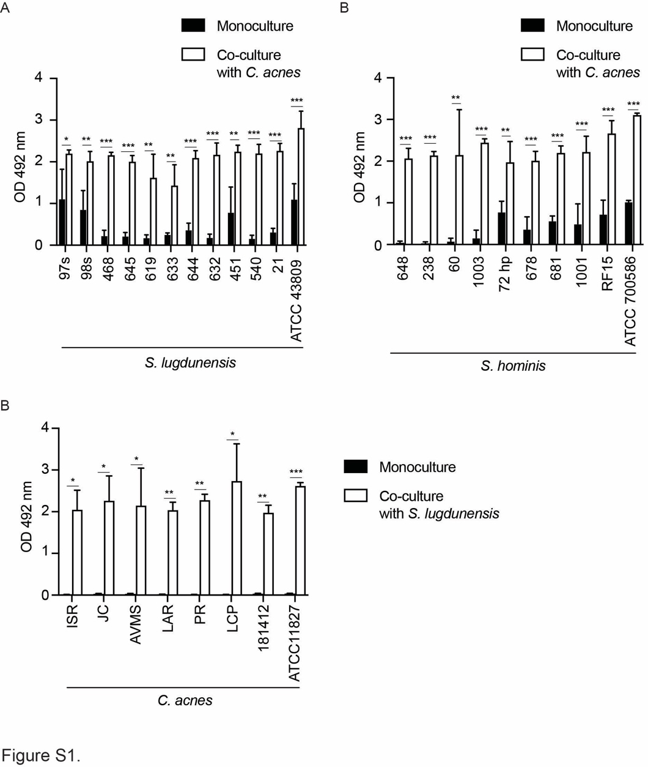
Figure S1. Increased biofilm formation in co-cultures of C. acnes with S. lugdunensis or S. hominis is consistent across different strains of each species. A. Biofilm formation of different strains of S. lugdunensis with and without the presence of C. acnes (LCP) after 72 h of incubation. B. Biofilm formation of different strains of S. hominis with and without the presence of C. acnes (LCP) after 72 h of incubation. C. Biofilm formation of different strains of C. acnes with and without the presence of S. lugdunensis (546) after 72 h of incubation. Mean values of 2 independent experiments are shown, and error bars represent the SD. Statistical analyses were performed with Multiple unpaired t- test (A), the Mann-Whitney test (B and C). ** P<0.01, ***P<0.001.
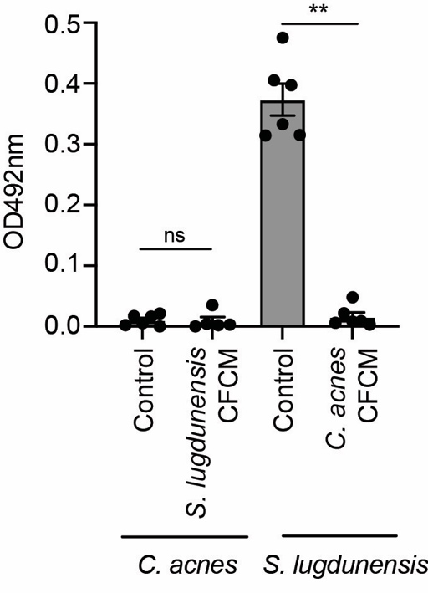
Figure S2. Cell free conditioned media (CFCM) of one of the species does not increase biofilm formation of the other. Biofilm formation of C. acnes and S. lugdunensis with a control CFCM or in the presence of S. lugdunensis (546) CFCM or C. acnes (LCP) CFCM, respectively, after 72 h of incubation. Mean values of 2 independent experiments are shown, and error bars represent the SEM. Statistical analyses were performed with Multiple unpaired t- test (A), the Mann-Whitney test (B and C). ns: not significant; ** P<0.01.

