SUPPLEMENTARY MATERIALS
SM1. Focus group semi-structured interview guide
Opening: Welcome and Explanation of the Meeting
Welcome and Explanation of the Meeting: "Good morning/afternoon! It is a pleasure to have you here. We know your schedules are hectic, so thank you very much for dedicating this time.
We would like to start by acknowledging and deeply valuing the experience and essential work each of you performs in the complex care of trans children and adolescents. The knowledge gained through your daily clinical practice is invaluable.
Today, the idea is precisely to exchange views on this expertise: the day-to-day reality of providing care, the clinical challenges that stand out most, and your thoughts on current care guidelines. Your contribution is fundamental to improving our research and future interventions."
Explanation of Group Dynamics: "Here, your knowledge is our primary guide. There are no right or wrong answers; we want to capture your real-world experience—what works, what doesn't, and what we need to know to create better interventions. Please feel free to speak openly."
Icebreaker Activity: Each professional should state:
- Their name.
- Their specialty (what they do).
- How long they have been working with (or dedicating themselves to) this population.
Family and Social Environment
Opening question: "In your practice, what role do the family and the environment play in the health and development of trans children and adolescents? How do you observe this dynamic in your day-to-day work?"
Probes (if necessary):
- Do you notice a significant difference between families that are supportive and those that struggle more?
- What are the major sources of stress or conflict within the family environment that you frequently hear about?
- Does having contact with other trans people (adults or youth) seem to make a difference in their well-being?
Body, Mental Health, and Development
Opening question: "What do you see as the main challenges for trans children and adolescents regarding their bodies, mental health, and development during this stage of life?"
Probes (if necessary):
- What are the major concerns they raise regarding their bodies (dysphoria, body image, puberty)?
- Which body-image-related risk behaviors (attempts to alter their appearance) do you need to be particularly alert to?
- Do you notice that body image issues increase the risk of eating disorders and/or mental health problems in this group?
- In your view, what signs of healthy development should we encourage in this population?
School
Opening question: Let’s talk a bit now about the schools attended by the children and adolescents you work with. What are your impressions of them? And what do the young people tell you?
Probes (if necessary):
- Is it a welcoming environment or a source of stress?
- What are the most common complaints?
Gender-Affirming Therapies and Policy
Opening question: "In managing care, what are the biggest challenges when guiding children, adolescents, and their families through the stages of puberty blocking, hormone therapy, and surgery?"
Probes (if necessary):
- Do you notice significant prejudice or difficulties regarding access to other health services (outside this outpatient clinic)?
- What expectations do young people form regarding puberty blockers or hormone therapy? Are these expectations realistic, or do they need to be managed?
- What clinical aspects and risks (physical, emotional) do you need to monitor closely at all times?
Opening question: "What were your thoughts and feelings when the new CFM resolution was released?"
Probes (if necessary):
- How do you view the justifications given for this decision?
- What do you think motivated this resolution?
- How was it received by the children and adolescents you work with? And by their families?
- Did you observe any changes in patient or family behavior following the resolution?
- Did this guideline expose any shortcomings or training needs within our care network?

SM2. COREQ Checklist
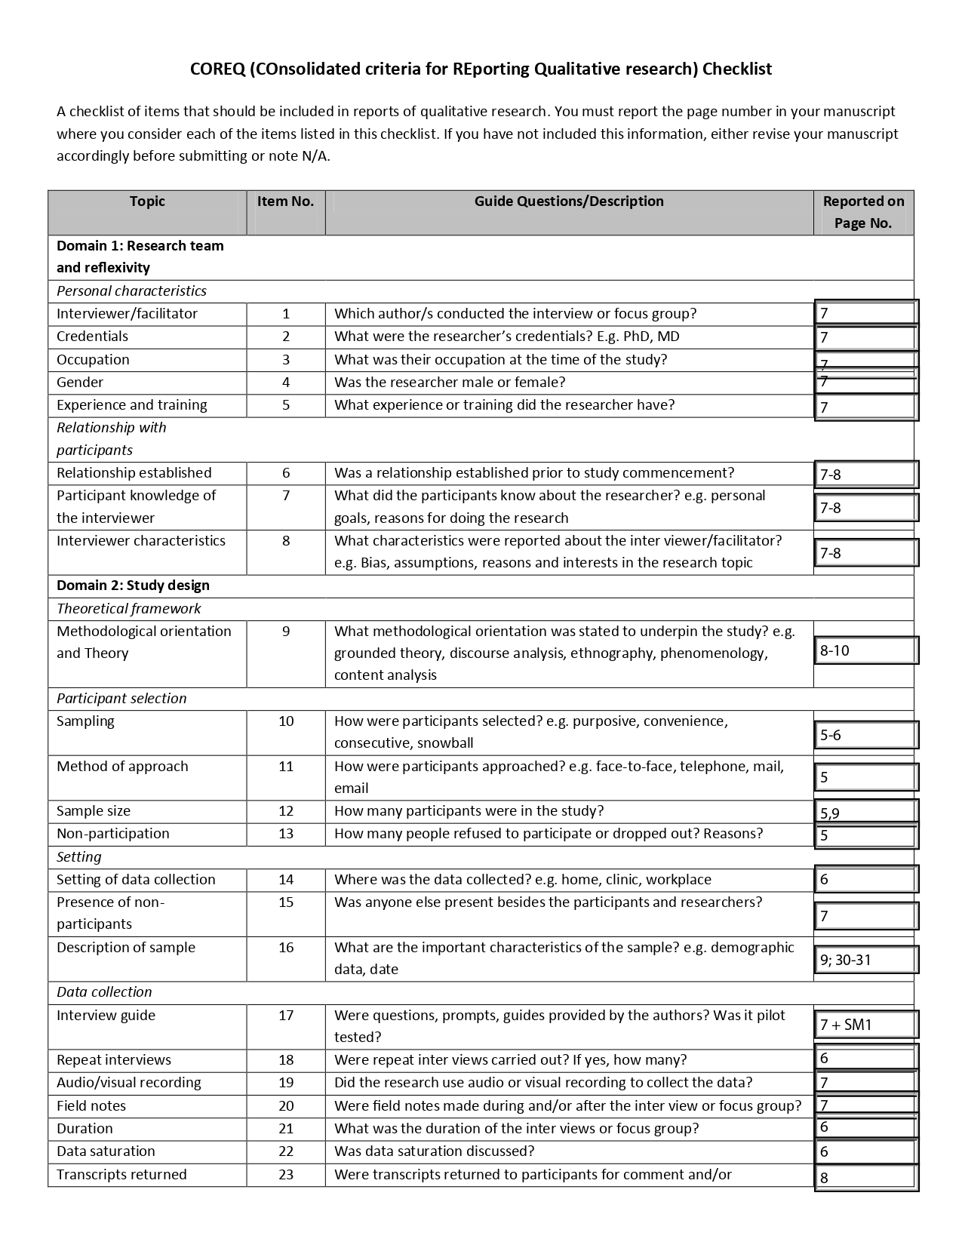
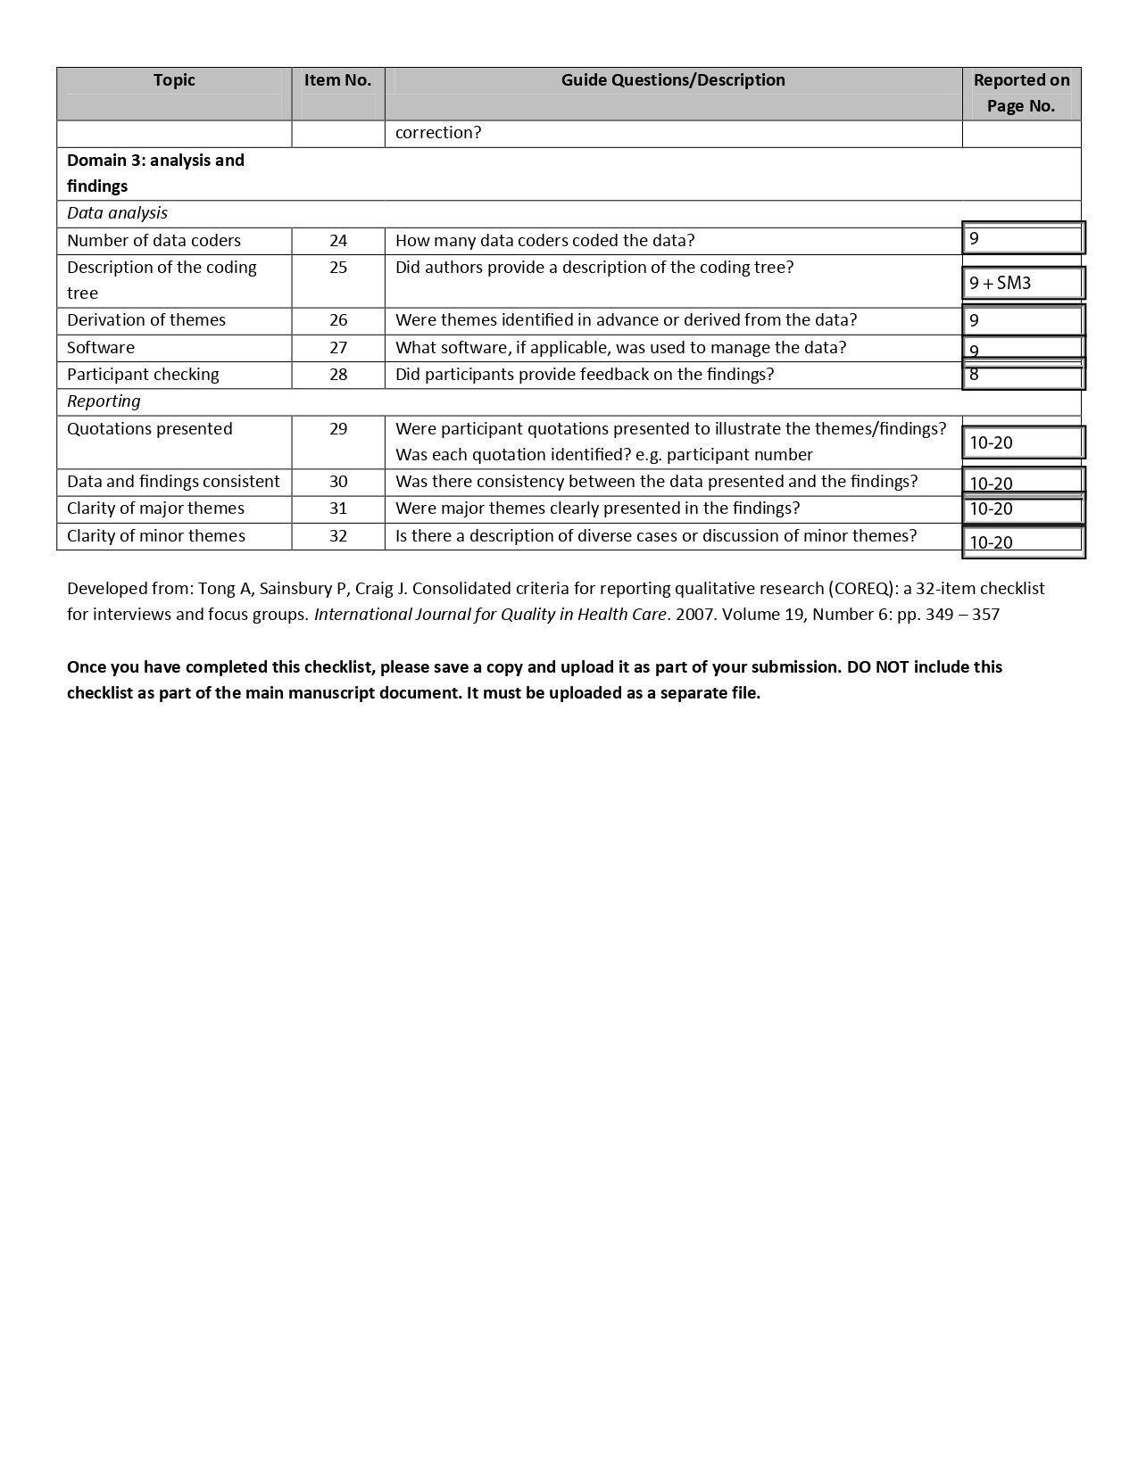
SM3. Codebook
Theme | Subtheme | Short name | Short description | Detailed description | Inclusion criteria | Exclusion criteria | Typical example | Atypical example | Close but no
Healthcare Professionals' Responses to the New Resolution | Professionals' opinions | Opinions | What professionals think about Brazil’s Federal Council of Medicine resolution (2.427/2025) restrictions on gender-affirming care. | The central focus of this theme is the professionals’ opinions about the new resolution. We aim to understand what they think about the imposed restrictions, the justifications used, the medical community, the actions/movements resulting from the resolution, and its consequences for transgender people lives. | Includes statements in which professionals express opposing, neutral, or favorable opinions regarding the restrictions imposed by the new resolution, particularly concerning puberty blockers, hormone therapy, and gender-affirming surgeries. It also includes opinions related to the justifications for the resolution, the medical community, and the personal, collective, and legal actions/movements arising from the resolution and its consequences for those they care for and other trans people. | It does not include professionals' opinions related to other subjects as well as their feelings and behaviors related to the imposed restrictions. | “[…] it’s a step backward; it’s moralistic […] it isn’t based on real science.” (P3, 62 years, cisgender woman) | “I understand, on one hand, the issue regarding the change in the law […] the thinking behind it being that an adolescent might not yet be sure of what they want. And there’s also the fact that hormone therapy can lead to other health issues […] In my view […] I don’t think that would be the case here.” (P14, 36 years, cisgender woman)
Healthcare Professionals' Responses to the New Resolution | Professionals' feelings | Feelings | How professionals feel about Brazil’s Federal Council of Medicine resolution (2.427/2025) restrictions on gender-affirming care. | The central focus of this theme is how professionals feel about the new resolution. The goal is to understand their emotional responses to the imposed restrictions, the justifications used, the medical community, the actions/movements resulting from the resolution, and its consequences for the lives of those they care for and other trans people. | Includes statements in which profesisonals describe positive, neutral, or negative feelings, sensations, or emotions related to the restrictions imposed by the new resolution, particularly concerning puberty blockers, hormone therapy, and gender-affirming surgeries. Also includes their emotional responses to the justifications used, the medical community, actions/movements, and the consequences of the resolution for the lives of those they care for and other trans people. | It does not include professionals feelings related to other subjects as well as their opinions and behaviors related to the imposed restrictions. | "I really think we share all these feelings, all this indignation […] bearing the anxiety and anguish here […]."(P6, 37 years, cisgender man) | "Up until the first legal results, I was very hopeless […] but after this fifth case […] there is hope here at AMTIGOS…” (P9, 64 years, cisgender man)
Healthcare Professionals' Responses to the New Resolution | Professionals' actions and positioning | Actions and positioning | What professionals are doing about Brazil’s Federal Council of Medicine resolution (2.427/2025) restrictions on gender-affirming care. | This theme focuses on what professionals are doing in response to the new resolution. The aim is to understand the actions and behaviors they have taken to confront or cope with the imposed restrictions, the justifications used, the medical community, the resulting actions/movements, and the consequences of the resolution for the lives of those they care for and other trans people. | Includes statements in which professionals describe their actions and behaviors, whether positive, neutral, or negative, in relation to the restrictions imposed by the new resolution—particularly regarding puberty blockers, hormone therapy, and gender-affirming surgeries—as well as actions related to the medical community, and personal, collective, and legal responses to the resolution and its consequences for the lives of those they care for and other trans people. | It does not include professionals actions and behaviors related to other subjects as well as their opinions and feelings related to the imposed restrictions. | “We have been preparing adolescents and children to learn how to talk to their families, grandparents, godmothers, neighbors, pastors, and the church […] So, I think that is the direction our work has taken.” (P1, 57 years, cisgender woman) | “If there isn’t a responsible family member, or if the family—the couple—doesn’t seek understanding, we won’t provide follow-up.” (P9, 64 years, cisgender man) | “So, what did the CFM do? […] Now they’re moving to control children and adolescents […] it’s a hunger for control.” (P1, 57 years, cisgender woman)
Healthcare Professionals' Responses to the New Resolution | Professionals' perceptions on its impact on clinical practice | Impact on clinical practice | What professionals perceived that change or think will change on clinical practice with Brazil’s Federal Council of Medicine resolution (2.427/2025) restrictions on gender-affirming care. | The essence of this theme is to capture what professionals think might or will happen as a result of the new resolution imposing restrictions on gender-affirming therapies on clinical practice. The aim is to understand the projections they make regarding clinical practice, health, quality of life, and social (and political) integration in a scenario where the resolution is enforced. | Includes statements in which professionals describe how they believe the restrictions imposed by the resolution will affect the lives of those they care for (physical and mental health, social interactions), the lives of other trans people, and the professionals involved in trans care, as well as society in general. | It does not include professionals perspectives related to other subjects or current emotions or actions already taken. | “So, essentially, families get frustrated—not to mention the children—and they’re left wondering: ‘What do I do now to hold things together for another two years?’ […] The only thing I can do is focus on something else while the resolution stalls, because the families I work with don’t have the financial means to fund a lawsuit.” (P7, 53 years, cisgender woman) | "I’m basically out of work. And I feel that, just with the patients we already have, I know how much good I can do for the patients who are there…” (P8, 34 years, cisgender woman) | “We’ve been encouraging families to file individual lawsuits and […] provide reports and medical evaluations, and appear to give testimony […].” (P9, 64 years, cisgender man)
Professionals' perceptions on clinical care |  | Encounters in healthcare settings | Experiences and practices of professionals in providing care to transgender children and adolescents, as well as ethical conflicts in care and barriers within the system. | This theme captures how professionals describe the care provided, including clinical approaches, decision-making, relationships with patients, their families and school, and perceptions of the quality of care. It also addresses situations where professionals face dilemmas involving age, autonomy, family, risks, and interventions, as well as structural difficulties in accessing and providing care. | Includes statements in which professionals describe care provided, clinical procedures, interaction with patients/families, perception of quality of care, difficult decisions, conflicts between family/school and child/adolescent regarding their care, doubts about interventions, lack of services, and staff preparedness. | It does not include reports of experiences with family, or in school, or public settings. | “We are all the ones providing care. So, care is not restricted to hormone therapy.” (P1, 57 years, cisgender woman) | "We have teenagers who arrive at NESA at the age of 14 and open their medical records alone, because that's how we understand it. The Ministry of Health's guidance is that teenagers have to have access to healthcare alone." (P10, 52 years, cisgender woman) | “It is important for the family environment to be well strengthened to welcome this child and adolescent [...] this will be an important support for mental health.” (P12, 41 years, cisgender man)
Professionals' perceptions on the transition process |  | Transition process | Professionals’ observations of child/adolescent’s gender identity realization and transition, including perceptions of distress or well-being and descriptions of their own role and involvement in the process. | The central focus of this theme is professionals’ perspectives on the child/adolescent’s transition journey and their own involvement in that process. It encompasses professionals’ observations of early signs of gender-related distress or dissonance, changes in mood, behavior, or well-being over time, and perceived shifts toward greater comfort, confidence, or authenticity as the child/adolescent’s gender becomes more intelligible and affirmed. It also captures professionals’ reflections on their emotional responses, learning processes, and practical involvement in supporting transition-related actions. The focus is on how professionals interpret the transition process and their role within it. | Includes statements in which professionals describe their perceptions of the child/adolescent’s distress, discomfort, or well-being before and after transition-related changes, observed emotional or behavioral changes associated with gender affirmation, their own understanding of the child/adolescent’s gender identity realization, their involvement in social, legal, or medical aspects of the transition and feelings, challenges, or reflections related to supporting the transition process. | It does not include child/adolescents’ first-person accounts of their transition experiences, professionals’ expectations about the child/adolescent’s future unrelated to the transition process, experiences focused solely on school, healthcare systems, or public interactions unless explicitly connected to the transition process. | "I think it’s a matter of dealing with expectations—both the adolescents' and the parents'—because it’s a process. So, I always say: everyone transitions, and everyone transitions in their own time."(P3, 62 years, cisgender woman) | "So, she might give up on a transition, but it’s not a change in her gender identity; it’s not about her gender—it’s about stepping back from that social step [...] some people choose more strategic moments in their lives to minimize social impact."(P13, 40 years, cisgender woman)

