Subthalamic deep brain stimulation improves dynamic vergence eye movements in Parkinson’s disease
Muthig et al., 2026

S1. UPDRS III Video Acquisition
Video recordings were obtained using a standardized acquisition protocol based on the MDS-UPDRS guidelines, optimized for computer vision-based analysis. Participants were recorded in a controlled environment with a stable camera setup, ensuring full-body visibility and minimal background disturbance. For each condition (OFF/OFF, MED, DBS), multiple task-specific recordings were acquired to capture all relevant motor items of the MDS-UPDRS Part III, including speech, facial expression, bradykinesia, tremor, gait, and postural stability.
Each recording session followed a predefined sequence of tasks and camera positions. Tasks assessing limb movements were performed separately for each side. Motor tasks were carried out for a standardized duration or number of repetitions, in accordance with established UPDRS procedures. To ensure reproducibility, calibration procedures and consistent camera positioning were applied across all recordings.
A detailed description of the acquisition protocol and task instructions is provided below:
Speech and facial expression were assessed using standardized verbal prompts and instructed facial movements. Bradykinesia tasks included finger tapping, hand opening-closing, and pronation–supination movements. Lower limb function was assessed using foot tapping and leg agility tasks. Gait and postural stability were evaluated through standardized walking and pull-test procedures.

S2. Experimental Setup
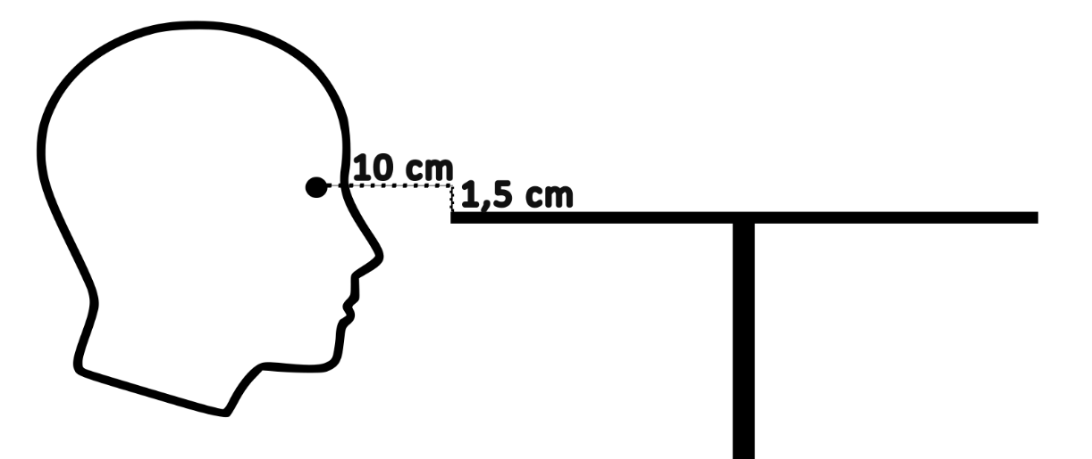
Figure S1. Experimental setup. Participants were seated centrally in front of the horizontal screen, with the midpoint of the eyes positioned in an approximate distance of 10 cm in front of, and 1.5 cm above the screen’s edge.
S3. Vergence Reconstruction and Preprocessing
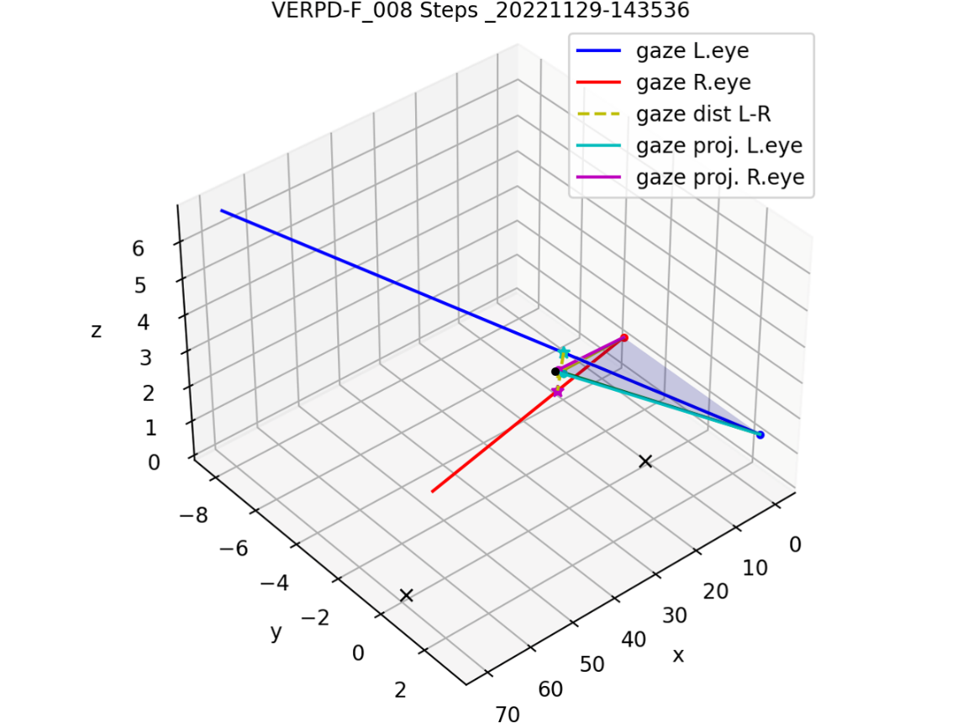
Figure S2. Schematic illustration of vergence reconstruction based on modeled gaze vectors. The gaze vectors originating from the left and right eye are shown as blue and red lines. The shortest connecting segment between the gaze vectors (gaze distance) is indicated by the yellow dashed line, and its midpoint was used together with the eye positions to define a projection plane (semi-transparent blue-gray triangle). Projection of the gaze vectors onto this plane yielded the green and magenta vectors, which were subsequently used to calculate vergence.
Each eye’s gaze vectors were first calculated in display coordinates, based on the assumption that the eyes are positioned 10 cm in front of and 1.5 cm above the display. This positioning was verified during each measurement using the VOG goggle’s integrated calibration laser. Each subject’s individual interpupillary distance was used to model the horizontal position of each eye. The resulting positions of the left and right eyes were used as the starting points for the respective gaze vectors, which were used to compute each eye’s vergence position relative to the central beam of the calibration laser in display coordinates.
Vergence was calculated as the angle between the projected gaze vectors (Figure S2). For subsequent computation of the maximum near point of convergence, the intersection point of the projected gaze vectors was used. To calculate the convergence parameters, the convergence data (position and velocity) were filtered using a Gaussian filter (10 Hz) to reduce high-frequency noise.
Slow vergence
The latency of the vergence pursuit movement was calculated as the time difference between stimulus onset (the start of the stimulus movement) and the onset of the convergence change corresponding to the direction of the stimulus movement.
The maximum and minimum convergence were determined as the extreme values of convergence in a time interval during the static presentation of the stimulus. The gain of the pursuit movement was calculated as the slope of the linear regression of the ratio between the measured convergence and the expected convergence angle resulting from interpupillary distance as well as stimulus position and movement on the screen.
Fast vergence
The saccadic aspects of vergence were identified within a 1-second window following the stimulus jump. The start and end of the saccade were detected using a velocity threshold of 10% of the peak velocity. Peak velocity was defined as the absolute maximum value of velocity between the start and end of the saccade. The amplitude of the saccade was calculated from the difference between the end position and the start position of the saccade. The maximum and minimum convergence were determined as the extreme values of vergence in a time interval between the end of the saccade and the next stimulus jump.
Gain and latency computations were similar to those used in slow vergence.

S4. Supplementary: DBS electrode localization
S4.1 Imaging data and lead models
The preoperative MRI comprised a T1-weighted volume (1 mm isotropic in 22 patients; 1.04 × 1.04 × 1.0 mm and 0.59 × 0.59 × 2 mm in the other two), an axial T2-weighted acquisition (0.69 × 0.69 × 2 mm; in one patient each 0.9 × 0.9 mm with 2.5-mm slices at 2.75-mm spacing and 1.2 × 1.2 × 2 mm) and, in 21 patients, a susceptibility-weighted (T2*-weighted) volume (1.15 mm isotropic). The postoperative CT was reconstructed at 0.625 × 0.625 × 1 mm with a soft-tissue kernel and an intensity ceiling of 3071 Hounsfield units (HU); one patient was scanned with a bone kernel and a 2° gantry tilt (0.47 × 0.47 × 0.7 mm). Images were converted with dcm2niix¹ and arranged in Brain Imaging Data Structure (BIDS) format. Lead models and stimulation programs were taken from the clinical records: Boston Scientific Vercise Cartesia directional leads (15 patients), Cartesia HX (1), Medtronic SenSight B33005 (6), Abbott Infinity directional 6172 right and 6173 left (1) and Medtronic 3389 (1).
S4.2 Image processing and reconstruction
The Lead-DBS v3.2.1² was used in MATLAB R2026a for processing. The T2- and T2*-weighted images were coregistered to the T1-weighted anchor with the hybrid SPM/ANTs method (ANTs alone in one patient). One CT, acquired at about 180° to the MRI, was rotated into the MRI orientation in two header-only steps before a rigid registration, and the bone-kernel CT was registered with FLIRT³ (12 degrees of freedom) after gantry-tilt correction. Normalization used the ANTs preset “Effective: Low Variance, Default” with subcortical refinement (T1 and T2 only in the three patients without T2*). Brain-shift correction was not applied, because on visual review it worsened the alignment significantly.
PaCER⁴ centered the contacts of the lead model on the contact band detected along the fitted trajectory. Because Lead-DBS v3.2.1 passes no PaCER model for SenSight, Abbott and Cartesia HX leads, its PaCER interface was modified to fit them with the PaCER template of the same contact pitch (Medtronic 3389, or 3387 for Abbott 6173). For the Cartesia HX leads the metal threshold was raised to 1600 HU and all 16 contacts were placed along the fitted trajectory.
S4.3 Quality control
For every lead we verified the lead model and contact count against the record, the contact spacing (1.99–2.06 mm for 2-mm-pitch leads, 3.01 mm for the 3-mm-pitch lead), the hemisphere assignment, the absence of brain-shift transforms, that every contact lay in metal on the CT (minimum 1684 HU, in the bone-kernel CT), and that the stored MNI coordinates were equal to the current warp. The reconstructed axis lay on the center of the metal artifact within 0.2 mm in 47 of 48 leads (median 0.05 mm; 0.36 mm in the remaining lead). All reconstructions were inspected visually.
Lead depth was checked against the distal end of the metal on the CT with two independent methods. A threshold method located the half-maximum of the CT intensity profile along the axis and compared its distance from the deepest contact with the cohort median (1.35 mm for leads whose tip is the deepest contact, 1.6 mm for plastic-tip leads; for the bone-kernel CT, the mean of the half-maximum and steepest-descent positions). A forward model of each lead (contact geometry, 1.3 mm diameter, Gaussian blur, clipping at 3071 HU) was fitted to the CT within a cylinder of 6 mm diameter; fits to the two halves of the cylinder agreed within 0.25 mm. Both measures were positive when the true lead lies deeper than reconstructed and correlated across leads (r = 0.88). After the subtraction of a cohort-wide offset of +0.18 mm, the forward model placed all leads within −0.42 to +0.34 mm.
Accuracy was estimated with the three-cornered-hat decomposition⁵ which assigns a root-mean-square (RMS) error to each of three methods from their pairwise disagreements, assuming uncorrelated errors. For coregistration, the raw CT was additionally registered with FLIRT³ (normalized mutual information, rigid) and BRAINSFit⁶ (Mattes mutual information, rigid). In the 16 patients in which all three methods placed the contacts in metal (above 2000 HU), the RMS errors at the contacts were 0.37 mm (Lead-DBS), 0.33 mm (FLIRT) and 0.42 mm (BRAINSFit). Re-registering the aligned CT with BRAINSFit and ANTs in all 24 patients led to median residuals of 0.21 and 0.37 mm.
For normalization, each T1-weighted image was additionally normalized with SynthMorph⁷ and SPM12 SHOOT⁸, and the methods were compared at the 376 contact positions of the initial reconstruction. After exclusion of 12 leads where one method was an outlier (all flagged for SHOOT), the RMS errors over 36 leads were 0.31 mm (ANTs), 1.29 mm (SynthMorph) and 1.66 mm (SHOOT). In ANTs and SynthMorph, the contact array of one patient was stretched 1.35–1.40-fold into MNI space (cohort median 1.09). The resulting errors were comparable to the test–retest variability of Lead-DBS lead reconstruction⁹.
S4.4 Atlas STN fitted to the patient MRI
The DISTAL atlas was used as distributed through Lead-DBS^{2,10}. The STN, substantia nigra, thalamus and red nucleus were warped to native space and fitted to each patient’s T2- and T2*-weighted images with a nine-parameter transform (per axis: translation ≤ 5 mm, rotation ≤ 15°, scale 0.75–1.33) that maximized the intensity contrast between the structures and a surrounding shell. The full DISTAL subdivisions were extracted and the nuclei were fitted jointly because the STN and substantia nigra form one quasi-continuous hypointense band. The mean transform per hemisphere was subtracted within imaging modality: for the 21 patients with T2*, their own mean; for the three patients without T2*, the mean of T2-only refits of those 21 patients, which lie about 1.1 mm anterior to the full fits. The remaining patient-specific translation had a median of 0.45 mm (maximum 1.84 mm). Fits started 2–2.8 mm away returned to within 0.5 mm in 47 of 48 tests, and T2-only refits differed from the full fits by a median of 0.61 mm beyond the modality offset.
S4.5 Contact assignment
Contacts were assigned as described in the main Methods, with atlas values rounded to four decimals before the 0.5 threshold. Two leads used anodal stimulation, and the contacts of one patient’s additional 30-Hz program (the deepest contact on each side) were not counted. Contact positions in MNI space are shown for the cohort in Supplementary Figure S3 and per patient in Supplementary Figure S4. Against the fitted STN in native space, 208 of 392 contacts lay within the STN and 46 of 48 leads had at least one contact within it; no active contact outside it lay within the substantia nigra. The warped atlas STN in native space contained 82 of the 135 active contacts.
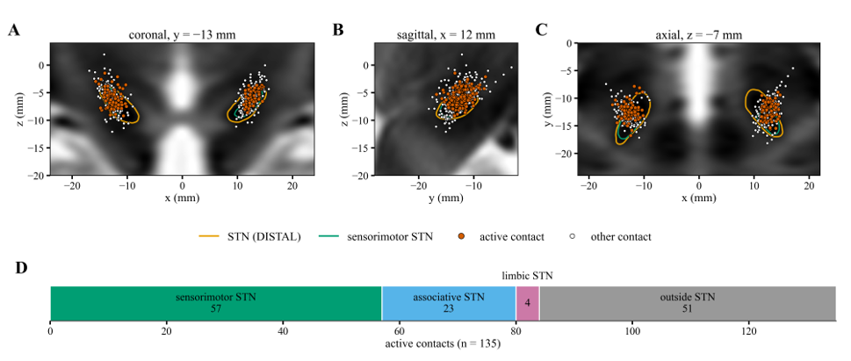Figure S3. Location of reconstructed DBS electrode contacts in standard space. (A–C) Contacts of all 48 leads on coronal (A, y = −13 mm), sagittal (B, x = 12 mm; left leads mirrored) and axial (C, z = −7 mm) sections of the MNI ICBM 2009b nonlinear asymmetric T2-weighted template, projected from within 6 mm of each section (386–391 of 392 contacts); STN membership was determined in three dimensions. Orange, DISTAL STN; green, its sensorimotor subdivision; filled vermilion, active contacts; open, other contacts. (D) Location of the 135 active contacts. Neurological convention (patient’s right on the right).
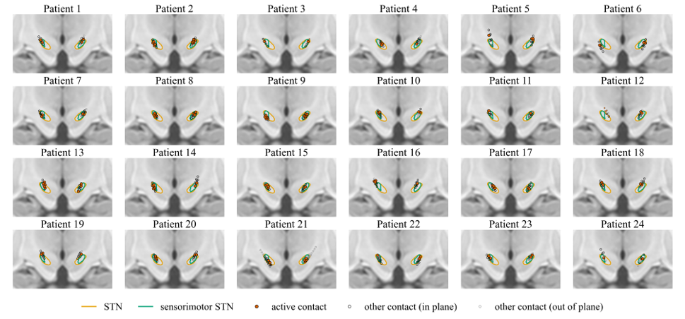Figure S4. Electrode contacts relative to the STN in standard space, per patient. One panel per patient: all contacts on a coronal section of the MNI ICBM 2009b nonlinear asymmetric T1-weighted template at y = −12.8 mm (mean STN centroid). Orange, DISTAL STN; green, its sensorimotor subdivision; filled vermilion, active contacts (in one patient also the deepest contact on each side, used by an additional 30-Hz program); open black, other contacts within 3 mm of the section; small gray and faded symbols, contacts farther away, shown in projection. Neurological convention.

S5. Supplementary Results: Conjugate Eye Movements
Table S1. Descriptive Statistics for Conjugate Eye Movement Parameters in pwPD OFF/OFF, pwPD DBS, and Age-Matched Controls
Parameter |  |  |  | PD OFF/OFF |  | DBS ON |  | HC
 |  |  |  | M | (SD) | M | SD | M | SD
Smooth pursuit gain
 | horizontal |  | 0.1 Hz | 0.811 | (± 0.130) | 0.843 | (± 0.119) | 0. 851 | (± 0.146)
 |  |  | 0.2 Hz | 0.760 | (± 0.138) | 0.815 | (± 0.128) | 0.807 | (± 0.156)
 | vertical |  | 0.1 Hz | 0.757 | (± 0.152) | 0.755 | (± 0.167) | 0.732 | (± 0.191)
 |  |  | 0.2 Hz | 0.729 | (± 0.145) | 0.740 | (± 0.163) | 0.685 | (± 0.196)
Saccadic gain
 | horizontal |  |  | 0.486 | (± 0.239) | 0.598 | (± 0.245) | 0.782 | (± 0.196)
 | vertical |  |  | 0.382 | (± 0.271) | 0.572 | (± 0.228) | 0.809 | (± 0.159)
Saccadic latency
 | horizontal |  |  | 0.216 | (± 0.049) | 0.212 | (± 0.040) | 0.225 | (± 0.033)
 | vertical |  |  | 0.239 | (± 0.056) | 0.250 | (± 0.044) | 0.239 | (± 0.032)
N30 saccades |  |  |  | 42.33 | (± 10.36) | 45.33 | (± 12.60) | 52.72 | (± 13.49)
Note. M = mean, SD = standard deviation.

Table S2. Comparison of Age-Matched Controls and pwPD OFF/OFF on Conjugate Eye Movements
Parameter | Task |  | U | p | r | 95 % CI
Smooth pursuit gain
 | horizontal | 0.1 Hz | 532.5 | .131 | .233 | [-0.064, 0.491]
 |  | 0.2 Hz | 557 | .060 | .289 | [-0.003, 0.536]
 | vertical | 0.1 Hz | 437 | .946 | .012 | [-0.280, 0.303]
 |  | 0.2 Hz | 387 | .502 | -.104 | [-0.384, 0.194]
Saccadic gain
 | horizontal |  | 729 | <.001* | .688 | [0.495, 0.816]
 | vertical |  | 769 | <.001* | .780 | [0.632, 0.873]
Saccadic latency
 | horizontal |  | 489 | .393 | .132 | [-0.166, 0.408]
 | vertical |  | 420 | .862 | -.028 | [-0.317, 0.266]
N30 Saccades |  |  | 641.5 | .002* | .485 | [0.225, 0.681]
Note. Mann-Whitney U tests were performed to assess differences in conjugate eye movement parameters between age-matched controls and pwPD OFF/OFF. p-values are two-tailed.

Table S3. Comparison of Conjugate Eye Movement Parameters Across Therapy States in pwPD Using Friedman Tests
Parameter | Task |  | χ² (Friedman) | df | p | Kendall’s W
Smooth pursuit gain
 | horizontal | 0.1Hz | 6.532 | 2 | .038* | .136
 |  | 0.2Hz | 6.337 | 2 | .042* | .132
 | vertical | 0.1Hz | 0.147 | 2 | .929 | .003
 |  | 0.2Hz | 1.083 | 2 | .582 | .023
Saccadic gain
 | horizontal |  | 3.583 | 2 | .167 | .075
 | vertical |  | 10.750 | 2 | .005* | .224
Saccadic latency
 | horizontal |  | 1.043 | 2 | .593 | .022
 | vertical |  | 2.215 | 2 | .330 | .046
N30 saccades |  |  | 3.851 | 2 | .146 | .080
Note. Friedman tests were performed to compare repeated measurements at PD OFF/OFF, MED and DBS. Effect sizes are reported as Kendall’s W. p-values are two-tailed.

Table S4. Post hoc Pairwise Comparisons of Treatment Conditions in pwPD on Conjugate Eye Movements
Parameter | Task |  | OFF/OFF vs MED ON |  | OFF/OFF vs DBS ON
Smooth pursuit gain |  |  | p | r | p | r
 | horizontal | 0.1 Hz | .151 |  | .010* | -.406
 |  | 0.2 Hz | .879 |  | .022* | -.410
Saccadic gain
 | vertical |  | .633 |  | .006* | -.660
Note. Conover post hoc tests were conducted for variables with significant Friedman results. p-values were not adjusted.

Table S5. Comparisons between Age-Matched Controls and pwPD with Active DBS on Conjugate Eye Movements
Parameter | Task |  | U | p | r | 95 % CI
Smooth pursuit gain
 | horizontal | 0.1 Hz | 396.5 | .597 | .082 | [-0.215, 0.365]
 |  | 0.2 Hz | 434.5 | .976 | -.006 | [-0.228, 0.287]
 | vertical | 0.1 Hz | 442.5 | .880 | -.024 | [-0.314, 0.270]
 |  | 0.2 Hz | 493.5 | .357 | -.140 | [-0.417, 0.156]
Saccadic gain
 | horizontal |  | 208 | <.001* | .519 | [0.267, 0.704]
 | vertical |  | 143 | <.001* | .669 | [0.469, 0.804]
Saccadic latency
 | horizontal |  | 364 | .308 | .157 | [-0.141, 0.430]
 | vertical |  | 547.5 | .082 | -.267 | [-0.519, 0.027]
N30 Saccades |  |  | 301.5 | .050 | .302 | [0.012, 0.546]
Note. Mann-Whitney U tests were conducted for all conjugate eye movement parameters. For significantly changed parameters due to DBS treatment in pwPD, these comparisons additionally served to illustrate direction and degree of normalization. p-values are two-tailed.

S6. Additional Results: Vergence Performance in pwPD OFF/OFF According to Diplopia Status
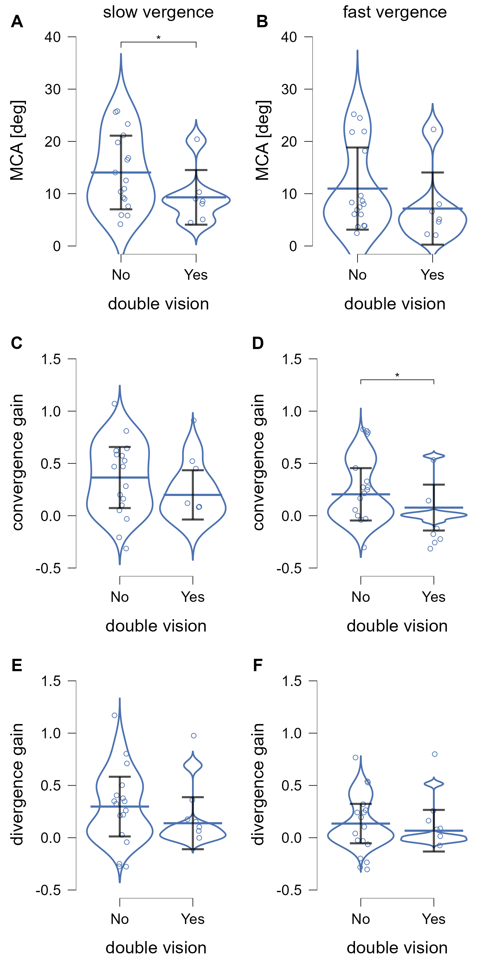
Figure S5. Comparison of vergence parameters in pwPD with vs. without self-reported double vision. Each data point represents one participant and violin widths reflect data distribution. Statistical significance is indicated. Corresponding descriptive statistics are summarized in Table S6, while detailed statistical results can be found in Table S7.
Table S6. Descriptive Statistics for Dynamic Vergence Parameters (MCA and Gain) in pwPD OFF/OFF with and without Self-Reported Diplopia
Parameter |  |  | No Diplopia |  | Diplopia
 |  |  | M | (SD) | M | (SD)
Vergence gain
 | slow vergence | CONV | 0.365 | (± 0.292) | 0.199 | (± 0.236)
 |  | DIV | 0.298 | (± 0.285) | 0.139 | (± 0.249)
 | fast vergence | CONV | 0.205 | (± 0.250) | 0.078 | (± 0.219)
 |  | DIV | 0.135 | (± 0.189) | 0.067 | (± 0.199)
MCA
 | slow vergence |  | 14.05 | (± 7.04) | 9.30 | (± 5.23)
 | fast vergence |  | 10.98 | (± 7.86) | 7.16 | (± 6.90)
Note. M = mean, SD = standard deviation. Abbreviations: CONV = convergence; DIV = divergence.

Table S7. Mann–Whitney U Test Results for Dynamic Vergence Parameters (MCA and Gain) in pwPD OFF/OFF with and without Self-Reported Diplopia.
Parameter | Task |  | U | p | r | 95 % CI
Vergence gain
 | slow vergence | CONV | 80.0 | .105 | -.345 | [-0.661, ∞]
 |  | DIV | 78.0 | .130 | -.311 | [-0.639, ∞]
 | fast vergence | CONV | 82.0 | .044* | -.464 | [-0.736, ∞]
 |  | DIV | 82.0 | .083 | -.378 | [-0.682, ∞]
MCA
 | slow vergence |  | 87.0 | .043* | -.462 | [-0.733, ∞]
 | fast vergence |  | 82.0 | .083 | -.378 | [-0.682, ∞]
Note. One-tailed Mann–Whitney U tests were conducted under the a-priori hypothesis that pwPD with diplopia would show decreased vergence function (lower MCA and gain values) than participants without diplopia. Abbreviations: CONV = convergence; DIV = divergence

S7. Additional Results: Vergence Eye Movements
Table S8. Descriptive Statistics for Vergence Eye Movement Parameters in pwPD OFF/OFF, pwPD DBS ON and Age-Matched Controls
Parameter |  |  | PD OFF/OFF |  | DBS ON |  | HC
 |  |  | M | (SD) | M | (SD) | M | (SD)
Vergence gain
 | slow vergence | CONV | 0.317 | (± 0.282) | 0.440 | (± 0.276) | 0.660 | (± 0.269)
 |  | DIV | 0.251 | (± 0.280) | 0.335 | (± 0.298) | 0.547 | (± 0.335)
 | fast vergence | CONV | 0.166 | (± 0.244) | 0.205 | (± 0.267) | 0.346 | (± 0.311)
 |  | DIV | 0.115 | (± 0.190) | 0.140 | (± 0.203) | 0.330 | (± 0.275)
MCA
 | slow vergence |  | 12.67 | (± 6.82) | 15.23 | (± 7.35) | 20.91 | (± 7.53)
 | fast vergence |  | 9.86 | (± 7.65) | 11.14 | (± 8.18) | 16.96 | (± 9.64)
Vergence stability
 | slow vergence |  | 1.550 | (± 1.409) | 1.197 | (± 1.267) | 1.222 | (± 1.074)
 | fast vergence |  | 1.769 | (± 1.439) | 1.730 | (± 1.226) | 2.793 | (± 2.342)
Latency
 | slow vergence |  | 2.126 | (± 1.832) | 1.303 | (± 1.213) | 0.982 | (± 1.350)
 | fast vergence | CONV | 0.399 | (± 0.170) | 0.394 | (± 0.177) | 0.317 | (± 0.176)
 |  | DIV | 0.278 | (± 0.151) | 0.222 | (± 0.120) | 0.202 | (± 0.101)
Note. M = mean, SD = standard deviation. Vergence stability was derived from the standard deviation of convergence during fixation at the extreme target position; lower values indicate greater stability. Abbreviations: CONV = convergence; DIV = divergence.

Table S9. Changes Across Treatment Conditions in pwPD on Vergence Eye Movement
Variable | Task |  | χ² (Friedman) | df | p | Kendall’s W
Vergence Gain
 | slow vergence | CONV | 12.33 | 2 | .002* | .257
 |  | DIV | 12.58 | 2 | .002* | .262
 | fast vergence | CONV | 5.30 | 2 | .070 | .115
 |  | DIV | 4.08 | 2 | .130 | .085
MCA
 | slow vergence |  | 10.58 | 2 | .005* | .220
 | fast vergence |  | 2.08 | 2 | .353 | .043
Vergence stability
 | slow vergence |  | 2.33 | 2 | .311 | .049
 | fast vergence |  | 2.33 | 2 | .311 | .049
Latency
 | slow vergence |  | 4.99 | 2 | .083 | .104
 | fast vergence | CONV | 0.35 | 2 | .840 | .008
 |  | DIV | 0.25 | 2 | .882 | .005
Note. Friedman tests were performed to compare repeated measurements at PD OFF/OFF, MED and DBS. Effect sizes are reported as Kendall’s W. p-values are two-tailed. Abbreviations: CONV = convergence; DIV = divergence.

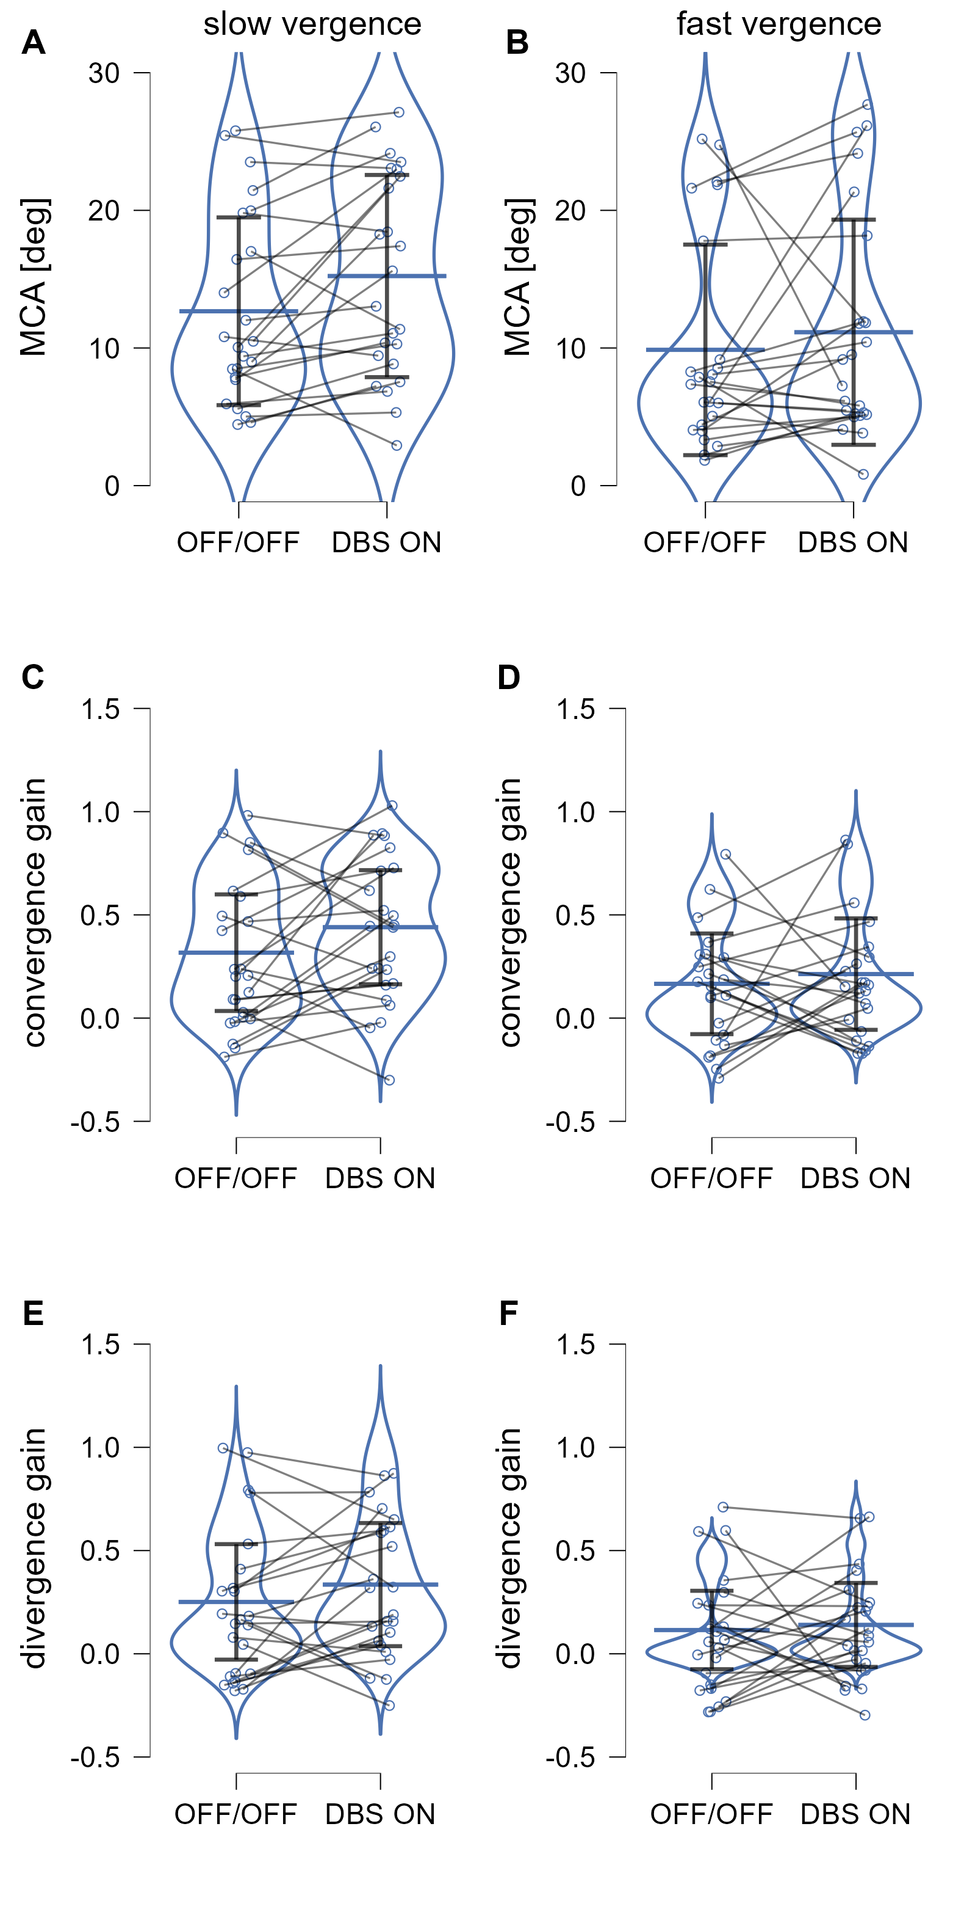
Figure S6. Individual changes in vergence parameters (MCA and gain) from OFF/OFF to DBS conditions in pwPD during slow (left) and fast (right) vergence tasks. Each line represents one pwPD and connects repeated measurements across both conditions.
Table S10. Comparison between Age-Matched Controls and pwPD with Active DBS
Variable | Task |  | U | p | r | 95 % CI
Vergence gain
 | slow vergence | CONV | 235 | .003* | -.456 | [-0.660, -0.189]
 |  | DIV | 282 | .023* | -.347 | [-0.580, -0.062]
 | fast vergence | CONV | 281 | .090 | -.268 | [-0.525, 0.033]
 |  | DIV | 239 | .016* | -.378 | [-0.608, -0.089]
MCA
 | slow vergence |  | 256 | .007* | -.407 | [-0.625, -0.131]
 | fast vergence |  | 255 | .033* | -.336 | [-0.577, -0.041]
Vergence stability
 | slow vergence |  | 477 | .505 | -.104 | [-0.384, 0.194]
 | fast vergence |  | 549 | .079 | -.271 | [-0.522, 0.023]
Latency
 | slow vergence |  | 545 | .090 | .262 | [-0.033, 0.514]
 | fast vergence | CONV | 480.5 | .112 | .251 | [-0.051, 0.512]
 |  | DIV | 407 | .709 | .060 | [-0.243, 0.352]
Note. Mann-Whitney U tests were conducted for all vergence eye movement parameters. For significantly changed variables due to DBS treatment in pwPD, these comparisons additionally served to illustrate direction and degree of normalization of those parameters. p-values are two-tailed. Abbreviations: CONV = convergence; DIV = divergence.

S8. Additional Results: Relationship between cognitive performance (MoCA) and ocular motor measures
In pwPD, no significant associations were observed between MoCA scores and conjugate eye movement parameters in the OFF/OFF state. (all p > .05). In the control group, small to moderate positive associations between MoCA scores and smooth pursuit gain as well as vertical saccadic gain (rₛ up to .385, p = .006) were observed but did not survive adjustment for age. No significant correlations were found between MoCA scores and vergence parameters (all p > .05).

S9. Supplementary Results: Relationship of Ocular Motor Parameters and Motor Severity
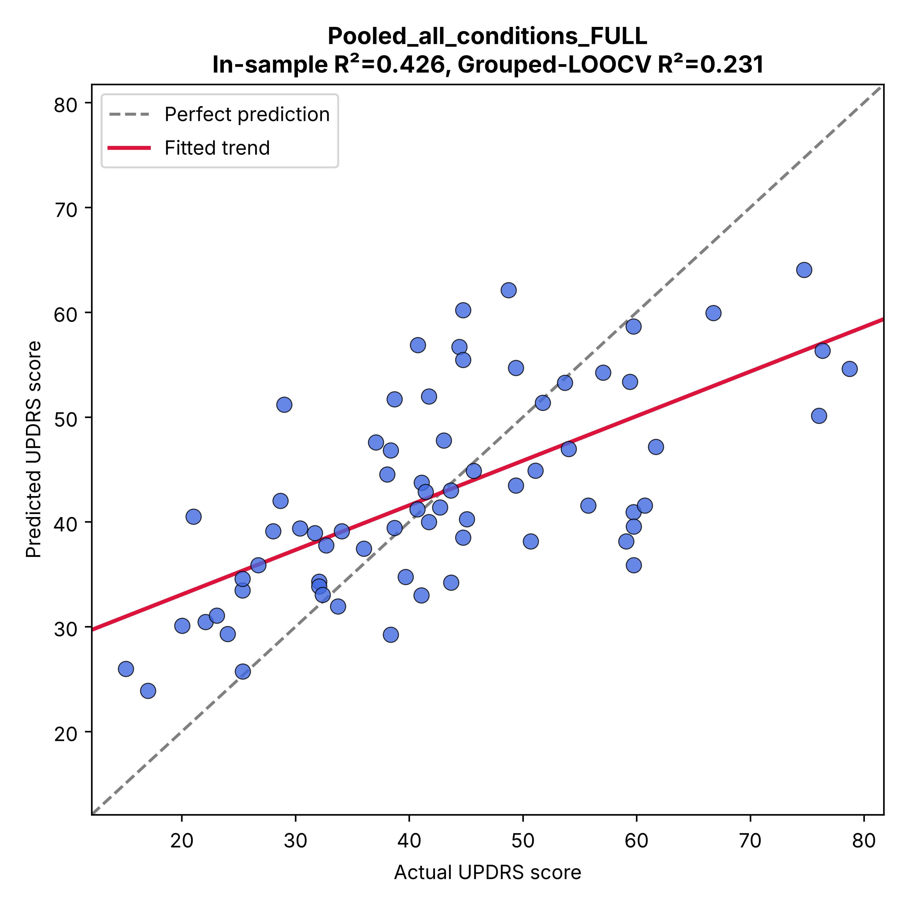Figure S7. Multivariable prediction of motor severity from ocular motor features. Observed versus in-sample predicted MDS-UPDRS-III scores from the multivariable model including ocular motor features across therapeutic conditions. The model explained 42.6% of the variance in-sample (R² = 0.426) and retained predictive performance under grouped leave-one-subject-out cross-validation (LOOCV; R² = 0.231), with observations from each participant held out together. The dashed line indicates perfect prediction and the solid line the fitted relationship between observed and predicted scores. Vertical and horizontal saccadic gain emerged as the strongest contributors to the model, with coefficients of opposite direction (vertical gain: B = −39.20, p < .001; horizontal gain: B = 28.95, p = .001; standard errors clustered by participant).

