Supplementary Materials for
Steering device-quality perovskites with unique substrate tolerance
Ningyu Ren^{1,2,3,4,5,6*}, Pengyang Wang^{1,2,3,4*},Junke Jiang^{7,8,9*}, Renjie Li^{1,2,3,4}, Wei Han^{1,2,3,4}, Jingjing Liu^{1,2,3,4}, Zhao Zhu^{1,2,3,4}, Bingbing Chen^{1,2,3,4}, Qiaojing Xu^{1,2,3,4}, Tiantian Li^{5,6}, Biao Shi^{1,2,3,4}, Qian Huang^{1,2,3,4}, Dekun Zhang^{1,2,3,4}, Sofia Apergi^{7,8}, Geert Brocks^{7,8}, Chenjun Zhu^{5,6}, Shuxia Tao^{7,8†}, Ying Zhao^{1,2,3,4}, Xiaodan Zhang^{1,2,3,4†}

Correspondence to Shuxia Tao (s.x.tao@tue.nl) (S.T.) and Xiaodan Zhang (xdzhang@nankai.edu.cn )(X.Z.).

This PDF file includes:
Materials and Methods
Figs. S1 to S23
Tables S1 to S4
Supplementary Note 1 to 2 (Figs. S24 to S30)
References 1-45.

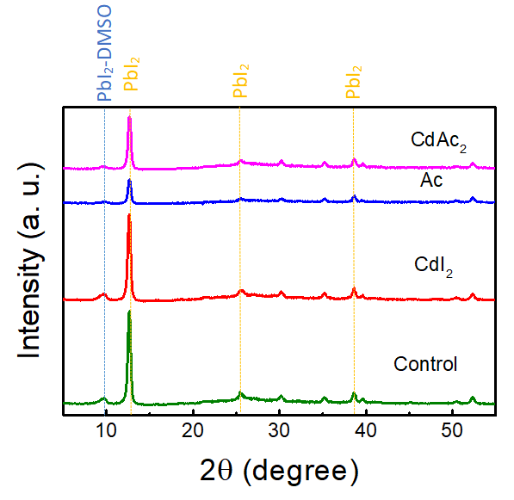
Supplementary Fig. 1. The x-ray diffraction patterns of PbI₂ film on the rigid substrate without addition and with Ac, CdI_{2,} and CdAc₂.

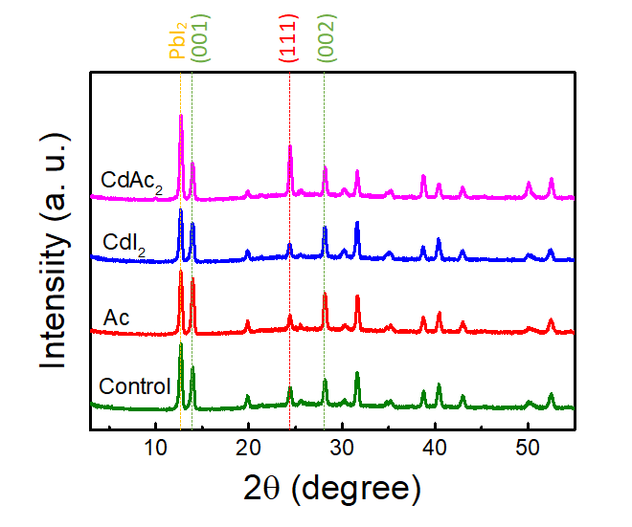
Supplementary Fig. 2. The x-ray diffraction patterns of perovskite films on the rigid substrate without addition and with Ac, CdI_{2,} and CdAc₂.

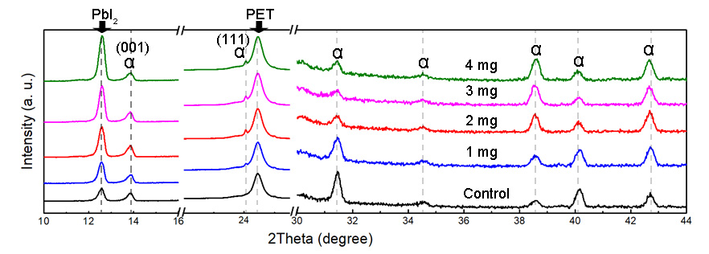
Supplementary Fig. 3. XRD spectra of the perovskite films on the flexible substrate with CdAc₂ introduced from 0 to 4 mg, respectively.

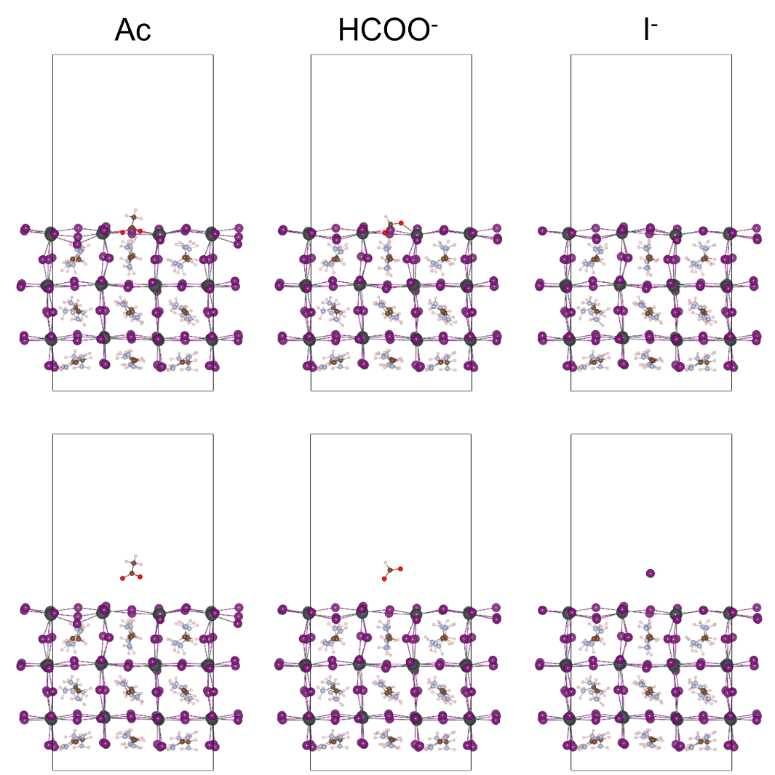
Supplementary Fig. 4. DFT-relaxed slabs of FAPbI₃ with Ac, HCOO⁻, and I⁻ adsorbed at an iodide-vacancy site (top) on the PbI₂-terminated surface and move away for ~4 Å (bottom), respectively.

Supplementary Fig. 5. The relative interaction strengths of Ac, HCOO⁻, and I⁻ with the I⁻ vacancy at the FAPbI₃ surface.

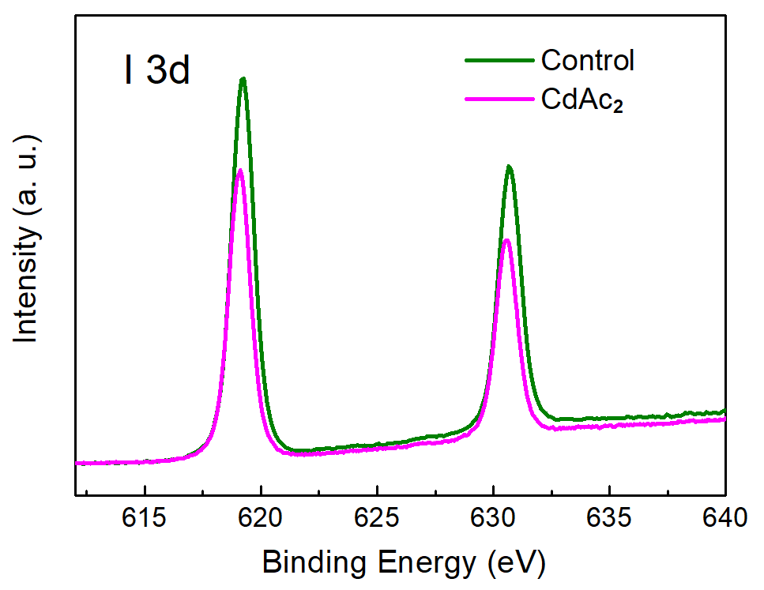
Supplementary Fig. 6. XPS spectra of I 3d for perovskite film wo/w CdAc₂ introduced.

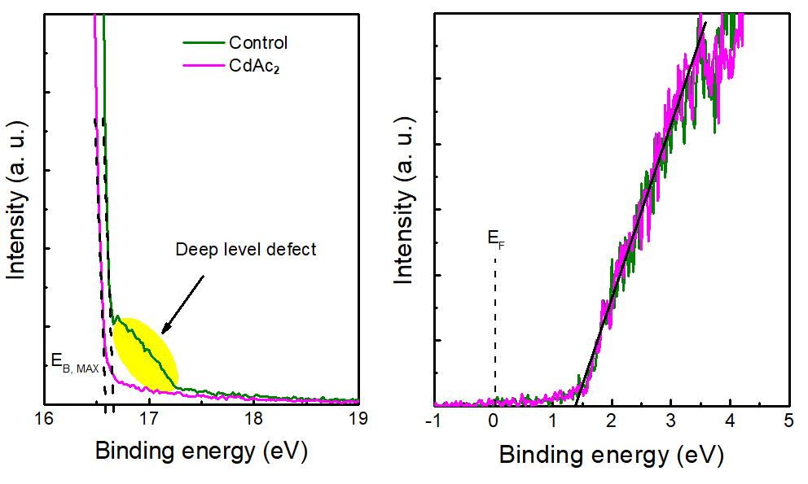-
Supplementary Fig. 7. UPS data for perovskite film wo/w CdAc₂ introduced. Helium Iα (hν= 21.22 eV) spectra of secondary electron cut-off (left panel) and UPS spectra in the valence band (VB) region (right panel) are shown.

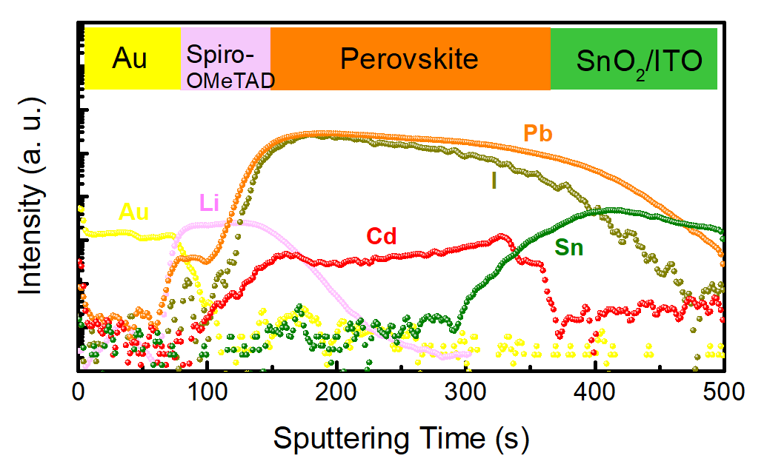
Supplementary Fig. 8. The elements mapping in perovskite films. Depth profiles of Br, I, Sn, Pb, Cd, Li, Au in flexible perovskite devices by SIMS.

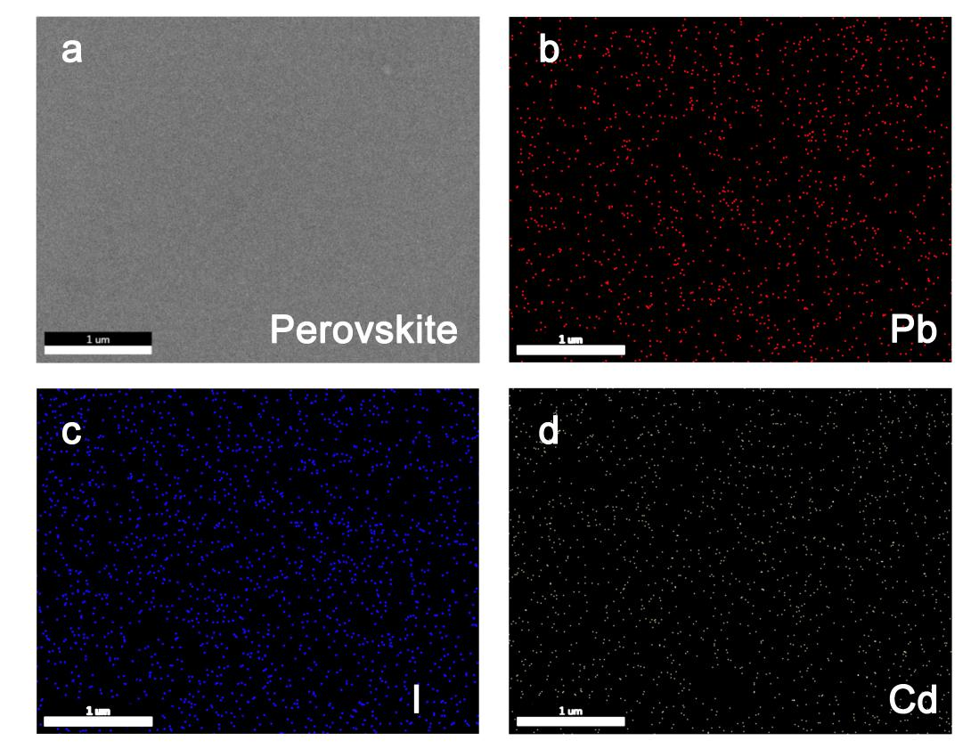
Supplementary Fig. 9. Energy dispersive spectrometer (EDS) mapping spectra of perovskite film with CdAc₂ introduced.

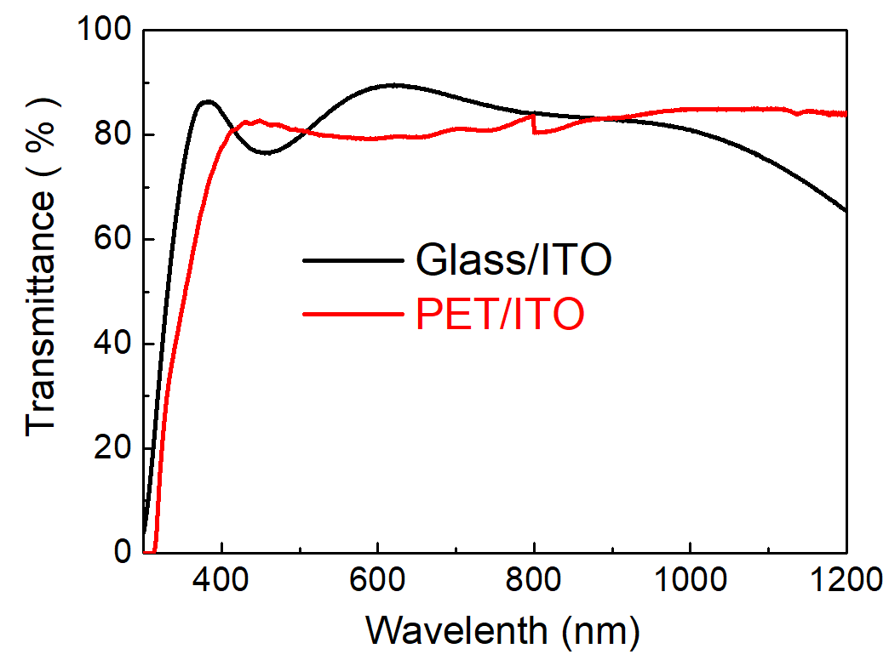
Supplementary Fig. 10. Transmittance spectra of substrates including Glass/ITO and PET/ITO.

Supplementary Fig. 11. Box charts of Jsc (a), Voc (b), FF (c), and PCE (d) of PSCs with various concentration (0, 1, 2, 3 and 4 mg/mL) of CdAc₂ alloying.

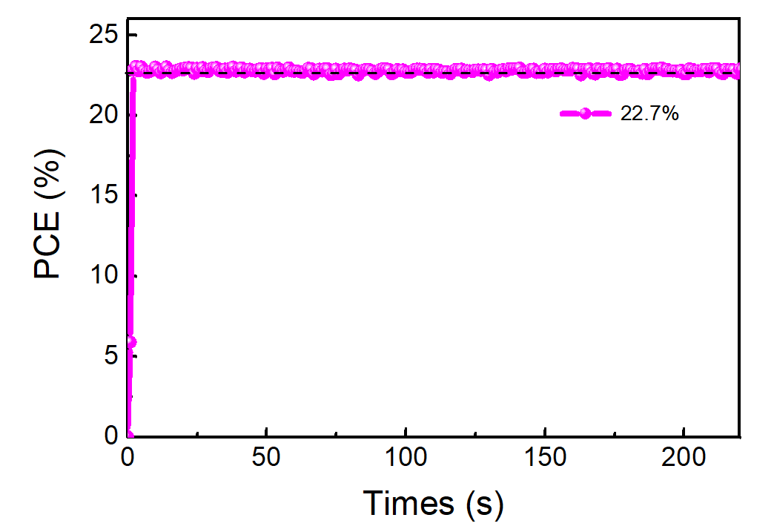
Supplementary Fig. 12. The steady-state PCE of FPSCs with CdAc₂ treatment.

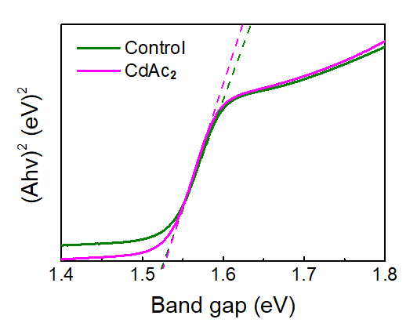
Supplementary Fig. 13. Tauc plots of the perovskite films wo/w CdAc₂ introduced. Tauc plots of the perovskite with CdAc₂ treatment. The bandgap of the perovskite are 1.53 eV.

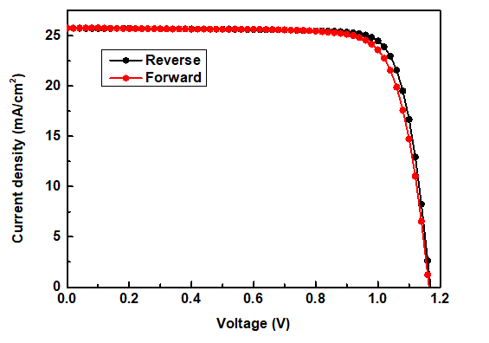
Supplementary Fig. 14. J–V curves of the best-performing device based on glass substrate with CdAc₂ introduced.

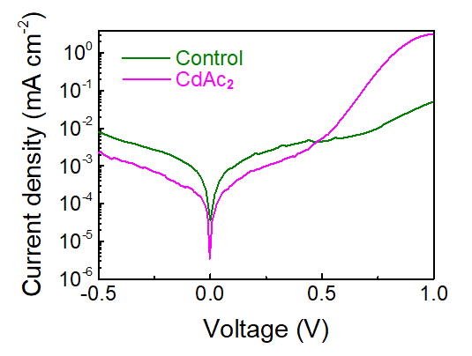
Supplementary Fig. 15. Dark J−V curves for PSCs without and with CdAc₂ introduced.

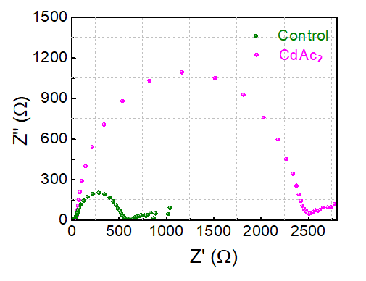
Supplementary Fig. 16. Nyquist curves of PSCs with CdAc₂ alloying under Voc in the dark.

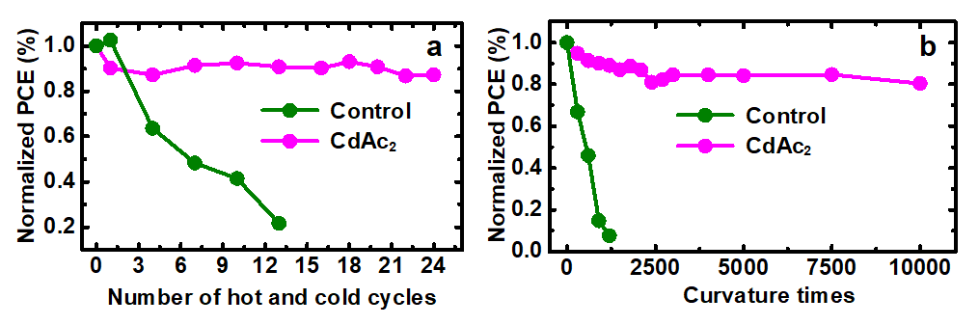
Supplementary Fig. 17. (a), Bending durability of FPSCs as a function of bending cycles with a radius of 3 mm. (b), The thermal stability of control and CdAc₂ treated FPSCs.

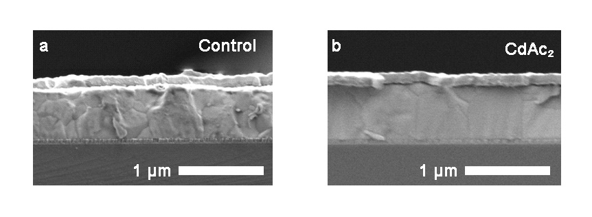
Supplementary Fig. 18. Cross-section images of control (a) and CdAc₂ treated (b) wide bandgap (1.68-eV) perovskite by a one-step method.

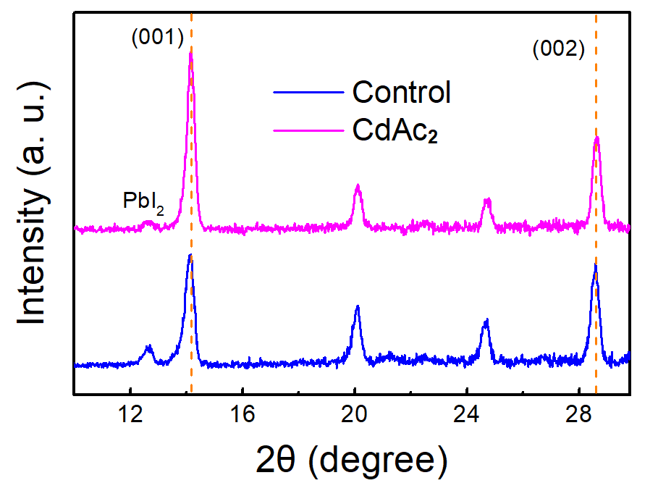
Supplementary Fig. 19. The x-ray diffraction patterns of wide bandgap (1.68-eV) perovskite films without addition and with CdAc₂.

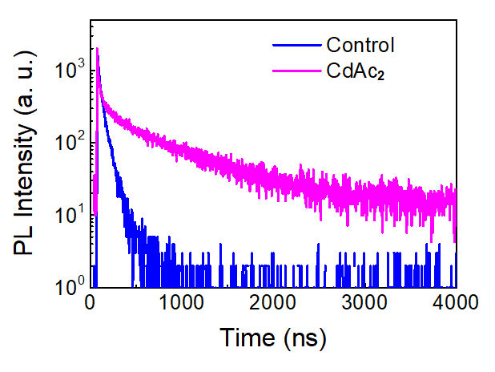
Supplementary Fig. 20. Time-resolved photoluminescence of wide bandgap (1.68-eV) perovskite films without addition and with CdAc₂.

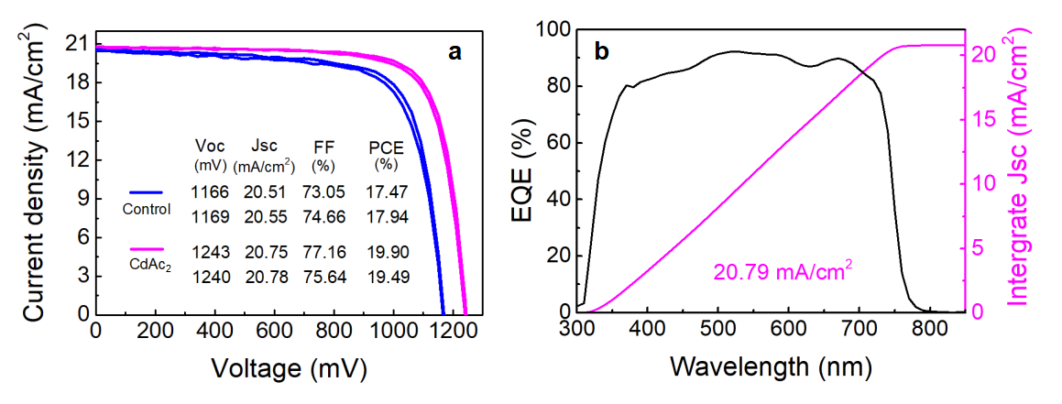
Supplementary Fig. 21. (a) The J-V characteristics of wide bandgap single-junction PSCs without and with CdAc₂ treatment. (b) The external quantum efficiency (EQE) of PSCs with CdAc₂ treatment.

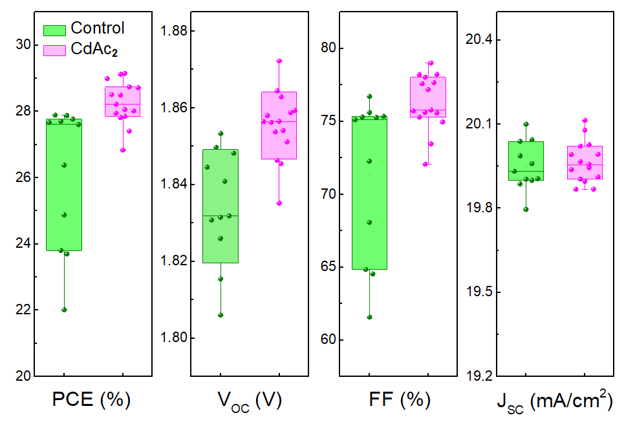
Supplementary Fig. 22. Statistics of the PCE of tandem solar cells without and with CdAc₂.
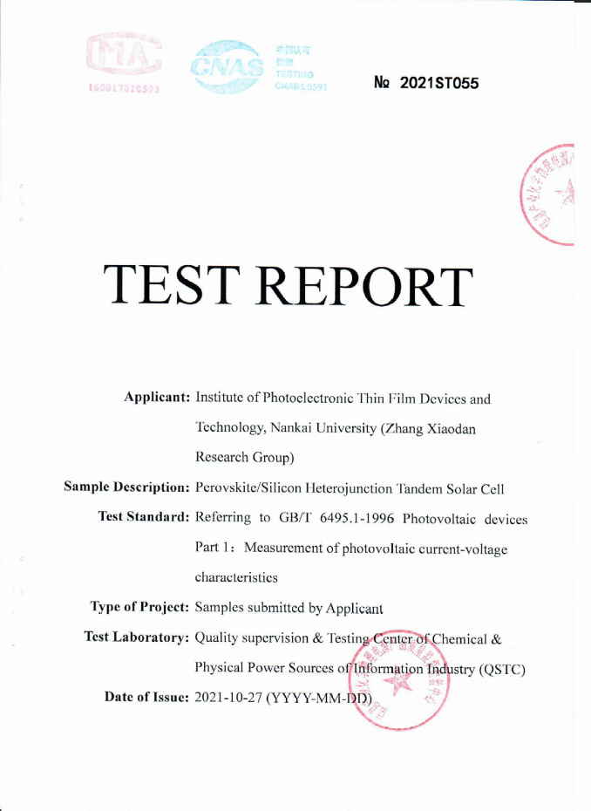-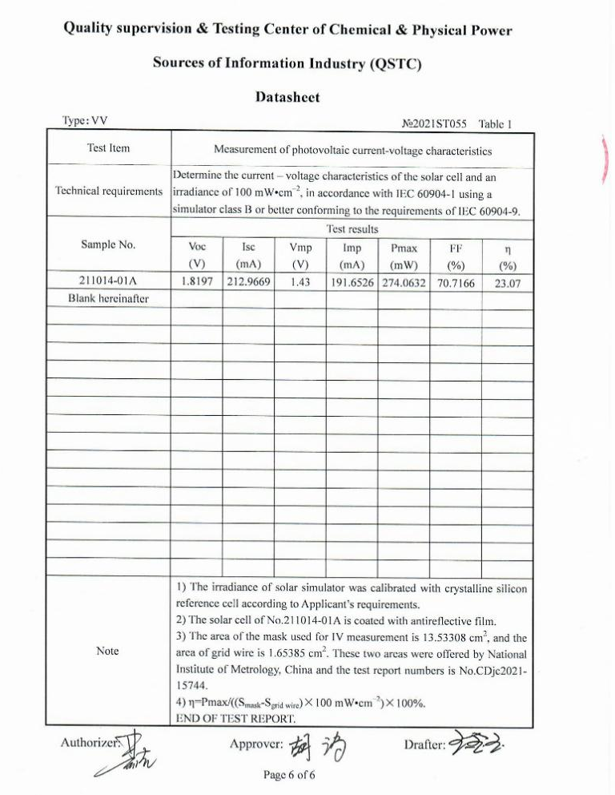
Supplementary Fig. 23. Certification results of large-area perovskite/silicon TSCs with an active area of 11.879 cm².
Supplementary Table 1. Summarize the TRPL lifetime for perovskite films without and with CdAc₂ introduced.

 | $$τ_{1}(ns)$$ | $$τ_{2}(ns)$$ | $$B_{1}$$ | $$B_{2}$$
PbI₂ Control | 175 | 530 | 724 | 805
CdAc₂ Control | 2304 | 6514 | 362 | 732

Supplementary Table 2. Comparison of flexible devices performance of this work with previously published results.
Device Structure | Type | V_{OC} (V) | J_{SC} (mA/cm²) | FF (%) | PCE (%) | Years | References
PET/ITO/ZnO/Perovskite/Spiro-OMeTAD/Au | N-I-P | 0.80 | 8.6 | 43.14 | 2.62 | 2013 | 1
PET/ITO/ZnO/Perovskite /spiro-OMeTAD/Ag | N-I-P | 1.03 | 13.4 | 73.9 | 10.2 | 2013 | 2
PET/ITO/PEDOT:PSS/ Perovskite /PCBM/TiOx/Al | P-I-N | 0.88 | 14.4 | 51 | 6.4 | 2013 | 3
PET/ITO/PEDOT:PSS/ Perovskite /PCBM/C60/Ag | N-I-P | 0.86 | 14.62 | 75 | 9.43 | 2014 | 4
PET/ITO/am-TiO₂ /Perovskite/Spiro-OMeTAD/Au | N-I-P | 1.03 | 20.9 | 70 | 15.07 | 2015 | 5
Willow glass/ITO/ZnO/Perov-  skite/Spiro-OMeTAD/Au | N-I-P | 0.98 | 19.3 | 69 | 13.14 | 2015 | 6
PET/ITO/TiO₂/Nb:TiO₂/Perovs-  kite/Spiro-OMeTAD/Au | N-I-P | 1.04 | 20.20 | 766 | 16.01 | 2016 | 7
PET/ITO/SnO₂/C60-SAM  /perovskite/spiro-OMeTAD/Au, | N-I-P | 1.101 | 22.11 | 75.42 | 18.36 | 2017 | 8
PET/ITO/PTAA/Perovskite/Fullerene/BCP/Cu | P-I-N | 1.06 | 22.8 | 74.6 | 18.1 | 2017 | 9
PEN/ITO/m-TiO₂/Perovskite  /Spiro-OMeTAD/Au | N-I-P | 1.12 | 22.45 | 70.6 | 17.69 | 2018 | 10
PDMS/TFSA-doped GR/PEDOT  :PSS/Perovskite/PCBM/Al | P-I-N | 1.07 | 22.1 | 77 | 18.3 | 2018 | 11
PET/ITO/TiO₂ /Perovs-  kite/Spiro-OMeTAD /MoO₃/Ag | N-I-P | 1.10 | 21.62 | 76 | 18.1 | 2019 | 12
PEN/ITO/TiO₂ /Perovs-  kite/Spiro-OMeTAD /Au | N-I-P | 1.11 | 23.06 | 76.02 | 19.51 | 2019 | 13
PET/ITO/PEDOT:PSS:EVA/ Perovskite/PCBM/ Ag | P-I-N | 1.18 | 21.26 | 79 | 19.87 | 2020 | 14
PET/NiOx/PMMA/Perovskite/  PCBM/BCP/Ag | P-I-N | 1.12 | 22.18 | 80.56 | 20.01 | 2020 | 15
PET/ITO/Zn₂SnO₄/SnO₂/Perovs-  kite/Spiro-OMeTAD/Au | N-I-P | 1.19 | 21.9 | 79.5 | 20.75 | 2020 | 16
PET/ITO/SnO₂/Perovskite  /Spiro-OMeTAD/Au | N-I-P | 1.15 | 22.4 | 78.2 | 20.1 | 2021 | 17
PEN/ITO/HfO₂/SnO₂/Perovs-  kite/Spiro-OMeTAD/Au | N-I-P | 1.126 | 23.32 | 80.35 | 21.10 | 2021 | 18
PEN/ITO/PTAA/Perovskite  /Origanic BHJ/Zr(acac)₄/Au | P-I-N | 1.127 | 24.82 | 77.68 | 21.73 | 2021 | 19
PET/ITO /SnO₂/Perovs-  kite/Spiro-OMeTAD/Au | N-I-P | 1.167 | 24.69 | 79.63 | 22.78 | This work

Supplementary Table 3. Summary of progress on perovskite/silicon TSCs with the efficiency over 25%.
The texture of silicon substrates | Fabrication methods | V_{OC} (V) | J_{SC} (mA/cm²) | FF (%) | PCE (%) | Certification | Years | References
Double-side | Evaporation-solution hybrid | 1.79 | 19.5 | 73.1 | 25.52 | Yes | 2018 | 20
Single-side | Spin-coating | 1.80 | 17.8 | 79.4 | 25.4 | No | 2018 | 21
Single-side | Spin-coating | 1.76 | 18.5 | 78.5 | 25.5 | No | 2018 | 22
Single-side | Spin-coating | 1.77 | 18.4 | 77.0 | 25.0 | No | 2018 | 23
- | - | - | - | - | 27.3 | Yes | 2018 | 24
- | - | 1.80 | 19.8 | 78.7 | 28.0 | Yes | 2019 | 25
Single-side | Spin-coating | 1.79 | 19.0 | 74.6 | 25.2 | Yes | 2019 | 26
Double-side | Evaporation-solution hybrid | 1.74 | 19.5 | 74.7 | 25.1 | No | 2019 | 27
Single-side | Spin-coating | 1.77 | 19.2 | 76.6 | 26.1 | No | 2019 | 28
Single-side | Spin-coating | 1.78 | 17.81 | 78.64 | 25.0 | Yes | 2019 | 28
Single-side | Spin-coating | 1.89 | 19.1 | 75.3 | 27.1 | No | 2020 | 29
Single-side | Spin-coating | 1.88 | 18.55 | 74.85 | 26.1 | Yes | 2020 | 29
Double-side | Spin-coating | 1.78 | 19.3 | 75.4 | 25.7 | Yes | 2020 | 30
Single-side | Spin-coating | 1.76 | 19.2 | 79.2 | 26.7 | No | 2020 | 31
Double-side | Blade-coating | 1.82 | 19.2 | 75.3 | 26.2 | No | 2020 | 32
Single-side | Spin-coating | 1.77 | 17.7 | 80.3 | 25.1 | Yes | 2020 | 43
Double-side | Evaporation-solution hybrid | 1.73 | 19.8 | 73.1 | 25.1 | Yes | 2020 | 34
Single-side | Spin-coating | 1.90 | 19.26 | 79.5 | 29.15 | Yes | 2020 | 35
- | - | - | - | - | 29.52 | Yes | 2020 | 36
Double-side | Spin-coating | 1.72 | 19.7 | 74.6 | 25.2 | Yes | 2021 | 37
Double-side | Spin-coating | 1.84 | 19.6 | 76.0 | 27.4 | No | 2021 | 38
Double-side | Evaporation-solution hybrid | 1.81 | 19.39 | 77.9 | 27.29 | No | 2021 | 39
Double-side | Spin-coating | 1.86 | 19.77 | 79.38 | 29.25 | No | This work

Supplementary Table 4. The summary of reported monolithic perovskite/silicon TSCs with area larger than 10 cm².
Area (cm²) | Fabrication methods | Type | V_{OC} (V) | J_{SC} (mA/cm²) | FF (%) | PCE (%) | Certification | Years | References
16 | Spin-coating | N-I-P | 1.66 | 15.6 | 68 | 17.6 | No | 2018 | 40
12.96 | Evaporation-solution hybrid | N-I-P | 1.77 | 16.5 | 65.4 | 19.1 | No | 2018 | 41
16 | Spin-coating | N-I-P | 1.74 | 16.2 | 78 | 21.8 | No | 2018 | 42
57.4 | Screen-printing | P-I-N | 1.72 | 17.48 | 75 | 22.6 | No | 2019 | 43
11.8792 | Spin-coating | P-I-N | 1.83 | 17.98 | 70.6 | 23.23 | No | This work
11.8792 | Spin-coating | P-I-N | 1.82 | 17.93 | 70.7 | 23.07 | Yes

Supplementary Note 1.
Theoretical insight for more pin-hole formation
In the first step of the two-step method to synthesize the PbI₂ film, more pin-holes are formed after the addition of CdAc₂. Here, DFT is used to explore the effects of the CdAc₂. Previous work shows that the Cd can be incorporated into the perovskite structure and occupy the B-site⁴⁴. To see whether a small amount of Cd could also mix with Pb, we evaluate the reaction energy. We construct a model to evaluate the reaction energy for the Cd incorporation (Supplementary Fig. 24). The reaction energy is calculated by the equation as follows:
Pb₁₆I₃₂ + CdI₂ CdPb₁₅I₃₂ + PbI₂ (1)
The small reaction energy (0.015 eV / formula unit) indicates a small amount of CdI₂ could mix into PbI₂ layers thermally.
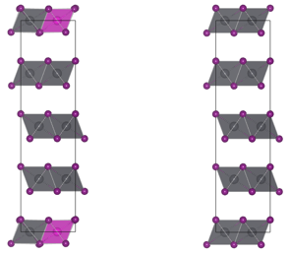
Supplementary Fig. 24. The models of the Cd mixed (left) and the pristine (right) PbI₂ bulk structure. The pink and dark grey colors indicate Cd and Pb, respectively.

We then focus on the effect of Ac in influencing the formation of the layered structure of PbI₂. The effective ionic radius of the Ac anion is 162 pm, and it is smaller than the chloride anion (181 pm), which is known unable to mix with FAPbI₃⁴⁵. Therefore, we conclude that Ac anions cannot be incorporated into the cubic lattice of α-FAPbI₃. We speculate that the Ac would locate at the grain boundary and play a role in guiding the growth of perovskite and passivating defects. For that, we construct a four-layer PbI₂ model with or without the Ac substitution of I⁻, see Supplementary Fig. 25. The interlayer binding energy is calculated by the following equation:
E_{bind} = E [PbI₂ four-layers] – 2×E [PbI₂ two-layers] (2)
The interlayer binding energy significantly decreases from -0.06 eV/formula unit to -0.01 eV/formula unit. This indicates that the incorporation of Ac remarkably reduces the interlayer binding strength of PbI₂. We, therefore, conclude that adding CdAc₂ will weaken the interlayer binding strength of the PbI₂ layer, resulting in more pin-holes after the film formation.

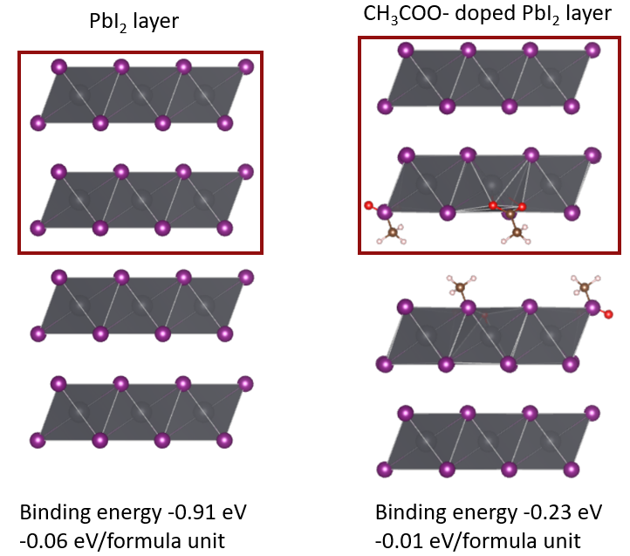
Supplementary Fig. 25. The models of the pristine PbI₂ layer and the Ac incorporated PbI₂ layer. The binding energies and the binding energies normalized to the formula unit are listed at the bottom. The binding energy of the model are normalized to each PbI₂ (including part of PbAc₂ in the substituted model). The pink and dark grey colours indicate Cd and Pb, respectively.

Supplementary Note 2.
Theoretical insight for the larger grain size
At the second step, i.e. the conversion from layered PbI₂ structure to perovskite, the Ac needs to be exchanged with the I⁻. We here evaluate the feasibility of the I⁻ substituting the Ac⁻. For that, we construct models (Supplementary Fig. 26) and access the reaction energy of exchanging the Ac⁻ by HI or FAI by the following equations:
Pb₈I₁₄(CH₃COO)₂ + 2HI Pb₈I₁₆ + 2CH₃COOH (3)
Pb₈I₁₄(CH₃COO)₂ + 2FAI Pb₈I₁₆ + 2CH₃COOH_FA(deprotonated) (4)
The calculated reaction energy is -2.70 eV and -1.09 eV for HI and FAI, respectively. Such negative formation energies indicate Ac can be easily exchanged from layers by I⁻.

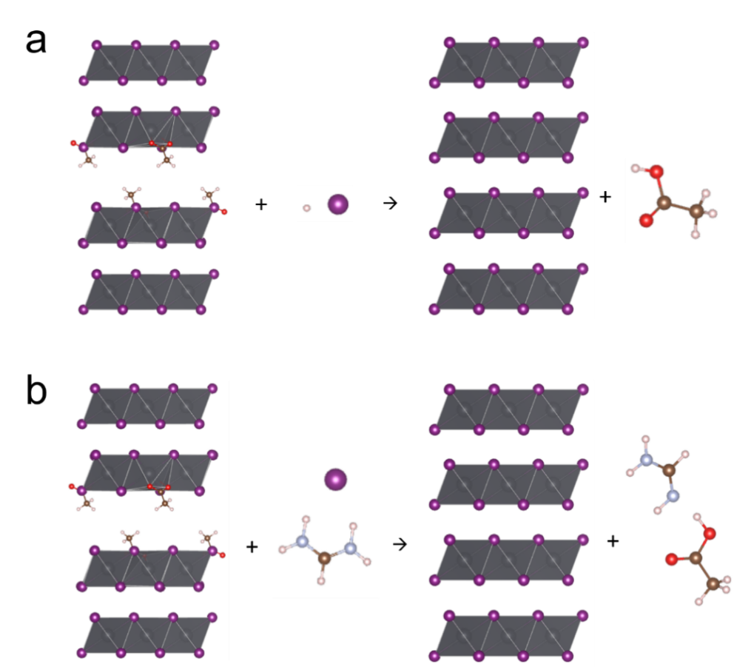
Supplementary Fig. 26. The scheme for the calculation of reaction energy for exchanging the Ac by (a) HI or (b) FAI. The pink, dark grey, red, blue, brown, light red coloured spheres indicate Cd, Pb, O, N, C, H, respectively.

Because of the incorporation of Cd in the PbI₂ layered structure, it has consequences on the transform from layered structure to perovskite. The transformation from a face-sharing structure in PbI₂ to a corner-sharing structure in perovskite requires (1) the breaking the metal-I bond in MI₂ layer and followed by formation of new M-I bonds in 3D perovskites. To get a picture of the strength of the involved bonds, we calculate the energy cost of removing one I in both 2D and 3D systems as:
E_{eli} [ion] = E_{tot} [ion-vac] – E_{tot} [surface] + μ[ion] + qE_{Fermi} (5)
The E_{Fermi} and μ[ion] is assumed to be the same. We define the difference in the energy cost due to the introduction of Cd, as:
ΔE_{eli} = E_{eli} [ion] [Cd] – E_{eli} [ion] (6)
For the PbI₂, we constructed a one-layer PbI₂ model to evaluate the defect formation energy (Supplementary Fig. 27). The energy cost increase with the incorporation of Cd (0.02 eV/formula unit), indicating a harder removal of the I⁻ (Supplementary Fig. 28). This indicates the bond in PbI₂ becoming more difficult to break, leading to a higher activation barrier of the PbI₂ to perovskite transformation, thus slowing down the corresponding reaction process. The slab models to evaluate the defect formation energy of perovskites are shown in Supplementary Fig. 29. In contrast, the energy cost in the perovskite is decreased (-0.03 eV/formula unit), which indicates that the Cd-I bond in the perovskite is harder to form and potentially slowing down the crystallization process (Supplementary Fig. 30). Our calculation results also show that the introduction of Cd can greatly reduce the defects of FAPbI₃ film.

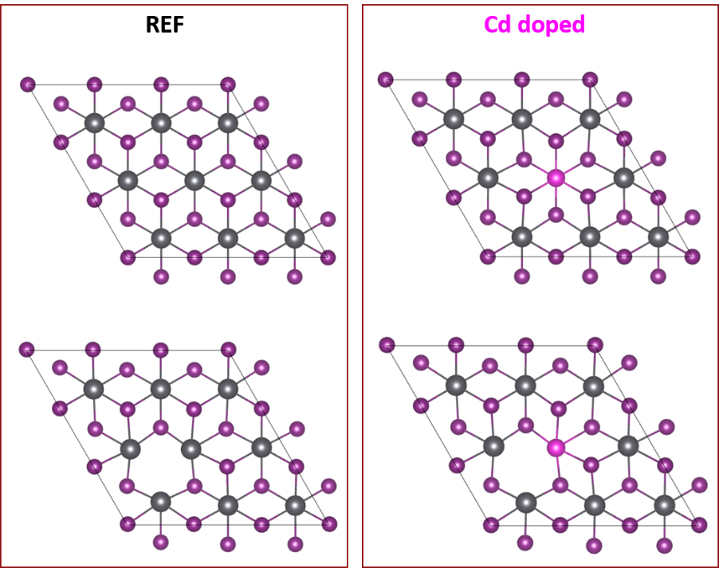₋
Supplementary Fig. 27. The models for calculating the defect formation energies of a I vacancy in the PbI₂ layer with and without the incorporation of Cd. The pink and dark grey colors indicate Cd and Pb, respectively.

Supplementary Fig. 28. Defect formation energy of a I vacancy in PbI₂ layer with and without the incorporation of Cd. The defect formation energy of the model are normalized to each PbI₂ (including part of CdI₂ in the substituted model). The value is normalized to per PbI₂ unit as 0.02 eV/formula unit.

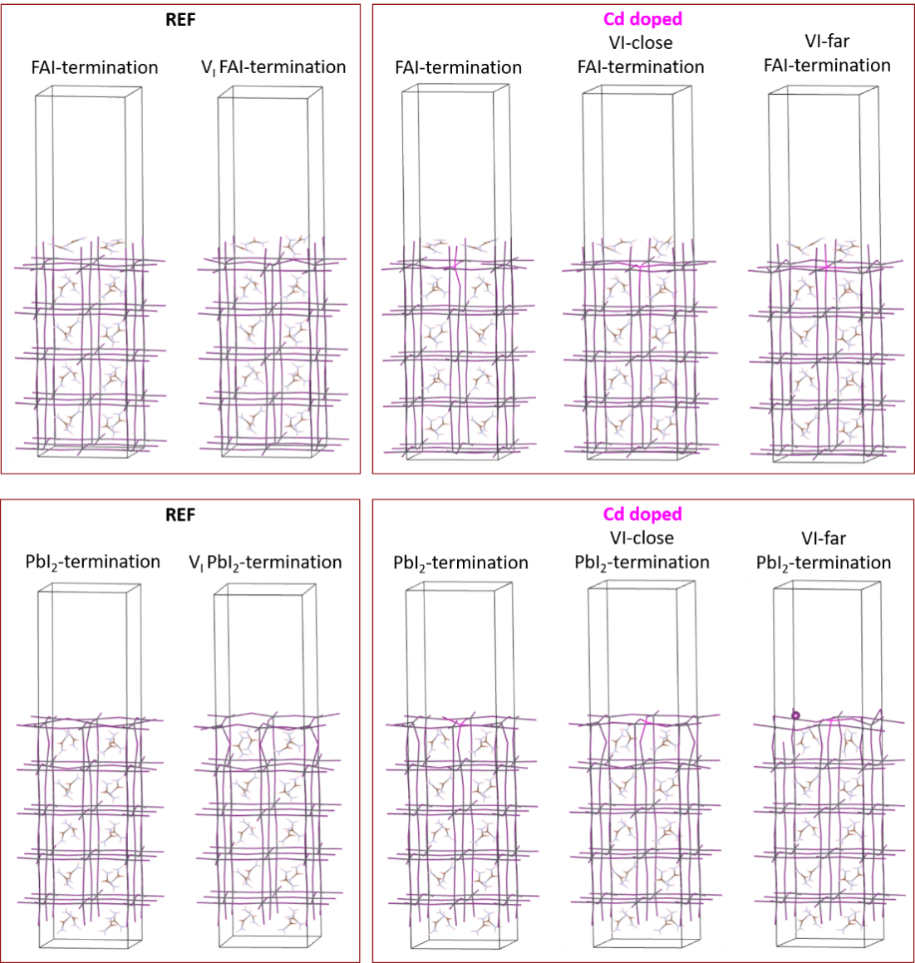
Supplementary Fig. 29. The models for calculating the defect formation energy of FAPbI₃ with the incorporation of Cd on the FAI- and PbI₂-termination, respectively.

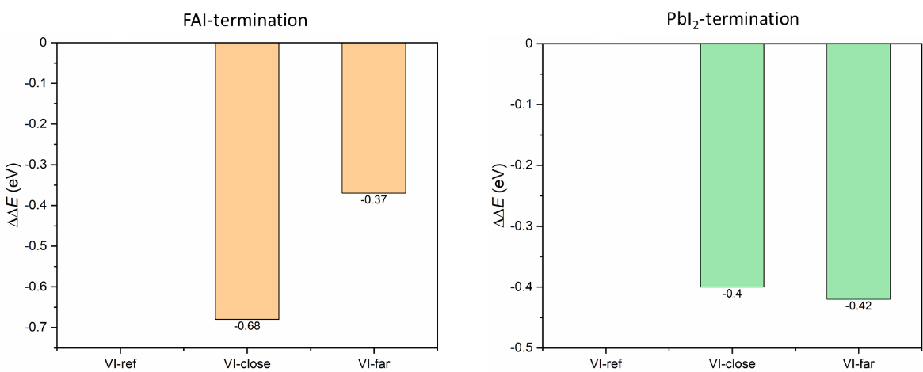
Supplementary Fig. 30. Defect formation energy of FAPbI₃ with the incorporation of Cd on the FAI- and PbI₂-termination, respectively. The maximum value -0.68 eV from FAI-termination is the largest difference found in the two systems and this value is normalized to -0.03 eV/formula unit. The defect formation energy of the model are normalized to each AMX₃ (A = FA; M = Pb, Cd; X = I), and there are 20 AMX₃ unit included in our model.

References
1. Kumar, M. H. et al. Flexible, low-temperature, solution processed ZnO-based perovskite solid state solar cells. Chem. Commun. 49, 11089-11091 (2013).
2. Liu, D. Kelly, T. L. Perovskite solar cells with a planar heterojunction structure prepared using room-temperature solution processing techniques. Nature Photon. 8, 133-138 (2013).
3. Docampo, P. et al. Efficient organometal trihalide perovskite planar-heterojunction solar cells on flexible polymer substrates. Nat. Commun. 4, 2761 (2013).
4. Jung, J. W. et al. Low-temperature processed high-performance flexible perovskite solar cells via rationally optimized solvent washing treatments. RSC Adv. 4, 62971-62977 (2014).
5. Yang, D. et al. High efficiency flexible perovskite solar cells using superior low temperature TiO₂. Energy Environ. Sci. 8, 3208-3214 (2015).
6. Tavakoli, M. et al. Highly efficient flexible perovskite solar cells with antireflection and self-cleaning nanostructures. ACS Nano 9, 10287-10295 (2015).
7. Jeong, I. et al. A tailored TiO₂ electron selective layer for high-performance flexible perovskite solar cells via low temperature UV process. Nano Energy 28, 380-389 (2016).
8. Wang, C. et al. Water vapor treatment of low-temperature deposited SnO₂ electron selective layers for efficient flexible perovskite solar cells. ACS Energy Lett. 2, 2118-2124 (2017).
9. Bi, C. et al. DeLuca and J. Huang, Efficient flexible solar cell based on composition-tailored hybrid perovskite. Adv. Mater. 29 1605900 (2017).
10. Jiang, J. et al. High-performance flexible perovskite solar cells with effective interfacial optimization processed at low temperatures. ChemSusChem 11, 4131-4138 (2018).
11. Heo, J. H. et al. Super-flexible bis(trifluoromethanesulfonyl)-amide doped graphene transparent conductive electrodes for photo-stable perovskite solar cells. J. Mater. Chem. A 6, 8251-8258 (2018).
12. Li, M. et al. Perovskite grains embraced in a soft fullerene network make highly efficient flexible solar cells with superior mechanical stability. Adv. Mater. 31, e1901519 (2019).
13. Huang, K. et al. High-performance flexible perovskite solar cells via precise control of electron transport layer. Adv. Energy Mater. 9, 1901419 (2019).
14. Meng, X. et al. Bio-inspired vertebral design for scalable and flexible perovskite solar cells. Nat. Commun. 11, 3016 (2020).
15. Ru, P. et al. High Electron affinity enables fast hole extraction for efficient flexible inverted perovskite solar cells. Adv. Energy Mater. 10, 1903487 (2020).
16. Chung, J. et al. Record-efficiency flexible perovskite solar cell and module enabled by a porous-planar structure as an electron transport layer. Energy Environ. 13, 4854-4861 (2020).
17. Dong, Q. et al. Interpenetrating interfaces for efficient perovskite solar cells with high operational stability and mechanical robustness. Nat. Commun. 12, 973 (2021).
18. Jiang, N. et al. Enhanced efficiency and mechanical robustness of flexible perovskite solar cells by using HPbI₃ Additive. Solar RRL 5, 2000821 (2021).
19. Wu, S. et al. Low-bandgap organic bulk-heterojunction enabled efficient and flexible perovskite solar cells. Adv. Mater. 2105539 (2021).
20. Sahli, F. et al. Fully textured monolithic perovskite/silicon tandem solar cells with 25.2% power conversion efficiency. Nat. Mater. 17, 820-826 (2018).
21. Chen, B. et al. Grain engineering for perovskite/silicon monolithic tandem solar cells with efficiency of 254%. Joule 3, 177-190 (2018).
22. Jošt, M. et al. Textured interfaces in monolithic perovskite/silicon tandem solar cells: advanced light mangement for improved efficiency and energy yield. Energy Environ. Sci. 11, 3511-3523 (2018).
23. Bush, K. A. et al. Minimizing current and voltage losses to reach 25% efficient monolithic two-terminal perovskite-silicon tandem solar cells. ACS Energy Lett. 3, 2173-2180 (2018).
24. Oxford PV sets world record for perovskite solar cell, https://www.oxfordpv.com/news/oxford-pv-sets-world-record-perovskite-solarcell, (accessed: June 2018).
25. https://www.oxfordpv.com/news/oxford-pv-perovskite-solar-cellachieves-28-efficiency, (accessed: September 2019).
26. Mazzarella, L. et al. Infrared light management using a nanocrystalline silicon oxide interlayer in monlithic perovskite/silicon heterojunction tandem solar cells with efficiency above 25%. Adv. Energy Mater. 9, 1803241 (2019).
27. Nogay, G. et al. 25.1%-efficient monolithic perovskite/silicon tandem solar cell based on a-p-type monocrystalline textured silicon wafer and high-temperature passivating contacts. ACS Energy Lett. 4, 844-845 (2019).
28. Köhnen, E. et al. Highly efficient monolithic perovskite silicon tandem solar cells: analyzing the influence of current mismatch on device performance. Sustain. Energy Fuels 3, 1995-2005 (2019).
29. Xu, J. et al. Triple-halide wide-band gap perovskites with suppressed phase segregation for efficient tandems. Science 367, 1097-1104 (2020).
30. Hou, Y. et al. Sargent, Efficient tandem solar cells with solution-processed perovskite on textured crystalline silicon. Science 367, 1135-1140 (2020).
31. Kim, D. et al. Efficient, stable silicon tandem cells tandem cells enabled by anion-engineered wide-bandgap perovskites. Science 368, 155-160 (2020).
32. Chen, B. et al. Blade-coated perovskites on textured silicon for 26%-efficient monolithic perovskite/silicon tandem solar cells. Joule 4, 850-864 (2020).
33. Schulze, P. S. C. et al. 25.1% high-efficiency monolithic perovskite silicon tandem solar cell with a high bandgap perovskite absorber. Solar RRL 4, 2000152 (2020).
34. Aydin, E. et al. Interplay between temperature and bandgap energies on the outdoor performance of perovskite/silicon tandem solar cells. Nat. Energy 5, 851-859 (2020).
35. Al-Ashouri, A. et al. Monolithic perovskite/silicon tandem solar cell with >29% efficiency by enhanced hole extraction. Science 370, 1300-1309 (2020).
36. National renewble energy laboratory, (NREL) chart, https://www.nrel.gov/pv/assets/pdfs/pvefficiency-chart.20200104.pdf, (2020).
37. Bastiani, M. D. et al. Efficient bifacial monolithic perovskite/silicon tandem solar cells via bandgap engineering. Nat. Energy 6, 167-175 (2021).
38. Isikgor, F. H. et al. Concurrent cationic and anionic perovskite defect passivation enables 27.4% perovskite/silicon tandems with suppression of halide segregation. Joule 5, P1566 (2021).
39. Li, Y. C. et al. Wide bandgap interface layer induced stabilized perovskite/silicon tandem solar cells with stability over ten thousand hours. Adv. Energy Mater. 2102046 (2021).
40. Zheng, J. h. et al. Large area efficient interface layer free monolithic perovskite/homo-junction-silicon tandem solar cell with over 20% efficiency. Energy Environ. Sci. 11, 2432 (2018).
41. Sahli, F. et al. Improved optics in monolithic perovskite/silicon tandem solar cells with a nanocrystalline silicon recombination junction. Adv. Energy Mater. 8, 1701609 (2018).
42. Zheng, J. H. et al. 21.8% efficient monolithic perovskite/homo-junction-silicon tandem solar cell on 16 cm². ACS Energy Lett. 3, 2299−2300 (2018).
43. Kamino, B. A. et al. low-temperature screen-printed metallization for the scale-up of two-terminal perovskite−silicon tandems. ACS Appl. Energy Mater. 2, 3815−3821 (2019).
44. Jenkins, H. Thakur, K. Reappraisal of thermochemical radii for complex ions. J. Chem. Educ. 56, 576 (1979).
45. Jeong, J. et al. Pseudo-halide anion engineering for α-FAPbI₃ perovskite solar cells. Nature 592, 381-385 (2021).

