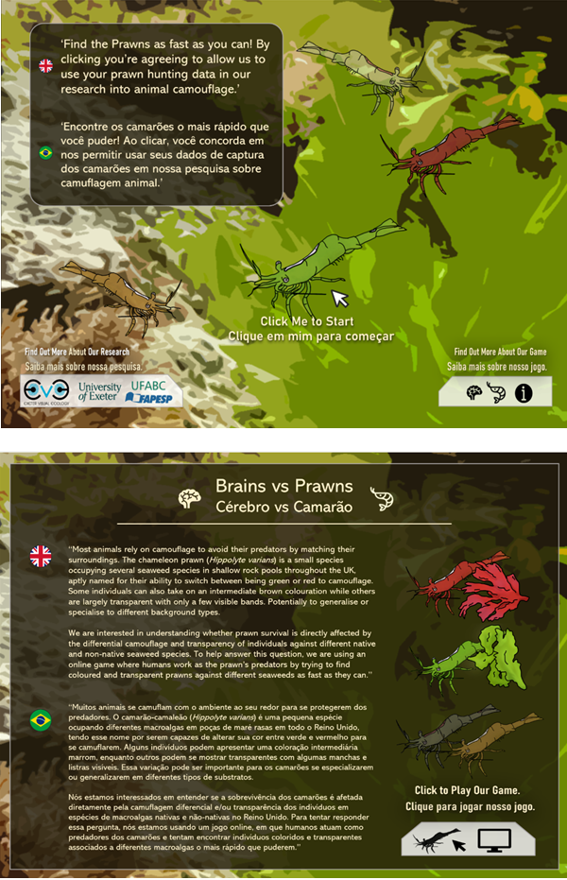
Figure S1. Welcome screen of the online “Find the Prawn” game used to investigate how the colour type of realistic computer-generated chameleon prawns (Hippolyte varians) and seaweed background influence detection by human participants acting as surrogate predators. Before starting the game, players were presented with a brief description of the study, instructions on how to play, and informed consent information. All game instructions were available in both English and Brazilian Portuguese.

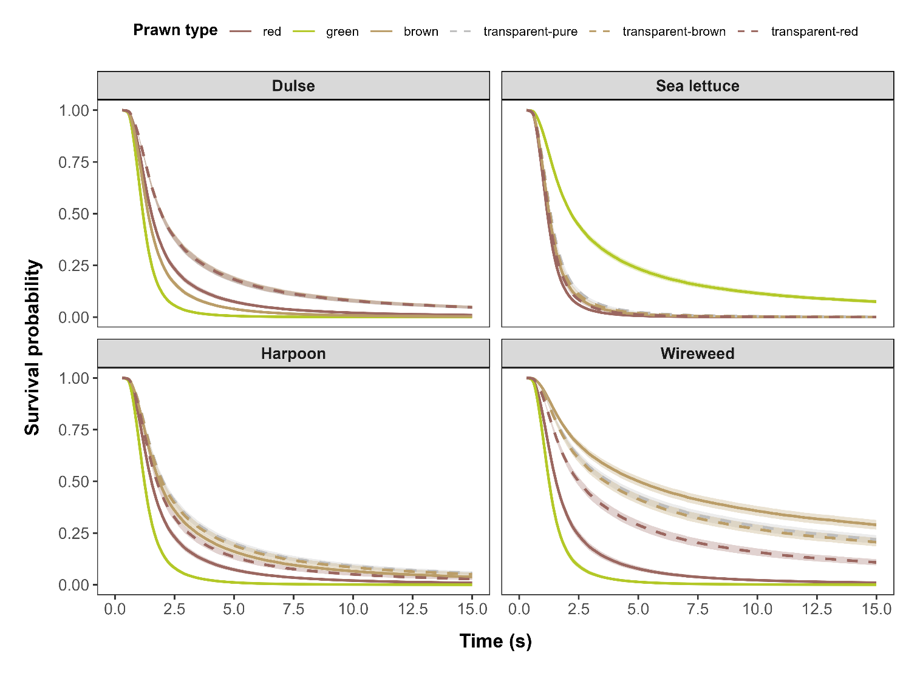
Figure S2. Survival curves showing the probability of remaining undetected over time for red, green, brown, transparent-pure, transparent-brown, and transparent-red chameleon prawn (Hippolyte varians) models presented against four seaweed backgrounds: red dulse (Palmaria palmata), green sea lettuce (Ulva lactuca), pink harpoon weed (Asparagopsis armata), and brown wireweed (Sargassum muticum) to human participants in an online “Find the Prawn” game. Differences among curves reflect variation in the hazard of detection of each prawn colour type across seaweed backgrounds. Shaded areas represent 95% confidence intervals, based on 45,888 prawn presentations from 3,367 participants.

Table S1. Pairwise Tukey post-hoc comparisons from the generalized linear mixed-effects model testing for differences in the probability of timeout (i.e., failure to detect the prawn within the 15-s time limit) among six computer-generated chameleon prawn (Hippolyte varians) colour types (solid-red, SR; solid-green, SG; solid-brown, SB; transparent-pure, TP; transparent-brown, TB; and transparent-red, TR) presented against four seaweed backgrounds (red dulse, Palmaria palmata; green sea lettuce, Ulva lactuca; pink harpoon weed, Asparagopsis armata; and brown wireweed, Sargassum muticum) in the online "Find the Prawn" game. Human participants acted as surrogate predators. Significant pairwise differences are shown in bold.
Dulse (Palmaria palmata)
Contrast | Estimate | SE | Z ratio | p value
SR – SG | 1.437 | 0.388 | 3.71 | 0.003
SR – SB | 0.779 | 0.317 | 2.46 | 0.136
SR – TP | -1.028 | 0.225 | -4.56 | < 0.0001
SR – TB | -1.555 | 0.217 | -7.18 | < 0.0001
SR – TR | -1.341 | 0.219 | -6.12 | < 0.0001
SG – SB | -0.658 | 0.424 | -1.55 | 0.630
SG – TP | -2.466 | 0.361 | -6.83 | < 0.0001
SG – TB | -2.993 | 0.356 | -8.40 | < 0.0001
SG – TR | -2.778 | 0.358 | -7.77 | < 0.0001
SB – TP | -1.808 | 0.283 | -6.38 | < 0.0001
SB – TB | -2.335 | 0.276 | -8.45 | < 0.0001
SB – TR | -2.120 | 0.278 | -7.62 | < 0.0001
TP – TB | -0.527 | 0.163 | -3.24 | 0.015
TP – TR | -0.312 | 0.166 | -1.88 | 0.412
TB – TR | 0.215 | 0.153 | 1.40 | 0.727
Sea lettuce (Ulva lactuca)
Contrast | Estimate | SE | Z ratio | p value
SR – SG | -2.214 | 0.260 | -8.51 | < 0.0001
SR – SB | 0.327 | 0.361 | 0.91 | 0.945
SR – TP | -0.146 | 0.328 | -0.45 | 0.998
SR – TB | -0.040 | 0.327 | -0.12 | 1.000
SR – TR | -0.085 | 0.326 | -0.26 | 1.000
SG – SB | 2.541 | 0.292 | 8.70 | < 0.0001
SG – TP | 2.068 | 0.249 | 8.29 | < 0.0001
SG – TB | 2.174 | 0.249 | 8.74 | < 0.0001
SG – TR | 2.130 | 0.248 | 8.58 | < 0.0001
SB – TP | -0.473 | 0.353 | -1.34 | 0.763
SB – TB | -0.367 | 0.352 | -1.04 | 0.903
SB – TR | -0.412 | 0.352 | -1.17 | 0.852
TP – TB | 0.106 | 0.319 | 0.33 | 0.999
TP – TR | 0.062 | 0.318 | 0.19 | 1.000
TB – TR | -0.044 | 0.317 | -0.14 | 1.000
Harpoon (Asparagopsis armata)
Contrast | Estimate | SE | Z ratio | p value
SR – SG | 1.343 | 0.332 | 4.04 | 0.0007
SR – SB | -0.493 | 0.215 | -2.30 | 0.195
SR – TP | -0.975 | 0.203 | -4.80 | < 0.0001
SR – TB | -0.935 | 0.201 | -4.64 | < 0.0001
SR – TR | -0.562 | 0.213 | -2.64 | 0.088
SG – SB | -1.836 | 0.320 | -5.73 | < 0.0001
SG – TP | -2.317 | 0.313 | -7.39 | < 0.0001
SG – TB | -2.278 | 0.312 | -7.29 | < 0.0001
SG – TR | -1.905 | 0.320 | -5.96 | < 0.0001
SB – TP | -0.481 | 0.184 | -2.62 | 0.092
SB – TB | -0.441 | 0.182 | -2.43 | 0.147
SB – TR | -0.068 | 0.195 | -0.35 | 0.999
TP – TB | 0.040 | 0.168 | 0.24 | 1.000
TP – TR | 0.413 | 0.181 | 2.28 | 0.204
TB – TR | 0.373 | 0.180 | 2.08 | 0.300
Wireweed (Sargassum muticum)
Contrast | Estimate | SE | Z ratio | p value
SR – SG | 1.593 | 0.518 | 3.08 | 0.025
SR – SB | -3.536 | 0.241 | -14.66 | < 0.0001
SR – TP | -2.977 | 0.242 | -12.31 | < 0.0001
SR – TB | -2.865 | 0.244 | -11.73 | < 0.0001
SR – TR | -1.932 | 0.254 | -7.60 | < 0.0001
SG – SB | -5.129 | 0.476 | -10.77 | < 0.0001
SG – TP | -4.571 | 0.476 | -9.59 | < 0.0001
SG – TB | -4.458 | 0.478 | -9.33 | < 0.0001
SG – TR | -3.526 | 0.483 | -7.30 | < 0.0001
SB – TP | 0.558 | 0.123 | 4.53 | < 0.0001
SB – TB | 0.671 | 0.128 | 5.26 | < 0.0001
SB – TR | 1.603 | 0.148 | 10.82 | < 0.0001
TP – TB | 0.113 | 0.131 | 0.86 | 0.955
TP – TR | 1.045 | 0.149 | 7.00 | < 0.0001
TB – TR | 0.932 | 0.153 | 6.08 | < 0.0001

Table S2. Pairwise Tukey post-hoc comparisons from the mixed-effects survival model testing for differences in the hazard of detection among six computer-generated chameleon prawn (Hippolyte varians) colour types (solid-red, SR; solid-green, SG; solid-brown, SB; transparent-pure, TP; transparent-brown, TB; and transparent-red, TR) presented against four seaweed backgrounds (red dulse, Palmaria palmata; green sea lettuce, Ulva lactuca; pink harpoon weed, Asparagopsis armata; and brown wireweed, Sargassum muticum) in the online "Find the Prawn" game. Human participants acted as surrogate predators. Significant pairwise differences are shown in bold.
Dulse (Palmaria palmata)
Contrast | Estimate | SE | Z ratio | p value
SR – SG | -0.876 | 0.034 | -25.78 | < 0.0001
SR – SB | -0.265 | 0.033 | -7.91 | < 0.0001
SR – TP | 0.552 | 0.034 | 16.20 | < 0.0001
SR – TB | 0.561 | 0.035 | 16.23 | < 0.0001
SR – TR | 0.526 | 0.034 | 15.29 | < 0.0001
SG – SB | 0.612 | 0.033 | 18.38 | < 0.0001
SG – TP | 1.429 | 0.034 | 41.81 | < 0.0001
SG – TB | 1.438 | 0.035 | 41.45 | < 0.0001
SG – TR | 1.402 | 0.034 | 40.69 | < 0.0001
SB – TP | 0.817 | 0.034 | 24.33 | < 0.0001
SB – TB | 0.826 | 0.034 | 24.22 | < 0.0001
SB – TR | 0.791 | 0.034 | 23.34 | < 0.0001
TP – TB | 0.009 | 0.034 | 0.26 | 1.000
TP – TR | -0.026 | 0.034 | -0.77 | 0.973
TB – TR | -0.035 | 0.035 | -1.01 | 0.914
Sea lettuce (Ulva lactuca)
Contrast | Estimate | SE | Z ratio | p value
SR – SG | 1.727 | 0.031 | 54.76 | < 0.0001
SR – SB | 0.302 | 0.030 | 10.08 | < 0.0001
SR – TP | 0.444 | 0.030 | 14.68 | < 0.0001
SR – TB | 0.355 | 0.030 | 11.96 | < 0.0001
SR – TR | 0.200 | 0.030 | 6.67 | < 0.0001
SG – SB | -1.425 | 0.031 | -45.78 | < 0.0001
SG – TP | -1.283 | 0.031 | -41.10 | < 0.0001
SG – TB | -1.372 | 0.031 | -44.54 | < 0.0001
SG – TR | -1.527 | 0.031 | -49.12 | < 0.0001
SB – TP | 0.142 | 0.030 | 4.76 | < 0.0001
SB – TB | 0.053 | 0.029 | 1.81 | 0.457
SB – TR | -0.102 | 0.030 | -3.45 | 0.007
TP – TB | -0.089 | 0.030 | -3.00 | 0.032
TP – TR | -0.244 | 0.030 | -8.15 | < 0.0001
TB – TR | -0.155 | 0.029 | -5.29 | < 0.0001
Harpoon (Asparagopsis armata)
Contrast | Estimate | SE | Z ratio | p value
SR – SG | -0.734 | 0.037 | -20.05 | < 0.0001
SR – SB | 0.509 | 0.036 | 13.96 | < 0.0001
SR – TP | 0.704 | 0.037 | 18.96 | < 0.0001
SR – TB | 0.592 | 0.037 | 16.00 | < 0.0001
SR – TR | 0.414 | 0.037 | 11.29 | < 0.0001
SG – SB | 1.244 | 0.036 | 34.25 | < 0.0001
SG – TP | 1.438 | 0.037 | 38.76 | < 0.0001
SG – TB | 1.326 | 0.037 | 35.88 | < 0.0001
SG – TR | 1.149 | 0.037 | 31.36 | < 0.0001
SB – TP | 0.194 | 0.037 | 5.30 | < 0.0001
SB – TB | 0.083 | 0.037 | 2.26 | 0.211
SB – TR | -0.095 | 0.036 | -2.62 | 0.093
TP – TB | -0.111 | 0.037 | -2.99 | 0.033
TP – TR | -0.289 | 0.037 | -7.82 | < 0.0001
TB – TR | -0.178 | 0.037 | -4.82 | < 0.0001
Wireweed (Sargassum muticum)
Contrast | Estimate | SE | Z ratio | p value
SR – SG | -0.589 | 0.043 | -13.77 | < 0.0001
SR – SB | 1.727 | 0.046 | 37.44 | < 0.0001
SR – TP | 1.484 | 0.044 | 33.36 | < 0.0001
SR – TB | 1.435 | 0.045 | 31.73 | < 0.0001
SR – TR | 0.981 | 0.044 | 22.08 | < 0.0001
SG – SB | 2.316 | 0.046 | 49.89 | < 0.0001
SG – TP | 2.074 | 0.045 | 46.38 | < 0.0001
SG – TB | 2.024 | 0.045 | 44.52 | < 0.0001
SG – TR | 1.571 | 0.045 | 35.06 | < 0.0001
SB – TP | -0.243 | 0.047 | -5.16 | < 0.0001
SB – TB | -0.292 | 0.048 | -6.11 | < 0.0001
SB – TR | -0.746 | 0.047 | -15.73 | < 0.0001
TP – TB | -0.049 | 0.046 | -1.07 | 0.895
TP – TR | -0.503 | 0.046 | -10.98 | < 0.0001
TB – TR | -0.454 | 0.047 | -9.74 | < 0.0001

Table S3. Pairwise Tukey post-hoc comparisons from the generalized linear mixed-effects model testing for differences in the probability of timeout (i.e., failure to detect the prawn within the 15-s time limit) among four computer-generated chameleon prawn (Hippolyte varians) colour types (red, green, brown and transparent) presented against four seaweed backgrounds (red dulse, Palmaria palmata; green sea lettuce, Ulva lactuca; pink harpoon weed, Asparagopsis armata; and brown wireweed, Sargassum muticum) in the online "Find the Prawn" game. Human participants acted as surrogate predators. Significant pairwise differences are shown in bold.
Dulse (Palmaria palmata)
Contrast | Estimate | SE | Z ratio | p value
Red – Green | 1.438 | 0.387 | 3.71 | 0.001
Red – Brown | 0.781 | 0.317 | 2.47 | 0.065
Red – Transparent | -1.314 | 0.199 | -6.59 | < 0.0001
Green – Brown | -0.657 | 0.424 | -1.55 | 0.407
Green – Transparent | -2.753 | 0.346 | -7.96 | < 0.0001
Brown – Transparent | -2.096 | 0.263 | -7.96 | < 0.0001
Sea lettuce (Ulva lactuca)
Contrast | Estimate | SE | Z ratio | p value
Red – Green | -2.214 | 0.260 | -8.51 | < 0.0001
Red – Brown | 0.327 | 0.361 | 0.91 | 0.801
Red – Transparent | -0.089 | 0.270 | -0.33 | 0.988
Green – Brown | 2.541 | 0.292 | 8.72 | < 0.0001
Green – Transparent | 2.125 | 0.168 | 12.69 | < 0.0001
Brown – Transparent | -0.416 | 0.301 | -1.38 | 0.510
Harpoon (Asparagopsis armata)
Contrast | Estimate | SE | Z ratio | p value
Red – Green | 1.346 | 0.332 | 4.06 | 0.0003
Red – Brown | -0.492 | 0.214 | -2.29 | 0.100
Red – Transparent | -0.834 | 0.178 | -4.68 | < 0.0001
Green – Brown | -1.838 | 0.320 | -5.75 | < 0.0001
Green – Transparent | -2.180 | 0.298 | -7.33 | < 0.0001
Brown – Transparent | -0.342 | 0.156 | -2.19 | 0.125
Wireweed (Sargassum muticum)
Contrast | Estimate | SE | Z ratio | p value
Red – Green | 1.594 | 0.518 | 3.08 | 0.011
Red – Brown | -3.528 | 0.241 | -14.64 | < 0.0001
Red – Transparent | -2.659 | 0.232 | -11.48 | < 0.0001
Green – Brown | -5.122 | 0.476 | -10.76 | < 0.0001
Green – Transparent | -4.253 | 0.471 | -9.02 | < 0.0001
Brown – Transparent | 0.869 | 0.102 | 8.49 | 0.0004

Table S4. Pairwise Tukey post-hoc comparisons from the mixed-effects survival model testing for differences in the hazard of detection among four computer-generated chameleon prawn (Hippolyte varians) colour types (red, green, brown and transparent) presented against four seaweed backgrounds (red dulse, Palmaria palmata; green sea lettuce, Ulva lactuca; pink harpoon weed, Asparagopsis armata; and brown wireweed, Sargassum muticum) in the online "Find the Prawn" game. Human participants acted as surrogate predators. Significant pairwise differences are shown in bold.
Dulse (Palmaria palmata)
Contrast | Estimate | SE | Z ratio | p value
Red – Green | -0.874 | 0.034 | -25.72 | < 0.0001
Red – Brown | -0.262 | 0.033 | -7.83 | < 0.0001
Red – Transparent | 0.544 | 0.028 | 19.46 | < 0.0001
Green – Brown | 0.612 | 0.033 | 18.39 | < 0.0001
Green – Transparent | 1.418 | 0.028 | 50.49 | < 0.0001
Brown – Transparent | 0.806 | 0.027 | 29.47 | < 0.0001
Sea lettuce (Ulva lactuca)
Contrast | Estimate | SE | Z ratio | p value
Red – Green | 1.724 | 0.031 | 54.67 | < 0.0001
Red – Brown | 0.301 | 0.030 | 10.06 | < 0.0001
Red – Transparent | 0.336 | 0.025 | 13.66 | < 0.0001
Green – Brown | -1.423 | 0.031 | -45.72 | < 0.0001
Green – Transparent | -1.388 | 0.026 | -53.61 | < 0.0001
Brown – Transparent | 0.035 | 0.024 | 1.45 | 0.469
Harpoon (Asparagopsis armata)
Contrast | Estimate | SE | Z ratio | p value
Red – Green | -0.733 | 0.037 | -20.03 | < 0.0001
Red – Brown | 0.506 | 0.036 | 13.88 | < 0.0001
Red – Transparent | 0.571 | 0.030 | 18.96 | < 0.0001
Green – Brown | 1.239 | 0.036 | 34.15 | < 0.0001
Green – Transparent | 1.304 | 0.030 | 43.38 | < 0.0001
Brown – Transparent | 0.065 | 0.030 | 2.18 | 0.127
Wireweed (Sargassum muticum)
Contrast | Estimate | SE | Z ratio | p value
Red – Green | -0.591 | 0.043 | -13.81 | < 0.0001
Red – Brown | 1.721 | 0.046 | 37.30 | < 0.0001
Red – Transparent | 1.314 | 0.036 | 36.61 | < 0.0001
Green – Brown | 2.311 | 0.046 | 49.79 | < 0.0001
Green – Transparent | 1.905 | 0.036 | 52.59 | < 0.0001
Brown – Transparent | -0.406 | 0.039 | -10.37 | < 0.0001

Table S5. Tukey post-hoc pairwise comparisons from the mixed-effects survival models testing for differences in the hazard of detection among four computer-generated chameleon prawn (Hippolyte varians) colour types (red, green, brown, and transparent) as a function of their level of (a) achromatic contrast and (b) chromatic contrast to the surrounding seaweed background in the online “Find the Prawn” game. Human participants acted as surrogate predators. Significant pairwise differences are shown in bold.
- Achromatic contrast
Contrast | Estimate | SE | Z ratio | p value
Red – Green | -0.037 | 0.002 | -17.36 | < 0.0001
Red – Brown | -0.017 | 0.002 | -7.86 | < 0.0001
Red – Transparent | -0.067 | 0.002 | -27.77 | < 0.0001
Green – Brown | 0.020 | 0.002 | 8.99 | < 0.0001
Green – Transparent | -0.030 | 0.003 | -9.99 | < 0.0001
Brown – Transparent | -0.050 | 0.003 | -18.59 | < 0.0001
- Chromatic contrast
Contrast | Estimate | SE | Z ratio | p value
Red – Green | -0.006 | 0.002 | -3.18 | 0.008
Red – Brown | -0.022 | 0.001 | -21.02 | < 0.0001
Red – Transparent | -0.085 | 0.002 | -49.10 | < 0.0001
Green – Brown | -0.016 | 0.002 | -7.73 | < 0.0001
Green – Transparent | -0.080 | 0.003 | -26.01 | < 0.0001
Brown – Transparent | -0.064 | 0.002 | -37.61 | < 0.0001

