Supporting information

Methods - Censoring analysis
The high- and low-risk Cox-PH models used to assess informative censoring produced substantially different estimates from one another (Fig. 2, Table S1), suggesting the presence of informative censoring within the dataset. Censoring was significantly positively associated with smoking in the household (HR = 1.28, CI = 1.24–1.61), mean BMI in the second year of life (effect at 10 years HR = 1.22, CI = 1.05–1.43) and having a high index of deprivation (HR = 1.35, CI = 1.12–1.62; Fig. 2 and Table S1). Low exposure to gonadal hormones (<=448 days) was associated with a reduced hazard of censoring. As gonadal exposure and mean BMI were also significant in the unweighted Cox-PH death model (Table S1), this further suggested informative censoring and consequently, we applied Inverse Probability of Censoring Weighting (IPCW) to the Cox-PH death model to reduce this bias.

Results - Neuter status
As some dogs were censored before or at 24 months and entire, we could not define neuter status above 24 months. For 104 dogs, owners provided an age range rather than a specific date. These dogs were retained but were only included in selected classifications, e.g. a dog neutered between 4-13 months could be placed in the under 24 months gonad exposure category, but not in the under 12- or 6-month categories. In the calculation of median gonadal hormone exposure, two dogs that were reported as being spayed at 33 and 35 days were removed as this was considered likely to be incorrect. These dogs were retained for the main analysis as it was deemed likely they were neutered before 6 months and could therefore be categorised.

Tables

Table S1. Hazard ratios for multiple multivariable Cox proportional hazard (Cox PH) models including 2540 Labrador Retrievers. The ‘Censoring’ model estimated the hazard of being lost to follow-up (LTFU, n.b. administrative censoring and deaths are classed as ‘not censored’; orange) and four Cox-PH models estimated the hazard of death; the ‘Unweighted’ final model, final model weighted by Inverse Probability of Censoring, ‘IPCW’, ‘High risk’ (all LTFU dogs assumed to die the day after LTFU; red) and ‘Low risk’ (all LTFU dogs assumed to live until same age as longest-lived dog in study- 5755 days) models. Models share the same specifications except weighting and the censoring model does not include the time-varying effect for mean body mass index (BMI) over time. Mean BMI variables are expressed as a standardised hazard ratio interpreted as the hazard associated with a change from the 10th to the 90th percentile of BMI.
Model | Variable | Hazard ratio (95% CI) | Standard error | Statistic
Unweighted | Sex: Male | 1.186 (1.037-1.356) | 0.068 | 2.496
Unweighted | Smoking in household | 1.079 (0.877-1.327) | 0.106 | 0.716
Unweighted | Titbits given | 1.13 (0.918-1.39) | 0.106 | 1.153
Unweighted | Dry food only | 1.11 (0.96-1.283) | 0.074 | 1.405
Unweighted | Raw diet | 1.333 (1.059-1.678) | 0.117 | 2.445
Unweighted | Colour: Chocolate | 0.98 (0.82-1.17) | 0.09 | -0.228
Unweighted | Colour: Yellow | 1.14 (0.978-1.328) | 0.078 | 1.679
Unweighted | IMD category 4-5 | 1.048 (0.878-1.25) | 0.09 | 0.517
Unweighted | Gonadal exposure (<= 448 days) | 1.194 (1.044-1.366) | 0.069 | 2.588
Unweighted | Mean BMI in 2nd yr (at 10 yrs) | 1.266 (1.079-1.484) | 0.002 | 2.899
Unweighted | Mean BMI in 2nd yr (over time) | 1.169 (0.754-1.812) | 0.006 | 0.697
Unweighted | Extreme fetch in 2nd yr (>90th PC) | 1.253 (1.008-1.557) | 0.111 | 2.036
Inverse Probability of censoring weighted (IPCW) model | Sex: Male | 1.183 (1.034-1.355) | 0.058 | 2.44
Inverse Probability of censoring weighted (IPCW) model | Smoking in household | 1.108 (0.899-1.364) | 0.087 | 0.961
Inverse Probability of censoring weighted (IPCW) model | Titbits given | 1.157 (0.94-1.425) | 0.09 | 1.376
Inverse Probability of censoring weighted (IPCW) model | Dry food only | 1.113 (0.961-1.289) | 0.063 | 1.433
Inverse Probability of censoring weighted (IPCW) model | Raw diet | 1.337 (1.059-1.689) | 0.102 | 2.437
Inverse Probability of censoring weighted (IPCW) model | Colour: Chocolate | 0.961 (0.804-1.149) | 0.076 | -0.437
Inverse Probability of censoring weighted (IPCW) model | Colour: Yellow | 1.149 (0.986-1.34) | 0.067 | 1.776
Inverse Probability of censoring weighted (IPCW) model | IMD category 4-5 | 1.051 (0.88-1.255) | 0.073 | 0.552
Inverse Probability of censoring weighted (IPCW) model | Gonadal exposure (<= 448 days) | 1.185 (1.036-1.355) | 0.058 | 2.474
Inverse Probability of censoring weighted (IPCW) model | Mean BMI in 2nd yr (at 10 yrs) | 1.265 (1.071-1.494) | 0.002 | 2.768
Inverse Probability of censoring weighted (IPCW) model | Mean BMI in 2nd yr (over time) | 1.191 (0.802-1.771) | 0.006 | 0.866
Inverse Probability of censoring weighted (IPCW) model | Extreme fetch in 2nd yr (>90th PC) | 1.238 (0.994-1.54) | 0.092 | 1.909
High risk | Sex: Male | 1.071 (0.967-1.185) | 0.052 | 1.321
High risk | Smoking in household | 1.169 (1.004-1.361) | 0.078 | 2.008
High risk | Titbits given | 1.105 (0.931-1.311) | 0.087 | 1.145
High risk | Dry food only | 1.1 (0.985-1.227) | 0.056 | 1.696
High risk | Raw diet | 1.128 (0.945-1.346) | 0.09 | 1.335
High risk | Colour: Chocolate | 0.964 (0.841-1.104) | 0.069 | -0.534
High risk | Colour: Yellow | 1.047 (0.933-1.176) | 0.059 | 0.78
High risk | IMD category 4-5 | 1.173 (1.033-1.333) | 0.065 | 2.454
High risk | Gonadal exposure (<= 448 days) | 1.032 (0.931-1.143) | 0.052 | 0.598
High risk | Mean BMI in 2nd yr (at 10 yrs) | 1.257 (1.099-1.437) | 0.002 | 3.337
High risk | Mean BMI in 2nd yr (over time) | 1.03 (0.859-1.234) | 0.003 | 0.316
High risk | Extreme fetch in 2nd yr (>90th PC) | 1.232 (1.047-1.449) | 0.083 | 2.517
Low risk | Sex: Male | 1.099 (0.993-1.216) | 0.052 | 1.821
Low risk | Smoking in household | 0.978 (0.84-1.138) | 0.078 | -0.29
Low risk | Titbits given | 0.781 (0.66-0.924) | 0.086 | -2.885
Low risk | Dry food only | 0.99 (0.887-1.104) | 0.056 | -0.189
Low risk | Raw diet | 1.089 (0.913-1.3) | 0.09 | 0.951
Low risk | Colour: Chocolate | 1.077 (0.94-1.233) | 0.069 | 1.071
Low risk | Colour: Yellow | 1.045 (0.931-1.174) | 0.059 | 0.748
Low risk | IMD category 4-5 | 0.912 (0.802-1.037) | 0.066 | -1.401
Low risk | Gonadal exposure (<= 448 days) | 1.173 (1.058-1.299) | 0.052 | 3.043
Low risk | Mean BMI in 2nd yr (at 10 yrs) | 1.044 (0.924-1.18) | 0.002 | 0.69
Low risk | Mean BMI in 2nd yr (over time) | 0.893 (0.66-1.208) | 0.004 | -0.736
Low risk | Extreme fetch in 2nd yr (>90th PC) | 1.056 (0.898-1.242) | 0.083 | 0.659
Censoring | Sex: Male | 0.932 (0.797-1.089) | 0.079 | -0.889
Censoring | Smoking in household | 1.282 (1.024-1.605) | 0.115 | 2.164
Censoring | Titbits given | 1.041 (0.77-1.406) | 0.154 | 0.258
Censoring | Dry food only | 1.081 (0.914-1.279) | 0.086 | 0.913
Censoring | Raw diet | 0.899 (0.682-1.184) | 0.141 | -0.757
Censoring | Colour: Chocolate | 0.959 (0.775-1.186) | 0.108 | -0.389
Censoring | Colour: Yellow | 0.94 (0.787-1.123) | 0.091 | -0.681
Censoring | IMD category 4-5 | 1.345 (1.116-1.621) | 0.095 | 3.117
Censoring | Gonadal exposure (<= 448 days) | 0.84 (0.716-0.986) | 0.082 | -2.133
Censoring | Mean BMI in 2nd yr (at 10 yrs) | 1.228 (1.05-1.438) | 0.002 | 2.563
Censoring | Extreme fetch in 2nd yr (>90th PC) | 1.192 (0.932-1.523) | 0.125 | 1.399

Table S2. Median survival estimates for selected dog profiles estimated from the multivariable IPCW-adjusted Cox PH model with a time-varying effect for mean BMI. Variables not in the table are fixed at the most common option (household smoking status = no, IMD = 0, gonad exposure for at least 12 months = yes, extreme fetch, chase or retrieve activity = no, mean mean BMI, titbits = yes, raw diet = no, diet type = dry only). 95% confidence intervals were calculated by non-parametric bootstrapping.
Sex | Gonadal hormone exposure | Mean BMI | Raw diet | Median survival in years (95% CI)
Female | < 448 days | 73 | No raw | 12.95 (12.72-13.24)
Female | < 448 days | 73 | Raw | 12.51 (12.05-12.97)
Female | < 448 days | 109 | No raw | 12.58 (12.24-12.89)
Female | < 448 days | 109 | Raw | 12.14 (11.58-12.6)
Female | >= 448 days | 73 | No raw | 13.21 (12.93-13.52)
Female | >= 448 days | 73 | Raw | 12.81 (12.37-13.25)
Female | >= 448 days | 109 | No raw | 12.86 (12.52-13.12)
Female | >= 448 days | 109 | Raw | 12.4 (11.93-12.88)
Male | < 448 days | 73 | No raw | 12.74 (12.4-12.99)
Male | < 448 days | 73 | Raw | 12.23 (11.74-12.75)
Male | < 448 days | 109 | No raw | 12.33 (12.01-12.71)
Male | < 448 days | 109 | Raw | 11.8 (11.26-12.34)
Male | >= 448 days | 73 | No raw | 12.96 (12.72-13.24)
Male | >= 448 days | 73 | Raw | 12.51 (12.04-12.97)
Male | >= 448 days | 109 | No raw | 12.59 (12.28-12.88)
Male | >= 448 days | 109 | Raw | 12.14 (11.58-12.59)

Table S3. Estimates of mean bodyweight (kg) for 2540 Labrador Retrievers between 12 and 24 months and risk factors from a multivariable linear model. Variables in bold were statistically significant.
Variable | Estimate (95% CI) | Standard error | Statistic
Intercept | 8.94 (6.62-11.27) | 1.19 | 7.54
Sex: female | Baseline
Sex: male | 3.97 (3.62-4.32) | 0.18 | 22.13
Colour: black | Baseline
Colour: chocolate | 1.8 (1.37-2.23) | 0.22 | 8.24
Colour: fox red | -0.87 (-1.6–0.14) | 0.37 | -2.34
Colour: yellow | 0.53 (0.17-0.9) | 0.19 | 2.86
Mean height | 0.3 (0.26-0.34) | 0.02 | 14.14
IMD: quintile 1 - least deprived | Baseline
IMD: quintile 2 | -0.07 (-0.46-0.33) | 0.2 | -0.33
IMD: quintile 3 | 0.28 (-0.14-0.7) | 0.22 | 1.29
IMD: quintile 4 | 1.1 (0.59-1.62) | 0.26 | 4.18
IMD: quintile 5 - most deprived | 1.61 (0.89–2.33) | 0.37 | 4.39
Total exercise (hours per week) | 0.01 (0–0.03) | 0.01 | 1.71
No raw food | Baseline
Raw diet | -0.44 (-0.95–0.07) | 0.26 | -1.7
Diet type: any wet food | Baseline
Diet type: only dry food | -0.58 (-0.92–0.25) | 0.17 | -3.42

Figures
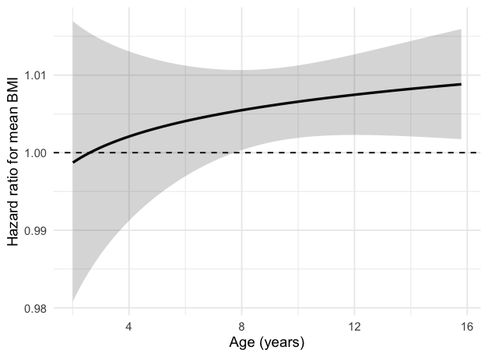

Figure S1. Body Mass Index (BMI) and age. The functional form of BMI over time, showing the increasing hazard ratio as dogs age calculated from the inverse probability of censoring Cox proportional hazard model.
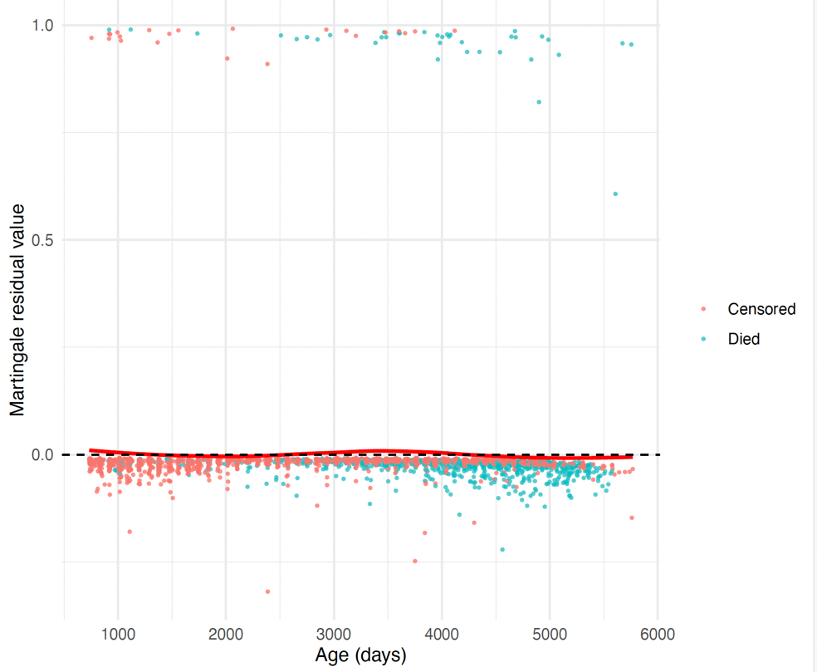

Figure S2. Martingale residuals for the inverse probability of censoring cox proportional hazards model after adding a smooth time-varying effect for mean BMI using a log(time) interaction centred at 10 years.
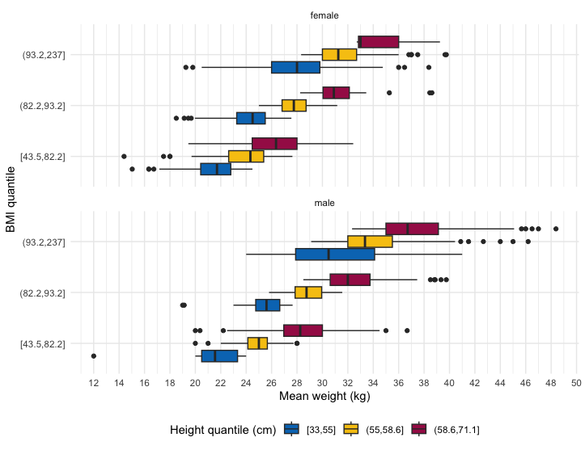

Figure S3. Plot to demonstrate the relationship between mean weight and mean body mass index (BMI) quantiles of 2540 Labrador Retrievers at three different mean height quantiles (short = blue, medium = yellow, tall = red). Height and weight were taken as the mean of values reported by owners between 12 and 24 months of age.

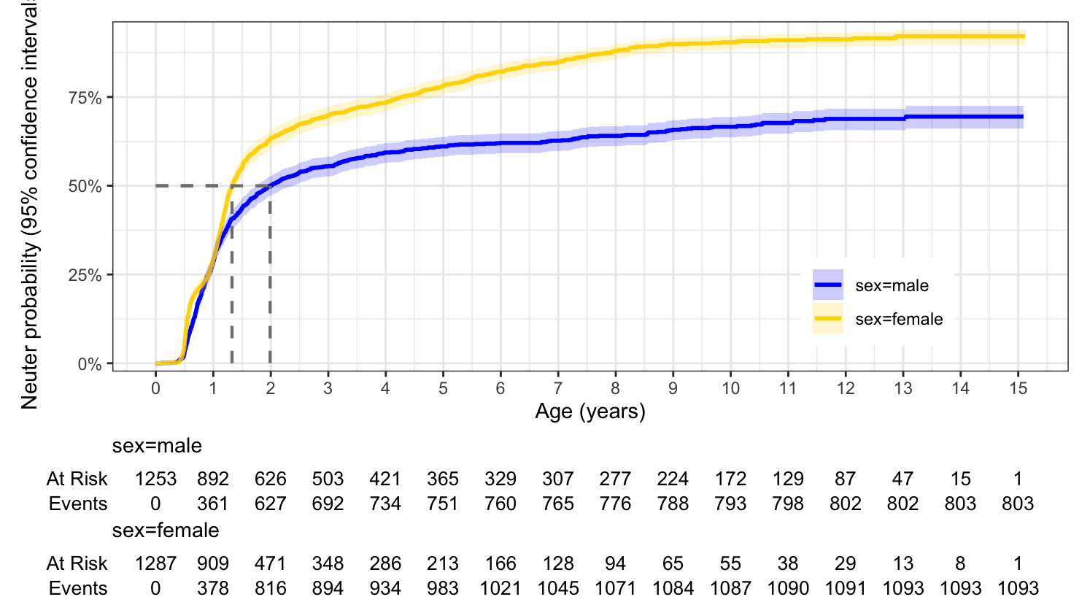

Figure S4. Survival curve for Kaplan Meier time-to-neuter analysis stratified by sex. Grey dashed lines highlight the median age of neutering for both sexes and the age when 75% of females were neutered (males did not reach this value).

