ADDITIONAL FILE 1 OF COVID-19 AMONG PATIENTS WITH INFLAMMATORY RHEUMATIC DISEASES
Supplementary figures
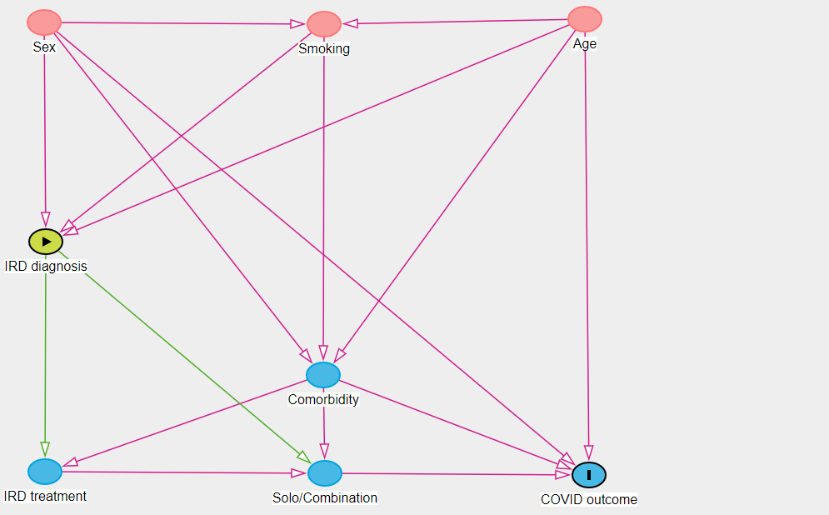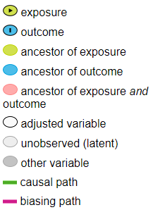
Figure S1. Directed acyclic graph depicting causal assumptions for the effect of IRD diagnosis on COVID outcome. In order to estimate the unbiased total effect of IRD treatment on COVID outcome, two minimum sufficient sets of adjustment variables can be identified from this model, (i) age, comorbidity, sex or (ii) age, sex, smoking. Prepared using DAGitty v. 3.0 (www.dagitty.net).

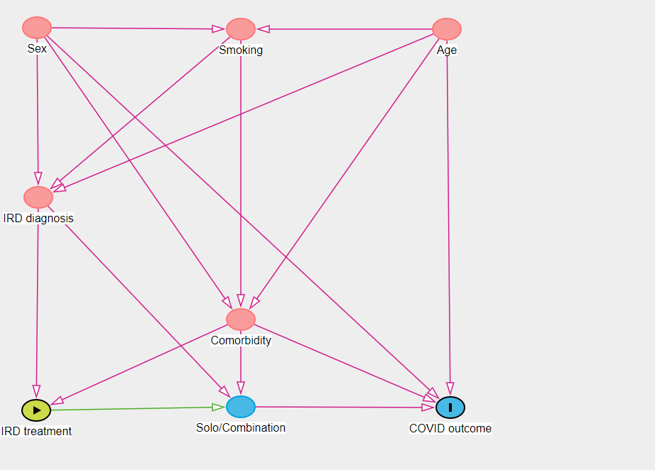
Figure S2. Directed acyclic graph depicting causal assumptions for the effect of IRD treatment on COVID outcome. In order to estimate the unbiased direct effect of IRD treatment on COVID outcome, two minimum sufficient sets of adjustment variables can be identified from this model, (i) Age, comorbidity, sex, combination treatment, or (ii) comorbidity, inflammatory rheumatic disease (IRD) diagnosis, combination treatment. Prepared using DAGitty v. 3.0 (www.dagitty.net).

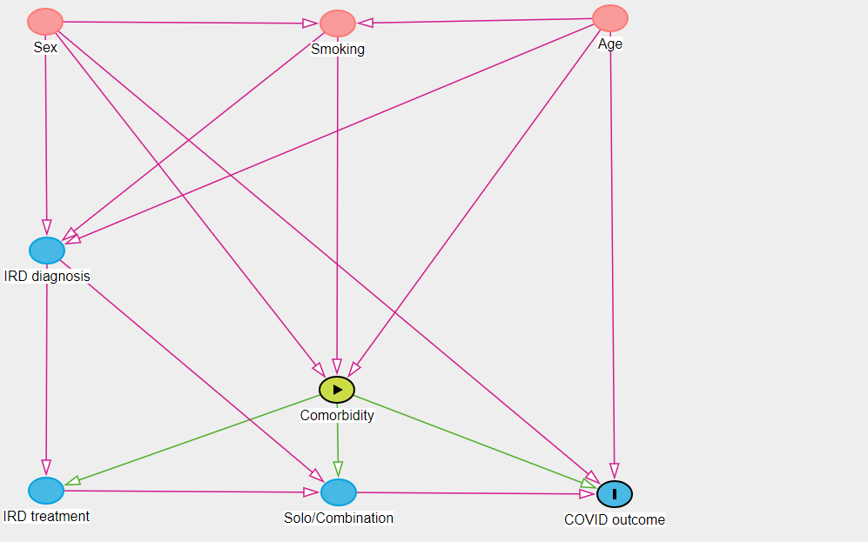
Figure S3. Directed acyclic graph depicting causal assumptions for the effect of comorbidity on COVID outcome. In order to estimate the unbiased total effect of comorbidity on COVID outcome, two minimum sufficient sets of adjustment variables can be identified from this model, (i) age, IRD diagnosis, sex or (ii) age, sex, smoking. Prepared using DAGitty v. 3.0 (www.dagitty.net).

Figure S4: Flow diagram of the outcome of COVID-19 in patients with inflammatory rheumatic diseases

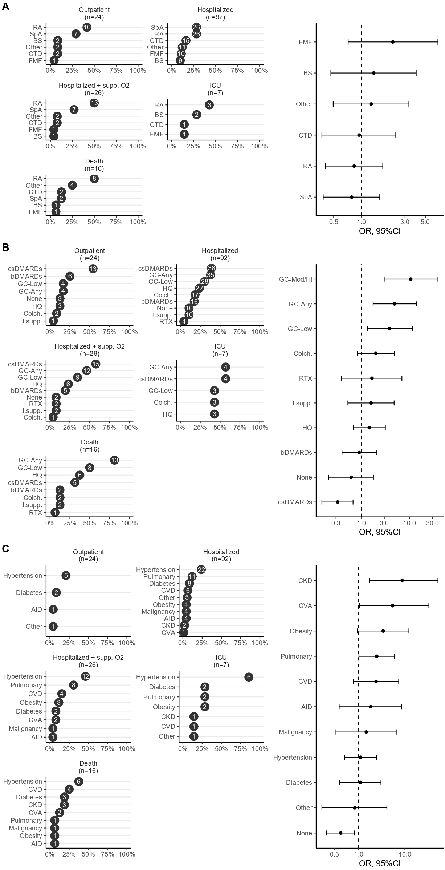

Figure S5: Risk factors of a worse COVID-19 outcome in patients with inflammatory rheumatic diseases. Figure illustrates the ranked proportions of IRD diagnoses (A), IRD treatments (B), and comorbidities (C) for each outcome category and the association of each with a worse outcome, analyzed using proportional odds logistic regression where the dependent variable was the 5-level ordinal outcome and the independent variable of interest was the type of IRD treatment, comorbidity or primary IRD diagnosis.
Disease outcome was classified in 5 ordinal categories; (i) outpatient management, (ii hospitalization without oxygen requirement, (iii) hospitalization with oxygen requirement, (iv) ICU admission, and (v) death.
High/moderate glucocorticoid dose (GC-Mod/Hi) was defined as a daily dose of≥7.5 mg prednisolone.
csDMARDs included methotrexate, sulfasalazine, leflunomide, immunosuppressives included mycophenolate mofetil, tacrolimus, azathioprine and bDMARDs included tumor necrosis factor inhibitors, abatacept, anakinra, secukinumab and tocilizumab.
AID: additional immune disorder; bDMARDs, biologic DMARDs; BS: Behçet syndrome; CKD: chronic kidney disease; Colc.: colchicine; csDMARDs, conventional synthetic DMARDs; CTD: connective tissue disease; CVA: cerebrovascular accident; CVD: cardiovascular disease; DMARDs, disease-modifying antirheumatic drugs; FMF: Familial Mediterranean fever; GC: glucocorticoid; ICU: intensive care unit; IRD: inflammatory rheumatic disease; I.supp.: immunosuppressives; HQ: hydroxychloroquine; RA: rheumatoid arthritis; RTX: rituximab; SpA: spondyloarthritis;

Supplementary Table
Table S1. Characteristics of patients who needed ICU admission or those who died

Gender | Age (years) | IRD diagnosis | IRD treatment | Comorbidity | ICU admission | Outcome
Female | 35 | SLE | HQ, MMF, PRED 20 mg/day | CKD | IMV | Died
Female | 51 | RA | HQ, RTX, PRED 7.5 mg/day | HT, Obesity, CKD | IMV | Died
Female | 32 | SLE | HQ, PRED 5 mg/day | CVA | IMV | Died
Female | 72 | PMR | PRED 7.5 mg/day | None | IMV | Died
Female | 71 | RA | HQ, PRED 5 mg/day | None | IMV | Died
Female | 79 | Goodpasture syndrome | PRED 40 mg/day | None | IMV | Died
Male | 69 | RA | SAZ | HT, CVD, CKD | IMV | Died
Female | 38 | BS | COL | None | NIMV | Died
Female | 71 | RA | HQ, MTX, PRED 5 mg/day | HT | IMV | Died
Female | 64 | Sarcoidosis | PRED 20 mg/day | HT, DM | IMV | Died
Female | 78 | RA | MTX, PRED 5 mg/day | HT | IMV | Died
Female | 75 | PsA | MTX, LEF | HT, DM, CVD | IMV | Died
Male | 60 | RA | LEF, PRED 5 mg/day | COPD, CVD | IMV | Died
Male | 72 | RA | HQ, PRED 10 mg/day | AML | No | Died before ICU transfer
Male | 70 | RA | TNFi, PRED 5 mg/day | DM, CVD, CVA | IMV | Died
Female | 32 | FMF, SpA | AZA, COL, TNFi, PRED 10 mg/day | Crohn's disease | IMV | Died
Female | 73 | RA | HQ, MTX, PRED 10 mg/day | HT | IMV | Recovered
Male | 38 | FMF | COL | HT, Obesity | NIMV | Recovered
Male | 58 | BS | COL, SAZ | None | NIMV | Recovered
Male | 55 | BS | COL | HT, Asthma | IMV | Recovered
Female | 58 | Sjögren's syndrome | HQ, PRED 5 mg/day | HT, DM, ILD | NIMV | Recovered
Female | 88 | RA | HQ, LEF, PRED 7.5 mg/day | HT, CVD, CKD | IMV | Recovered
Female | 57 | RA | LEF, PRED 5 mg/day | HT, DM, Obesity | NIMV | Recovered
AML: acute myeloid leukemia; BS: Behçet syndrome; CKD: chronic kidney disease; COL: colchicine; COPD: chronic obstructive pulmonary disease; CVA: cerebrovascular accident; CVD: cardiovascular disease; DM: diabetes mellitus; FMF: familial Mediterranean fever; HQ: hydroxychloroquine; HT: hypertension; ICU: intensive care unit; ILD: interstitial lung disease; IMV: invasive mechanic ventilation; IRD: inflammatory rheumatic disease; LEF: leflunomide; MMF: mycophenolate mofetil; MTX: methotrexate; NIMV: non-invasive mechanic ventilation; PMR: polymyalgia rheumatica; PRED: prednisolone; PsA: psoriatic arthritis; RA: rheumatoid arthritis; RTX: rituximab; SAZ: sulfasalazine; SLE: systemic lupus erythematosus; SpA: spondyloarthritis; TNFi: tumor necrosis factor inhibitor

