Computational Modeling of Glucocorticoid Chronotherapy for Diseases with Cortisol Circadian Dysregulation

Samayadity Singh ª, Pramod Rajaram Somavanshi ^{a,b}

ª Physiosystems Engineering and Computational Medicine Laboratory, Systems and Computational Biology, School of Life Sciences, University of Hyderabad, Telangana, India
^{b} Asian Center for Endocrine Pancreas Research, Asian Healthcare Foundation, Asian Institute of Gastroenterology, Hyderabad, India

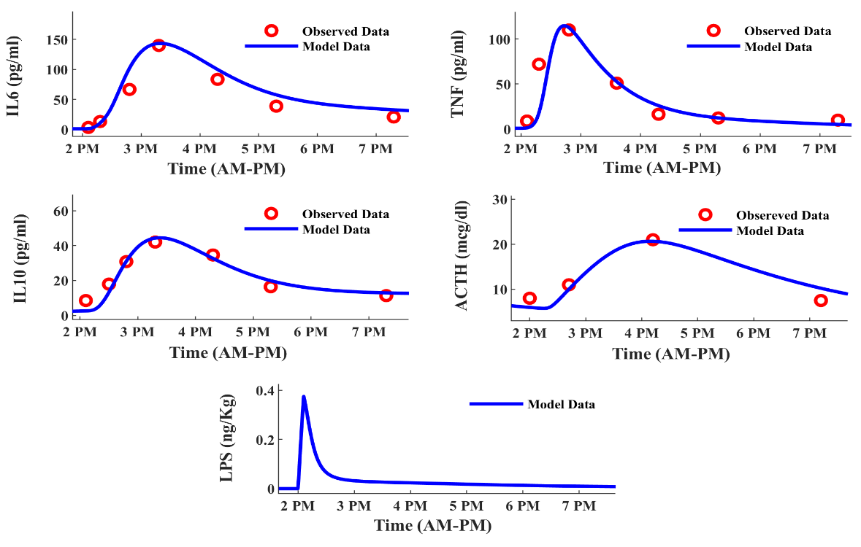
Appendix A. Supplementary data
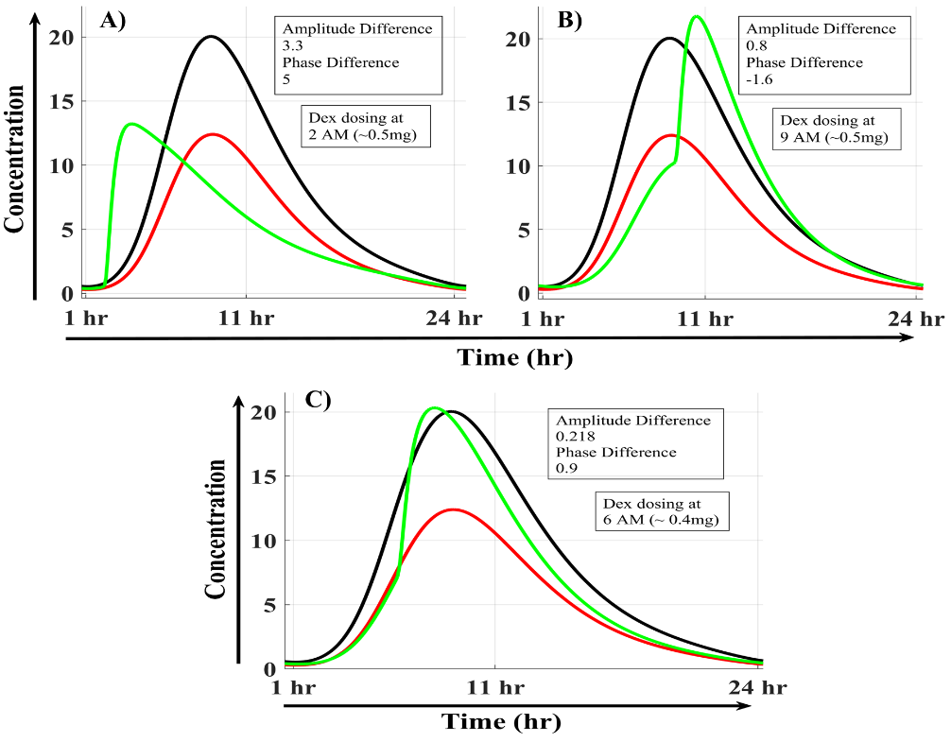
Figure S1. The simulated response profile of ACTH, Tumor Necrosis Factor (TNF), Interleukin 10 and 6 (IL10 and IL6), after insertion of LPS (0.4 ng/kg) in the models with cir3; the analysis cross-validates the model (with cir3) response curve against a previous study of Grigoleit et al 2010 [1]. And shows that cir3 drive has no concerning effects on the natural response profile of the model during LPS, and also models replicate similar physiological responses.
Figure S2. In our study, we used the treatment response analysis to assess changes in the phase and amplitude of the state variable after Dex treatment (green) under disease conditions (red), compared with the normal condition (black). The adjustment of the Dex dose is explained by these simulated cortisol profiles after Dex administration, during increased GR negative feedback on the HPA axis. As shown in Figures A-C, changes in Dex timing and concentration help to reset the perturbed circadian profiles of cortisol and other state variables in the HPA-inflammation system.

Table S1. The parameter values for the normal dynamics of the HPA-Inflammation model, as mentioned in the study of Somvanshi et al 2020 [2].

Parameters | Values | Description
Ki_{GR2} | 1.2 nM/mL | Inhibitory threshold for GRs negative feedback on CRH and ACTH
K_{st} | 10 pg/mL·h | Stress-related activation of CRH release
k_{crh} | 9.6 x 10⁻² /h | Degradation rate of CRH
v_{acth1} | 1.463 /h | Rate of ACTH secretion induced by CRH
k_{acth} | 431.2 x10⁻³ /h | Rate of ACTH degradation
k_{cort} | 0.99 /h | Rate of cortisol degradation
v_{cort} | 5.67 𝜇g/dL·hU | Rate of cortisol synthesis by StAR protein
km_{tnf3} | 40 pg/mL | Half saturation threshold for effect of TNF on ACTH secretion
v_{crh} | 0.067 /h | Rate of CRH secretion induced by TNF
v_{acth2} | 11.2 pg/mL·h | Rate of ACTH secretion induced by TNF
v_{stAR2} | 15 pg/mL·h | Rate of StAR protein synthesis induced by TNF
Cmax | 4 | Weighting parameter for peripheral circadian Rhythm
Ki_{GR1} | 50 nM/mL | Half saturation constant for inhibition of peripheral circadian drive by nuclear GR
v_{stAR1} | 22.5 x 10⁻³ AU/h | Rate of StAR protein synthesis induced by ACTH
k_{stAR} | 0.45 AU/h | Rate of StAR protein degradation
Ki_{IL61} | 100 pg/mL | Half-saturation constant for inhibition of StAR protein synthesis by IL6
k_{dex1} | 1.95 /h | Rate of dexamethasone degradation in 1st compartment
v_{dex} | 1.15 /h | Rate of dexamethasone appearance in plasma
k_{dex2} | 0.25 /h | Rate of dexamethasone degradation from plasma
f_{ac} | 16.65 | Weighted conversion factor for dexamethasone to cortisol activity
km_{GR1} | 25 nM/L·mg protein | Half saturation threshold of GR negative feedback on GR mRNA synthesis
v_{mrna} | 3.4 /h | Rate of GR mRNA synthesis
k_{mrna} | 112.4 x 10⁻³ /h | Rate of GR mRNA degradation
v_{pro} | 1.2 /h | Rate of GR protein synthesis
f_{r} | 0.49 | Fraction of GR-cortisol complex recycled
k_{on} | 32.9 x 10⁻⁴ /nM·h | Rate of cortisol-GR binding
k_{prot} | 57.2 x 10⁻³ /h | Degradation of GR protein
k_{t} | 0.63 /h | Rate of receptor translocation from cytoplasm to nucleus
k_{re} | 0.57 /h | Rate of GR cycling from nucleus to cytoplasm
𝜏_{c} | 0.14 | Transduction coefficient for cortisol from adrenal to periphery
ki_{tnf} | 10³ pg/mL | Inhibitory half saturation threshold for effect of TNF on GR nuclear translocation
lps_b | 10⁻⁷ ng/kg·h | Basal rate of LPS induction
k_{lps} | 2.7 x 10⁻⁵ /h.U | Rate of LPS degradation by phagocytes
v_{pgh1} | 4.99 x 10⁷ ·kg/h·ng | Rate of phagocyte activation by LPS
v_{pgh2} | 12.95 | Activation of phagocytes by TNF
km_{TNF1} | 1,693.95 pg/mL | Half saturation constant for activation of phagocytes by TNF
ki_{TGF1} | 72.12 x 10⁻⁴ pg/mL | Half saturation constant for inhibition of phagocytes by TGF
ki_{IL10} | 7.38 pg/mL | Half saturation constant for inhibition of phagocytes by IL10
k_{pgh} | 1.44 /h | Degradation rate of phagocytes
𝜏_{p} | 1.5 | Delay coefficient for phagocyte activity
v_{tgf1} | 0.16 x 10⁻⁸ pg/mL·U·h | Rate of activation of TGF by phagocytes
v_{tgf2} | 0.5 pg/mL·h | Rate of activation of TGF by GR
Km_{GR2} | 500 nM/mL | Half saturation constant for effect of GR on TGF activation
k_{tgf} | 63.5 x 10⁻³ /h | Rate of TGF degradation
v_{tnf1} | 25.52 pg/mL·h | Rate of TNF activation by phagocytes
Km_{Phg1} | 41.25 x 10⁴ U | Half saturation constant of phagocytes for activation of TNF
ki_{TGF2} | 0.14 pg/mL | Inhibitory constant for downregulation of TNF by TGF
v_{tnf2} | 106.54 x 10³ pg/mL·h | Rate of TNF positive feedback on its activation
Km_{TNF2} | 123.96 pg/mL | Half saturation constant for effect of TNF auto-regulation
Km_{IL61} | 80 pg/mL | Half saturation constant for inhibitory effect of IL6 on TNF
k_{tnf} | 1.25 /h | Rate of TNF degradation
b_{TNF} | 1.25 pg/mL·h | Basal rate of TNF synthesis
Km_{Phg2} | 161.01 x 10³ U | Half saturation constant for activation of IL10 by phagocytes
k_{il10} | 1.6 /h | Rate of IL10 degradation
v_{il101} | 1.34 x 10³ pg/mL·h | Rate of activation of IL10 by phagocytes
v_{il102} | 21.94 x 10² pg/mL·h | Rate of activation of IL10 by TGF
Km_{TGF1} | 0.76 pg/mL | Half saturation constant for IL10 activation by TGF
b_{IL6} | 1.5 pg/mL·h | Basal rate IL6 synthesis
Km_{Phg3} | 110 x 10⁵ pg/mL | Half saturation constant for activation of IL6 by phagocytes
Km_{IL6TNF} | 339.16 pg/mL | Half saturation constant of effect of TNF and IL6 on IL6 activation
Ki_{IL102} | 23.64 pg/mL | Half saturation constant for inhibition of IL6 by IL10
v_{il61} | 0.55 x 10⁵ pg/mL·h | Rate of IL6 activation by phagocytes
v_{il62} | 5 x 10⁵ /h | Rate of cytokine positive feedback on IL6 activation
k_{il6} | 1.63 /h | Rate of IL6 degradation
kac | 3 | Rate of GR-cortisol complex acetylation by CB
n1 | 1 | Hill coefficient for effect of GRs negative feedback
n2 | 2 | Hill coefficient for stimulatory effect of TNF on HPA axis
n3 | 2 | Hill coefficient for effect of GR on its mRNA synthesis
n4 | 2 | Hill coefficient for effect of TNF on GR nuclear translocation
n5 | 1 | Hill coefficient for effect of GR on TGF activation
n6 | 4 | Hill coefficient for effect of TGF on TNF inhibition
n7 | 2 | Hill coefficient for effect of IL6 on TNF inhibition
n8 | 2 | Hill coefficient for effect of phagocytes on IL10 activation
n9 | 6 | Hill coefficient for effect of TGF on IL10 activation
n10 | 2 | Hill coefficient for effect of cytokine on IL6 activation

Table S2. The Feedback responses used in the HPA-Inflammation model, for defining the GR-mediated crosstalk between the two HPA axis and inflammation modules. Details of each parameter are provided in Supplementary Table 1.

Feedback Responses | MM Equations
Negative feedback of GR on peripheral circadian drive | $$B_{GRn1}=\frac{Ki_{GR1}}{{GR}_{n}+Ki_{GR1}}$$
Negative modulation of CRH and ACTH by GR | $$B_{GRn2}=\frac{{Ki_{GR2}}^{n1}}{{{GR}_{n}}^{n1}+{Ki_{GR2}}^{n1}}$$
Positive feedback of GR activation on the GR mRNA production | $$F_{GRn1}=\frac{{{GR}_{n}}^{n3}}{{{GR}_{n}}^{n3}+{Km_{GR1}}^{n3}}$$
Positive feedback of GR on the production of TGF | $$F_{GRn2}=\frac{{{GR}_{n}}^{n5}}{{{GR}_{n}}^{n5}+{Km_{GR2}}^{n5}}$$
Positive feedback of TNF modulation on ACTH and STARp | $$F_{TNF1}=\frac{{C_{TNF}}^{n2}}{{C_{TNF}}^{n2}+{Km_{TNF3}}^{n2}}$$
Negative modulation of STARp by IL6 | $$B_{IL61}=\frac{Ki_{IL61}}{C_{IL6}+Ki_{IL61}}$$
Negative feedback of TNF on the GR nuclear transport | $$B_{TNF1}=\frac{{Ki_{TNF}}^{n4}}{{C_{TNF}}^{n4}+{Ki_{TNF}}^{n4}}$$
Positive feedback of TNF activation on phagocytes | $$F_{TNF2}=\frac{C_{TNF}}{C_{TNF}+Km_{TNF1}}$$
Self-activation feedback of TNF | $$F_{TNF3}=\frac{C_{TNF}}{C_{TNF}+Km_{TNF2}}$$
Positive feedback of phagocytosis on TNF production | $$F_{Phg}=\frac{{C_{Phg}}^{n8}}{{C_{Phg}}^{n8}+{Km_{Phg1}}^{n8}}$$
Positive modulation of IL10 production by the phagocytosis | $$F_{Phg1}=\frac{{C_{Phg1}}^{n8}}{{C_{Phg1}}^{n8}+{Km_{Phg2}}^{n8}}$$
Positive modulation on IL6 production due to phagocytosis | $$F_{Phg12}=\frac{C_{Phg1}}{C_{Phg1}+Km_{Phg3}}$$
Negative feedback of TGF activation on phagocytes | $$B_{TGF1}=\frac{Ki_{TGF1}}{C_{TGF}+Ki_{TGF1}}$$
Negative feedback of TGF activation on TNF | $$B_{TGF2}=\frac{{Ki_{TGF1}}^{n6}}{{C_{TGF}}^{n6}+{Ki_{TGF1}}^{n6}}$$
Positive feedback of TGF activation on IL10 activation | $$F_{TGF}=\frac{{C_{TGF}}^{n9}}{{C_{TGF}}^{n9}+{Km_{TGF1}}^{n9}}$$
Negative modulation of IL10 on phagocytosis | $$B_{IL101}=\frac{Ki_{IL10}}{C_{IL10}+Ki_{IL10}}$$
Negative feedback of IL10 activation on the production of IL6 | $$B_{IL102}=\frac{Ki_{IL102}}{C_{IL10}+Ki_{IL102}}$$
Negative feedback of IL6 on the activation of TNF | $$\left(1-F_{IL6}\right)=\left(1-\frac{{C_{IL6}}^{n7}}{{C_{IL6}}^{n7}+{Km_{IL61}}^{n7}}\right)$$
Positive feedback of IL6 and TNF activations on the production of IL6 | $$F_{IL6+TNF}=\frac{{C_{IL6+TNF}}^{n10}}{{C_{IL6+TNF}}^{n10}+{Km_{IL6+TNF}}^{n10}}$$

Each of the mathematical models was solved using the Ode15s solver in MATLAB, with relative and absolute error tolerances of 1e-10. The MATLAB graphical editor is used to capture and plot the 24-hr dynamics of model variables. The phase-amplitude plots of the time-dependent effects of Dex were generated in Excel.

Table S3. A small set of perturbed parameter combinations (parameters 1 & 2) is tabulated; these are used to simulate different profiles of circadian dysregulation in cortisol expression (Phase & Amplitude), along with the optimum time window predicted by the ThrNN model.
Parameter 1 | Parameter 2 | Parameter value 1 | Parameter value 2 | Optimum dose Time | Effects on cortisol circadian parameters
 |  |  |  |  | Phase | Amplitude
V_acth1 | k_starp | 5.8536 | 1.8 | 9-10 | Advance | No change
n1 | k_crh | 2 | 0.048 | 7_8 | Advance | No change
kre | km_GR1 | 0.285 | 6.25 | 3-4 | Delay | No change
Ki_GR1 | k_starp | 1.2 | 0.9 | 6-8 | Advance | Decreased
V_starp1 | k_starp | 0.005625 | 0.225 | 2-6 | Delay | Decreased
V_cort | k_starp | 2.835 | 0.225 | 5_6 | Delay | Decreased
V_starp1 | n1 | 0.09 | 4 | 8_9 | Advance | Increased
V_cort | n1 | 22.68 | 4 | 8_9 | Advance | Increased
k_cort | n1 | 0.495 | 4 | 3-4 | Delay | Increased
V_GRprot | Ki_GR | 1.2 | 200 | 2-3 | Delay | Increased
Ki_GR1 | k_GRprot | 0.6 | 0.0572 | 5-6 | No change | Decreased
V_GRmrna | K_strs | 1.7 | 10 | 1-2 | No change | Increased

- HPA-Inflammation model:
Calibrated drivers were incorporated to model circadian rhythms in the peripheral and HPA axes, as per the previous study (Somvanshi et al., 2020). The 24hr entrainment rhythm of SCN is integrated by the variable circadian driver cir1(t) (Eq 1), wherein omega ($Ω=\frac{2*pi}{24}$) is used for modeling the 24 hr periodic cycle for calculating the circadian rhythm for Hypothalamus variable i e., CRH (Eq 3),
$cir1(t)=2*\left(1+cos(Ω*t)\right)$ — (1)

The HPA axis module details the signalling dynamics between the variables by the following ODEs, and in which the circadian drive from adrenal to peripheral clock is represented by the cir2(t) variable. The equation $\frac{Ki_{GR}}{Ki_{GR}+{GR}_{n}}$ integrate the negative feedback of GR on the circadian expression of cortisol.
$cir2(t)=\left(4-cir1(t)\right)*\left(\frac{Ki_{GR}}{Ki_{GR}+{GR}_{n}}\right)$ — (2)

For defining the circadian dynamics Corticotropin releasing hormone (CRH) following ODE is use $\frac{dCRH}{dt}=\left(K_{strs}*\left(1+st\right)*\left(\frac{{Ki_{GR1}}^{n1}}{{Ki_{GR1}}^{n1}+GR1^{n1}}\right)*\left(cir1(t)\right)*\left(1+V_{crh}*TNF\right)-k_{crh}*CRH\right)$
— (3)
Where, the stress dependent activation rate of the CRH expression defined by the $K_{strs}*\left(1+st\right)$, the $\left(1+V_{crh}*TNF\right)$ expression is for the positive feedback of pro-inflammatory cytokine on the CRH, the negative feedback by GR represents by $\left(\frac{{Ki_{GR1}}^{n1}}{{Ki_{GR1}}^{n1}+GR1^{n1}}\right)$, and degradation rate by ${(k}_{crh}*CRH)$.
Adrenocorticotropic hormone (ACTH) circadian dynamic represented by the following ODE,
$\frac{dACTH}{dt}=\left(V_{acth1}*CRH*\left(\frac{{Ki_{GR1}}^{n1}}{{Ki_{GR1}}^{n1}+GR1^{n1}}\right)*\left(1+V_{acth2}*\left(\frac{TNF^{n2}}{{Km_{tnf3}}^{n2}+TNF^{n2}}\right)\right)-k_{acth}*ACTH\right)$
— (4)
The rate of ACTH synthesis based on CRH stimulation depicts by ${(V}_{acth1}*CRH)$, positive feedback of TNF for regulating the CRH production defined by the hills equation $\left(1+V_{acth2}*\left(\frac{TNF^{n2}}{{Km_{tnf3}}^{n2}+TNF^{n2}}\right)\right)$. The negative regulation of GR on the production of CRH in pituitary gland is integrated by $\left(\frac{{Ki_{GR1}}^{n1}}{{Ki_{GR1}}^{n1}+GR1^{n1}}\right)$.
The rhythmic expression of StAR (Steroidogenic Acute Regulatory) protein is enumerated by the given ODE,
$${\frac{dStARp}{dt}=s0*(V}_{starp1}*\left(ACTH*cir2(t)\right)*\left(1+V_{starp2}*\left(\frac{TNF^{n2}}{{Km_{tnf3}}^{n2}+TNF^{n2}}\right)*\left(\frac{Kil6}{Kil6+IL6}\right)\right)$$
$-k_{starp}*StARp)$ — (5)
The stimulation of StARp through ACTH signaling is expressed by ${(V}_{starp1}*\left(ACTH*cir2\right))$, wherein cir2(t) represents the adrenal circadian drive for physiological expression periodicity. The cumulative feedback of proinflammatory cytokines on the StARp stimulation is represented by the respective hills equations $\left(1+V_{starp2}*\left(\frac{TNF^{n2}}{{Km_{tnf3}}^{n2}+TNF^{n2}}\right)*\left(\frac{Kil6}{Kil6+IL6}\right)\right)$.
Cortisol activation via StARp is determined by the following ODE,
$\frac{dCORT}{dt}=\left(V_{cort}*StARp-k_{cort}*CORT\right)$ — (6)
Where, ${(V}_{cort}*StARp)$ shows the rate of cortisol activation by StARp, and ${(k}_{cort}*CORT)$ represents degradation rate of cortisol.
Time-dependent release of Dexamethasone in the biological system,
$\frac{dDex1}{dt}=Dex-k_{dex1}*Dex1$ — (7)
$\frac{dDex2}{dt}=V_{dex2}*Dex1-k_{dex2}*Dex2$ — (8)
In Eqs. 8 and 9, the ingested, plasma, and delayed amounts of dexamethasone in the system are represented by Dex, Dex1, and Dex2, respectively.
The amount of peripheral cortisol available after the StARp stimulation is calculated by given ODE,
$\frac{dCORTp}{dt}=\left(\frac{1}{τc}\right)*\left(CORT+\left(fac*Dex2\right)-CORTp\right)$ — (9)
The $\frac{1}{τc}*(CORT+\left(fac*Dex2\right))$ represents fraction of cytosolic cortisol and Dex getting released with a delay $(\frac{1}{τc})$ in the peripheral system, and $(\frac{1}{τc}*CORTp)$ is a rate limiting term for the corticosteroid release.
The time dependent changes in GR mRNA transcript concentration is calculated by the given ODE,
$\frac{dGR_{mrna}}{dt}=V_{GRmrna}*(1-F_{GRn1})-k_{GRmrna}*{GR}_{mrna}$ — (10)
Where, rate of GRmRNA transcription with a self-repression “$(1-F_{GRn1})$” is represented by $(V_{GRmrna}*(1-F_{GRn1}))$, and the degradation of GRmRNA is enumerated by the $(k_{GRmrna}*{GR}_{mrna})$.
Translated GR protein dynamics is estimated by the given ODE,
$\frac{dGR_{prot}}{dt}={(V}_{GRprot}*GR_{mrna}+fr*kre*GR-kon*\left(CORTp\right)*GR_{prot}$
$-k_{GRprot}*GR_{prot})$ — (11)
Where, the rate GR translation via accessible GRmRNA ${(V}_{GRprot}*GR_{mrna})$ and the concentration of recycled fraction of nuclear GR $(fr*kre*GR)$, cumulatively represents the synthesis of GR protein. The $(kon*\left(CORTp\right)*GR_{prot})$ equation stand for negative effect of GR-cortisol complex on the synthesis of GR protein, and the natural rate of GR protein degradation is formulated as $(k_{GRprot}*GR_{prot})$.
The time dynamics of cytosolic GR is enumerated by the given ODE,
$\frac{dGR_{cyt}}{dt}=kon*\left(CORTp\right)*GR_{prot}-krt*GR_{cyt}*\left(\frac{{ki_{tnf}}^{n4}}{TNF^{n4}+{ki_{tnf}}^{n4}}\right)$ — (12)
Where, the cytosolic concentration of GR depends on the amount of GR getting used up for GR-cortisol complex ($kon*\left(CORTp\right)*GR_{prot}$) and fraction that is transferred in the nucleus as an active GR-cortisol complex.
The dynamic concentration of Nuclear GR is calculated by the given ODE,
$\frac{dGR}{dt}=krt*GR_{cyt}*\left(\frac{{ki_{tnf}}^{n4}}{TNF^{n4}+{ki_{tnf}}^{n4}}\right)-kre*GR$ — (13)
In eq14, the amount of nuclear GR-cortisol complex is represented by the translocation rate of cytosolic GR-cortisol complex with negative feedback of proinflammatory cytokines $krt*GR_{cyt}*\left(\frac{{ki_{tnf}}^{n4}}{TNF^{n4}+{ki_{tnf}}^{n4}}\right)$, and also depends on the rate at which nuclear GR recycles back to cytosol.
To reproduce the physiological phase differences between the HPA axis and immune variables, we incorporated an additional circadian drive (cir3(t): Rhythm in phagocytic cells) to provide a correct phase difference of ~ 5.5 - 6 hr (Bauer et al., 1994; Wright et al., 2015).
$cir3(t)=2*\left(1+cos\left(Ω*t+0.5\right)\right)$ — (14)
The basal or disease-causing levels of lipopolysaccharide (LPS) is calculated by the given ODE,
$\frac{dLPS}{dt}={lps}_{b}*\left(1+\right)-k_{lps}*LPS*Phg$ — (15)
Where, basal concentration of LPS in the system represented by the (${lps}_{b}*\left(1+\right)$), and the rate of phagocytic cleaning of LPS is calculated by ($k_{lps}*LPS*Phg$).
The dynamic functioning of Phagocytes is defined by given ODE,
$\frac{dPhg}{dt}=V_{phg1}*\left(\left(cir3(t)+\left(\frac{V_{phg2}*TNF}{Km_{tnf1}+TNF}\right)\right)*\left(\frac{Ki_{tgf1}}{Ki_{tgf1}+TGF}\right)*\left(\frac{Ki_{IL10}}{Ki_{IL10}+IL10}\right)\right)*$ $LPS-k_{phg}*Phg$ — (16)
$\frac{dPhg1}{dt}=\left(\frac{1.0}{tp}\right)*\left(Phg-Phg1\right)$ — (17)
Rhythmic stimulation of phagocytes by the LPS and proinflammatory cytokine signaling defined by the $(V_{phg1}*\left(\left(cir3+\left(\frac{V_{phg2}*TNF}{Km_{tnf1}+TNF}\right)\right)*\left(\frac{Ki_{tgf1}}{Ki_{tgf1}+TGF}\right)*\left(\frac{Ki_{IL10}}{Ki_{IL10}+IL10}\right)\right))$ along with the negative feedback of anti-inflammatory cytokines. The $(k_{phg}*Phg)$ stand for determining the degraded phagocytes at rate of $k_{phg}$.
The dynamic concentration of Transforming growth factor (TGF) is enumerated by the following ODE,
$\frac{dTGF}{dt}=\left(V_{tgf1}*Phg+\left(\frac{V_{tgf2}*GR^{n5}}{{Km_{GR2}}^{n5}+GR^{n5}}\right)-k_{tgf}*TGF\right)$ — (18)
Where, phagocyte and GR based activation of TGF is represented by the$\left(V_{tgf1}*Phg+\left(\frac{V_{tgf2}*GR^{n5}}{{Km_{GR2}}^{n5}+GR^{n5}}\right)\right)$. And ($k_{tgf}*TGF$) provides the degraded concentration of TGF.
The dynamic concentration of Tumor Necrosis Factor (TNF) is calculated by the following ODE,
$\frac{dTNF}{dt}=tnf_{b}+\left(\frac{Phg}{Km_{phg1}+Phg}\right)*\left(V_{tnf1}+V_{tnf2}*\left(\frac{TNF}{Km_{tnf2}+TNF}\right)\right)*\left(\frac{{Ki_{tgf2}}^{n6}}{{Ki_{tgf2}}^{n6}+TGF^{n6}}\right)*\left(1-\left(\frac{IL6^{n7}}{{Km_{il61}}^{n7}+IL6^{n7}}\right)\right)-k_{tnf}*\left(TNF\right)$ — (19)
Where the basal concentration of TNF is defined by $tnf_{b}$, and the stimulation of TNF by the phagocytosis and self-activation is represented in the 2nd equation, in which the inhibitory effects of proinflammatory cytokines are also considered.
The dynamic concentration of Interleukin 10 (IL10) is calculated by the given ODE $\frac{dIL10}{dt}=\left(\left(\frac{V_{il101}*Phg1^{n8}}{Phg1^{n8}+{Km_{phg2}}^{n8}}\right)+\left(\frac{V_{il102}*TGF^{n9}}{{Km_{tgf3}}^{n9}+TGF^{n9}}\right)-k_{il10}*IL10\right)$
—(20)
The phagocytic and TGF based stimulation of IL10 production defined by the respective equations $\left(\frac{V_{il101}*Phg1^{n8}}{Phg1^{n8}+{Km_{phg2}}^{n8}}\right)$ and $\left(\frac{V_{il102}*TGF^{n9}}{{Km_{tgf3}}^{n9}+TGF^{n9}}\right)$. Whereas, the effects of degradation on the IL10 concentration determined by${(k}_{il10}*IL10)$.
The periodic concentration of Interleukin 6 (IL6) is calculated by the given ODE,
$$\frac{dIL6}{dt}=il6_{b}+\left(\frac{Phg1}{Km_{phg3}+Phg1}\right)*\left(V_{il61}+\frac{V_{il62}*(TNF+IL6)^{n10}}{({Km}_{il6tn}f^{n10}+(TNF+IL6)^{n10})}\right)*$$
$\left(\frac{{Ki}_{il102}}{({Ki}_{il102}+(IL10))}\right)-k_{il6}*IL6-k_{il6}*IL6$ — (21)
Positive signaling in the production of IL 6 cytokine are provided by the phagocytes, TNF, and IL6 (proinflammatory cytokines), which are defined by the given equation $\left(\frac{Phg1}{Km_{phg3}+Phg1}\right)*\left(V_{il61}+\frac{V_{il62}*(TNF+IL6)^{n10}}{({Km}_{il6tn}f^{n10}+(TNF+IL6)^{n10})}\right)*\left(\frac{{Ki}_{il102}}{({Ki}_{il102}+(IL10))}\right)$, wherein the signaling is provided by considering the hill kinetic equation. IL6 degradation dynamics is considered by the $k_{il6}*IL6$ equation.
The initial values for each of the variables and the parameter values for normal condition are taken from the previous study of (Somvanshi et al., 2020), and respective values of each parameter are shown along with their descriptions in the Supplemental Table S1. The model is also calibrated to determine the time-dependent dose effects of dexamethasone on the human HPA-inflammation system. To determine the optimal timing of Dex-induced effects, we analyzed phase and amplitude differences in the HPA-immune axis (normal system) following Dex administration.

References:
Bauer J, Hohagen F, Ebert T, Timmer J, Ganter U, Krieger S et al. (1994). Interleukin-6 serum levels in healthy persons correspond to the sleep-wake cycle. Clin Investig, 72(4).
Grigoleit J-S, Oberbeck JR, Lichte P, Kobbe P, Wolf OT, Montag T et al. (2010). Lipopolysaccharide-induced experimental immune activation does not impair memory functions in humans. Neurobiol Learn Mem, 94(4):561–567.
Somvanshi PR, Mellon SH, Yehuda R, Flory JD, Makotkine I, Bierer L et al. (2020). Role of enhanced glucocorticoid receptor sensitivity in inflammation in PTSD: insights from computational model for circadian-neuroendocrine-immune interactions. American Journal of Physiology-Endocrinology and Metabolism, 319(1):E48–E66.
Wright KP, Drake AL, Frey DJ, Fleshner M, Desouza CA, Gronfier C et al. (2015). Influence of sleep deprivation and circadian misalignment on cortisol, inflammatory markers, and cytokine balance. Brain Behav Immun, 47:24–34.

