Figure 1: Validated Structural Model Path (Rural)
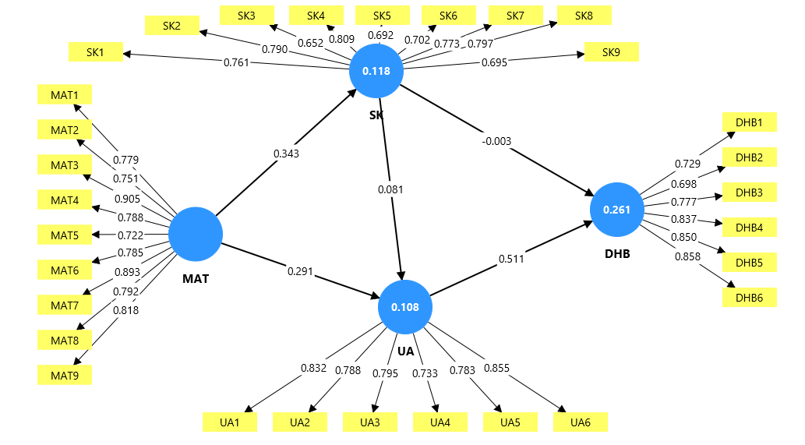

Figure 2: Validated Structural Model Path (Urban)
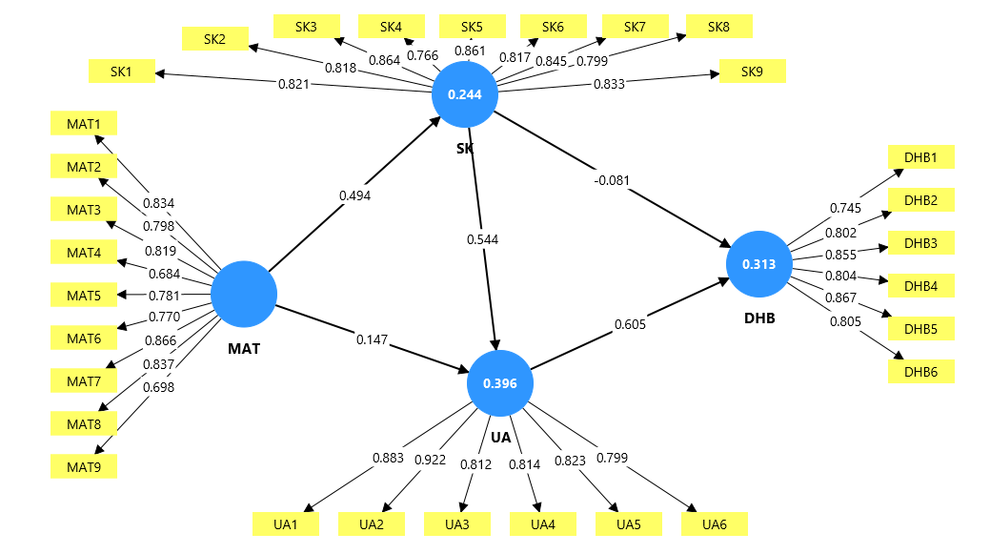

Figure 3 Validated Structural Model Path (Complete)
