Supplementary material
PCR experiments:

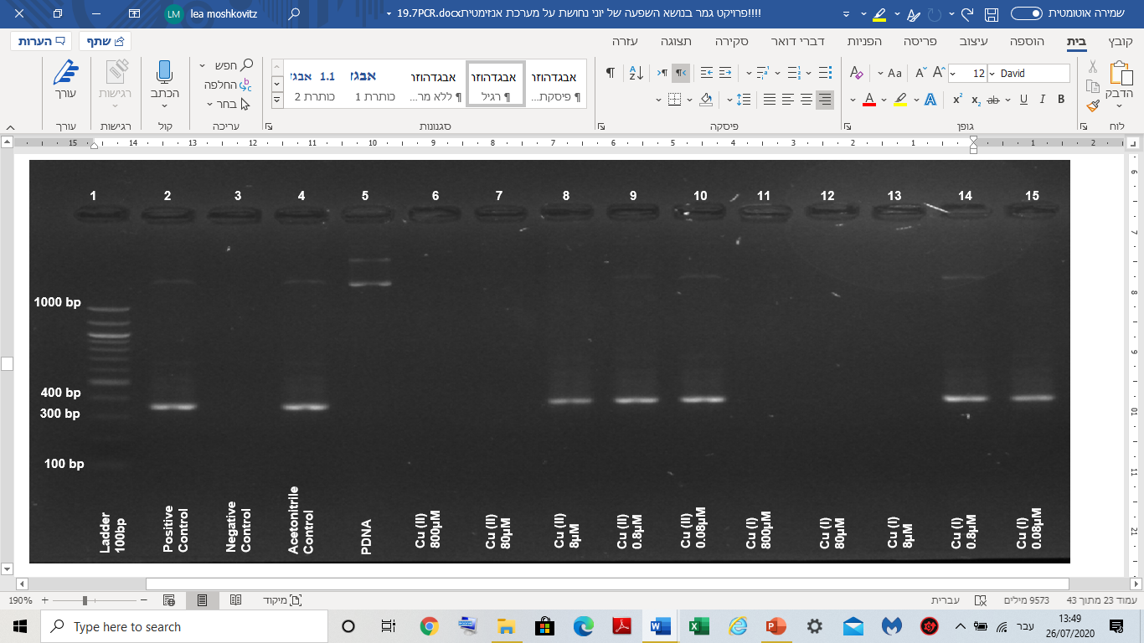
Figure 12: Example of Electrophoresis results of PCR experiments in aerobic conditions. Using Normal Solution Composition (NSC), adding Cu⁺² and Cu⁺ ions at final concentrations from 80 to 0.08μM.
Even without maintaining an anaerobic atmosphere, copper ions inhibit the enzyme polymerase. Monovalent copper is much more active than divalent.

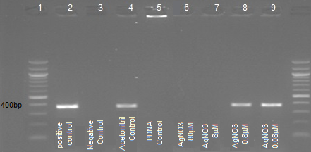
Figure 13: Electrophoresis results of PCR experiments. Adding Ag⁺ ions at final concentrations from 80 to 0.08μM.
The monovalent silver ion inhibits the enzyme, although much less than the monovalent copper ions.

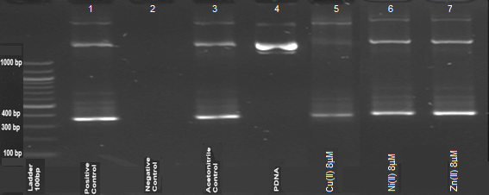
Figure 14: Comparison of the effect of 0.8μM Cu⁺²,Ni⁺², Zn⁺² ions on PCR reactions under anaerobic conditions.
For comparison, the effect of nickel and zinc ions on the PCR system was examined, no inhibitory effect was detected.

Phosphatase experiments:

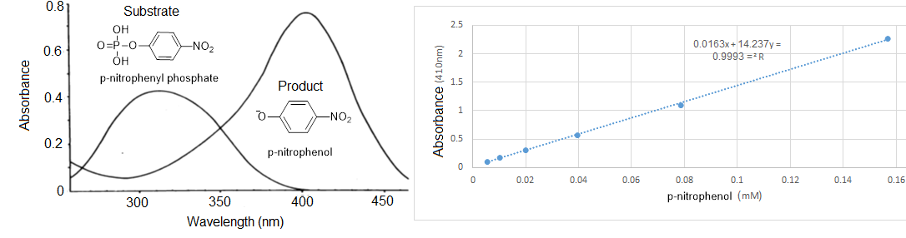

Figure 15: Absorption graph (left) of the reactant and product in the phosphatase enzymatic reaction and a calibration curve (right) of the product (p-nitrophnol) concentration against absorption at a wavelength of 410nm at pH=9.4 (buffer carbonate/bi-carbonate).
The difference in the absorption spectrum in the UV-vis range between the reactant and the product allows direct monitoring of the reaction, including kinetic research.

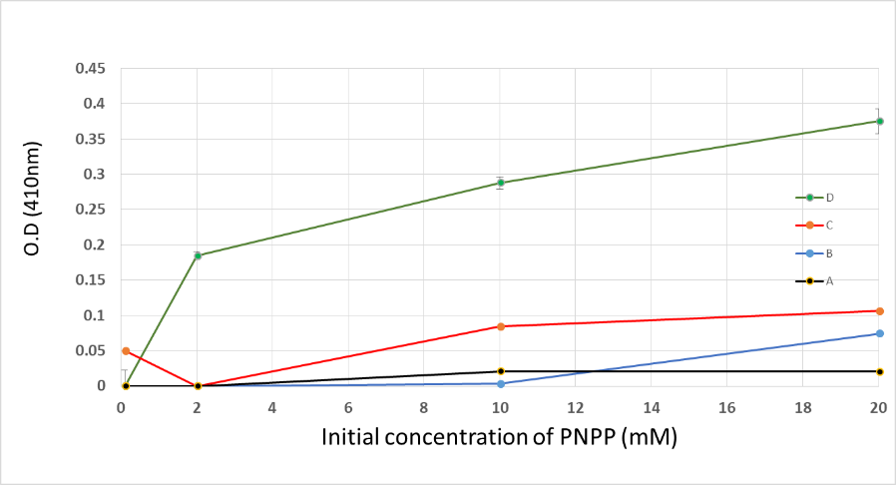

Figure 16: Absorption graph of the product in the phosphatase enzymatic reaction with the addition of 10mM Cu⁺² (D), 0.1mM Cu⁺ (C), 1mM Cu⁺ (B) and 10 mM Cu⁺ (A) under anaerobic conditions.
Comparing the effect of different concentrations of monovalent copper ions on the enzymatic reaction compared to a relatively high concentration of divalent copper ions, demonstrates the significant inhibition of the monovalent copper ions on Phosphatase.
Ligase DNA experiments:
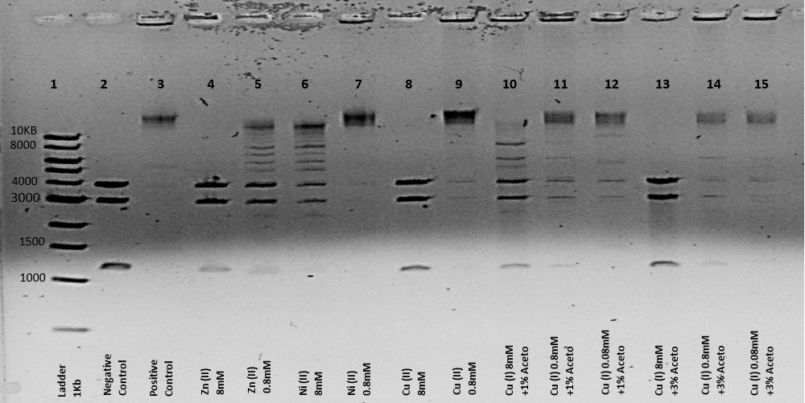

Figure 17: Electrophoresis results of DNA segments (from plasmids cut by restriction enzymes) that were incubated with Quick ligase enzymes for 24h, in the presence of metals ions (1% and 3% CH₃CN), under anaerobic conditions.
The effect of copper ions was tested on the enzyme Quick ligase In addition to experiments performed with the ligase T4 DNA enzyme, the results are similar and show significant inhibition of the copper ions in general and the monovalent copper ions in particular.

Restriction enzyme EcoP15I experiments:
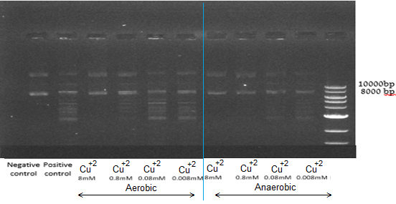

Figure 18: Electrophoresis results of restriction enzyme EcoP15I operating on pZIP plasmids in the presence of Cu²⁺ ions (1% CH₃CN) under aerobic and anaerobic conditions.
The effect of the divalent copper ions was tested on restriction enzyme EcoP15I, the results show a significant inhibition of the copper ions which is increased in an anaerobic atmosphere. The findings suggest that the fraction of monovalent copper ions plays a large part in the inhibition, in the aerobic atmosphere the monovalent copper ions in the medium react with oxygen and their concentration decreases.
In addition, one can learn from the results that oxygen has a negative effect on the inhibition which implies that the formation of ROS has a negligible effect on the enzyme activity.
Amylase enzyme experiments: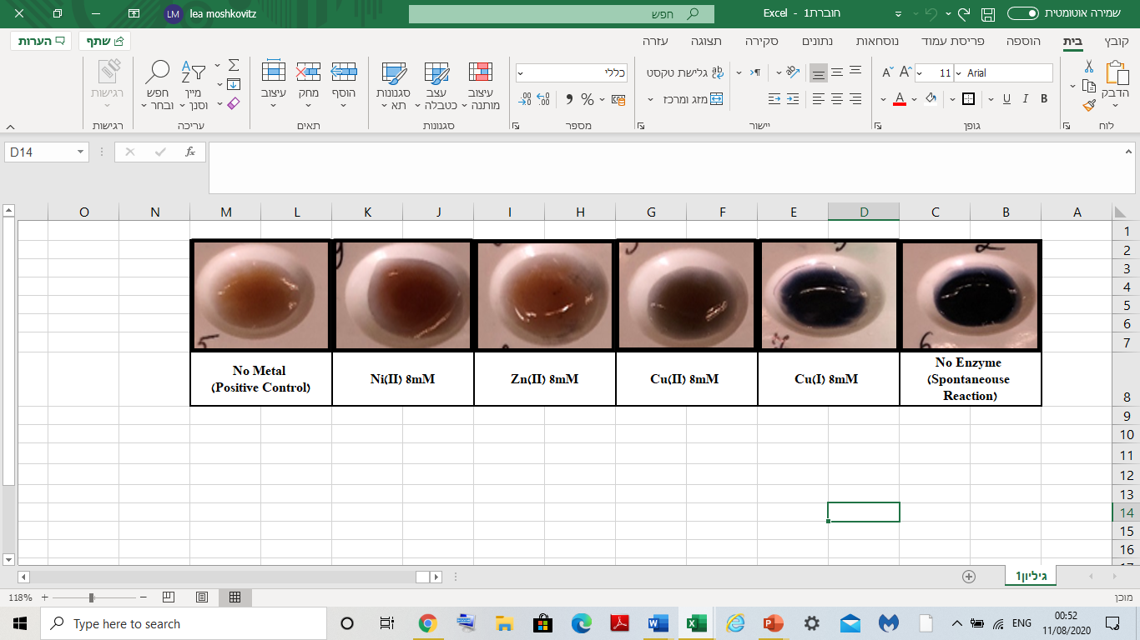

Figure 19: Iodine test (KI and I2) for Alpha-amylase enzyme activity on 3% starch in the presence of 8mM Cu²⁺ , Ni²⁺, Zn²⁺, and Cu⁺ ions (1% CH₃CN) under anaerobic conditions, pH 5, 40 ºC, for 60min.
To reinforce the results showing that monovalent copper ions inhibit amylase enzyme, a qualitative experiment was performed that monitors the breakdown of starch with the help of I₃⁻ which forms a color complex with the starch. The results well demonstrate that monovalent copper ions prevent the breakdown of starch by amylase enzyme.

