Supplementary Materials for
Synthesis and characterization of antibacterial viscose nonwoven fabric by the cooperative action of Se nanoparticles and amino hyperbranched polymer
Yao Xiao ¹, Zhenzheng Gan¹, Erying Dong², Jiawei Yan³, Wanwan Liu^{1*}, Guangyu Zhang ^{1，2*}
1) National & Local Joint Engineering Research Center of Technical Fiber Composites for Safe and Protection, School of Textile and Clothing, Nantong University, Nantong 226019, P. R. China;
2) Zhejiang Kingsafe Nonwoven Fabric Group Co., Ltd, Huzhou., Zhejiang, 313100, China;
3) Faculty of Textile Science and Technology, Shinshu University, 3-15-1, Tokida, Ueda, Nagano 386-8567, Japan.
∗Corresponding author: liuww@ntu.edu.cn and zgyu85@ntu.edu.cn

Characterization.
The Se content in the VNF was measured using a Vista MPX Inductively Coupled Plasma Atomic Emission Spectrometer (ICP-AES) (Varian, USA). 100 mg sample was cut into small pieces and immersed in 10 ml solution of HNO₃ (65%). After dissolved, 90 ml deionized water was used to dilute it. 1 ml of the diluted solution was then drawn to measure the concentration of Se. The Se content in cotton fabric was calculated by Eq. (1):
C_{Se} (mg/kg) = Cse × 10⁻³ (1)
Where, Cse (mg/L) is the concentration of Se in the solution.

The antibacterial activities of Se NPs with concentration of 0.05mM and 0.1mM aqueous solution against S. aureus and E. coli were determined by qualitative disk diffusion method. An agar plate was prepared by pouring the solid culture onto sterile circular plates. Then 1 ml of microbial culture (1×10⁶-5×10⁶ CFU/ml) was uniformly distributed on each plate. Oxford cups (inner diameter 6.0 mm, outer diameter 7.8 mm, height 10.0 mm) were placed on the plates and the Se NPs aqueous solution were added. The plates were placed in an incubator for 24 h at 37℃. After incubation, the zone of inhibition around the oxford cups could determine the antibacterial property of the Se NPs.

Fig.S1 The concentration-dependent Se content of VNF at 60℃
Figure S2. FT-IR spectra of (a) VNF, (b) Se NPs-coated VNF, (c) HBP

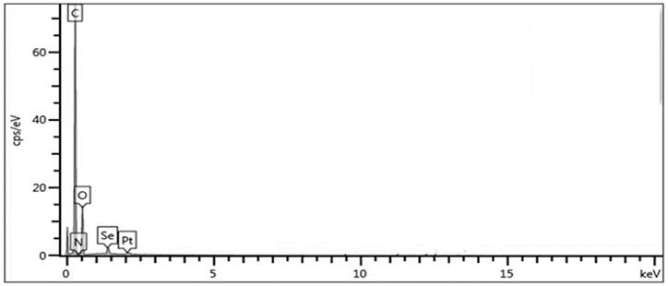
Figure S3. EDS images of Se NPs-coated VNF

Fig.S4 Antibacterial activities of Se NPs aqueous solution determined by oxford cup qualitative test of E. Coli, (a) the photographs of inhibition zone of deionized water, (b) inhibition zone of Se NPs with 0.05mM and (c) inhibition zone of Se NPs with 0.1mM

Fig.S5 Antibacterial activities of Se NPs aqueous solution determined by oxford cup qualitative test of S. aureus , (a) the photographs of inhibition zone of deionized water, (b) inhibition zone of Se NPs with 0.05mM and (c) inhibition zone of Se NPs with 0.1mM
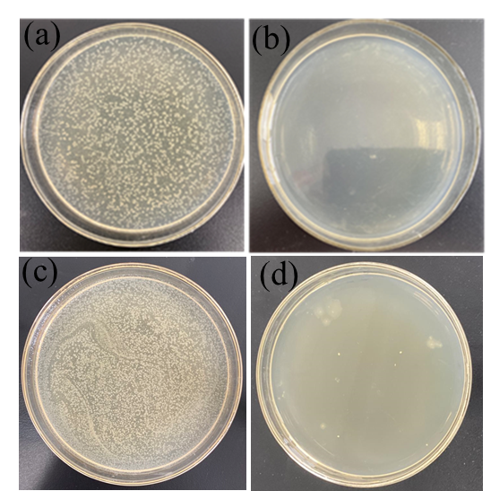
Fig.S6. E. coli colonies of (a) VNF (b) Se NPs-coated VNF and S. aureus colonies of (c) VNF (d) Se NPs-coated VNF.

