Supplemental Tables
Supplemental Table 1. Cadence of ctDNA testing following positive or negative ctDNA test results in postoperative surveillance. Patients with ≥2 postoperative ctDNA tests who had a positive ctDNA test result tended to have a shorter median time to next test compared to those with negative ctDNA results.
Event Group | Informative events** (n) | Time to next test, months; median (range)
After positive* ctDNA test result | 1418 | 1.84 (0.1–16.3)
After negative* ctDNA test result | 4642 | 3.21 (0.13–37.25)
After two consecutive negative ctDNA test results | 3321 | 3.02 (0.03–24.82)
*: independent of any prior ctDNA test result
** Events with subsequent ctDNA testing

Supplemental Table 2. Time to next test and relapse rates among patients grouped by results of subsequent ctDNA testing.
Subsequent ctDNA test results  (test → next test ) | n Patients* | Time to next test, months;  median (range) | Relapse (n) | No Relapse (n) | Relapse rate (%)
Negative → Negative | 4991 | 3.41 (0.033-33.5) | 69 | 4922 | 1.38%
Positive → Negative | 106 | 2.77 (0.45-10.3) | 9 | 97 | 8.49%
Negative → Positive | 188 | 1.69 (0.46-6.13) | 35 | 153 | 18.62%
Positive → Positive | 407 | 2.07 (0.20-16.3) | 148 | 259 | 36.36%

Supplemental Figures
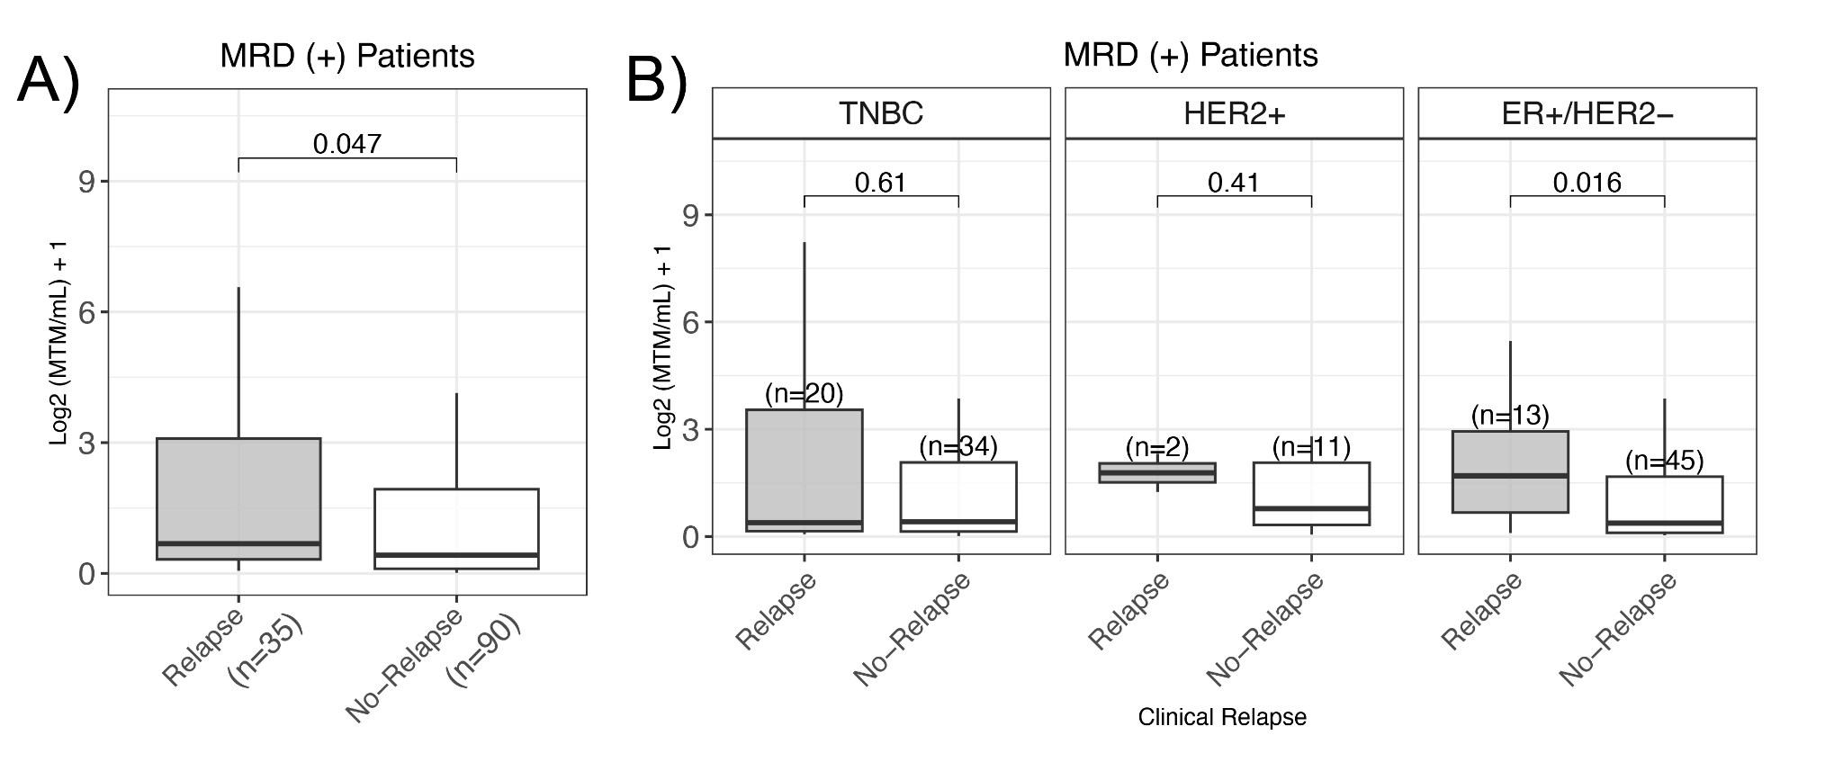Supplemental Figure 1. Wilcox-test (non-parametric unpaired test) of ctDNA levels (MTM/mL) in patients who experienced relapse vs. those who did not among A) all patients and B) patients grouped by breast cancer molecular subtype.

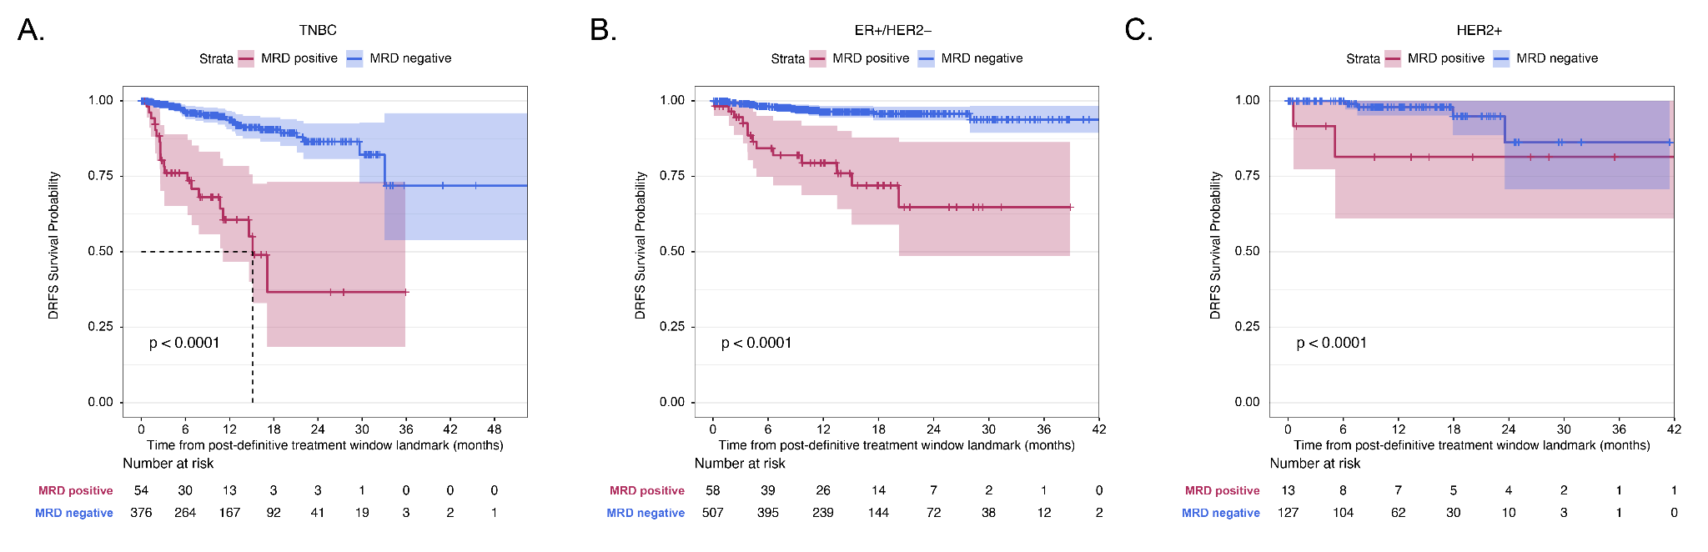
Supplemental Figure 2. Prognostic significance of molecular residual disease (MRD) at 3-months post-surgery by receptor subtype. A-C. Kaplan-Meier survival analysis indicated that patients who were ctDNA-positive in the post-operative window (MRD+) experienced significantly inferior DRFS compared to those who were ctDNA-negative in A) TNBC, B) ER+/HER2-, and C) HER2+
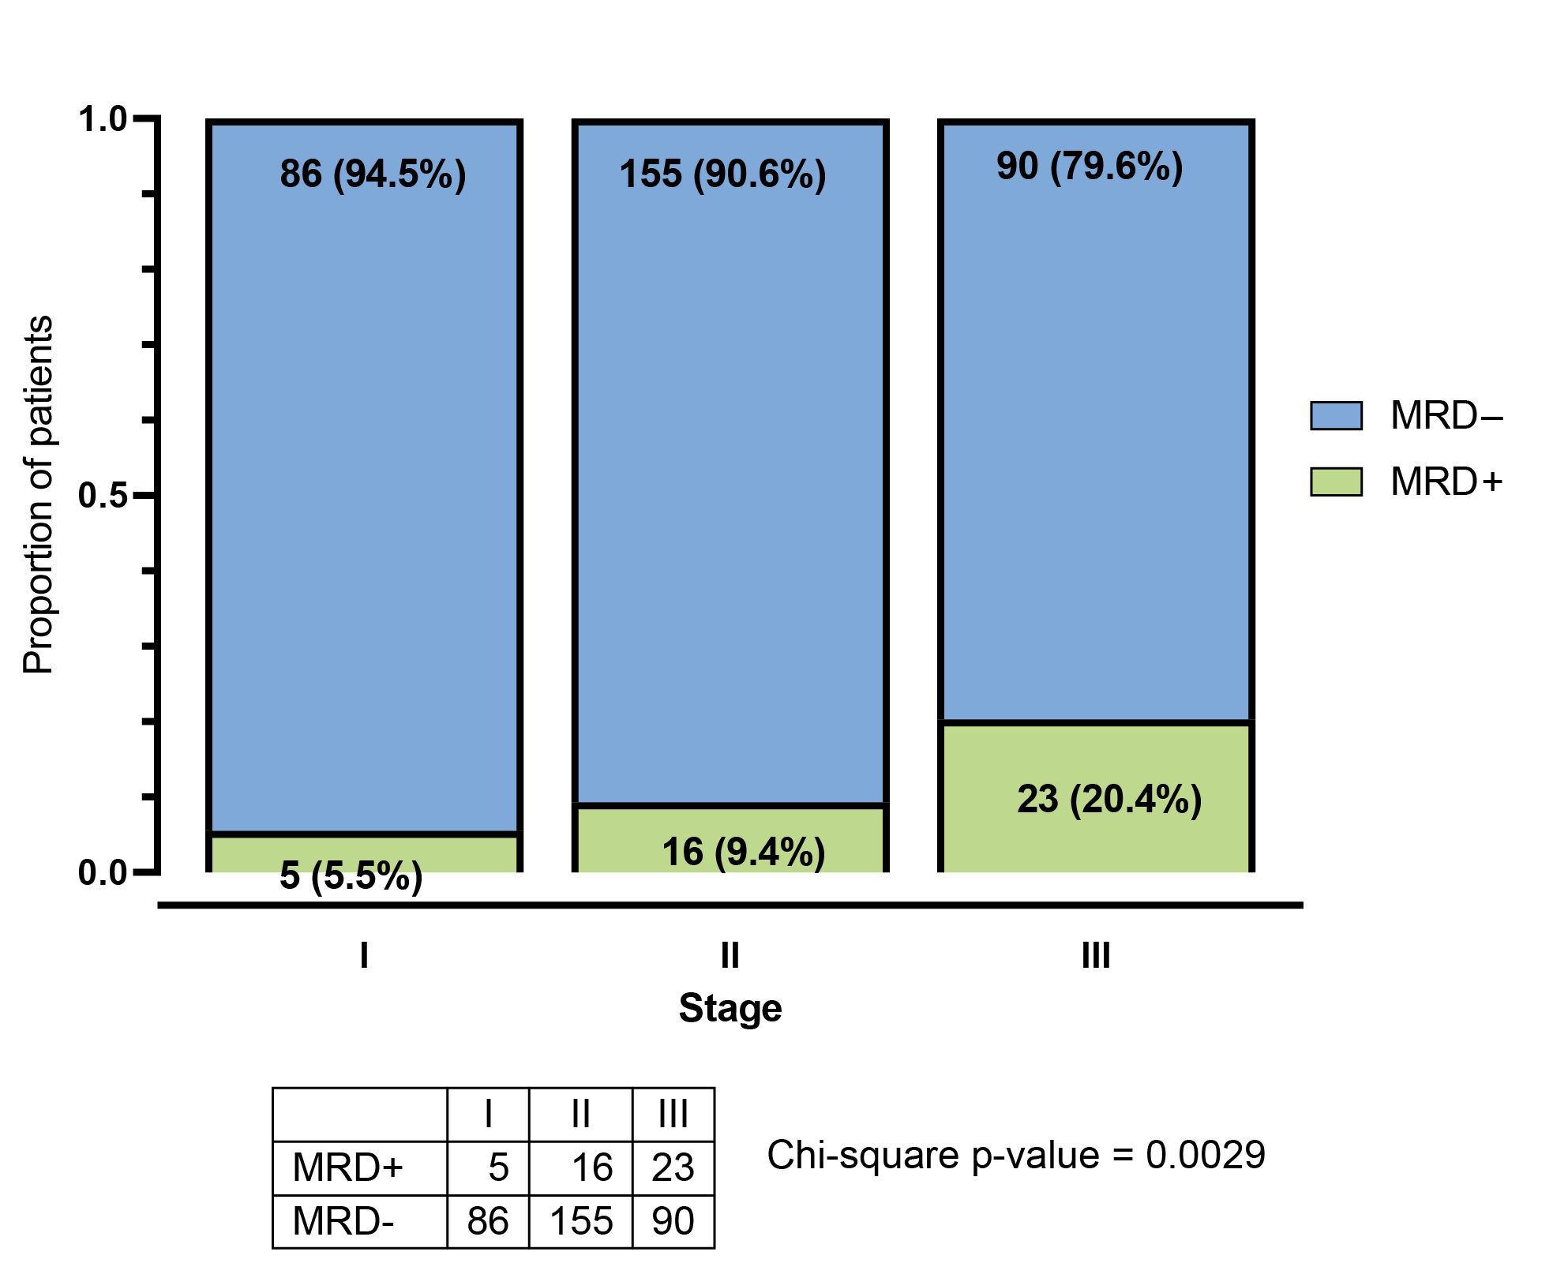
Supplemental Figure 3. In the single-institution actionability cohort, tumor stage distribution was significantly different among the MRD-positive (MRD+) and MRD-negative (MRD-) groups.

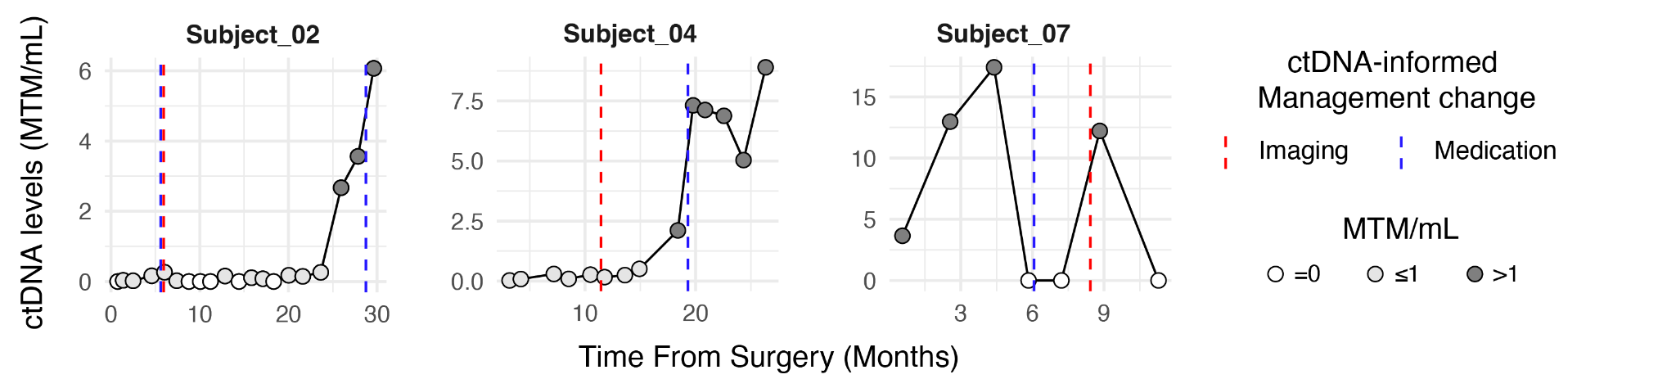

Supplemental Figure 4. ctDNA dynamics for patients in single-institution cohort with ctDNA-informed medication change who did not clear ctDNA

