suplemmentary file 1

Toxicity evaluation of choline ionic liquid-based nanocarriers of pharmaceutical agent for lung treatment with extra antitumor activity
Katarzyna Niesyto¹, Magdalena Skonieczna^{*2,3}, Malgorzata Adamiec-Organisciok^{2,3}, Dorota Neugebauer¹
¹ Department of Physical Chemistry and Technology of Polymers, Faculty of Chemistry, Silesian University of Technology, Strzody 9, 44-100, Gliwice, Poland
² Department of Systems Biology and Engineering, Faculty of Automatic Control, Electronics and Computer Science, Silesian University of Technology, 44‐100 Gliwice, Poland
³ Biotechnology Centre, Silesian University of Technology, Krzywoustego 8, 44-100 Gliwice, Poland
*corresponding author: magdalena.skonieczna@polsl.pl

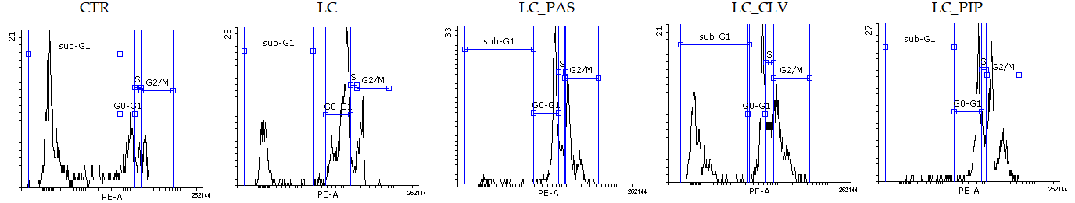
Figure S1. Typical histograms of the BEAS-2B cell cycle after 72 h of treatment with 50 μg/mL of tested compounds.
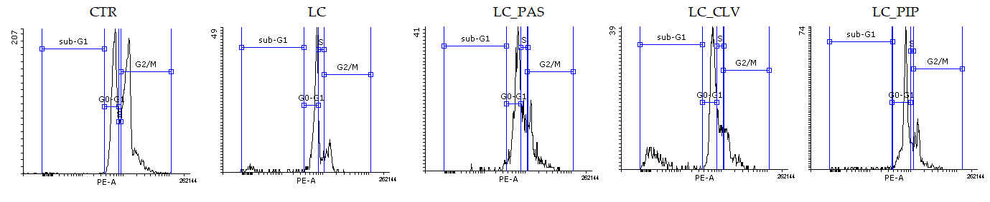
Figure S2. Typical histograms of the A549 cell cycle after 72 h of treatment with 50 μg/mL of tested compounds.
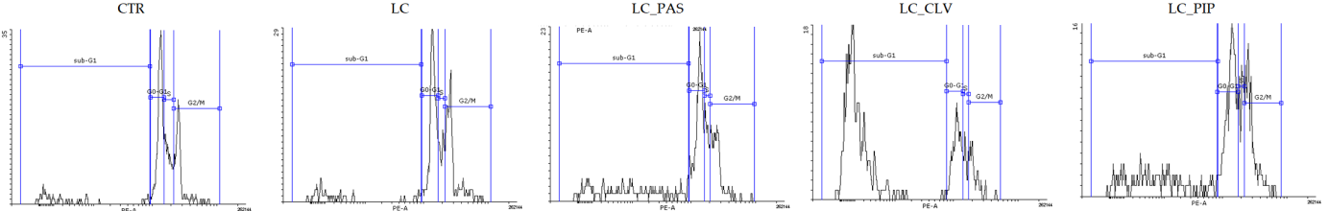
Figure S3. Typical histograms of the H1299 cell cycle after 72 h of treatment with 50 μg/mL of tested compounds.

