Supplementary Material

Table S1: Results of the models describing bumblebee elevational shift across species. We ran one model for the mean elevation, elevational range and the upper and lower bound of the elevational range each.
Model | Variable | Estimate | Std. Error | z Value | p Value
Mean | (Intercept) | 1048.3 | 90.6 | 11.57 | < 0.001
 | 1900-1950 | 33.2 | 46.6 | 0.71 | 0.475
 | 1951-1980 | 111.0 | 46.5 | 2.39 | 0.017
 | 1981-2000 | 128.3 | 46.6 | 2.75 | 0.006
 | 2001-2010 | 40.5 | 46.8 | 0.87 | 0.387
 | 2011-2023 | 179.4 | 46.8 | 3.84 | < 0.001
Range | (Intercept) | 1386.5 | 128.3 | 10.81 | < 0.001
 | 1900-1950 | 383.0 | 142.4 | 2.69 | 0.007
 | 1951-1980 | 481.1 | 141.7 | 3.40 | < 0.001
 | 1981-2000 | 518.5 | 142.7 | 3.63 | < 0.001
 | 2001-2010 | 394.5 | 143.5 | 2.75 | 0.006
 | 2011-2023 | 395.4 | 143.5 | 2.76 | 0.006
Upper bound | (Intercept) | 1793.1 | 99.7 | 17.98 | < 0.001
 | 1900-1950 | 320.9 | 72.1 | 4.45 | < 0.001
 | 1951-1980 | 446.5 | 72.0 | 6.20 | < 0.001
 | 1981-2000 | 470.4 | 72.2 | 6.52 | < 0.001
 | 2001-2010 | 346.8 | 72.4 | 4.79 | < 0.001
 | 2011-2023 | 522.9 | 72.5 | 7.22 | < 0.001
Lower bound | (Intercept) | 379.1 | 108.7 | 3.49 | < 0.001
 | 1900-1950 | -47.3 | 120.6 | -0.39 | 0.695
 | 1951-1980 | -5.7 | 120.0 | -0.05 | 0.961
 | 1981-2000 | -13.6 | 120.9 | -0.11 | 0.910
 | 2001-2010 | 33.4 | 121.5 | 0.28 | 0.783
 | 2011-2023 | 195.7 | 121.5 | 1.61 | 0.107

Table S2: Results of the models describing wild bee elevational shift across species. We ran one model for the mean elevation, elevational range and the upper and lower bound of the elevational range each.
Model | Variable | Estimate | Std. Error | z Value | p Value
Mean | (Intercept) | 733.4 | 22.6 | 32.40 | < 0.001
 | 1900-1950 | 79.4 | 15.6 | 5.09 | < 0.001
 | 1951-1980 | -44.9 | 15.6 | -2.88 | 0.004
 | 1981-2000 | 86.4 | 15.5 | 5.59 | < 0.001
 | 2001-2010 | 117.5 | 15.7 | 7.47 | < 0.001
 | 2011-2023 | 43.1 | 15.5 | 2.78 | 0.006
Range | (Intercept) | 1605.3 | 51.8 | 31.01 | < 0.001
 | 1900-1950 | 214.2 | 59.1 | 3.63 | < 0.001
 | 1951-1980 | 33.2 | 58.7 | 0.57 | 0.571
 | 1981-2000 | 193.6 | 57.5 | 3.37 | < 0.001
 | 2001-2010 | 240.6 | 59.2 | 4.06 | < 0.001
 | 2011-2023 | 25.9 | 58.1 | 0.45 | 0.656
Upper bound | (Intercept) | 1660.7 | 41.7 | 39.79 | < 0.001
 | 1900-1950 | 247.4 | 36.5 | 6.79 | < 0.001
 | 1951-1980 | 49.4 | 36.5 | 1.36 | 0.175
 | 1981-2000 | 319.4 | 36.2 | 8.83 | < 0.001
 | 2001-2010 | 360.2 | 36.8 | 9.79 | < 0.001
 | 2011-2023 | 141.8 | 36.3 | 3.90 | < 0.001
Lower bound | (Intercept) | 310.4 | 20.6 | 15.02 | < 0.001
 | 1900-1950 | -42.2 | 23.6 | -1.79 | 0.073
 | 1951-1980 | -133.5 | 23.4 | -5.70 | < 0.001
 | 1981-2000 | -97.0 | 23.0 | -4.22 | < 0.001
 | 2001-2010 | -24.5 | 23.6 | -1.04 | 0.300
 | 2011-2023 | -92.8 | 23.2 | -4.00 | < 0.001

Table S3: Results of the models describing hoverfly elevational shift across species. We ran one model for the mean elevation, elevational range and the upper and lower bound of the elevational range each.
Model | Variable | Estimate | Std. Error | z Value | p Value
Mean | (Intercept) | 922.1 | 57.7 | 15.98 | < 0.001
 | 2001-2010 | 207.8 | 58.5 | 3.55 | < 0.001
 | 2011-2023 | 109.3 | 53.1 | 2.06 | < 0.001
Range | (Intercept) | 1608.0 | 83.6 | 19.24 | < 0.001
 | 2001-2010 | 19.4 | 97.7 | 0.20 | 0.843
 | 2011-2023 | 14.7 | 84.2 | 0.18 | 0.861
Upper bound | (Intercept) | 1828.3 | 66.2 | 27.60 | < 0.001
 | 2001-2010 | 199.2 | 67.4 | 2.96 | 0.003
 | 2011-2023 | 134.2 | 60.9 | 2.20 | 0.028
Lower bound | (Intercept) | 261.6 | 58.0 | 4.52 | < 0.001
 | 2001-2010 | 179.3 | 64.8 | 2.77 | 0.006
 | 2011-2023 | 76.6 | 57.7 | 1.33 | 0.184

Table S4: Elevational shifts per bumblebee species
Species | Estimate | Std. Error | Conf. low | Conf. high
Bombus alpinus | 4.08 | 0.87 | 2.37 | 5.79
Bombus argillaceus | -1.60 | 0.66 | -2.89 | -0.31
Bombus barbutellus | 0.41 | 0.45 | -0.48 | 1.30
Bombus bohemicus | 0.48 | 0.40 | -0.31 | 1.26
Bombus campestris | 0.62 | 0.30 | 0.02 | 1.21
Bombus confusus | -0.05 | 0.54 | -1.11 | 1.01
Bombus cryptarum | 0.83 | 1.10 | -1.32 | 2.99
Bombus gerstaeckeri | 0.77 | 0.70 | -0.61 | 2.15
Bombus hortorum | -1.68 | 0.29 | -2.25 | -1.10
Bombus humilis | -1.23 | 0.28 | -1.79 | -0.68
Bombus hypnorum | -0.30 | 0.40 | -1.08 | 0.48
Bombus jonellus | 0.74 | 0.95 | -1.13 | 2.61
Bombus lapidarius | -1.27 | 0.25 | -1.75 | -0.78
Bombus lucorum | -5.36 | 0.34 | -6.02 | -4.70
Bombus mendax | 1.98 | 0.58 | 0.84 | 3.12
Bombus mesomelas | 3.77 | 0.47 | 2.84 | 4.69
Bombus monticola | 1.76 | 0.51 | 0.76 | 2.77
Bombus mucidus | 2.07 | 0.62 | 0.86 | 3.28
Bombus muscorum | 0.22 | 0.50 | -0.76 | 1.20
Bombus norvegicus | 0.48 | 1.10 | -1.67 | 2.63
Bombus pascuorum | -1.75 | 0.20 | -2.13 | -1.36
Bombus pomorum | 2.94 | 0.77 | 1.43 | 4.45
Bombus pratorum | -1.43 | 0.32 | -2.06 | -0.81
Bombus pyrenaeus | 2.22 | 0.48 | 1.28 | 3.17
Bombus quadricolor | 4.07 | 0.79 | 2.53 | 5.62
Bombus ruderarius | 2.90 | 0.55 | 1.82 | 3.98
Bombus ruderatus | -0.64 | 0.51 | -1.64 | 0.35
Bombus rupestris | -1.23 | 0.60 | -2.39 | -0.06
Bombus sichelii | 2.03 | 0.46 | 1.13 | 2.93
Bombus soroeensis | 0.65 | 0.38 | -0.10 | 1.41
Bombus subterraneus | 2.65 | 0.89 | 0.91 | 4.38
Bombus sylvarum | -0.62 | 0.33 | -1.27 | 0.02
Bombus sylvestris | -1.01 | 0.54 | -2.06 | 0.05
Bombus terrestris | -0.88 | 0.28 | -1.42 | -0.34
Bombus vestalis | 1.62 | 0.68 | 0.28 | 2.96
Bombus veteranus | 2.13 | 0.48 | 1.19 | 3.08
Bombus wurflenii | 1.87 | 0.37 | 1.15 | 2.60

Table S5: Elevational shifts per wild bee species
Species | Estimate | Std. Error | Conf. low | Conf. high
Amegilla albigena | 1.97 | 0.91 | 0.18 | 3.75
Andrena agilissima | 0.27 | 0.60 | -0.90 | 1.45
Andrena barbareae | 0.77 | 1.08 | -1.35 | 2.88
Andrena barbilabris | 0.36 | 0.76 | -1.12 | 1.85
Andrena bicolor | 0.49 | 0.52 | -0.54 | 1.51
Andrena bucephala | 1.99 | 0.55 | 0.90 | 3.07
Andrena chrysosceles | 0.33 | 0.53 | -0.70 | 1.36
Andrena cineraria | -0.50 | 0.69 | -1.86 | 0.86
Andrena combinata | 1.65 | 0.87 | -0.04 | 3.35
Andrena curvungula | 2.04 | 0.94 | 0.20 | 3.88
Andrena dorsata | 1.18 | 0.50 | 0.20 | 2.17
Andrena falsifica | 0.52 | 1.02 | -1.48 | 2.51
Andrena flavipes | -0.86 | 0.34 | -1.54 | -0.19
Andrena fucata | 3.67 | 0.98 | 1.74 | 5.59
Andrena fulva | 1.82 | 0.51 | 0.82 | 2.81
Andrena fulvago | -0.71 | 0.85 | -2.37 | 0.96
Andrena fulvata | 1.02 | 0.47 | 0.10 | 1.93
Andrena gravida | -0.19 | 0.35 | -0.88 | 0.49
Andrena haemorrhoa | 1.37 | 0.43 | 0.53 | 2.21
Andrena hattorfiana | 0.48 | 0.63 | -0.76 | 1.72
Andrena helvola | 1.43 | 0.62 | 0.21 | 2.65
Andrena humilis | -0.18 | 0.49 | -1.14 | 0.78
Andrena intermedia | 3.26 | 0.95 | 1.40 | 5.13
Andrena labiata | -2.35 | 0.85 | -4.01 | -0.69
Andrena lagopus | 2.52 | 0.76 | 1.03 | 4.01
Andrena lapponica | 2.26 | 1.13 | 0.05 | 4.47
Andrena lathyri | 0.33 | 0.71 | -1.06 | 1.72
Andrena minutula | -1.92 | 0.47 | -2.84 | -1.00
Andrena minutuloides | -0.54 | 0.64 | -1.80 | 0.72
Andrena nigroaenea | 2.19 | 0.67 | 0.87 | 3.51
Andrena nitida | 0.88 | 0.43 | 0.03 | 1.72
Andrena nitidiuscula | 3.03 | 1.08 | 0.91 | 5.14
Andrena praecox | 2.41 | 0.80 | 0.84 | 3.98
Andrena proxima | 0.39 | 0.68 | -0.94 | 1.71
Andrena rosae | -1.16 | 0.57 | -2.29 | -0.04
Andrena russula | 2.20 | 0.92 | 0.39 | 4.01
Andrena scotica | 3.23 | 0.74 | 1.77 | 4.68
Andrena strohmella | 1.71 | 0.77 | 0.20 | 3.23
Andrena subopaca | 1.32 | 0.67 | 0.01 | 2.63
Andrena tibialis | 0.36 | 0.72 | -1.06 | 1.78
Andrena vaga | 0.33 | 0.55 | -0.75 | 1.40
Andrena ventralis | -0.32 | 0.49 | -1.27 | 0.64
Andrena viridescens | 1.31 | 0.59 | 0.16 | 2.47
Andrena wilkella | 0.46 | 0.69 | -0.89 | 1.82
Anthidiellum strigatum | -0.36 | 0.56 | -1.46 | 0.74
Anthidium manicatum | -1.57 | 0.44 | -2.44 | -0.70
Anthidium oblongatum | -1.38 | 0.64 | -2.64 | -0.13
Anthidium punctatum | -1.63 | 0.71 | -3.02 | -0.23
Anthophora aestivalis | 2.68 | 0.58 | 1.54 | 3.82
Anthophora crinipes | 0.28 | 0.62 | -0.93 | 1.49
Anthophora furcata | -0.40 | 0.59 | -1.56 | 0.77
Anthophora plumipes | -0.61 | 0.34 | -1.27 | 0.05
Anthophora quadrimaculata | 0.59 | 0.70 | -0.78 | 1.95
Ceratina chalybea | 0.33 | 0.96 | -1.55 | 2.22
Ceratina cucurbitina | -1.33 | 0.77 | -2.84 | 0.18
Ceratina cyanea | 0.30 | 0.56 | -0.80 | 1.41
Chelostoma campanularum | -1.50 | 0.54 | -2.56 | -0.44
Chelostoma distinctum | 1.37 | 0.85 | -0.30 | 3.05
Chelostoma florisomne | -2.64 | 0.47 | -3.57 | -1.71
Chelostoma rapunculi | -3.14 | 0.51 | -4.14 | -2.13
Coelioxys afer | -1.35 | 0.91 | -3.13 | 0.44
Coelioxys elongatus | 0.46 | 1.16 | -1.82 | 2.73
Coelioxys quadridentatus | 2.11 | 0.94 | 0.27 | 3.95
Coelioxys rufescens | -2.08 | 0.87 | -3.79 | -0.37
Colletes cunicularius | 0.24 | 0.34 | -0.43 | 0.91
Colletes daviesanus | -1.19 | 0.50 | -2.17 | -0.21
Colletes impunctatus | 3.47 | 0.77 | 1.96 | 4.98
Colletes similis | 0.27 | 0.56 | -0.83 | 1.37
Dasypoda hirtipes | 0.32 | 0.87 | -1.38 | 2.03
Dufourea alpina | 1.00 | 0.83 | -0.63 | 2.64
Dufourea dentiventris | 0.78 | 0.68 | -0.56 | 2.12
Eucera longicornis | 0.46 | 0.65 | -0.81 | 1.73
Eucera nigrescens | -0.55 | 0.44 | -1.41 | 0.30
Halictus langobardicus | -2.16 | 0.90 | -3.92 | -0.39
Halictus maculatus | -2.32 | 0.48 | -3.26 | -1.38
Halictus quadricinctus | 0.37 | 0.98 | -1.56 | 2.29
Halictus rubicundus | -0.37 | 0.53 | -1.42 | 0.67
Halictus scabiosae | -2.77 | 0.44 | -3.63 | -1.91
Halictus sexcinctus | 1.04 | 0.57 | -0.08 | 2.16
Halictus simplex | -1.73 | 0.53 | -2.77 | -0.70
Heriades crenulata | -4.59 | 0.84 | -6.23 | -2.95
Heriades truncorum | -2.64 | 0.48 | -3.59 | -1.69
Hoplitis adunca | -2.61 | 0.52 | -3.62 | -1.59
Hoplitis anthocopoides | 2.12 | 1.17 | -0.17 | 4.40
Hoplitis claviventris | 0.56 | 0.68 | -0.76 | 1.89
Hoplitis lepeletieri | 1.67 | 0.64 | 0.41 | 2.93
Hoplitis leucomelana | -1.93 | 0.81 | -3.51 | -0.35
Hoplitis loti | 0.88 | 0.65 | -0.40 | 2.16
Hoplitis mitis | 0.78 | 1.10 | -1.38 | 2.93
Hoplitis tridentata | -4.86 | 1.45 | -7.70 | -2.02
Hoplitis tuberculata | -0.01 | 0.64 | -1.26 | 1.25
Hoplitis villosa | 0.79 | 0.75 | -0.68 | 2.26
Hylaeus alpinus | 4.61 | 1.15 | 2.35 | 6.88
Hylaeus angustatus | 2.41 | 0.98 | 0.50 | 4.33
Hylaeus annulatus | 2.70 | 0.79 | 1.15 | 4.25
Hylaeus brevicornis | 0.28 | 0.63 | -0.97 | 1.52
Hylaeus communis | -0.84 | 0.41 | -1.65 | -0.02
Hylaeus confusus | 2.15 | 0.59 | 0.99 | 3.32
Hylaeus difformis | 0.37 | 0.80 | -1.20 | 1.94
Hylaeus dilatatus | 0.30 | 0.80 | -1.26 | 1.86
Hylaeus gibbus | -1.36 | 0.70 | -2.73 | 0.00
Hylaeus gredleri | -0.27 | 0.46 | -1.17 | 0.62
Hylaeus hyalinatus | -0.46 | 0.54 | -1.51 | 0.59
Hylaeus kahri | 4.02 | 1.06 | 1.94 | 6.09
Hylaeus nigritus | 0.39 | 0.69 | -0.96 | 1.74
Hylaeus punctatus | -1.23 | 0.64 | -2.48 | 0.03
Hylaeus signatus | -1.05 | 0.49 | -2.01 | -0.09
Hylaeus sinuatus | 0.33 | 0.57 | -0.78 | 1.45
Hylaeus styriacus | 3.25 | 0.77 | 1.75 | 4.76
Hylaeus variegatus | -0.75 | 0.79 | -2.31 | 0.81
Lasioglossum aeratum | 4.91 | 1.14 | 2.68 | 7.14
Lasioglossum albipes | 1.53 | 0.48 | 0.60 | 2.47
Lasioglossum calceatum | 0.05 | 0.34 | -0.63 | 0.72
Lasioglossum costulatum | 2.90 | 1.02 | 0.91 | 4.89
Lasioglossum cupromicans | 0.88 | 1.39 | -1.86 | 3.61
Lasioglossum discus | -5.08 | 0.62 | -6.29 | -3.87
Lasioglossum fratellum | 0.80 | 1.36 | -1.86 | 3.46
Lasioglossum fulvicorne | 1.52 | 0.52 | 0.50 | 2.54
Lasioglossum glabriusculum | -3.75 | 0.44 | -4.61 | -2.89
Lasioglossum interruptum | 0.35 | 0.71 | -1.03 | 1.74
Lasioglossum laevigatum | 5.30 | 0.69 | 3.95 | 6.66
Lasioglossum laticeps | -0.17 | 0.36 | -0.89 | 0.54
Lasioglossum lativentre | 2.24 | 0.65 | 0.96 | 3.51
Lasioglossum leucopus | 3.16 | 0.92 | 1.37 | 4.96
Lasioglossum leucozonium | -2.35 | 0.45 | -3.22 | -1.48
Lasioglossum lineare | 1.36 | 0.51 | 0.36 | 2.36
Lasioglossum lucidulum | -1.83 | 0.77 | -3.33 | -0.32
Lasioglossum malachurum | -1.31 | 0.31 | -1.92 | -0.71
Lasioglossum marginatum | -2.33 | 0.97 | -4.23 | -0.42
Lasioglossum minutissimum | -5.21 | 0.68 | -6.54 | -3.87
Lasioglossum morio | -1.45 | 0.37 | -2.16 | -0.73
Lasioglossum nigripes | -0.37 | 0.51 | -1.36 | 0.62
Lasioglossum nitidiusculum | 0.36 | 0.71 | -1.03 | 1.76
Lasioglossum nitidulum | 0.40 | 0.55 | -0.67 | 1.47
Lasioglossum parvulum | 2.34 | 0.70 | 0.97 | 3.71
Lasioglossum pauxillum | -0.83 | 0.38 | -1.58 | -0.08
Lasioglossum politum | -0.39 | 0.36 | -1.09 | 0.32
Lasioglossum punctatissimum | 0.35 | 0.74 | -1.09 | 1.80
Lasioglossum rufitarse | 5.71 | 1.01 | 3.73 | 7.69
Lasioglossum semilucens | 2.24 | 1.08 | 0.11 | 4.36
Lasioglossum sexnotatum | 3.22 | 0.74 | 1.78 | 4.66
Lasioglossum tricinctum | 1.90 | 1.04 | -0.13 | 3.94
Lasioglossum villosulum | -1.48 | 0.48 | -2.41 | -0.54
Lasioglossum xanthopus | 0.37 | 0.94 | -1.48 | 2.22
Lasioglossum zonulum | -1.79 | 0.47 | -2.72 | -0.86
Macropis europaea | -1.75 | 0.47 | -2.68 | -0.82
Macropis fulvipes | -1.23 | 0.88 | -2.96 | 0.50
Megachile alpicola | -4.56 | 0.89 | -6.31 | -2.81
Megachile analis | 0.91 | 0.87 | -0.80 | 2.61
Megachile apicalis | -0.64 | 0.66 | -1.94 | 0.66
Megachile argentata | -2.70 | 0.62 | -3.91 | -1.48
Megachile centuncularis | 0.36 | 0.63 | -0.88 | 1.59
Megachile circumcincta | -2.91 | 0.67 | -4.22 | -1.59
Megachile ericetorum | -0.96 | 0.40 | -1.75 | -0.17
Megachile leachella | 0.43 | 1.22 | -1.97 | 2.83
Megachile maritima | 0.36 | 0.83 | -1.26 | 1.99
Megachile melanopyga | -1.41 | 1.01 | -3.40 | 0.57
Megachile nigriventris | -1.40 | 0.94 | -3.25 | 0.45
Megachile parietina | -0.43 | 0.71 | -1.81 | 0.95
Megachile pyrenaea | 0.77 | 1.14 | -1.47 | 3.00
Megachile pyrenaica | 3.01 | 0.79 | 1.47 | 4.56
Megachile rotundata | -1.61 | 0.91 | -3.39 | 0.17
Megachile versicolor | -2.08 | 0.72 | -3.49 | -0.67
Megachile willughbiella | -2.11 | 0.54 | -3.17 | -1.04
Melecta albifrons | 0.30 | 0.46 | -0.60 | 1.21
Melecta luctuosa | 4.59 | 0.87 | 2.88 | 6.31
Melitta haemorrhoidalis | 0.53 | 0.76 | -0.96 | 2.02
Melitta leporina | 0.35 | 0.61 | -0.85 | 1.54
Melitta tricincta | 4.44 | 1.41 | 1.67 | 7.20
Nomada alboguttata | 0.28 | 0.79 | -1.27 | 1.83
Nomada atroscutellaris | 2.91 | 0.92 | 1.11 | 4.71
Nomada bifasciata | -0.33 | 0.56 | -1.43 | 0.77
Nomada conjungens | 0.39 | 0.94 | -1.45 | 2.23
Nomada fabriciana | 0.36 | 0.53 | -0.68 | 1.40
Nomada flava | 0.32 | 0.43 | -0.53 | 1.16
Nomada flavoguttata | 1.47 | 0.50 | 0.49 | 2.45
Nomada flavopicta | 0.36 | 0.69 | -0.99 | 1.72
Nomada fucata | 0.28 | 0.80 | -1.28 | 1.84
Nomada fulvicornis | 2.05 | 0.66 | 0.76 | 3.33
Nomada goodeniana | 0.31 | 0.45 | -0.58 | 1.19
Nomada hirtipes | 1.30 | 1.00 | -0.66 | 3.25
Nomada integra | 0.42 | 0.63 | -0.82 | 1.66
Nomada lathburiana | -1.44 | 0.95 | -3.30 | 0.43
Nomada marshamella | 2.77 | 0.73 | 1.34 | 4.19
Nomada panzeri | 0.48 | 0.71 | -0.90 | 1.87
Nomada ruficornis | 0.33 | 0.54 | -0.72 | 1.39
Nomada sexfasciata | 0.30 | 0.64 | -0.95 | 1.55
Nomada signata | 0.35 | 0.85 | -1.31 | 2.01
Nomada striata | 1.90 | 0.70 | 0.52 | 3.27
Nomada succincta | 0.39 | 0.87 | -1.32 | 2.10
Nomiapis diversipes | -3.85 | 0.88 | -5.58 | -2.12
Osmia andrenoides | -1.79 | 1.28 | -4.31 | 0.72
Osmia aurulenta | 0.43 | 0.47 | -0.49 | 1.36
Osmia bicolor | 0.42 | 0.50 | -0.56 | 1.41
Osmia bicornis | -0.80 | 0.39 | -1.57 | -0.02
Osmia brevicornis | 0.38 | 0.95 | -1.49 | 2.25
Osmia caerulescens | -2.18 | 0.50 | -3.16 | -1.20
Osmia cornuta | 0.33 | 0.58 | -0.80 | 1.46
Osmia gallarum | 0.48 | 1.07 | -1.62 | 2.58
Osmia inermis | 3.46 | 0.94 | 1.62 | 5.31
Osmia labialis | 0.73 | 1.30 | -1.82 | 3.28
Osmia leaiana | -1.30 | 0.60 | -2.47 | -0.13
Osmia mustelina | 1.86 | 0.89 | 0.13 | 3.60
Osmia niveata | 0.49 | 0.70 | -0.88 | 1.85
Osmia parietina | -2.71 | 0.85 | -4.38 | -1.05
Osmia rufohirta | -1.39 | 0.51 | -2.40 | -0.39
Osmia spinulosa | -2.27 | 1.13 | -4.48 | -0.06
Osmia submicans | 0.48 | 0.79 | -1.08 | 2.03
Osmia uncinata | -1.49 | 1.18 | -3.80 | 0.82
Osmia xanthomelana | 0.65 | 0.72 | -0.76 | 2.05
Panurginus montanus | -0.36 | 0.80 | -1.93 | 1.21
Panurgus banksianus | 2.10 | 0.65 | 0.82 | 3.39
Panurgus calcaratus | 3.96 | 0.78 | 2.43 | 5.49
Panurgus dentipes | 0.47 | 1.15 | -1.79 | 2.73
Pseudoanthidium nanum | -0.65 | 0.98 | -2.58 | 1.27
Rhodanthidium septemdentatum | -2.04 | 0.91 | -3.81 | -0.26
Seladonia smaragdula | 0.25 | 1.44 | -2.58 | 3.07
Seladonia subaurata | -6.31 | 0.72 | -7.72 | -4.89
Seladonia tumulorum | -2.26 | 0.92 | -4.07 | -0.44
Sphecodes albilabris | -0.09 | 0.54 | -1.14 | 0.97
Sphecodes crassus | 0.42 | 0.71 | -0.98 | 1.82
Sphecodes ephippius | -0.06 | 0.41 | -0.87 | 0.75
Sphecodes ferruginatus | 0.45 | 0.58 | -0.68 | 1.58
Sphecodes geoffrellus | 0.58 | 0.88 | -1.14 | 2.30
Sphecodes gibbus | -0.79 | 0.48 | -1.74 | 0.16
Sphecodes hyalinatus | 3.53 | 0.98 | 1.61 | 5.46
Sphecodes longulus | -0.23 | 0.70 | -1.60 | 1.13
Sphecodes miniatus | 2.67 | 0.99 | 0.74 | 4.60
Sphecodes monilicornis | -0.07 | 0.44 | -0.94 | 0.80
Sphecodes niger | 2.10 | 0.63 | 0.87 | 3.34
Sphecodes pellucidus | 2.63 | 0.78 | 1.11 | 4.15
Sphecodes puncticeps | 0.35 | 0.57 | -0.76 | 1.47
Sphecodes reticulatus | -0.80 | 0.65 | -2.07 | 0.48
Sphecodes ruficrus | 0.26 | 0.36 | -0.45 | 0.97
Sphecodes rufiventris | 0.36 | 0.75 | -1.11 | 1.82
Sphecodes scabricollis | 0.31 | 0.79 | -1.23 | 1.85
Stelis breviuscula | 0.36 | 0.96 | -1.53 | 2.25
Stelis ornatula | 0.55 | 1.27 | -1.95 | 3.05
Stelis phaeoptera | 2.95 | 0.87 | 1.23 | 4.66
Stelis punctulatissima | -1.89 | 0.74 | -3.34 | -0.45
Thyreus orbatus | 3.00 | 1.28 | 0.50 | 5.51
Trachusa byssina | 1.34 | 0.61 | 0.14 | 2.55
Xylocopa violacea | 1.42 | 0.60 | 0.24 | 2.60

Table S6: Elevational shifts per hoverfly species
Species | Estimate | Std. Error | Conf. low | Conf. high
Baccha elongata | 0.37 | 4.91 | -9.25 | 9.99
Cheilosia illustrata | 0.53 | 2.22 | -3.83 | 4.89
Chrysotoxum arcuatum | 0.76 | 3.37 | -5.84 | 7.36
Chrysotoxum bicinctum | 0.49 | 2.98 | -5.34 | 6.33
Chrysotoxum cautum | -9.90 | 2.84 | -15.47 | -4.33
Episyrphus balteatus | 0.31 | 0.26 | -0.19 | 0.81
Eristalis arbustorum | -6.59 | 1.98 | -10.47 | -2.71
Eristalis jugorum | 0.61 | 3.11 | -5.48 | 6.70
Eristalis nemorum | 0.41 | 3.52 | -6.48 | 7.30
Eristalis pertinax | 0.40 | 2.48 | -4.47 | 5.26
Eristalis rupium | 0.65 | 1.81 | -2.91 | 4.20
Eristalis similis | 0.52 | 3.16 | -5.67 | 6.71
Eristalis tenax | 0.36 | 1.64 | -2.86 | 3.58
Eupeodes corollae | 0.43 | 5.75 | -10.85 | 11.71
Eupeodes luniger | 0.48 | 7.43 | -14.09 | 15.05
Helophilus pendulus | 0.33 | 7.59 | -14.54 | 15.21
Helophilus trivittatus | 0.26 | 6.91 | -13.29 | 13.81
Lapposyrphus lapponicus | 0.54 | 3.39 | -6.10 | 7.18
Melanostoma mellinum | 0.41 | 4.11 | -7.64 | 8.45
Meliscaeva auricollis | 0.53 | 4.63 | -8.55 | 9.60
Meliscaeva cinctella | 0.49 | 3.26 | -5.90 | 6.88
Merodon cinereus | 4.59 | 0.98 | 2.67 | 6.50
Merodon equestris | -3.94 | 0.96 | -5.83 | -2.06
Myathropa florea | 0.31 | 2.54 | -4.68 | 5.29
Platycheirus albimanus | 0.62 | 4.88 | -8.95 | 10.19
Rhingia campestris | 0.47 | 4.10 | -7.56 | 8.50
Scaeva pyrastri | 0.53 | 4.95 | -9.17 | 10.22
Scaeva selenitica | 0.60 | 5.77 | -10.71 | 11.92
Sericomyia bombiformis | 0.66 | 5.70 | -10.52 | 11.84
Sphaerophoria scripta | 0.33 | 4.02 | -7.54 | 8.21
Syritta pipiens | 0.27 | 3.12 | -5.84 | 6.38
Syrphus ribesii | 0.49 | 3.77 | -6.89 | 7.87
Syrphus torvus | 0.62 | 8.90 | -16.83 | 18.06
Syrphus vitripennis | 0.51 | 4.72 | -8.74 | 9.77
Volucella bombylans | 0.56 | 4.97 | -9.19 | 10.31
Volucella inanis | 0.41 | 4.70 | -8.80 | 9.62
Volucella pellucens | 0.49 | 2.53 | -4.47 | 5.45
Volucella zonaria | 0.24 | 1.70 | -3.08 | 3.57
Xylota segnis | 0.43 | 2.93 | -5.31 | 6.17

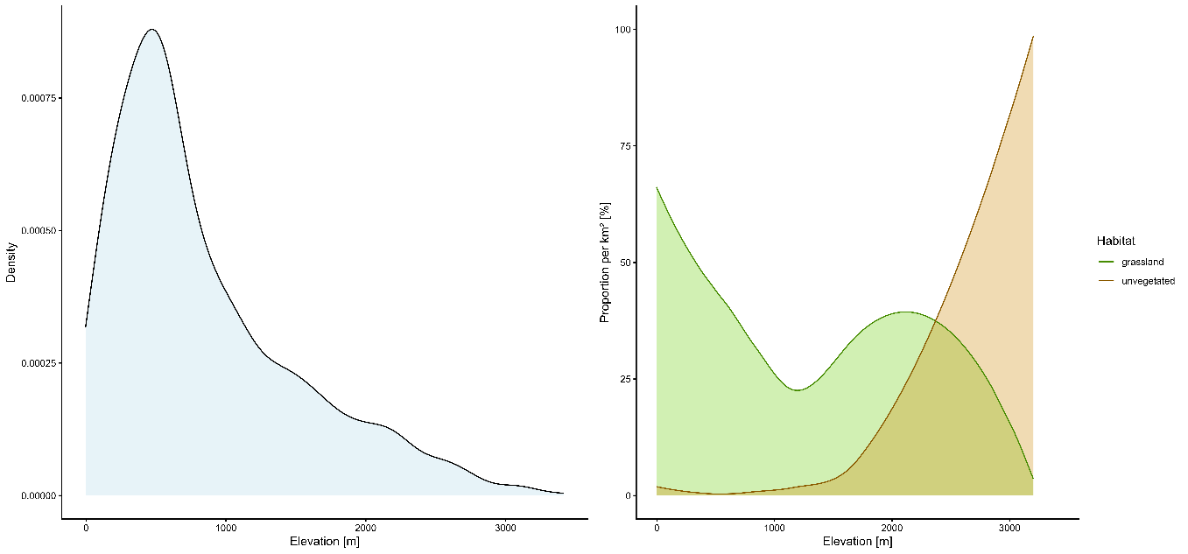
Figure S1: Grassland and unvegetated area along elevation and distribution of elevation values in the Alps. We sampled 1000 grid cells 1 × 1 km randomly from our study area. For each grid cell we calculated the average elevation from a digital elevation model (Hengl et al. 2020). We extracted the % of grassland for each cell as the sum of periodically and permanent herbaceous land cover, as well as the non- or sparsely vegetated % from the CLCplus Backbone Land Cover product of 2021 (https://land.copernicus.eu/en/products/clc-backbone/clc-backbone-2021).

Table S7: Trimmed means, upper, lower edge, elevational range, and number of records per species and time period. For readability reasons, only the head of the table is shown here. The full table with values for all species is available electronically as csv file (“Supplement 8_species elevation.csv”).
Group | Species | Time period | Lower | Upper | Range | Mean | SD | N
bumblebees | Bombus alpinus | 1817-1899 | 1857.88681 | 2297.53433 | 439.647522 | 2077.71057 | 327.239731 | 2
bumblebees | Bombus alpinus | 1900-1950 | 1192.60028 | 3057.76282 | 1865.16255 | 2261.92975 | 432.376291 | 74
bumblebees | Bombus alpinus | 1951-1980 | 1156.54331 | 2772.82813 | 1616.28481 | 2158.56641 | 457.365243 | 49
bumblebees | Bombus alpinus | 1981-2000 | 1505.25717 | 2836.67374 | 1331.41657 | 2344.72616 | 326.88302 | 50
bumblebees | Bombus alpinus | 2001-2010 | 2004.81716 | 3010.72607 | 1005.90891 | 2551.00944 | 285.481459 | 25
bumblebees | Bombus alpinus | 2011-2023 | 2058.50649 | 3272.51925 | 1214.01277 | 2671.61354 | 346.324903 | 32
bumblebees | Bombus argillaceus | 1817-1899 | 292.175269 | 916.524861 | 624.349593 | 567.714146 | 218.447356 | 8
bumblebees | Bombus argillaceus | 1900-1950 | 5.96028711 | 1943.58845 | 1937.62817 | 665.237373 | 387.502621 | 147
bumblebees | Bombus argillaceus | 1951-1980 | 118.298056 | 1936.34253 | 1818.04447 | 857.707685 | 439.456425 | 112
bumblebees | Bombus argillaceus | 1981-2000 | 44.8138289 | 2259.44524 | 2214.63141 | 933.127379 | 552.260135 | 84
bumblebees | Bombus argillaceus | 2001-2010 | 62.6720656 | 1970.9354 | 1908.26334 | 741.69375 | 558.089909 | 88
bumblebees | Bombus argillaceus | 2011-2023 | 7.97781165 | 1816.84527 | 1808.86746 | 236.616551 | 431.290814 | 99
bumblebees | Bombus armeniacus | 1900-1950 | 115.294701 | 261.928845 | 146.634145 | 153.633988 | 54.8833008 | 9
bumblebees | Bombus armeniacus | 1951-1980 | 134.037933 | 134.037933 | 0 | 134.037933 | NA | 1
bumblebees | Bombus barbutellus | 1817-1899 | 407.99471 | 1604.72002 | 1196.72531 | 829.999031 | 450.251307 | 12
bumblebees | Bombus barbutellus | 1900-1950 | 129.778342 | 1806.88848 | 1677.11014 | 717.651144 | 434.376081 | 245
bumblebees | Bombus barbutellus | 1951-1980 | 144.879828 | 2107.67996 | 1962.80013 | 821.145255 | 505.836529 | 230
bumblebees | Bombus barbutellus | 1981-2000 | 190.660864 | 2088.70928 | 1898.04841 | 831.306747 | 471.182039 | 295
bumblebees | Bombus barbutellus | 2001-2010 | 226.173338 | 1945.02394 | 1718.8506 | 709.951748 | 415.724879 | 290
bumblebees | Bombus barbutellus | 2011-2023 | 380.591904 | 2078.62903 | 1698.03713 | 876.692834 | 466.995983 | 261
bumblebees | Bombus bohemicus | 1817-1899 | 404.268236 | 1848.91251 | 1444.64427 | 808.320797 | 487.178319 | 15
bumblebees | Bombus bohemicus | 1900-1950 | 253.980234 | 2176.19486 | 1922.21462 | 917.952696 | 511.395289 | 336
bumblebees | Bombus bohemicus | 1951-1980 | 249.03902 | 2257.31856 | 2008.27954 | 958.617085 | 493.09258 | 289
… | … | … | … | … | … | … | … | …

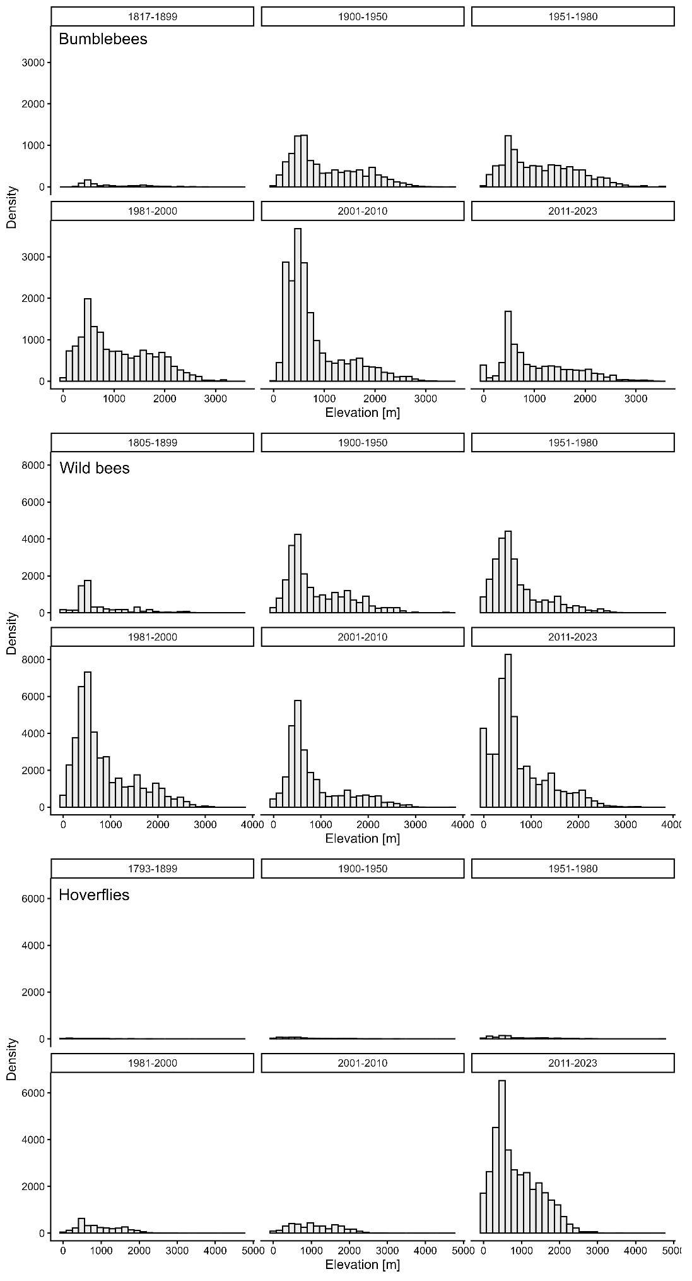
Figure S2: Histograms of the absolute frequency of bumblebee, wild bee and hoverfly records in the study area per time period. For bumblebees and bees, there is a small bias towards low elevations in the most recent time period (2011-2023) likely caused by citizen science observations in low elevated, densely populated areas.

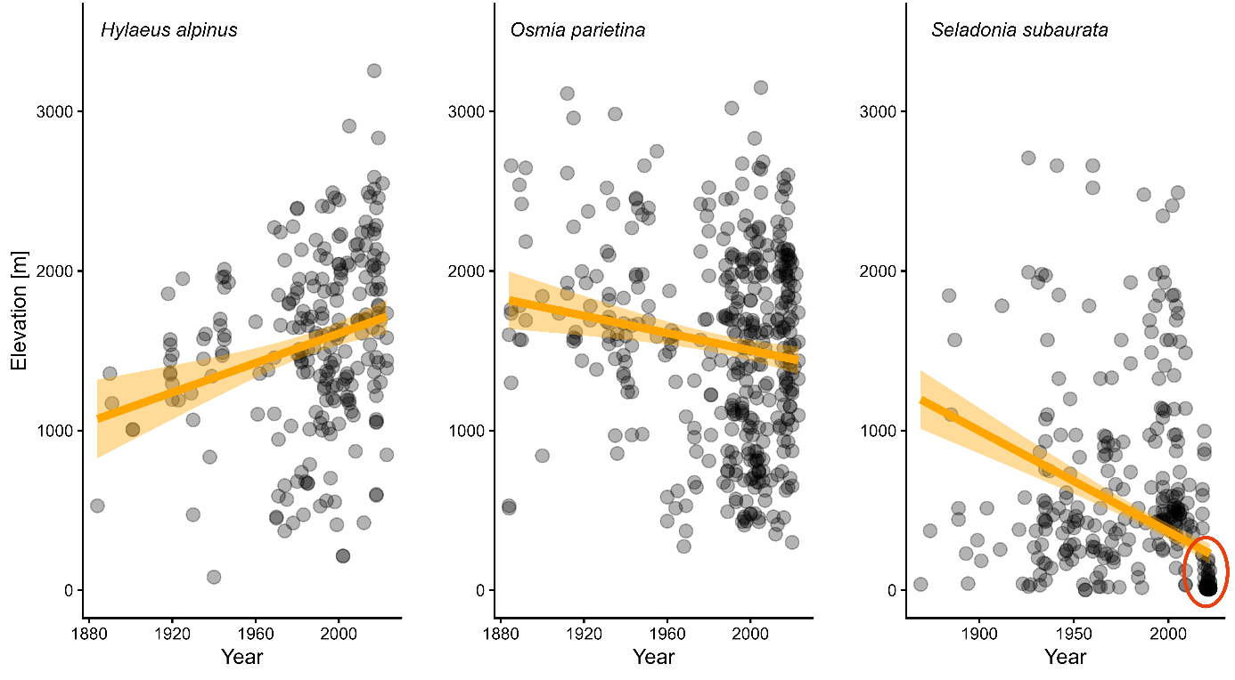
Figure S3: Occurrence records per year for three bee species: Hylaeus alpinus, Osmia parietina and Seladonia subaurata. For H. alpinus and O. parietina there is no obvious clustering of records over time and elevation. For S. subaurata there is a dense cluster of records in recent years in low elevations (red circle), likely caused by citizen science observations in densely populated, low elevation areas.

