Appendix A Score distributions and regression diagnostics
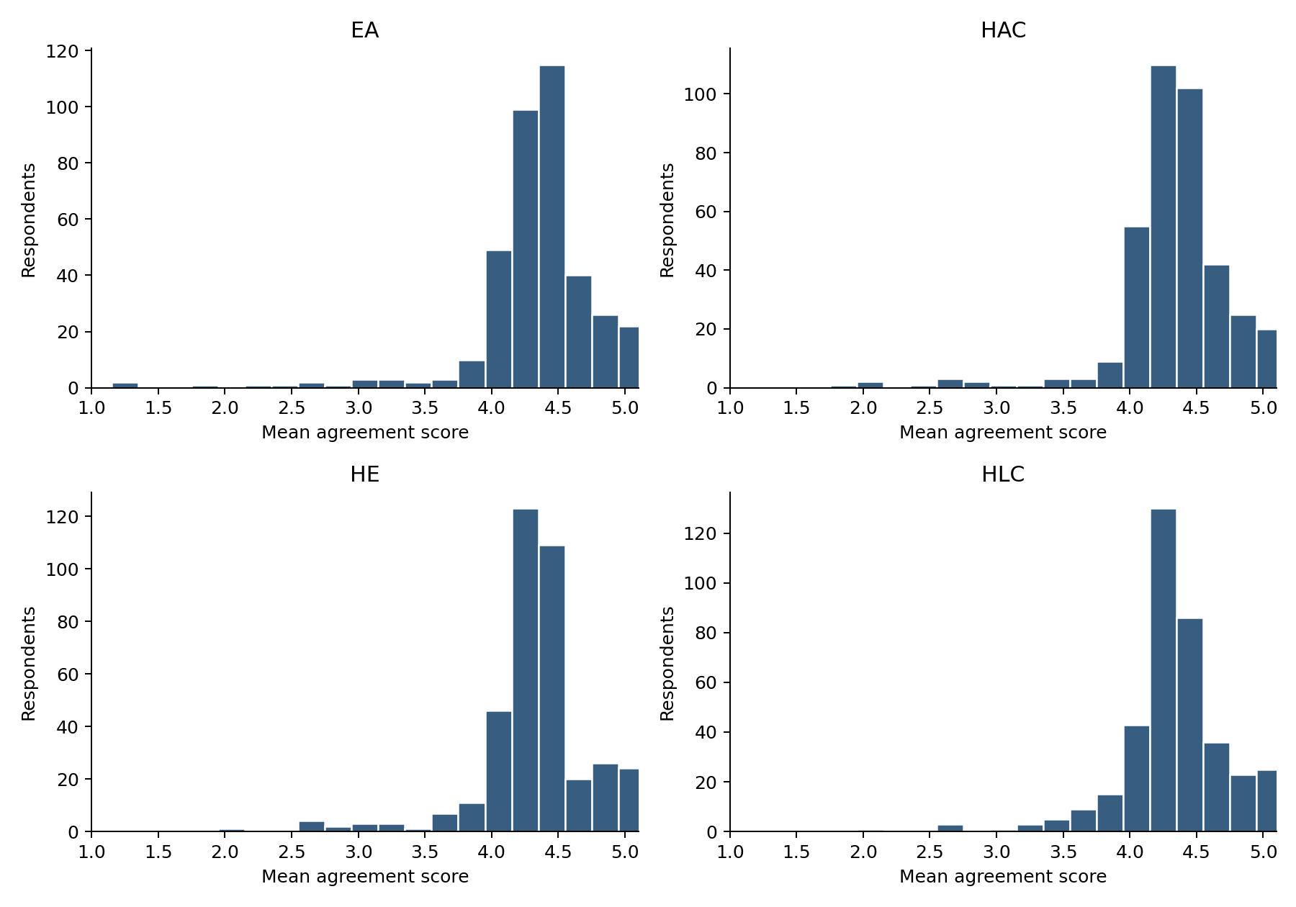
Figure Distribution of the four mean agreement scores. All 380 records are included.
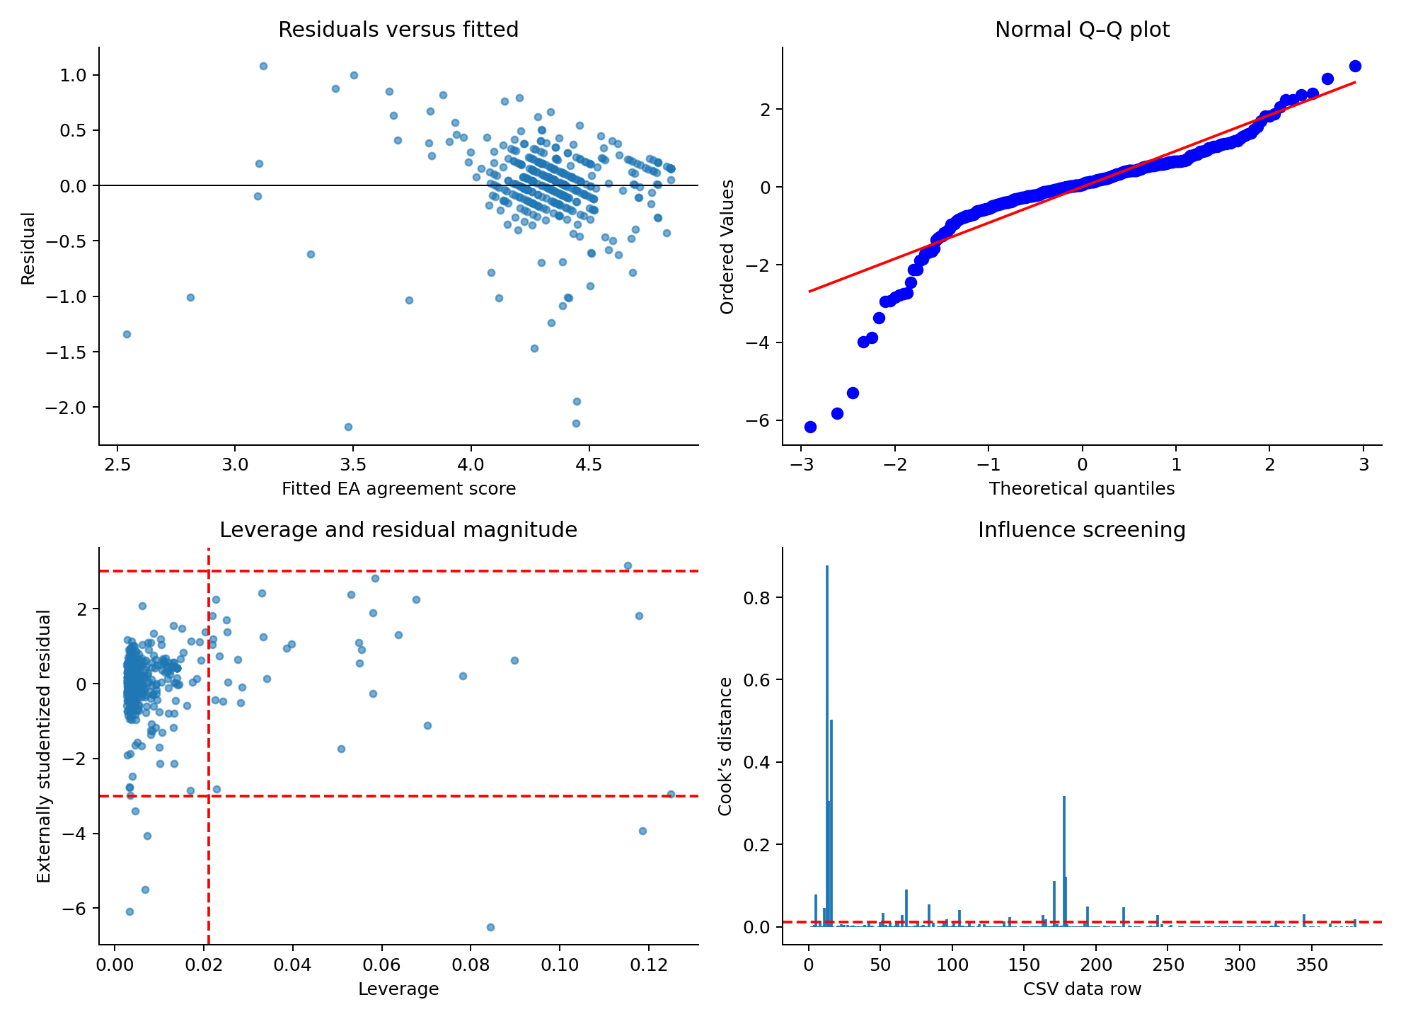
Figure A2 Baseline OLS diagnostic plots. Dashed lines mark influence-screening thresholds. Row numbers refer to data rows in the CSV, excluding its header. No record is removed from the main model.

