A Multi-Epitope Vaccine Candidate with Predicted Broad Genotype Coverage Against Toxoplasma gondii Designed by Reverse Vaccinology and Immunoinformatics Strategies
Supplementary Material 3: Figures
Mostafa R. Zaher^{1*} and Dalia M. El-Husseini²
¹ Genome Research Unit, Animal Health Research Institute (AHRI), Agricultural Research Center (ARC), Giza 12618, Egypt.
² Nanomaterials Research and Synthesis Unit, Animal Health Research Institute (AHRI), Agricultural Research Center (ARC), Giza 12618, Egypt.
Corresponding Author: Mostafa R. Zaher, e-mail: mostafa.r.zaher@ahri.gov.eg
Data represented here are:
- Fig S1: secondary structure prediction analysis of vaccine constructs.
- Fig S2: Immune simulation analysis using the C-ImmSim webserver.
- Fig S3: Per-residue Cα root-mean-square fluctuation (RMSF).
- Fig S4: Radius of gyration (Rg) versus time.
- Fig S5: Solvent-accessible surface area (SASA) versus time.
- Fig S6: Number of intermolecular hydrogen bonds at the receptor-vaccine interface versus time
- Fig S7: Top interface residues for each chain and complex.
- Fig S8: Time course of the top interface contacts.

Fig. S1 secondary structure prediction analysis of vaccine constructs A) MEV-1A, B) MEV-2A, and C) MEV-3A

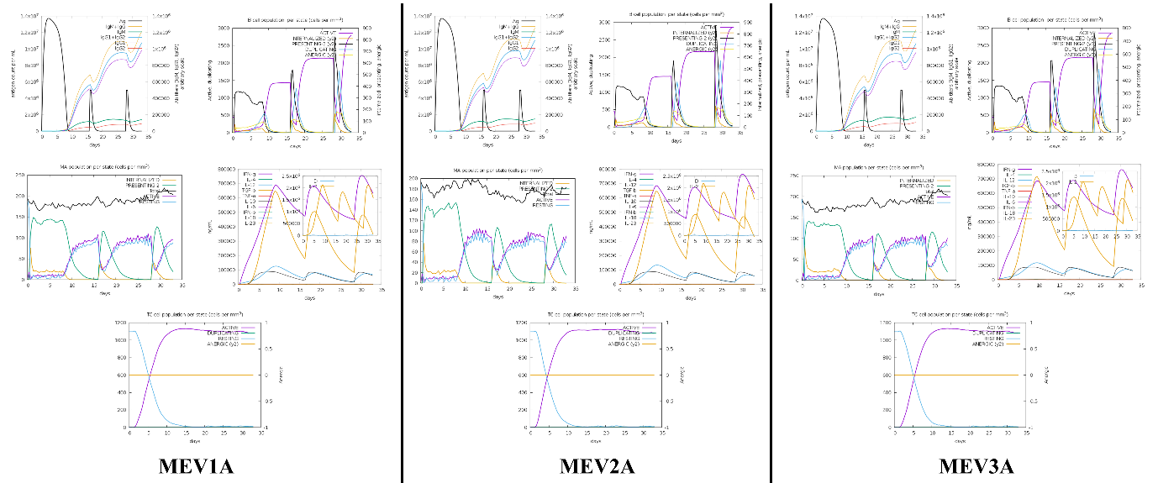
Fig. S2 Immune simulation analysis using the C-ImmSim webserver for highly performing vaccine constructs against Human leukocyte alleles.

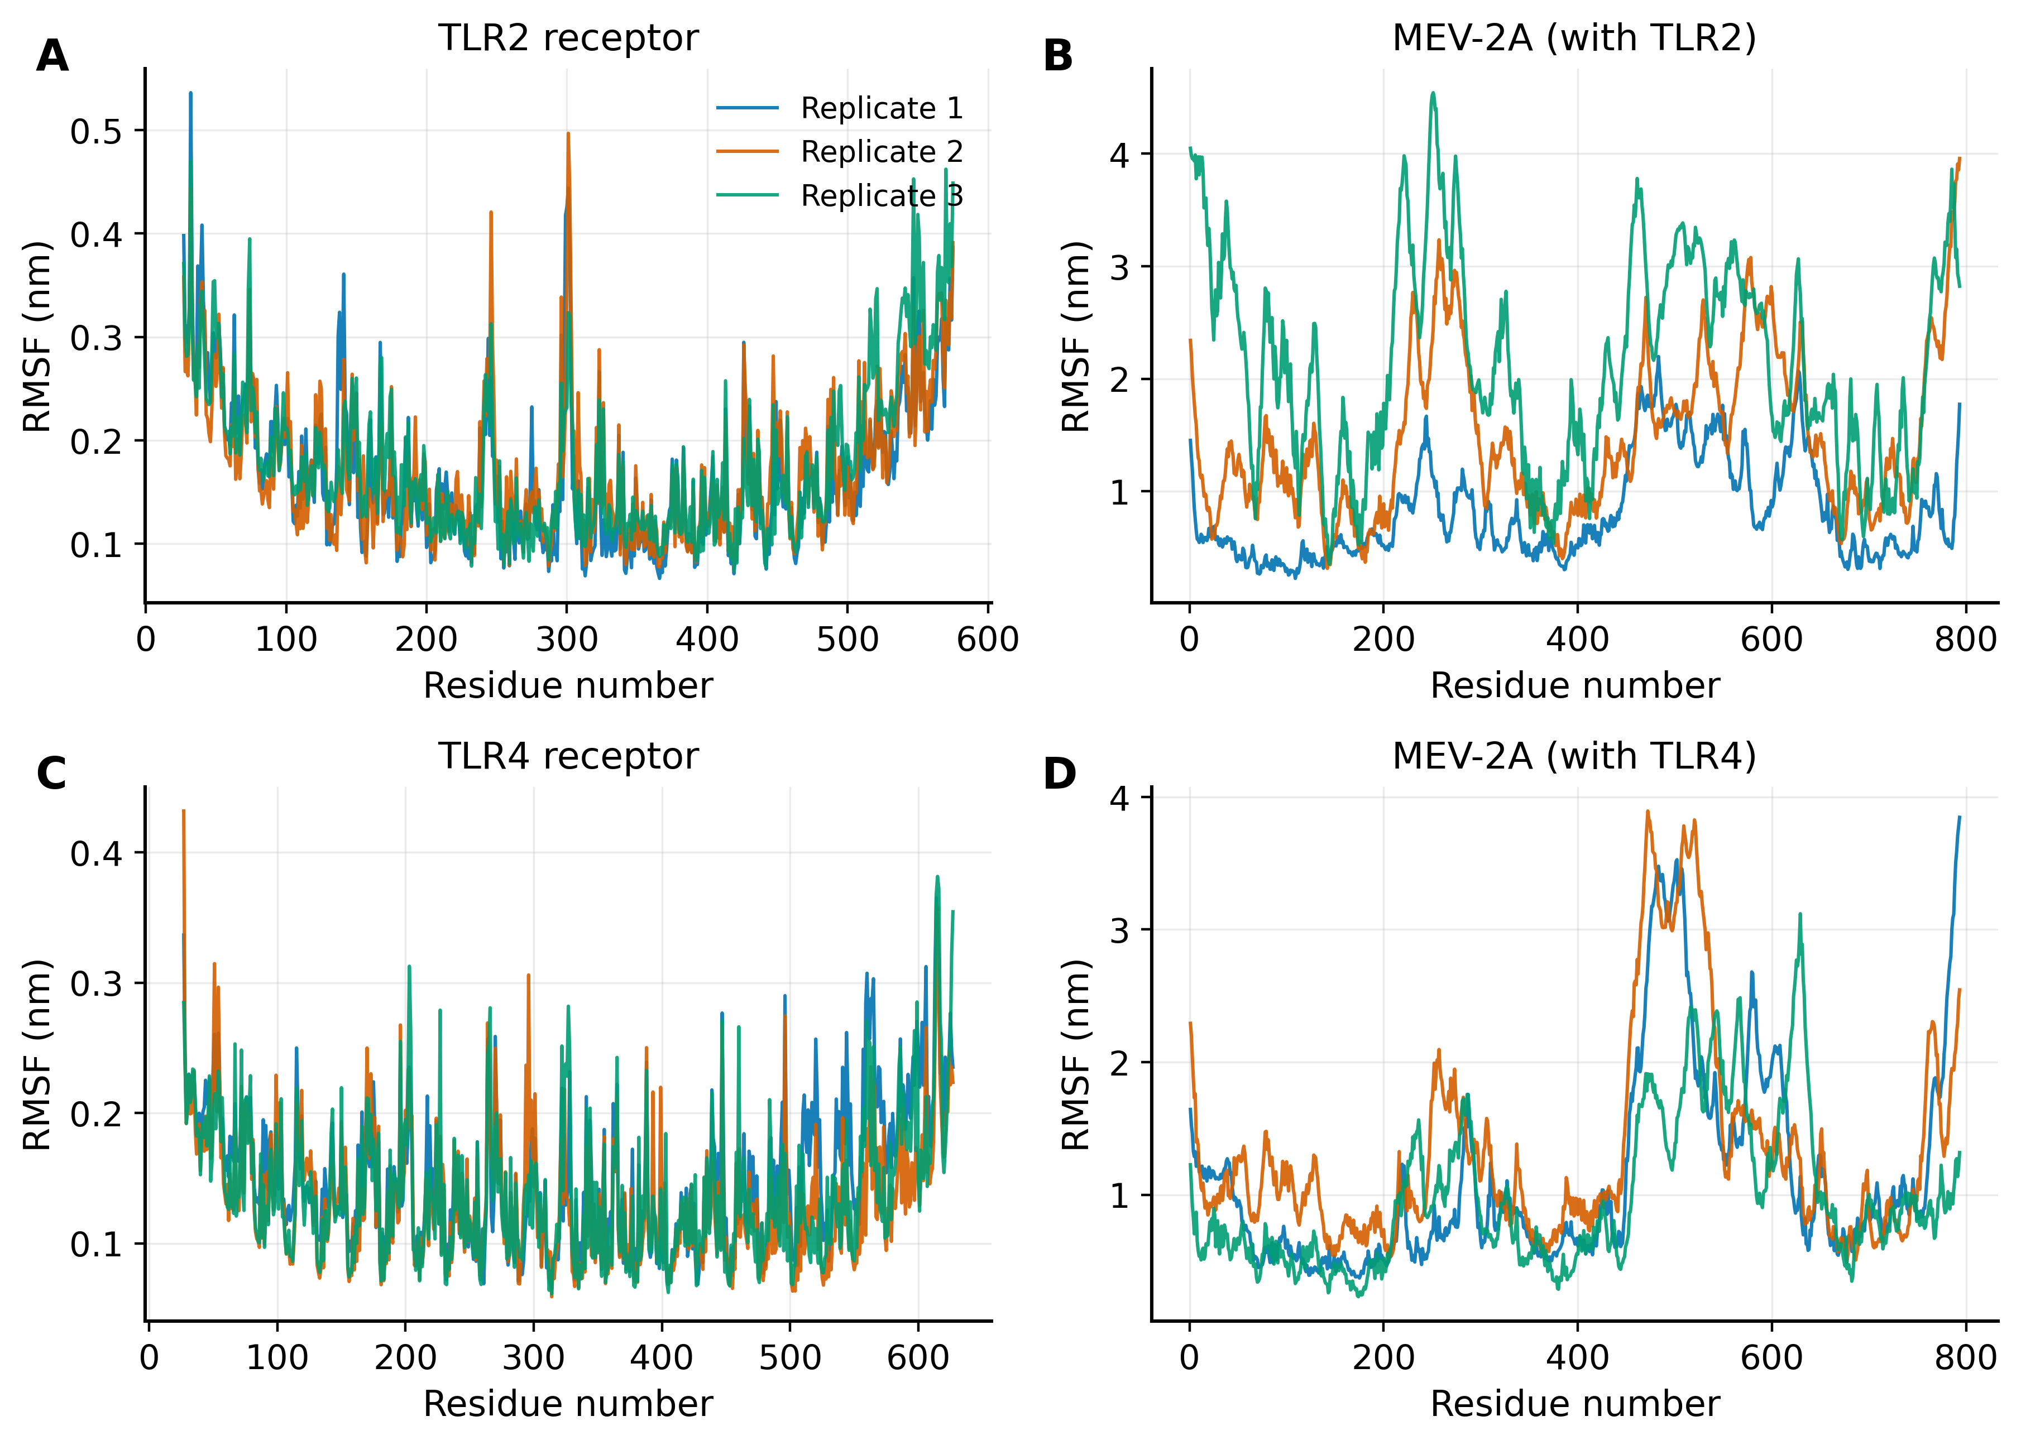
Fig. S3 Per-residue Cα root-mean-square fluctuation (RMSF). (A, C) TLR2 and TLR4 receptors; (B, D) the MEV-2A construct. Receptor fluctuations are low and uniform, whereas MEV-2A flexibility localises to the inter-epitope linker and terminal regions.
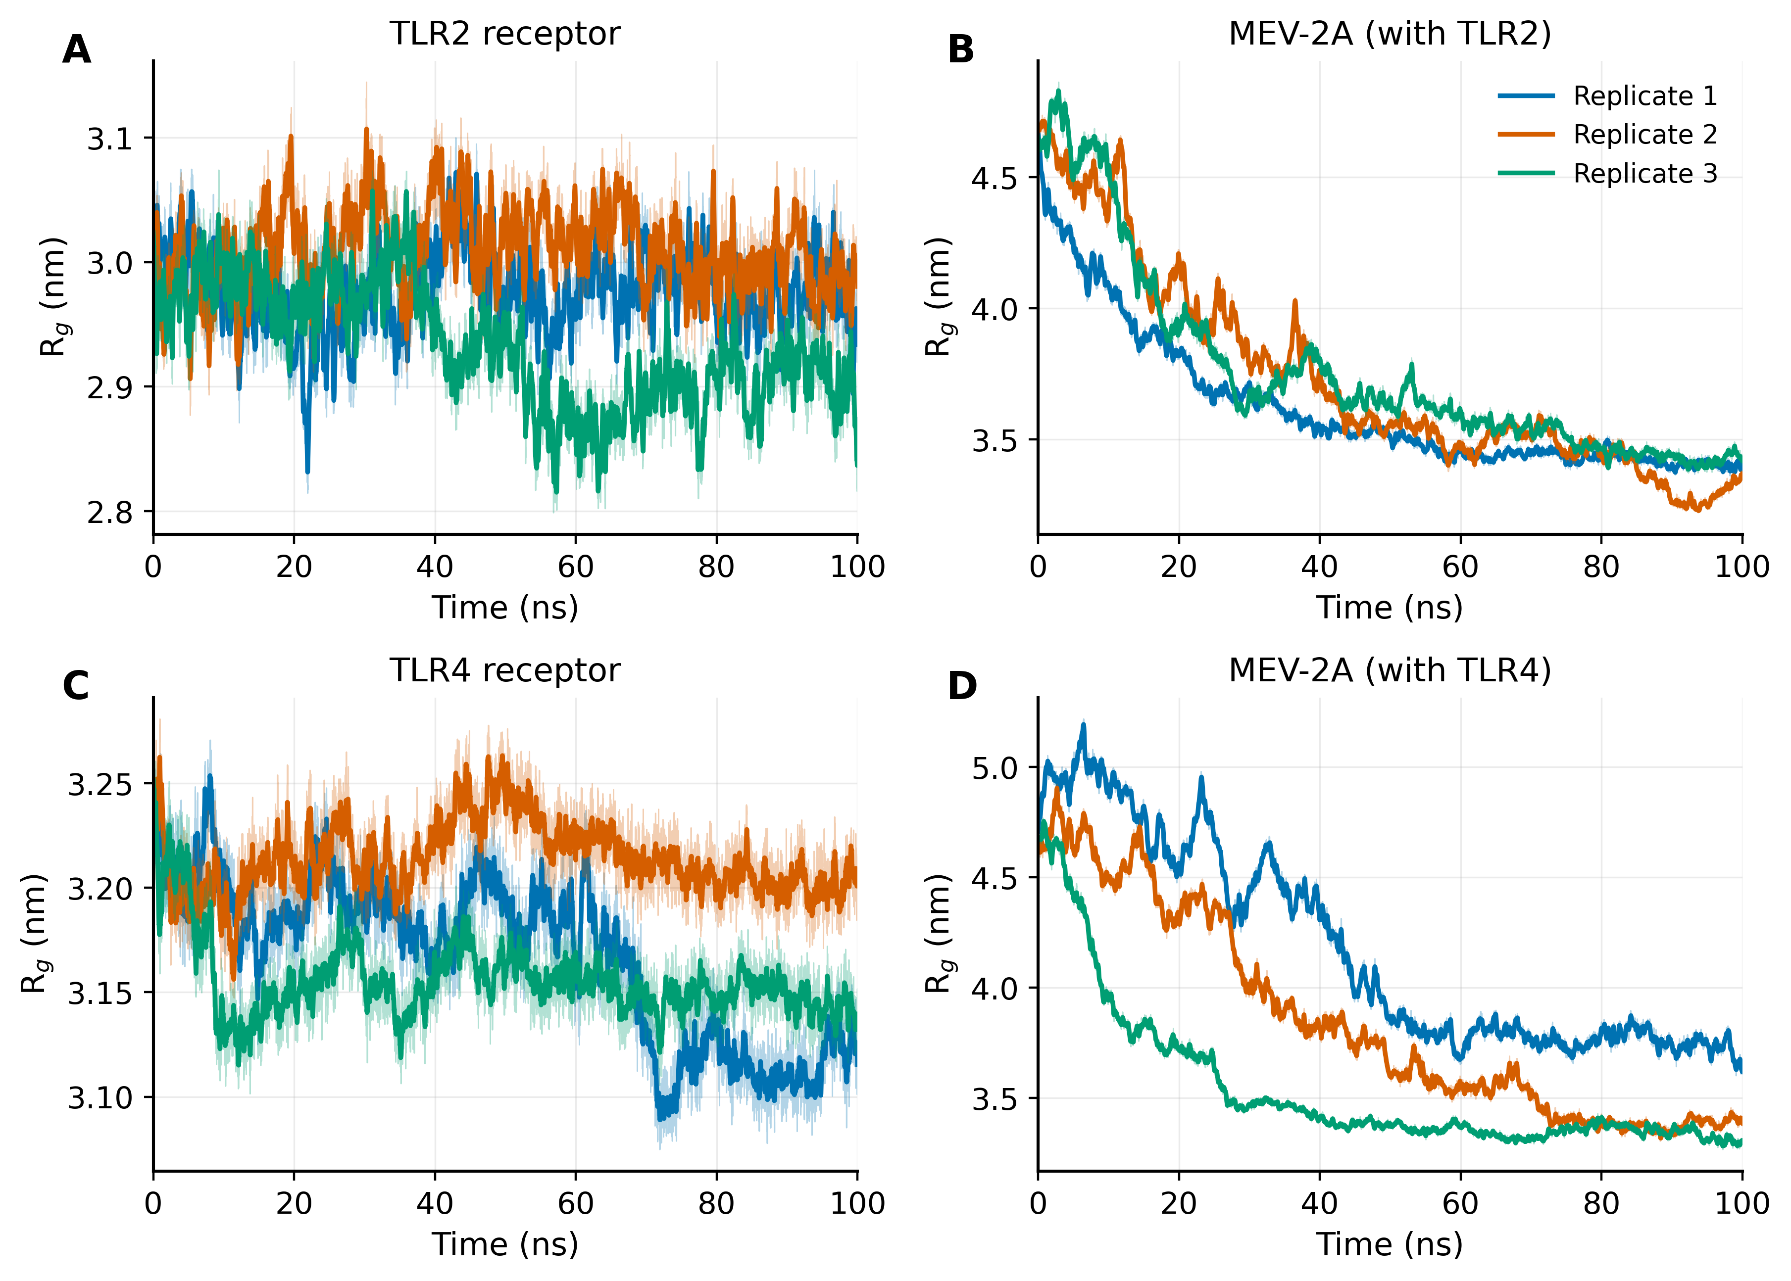
Fig. S4 Radius of gyration (Rg) versus time. Receptors (A, C) remain compact and invariant, whereas MEV-2A (B, D) compacts progressively before stabilising.
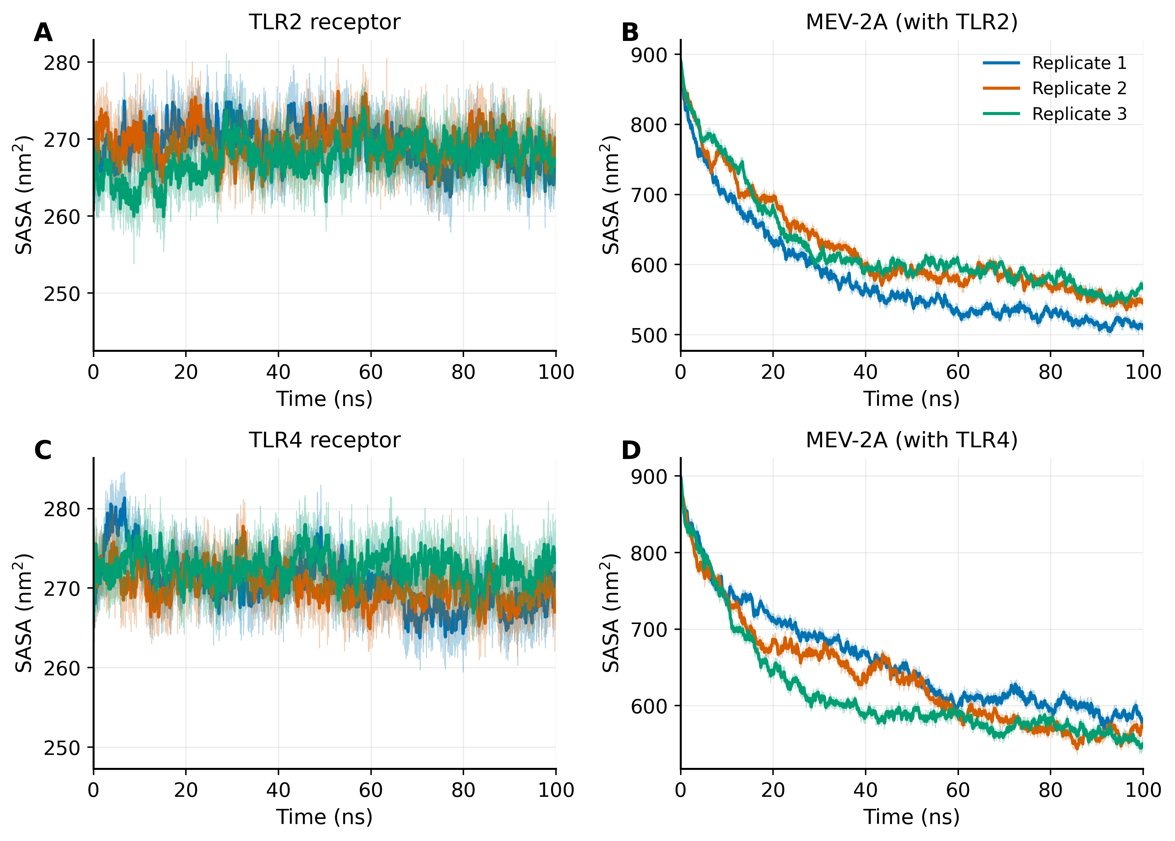
Fig. S5 Solvent-accessible surface area (SASA) versus time. Receptor SASA (A, C) is essentially constant; MEV-2A SASA (B, D) decreases and plateaus, with the extent of compaction varying between replicates.
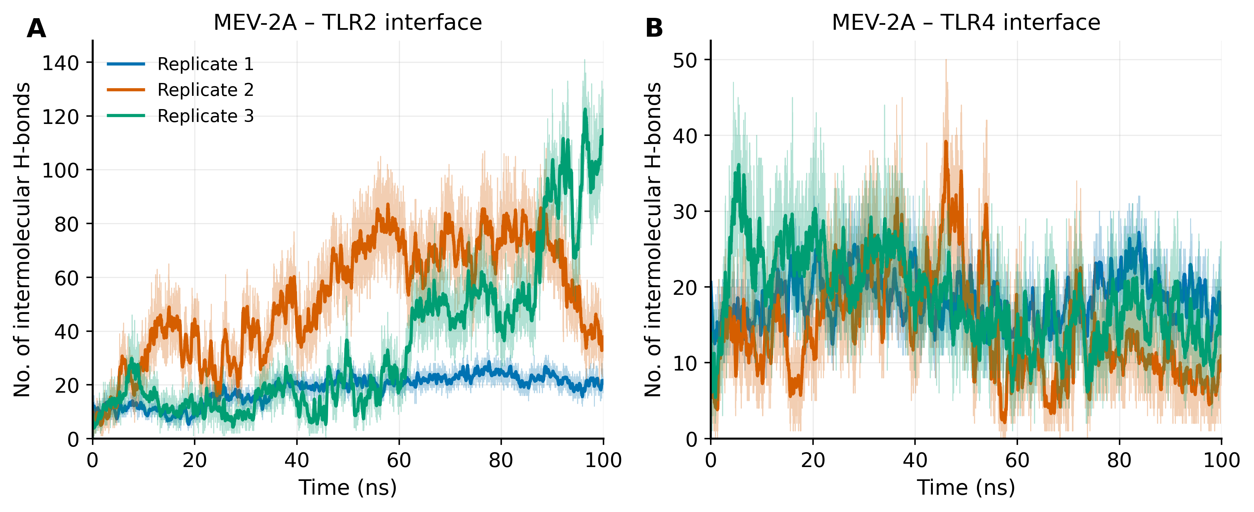
Fig. S6 Number of intermolecular hydrogen bonds at the receptor-vaccine interface versus time for the (A) MEV-2A-TLR2 and (B) MEV-2A-TLR4 complexes across the three replicates. Bold lines, running averages.
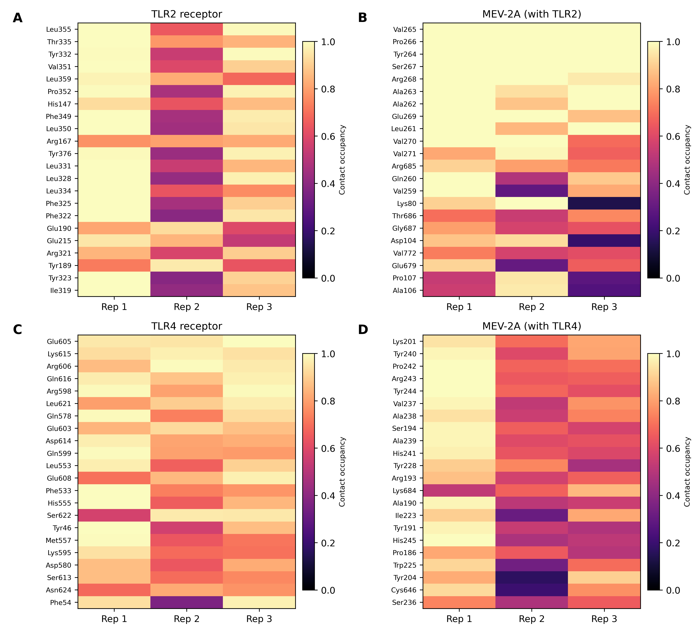
Fig. S7 Top interface residues for each chain and complex. The heatmaps show the contact occupancy (fraction of frames within 4.5 Å of the partner chain) of the 22 most frequently contacting residues, for the three replicates. (A, B) TLR2 receptor and MEV-2A residues in MEV-2A-TLR2; (C, D) TLR4 receptor and MEV-2A residues in MEV-2A-TLR4. Residues are labelled by name and number and ordered by mean occupancy from top to bottom.

Fig. S8 Time course of the top interface contacts. For each of the top interface residues (y-axis, named) and each time point (x-axis), the colour shows the number of replicates (0 to 3) in which that residue is in contact with the partner chain. (A, B) MEV-2A-TLR2; (C, D) MEV-2A-TLR4. Solid dark bands mark residues engaged in all three replicates for the whole trajectory; lighter shading marks transient or replicate-specific contacts.

