Supplementary information (SI)
Triboelectrification induced self-powered microbial disinfection using nanowire-enhanced localized electric field

Zheng-Yang Huo^{1, ‡}, Young Jun Kim^{1, ‡}, In-Yong Suh¹, Dong-Min Lee¹, Jeong Hwan Lee¹, Ye Du², Si Wang^{1, 3}, Hong-Joon Yoon¹, and Sang-Woo Kim^{1, 4, 5, *}

¹School of Advanced Materials Science and Engineering, Sungkyunkwan University (SKKU), Suwon, 16419, Republic of Korea.
²College of Architecture and Environment, Sichuan University, Chengdu, 610065, PR China.
³State Key Laboratory of Electronic Thin Films and Integrated Devices, School of Optoelectronic Science and Engineering, University of Electronic Science and Technology of China (UESTC), Chengdu 610054, PR China.
⁴SKKU Advanced Institute of Nanotechnology (SAINT), Sungkyunkwan University (SKKU), Suwon, 16419, Republic of Korea.
⁵Samsung Advanced Institute for Health Sciences & Technology (SAIHST), Sungkyunkwan University (SKKU), Suwon 16419, Republic of Korea.

*Address correspondence to kimsw1@skku.edu
‡ Z.-Y. Huo and Y.J. Kim contributed equally to this work.

Table of Contents
Figures
Supplementary Fig. 1. Photo of the RV-disinfection system.
Supplementary Fig. 2. SEM of Cu(OH)₂ nanowires-modified copper electrode.
Supplementary Fig. 3. SEM and TEM of Cu₃P nanowires-modified copper electrode.
Supplementary Fig. 4. Photo of the V-TENG.
Supplementary Fig. 5. Output voltage of the top and middle layer of the V-TENG.
Supplementary Fig. 6. Output voltage of the TENG with various amplitudes.
Supplementary Fig. 7. Output current of the TENG after rectification.
Supplementary Fig. 8. Structure of the V-TENG-powered RV-disinfection system.
Supplementary Fig. 9. Process of microbial quantification.
Supplementary Fig. 10. Disinfection performance of RV-disinfection with various amplitudes.
Supplementary Fig. 11. Disinfection performance of RV-disinfection for treating the intermittent viral bioaerosols containing MS2.
Supplementary Fig. 12. Disinfection performance of RV-disinfection for treating E. coli with different concentrations.
Supplementary Fig. 13. Disinfection performance of RV-disinfection for treating MS2 with different concentrations.
Supplementary Fig. 14. Simulation of the contact efficiency of particles after flowing through the negative electrode with different structures (macro-mesh, slope, and column).
Tables
Supplementary Table 1. Details for the experiment conditions of air disinfection methods in comparison of Fig. 3h.
Supplementary Table 2. Parameters used for airfield simulation.
Supplementary Table 3. Parameter used for electric field simulation.
Additional discussions
Additional discussion 1. The design of the V-TENG
Additional discussion 2. The design of the duct
Additional discussion 3. Calculation of microbes trapped by the positive/ground electrode.
Figures:
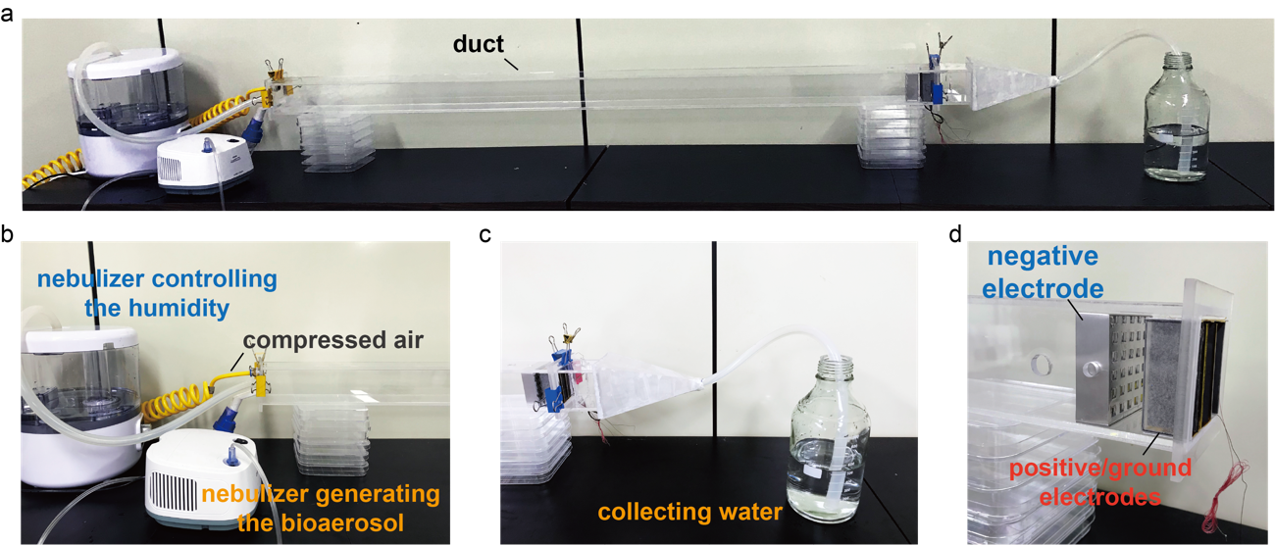
Fig. S1 Photo of the RV-disinfection system. a Photo showing the whole system of RV-disinfection. b Photo showing the bioaerosol generation system as well as the airflow generation and humidity control systems. c Photo showing the air collecting system. d Photo showing the negative electrode and integrated positive/ground electrodes.

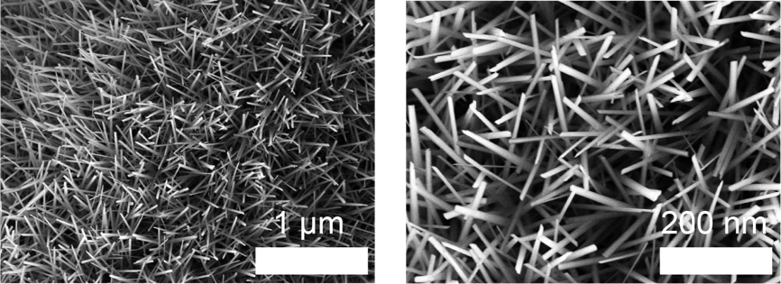
Fig. S2 Scanning electron microscope (SEM) images showing the copper hydroxide nanowires-modified copper electrode (Cu(OH)₂NW).

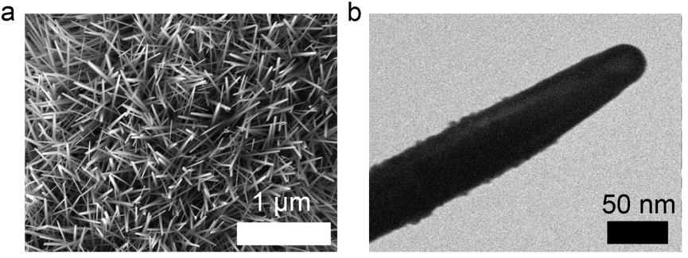
Fig. S3 SEM and transmission electron microscope (TEM) images showing the copper-phosphide-nanowire-modified copper electrode (Cu₃PNW-Cu). The TEM measurement was performed using the JEM-2100F from JEOL.

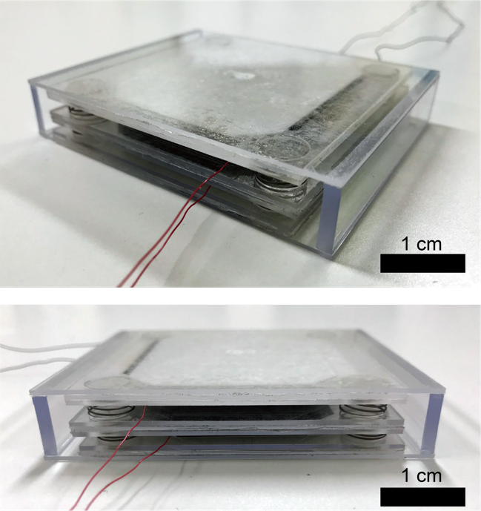
Fig. S4 Photo of the V-TENG with three layers (top, middle, and bottom) and a closed structure.

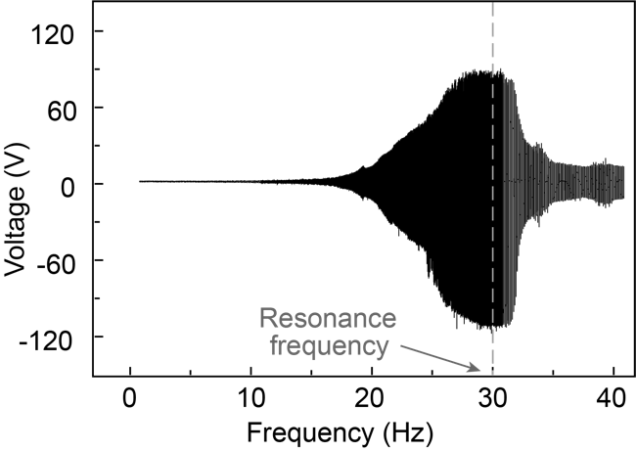
Fig. S5 Output voltage of the top and middle layer of the V-TENG with a frequency sweep from 1 Hz to 40 Hz at a constant amplitude of 500 μm. The largest output occurs when the vibration frequency is the same with the resonance frequency of the V-TENG (30 Hz).

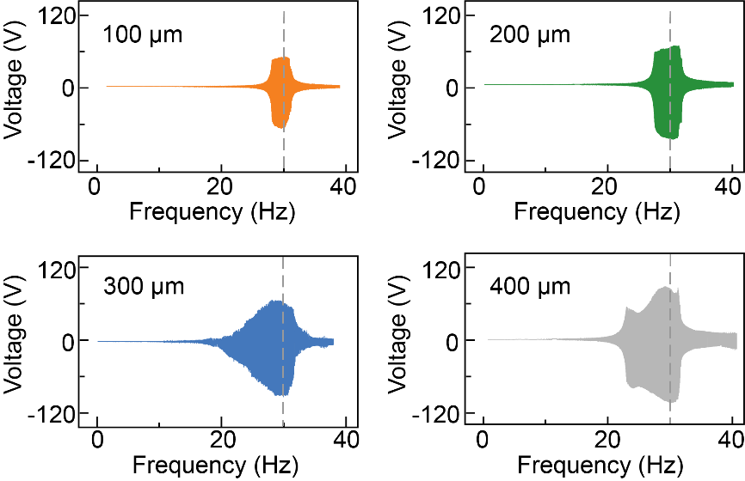
Fig. S6 Output voltage of the V-TENG with a frequency sweep from 1 Hz to 40 Hz with various amplitudes (100, 200, 300, and 400 μm). The largest output occurs when the vibration frequency is the same with the resonance frequency of the V-TENG (30 Hz).

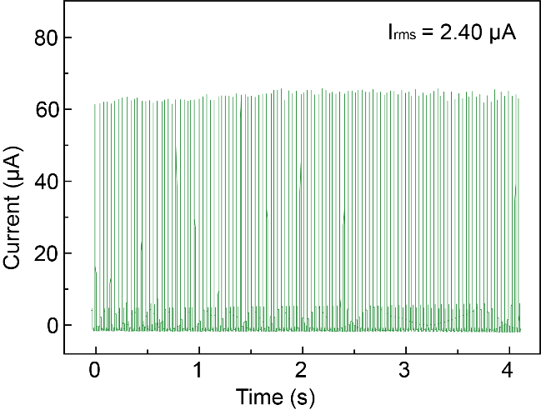
Fig. S7 Output current of the V-TENG after rectification at a constant amplitude (500 μm) and frequency (30 Hz).

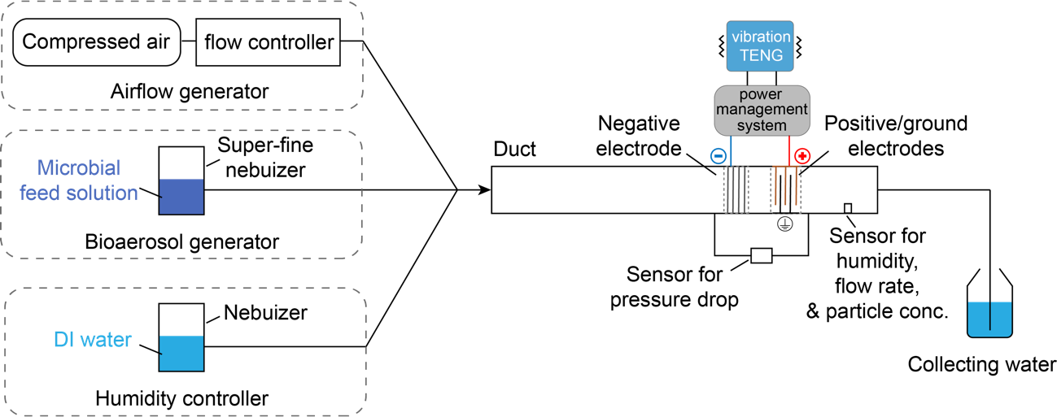
Fig. S8 Structure of the V-TENG-powered RV-disinfection system. The feed solutions containing a high concentration of bacteria or viruses were added into a super-fine air compressed nebulizer and bacterial or viral bioaerosols were generated by the nebulizer to feed the duct. Airflow rates in the duct were controlled in the range from 0.5 to 2 m/s using compressed gas and the humidity was set at 30% using another nebulizer generating water mist in the duct. The airflow rate, the humidity, and the particle concentration were monitored using integrated sensors. After passing through the disinfection filter, the airflow with bacteria or viruses will be collected in a narrow mouth bottle containing 500-mL sterilized deionized (DI) water and the pressure drop will be measured. All the bacteria or viruses will remain in the water for the future quantification.

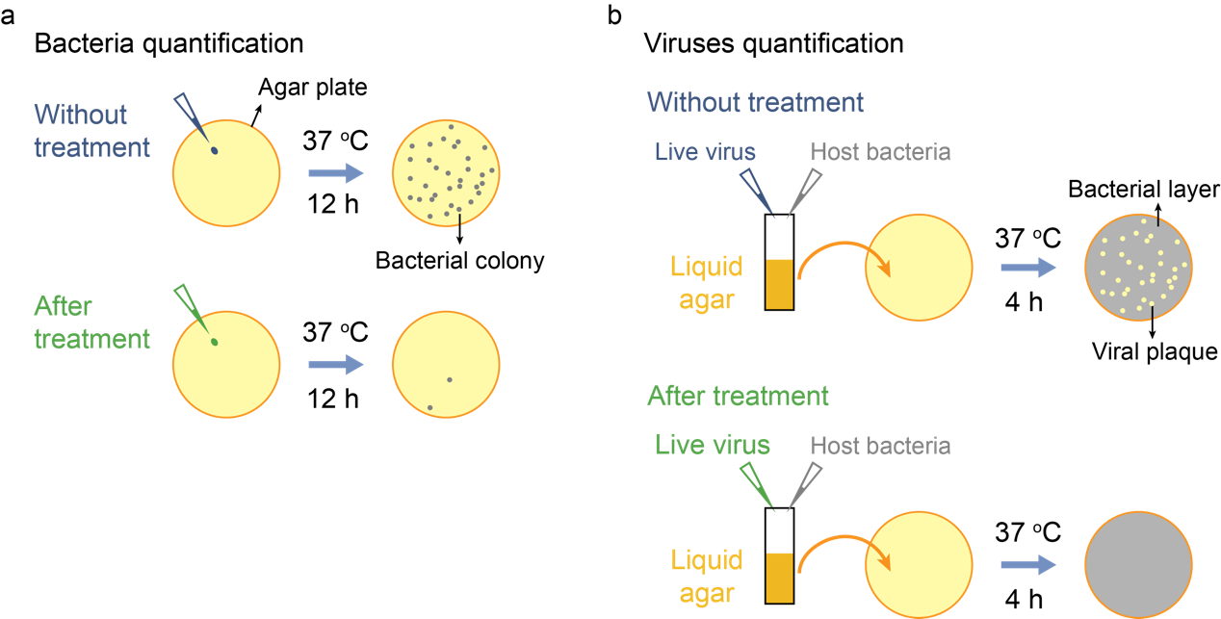

Fig. S9 Process of microbial quantification. a Schematic of bacteria viability assessment procedures. After the airflow passing through the duct and collected in the collecting DI water with or without the power from V-TENG, 0.1 mL of collecting water is added to an agar plate and spread evenly using an L-shape spreader. Then put the plate to the incubator at 37 ºC for 12 h. Bacterial colonies will present on the agar plate and one bacterial colony represents one single live bacterium. b Schematic of virus enumeration procedures. The collecting water (0.1 mL) with viruses is added into a warm liquid agar solution (0.5 mL, ~45 ºC). Solution with host bacteria (0.1 mL) will also be added to the liquid agar solution. Then the liquid agar solution will be added to an agar plate. After incubation at 37 ºC for 4 h, a thin layer of host bacteria will grow on the agar plate, and if there are live viruses, it will infect and break down the host bacteria and finally form a transparent viral plaque. One viral plaque presenting on the agar plate represents one single live virus. If no bacterial colony or viral plaque was found after incubation, it indicates that all the microbes are inactivated with no live microbes that are detected in the water.

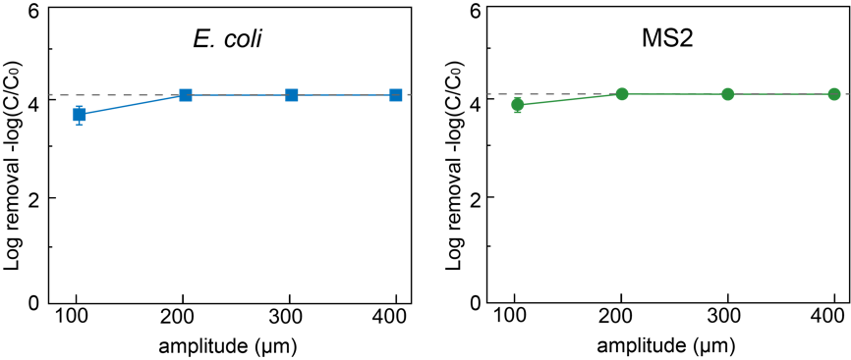
Fig. S10 Disinfection efficiency for E. coli and MS2 using RV-disinfection methods at various amplitudes (from 100 to 400 µm) and a fixed airflow rate (2 m/s). The dashed line indicates that all microbes (bacteria and viruses) are inactivated and no live microbes can be detected. Error bars represent the standard deviation of three replicate measurements. When applied with smaller amplitudes (100 to 400 μm), the power outputs generated from the V-TENG are sufficient to drive the RV-disinfection system for high-performance disinfection.

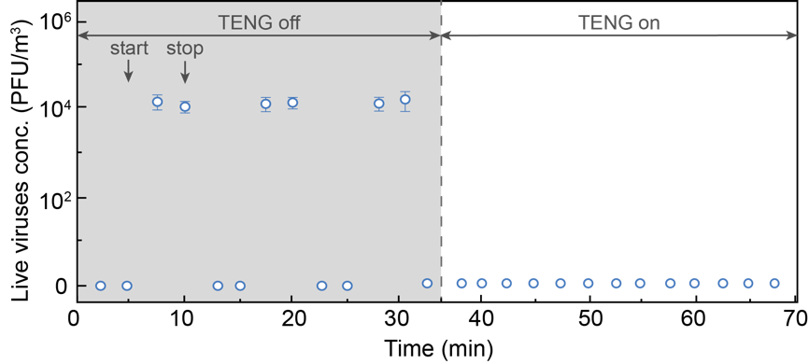
Fig. S11 Disinfection performance of the RV-disinfection method for treating the intermittent viral bioaerosols containing MS2. No live viruses can be detected in the intermittent bacterial bioaerosols after passing through the V-TENG powered RV-disinfection system. The V-TENG is operated at a constant amplitude (500 μm) and frequency (30 Hz) and the airflow rate is fixed at 2 m/s. Error bars represent the standard deviation of three replicate measurements.

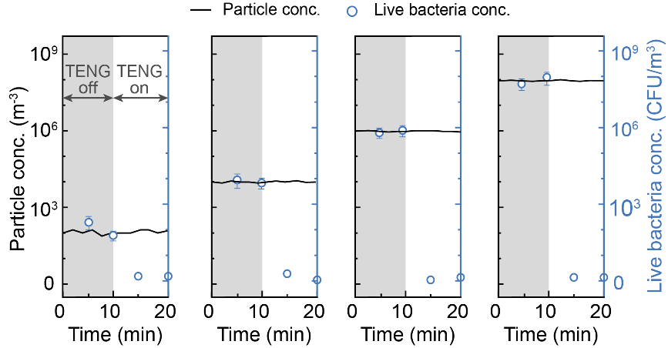
Fig. S12 Disinfection performance of the RV-disinfection method for treating E. coli with different concentrations (from 10² to 10⁸ colony-forming unit/m³, CFU/m³). No live bacteria can be detected after passing through the V-TENG powered RV-disinfection system. The V-TENG is operated at a constant amplitude (500 μm) and frequency (30 Hz) and the airflow rate is fixed at 2 m/s. Error bars represent the standard deviation of three replicate measurements.

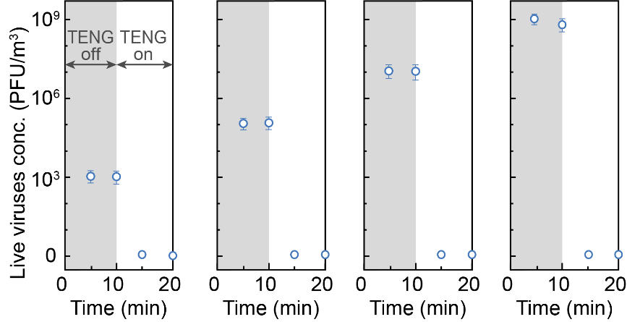
Fig. S13 Disinfection performance of the RV-disinfection method for treating MS2 with different concentrations (from 10³ to 10⁹ plaque-forming unit/m³, PFU/m³). No live virus can be detected after passing through the V-TENG powered RV-disinfection system. The V-TENG is operated at a constant amplitude (500 μm) and frequency (30 Hz) and the airflow rate is fixed at 2 m/s. Error bars represent the standard deviation of three replicate measurements.

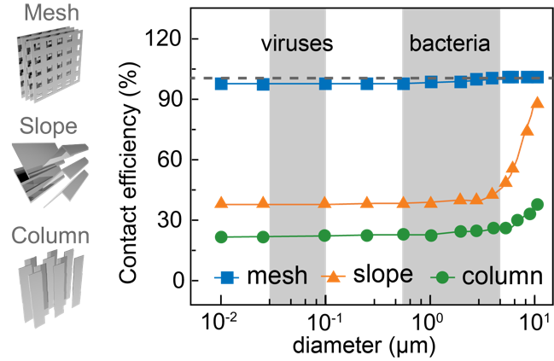
Fig. S14 Simulation of the electrode’s contact efficiency (percentage of particles contacting the electrode) after flowing through the 4-layer electrode with different structures (macro-mesh, slope, and column). The dashed line indicates 100% contact efficiency. The macro-mesh structure is confirmed to be the ideal electrode structure due to it giving the highest contact efficiency compared to other structures (slope and column).

Tables:
Supplementary Table 1. Details for the experiment conditions of air disinfection methods in comparison of Fig. 3h (materials, disinfection mechanisms, energy demands, and bacteria strain).
 | Materials | Mechanisms | Energy demands | Microbial strain
1* | Cu₃PNW-Cu | Electroporation | Self-powered | E. coli, B. subtilis, & MS2
2 | MOF-filter | Photocatalytic | Sunlight | E. coli
3 | TiO₂-film | Photocatalytic | Ultraviolet radiation | E. coli
4 | ZnO-Al₂O₃-filter | Antibacterial nanomaterial | No | B. atrophaeus
5 | Fe₂O₃NW-Fe mesh | Electroporation | Electricity | E. coli & S. epidermidis
6 | Vacuum UV | UV disinfection | Electricity | E. coli
7 | UV-LED | UV disinfection | Electricity | E. coli, S. Typhimurium,  S. aureus, & MS2
* This work, other reviewed works see the reference (2-7) below.
[2]. Li, Ping, et al. "Metal-organic frameworks with photocatalytic bactericidal activity for integrated air cleaning." Nature Communications 10.1 (2019): 1-10.
[3]. Sánchez, Benigno, et al. "Photocatalytic elimination of indoor air biological and chemical pollution in realistic conditions." Chemosphere 87.6 (2012): 625-630.
[4]. Dutheil de la Rochère, Aliénor, et al. "Exploring the antimicrobial properties of dark-operating ceramic-based nanocomposite materials for the disinfection of indoor air." PloS one 14.10 (2019): e0224114.
[5]. Wang, Dawei, et al. "Iron oxide nanowire-based filter for inactivation of airborne bacteria." Environmental Science: Nano 5.5 (2018): 1096-1106.
[6]. Huang, Haibao, et al. "Photocatalytic destruction of air pollutants with vacuum ultraviolet (VUV) irradiation." Catalysis Today 175.1 (2011): 310-315.
[7]. Kim, Do-Kyun, and Dong-Hyun Kang. "UVC LED irradiation effectively inactivates aerosolized viruses, bacteria, and fungi in a chamber-type air disinfection system." Applied and Environmental Microbiology 84.17 (2018).

Supplementary Table 2. Parameters used for airfield simulation.
Parameter | Unit | Value
Airflow rate | m/s | 2
Length of the duct | m | 1.4
Cross area of the duct | cm × cm | 6 × 6
Cross area of the negative electrode | cm × cm | 6 × 6
Thickness of the negative electrode | mm | 1
Size of the pore on the negative electrode | cm × cm | 5 × 5
Distance between different layers | mm | 3

Supplementary Table 3. Parameters used for electric field simulation.
Parameter | Unit | Value
Size of the electrode | cm × cm | 6 × 2
Distance between two electrodes | cm | 1
Density of the nanowire | µm⁻² | 9
Distance between two nanowires | µm | 0.5
Length of the nanowire | µm | 5
Diameter of the nanowire | nm | 50
Electric potential | V | 100
Vacuum permittivity | F/m | 8.85E-12*
Relative Permittivity of air (𝜀_{𝑓}) | 1 | 1.0006*
* Reference: CRC handbook of chemistry and physics, 1988.

Additional discussions:
Additional discussion 1. The design of the V-TENG.
To ensure the high output of the V-TENG, the resonance frequency of the middle layer of the V-TENG was designed the same with the common operation frequency of the ventilator of the indoor building.
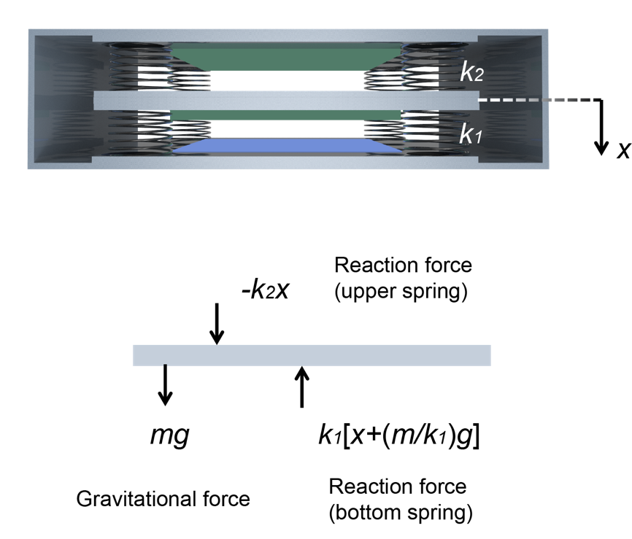
Fig. S15 Schematic showing the structure of the V-TENG.
As the structure shown in Fig. S15, the middle layer with the mass of m (g) was supported by the springs with the constant of k (N/m). The displacement of the middle layer during the vibration is x (m) and the acceleration of the middle layer is a. The movement can be described according to the following equation (Eq. 1).
$mg-k_{2}x-k_{1}\left(x+\frac{m}{k_{1}}g\right)=ma$ (1)
Since acceleration and displacement are functions of time and if we assume that the remaining variables are constant, we can get a homogeneous linear ordinary differential equation with constant coefficients (Eq. 2):
$\ddot{x}+\frac{(k_{1}+k_{1} )}{m}x=0$ (2)
The general solution of this differential equation can be expressed with the following equation (Eq. 3):
$x=Asin\left(ωt\right)+Bcos\left(ωt\right)$ (3)
where $ω$ is the resonance frequency of the system, A is the variable, and B can be determined by the boundary conditions of the system. Thus the $ω$ can be determined as shown in Eq. 4*.
$ω=\frac{1}{2π}\sqrt{\frac{k_{1}+k_{2}}{m}}$ (4)
When k₁ = k₂ = 4 * 82.712 = 330.84 N/m (each spring with a constant of 82.712 N/m) and m = 0.02 kg the $ω$ can be calculated as 28.95 Hz. The highest output can be obtained near the resonance frequency since the displacement of the middle layer can be maximized.

* Reference: Chen J, Zhu G, Yang W, Jing Q, Bai P, Yang Y, et al. Harmonic‐resonator‐based triboelectric nanogenerator as a sustainable power source and a self‐powered active vibration sensor. Advanced Materials 2013, 25(42): 6094-6099

Additional discussion 2. The design of the duct.
The duct was designed according to the practical application of the ventilation system of indoor buildings and the parameters of the duct and the operation was shown in Supplementary Table 2 and the structure of the duct was shown in Fig. S16.
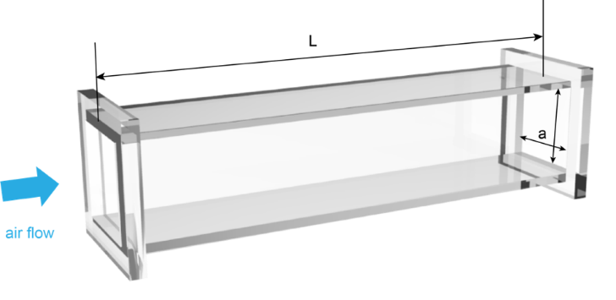
Fig. S16 Schematic showing the duct.
To make sure the airflow in the duct is laminar flow and decrease the impact of mass transfer introduced by the turbulence, the length of the duct was design based on the following equations (Eq. 5 to 8):
$Re=ρvD/μ$ (5)
$D=4A/p$ (6)
$A=a^{2}$ (7)
$p=4a$ (8)
where Re is the Reynolds number, $ρ$ is the density of the air (1.2 kg/m³), $v$ is the airflow rate (2 m/s), D is the characteristic length of the duct, A is the area of the cross area of the duct, a is the width of the duct (6 cm), p is the length of the surrounding flow, and $μ$ is the viscosity of the air (1.8 × 10⁻⁵ kg/(m·s). The Re number was calculated as 7955.8 which is in the range of turbulence flow. To ensure the laminar flow in the duct, the length (L) was calculated based on the following equation (Eq. 9):
$L=4.4D{×Re}^{\frac{1}{6}}$ (9)
and the length of the duct was calculated as 1.18 m. Thus, in this study, the length of the duct was designed as 1.4 m to ensure the inside laminar flow.
Additional discussion 3. Calculation of microbes trapped by the positive/ground electrode.
When the negatively charged microbes flow through the positive/ground integrated electrodes, they will be trapped on the positive electrode surface by the electrostatic attraction. The schematic in Fig. S17 showed the microbes flowing in between the positive/ground integrated electrodes.
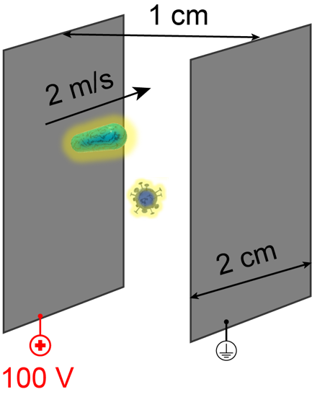
Fig. S17 Schematic showing the microbes flowing in between the positive/ground integrated electrodes.
The time for microbes approaching to the positive electrode surface (t) will be quantified based on the following equations (Eq. 10 to 12):
$D=\frac{1}{2}at^{2}$ (10)
$a=\frac{F}{m}$ (11)
$F=E×q$ (12)
where D is the distance between the positive and ground electrode (1 cm), a is the acceleration of the microbes in the horizontal direction, F is the force on the microbes in the horizontal direction, which is the force of electrostatic attraction, m is the mass of the microbes (10⁻¹² and 10⁻¹⁸ g for bacterium and virus), E is the electric field strength between the positive and ground electrode (10⁴ V/m), and q is the charges carried by the microbes (6.1×10⁻¹⁰ and 7.2×10⁻¹² C for bacterium and virus)*. When considering these parameters, the time for microbes approaching to the positive electrode surface was calculated ~10⁻⁵ and ~10⁻⁷ s, respectively, which is significantly smaller than the time needed for airflow passing through the electrode (2 cm ÷ 2 m/s = 0.01 s). Thus, attributed to the charging of microbes, the microbes can be trapped to the positive electrode surface effectively, ensuring the disinfection efficiency.
If considering the air resistance during the trapping process, due to the microbes move in the laminar flow, the air resistance (F_{d}) can be described as the following equation (Eq. 13):
$F_{d}=6πμrV$ (13)
where r is the radius of the microbes, $μ$ is the viscosity of the air (1.8 × 10⁻⁵ kg/(m·s), and V is the speed of the microbes. The possible highest speed can be calculated as follows (Eq. 14):
$V=a×t$ (14)
where a is the acceleration caused by the force of electrostatic attraction (6×10⁶ m/s²), and t is the movement time (~10⁻⁵ s). So, the V can be calculated as 60 m/s and the F_{d} for the bacteria was 10⁻¹¹ N, which is significantly lower than the force of electrostatic attraction (F=m$×$a; 10⁻⁶ N). Thus, the air resistance will not impact the trapping time.
* Reference:
Mass of E. coli: the database of ecmdb: E. Coli Numbers and Stats - https://ecmdb.ca/e_coli_stats
Mass of MS2: Kuzmanovic, Deborah A., et al. "Bacteriophage MS2: molecular weight and spatial distribution of the protein and RNA components by small-angle neutron scattering and virus counting." Structure 11.11 (2003): 1339-1348.

