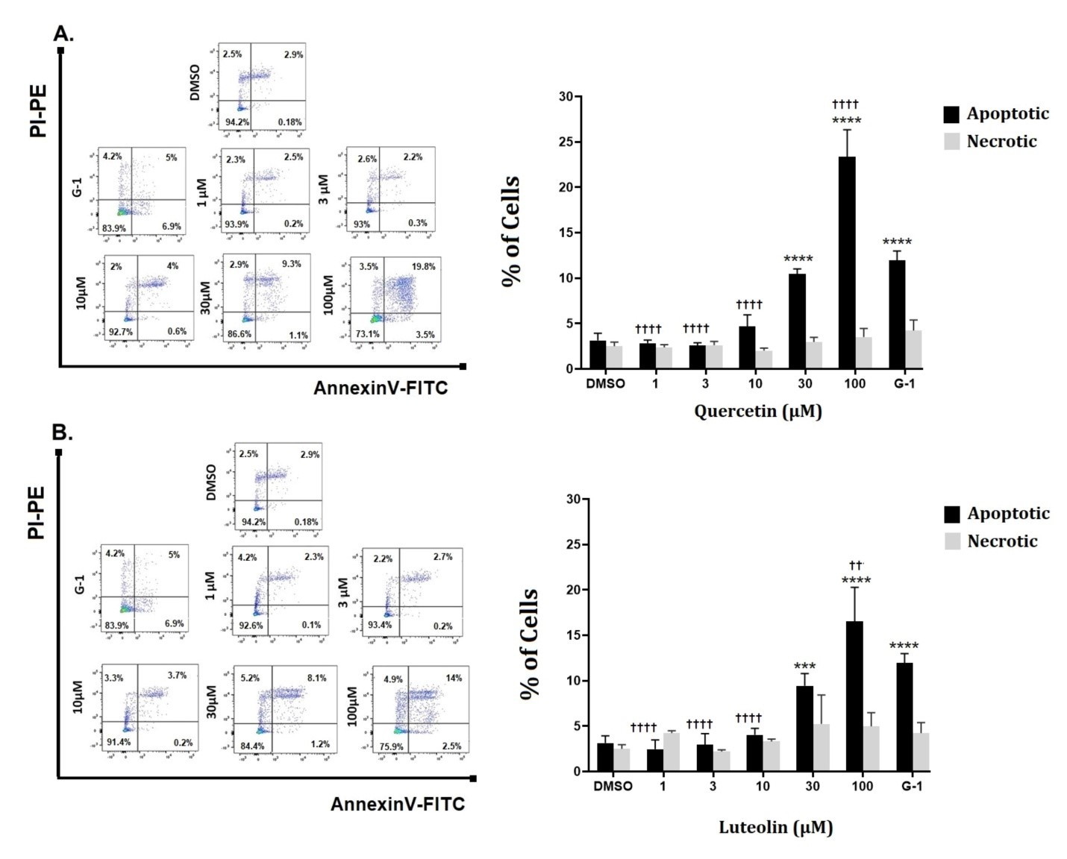
Figure S1. Effect of quercetin (A) and luteolin (B), G-1 (positive control), and 0.2% DMSO (negative control) on the protein expression of T-AKT, P-AKT/T-AKT, T-ERK, P-ERK/T-ERK, T-FAK, and p-FAK/T-FAK in MeWo cells, assessed by Western blotting. Statistical significance was determined using one-way ANOVA followed by Dunnett’s multiple comparisons test. (*p < 0.05, **p < 0.01, ***p < 0.001, ****p < 0.0001 compared to DMSO; †p < 0.05, ††p < 0.01, †††p < 0.001, ††††p < 0.0001 compared to G-1). In the presence of 3 µM of the antagonist G15, the relative protein expressions were significantly reversed, with the following levels of significance: ■p < 0.05, ■■p < 0.01, ■■■p < 0.001, ■■■■p < 0.0001 compared to the same concentration and ligand in the absence of G15.

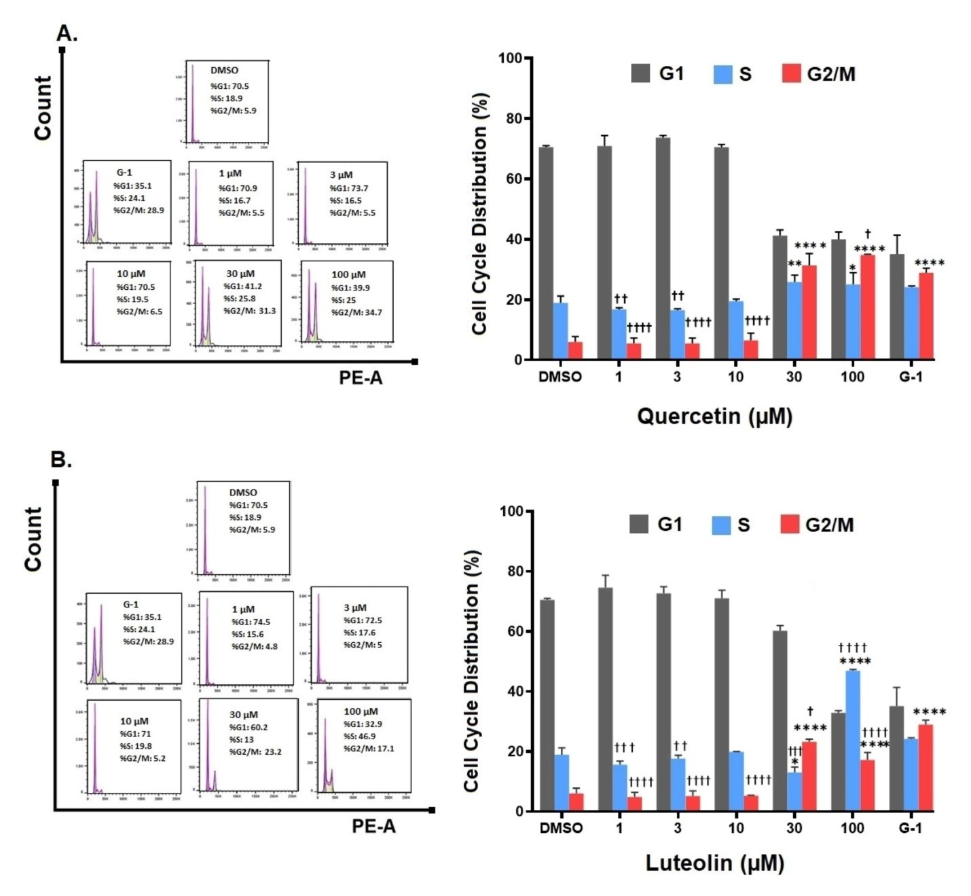
Figure S2. Cell cycle distribution of cultured MeWo cell line. Cells were treated with the indicated concentrations of quercetin (A) or luteolin (B), 1µM of G-1 as a positive control, and 0.2% DMSO as a negative control. After 48 hrs. cells were fixed, stained with PI, and analyzed by flow cytometry (left panels). The percentage of cells in G1, S and G2/M phases for each treatment was calculated and analyzed (right panels). Data are presented as the means ± SD of three independent experiments. Statistical significance was determined using 2-way ANOVA followed by Dunnett's multiple comparisons test. *p < 0.05, **P < 0.01****p < 0.0001 compared to DMSO; † p < 0.05, ††p <0.01, ††† p<0.001, †††† p <0.0001 compared to G-1.

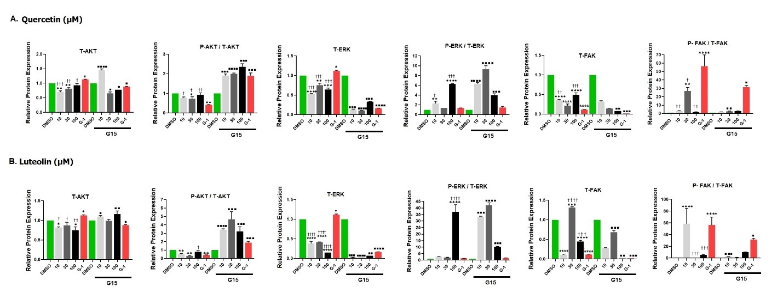
Figure S3. Effect of quercetin (A) and luteolin (B), G-1 (positive control), and 0.2% DMSO (negative control) on the protein expression of T-AKT, P-AKT/T-AKT, T-ERK, P-ERK/T-ERK, T-FAK, and p-FAK/T-FAK in MeWo cells, assessed by Western blotting. Statistical significance was determined using one-way ANOVA followed by Dunnett’s multiple comparisons test. (*p < 0.05, **p < 0.01, ***p < 0.001, ****p < 0.0001 compared to DMSO; †p < 0.05, ††p < 0.01, †††p < 0.001, ††††p < 0.0001 compared to G-1). In the presence of 3 µM of the antagonist G15, the relative protein expressions were significantly reversed, with the following levels of significance: ■p < 0.05, ■■p < 0.01, ■■■p < 0.001, ■■■■p < 0.0001 compared to the same concentration and ligand in the absence of G15.

