Supporting Information
Thibaut C. Babin*, Stephan Pissot, Laura Bernard, Pierre R. Marcoux, Maxime Gougis, Pascal Mailley
Figure S1: pH calibration curves for our polyaniline ink electrodes before and after sterilization.
Figure S2: pH calibration curves for our iridium oxide ink electrodes after sterilization.
Figure S3: Bacterial biomass correlation with our potentiometric signals.
Figure S4: Contamination of the sterile chamber implies potentiometric signature.
Figure S5: Measurement process for EIS measurement at the open circuit potential.
Figure S6: Potentiometric response of E. coli in human blood during the EIS experiment.
Figure S7: Potentiometric response of sterile human blood during the EIS experiment.
Figure S8: Detection of E. coli in human blood by derivation of polyaniline potential.
Figure S9: Detection of E. coli in human blood by derivation of iridium oxide potential.
Figure S10: Nyquist diagrams for a positive and a negative blood culture – Polyaniline.
Figure S11: Bode diagrams (impedance modulus) for a positive and a negative blood culture – Iridium oxide.
Figure S12: Bode diagrams (phase) for a positive and a negative blood culture – Iridium oxide.

Figure S1.
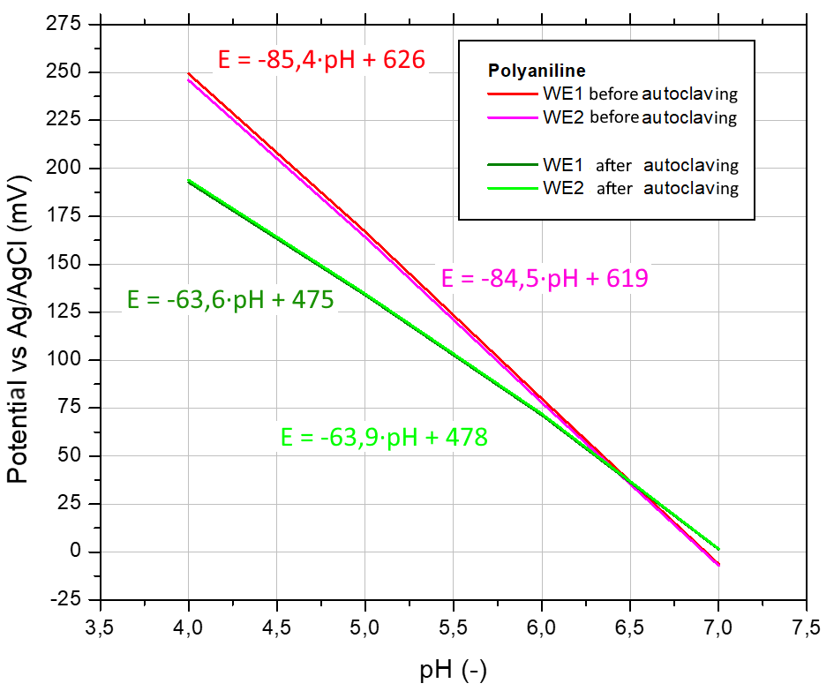
Figure S1: Calculation of the change in pH sensitivity of polyaniline after autoclave sterilization. The sterilization process causes here a loss of sensitivity of 20 mV/pH unit.

Figure S2.
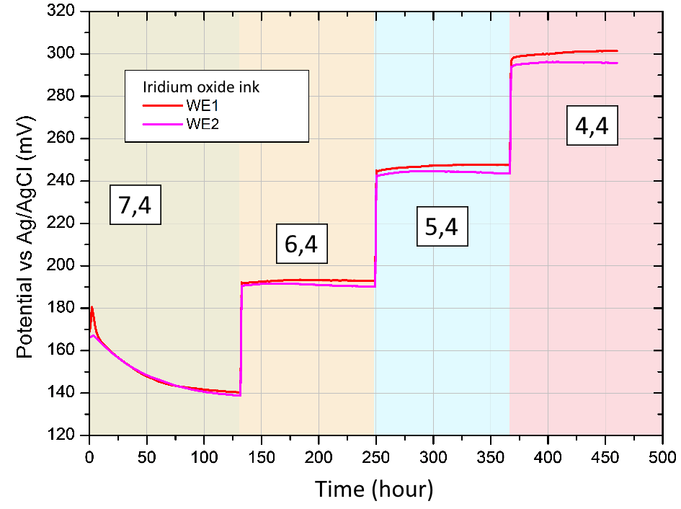
Figure S2: Electrochemical measurements of the potential of two (identical) electrodes made of iridium oxide ink, in solutions at different pH. The different pH values (noted on the curve) are obtained in 1X PBS solutions by adding 99% sulfuric acid.

Figure S3.
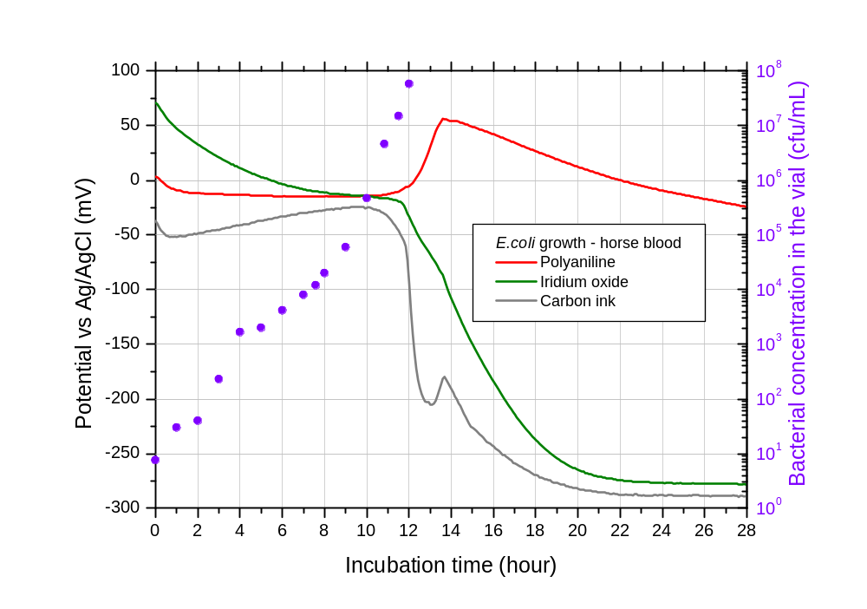
Figure S3: Potential-biomass correspondence during growth of E. coli (ATCC 8739) in a BACT/ALERT® FA Plus + defibrinated horse blood mixture.

Figure S4.
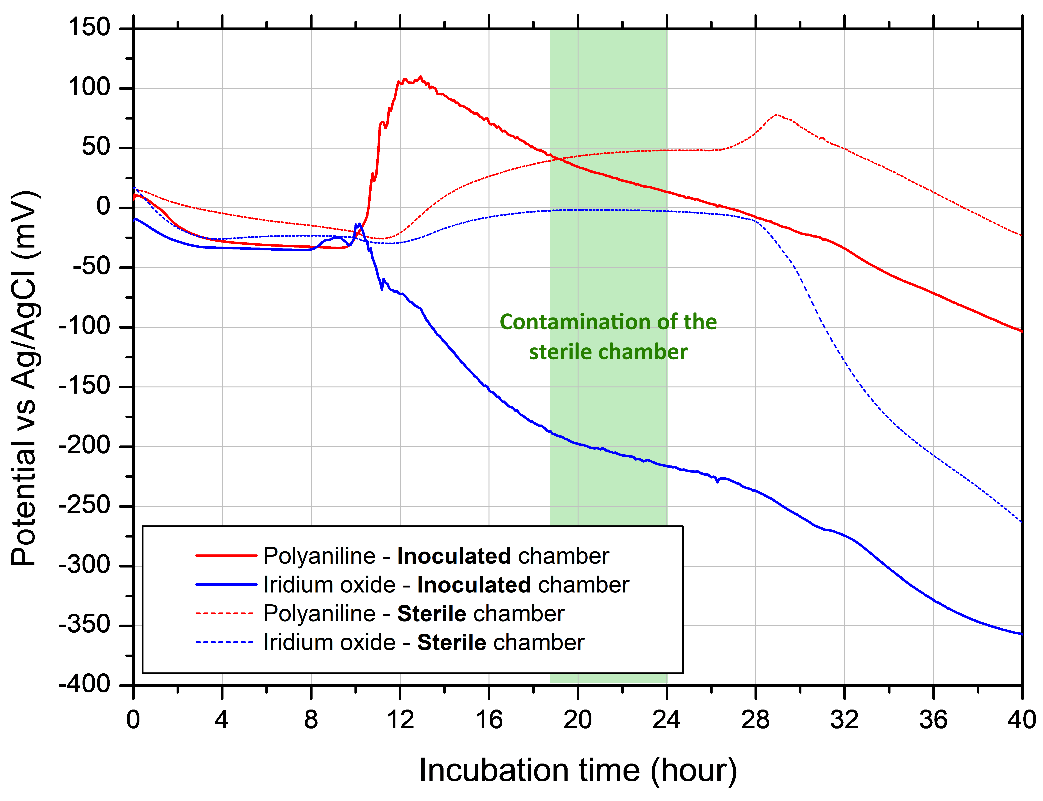
Figure S4: Potentiometric curves of polyaniline and iridium oxide electrodes placed in the sterile compartment after mixing with the blood culture of E. coli (ATCC 25922). Blood culture of human blood in BacT/ALERT® FA Plus, 37°C, 60 rpm.

Figure S5.
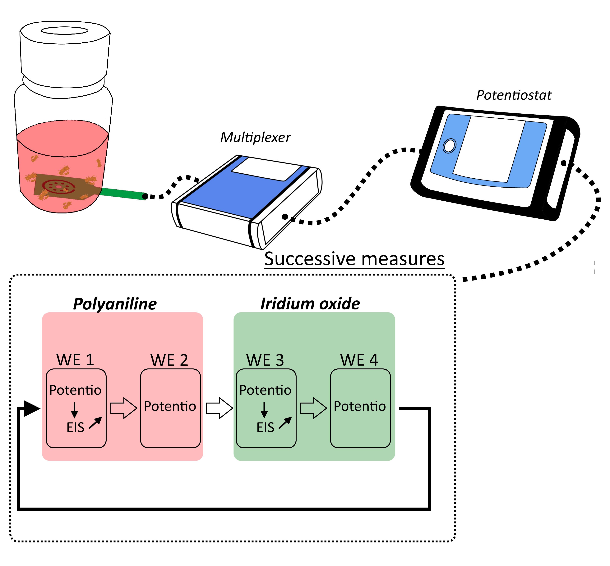
Figure S5: Measurement process for vials using impedance spectroscopy (Potentio = potentiometric measurement, EIS = impedance spectroscopy). Thanks to the multiplexer the measurements are successive. Only one electrode of each material is used for the impedance measurements, this allows to study the influence of this measurement on the detection by potentiometry. Only polyaniline and iridium oxide behaviors are studied is this article.

Figure S6.
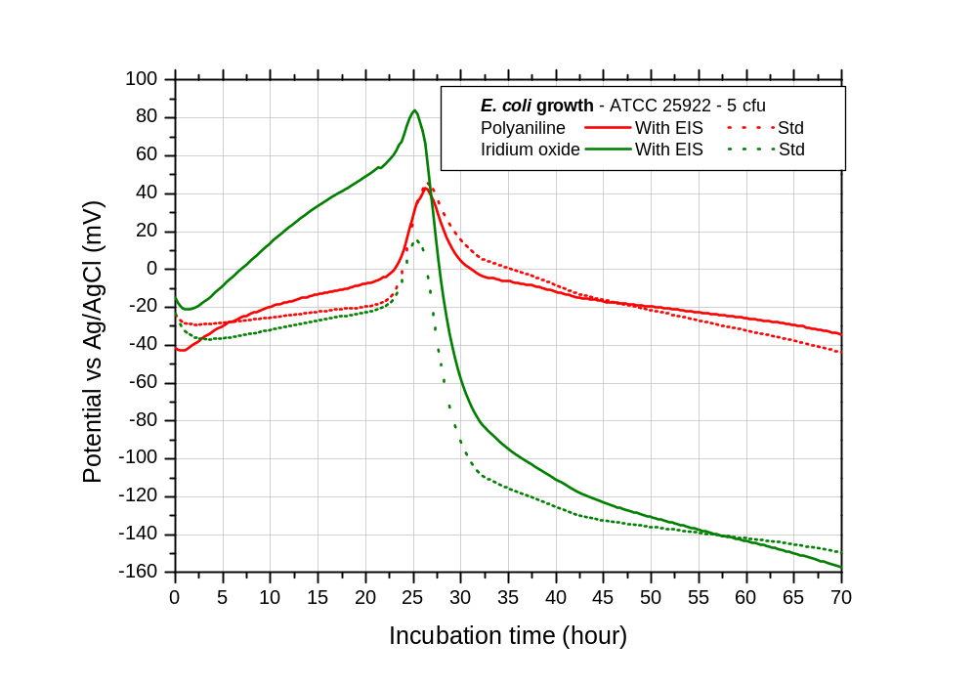
Figure S6: Potentiometric curves obtained for E. coli growth, with (With EIS) and without (Std) impedance measurement before potential measurement. Blood culture of human blood in BacT/ALERT® FA Plus, 20°C, 100 rpm. | Insert: Smoothed potential curves of iridium oxide electrodes.

Figure S7.
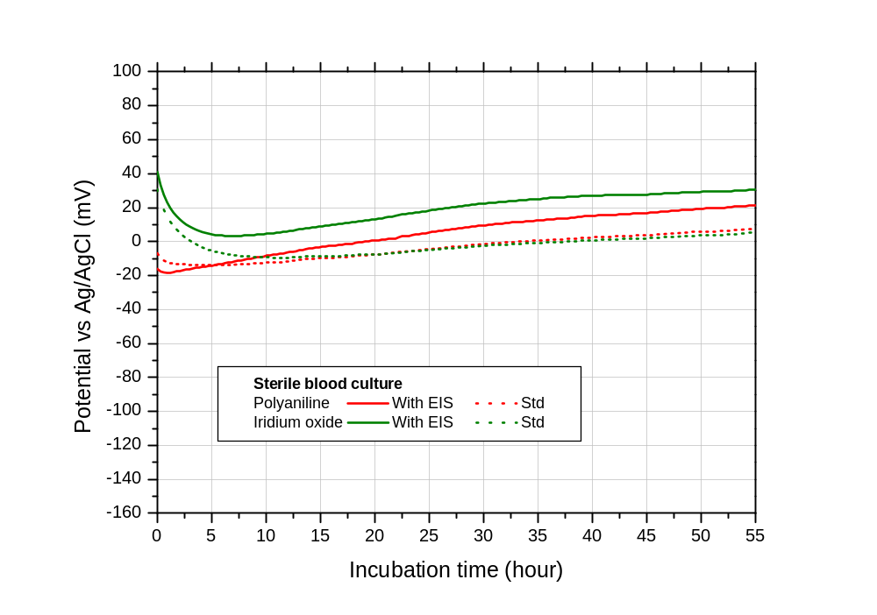
Figure S7: Potentiometric curves obtained for a sterile blood culture bottle, with and without impedance measurement before potential measurement. Blood culture of human blood in BacT/ALERT® FA Plus, 20°C, 100 rpm.

Figure S8.
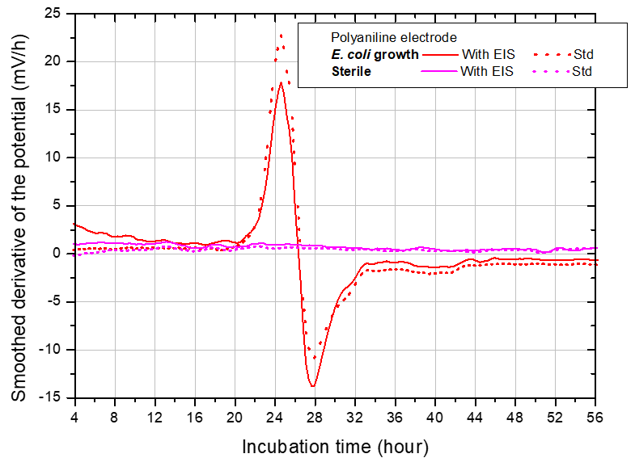
Figure S8: Detection with polyaniline electrodes by comparing the smoothed (k=5) derivative of the potential, with and without impedance measurement before potential measurement. Blood culture of human blood in BacT/ALERT® FA Plus, 20°C, 100 rpm.

Figure S9.
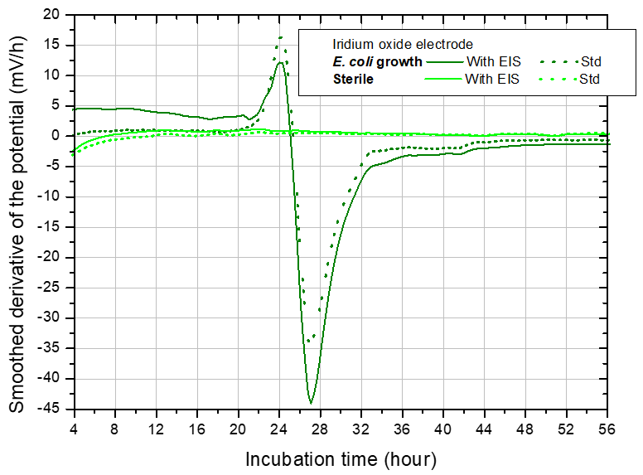
Figure S9: Detection with iridium oxide electrodes by comparing the smoothed (k=5) derivative of the potential, with and without impedance measurement before potential measurement. Blood culture of human blood in BacT/ALERT® FA Plus, 20°C, 100 rpm.

Figure S10.
a.  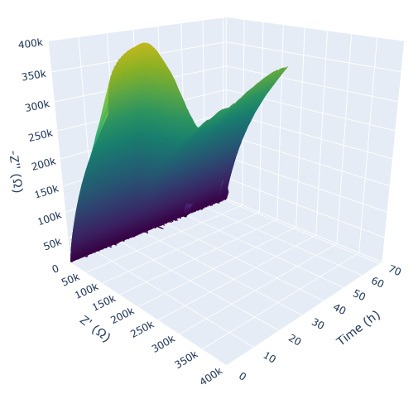 | b.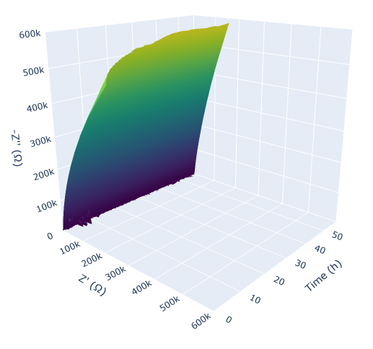
Figure S10: For a polyaniline ink electrode, between 1 kHz and 0.1 Hz, (a.) evolution of smoothed (using a three-point moving average, k=3) Nyquist diagram during E. coli growth; (b.) evolution of smoothed Nyquist diagram (k=3) during an incubation of sterile medium. Human blood cultures in BacT/ALERT® FA Plus, 20°C, 100 rpm.

Figure S11.
a. IrOx, inoculated compartment, modulus 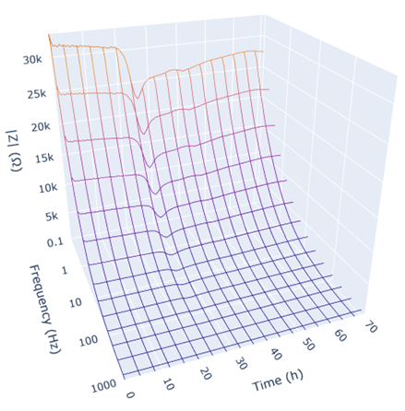 | b. IrOx, sterile compartment, modulus 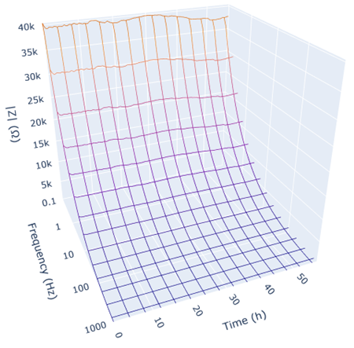
Figure S11: For an iridium oxide ink electrode, between 1 kHz and 0.1 Hz, (a.) evolution of smoothed (k=3) impedance modulus during E. coli growth; (b.) evolution of smoothed impedance modulus (k=3) in the sterile compartment. Human blood cultures in BacT/ALERT® FA Plus, 20°C, 100 rpm.

Figure S12.
- IrOx, inoculated compartment, phase | 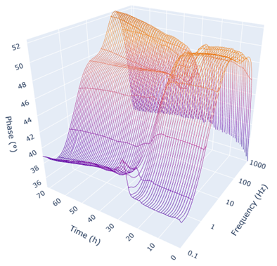
- IrOx, sterile compartment, phase | 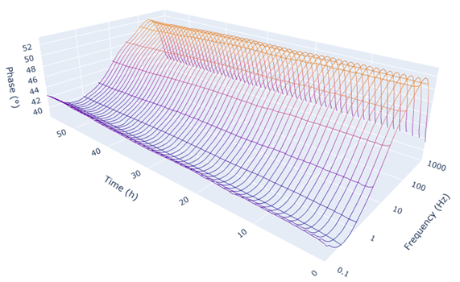
Figure S12: For an iridium oxide ink electrode, between 1 kHz and 0.1 Hz, (a.) evolution of smoothed (k=3) impedance phase during E. coli growth; (b.) evolution of smoothed (k=3) impedance phase in the sterile compartment. Human blood cultures in BacT/ALERT® FA Plus, 20°C, 100 rpm.

