Supplementary Information

Nanometric transverse displacement metrology in range of hundreds of micrometers with polarization-encoded metasurface
Haofeng Zang1,3, Zheng Xi1,3 , Zhiyu Zhang1,3 , Yonghua Lu1,2*, and Pei Wang1,2*
1Department of Optics and Optical Engineering, University of Science and Technology of China, Hefei 230026, China
2Advanced Laser Technology Laboratory of Anhui Province, Hefei, Anhui 230026, P. R. China
3These authors contributed equally: Haofeng Zang, Zheng Xi and Zhiyu Zhang
*E-mail: yhlu@ustc.edu.cn, wangpei@ustc.edu.cn

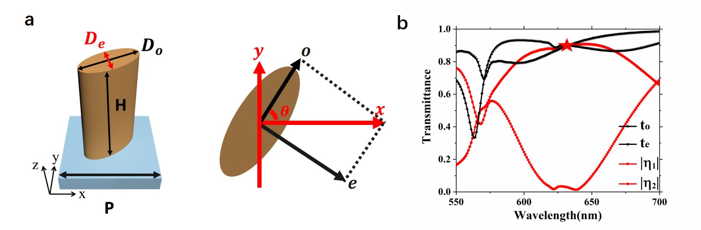
Supplementary Fig.1. The schematics and design for the dielectric nanoantenna. a, The perspective and top view of the nanoantenna, where $D_{o}=152 nm, D_{e}=104 nm, H=410 nm, P=300 nm$; b, The amplitude transmittance $t_{o}$, $t_{e}$ , amplitude transmittance of the incident polarization $|η_{1}|$ and polarization conversion efficiency $|η_{2}|$ of the nanoantenna as a function of wavelength, the red star represents the optimal working wavelength of our designed metasurface in which the half-wave plate condition is satisfied.

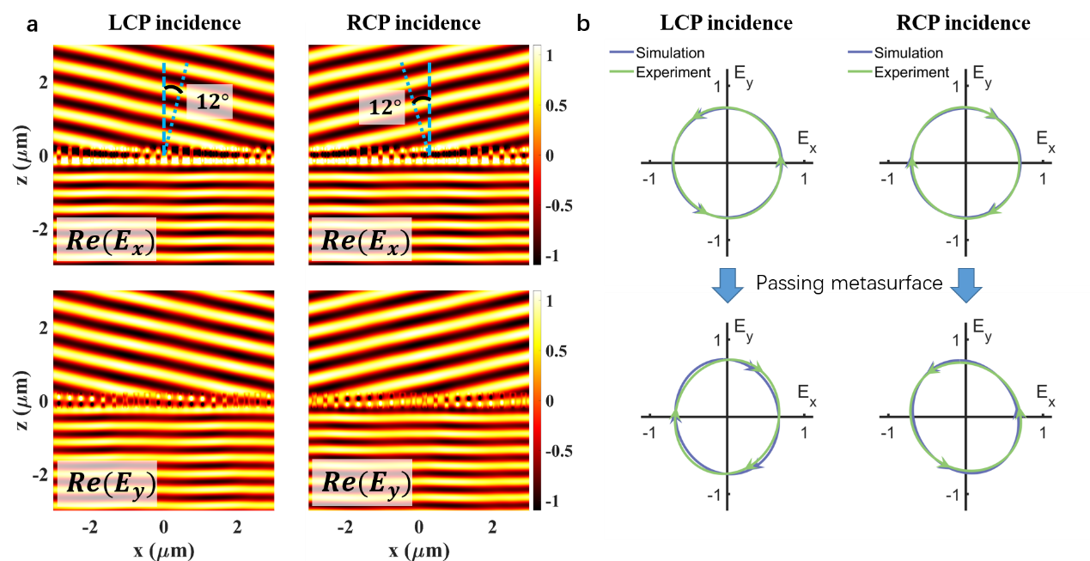
Supplementary Fig.2. The simulation results of the designed metasurface with period $Λ=3 μm$. a, The left column is the real parts of $E_{x}$ and $E_{y}$ in the xz-plane for LCP incident, indicating a $12°$ refraction angle which is consistent with the theoretical prediction of $θ=arcsin(\frac{λ}{Λ})$; the right column is for the RCP incident, the output reflects to the opposite direction; b, The upper figures are the polarization state of incident light, and the bottom figures are the polarization state of corresponding output light, which present the handness conversion between the circular polarizations. The blue lines are simulated results and the green lines are experimental results.

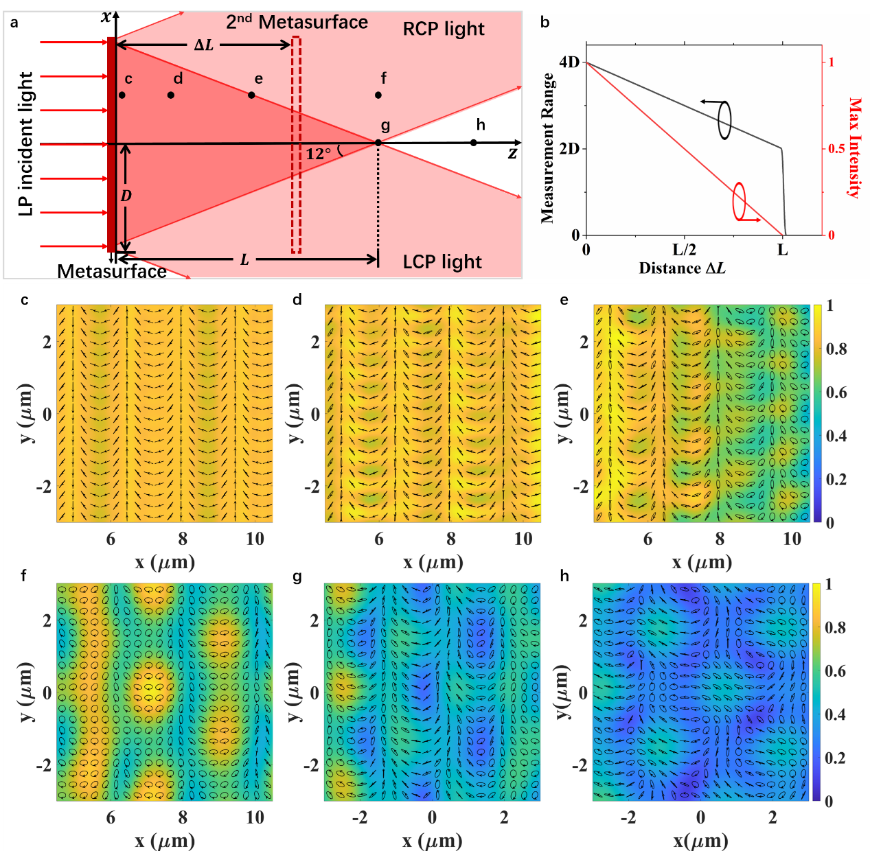
Supplementary Fig.3. The measurement range of the displacement metrology. a, The schematics for the measurement range depending on the metasurface size (D: the radius of the metasurface) and distance ($ΔL$) between the two metasurface. For linear polarization incident light, the output light splits into LCP and RCP and deflects to opposite direction with $12°$ to z axis ($Λ=3μm$). The superposition area of LCP and RCP (deep red area) is the effective area for displacement measure. Assuming the second metasurface placed behand first metasurface with distance $ΔL$, the measurement range and max measurement intensity greatly rely on $ΔL$. b, theoretical measurement range (black line) and maximum intensity (red line) for the displacement metrology. The increase of distance $ΔL$ causes the decrease of measurement range and max measurement intensity. c-h, The polarization and electric distribution of output in different sites: c $\left(1μm,\frac{D}{2}\right)$, d $\left(\frac{L}{6},\frac{D}{2}\right)$, e $\left(\frac{L}{2},\frac{D}{2}\right)$, f $\left(L,\frac{D}{2}\right)$, g $\left(L, 0\right)$, h $\left(\frac{6}{5}L, 0\right)$. The simulation was performed for a 30×30${μm}^{2}$ metasurface to calculate the amplitude and polarization of the electric field distributions in xy-plane. The background is the normalized amplitude of electric field. The polarization distributions at sites c and d (within the working area) are exactly the same as the theoretical prediction. Site e is on the border of working area. Beyond the superposition area (sites f, g and h), the deterioration of the polarization distribution makes the displacement metrology out of function.

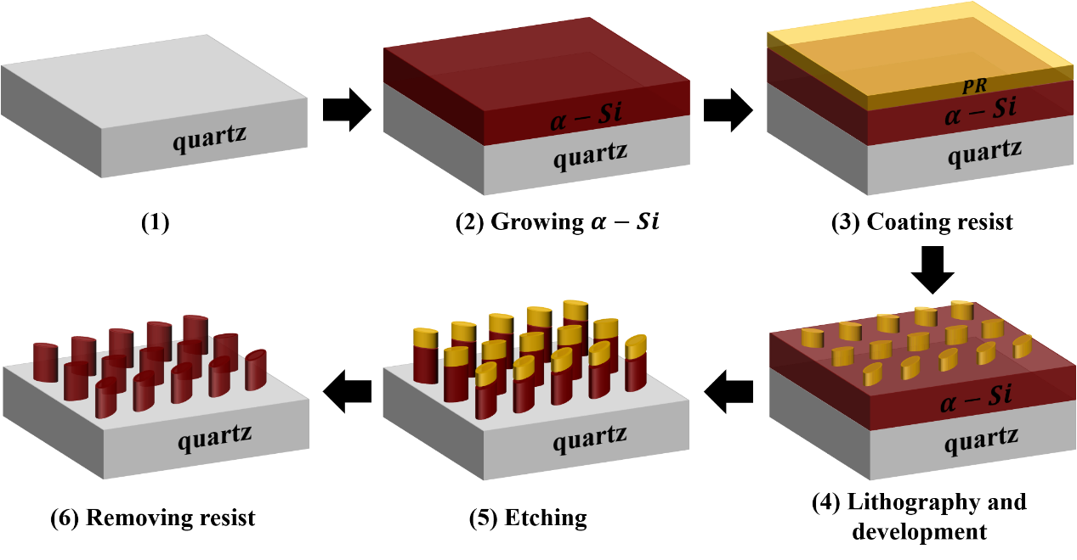
Supplementary Fig.4. The diagrammatic drawing of fabrication process. (1) The process starts with a fused quartz substrate. (2) Growing a 410-nm-thick $α-Si$ film on the substrate. (3) Coating a 120-nm-thick negative electron-beam resist layer. (4) Patterning the metasurface array into resist and developing resist to reveal the pattern. (5) Etching to transfer the pattern to $α-Si$ film. (6) Removing residual resist by buffered oxide etch (BOE) solutions.

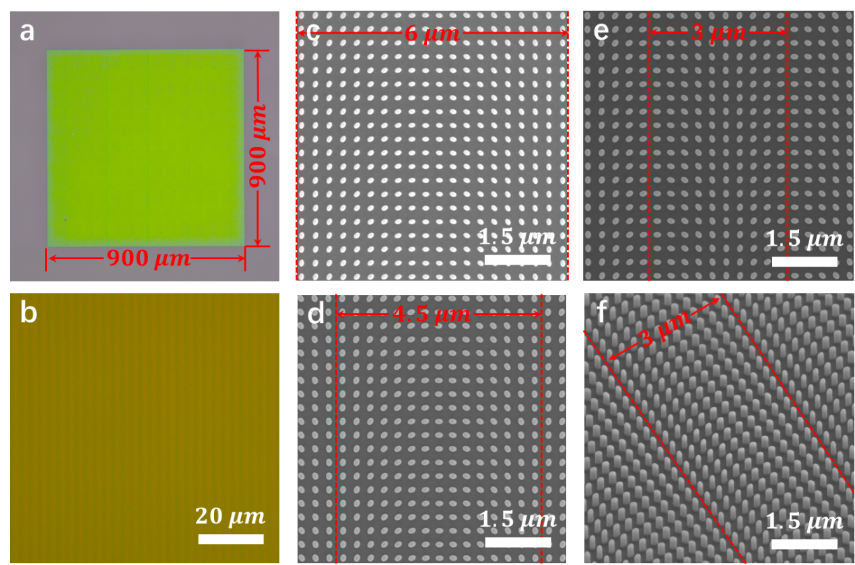
Supplementary Fig.5. The optical and the scanning electron microscope (SEM) images of the metasurface. a-b, Optical images of the fabricated metasurface and the partially enlarged image. c-e, Top view SEM images of metasurface with different period: c, $Λ=6 μm$, d, $Λ=4.5 μm$, e, $Λ=3 μm$, the red dashed boxes indicate a period of the pattern. f, The tilted view of the metasurface with period $Λ=3 μm$.

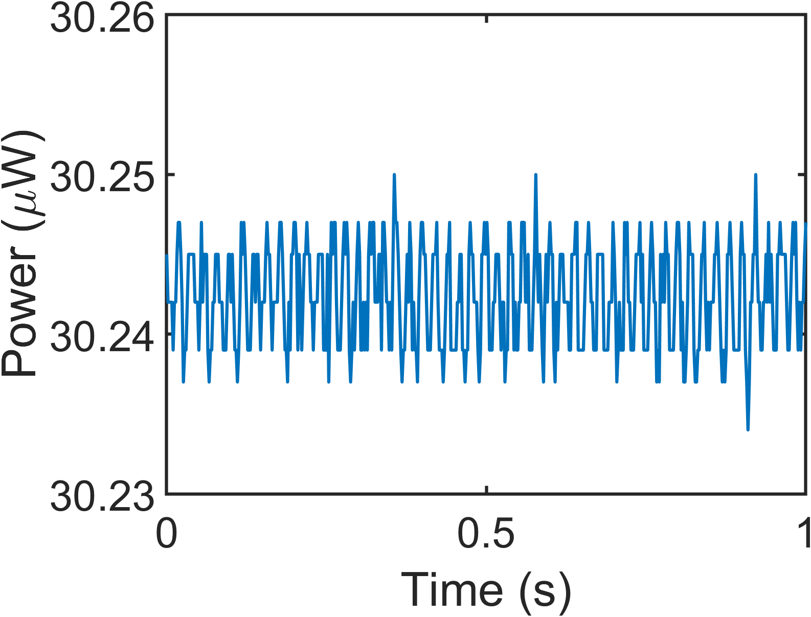
Supplementary Fig.6. Stability of measurement system. The line indicated the fluctuation of the laser intensity measured by power meter when it passes through the experimental setup without the metasurface sample. The laser power is stable enough during the measurement time (1 second) for each position, and the measured value is discrete due to the limitation by the resolution of the power meter. The average value of the measurement is 30.24 μW, and the standard deviation is 3.09 nW. Correspondingly, the relative error is 0.01%. The laser power is tuned to the same level of the optical signal we obtained in the following displacement sensing experiment to let the power meter work in a proper range and resolution.

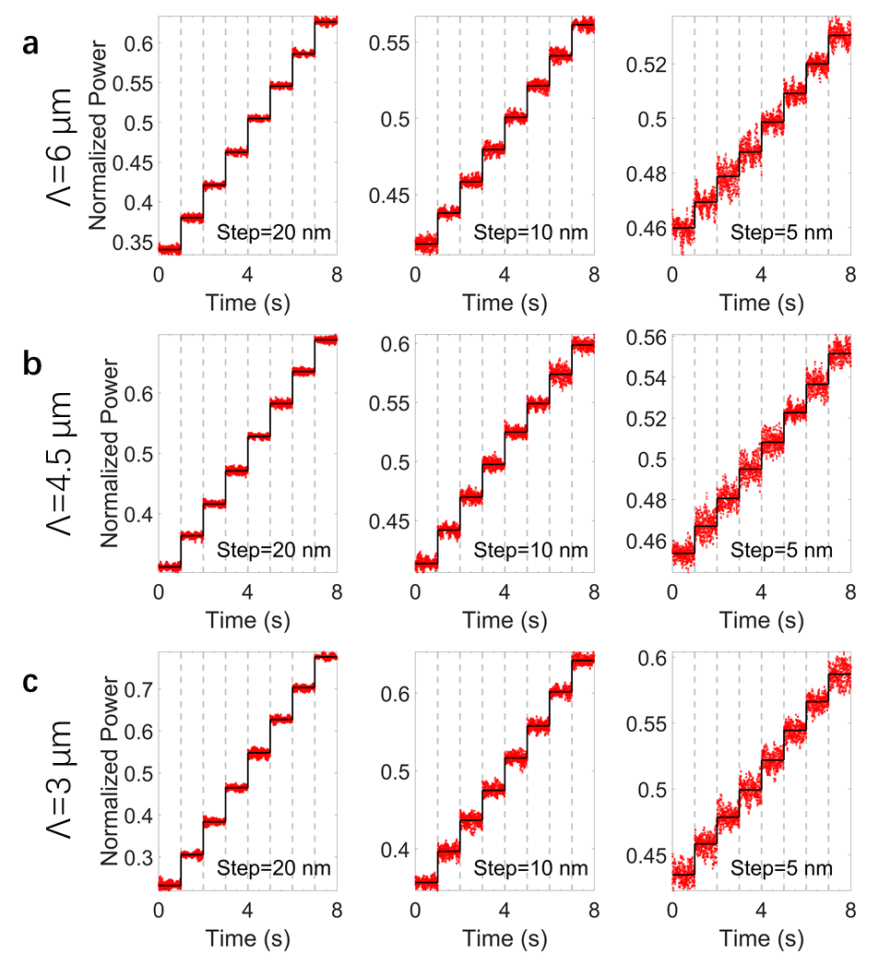
Supplementary Fig.7. Resolution of three different period PB-metasurface displacement sensors. Deterministic measurement results for sample with different period of a, 6 μm, b, 4.5 μm and c, 3 μm at different measurement step of 20 nm(left), 10 nm(center) and 5 nm(right). The red dots are normalized power in one measurement and the movement of the piezo stage indicated by the black stairs line with the step of 20 nm, 10 nm and 5 nm respectively.

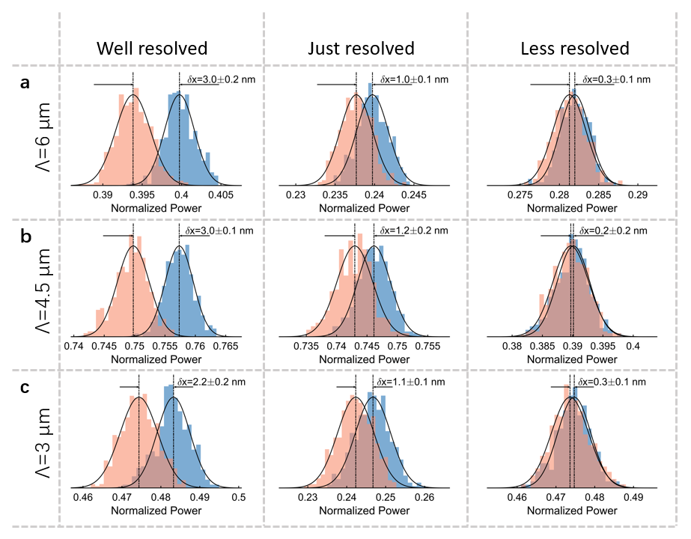
Supplementary Fig.8. Precision of resolve ability of three different period PB-metasurface displacement sensors. Statistics of the measurement power at different positions from the indeterministic measurement for samples with different period of a, 6 μm, b, 4.5 μm and c, 3 μm. The two positions are well resolved (left), just resolved (center) and less resolved (right). The same as the data processing method in Fig.3b, these statistical results are taken from the comparison between repeated measurements in the linear region of each sample measurement curve. The relative displacements can be just resolved from three samples are all about 1.1 nm with measurement precision of 0.1/0.2 nm. All three samples show almost the same measurement ability because of the influence of environmental noise.

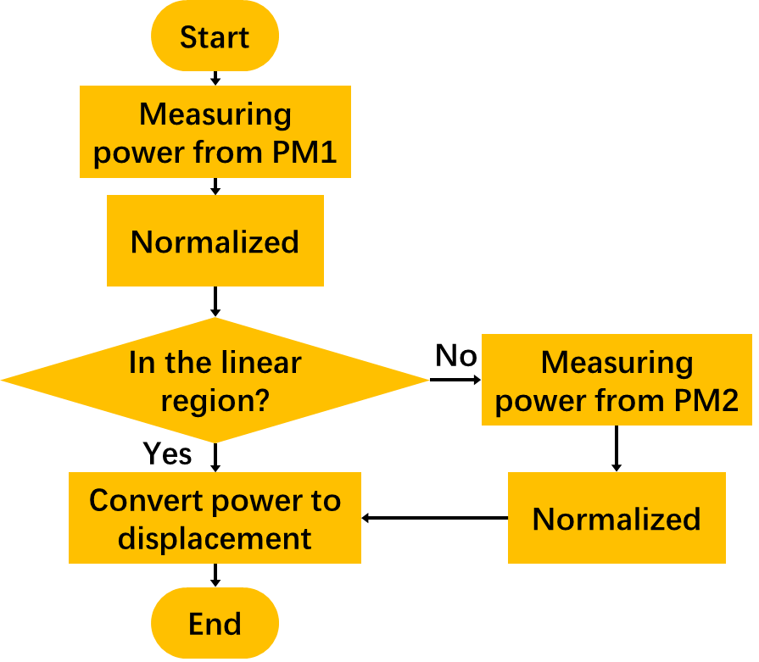
Supplementary Fig.9. Flowchart for full coverage of the linear region. The signal power is measured by the power meter 1, and then normalized according to the maximum and minimum power measured in advance. When the normalized power $P_{1}^{N}$ is in the linear region, the displacement is obtained according to $x=P_{1}^{N}/k_{1}$. If not, the signal power is measured and normalized by the power meter 2. The displacement also can be obtained by $x=P_{2}^{N}/k_{2}$ with high resolution in linear region.

Supplementary Table 1. Measurement results of the same sample at different time. Taking a sample with a period of 3 μm as an example, the table shows the fitting results measured at different time. Date/Time indicate the date and time of measurement. Experimental period $T_{exp}$ is calculated by fitting the entire measurement curve to a sine carve. We also calculate the slope k and the average width $\overline{W}$ in the linear region. To evaluate resolving ability of the system at different time, resolving ability R is calculated which defined as the ratio of the average width $\overline{W}$ and the slope k of the linear region. It can be clearly seen that the resolving ability of the system changes significantly with time, and it has better resolving ability after midnight when there is less environmental noise.

