(a) | 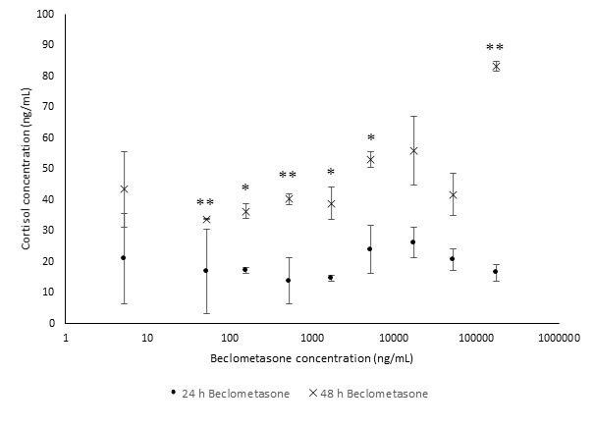
(b) | 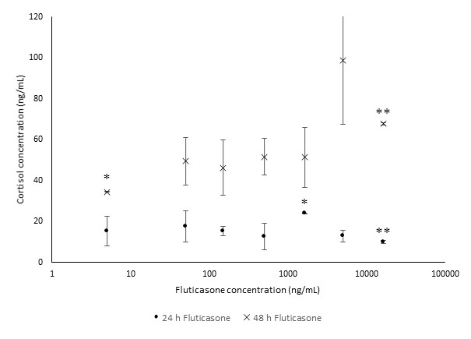
Supplementary Figure 1. Cortisol levels (ng/mL) in H295R cell supernatant after being treated with (a) beclometasone for 24 h (●) and 48 h () and (b) fluticasone. Error bars represent standard deviation; n=2-3. *p < 0.05. **p < 0.01. ***p < 0.001.

