Nominal and Real Cigarette Price Trends and Excise Tax Pass-Through: Longitudinal Evidence from a global dataset, 2008-2024 and implications for the World Health Organization’s 3 by 35 Initiative

Supplementary Tables and Figures

Supplementary Table S1: Brand matches over successive periods 3
Supplementary Table S2: Frequency of nominal price stickiness 4
Supplementary Table S3: Nominal price stickiness: share of identical local prices reported over prior period, sample restricted to instances with brands identical to previous year’s brand 5
Supplementary Table S4: Nominal price stickiness: share of identical local prices reported over prior period, sample restricted instances with brands identical in all 9 periods 5
Supplementary Table S5: Mean real international dollar prices over time across WHO regions 6
Supplementary Table S6: Median real international dollar prices over time across WHO regions 6
Supplementary Table S7: Mean real international dollar prices over time across World Bank 2024 income groups 7
Supplementary Table S8: Mean real international dollar prices over time across World Bank 2024 income groups 7
Supplementary Table S9: Median annual consumer price inflation across regional and income groups, 2008-2024 8
Supplementary Table S10: Summary statistics of real local currency price changes (in %) over previous periods 8
Supplementary Table S11: Summary statistics of changes in real price in local currency over prior periods : Countries with price observations in all periods 9
Supplementary Table S12: Summary statistics of changes in real price in local currency over prior periods : Countries with identical brands in all periods 9
Supplementary Table S13: Share of countries with real local currency prices 50% over prior years by WHO region 10
Supplementary Table S14: Share of countries with real local prices 50% over prior years by 2024 World Bank income group 10
Supplementary Table S15: Annual rates of growth of real price in local currency units (2008-24) and implied time required to raise prices 50% and 20% 11
Supplementary Table S16: Percent increase in price over previous period by period-specific deciles of percent increase in excise tax, local currency units 18
Supplementary Table S17: % increase in excise and tax regime type by price increase 19
Supplementary Table S18: Excise tax changes associated with 2-year PPP$ price increases of over 50%: Instances of two-year increase over 50% and explanations 20
Supplementary Table S19: Drivers of price increase in countries with 50% or larger price increase over 2 year windows 22
Supplementary Table S20: Pass-through of excise tax to prices: Coefficients from two-way fixed-effects regression of ln(price of cigarettes in international $) on ln(Excise Tax in international $) 23
Supplementary Table S21: Interaction of price measures and tax regime 24
Supplementary Table S22:Terminal digits in nominal local currency prices 25
Supplementary Figure F1: Change in real local currency prices over previous period by WHO region (countries with 4 or more price observations) 26
Supplementary Figure F2: Distribution of real price changes over 2- and 10-year lookback period 29
Supplementary Figure F3: Fraction of countries with real prices 20% and 50% higher by price quintile 30

Supplementary Table S1: Brand matches over successive periods
 | 2010 | 2012 | 2014 | 2016 | 2018 | 2020 | 2022 | 2024 | Total | Share
Initial match, identical brands | 125 | 123 | 162 | 157 | 139 | 148 | 153 | 167 | 1174 | 81%
Additional matches | 21 | 20 | 13 | 9 | 8 | 4 | 7 | 4 | 86 | 6%
Unmatched | 34 | 37 | 7 | 16 | 35 | 24 | 17 | 12 | 182 | 13%
Total # of prices | 180 | 180 | 182 | 182 | 182 | 176 | 177 | 183 | 1442 | 100%

Brands were matched as follows. First, brands were matched if they were spelled identically (1174 pairs of prices). Additional matches were then obtained. Any small spelling differences, capitalizations and blank spaces in brand names were tallied and corrected (e.g. “Kentuchy” and “Kentucky”). After that brand variants were evaluated and coded as the same brand if they were essentially identical (e.g. Gold Leaf and JP Gold Leaf) or sufficiently similar (e.g., 20 Mars and 20 Mars inter légère), or if multiple brands were provided by a country, with at least one brand overlapping. Marlboro Light and Marlboro (in Israel) and Marlboro and Philip Morris (in Andorra) were coded as the same brand. This process yielded 86 additional matches.

Supplementary Table S2: Frequency of nominal price stickiness
Number of countries by count of periods with sticky prices by WHO region (0= prices change in every period. 8 = prices identical in successive periods over 2008-24)
Region | 0 | 1 | 2 | 3 | 4 | 5 | 6 | 7 | 8 | Total
AFRO | 4 | 3 | 8 | 4 | 7 | 4 | 1 | 3 | 3 | 37
 | (10.81%) | (8.11%) | (21.62%) | (10.81%) | (18.92%) | (10.81%) | (2.7%) | (8.11%) | (8.11%) | (100%)
AMRO | 16 | 6 | 3 | 2 | 2 |  |  |  |  | 29
 | (55.17%) | (20.69%) | (10.34%) | (6.9%) | (6.9%) |  |  |  |  | (100%)
EMRO | 3 | 6 | 3 | 1 | 2 | 1 | 1 |  |  | 17
 | (17.65%) | (35.29%) | (17.65%) | (5.88%) | (11.76%) | (5.88%) | (5.88%) |  |  | (100%)
EURO | 30 | 14 | 3 | 1 | 1 |  |  |  |  | 49
 | (61.22%) | (28.57%) | (6.12%) | (2.04%) | (2.04%) |  |  |  |  | (100%)
SEARO | 3 | 1 | 3 | 2 |  |  |  |  |  | 9
 | (33.33%) | (11.11%) | (33.33%) | (22.22%) |  |  |  |  |  | (100%)
WPRO | 4 | 3 | 3 | 5 | 2 |  |  | 1 |  | 18
 | (22.22%) | (16.67%) | (16.67%) | (27.78%) | (11.11%) |  |  | (5.56%) |  | (100%)
Total | 60 | 33 | 23 | 15 | 14 | 5 | 2 | 4 | 3 | 159
 | (37.74%) | (20.75%) | (14.47%) | (9.43%) | (8.81%) | (3.14%) | (1.26%) | (2.52%) | (1.89%) | (100%)

Note: Analysis restricted to countries with a price observation in every time period. Zimbabwe dropped due to multiple currency changes. Figures in parentheses add up to 100 for each region.

Supplementary Table S3: Nominal price stickiness: share of identical local prices reported over prior period, sample restricted to instances with brands identical to previous year’s brand
Region |  | 2010 | 2012 | 2014 | 2016 | 2018 | 2020 | 2022 | 2024 | Total
AFRO |  | 0.50 | 0.58 | 0.39 | 0.42 | 0.44 | 0.32 | 0.44 | 0.30 | 0.43
AMRO |  | 0.30 | 0.10 | 0.16 | 0.24 | 0.09 | 0.14 | 0.08 | 0.00 | 0.14
EMRO |  | 0.33 | 0.14 | 0.20 | 0.37 | 0.39 | 0.22 | 0.27 | 0.33 | 0.28
EURO |  | 0.10 | 0.05 | 0.04 | 0.13 | 0.00 | 0.08 | 0.14 | 0.04 | 0.07
SEARO |  | 0.14 | 0.38 | 0.22 | 0.00 | 0.00 | 0.40 | 0.27 | 0.20 | 0.21
WPRO |  | 0.45 | 0.24 | 0.14 | 0.10 | 0.36 | 0.44 | 0.43 | 0.23 | 0.30
Total |  | 0.33 | 0.27 | 0.18 | 0.23 | 0.22 | 0.23 | 0.26 | 0.15 | 0.23

Note: The value in each cell is the fraction of countries in the WHO region reporting nominal prices for the most-sold brand identical to the price in the previous edition of the Report on the Global Tobacco Epidemic; 2010 is in comparison to 2008. Countries had to report prices in both periods AND report the same brand as in the previous period to be included. As a result, between 142 and 169 of the 195 countries were included in any given year (vs 176 to 182 countries when previous periods’ brands are not matched)

Supplementary Table S4: Nominal price stickiness: share of identical local prices reported over prior period, sample restricted instances with brands identical in all 9 periods

Region |  | 2010 | 2012 | 2014 | 2016 | 2018 | 2020 | 2022 | 2024 | Total
AFRO |  | 0.39 | 0.53 | 0.47 | 0.47 | 0.35 | 0.24 | 0.47 | 0.22 | 0.39
AMRO |  | 0.00 | 0.11 | 0.22 | 0.00 | 0.11 | 0.11 | 0.00 | 0.00 | 0.07
EMRO |  | 0.22 | 0.00 | 0.22 | 0.44 | 0.22 | 0.22 | 0.44 | 0.56 | 0.29
EURO |  | 0.10 | 0.00 | 0.10 | 0.10 | 0.00 | 0.00 | 0.00 | 0.00 | 0.04
SEARO |  | 0.20 | 0.00 | 0.00 | 0.00 | 0.00 | 0.20 | 0.40 | 0.40 | 0.15
WPRO |  | 0.44 | 0.33 | 0.11 | 0.22 | 0.33 | 0.44 | 0.44 | 0.11 | 0.31
Total |  | 0.25 | 0.22 | 0.24 | 0.25 | 0.20 | 0.20 | 0.31 | 0.20 | 0.23

Note: The value in each cell is the fraction of countries in the WHO region reporting nominal prices for the most-sold brand identical to the price in the previous edition of the Report on the Global Tobacco Epidemic; 2010 is in comparison to 2008. Countries had to report prices in both periods AND reporting the same brand as all periods 2008-24. As a result, between 59 and 60 of the 195 countries were included in any given year (vs between 142 and 169 countries when only the previous period’s brands are matched)

Supplementary Table S5: Mean real international dollar prices over time across WHO regions
 | AFRO | AMRO | EMRO | EURO | SEARO | WPRO | All regions
2008 | 4.27 (2.81) | 5.14 (2.44) | 3.51 (1.83) | 5.97 (2.75) | 6.13 (3.18) | 5.92 (3.93) | 5.11 (2.94)
2010 | 4.37 (2.73) | 5.80 (3.04) | 4.04 (2.40) | 6.56 (3.02) | 5.98 (3.56) | 5.91 (4.00) | 5.49 (3.16)
2012 | 4.10 (2.63) | 6.09 (2.99) | 4.25 (2.35) | 7.28 (3.11) | 6.44 (4.05) | 6.70 (4.38) | 5.84 (3.38)
2014 | 4.61 (2.83) | 6.48 (3.14) | 4.83 (2.73) | 8.06 (3.20) | 6.87 (4.75) | 6.85 (4.94) | 6.36 (3.64)
2016 | 5.07 (4.07) | 7.25 (3.60) | 5.39 (3.04) | 8.84 (3.40) | 8.83 (7.48) | 8.25 (5.79) | 7.19 (4.43)
2018 | 5.18 (4.41) | 7.60 (3.90) | 6.19 (4.60) | 9.19 (3.70) | 9.53 (7.33) | 8.37 (5.84) | 7.51 (4.78)
2020 | 5.26 (3.40) | 8.83 (4.13) | 7.28 (5.29) | 10.15 (4.01) | 11.94 (8.06) | 9.69 (7.31) | 8.46 (5.25)
2022 | 4.98 (3.15) | 8.12 (3.67) | 6.80 (4.16) | 9.92 (5.03) | 10.66 (6.85) | 9.14 (6.78) | 8.04 (5.08)
2024 | 5.13 (3.22) | 8.50 (3.59) | 6.33 (4.45) | 10.30 (5.14) | 10.67 (9.04) | 9.69 (7.43) | 8.23 (5.43)

Calculated for countries with price data in real international dollar price data (177 to 181 countries over 9 periods)

Supplementary Table S6: Median real international dollar prices over time across WHO regions
 | AFRO | AMRO | EMRO | EURO | SEARO | WPRO | All regions
2008 | 3.41 | 4.68 | 3.13 | 5.92 | 5.83 | 5.55 | 4.53
2010 | 3.73 | 5.15 | 3.74 | 6.71 | 6.02 | 4.88 | 4.89
2012 | 3.08 | 5.86 | 3.85 | 7.69 | 5.56 | 5.61 | 5.25
2014 | 3.36 | 5.70 | 4.64 | 8.34 | 6.52 | 5.36 | 5.42
2016 | 3.65 | 6.40 | 5.45 | 8.90 | 7.54 | 7.10 | 6.41
2018 | 3.65 | 7.02 | 5.31 | 9.16 | 7.62 | 6.82 | 6.66
2020 | 4.14 | 8.15 | 5.56 | 9.60 | 9.91 | 6.86 | 7.60
2022 | 3.96 | 7.64 | 6.31 | 9.13 | 8.72 | 7.27 | 7.18
2024 | 4.07 | 7.78 | 4.59 | 9.21 | 8.86 | 7.37 | 7.44

Calculated for countries with price data in real international dollar price data (177 to 181 countries over 9 periods)

Supplementary Table S7: Mean real international dollar prices over time across World Bank 2024 income groups
 | Low | Lower-middle | Upper-middle | High | All countries
2008 | 3.13 | 4.60 | 4.53 | 6.81 | 5.11
 | (1.82) | (2.51) | (2.46) | (3.19) | (2.94)
2010 | 3.14 | 4.75 | 4.80 | 7.47 | 5.49
 | (1.89) | (2.69) | (2.73) | (3.18) | (3.16)
2012 | 3.25 | 4.54 | 5.34 | 8.23 | 5.84
 | (1.86) | (2.85) | (2.92) | (3.17) | (3.38)
2014 | 3.74 | 5.05 | 5.74 | 8.95 | 6.36
 | (2.53) | (3.13) | (3.03) | (3.41) | (3.64)
2016 | 4.32 | 5.43 | 6.81 | 9.96 | 7.19
 | (4.35) | (4.15) | (3.97) | (3.57) | (4.43)
2018 | 4.20 | 5.57 | 7.45 | 10.36 | 7.51
 | (4.80) | (4.17) | (4.56) | (3.81) | (4.78)
2020 | 3.47 | 6.67 | 8.40 | 11.78 | 8.46
 | (1.15) | (5.04) | (5.04) | (4.34) | (5.25)
2022 | 3.61 | 6.27 | 8.02 | 10.93 | 8.04
 | (1.50) | (4.21) | (5.67) | (4.25) | (5.08)
2024 | 3.28 | 6.30 | 8.51 | 11.25 | 8.23
 | (1.66) | (4.97) | (5.41) | (4.78) | (5.43)
Calculated for countries with price data in real international dollar price data (177 to 181 countries over 9 periods)

Supplementary Table S8: Mean real international dollar prices over time across World Bank 2024 income groups
 | Low | Lower-middle | Upper-middle | High | All countries
2008 | 2.69 | 4.05 | 4.39 | 6.64 | 4.53
2010 | 2.63 | 4.04 | 4.37 | 6.99 | 4.89
2012 | 2.64 | 3.97 | 5.17 | 7.78 | 5.25
2014 | 2.88 | 3.91 | 5.18 | 8.50 | 5.42
2016 | 3.12 | 4.42 | 6.35 | 9.23 | 6.41
2018 | 2.76 | 4.43 | 6.63 | 9.46 | 6.66
2020 | 3.77 | 5.48 | 7.39 | 10.89 | 7.60
2022 | 3.30 | 5.28 | 6.92 | 9.76 | 7.18
2024 | 3.35 | 5.05 | 7.48 | 10.04 | 7.44

Calculated for countries with price data in real international dollar price data (177 to 181 countries over 9 periods)

Supplementary Table S9: Median annual consumer price inflation across regional and income groups, 2008-2024

 | Income group in 2024
Region | Low | Lower-middle | Upper-middle | High | All
AFRO | 5.9 | 5.6 | 4.3 | 2.6 | 5.3
AMRO |  | 5.7 | 3.6 | 2.4 | 3.6
EMRO | 11.0 | 4.5 | 6.0 | 2.0 | 3.7
EURO |  | 8.5 | 5.2 | 2.1 | 2.6
SEARO |  | 6.3 | 2.6 |  | 5.5
WPRO |  | 3.4 | 2.8 | 1.7 | 2.6
All | 6.3 | 5.2 | 3.8 | 2.1 | 3.6

Note: Median CPI inflation computed over 396, 884, 881 and 1031 observations for low, lower-middle, upper-middle, and high income country (2024 World Bank classification) for the years 2008 to 2024. Venezuela dropped for computation of mean.

Supplementary Table S10: Summary statistics of real local currency price changes (in %) over previous periods

 |  | Lookback period (years)
 | 2 | 4 | 6 | 8 | 10 | 12 | 14 | 16
Mean | 7% | 15% | 25% | 34% | 46% | 58% | 66% | 77%
Median | 3% | 10% | 17% | 23% | 31% | 37% | 40% | 49%
75th percentile | 14% | 26% | 39% | 54% | 67% | 81% | 90% | 101%
Max | 229% | 296% | 315% | 509% | 580% | 604% | 871% | 842%
Min | -72% | -75% | -69% | -80% | -72% | -70% | -69% | -67%
N | 1,372 | 1,199 | 1,025 | 855 | 678 | 507 | 339 | 170

Real price changes calculated as (P_{t}- P_{t-x}/ P_{t}) ´ 100, where x = 2,4,…,16. Countries where real prices were over 200% higher than 10 years prior in one or more years included Peru (2018), the Bahamas, Iran, Qatar (in 2020), Montenegro, Saudi Arabia, Turkmenistan (2018, 2020), Ukraine(2018, 2024), Gambia (2018-22) and Philippines (2018-24)
Countries where real prices were over 200% higher than 16 years prior were the Bahamas, Bahrain, Belarus, Gambia, Maldives, Montenegro, Nicaragua, Oman, the Philippines, Qatar, Russian Federation, Saudi Arabi, Turkmenistan, Ukraine and Uzbekistan, all in the year 2024.

Supplementary Table S11: Summary statistics of changes in real price in local currency over prior periods : Countries with price observations in all periods
 | Periods prior to current period
 | 2 | 4 | 6 | 8 | 10 | 12 | 14 | 16
Mean | 0.08 | 0.16 | 0.26 | 0.36 | 0.48 | 0.60 | 0.68 | 0.80
Median | 0.03 | 0.10 | 0.18 | 0.24 | 0.32 | 0.38 | 0.40 | 0.50
75th percentile | 0.14 | 0.26 | 0.40 | 0.55 | 0.68 | 0.81 | 0.90 | 1.01
Max | 2.29 | 2.96 | 3.15 | 5.09 | 5.80 | 6.04 | 8.71 | 8.42
Min | -0.72 | -0.71 | -0.68 | -0.69 | -0.68 | -0.64 | -0.69 | -0.67
N | 1,250 | 1,092 | 934 | 777 | 620 | 464 | 309 | 154

Supplementary Table S12: Summary statistics of changes in real price in local currency over prior periods : Countries with identical brands in all periods

 | Periods prior to current period
 | 2 | 4 | 6 | 8 | 10 | 12 | 14 | 16
Mean | 0.07 | 0.14 | 0.25 | 0.36 | 0.48 | 0.57 | 0.61 | 0.70
Median | 0.03 | 0.09 | 0.17 | 0.24 | 0.32 | 0.38 | 0.37 | 0.41
75th percentile | 0.13 | 0.27 | 0.44 | 0.59 | 0.68 | 0.84 | 0.82 | 0.92
Max | 1.28 | 1.62 | 1.75 | 2.31 | 2.79 | 2.78 | 3.13 | 3.49
Min | -0.41 | -0.40 | -0.48 | -0.54 | -0.60 | -0.49 | -0.53 | -0.61
N | 481 | 420 | 359 | 298 | 237 | 177 | 118 | 59

Supplementary Table S13: Share of countries with real local currency prices 50% over prior years by WHO region

vs years prior | 2 | 4 | 6 | 8 | 10 | 12 | 14 | 16
AFRO | 7% | 11% | 24% | 28% | 28% | 37% | 39% | 39%
AMRO | 6% | 23% | 26% | 26% | 46% | 51% | 63% | 77%
EMRO | 25% | 20% | 35% | 25% | 60% | 55% | 70% | 70%
EURO | 4% | 4% | 13% | 17% | 34% | 51% | 68% | 77%
SEARO | 0% | 0% | 10% | 30% | 60% | 60% | 70% | 70%
WPRO | 4% | 13% | 13% | 17% | 39% | 39% | 57% | 57%
Total | 7% | 12% | 20% | 23% | 40% | 47% | 59% | 64%

Supplementary Table S14: Share of countries with real local prices 50% over prior years by 2024 World Bank income group
vs years prior |  | 2 | 4 | 6 | 8 | 10 | 12 | 14 | 16
Low |  | 0.14 | 0.18 | 0.27 | 0.32 | 0.32 | 0.41 | 0.45 | 0.41
Lower middle |  | 0.08 | 0.14 | 0.27 | 0.27 | 0.43 | 0.47 | 0.53 | 0.55
Upper middle |  | 0.08 | 0.13 | 0.23 | 0.29 | 0.52 | 0.58 | 0.69 | 0.73
High |  | 0.03 | 0.06 | 0.10 | 0.11 | 0.29 | 0.40 | 0.60 | 0.73
Total |  | 0.07 | 0.12 | 0.20 | 0.23 | 0.40 | 0.47 | 0.59 | 0.64

Supplementary Table S15: Annual rates of growth of real price in local currency units (2008-24) and implied time required to raise prices 50% and 20%
Country | Income group (2024) | Annual trend rate of growth of real price |  | Implied time in full years to real price>1.5x | Implied time in full years to real price>1.2x
AFRO
Algeria | Upper middle | 6.7% | ** | 7 | 3
Angola | Lower middle | 4.5% | ** | 10 | 5
Benin | Lower middle | -1.3% | ** | Flat/decline | Flat/decline
Botswana | Upper middle | 2.6% | ** | >10 | >5
Burkina Faso | Low | 2.4% | ** | >10 | >5
Burundi | Low | 1.0% |  | >10 | >5
Cabo Verde | Lower middle | 3.0% | ** | >10 | >5
Cameroon | Lower middle | 0.7% |  | >10 | >5
Central African Republic | Low | -0.7% |  | Flat/decline | Flat/decline
Chad | Low | -1.8% | ** | Flat/decline | Flat/decline
Comoros | Lower middle | -3.1% | * | Flat/decline | Flat/decline
Congo | Lower middle | 1.5% | ** | >10 | >5
Côte d'Ivoire | Lower middle | -0.4% |  | Flat/decline | Flat/decline
Democratic Republic of the Congo | Low | -6.5% | ** | Flat/decline | Flat/decline
Equatorial Guinea | Upper middle | -2.7% | ** | Flat/decline | Flat/decline
Eritrea | Low
Eswatini | Lower middle | -1.1% | ** | Flat/decline | Flat/decline
Ethiopia | Low | 3.2% |  | >10 | >5
Gabon | Upper middle | 0.1% |  | >10 | >5
Gambia | Low | 11.3% | ** | 4 | 2
Ghana | Lower middle | 2.4% |  | >10 | >5
Guinea | Lower middle | -2.9% | ** | Flat/decline | Flat/decline
Guinea-Bissau | Low | 1.5% |  | >10 | >5
Kenya | Lower middle | 4.1% | * | >10 | 5
Lesotho | Lower middle | 0.4% |  | >10 | >5
Liberia | Low | 2.0% |  | >10 | >5
Madagascar | Low | 0.9% |  | >10 | >5
Malawi | Low | -3.6% |  | Flat/decline | Flat/decline
Mali | Low | -0.6% |  | Flat/decline | Flat/decline
Mauritania | Lower middle | -3.1% | ** | Flat/decline | Flat/decline
Mauritius | Upper middle | 3.5% | ** | >10 | >5
Mozambique | Low | 4.7% | ** | 9 | 4
Namibia | Upper middle | 0.8% |  | >10 | >5
Niger | Low | 0.1% |  | >10 | >5
Nigeria | Lower middle | -4.2% | ** | Flat/decline | Flat/decline
Rwanda | Low | 1.4% |  | >10 | >5
Sao Tome and Principe | Lower middle | -4.6% | ** | Flat/decline | Flat/decline
Senegal | Lower middle | 27.4% | * | 2 | 1
Seychelles | High | 24.5% |  | 2 | 1
Sierra Leone | Low | -0.4% |  | Flat/decline | Flat/decline
South Africa | Upper middle | 23.5% |  | 2 | 1
South Sudan | Low | -18.6% | ** | Flat/decline | Flat/decline
Togo | Low | 2.6% | ** | >10 | >5
Uganda | Low | 3.9% | ** | >10 | 5
United Republic of Tanzania | Lower middle | -0.2% |  | Flat/decline | Flat/decline
Zambia | Lower middle | 0.7% |  | >10 | >5
Zimbabwe | Lower middle
AMRO
Antigua and Barbuda | High income | 2.2% | * | >10 | >5
Argentina | Upper middle income | -0.2% |  | Flat/decline | Flat/decline
Bahamas | High income | 8.5% | ** | 5 | 3
Barbados | High income | 0.7% |  | >10 | >5
Belize | Upper middle income | 0.5% |  | >10 | >5
Bolivia (Plurinational State of) | Lower middle income | 2.2% | ** | >10 | >5
Brazil | Upper middle income | 0.1% |  | >10 | >5
Canada | High income | 1.8% | ** | >10 | >5
Chile | High income | 4.7% | ** | 9 | 5
Colombia | Upper middle income | 6.1% | ** | 7 | 4
Costa Rica | Upper middle income | 4.2% | ** | 10 | 5
Cuba | Upper middle income
Dominica | Upper middle income | 4.0% | ** | >10 | 5
Dominican Republic | Upper middle income | 4.3% | ** | 10 | 5
Ecuador | Upper middle income | 7.1% | ** | 6 | 3
El Salvador | Upper middle income | 4.4% | ** | 10 | 5
Grenada | Upper middle income | 2.0% | * | >10 | >5
Guatemala | Upper middle income | 0.3% |  | >10 | >5
Guyana | High income | 2.4% | ** | >10 | >5
Haiti | Lower middle income | -2.1% | ** | Not enough years | Not enough years
Honduras | Lower middle income | 4.0% | ** | >10 | 5
Jamaica | Upper middle income | 2.0% | ** | >10 | >5
Mexico | Upper middle income | 2.3% | ** | >10 | >5
Nicaragua | Lower middle income | 7.3% | ** | 6 | 3
Panama | High income | 3.3% | ** | >10 | >5
Paraguay | Upper middle income | 3.0% | ** | >10 | >5
Peru | Upper middle income | 6.3% | ** | 7 | 4
Saint Kitts and Nevis | High income | 3.1% | ** | >10 | >5
Saint Lucia | Upper middle income | 3.7% | ** | >10 | >5
Saint Vincent and the Grenadines | Upper middle income | 2.4% | * | >10 | >5
Suriname | Upper middle income | 3.4% | ** | >10 | >5
Trinidad and Tobago | High income | 0.4% |  | >10 | >5
United States of America | High income | 1.3% | ** | >10 | >5
Uruguay | High income | 1.7% | ** | >10 | >5
Venezuela (Bolivarian Republic of) | Lower middle income
EMRO
Afghanistan | Low income
Bahrain | High income | 8.1% | ** | 6 | 3
Djibouti | Lower middle income | -0.4% |  | Flat/decline | Flat/decline
Egypt | Lower middle income | 3.3% | ** | >10 | >5
Iran (Islamic Republic of) | Upper middle income | 8.1% | ** | 6 | 3
Iraq | Upper middle income | 3.6% |  | >10 | >5
Jordan | Lower middle income | 5.1% | ** | 9 | 4
Kuwait | High income | -0.9% |  | Flat/decline | Flat/decline
Lebanon | Lower middle income | -7.2% | ** | Flat/decline | Flat/decline
Libya | Upper middle income | -0.1% |  | Flat/decline | Flat/decline
Morocco | Lower middle income | 1.3% | ** | >10 | >5
Oman | High income
Pakistan | Lower middle income | 8.2% | ** | 6 | 3
Qatar | High income | 4.5% | ** | 10 | 5
Saudi Arabia | High income | 8.3% | ** | 6 | 3
Somalia | Low income | 9.3% | ** | 5 | 3
Sudan | Low income | -4.3% | ** | Flat/decline | Flat/decline
Syrian Arab Republic | Low income | -8.7% | ** | Flat/decline | Flat/decline
Tunisia | Lower middle income
United Arab Emirates | High income | 0.7% | * | >10 | >5
occupied Palestinian territory | Lower middle income | 7.9% | ** | 6 | 3
Yemen | Low income | -2.6% | ** | Flat/decline | Flat/decline
EURO
Albania | Upper middle income | 2.6% | ** | >10 | >5
Andorra | High income | 1.8% | * | >10 | >5
Armenia | Upper middle income | 0.4% |  | >10 | >5
Austria | High income | 1.1% | ** | >10 | >5
Azerbaijan | Upper middle income | 2.5% |  | >10 | >5
Belarus | Upper middle income | 8.1% | ** | 6 | 3
Belgium | High income | 3.0% | ** | >10 | >5
Bosnia and Herzegovina | Upper middle income | 6.5% | ** | 7 | 3
Bulgaria | High income | 0.8% |  | >10 | >5
Croatia | High income | 0.8% |  | >10 | >5
Cyprus | High income | 2.2% | ** | >10 | >5
Czechia | High income | 3.4% | ** | >10 | >5
Denmark | High income | 2.8% | ** | >10 | >5
Estonia | High income | 2.0% | * | >10 | >5
Finland | High income | 3.9% | ** | >10 | 5
France | High income | 3.7% | ** | >10 | 5
Georgia | Upper middle income | 5.8% | ** | 8 | 4
Germany | High income | 1.8% | ** | >10 | >5
Greece | High income | 1.7% | ** | >10 | >5
Hungary | High income | 5.3% | ** | 8 | 4
Iceland | High income | 1.5% | ** | >10 | >5
Ireland | High income | 3.9% | ** | >10 | 5
Israel | High income | 3.3% | ** | >10 | >5
Italy | High income | 1.7% | ** | >10 | >5
Kazakhstan | Upper middle income | 6.9% | ** | 7 | 3
Kyrgyzstan | Lower middle income | 6.8% | ** | 7 | 3
Latvia | High income | 2.5% | ** | >10 | >5
Lithuania | High income | 4.0% | ** | >10 | 5
Luxembourg | High income | 1.7% | ** | >10 | >5
Malta | High income | 1.1% | * | >10 | >5
Monaco | High income
Montenegro | Upper middle income | 9.2% | ** | 5 | 3
Netherlands (Kingdom of the) | High income | 2.9% | ** | >10 | >5
North Macedonia | Upper middle income | 3.8% | ** | >10 | 5
Norway | High income | 2.7% | ** | >10 | >5
Poland | High income | 3.7% | ** | >10 | >5
Portugal | High income | 0.7% |  | >10 | >5
Republic of Moldova | Upper middle income | 6.2% | ** | 7 | 4
Romania | High income | 4.2% | ** | 10 | 5
Russian Federation | High income | 7.5% | ** | 6 | 3
San Marino | High income | 1.1% | ** | >10 | >5
Serbia | Upper middle income | 6.5% | ** | 7 | 3
Slovakia | High income | 2.6% | ** | >10 | >5
Slovenia | High income | 2.9% | ** | >10 | >5
Spain | High income | 2.4% | * | >10 | >5
Sweden | High income | 1.1% | ** | >10 | >5
Switzerland | High income | 1.6% | ** | >10 | >5
Tajikistan | Lower middle income | 4.8% | ** | 9 | 4
Türkiye | Upper middle income | 2.7% | * | >10 | >5
Turkmenistan | Upper middle income | 13.6% | ** | 4 | 2
Ukraine | Upper middle income | 11.3% | ** | 4 | 2
United Kingdom | High income | 2.2% | ** | >10 | >5
Uzbekistan | Lower middle income | 8.6% | ** | 5 | 3
SEARO
Bangladesh | Lower middle income | 7.3% | ** | 6 | 3
Bhutan | Lower middle income | -15.7% |  | Not enough years | Not enough years
Democratic People's Republic of Korea | Low income
India | Lower middle income | 1.9% |  | >10 | >5
Indonesia | Upper middle income | 3.6% | ** | >10 | >5
Maldives | Upper middle income | 9.3% | ** | 5 | 3
Myanmar | Lower middle income | -3.2% | * | Flat/decline | Flat/decline
Nepal | Lower middle income | 4.4% | ** | 10 | 5
Sri Lanka | Lower middle income | 6.2% | ** | 7 | 4
Thailand | Upper middle income | 0.5% |  | >10 | >5
Timor-Leste | Lower middle income | 0.6% |  | >10 | >5
WPRO
Australia | High income | 6.2% | ** | 7 | 4
Brunei Darussalam | High income | 29.5% |  | Not enough years | Not enough years
Cambodia | Lower middle income | 0.5% |  | >10 | >5
China | Upper middle income | 4.1% | ** | >10 | 5
Cook Islands | High income
Fiji | Upper middle income | 7.1% | ** | 6 | 3
Japan | High income | 3.7% | ** | >10 | 5
Kiribati | Lower middle income | 0.2% |  | >10 | >5
Lao People's Democratic Republic | Lower middle income | -2.4% | * | Flat/decline | Flat/decline
Malaysia | Upper middle income | 2.9% | ** | >10 | >5
Marshall Islands | Upper middle income | 0.4% |  | >10 | >5
Micronesia (Federated States of) | Lower middle income | 6.0% | ** | 7 | 4
Mongolia | Upper middle income | 2.5% |  | >10 | >5
Nauru | High income | 6.8% | ** | 7 | 3
New Zealand | High income | 6.7% | ** | 7 | 3
Niue | High income
Palau | High income | 2.6% | * | >10 | >5
Papua New Guinea | Lower middle income | -0.3% |  | Flat/decline | Flat/decline
Philippines | Lower middle income | 14.8% | ** | 3 | 2
Republic of Korea | High income | 3.0% | ** | >10 | >5
Samoa | Lower middle income | 2.5% | ** | >10 | >5
Singapore | High income | 0.2% |  | >10 | >5
Solomon Islands | Lower middle income | -0.8% |  | Flat/decline | Flat/decline
Tonga | Upper middle income | 5.9% | ** | 8 | 4
Tuvalu | Upper middle income | 2.0% |  | >10 | >5
Vanuatu | Lower middle income | -0.6% | * | Flat/decline | Flat/decline
Viet Nam | Lower middle income | -0.5% |  | Flat/decline | Flat/decline

Note: Growth rates are the coefficients of a simple linear regression of the natural log of each country’s real price on year and a constant. Number of periods of data varies from 5 to 9 years. Growth rates were not calculated for observations with fewer than 4 years of data

Supplementary Table S16: Percent increase in price over previous period by period-specific deciles of percent increase in excise tax, local currency units

 | Mean % increase in LCU price over 2 years prior |  |  |  |  |  |  |  |  | Summary statistics, pooled
Deciles of % excise change | 2010 | 2012 | 2014 | 2016 | 2018 | 2020 | 2022 | 2024 |  | Mean | Median | Min | Max
1 | 9% | 5% | 4% | 0% | -5% | 2% | 3% | 2% |  | 3% | 0% | -100% |  | 95%
2 |  | 10% | 4% |  | 9% | 0% | 10% |  |  | 7% | 0% | -89% | 95%
3 | 41% | 6% | 10% | 5% | 0% | -4% | 1% | 5% |  | 9% | 2% | -68% | 98%
4 | 23% | 8% | -2% | 6% | 8% | 5% | 5% | 6% |  | 7% | 6% | -140% | 98%
5 | 28% | 12% | 10% | 8% | 6% | 7% | 3% | 11% |  | 10% | 8% | -20% | 98%
6 | 28% | 14% | 15% | 10% | 10% | 10% | 15% | 17% |  | 15% | 11% | -9% | 98%
7 | 23% | 2% | 9% | 19% | 15% | 13% | 14% | 14% |  | 14% | 15% | -96% | 99%
8 | 23% | 20% | 21% | 22% | 12% | 15% | 19% | 18% |  | 19% | 20% | -88% | 99%
9 | 26% | 31% | 20% | 23% | 24% | 30% | 23% | 34% |  | 26% | 28% | -54% | 96%
10 | 28% | 33% | 33% | 30% | 28% | 48% | 30% | 51% |  | 35% | 37% | -133% | 100%
All deciles | 23% | 14% | 12% | 12% | 11% | 13% | 13% | 16% |  | 14% | 11% | -140% | 100%
N | 157 | 132 | 162 | 164 | 163 | 163 | 162 | 172 |  | 1,275

Note: Excise tax increases are computed as the increase in excise tax yield (i.e. amount of tax per 20 cigarettes) between successive GTCR reports. Outliers defined as instances of local currency price change of less than -200%, as a result, 40 observations were dropped.

Supplementary Table S17: % increase in excise and tax regime type by price increase
 | % change in excise between 2 years |  |  |  |  |  | Tax regime |  |  |  |  | Count
% price change | Mean | SD | Median | Min | Max |  | Specific | Ad val | Mixed | No excise
less than 0 | -8% | 41% | -3% | -291% | 100% |  | 33% | 39% | 18% | 9% |  | 293
0 to 10pc | 8% | 14% | 5% | -43% | 100% |  | 35% | 18% | 42% | 5% |  | 449
10 to 20pc | 14% | 17% | 13% | -126% | 100% |  | 40% | 13% | 41% | 7% |  | 309
20 to 30pc | 28% | 25% | 25% | -51% | 100% |  | 36% | 24% | 31% | 10% |  | 137
30 to 40pc | 30% | 38% | 33% | -227% | 100% |  | 42% | 21% | 26% | 11% |  | 68
40 to 50pc | 44% | 30% | 45% | -6% | 100% |  | 52% | 15% | 18% | 15% |  | 28
50pc and over | 66% | 31% | 70% | -14% | 100% |  | 29% | 35% | 19% | 17% |  | 12
All | 10% | 30% | 8% | -291% | 100% |  | 35% | 25% | 31% | 9% |  | 1,296

Note: USD price changes greater than -200% only (4 observations dropped). Pooled over 8 periods (even numbered years 2010-24).

Supplementary Table S18: Excise tax changes associated with 2-year PPP$ price increases of over 50%: Instances of two-year increase over 50% and explanations
Region | Year | Country | PPP$ price change, % | PPP$ excise change, % | Excise in LCU, 2 years prior | Excise in LCU, current | Explanation
AFRO | 2014 | Algeria | 78% | 1% | 21.42 | 21.42 | Most-sold brand price increase without tax increase
AFRO | 2014 | Burundi | 82% | 30% | 307.49 | 440.00 | Specific tax introduced
AFRO | 2014 | Ethiopia | 66% | -9% | 2.03 | 2.09 | Most-sold brand price increase without tax increase
AFRO | 2014 | Gambia | 86% | 153% | 3.30 | 9.00 | Specific tax ~ tripled, 3.3 to 9 GMD/20 sticks
AFRO | 2020 | Ethiopia | 111% | 518% | 2.09 | 16.31 | Specific tax introduced, 8 ETB/20 sticks
AFRO | 2020 | Kenya | 89% | 24% | 50.00 | 63.14 | Specific tax increased, 2500 to 3157 KES
AFRO | 2020 | Liberia | 79% | 111% | 28.95 | 79.76 | Specific tax introduced, 79.76 LRD/20 sticks
AFRO | 2024 | Ethiopia | 93% | 79% | 14.18 | 39.46 | Specific tax increased, 8 to 20 ETB/20 sticks
AFRO | 2024 | Gabon | 127% | 79% | 197.05 | 311.74 | Specific tax increased, 150 to 250 XAF
AFRO | 2024 | Ghana | 75% | 302% | 1.08 | 7.15 | Specific tax introduced, 0.28 GHS/stick
AFRO | 2024 | Zambia | 67% | -6% | 1.78 | 2.00 | Specific tax increased, 88.75 to 100 ZMW/ 1000 sticks
AMRO | 2010 | Panama | 55% | 235% | 0.42 | 1.50 | Specific tax introduced, 1.5 USD/20 sticks
AMRO | 2012 | Bahamas | 89% | 60% | 0.84 | 1.32 | Most-sold brand price increase without tax increase
AMRO | 2012 | Iran (Islamic Republic of) | 76% | . | 0.00 | 0.00 | Most-sold brand price increase without tax increase
AMRO | 2016 | Ecuador | 79% | 84% | 1.85 | 3.20 | Specific tax increased, 0.0925 to 0.16 USD/ stick
AMRO | 2016 | Peru | 62% | 146% | 1.40 | 3.60 | Specific tax increased, 0.07 to 0.18 PEN/stick
AMRO | 2018 | Saint Vincent and the Grenadines | 70% | 2% | 0.31 | 0.31 | Most-sold brand price increase without tax increase
AMRO | 2020 | Antigua and Barbuda | 91% | . | 0.00 | 0.00 | Most-sold brand price increase without tax increase
AMRO | 2020 | Nicaragua | 153% | 318% | 12.21 | 50.00 | Specific tax increased, 610.53 to 2500 NIO/1000 sticks
AMRO | 2024 | Saint Lucia | 65% | 111% | 3.52 | 7.12 | Specific tax increased, 176 to 356 NIO/1000 sticks
EMRO | 2010 | Turkmenistan | 64% | 190% | 2600.05 | 1.43 | Minimum specific tax increased
EMRO | 2014 | Libya | 109% | . | 0.00 | 0.00 | Most-sold brand price increase without tax increase
EMRO | 2018 | Iran (Islamic Republic of) | 74% | 49% | 2000.00 | 4300.00 | Most-sold brand price increase without tax increase
EMRO | 2018 | Saudi Arabia | 100% | . | 0.00 | 13.41 | Ad valorem tax introduced, 100% of pre-tax price
EMRO | 2018 | United Arab Emirates | 80% | . | 0.00 | 9.76 | Ad valorem tax introduced, 100% of pre-tax price
EMRO | 2020 | Iran (Islamic Republic of) | 105% | 99% | 4300.00 | 16655.00 | Most-sold brand price increase without tax increase
EMRO | 2020 | Oman | 102% | . | 0.00 | 1.10 | Ad valorem tax introduced, 100% of pre-tax price
EMRO | 2020 | Qatar | 126% | . | 0.00 | 11.00 | Ad valorem tax introduced, 100% of pre-tax price
EMRO | 2024 | Iraq | 232% | . | 0.00 | 0.00 | Most-sold brand price increase without tax increase
EURO | 2010 | Ukraine | 75% | 191% | 0.80 | 2.95 | Specific tax increased, 30 to 90 UKH/1000 sticks
EURO | 2012 | Maldives | 68% | . | 0.00 | 0.00 | Import duty increased, 30 to 90 MVR/stick
EURO | 2012 | Turkmenistan | 133% | -12% | 1.43 | 1.43 | Minimum specific tax increased
EURO | 2014 | Belarus | 68% | 216% | 576.00 | 2500.00 | Specific tax increased, 28800 to 12500 BYR/1000 sticks
EURO | 2016 | Azerbaijan | 95% | 176% | 0.03 | 0.08 | Specific tax increased, 1.4112 to 4 AZN/1000 sticks
EURO | 2018 | Ukraine | 49% | 37% | 8.51 | 15.46 | Minimum specific tax increased
EURO | 2024 | Belarus | 108% | 214% | 0.66 | 2.14 | Specific tax increased, 32.94 to 106.88 BYN/1000 sticks
SEARO | 2012 | Brunei | 182% | 256% | 1.20 | 5.00 | Specific tax increased, 60 to 250 BND/1000 sticks
SEARO | 2016 | Sri Lanka | 56% | 34% | 332.20 | 475.00 | Specific tax increased, 16610 to 23750 LKR/1000 sticks
SEARO | 2024 | Sri Lanka | 64% | 55% | 862.00 | 1529.80 | Specific tax increased, 43100 to 76490 LKR/1000 sticks
WPRO | 2014 | Mongolia | 87% | 161% | 322.14 | 898.04 | Specific tax increased, 2 to 2.5 USD/ 100 cigarettes
WPRO | 2014 | Philippines | 75% | 515% | 2.72 | 17.00 | Specific tax increased, 2.72 to 17 PHP/20 sticks
WPRO | 2016 | Republic of Korea | 74% | 113% | 1322.50 | 2914.00 | Specific tax increased, 1322.5 to 2914 KRW/20 sticks
WPRO | 2018 | Tuvalu | 62% | -69% | 1.50 | 0.49 | Most-sold brand price increase without tax increase
WPRO | 2020 | Philippines | 78% | 32% | 35.00 | 45.00 | Specific tax increased, 35 to 45 PHP/20 sticks
WPRO | 2022 | Tuvalu | 103% | 1278% | 0.15 | 2.24 | Ad valorem tax increased
WPRO | 2024 | Kiribati | 91% | -4% | 2.20 | 2.20 | Most-sold brand price increase without tax increase
WPRO | 2024 | Marshall Islands | 89% | . | 0.00 | 0.00 | Most-sold brand price increase without tax increase

Supplementary Table S19: Drivers of price increase in countries with 50% or larger price increase over 2 year windows
Driver of price increase | Count
New ad val tax | 4
New specific tax | 6
Ad val rate increase | 1
Specific rate or minimum specific tax increase | 23
Import duty increased | 1
Price increase without tax increase | 13
All | 48

Supplementary Table S20: Pass-through of excise tax to prices: Coefficients from two-way fixed-effects regression of ln(price of cigarettes in international $) on ln(Excise Tax in international $)

 | Full sample |  |  |  | High income, 2024 |  | LMIC, 2024
 | (I) |  | (II) |  | (III) |  | (IV)
ln (excise tax, PPP$) | 0.32 | ** | 0.33 | ** | 0.38 | * | 0.32 | **
 | (0.04) | 0 | (0.04) | 0 | (0.15) | 0.2 | (0.04) | 0
 | 0.045022 |  | 0.045368 |  | 0.050943 |  | 0.044198
Constant | 1.19 | ** | 1.21 | ** | 1.22 | ** | 1.15 | **
 | (0.02) | 0 | (0.04) | 0 | (0.13) | 0.1 | (0.03) | 0
 | 0.22 |  | 0.43 |  | 0.13 |  | 0.28
Mixed |  |  | -0.06
Specific |  |  | (0.06) | 0.1
 |  |  | 0.00
 |  |  | (0.06) | 0.1
Overall R-squared | 0.73 |  | 0.73 |  | 0.74 |  | 0.64
# countries | 181 |  | 181 |  | 59 |  | 122
N (observations) | 1485 |  | 1485 |  | 481 |  | 1004
Note: Panel with observations in even-numbered years, 2008-24. Robust standard errors (clustered at the country level)
*** = significant at 99%, **= significant at 95%, * = significant at 90%
Omitted tax regime category = ad valorem. Restricted to observations where the dependent variable, 2-year price changes, is greater than -500%

Supplementary Table S21: Interaction of price measures and tax regime
 | (I) |  |  | (II)
Excise in PPP$ | 1.53 | *** | ln (excise tax, PPP$) | 0.26 | ***
 | (0.18) | 0.180605 |  | (0.04) | 0.150109
 | 0.045022 |  |  | 0.050943
Constant | 1.21 | *** | Constant | 1.15 | ***
 | (0.42) | 0.427199 |  | (0.03) | 0.124473
 | 0.22 |  |  | 0.13
Mixed | 0.40 |  | Mixed | -0.01
 | (0.38) | 0.38 |  | (0.06) | 0.06
Specific | 0.38 |  | Specific | 0.05
 | -0.48 |  |  | (0.05) | 0.05
Excise in PPP$ x Mixed | -0.23 |  | ln(Excise in PPP$) x Mixed | 0.13 | ***
 | (0.16) | 0.159395 |  | (0.04) | **
Excise in PPP$ x Specific | 0.01 |  | ln(Excise in PPP$) x Specific | 0.10
 | (0.17) |  |  | (0.05)
Overall R-squared | 0.79 |  |  | 0.79
# countries | 181 |  |  | 59
N (observations) | 1486 |  |  | 1489

Note: Panel with observations in even-numbered years, 2008-24. Robust standard errors (clustered at the country level)
*** = significant at 99%, **= significant at 95%, * = significant at 90%
Omitted tax regime category = ad valorem. Restricted to observations where the dependent variable, 2-year price changes, is greater than -500%

Supplementary Table S22:Terminal digits in nominal local currency prices
 | Fraction of price observations ending in "..0.00"
Region | 2008 | 2010 | 2012 | 2014 | 2016 | 2018 | 2020 | 2022 | 2024 | All years
AFRO | 0.69 | 0.70 | 0.67 | 0.77 | 0.76 | 0.74 | 0.86 | 0.88 | 0.84 | 0.77
AMRO | 0.15 | 0.24 | 0.21 | 0.21 | 0.23 | 0.39 | 0.23 | 0.31 | 0.29 | 0.25
EMRO | 0.23 | 0.27 | 0.32 | 0.45 | 0.50 | 0.48 | 0.43 | 0.33 | 0.45 | 0.38
EURO | 0.10 | 0.11 | 0.12 | 0.15 | 0.13 | 0.10 | 0.15 | 0.15 | 0.13 | 0.13
SEARO | 0.40 | 0.33 | 0.22 | 0.30 | 0.40 | 0.50 | 0.64 | 0.64 | 0.70 | 0.47
WPRO | 0.27 | 0.33 | 0.31 | 0.28 | 0.27 | 0.27 | 0.33 | 0.32 | 0.30 | 0.30
All regions | 0.31 | 0.33 | 0.32 | 0.37 | 0.37 | 0.39 | 0.42 | 0.42 | 0.42 | 0.37
 | Fraction of price observations ending in "..5.00"
Region | 2008 | 2010 | 2012 | 2014 | 2016 | 2018 | 2020 | 2022 | 2024 | All years
AFRO | 0.09 | 0.05 | 0.16 | 0.09 | 0.07 | 0.09 | 0.02 | 0.02 | 0.02 | 0.07
AMRO | 0.12 | 0.03 | 0.12 | 0.06 | 0.06 | 0.06 | 0.13 | 0.06 | 0.06 | 0.08
EMRO | 0.00 | 0.05 | 0.05 | 0.00 | 0.00 | 0.00 | 0.00 | 0.06 | 0.05 | 0.02
EURO | 0.04 | 0.02 | 0.02 | 0.10 | 0.06 | 0.12 | 0.08 | 0.04 | 0.08 | 0.06
SEARO | 0.30 | 0.22 | 0.11 | 0.10 | 0.00 | 0.00 | 0.18 | 0.09 | 0.00 | 0.11
WPRO | 0.00 | 0.00 | 0.04 | 0.00 | 0.00 | 0.04 | 0.04 | 0.08 | 0.09 | 0.03
All regions | 0.07 | 0.04 | 0.08 | 0.06 | 0.04 | 0.07 | 0.07 | 0.05 | 0.05 | 0.06

Supplementary Figure F1: Change in real local currency prices over previous period by WHO region (countries with 4 or more price observations)
AFRO
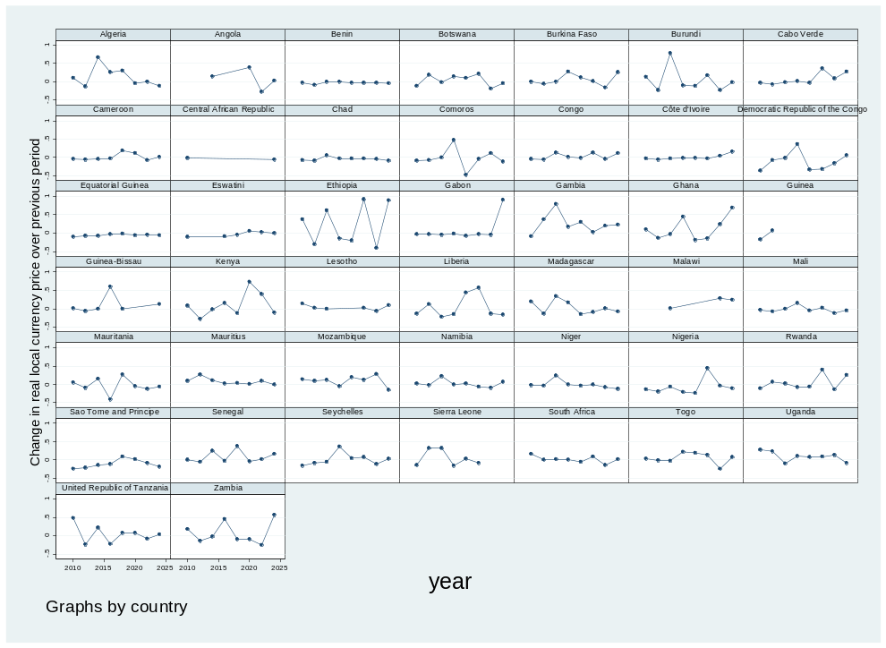
AMRO
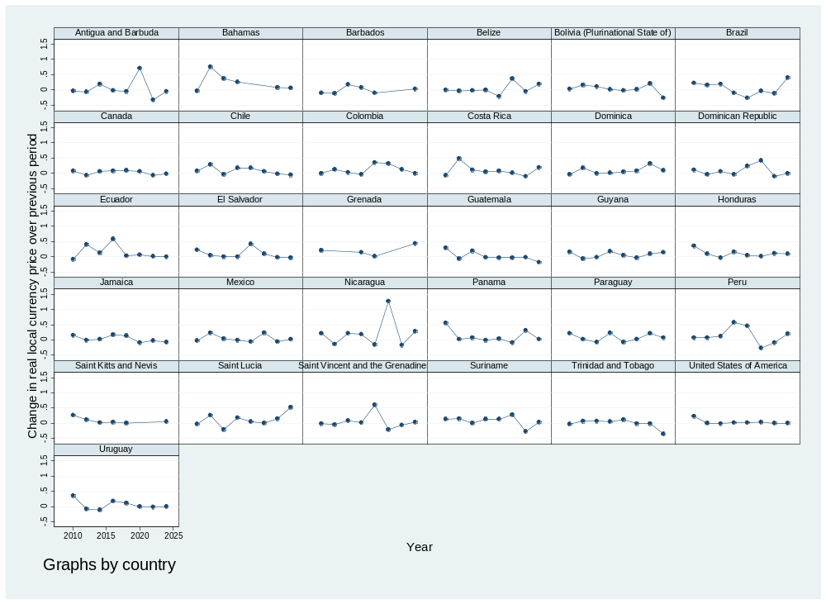
EMRO
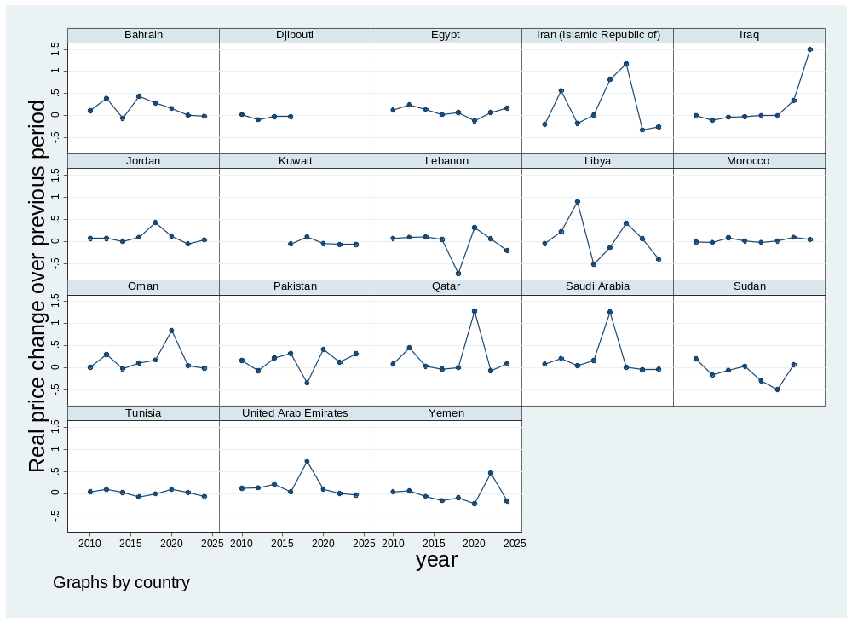
EURO
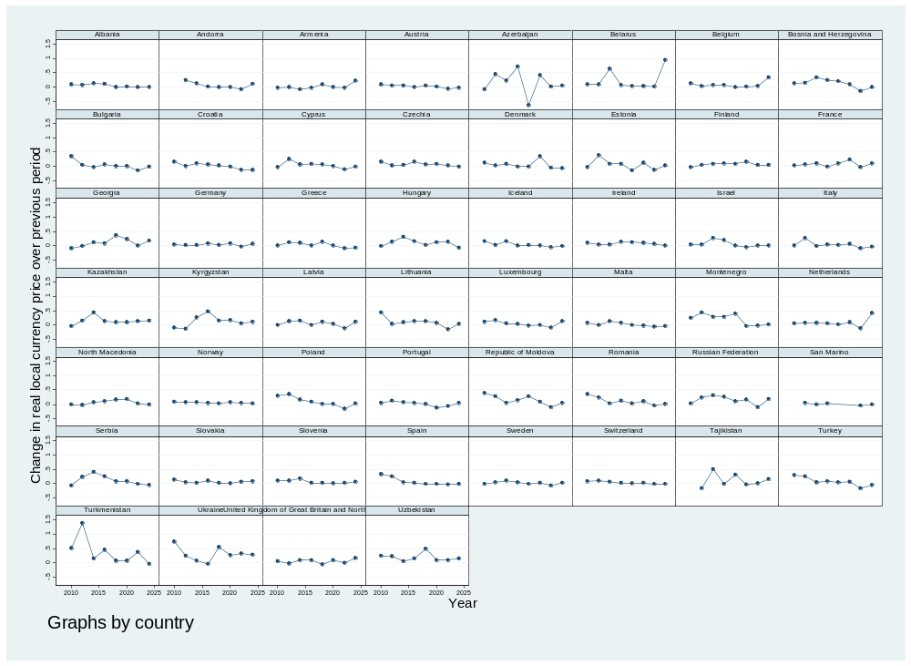

SEARO
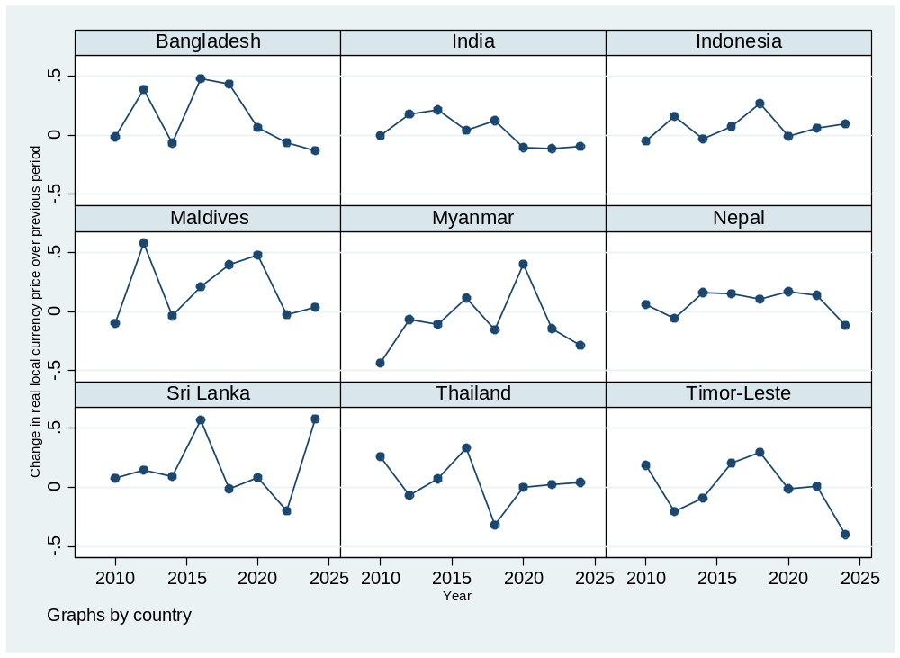
WPRO

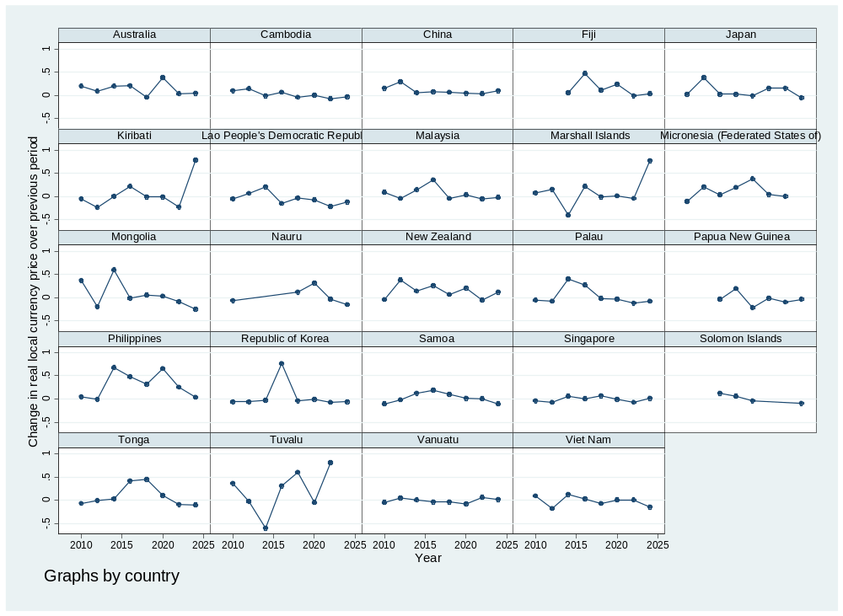

Supplementary Figure F2: Distribution of real price changes over 2- and 10-year lookback period
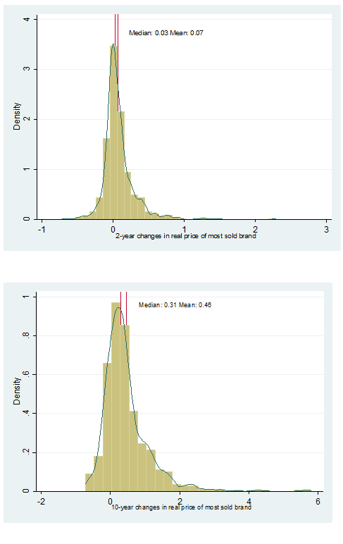

Supplementary Figure F3: Fraction of countries with real prices 20% and 50% higher by price quintile

Note: Quintiles of international dollar price computed in each year. Years 2018-24 included for 10-year lookback, and years 2010-24 included for 2-year lookback. Country counts vary by year, with 33 to 36 countries per quintile in a given year.

