Supplementary figures
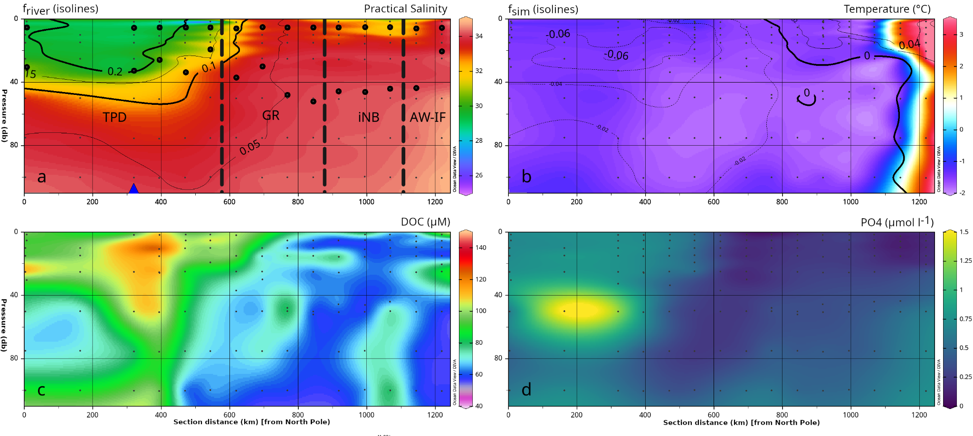
Fig. S1: Physical and hydrochemical conditions along the sampled transect. (a) Practical salinity and fraction of river water, (b) temperature and fraction of sea-ice melt, (c), concentration of dissolved organic carbon (DOC), and (d) phosphate (PO₄). The large black circles in panel (a) indicate locations where samples for microbial metabarcoding analysis were collected, the deeper sample is from the deep chlorophyll maxima (DCM) and thus indicates at what depth the DCM was located at a station. The vertical dashed lines in (a) delineate the four hydrographic regimes TPD, GR, iNB and AW-IF (see Fig. 1 and text). The blue triangle in (a) indicates the location of the vertex along the transect in Fig. 1. Figure created with Ocean Data View (Schlitzer, 2025).

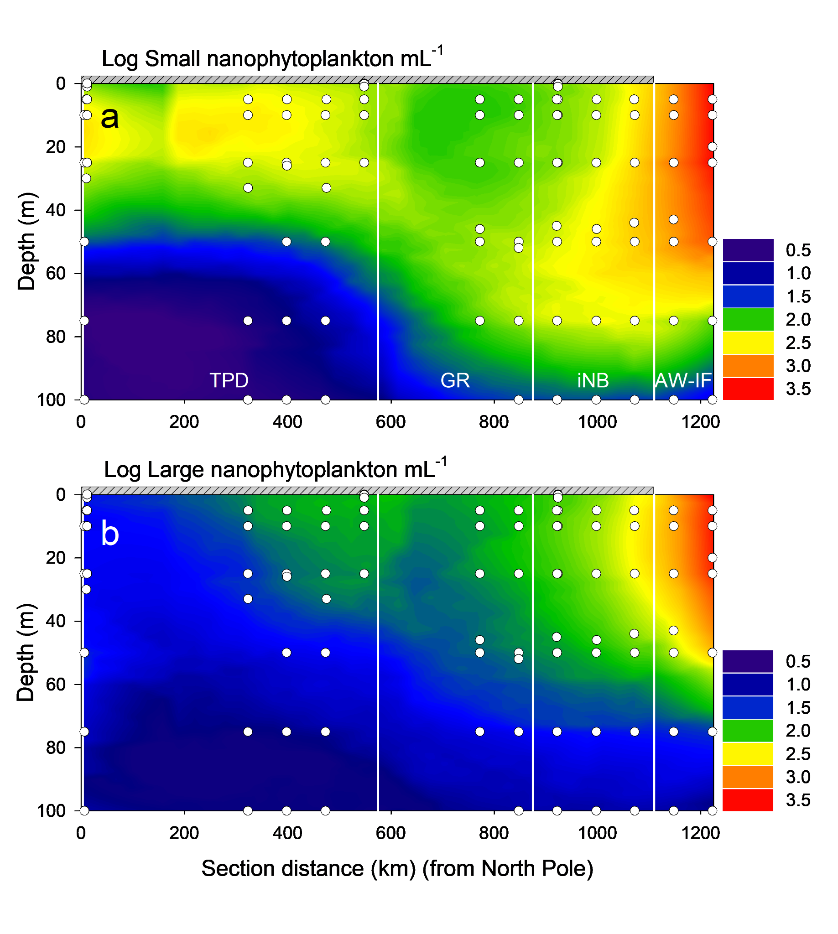
Fig. S2: Abundance of nano-phytoplankton along the transect. Abundance of (a) small and (b) large nano-phytplankton (distinct populations separated based on FCM side scatter signal). White vertical lines delineate the four hydrographic regimes TPD, GR, iNB and AW-IF (see Fig. 1 and text). Contour plots were made using inverse distance for data smoothing. The grey bar at 0-meter indicates ice cover.

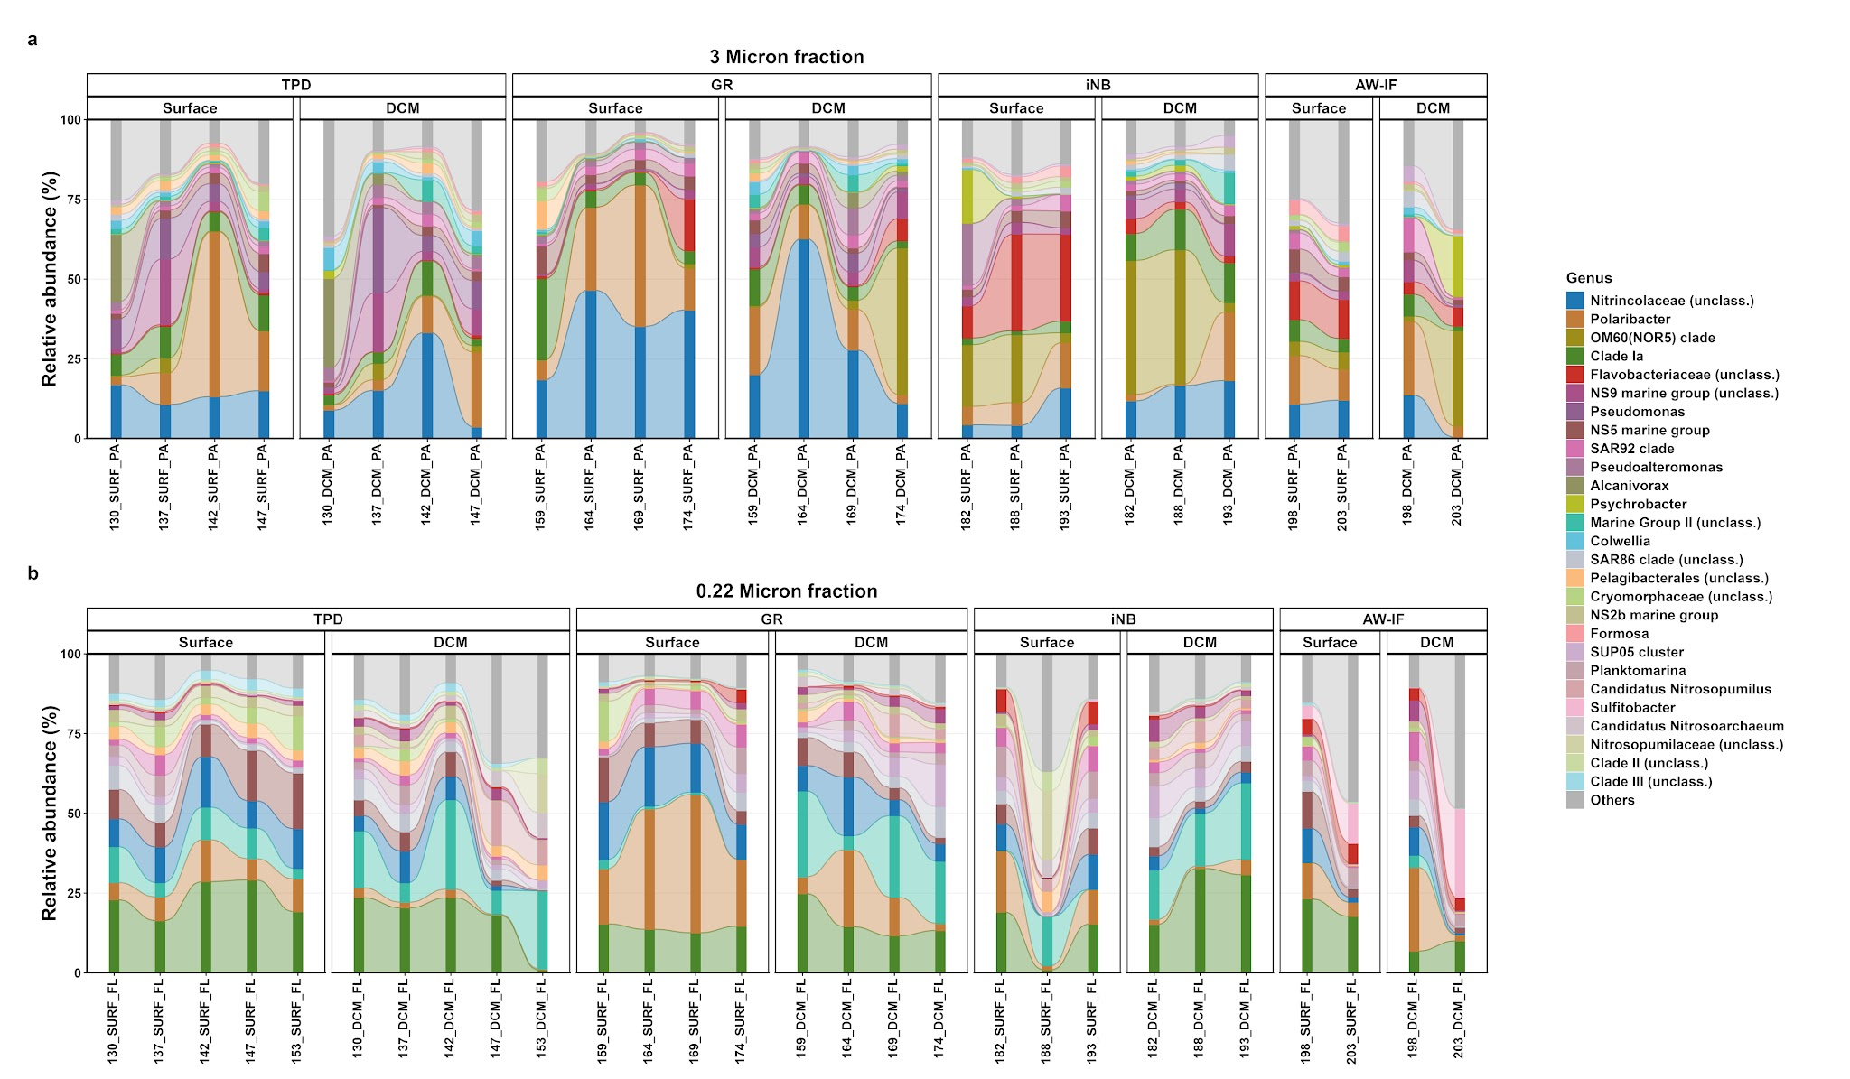

Fig. S3: Prokaryotic community composition showing the relative abundance (%) profiles of top 20 prokaryotic Genera among the size fractionated samples across different hydrographic regimes. (a) 3 Micron fraction and (b) 0.22 Micron fraction.

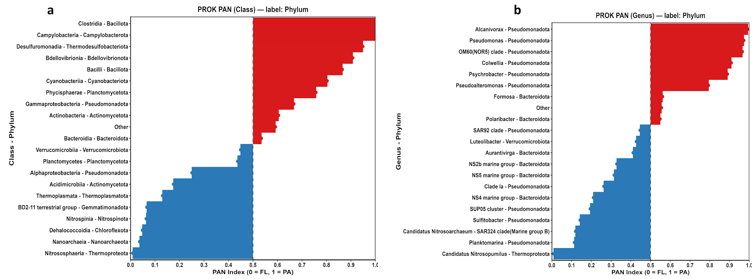
Fig. S4: Particle-association niche (PAN) index of prokaryotic lineages. PAN index distributions for prokaryotic classes (a) and Genera (b) between PA and FL groups. The index quantifies size-fraction preference; values > 0.5 (red bars) indicate enrichment in the particle-attached (PA) fraction, whereas values < 0.5 (blue bars) denote a free-living (FL) association. The vertical dashed line at 0.5 denotes a neutral preference.

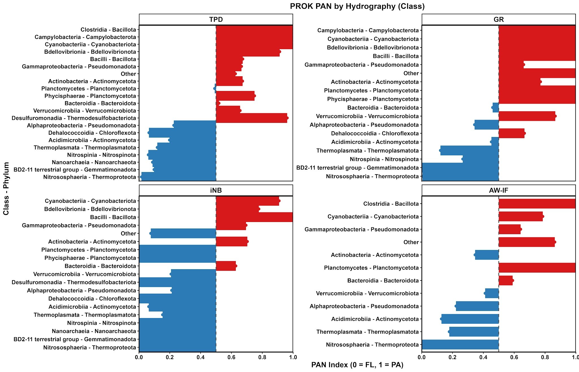
Fig. S5: Particle-association niche (PAN) index of prokaryotic taxon between different hydrographic regimes at class level. The index quantifies size-fraction preference; values > 0.5 (red bars) indicate enrichment in the particle-attached (PA) fraction, whereas values < 0.5 (blue bars) denote a free-living (FL) association. The vertical dashed line at 0.5 denotes a neutral preference.

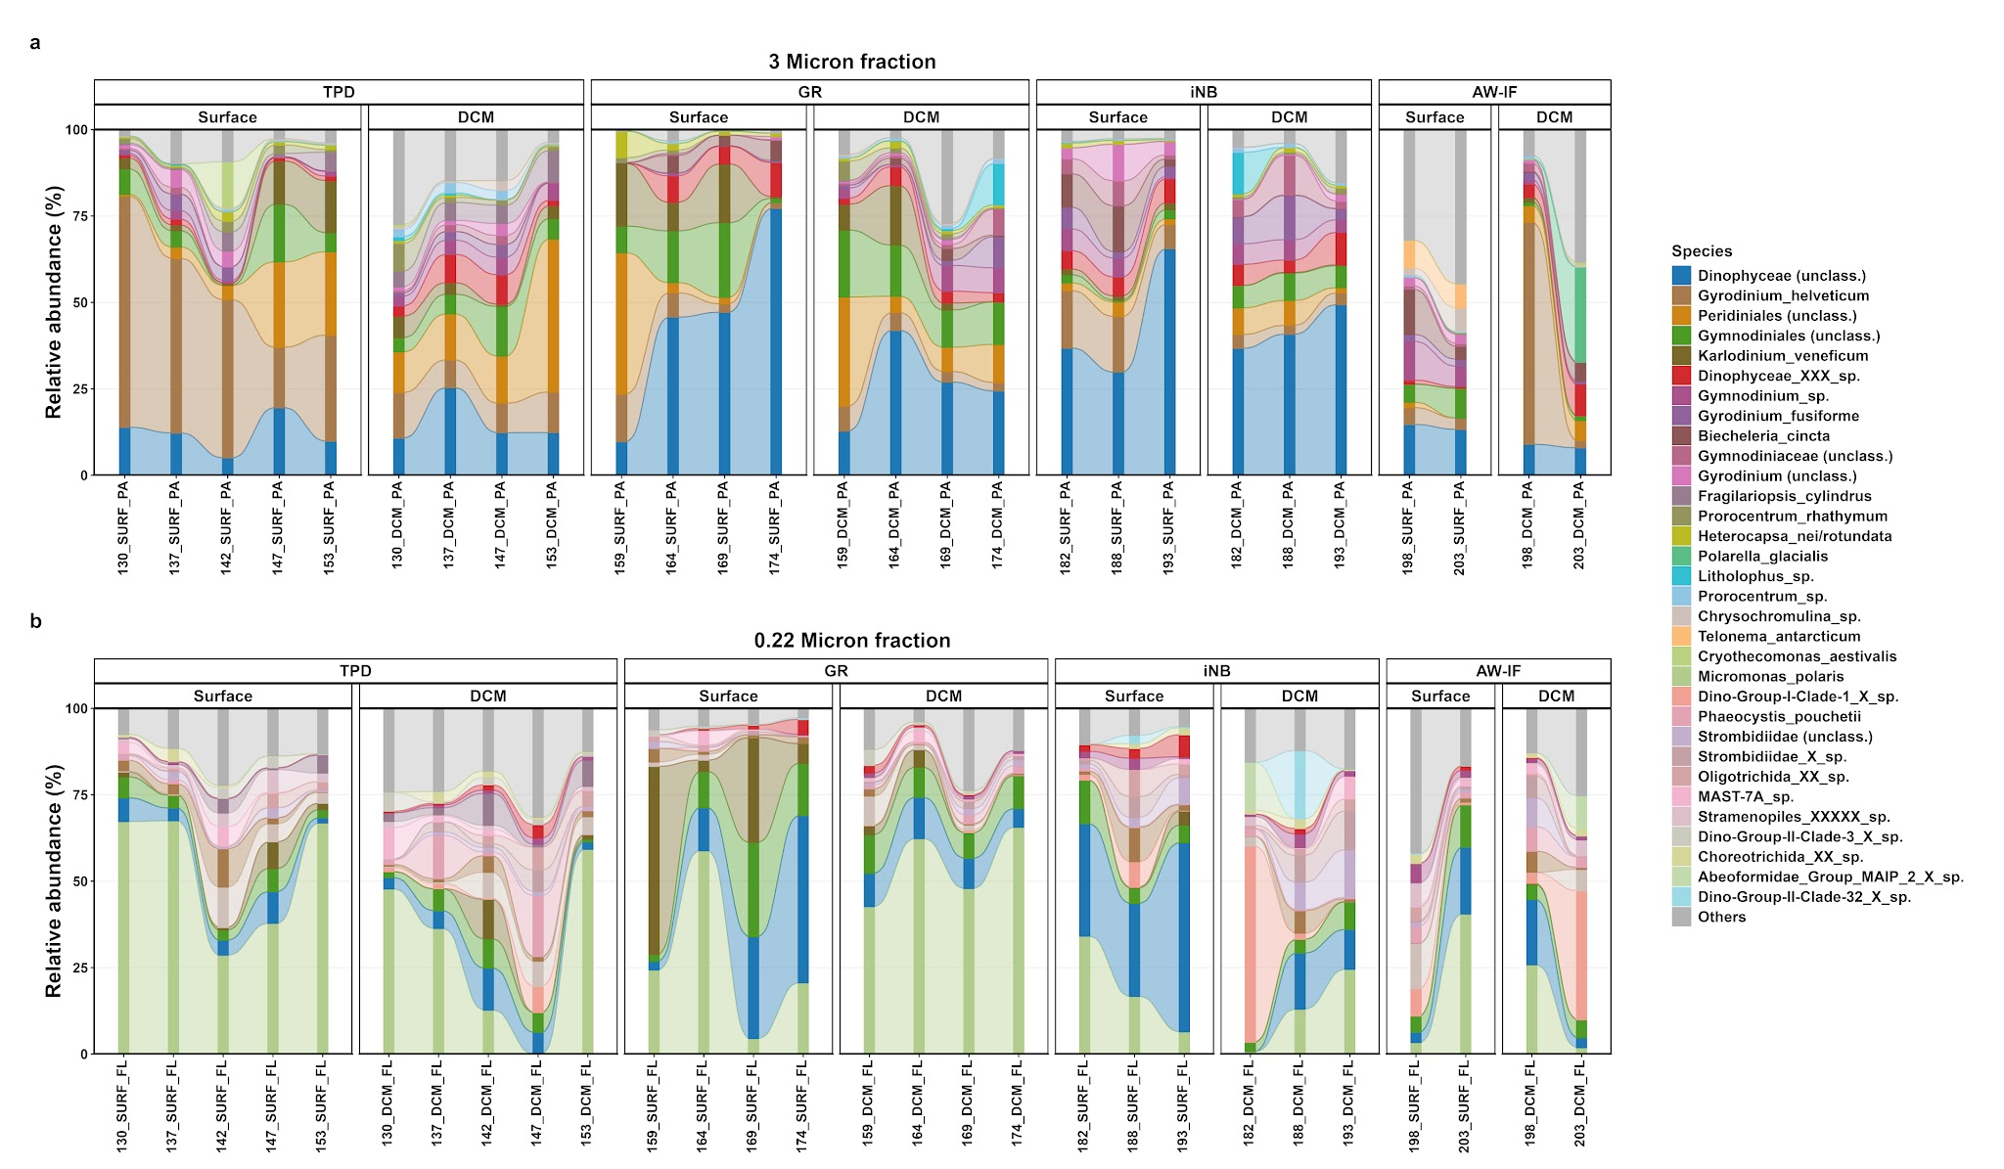
Fig. S6: Eukaryotic community composition showing the relative abundance (%) profiles of top 20 species among the size fractionated samples across different hydrographic regimes. (a) 3 micron fraction and (b) 0.22 micron fraction.

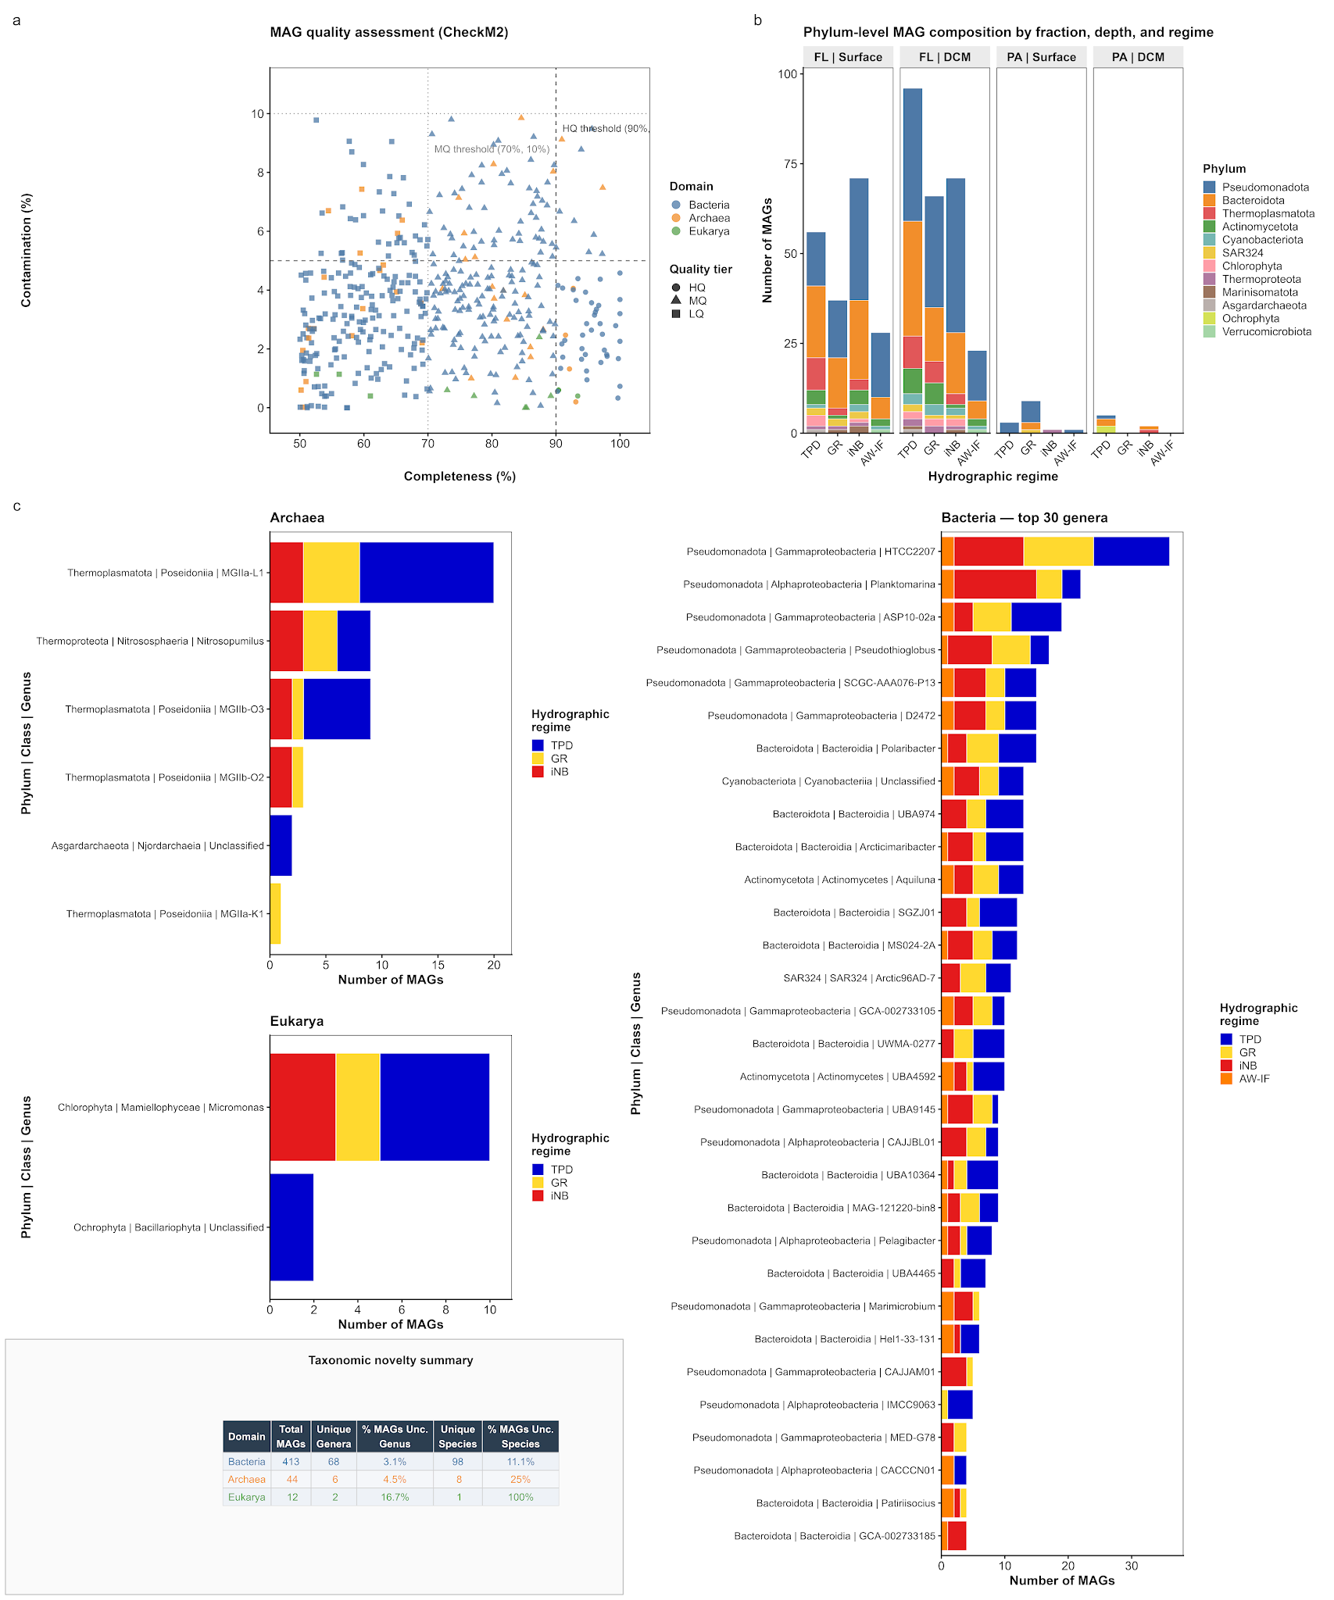

Fig. S7: MAG quality, taxonomic composition, and lineage diversity across different hydrographic regimes in the Central Arctic Ocean. (a), Scatter plot showing the completeness versus contamination statistics for the reconstructed MAGs (n= 469). Points represent individual MAGs coloured by domain and shaped by quality tier. Dashed and dotted lines denote high-quality (HQ; ≥90% completeness, ≤5% contamination), medium-quality (MQ; ≥70%, ≤10%) and low-quality (LQ; ≥50% - ≤70% , ≤10%) thresholds, respectively. (b) Recovery of total MAGs across hydrographic regimes (TPD, GR, iNB, AW-IF), stratified by size fraction [ Free-living (FL), Particle-attached (PA) and depth (Surface; DCM) at Phylum-level. (c) Taxonomic distribution of MAGs at Genus level among different domains including Archaea (n=44), Eukarya (n=12), and Bacteria (n=413), coloured by hydrographic regime. The embedded table summarizes taxonomic novelty, highlighting the percentage of reconstructed MAGs lacking genus- or species-level classification against the GtDBtK reference database.

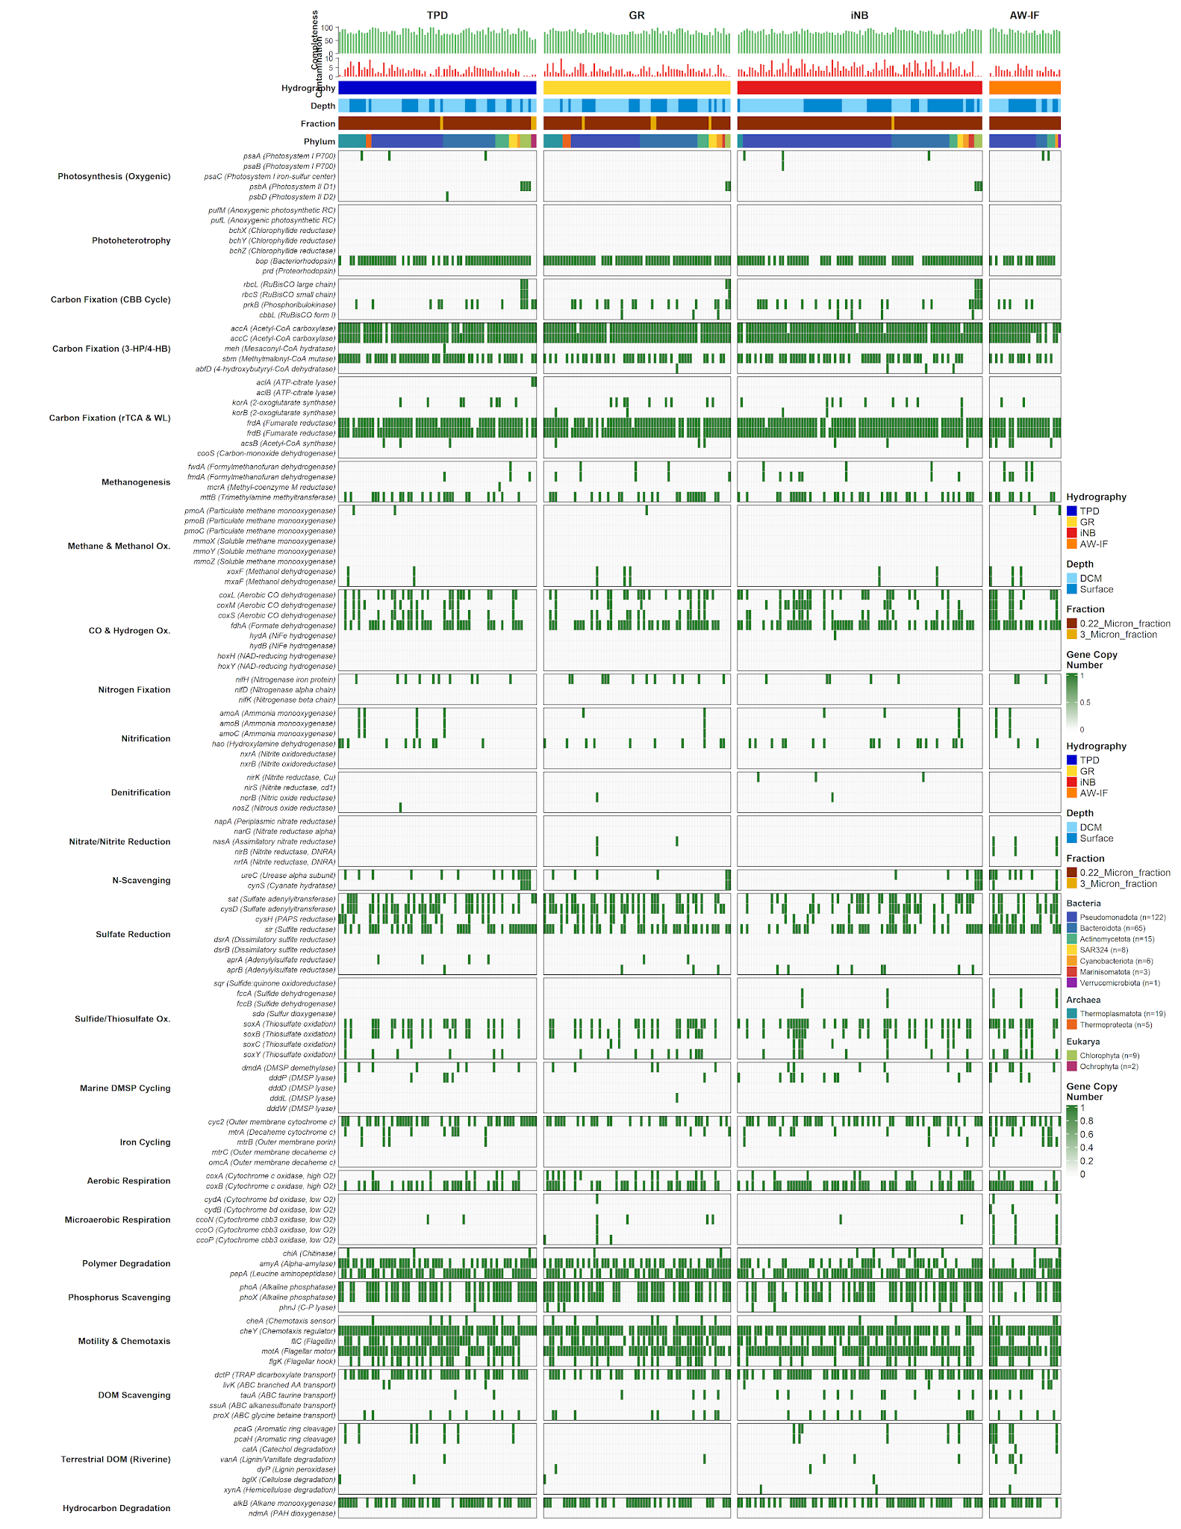
Fig. S8: Biogeochemical metabolic potential and differential abundance across Arctic Ocean hydrographic regimes. Heatmap displays the gene copy number (white to dark green) of key metabolic marker genes (n=118), Metagenome-Assembled Genomes (MAGs). Columns (MAGs) are grouped by hydrographic regime (TPD, GR, iNB, AW-IF) and ordered by phylum dominance. Top annotations indicate MAG quality (CheckM2 completeness and contamination) and environmental origin (Depth, size fraction).

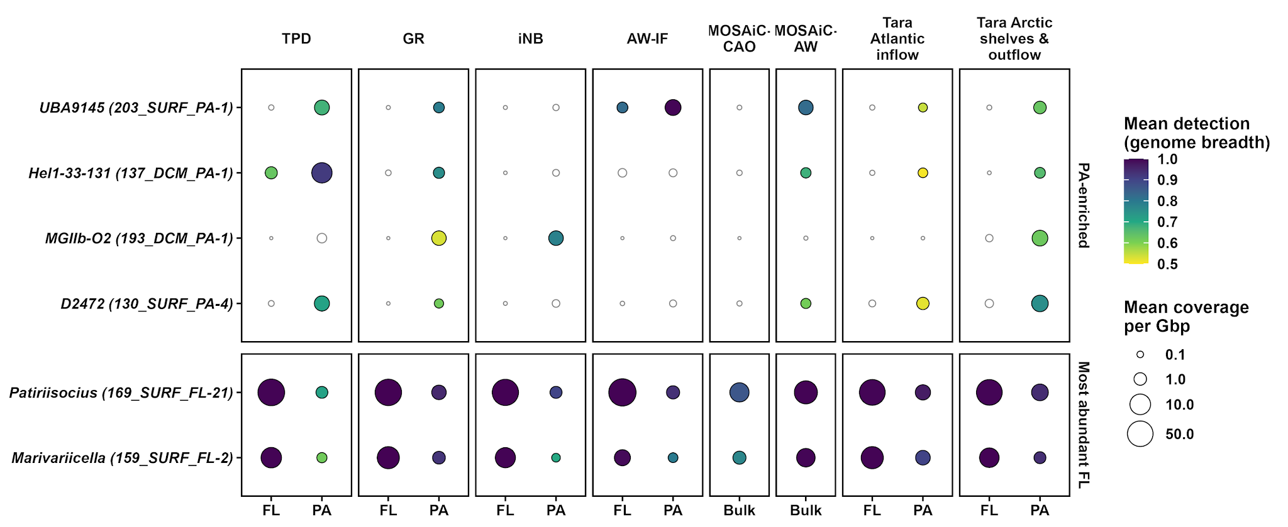
Fig. S9: Bubble plot showing the distribution of particle-attached and free-living sMAGs across the Arctic Ocean. Mean detection and coverage of selected sMAGs in free-living (FL, 0.22–3 µm), particle-attached (PA, >3 µm) and bulk seawater samples across different hydrographic regime (TPD, GR, iNB, AW-IF), Tara Arctic Oceans region (Atlantic inflow; Arctic shelves and outflow) and MOSAiC groups (MOSAiC-CAO, MOSAiC-AW). The two sMAGs with the highest mean coverage across FL samples are shown for comparison. Circle size shows mean coverage per Gbp of quality-filtered sequence (log scale), and fill shows mean detection (genome breadth). Open circles mark mean detection below 0.5.

