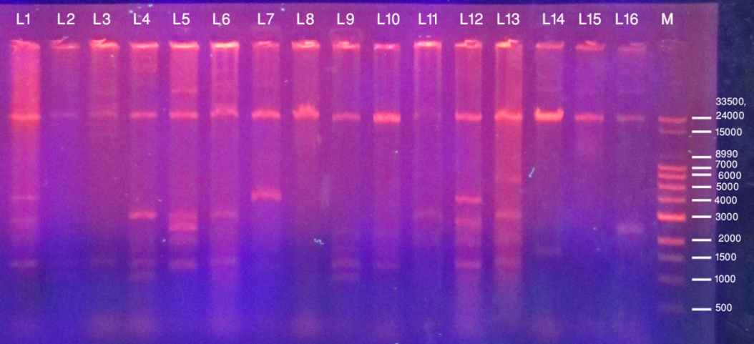
Lane1-16: Plasmid DNA of clinical isolates of MDR E. coli, M (Marker)- 33.5 Kb DNA Ladder
Photograph 5: Separation of plasmid DNA molecular weight on agarose gel stained with ethidium bromide.

