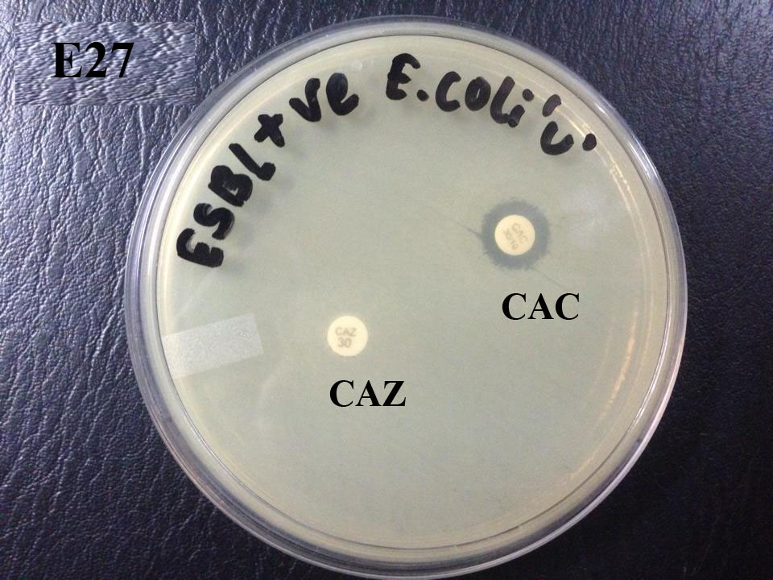

CAZ- Ceftazidime, CAC- Ceftazidime +Clavulanic Acid
Photograph 1 ESBL positive MDR E. coli isolate

