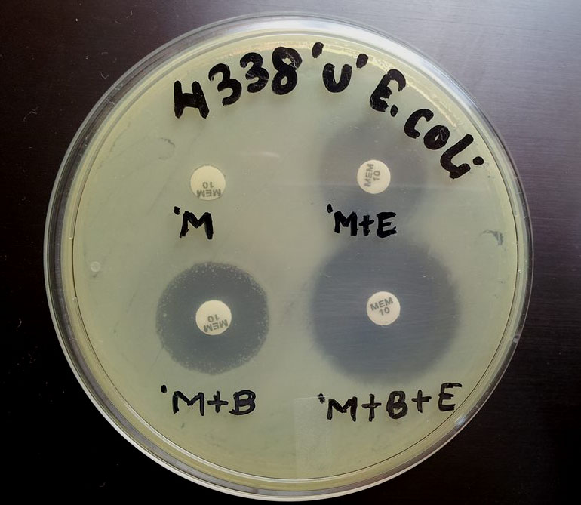
M-Meropenem, B- Boronic acid, E- EDTA
Photograph 4: MBL and KPC positive MDR E. coli isolate

