Table of Contents
eMethods
Section a1 Details of literature searching 3
Keywords 3
Study selection criteria 4
Section a2 Signaling questions for quality assessments 5
Risk of bias 5
Applicability 5
Section a3 Brief review of the data synthesis models used in this study 6
Hierarchical arm-based model for Network meta-analysis 6
Arm-based Model 6
Network meta-regression model 7
eResults
eFigures
eFigure 1. Optimal cutoff evaluation of biomarkers other than presepsin and PCT. 9
eFigure 2. Heatmaps for the diagnostic accuracies of included studies. 11
eFigure 3. Deek’s funnel plots for publication bias. 12
eFigure 4. Baujat’s plots. 15
eFigure 5. Funnel plots after adjustment of influence analyses. 17
eFigure 6. Diagnostic plots (Forest, diagnostic posterior density, and time-series plots) for each parameter in the hierarchical arm-based model for Markov Chain Monte Carlo (MCMC) process. 19
eFigure 7. Forest plots for the results of variable selection from univariable network meta-regressions. 25
eFigure 8. Forest plots for the results from multivariable network meta-regressions. 29
eFigure 9. Schematic for the node-splitting model. 31
eTables
eTable 1. characteristics of included studies. 32
eTable 2. Detailed characteristics of included studies. 33
eTable 3. Detailed diagnostic accuracies of included studies. 42
eTable 4. Cohen’s Kappa statistics of quality assessment. 52
eTable 5. Detailed quality assessment of included studies. 53
eTable 6. Tests of inconsistency using the node splitting model. 58
eTable 7. Statistics for heterogeneity. 60
eTable 8. Comparisons of the results between conventional and network meta-analysis……………………………………………………………..………………………………………61
eTable 9. The results of sensitivity analyses after non-full text abstract and the outliers removed…………………………………………………………………………………………………….62
eTable 10. Results of influence analyses. 63
eTable 11. The results of subgroup analyses considered published year. 64
eTable 12. The results of subgroup analyses considered sepsis proportion. 65
eTable 13. The results of subgroup analyses considered the risk assessment by QUADAS-2. 66
eTable 14. Brief review of meta-analyses for biomarkers of sepsis. 67
eReferences 70

Section a1 – Details of literature searching
- Keywords
- On PubMed (filter: "adult only"):
- For presepsin: ("Presepsin" OR "soluble CD14 subtype" OR "sCD14") AND "diagnosis" AND ("sepsis" OR "systemic inflammatory response syndrome" OR "SIRS") NOT ("review" OR "letter" OR "editorial" OR "abstract" OR "meta-analysis" OR "case report")
- For PCT: ("Procalcitonin" OR "PCT") AND "diagnosis" AND ("sepsis" OR "systemic inflammatory response syndrome" OR "SIRS") NOT ("review" OR "letter" OR "editorial" OR "abstract" OR "meta-analysis" OR "case report")
- For CRP: ("C-reactive protein" OR "CRP") AND "diagnosis" AND ("sepsis" OR "systemic inflammatory response syndrome" OR "SIRS") NOT ("review" OR "letter" OR "editorial" OR "abstract" OR "meta-analysis" OR "case report")
- For IL-6: ("Interleukin-6" OR "IL-6") AND "diagnosis" AND ("sepsis" OR "systemic inflammatory response syndrome" OR "SIRS") NOT ("review" OR "letter" OR "editorial" OR "abstract" OR "meta-analysis" OR "case report")
- For sTREM-1: ("soluble triggering receptor expressed on myeloid cells-1" OR "sTREM-1") AND "diagnosis" AND ("sepsis" OR "systemic inflammatory response syndrome" OR "SIRS") NOT ("review" OR "letter" OR "editorial" OR "abstract" OR "meta-analysis" OR "case report")
- For CD64: "CD64" AND "diagnosis" AND ("sepsis" OR "systemic inflammatory response syndrome" OR "SIRS") NOT ("review" OR "letter" OR "editorial" OR "abstract" OR "meta-analysis" OR "case report")
- For LBP: ("lipopolysaccharide-binding protein" OR "LBP") AND "diagnosis" AND ("sepsis" OR "systemic inflammatory response syndrome" OR "SIRS") NOT ("review" OR "letter" OR "editorial" OR "abstract" OR "meta-analysis" OR "case report")
- On EMBASE:
- For presepsin: ("Presepsin" or "presepsin" or "sCD14-ST" or "sCD14") and "diagnosis" and "sepsis" and "adult" not "review" not "meta-analysis" not "conference"
- For PCT: ("Procalcitonin" or "procalcitonin" or "PCT") and "diagnosis" and "sepsis" and "adult" not "review" not "meta-analysis" not "conference"
- For CRP: ("C-reactive protein" or "CRP") and "diagnosis" and "sepsis" and "adult" not "review" not "meta-analysis" not "conference"
- For IL-6: ("Interleukin-6" or "IL-6") and "diagnosis" and "sepsis" and "adult" not "review" not "meta-analysis" not "conference"
- For sTREM-1: ("soluble triggering receptor expressed on myeloid cells-1" or "sTREM-1") and "diagnosis" and "sepsis" and "adult" not "review" not "meta-analysis" not "conference"
- For CD64: "CD64" and "diagnosis" and "sepsis" and "adult" not "review" not "meta-analysis" not "conference"
- For LBP: ("LPS-binding protein" or "LBP") and "diagnosis" and "sepsis" and "adult" not "review" not "meta-analysis" not "conference"
- On Scopus:
- For presepsin: ("Presepsin" or "presepsin" or "sCD14-ST" or "sCD14") and "diagnosis" and "sepsis" and "adult"
- For PCT: ("Procalcitonin" or "procalcitonin" or "PCT") and "diagnosis" and "sepsis" and "adult"
- For CRP: ("C-reactive protein" or "CRP") and "diagnosis" and "sepsis" and "adult"
- For IL-6: ("Interleukin-6" or "IL-6") and "diagnosis" and "sepsis" and "adult"
- For sTREM-1: ("soluble triggering receptor expressed on myeloid cells-1" or "sTREM-1") and "diagnosis" and "sepsis" and "adult"
- For CD64: "CD64" and "diagnosis" and "sepsis" and "adult"
- For LBP: ("LPS-binding protein" or "LBP") and "diagnosis" and "sepsis" and "adult"
- Study selection criteria
- Inclusion criteria
- original articles
- containing diagnostic accuracy assessments of sepsis
- adult patients (i.e., ≥18 years old)
- Exclusion criteria
- irrelevant to sepsis, which was defined as:
- Sepsis-1;
- Sepsis-3;
- Severe sepsis
- non-diagnostic studies
- non-original articles
- duplicated searched results
- lack of necessary parameters for diagnostic accuracy assessments
- (proportion of patients with sepsis AND ((sensitivity AND specificity) OR (PPV AND NPV))) OR (2 x 2 contingency tables)
- patients with burns
- Our question is to study the diagnostic performance of biomarkers in differentiating infectious from non-infectious SIRS. However, no matter infected or not, patients with burn could have SIRS, which made it difficult to confirm the association of SIRS with infection. For burn patients specifically, there was the established guideline to distinguish infection by the American Burn Association (ABA).
- Using only non-systemic inflammatory response syndrome (SIRS) patients as a reference group.

Section a2 Signaling questions for quality assessments
- Risk of bias
- Is the study a case/control study by design? If “yes”, consider “high risk.”
- Patient selection
- Were patients retrospectively included? If “yes”, consider “high risk.”
- Is there a clear statement of a random selection of study participants? If “no”, consider “high risk.”
- Are there any self-determined patient-exclusion criteria (other than the previous use of antibiotics)? If “yes”, consider “unclear.”
- Index tests
- Is there the use of post-hoc cutoff? If “yes”, consider “high risk.”
- Reference standard
- Is the reference standard likely to correctly classify Sepsis 3.0 or Sepsis 1.0/2.0? If “no”, consider “high risk.”
- Flow and Timing
- Is there a clear statement of random selection? If “no”, consider “high risk.”
- Did all patients receive the reference standard?
- Did all patients receive the SAME reference standard?
- Did all patients be included in the analysis?
- Applicability
- Patient selection
- Is there inclusion of non-SIRS patients as a reference? If “yes”, consider “high risk.”
- Index tests
- Were the test results interpreted without knowledge of reference standard? If “yes”, consider “high risk.”
- Reference standard
- Was the reference standard interpreted without knowledge of biomarkers? If “yes”, consider “high risk.”
- Others: Is there any study providing diagnostic performance report but only have abstract without full text accessible? If “yes”, consider all domains “unclear.”

Section a3 ANOVA model for network meta-analysis
- Hierarchical arm-based (AB) model for network meta-analysis [10]
- Background
Meta-analysis is a statistical method that combines the different research results from the same clinical problem by two traditional models, namely, fixed-effect and random-effects models. The model, called the arm-based (AB) model, was utilised the classical two-way ANOVA model with random-effects for study and a fixed-effect for tests. The AB model was based on the assumption that the missing arms or tests are missing at random. In order to realize the network meta-analysis of diagnostic tests, Nyaga VN [10] was proposed an hierarchical AB model with extending both from the bivariate model [2] and the previous AB model by: (1) describing the distribution of diseased and healthy individuals by two binomial distributions, and (2) including a correlation between sensitivity and specificity with a shared study effects. Generally speaking, they expressed the logit-transformed sensitivity and specificity and the inherent correlation between sensitivity and specificity by the sum of fixed effects for the test and the correlated study-effects in the AB model, respectively. In the AB model, we can also evaluate the random error associated with various tests in a given study. Compared to the conventional bivariate models, the feature of great importance was the simultaneous modelling of within- and between-study variation across tests. Therefore, easily quantified credible intervals were allowed for the relative accuracies between biomarkers.
- Model
Assume that there are K tests and I studies. For a specific test in the study ,
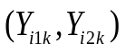: the true positives and true negatives.
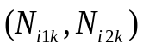: the diseased and healthy individuals.
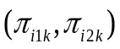: the “unobserved” sensitivity and specificity.
Two independent binomial distributions among the diseased and the healthy individuals were assumed under study-specific sensitivity and specificity as follows
where 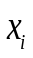 denotes one or more covariates which possibly affecting 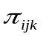.
- Arm-based model:

Where 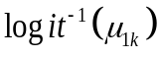 and 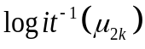 are the mean sensitivity and specificity in a hypothetical study without random effect, is the study effect representing the deviation of a study from the mean sensitivity or specificity, and is the sampling error associated with the sensitivity or specificity of the test in the study. The between-study variability is modelled by 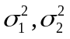 and in a variance-covariance matrix format. Also, 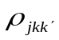 equals to 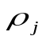, which represents the intra-study correlation coefficient. This coefficient contains information of , the variances across tests, and accounts for the between-study variability simultaneously.

- Network meta-regression model:
Extended the arm-based model as follows

where 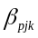 is the 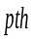 coefficient corresponding to the 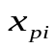 covariate in a hypothetical study with random effects equal to zero.

- Implementation
- Software: Stan language called by rStan package of R
- Model code (model_abnma.txt)
eFigure 1. Optimal cutoff evaluation of biomarkers.
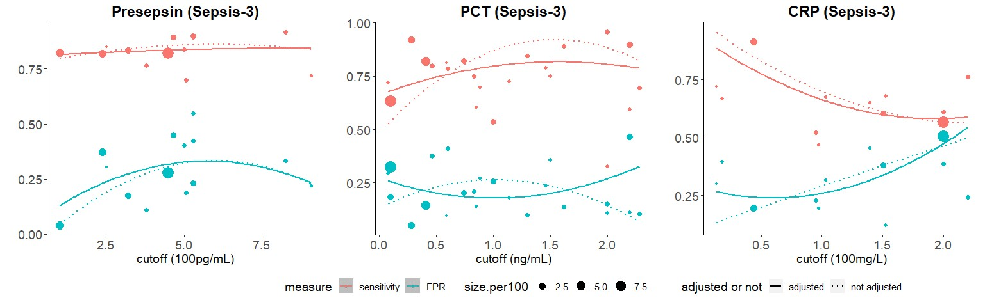

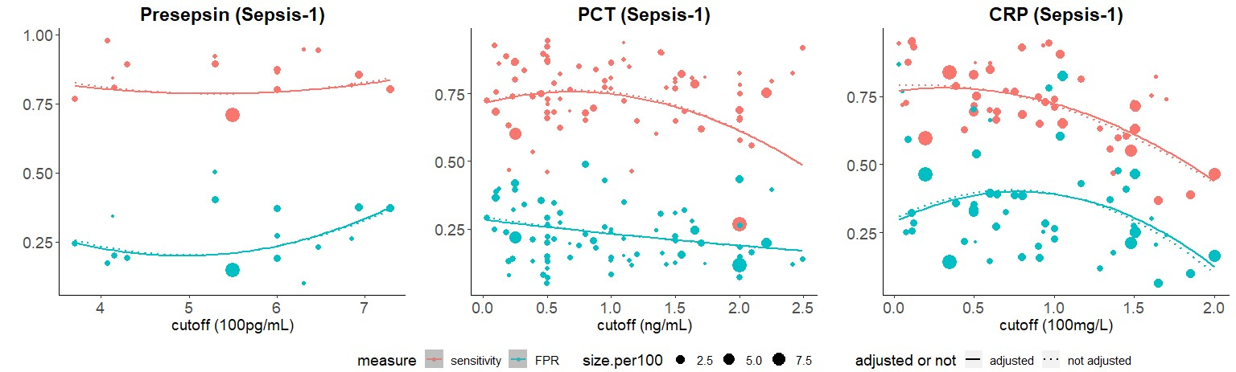
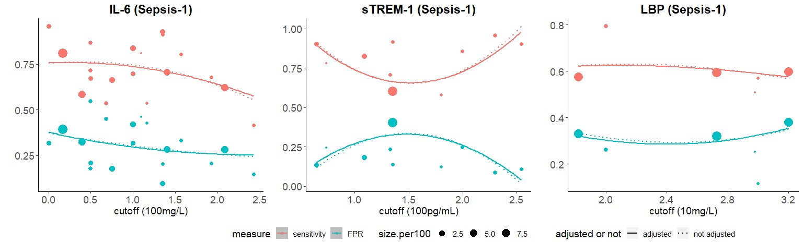

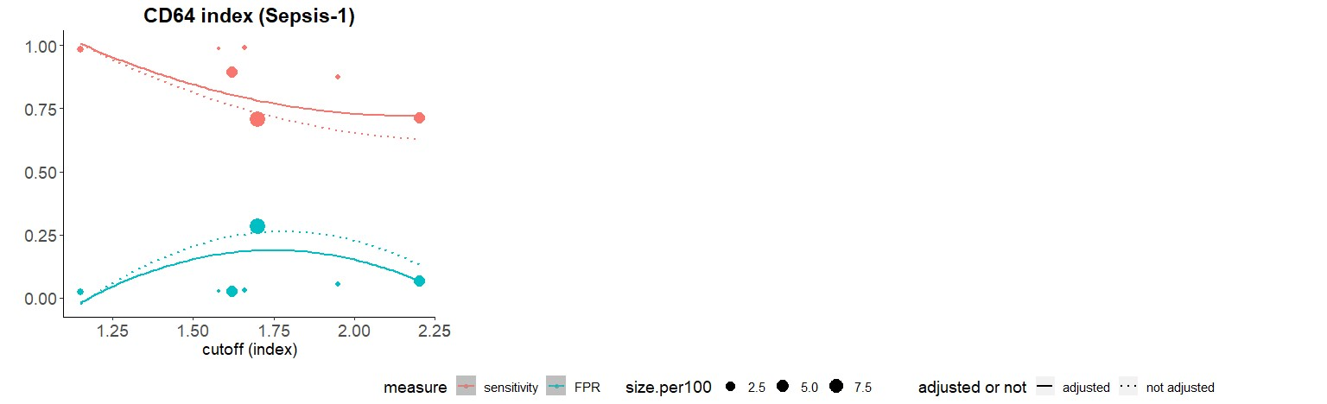

eFigure 2. Heatmaps for the diagnostic accuracies of included studies.

eFigure 3. Deeks’ funnel plot for publication bias.
Sepsis-3
Presepsin | PCT
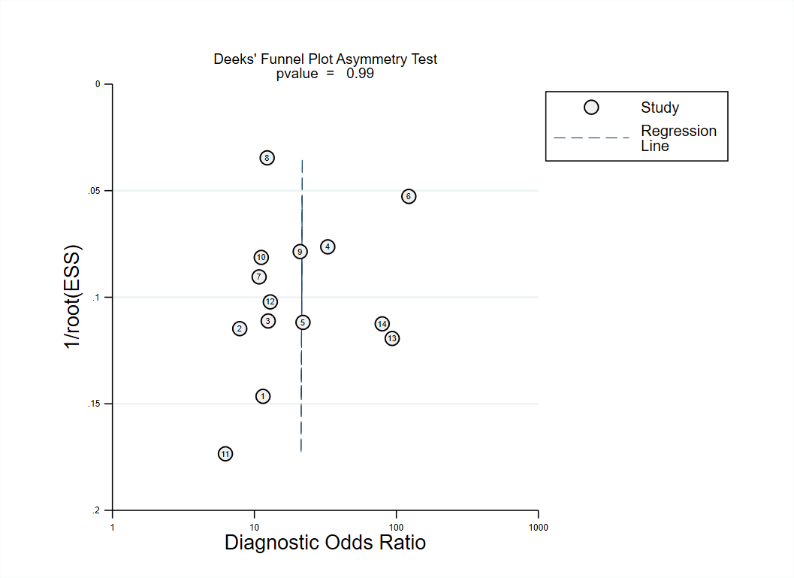 | 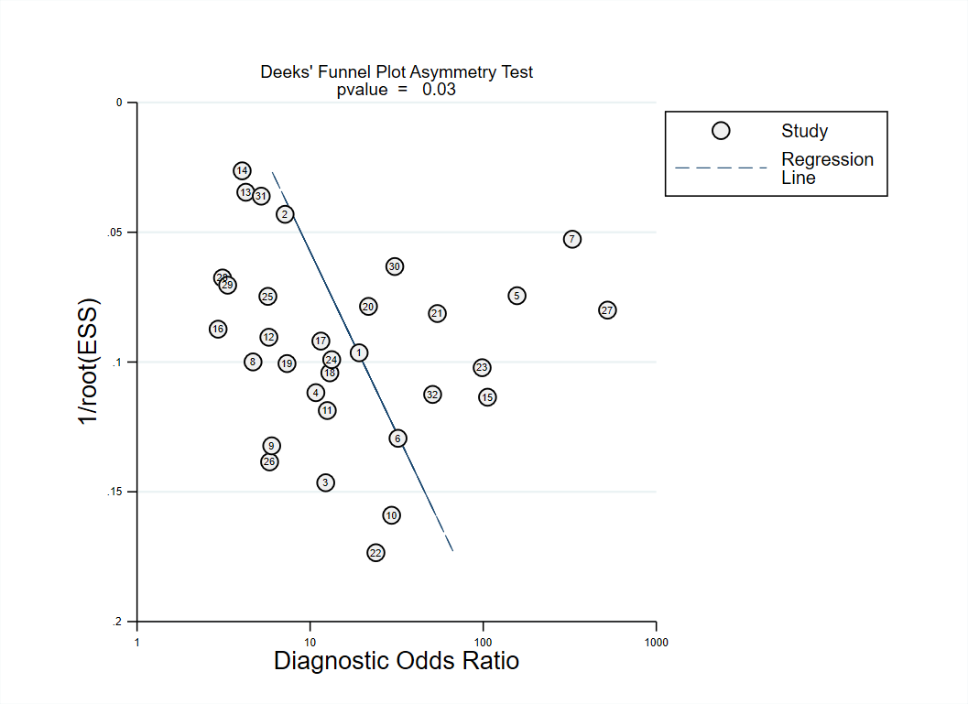
CRP | IL-6
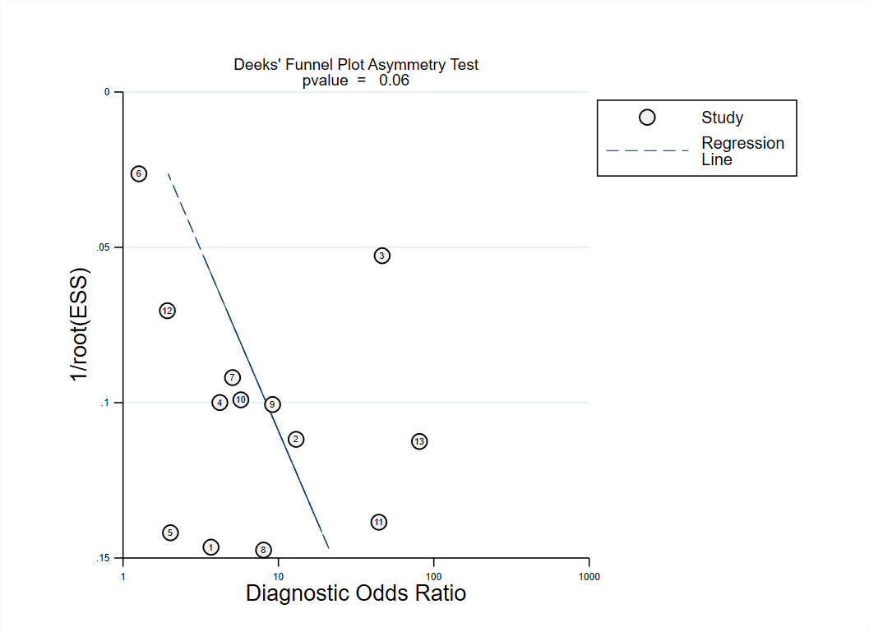 | 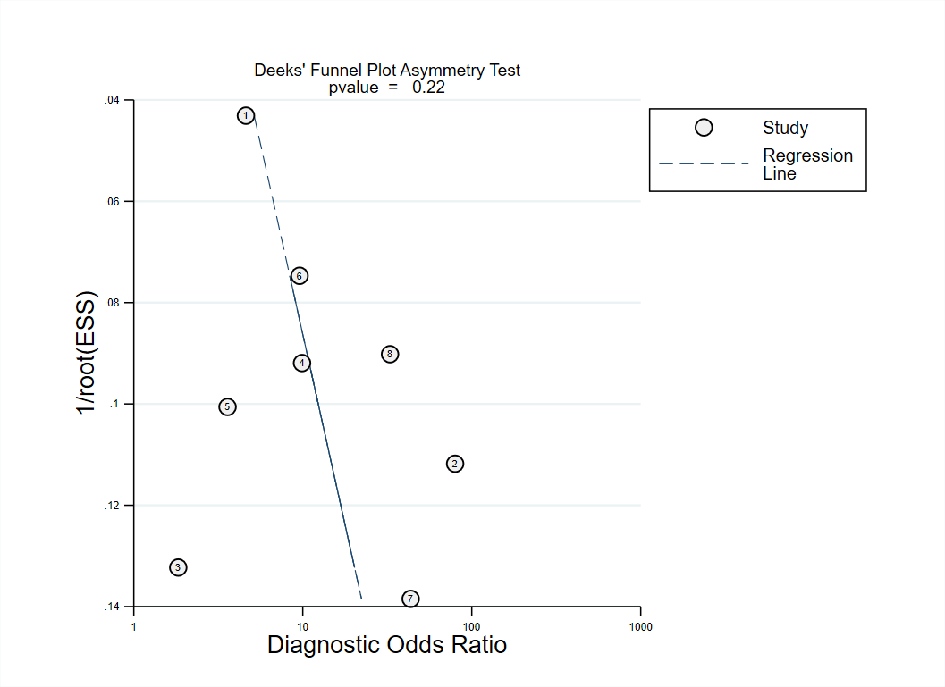
Sepsis-1
Presepsin | PCT
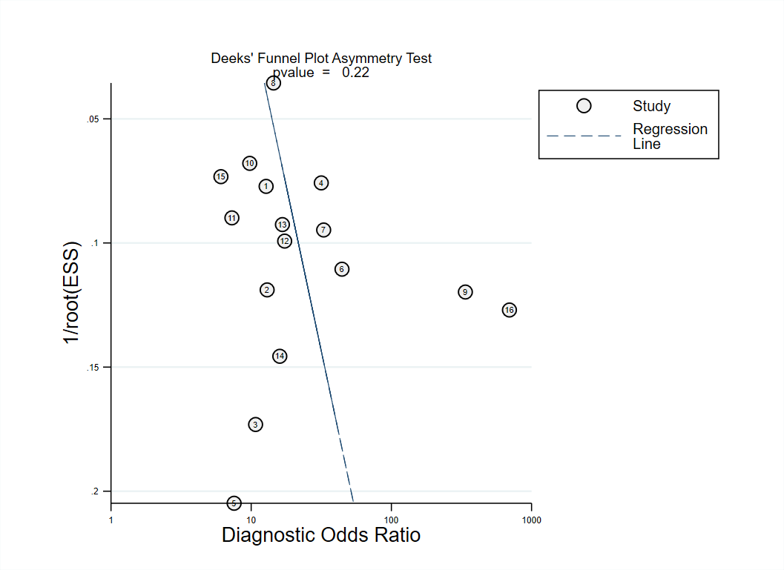 | 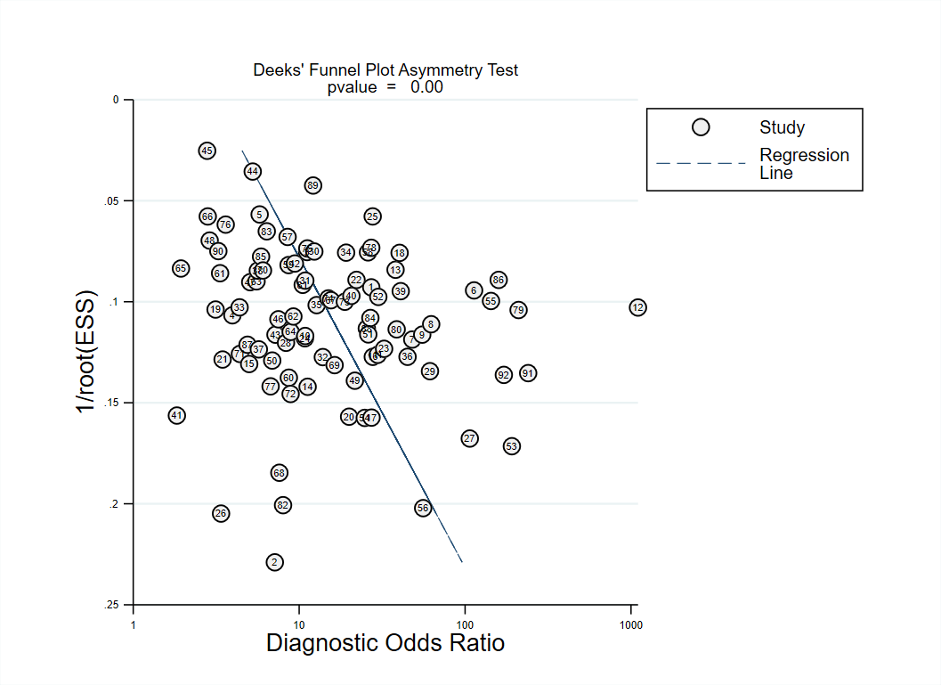
CRP | IL-6
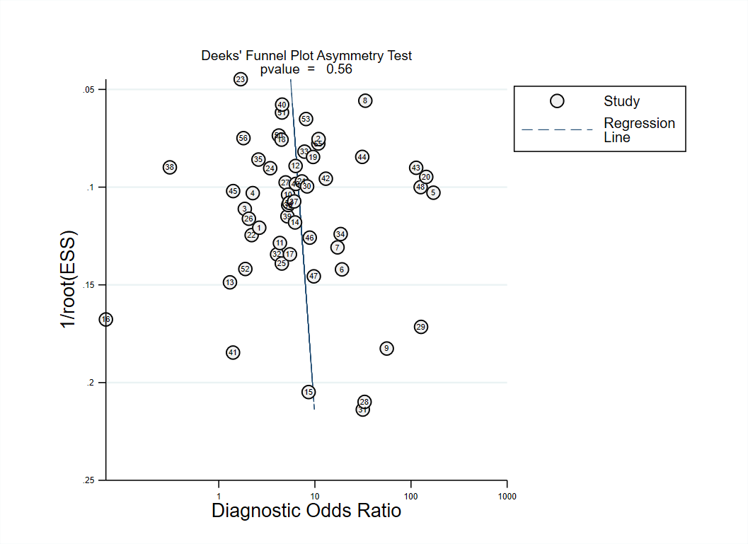 | 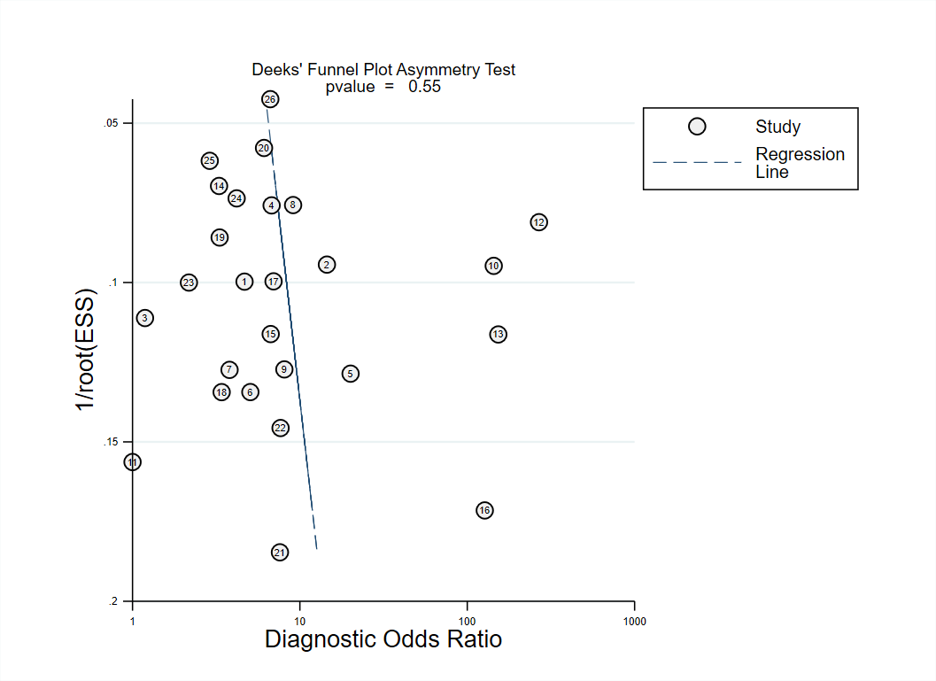

sTREM-1 | CD64
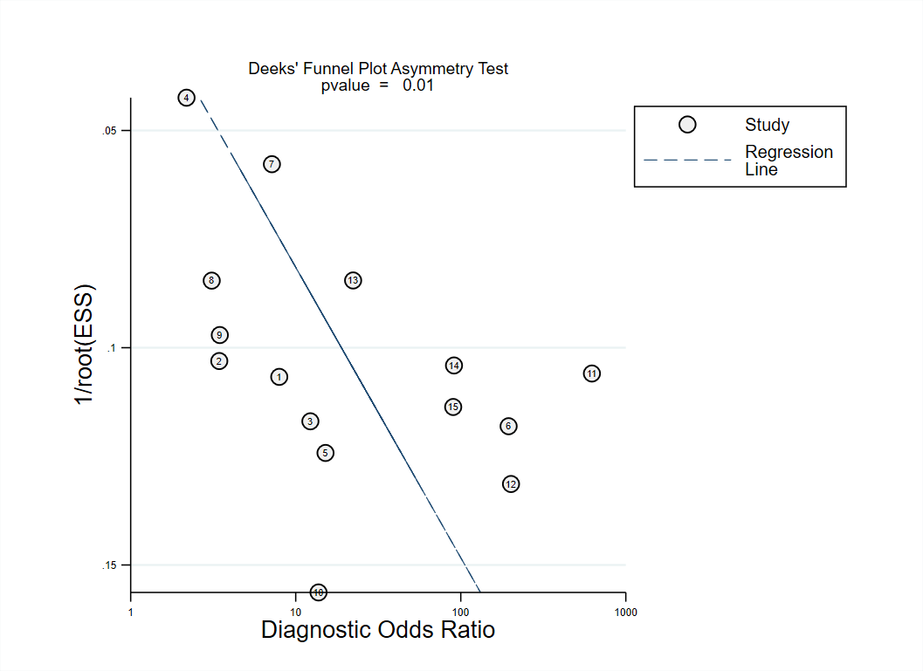 | 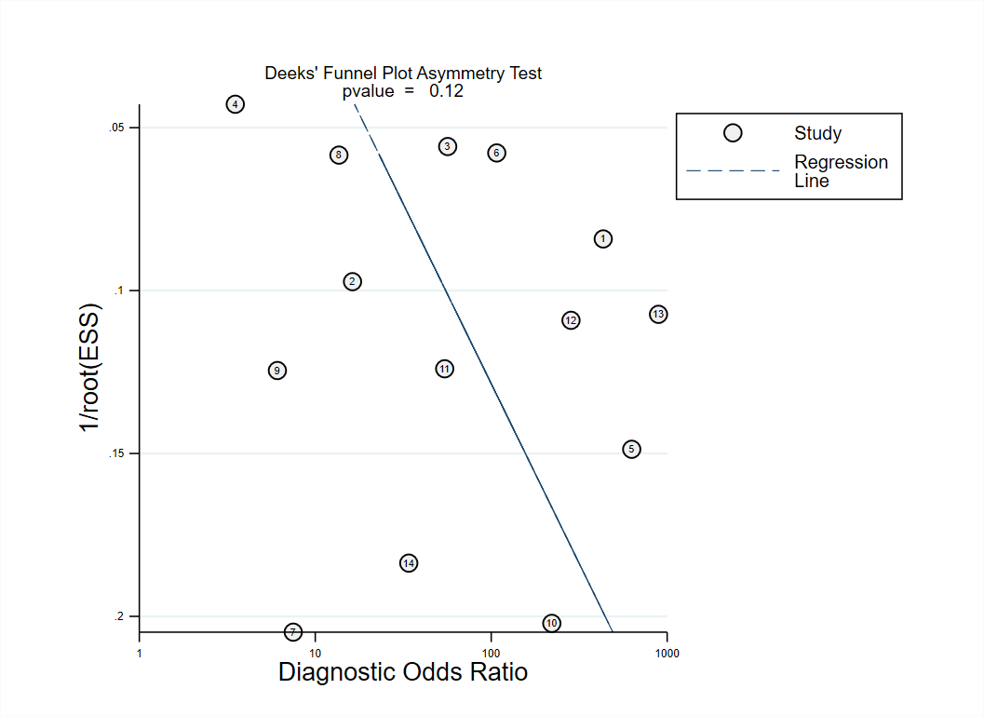
LBP
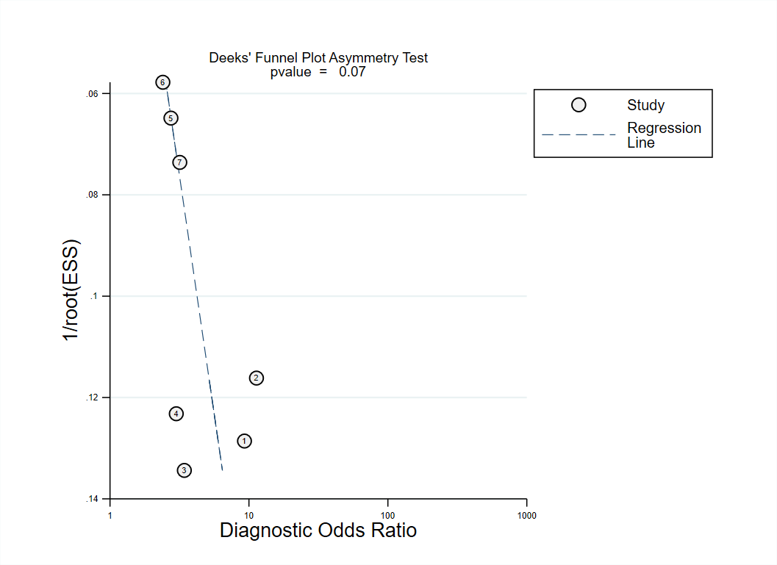

eFigure 4. Baujat’s plots

PCT (Sepsis-3)
PCT (Sepsis-1)
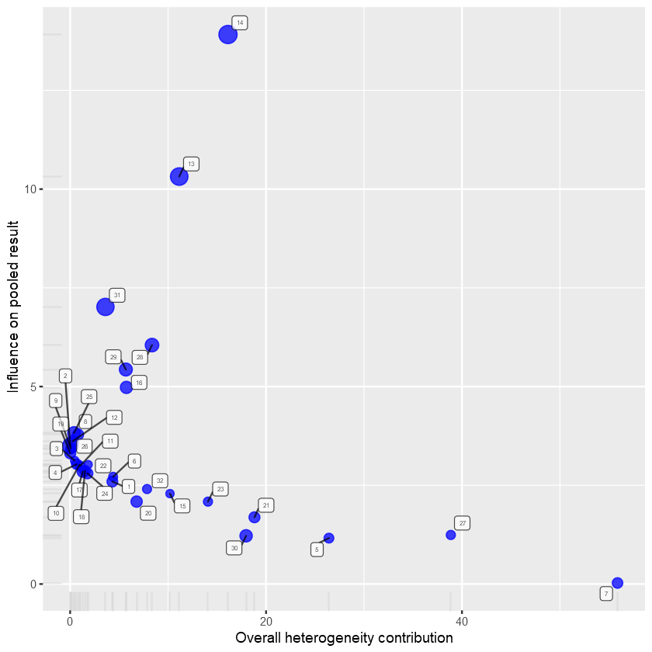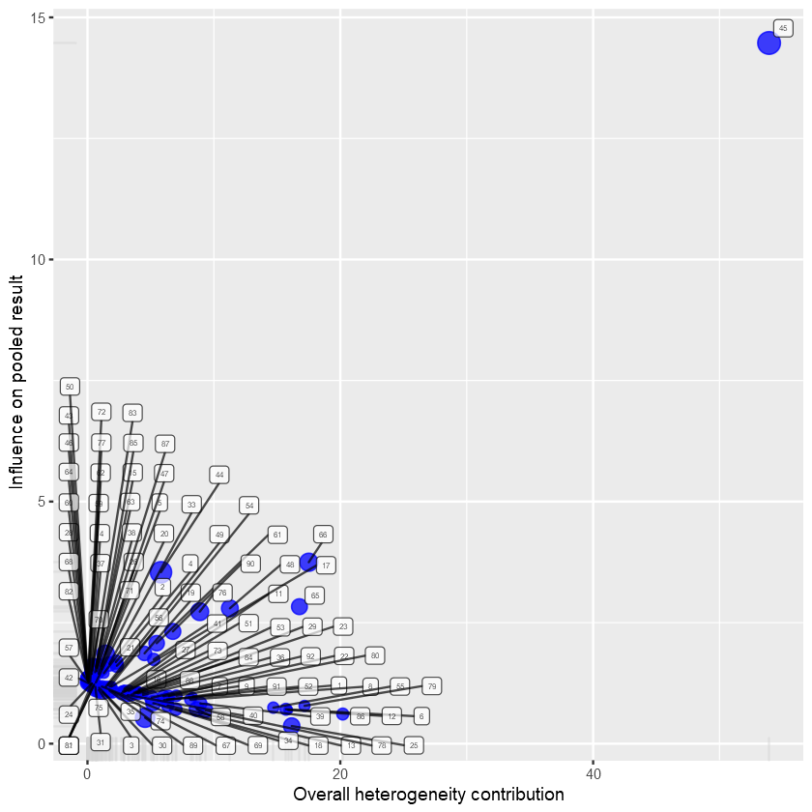

sTREM-1 (Sepsis-1)
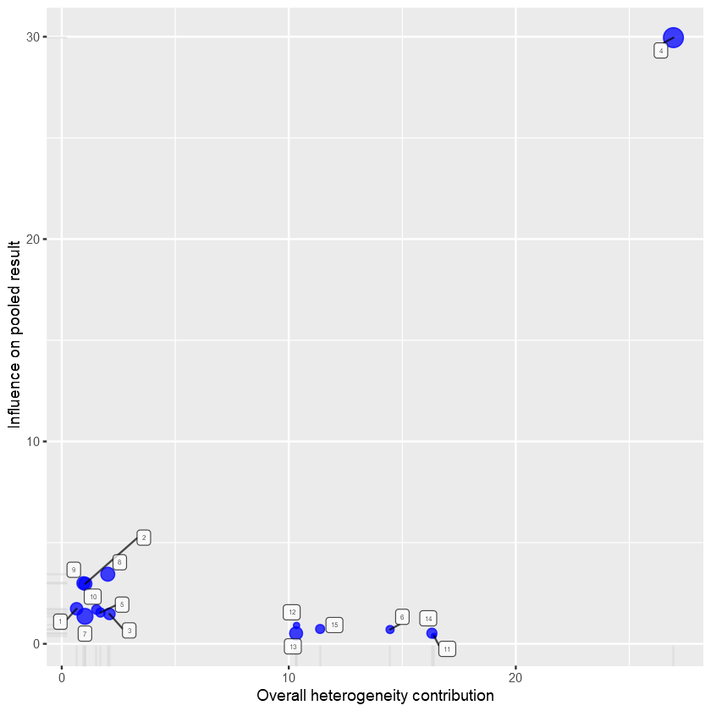

eFigure 5. Funnel plots after adjustment of influence analyses

PCT (Sepsis-1)
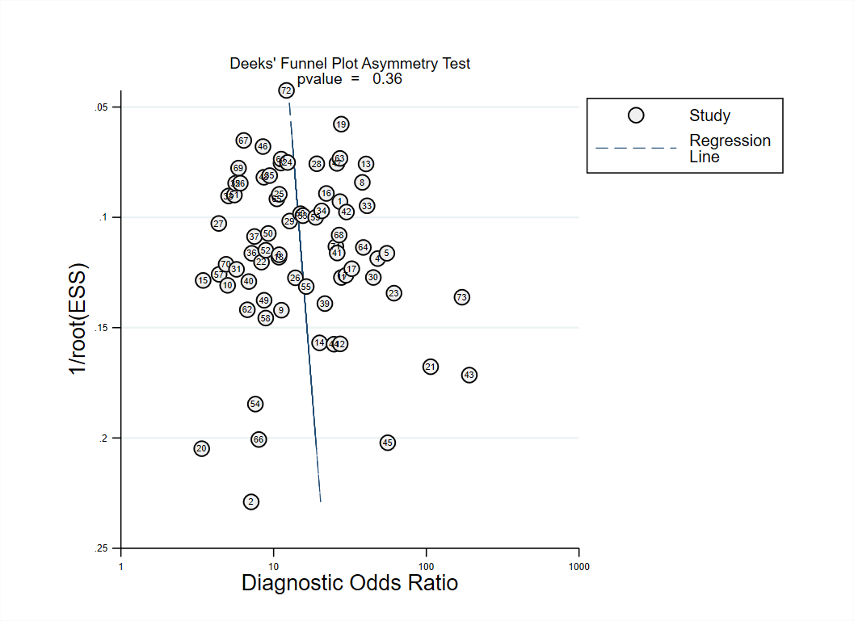

sTREM-1 (Sepsis-1)
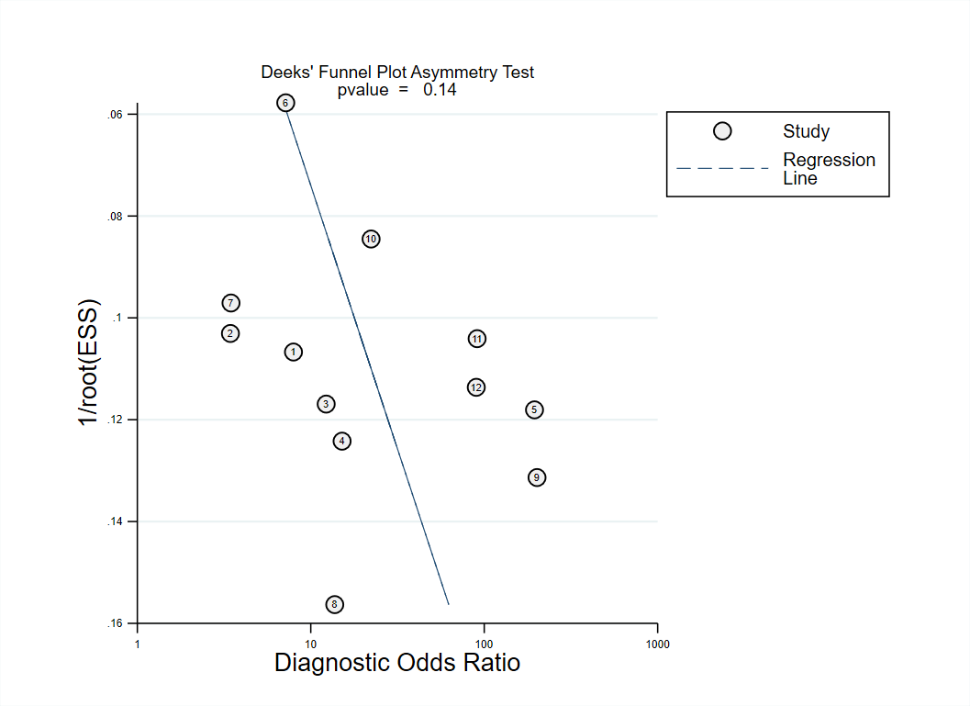

PCT (Sepsis-3)
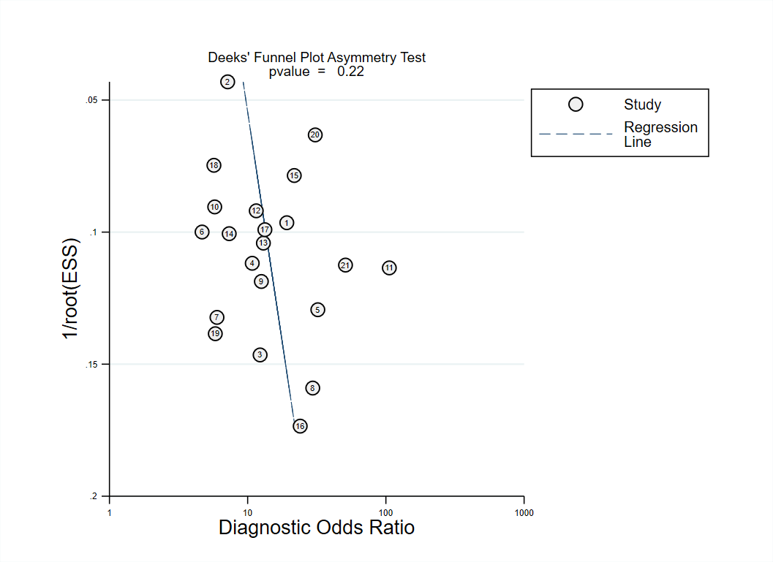

eFigure 6. Diagnostic plots (Forest, diagnostic posterior density, and time-series plots) for each parameter in the hierarchical arm-based model for Markov Chain Monte Carlo (MCMC) process.
Network meta-analysis for sepsis-1, parameter: logitmu
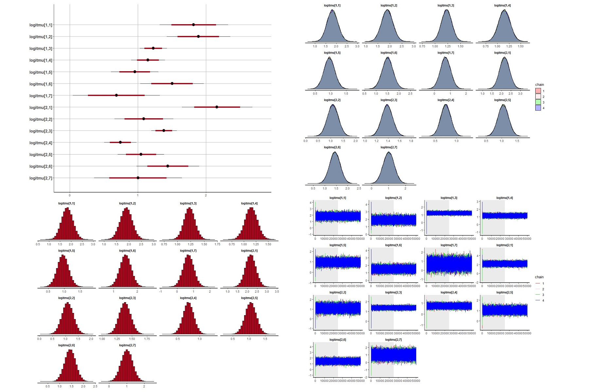
Network meta-analysis for sepsis-1, parameter: nu
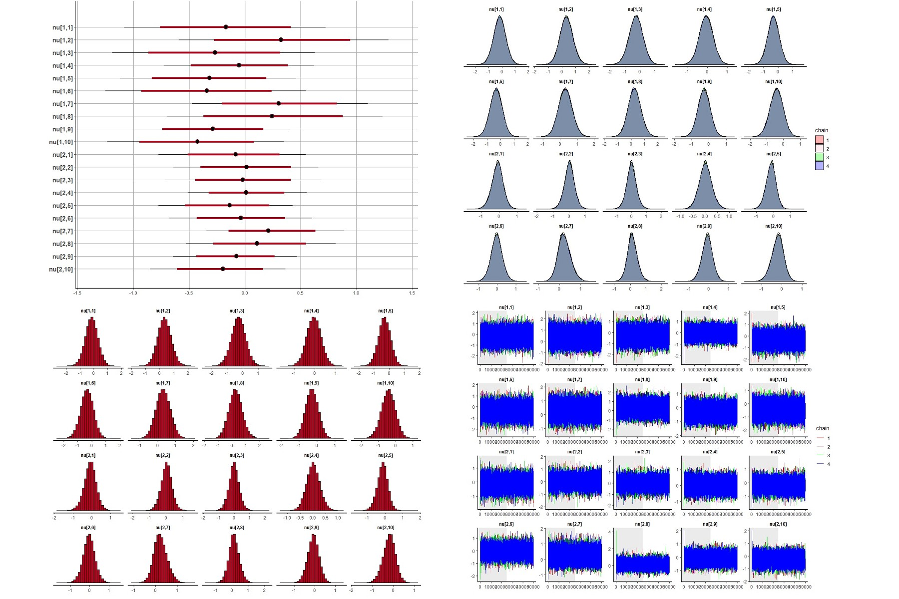
Network meta-analysis for sepsis-1, parameter: delta
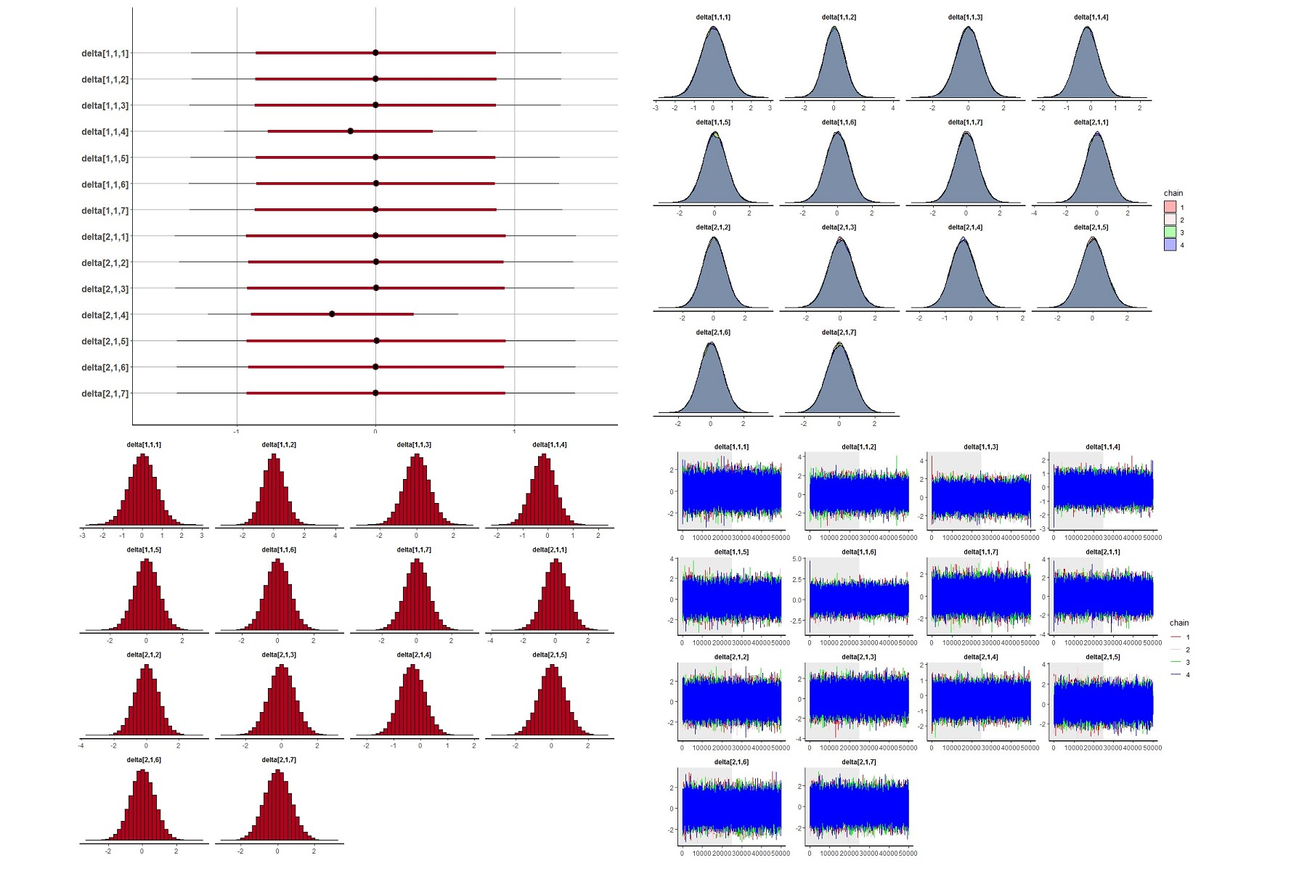
Network meta-analysis for sepsis-3, parameter: logitmu
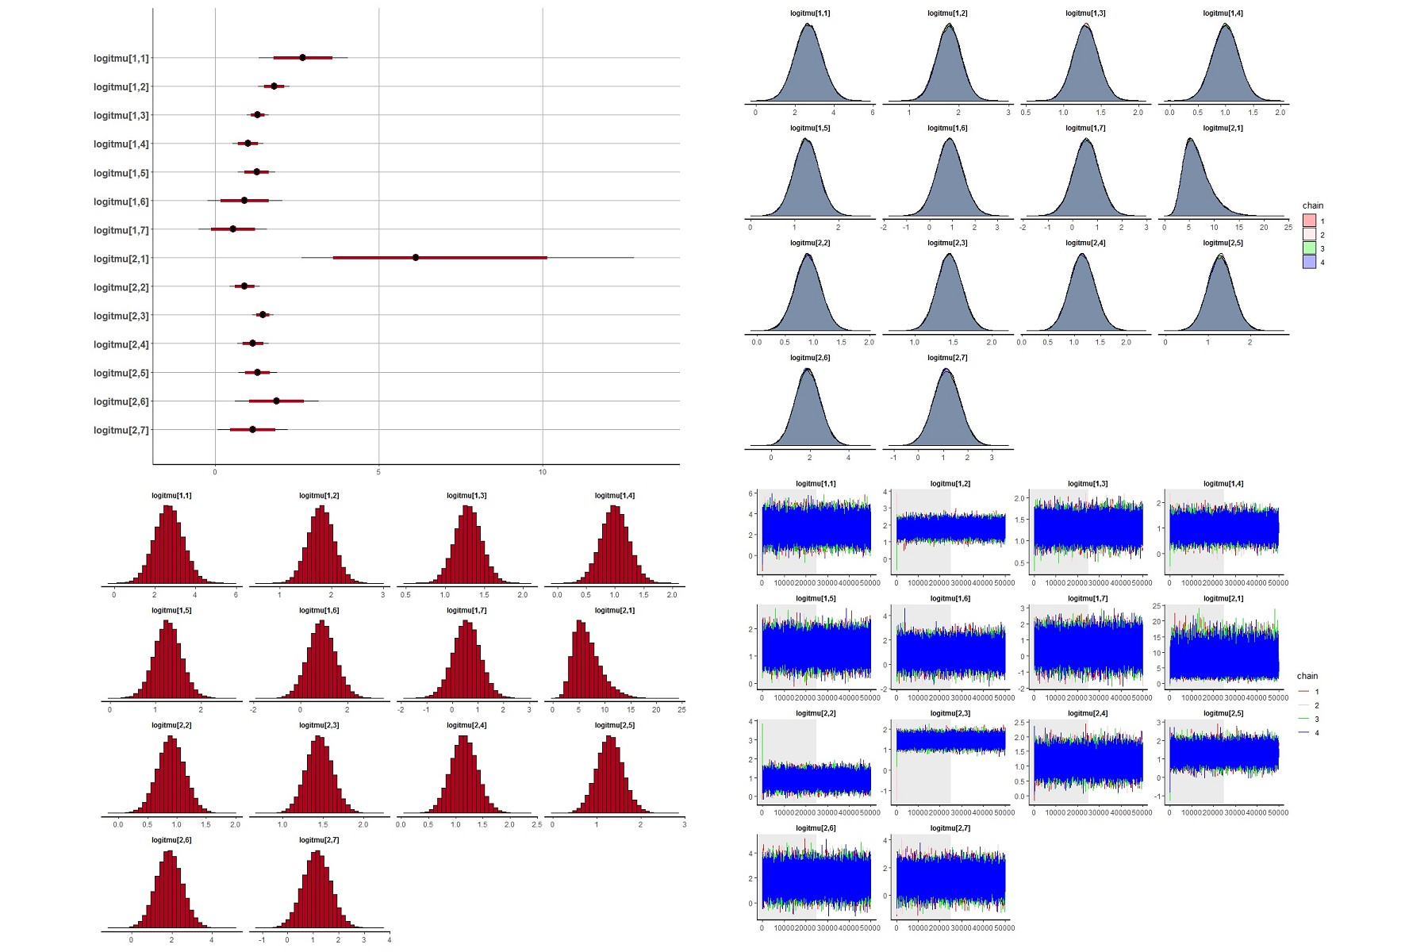
Network meta-analysis for sepsis-3, parameter: nu
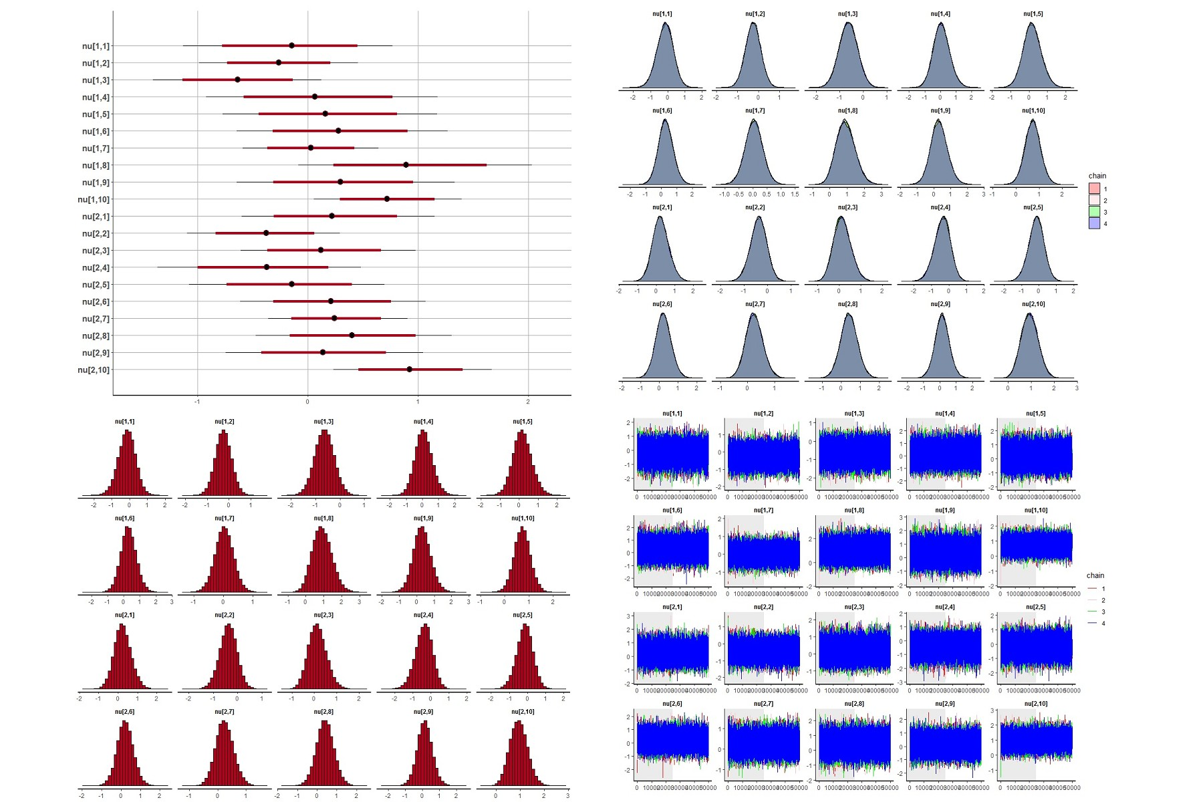
Network meta-analysis for sepsis-3, parameter: delta
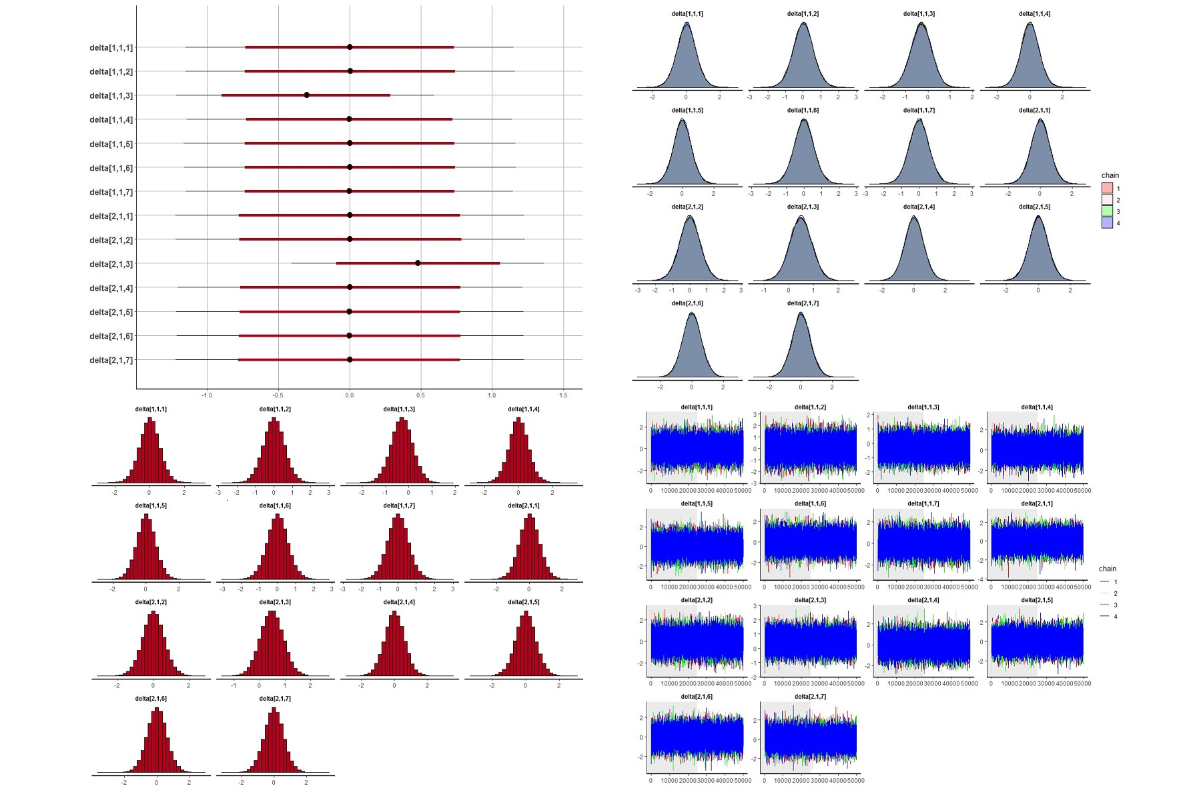
eFigure 7. Forest plots for the results of variable selection from univariable network meta-regression.
Sepsis-1 (Adjusted pooled sensitivity and specificity)
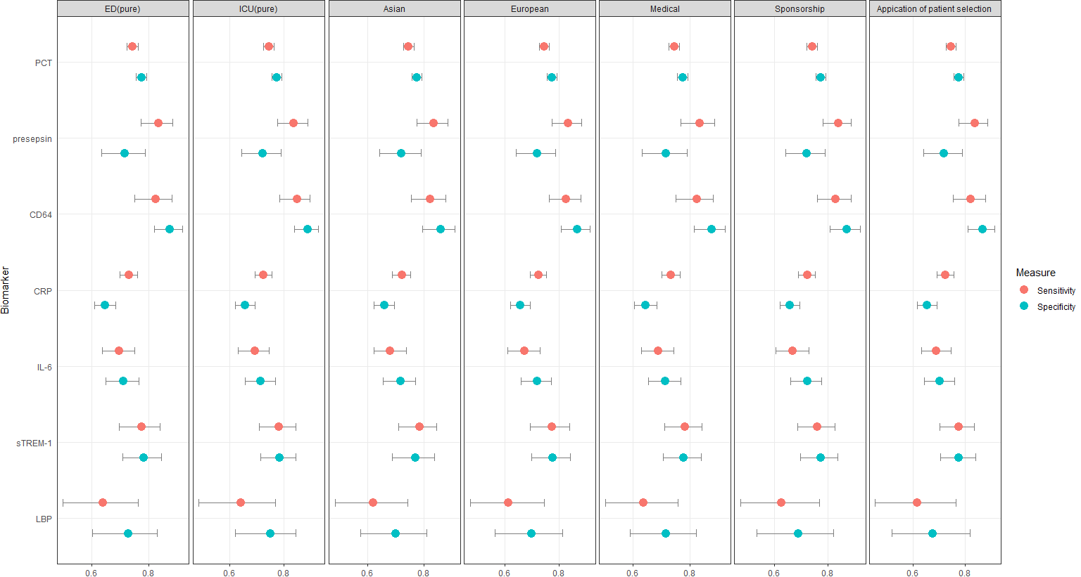
Note: PCT: procalcitonin, CRP: C-reactive protein, IL-6: interleukin-6, CD64: neutrophil CD64, sTREM-1: soluble triggering receptor expressed on myeloid cells 1, LBP: lipopolysaccharide-binding protein.

Sepsis-1 (Coefficient of univariable network meta-regression)
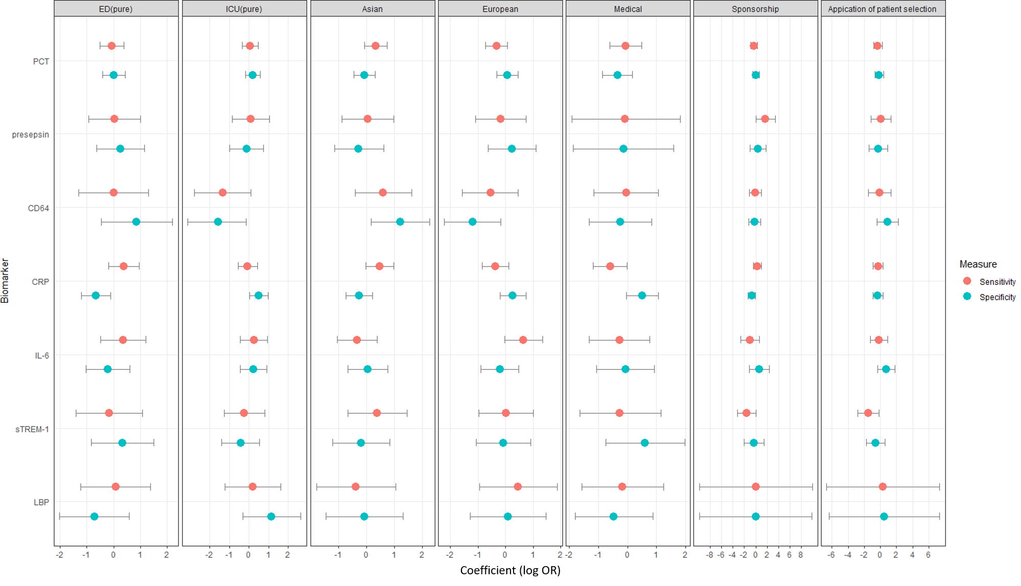
Note: PCT: procalcitonin, CRP: C-reactive protein, IL-6: interleukin-6, CD64: neutrophil CD64, sTREM-1: soluble triggering receptor expressed on myeloid cells 1, LBP: lipopolysaccharide-binding protein.

Sepsis-3 (Adjusted pooled sensitivity and specificity)
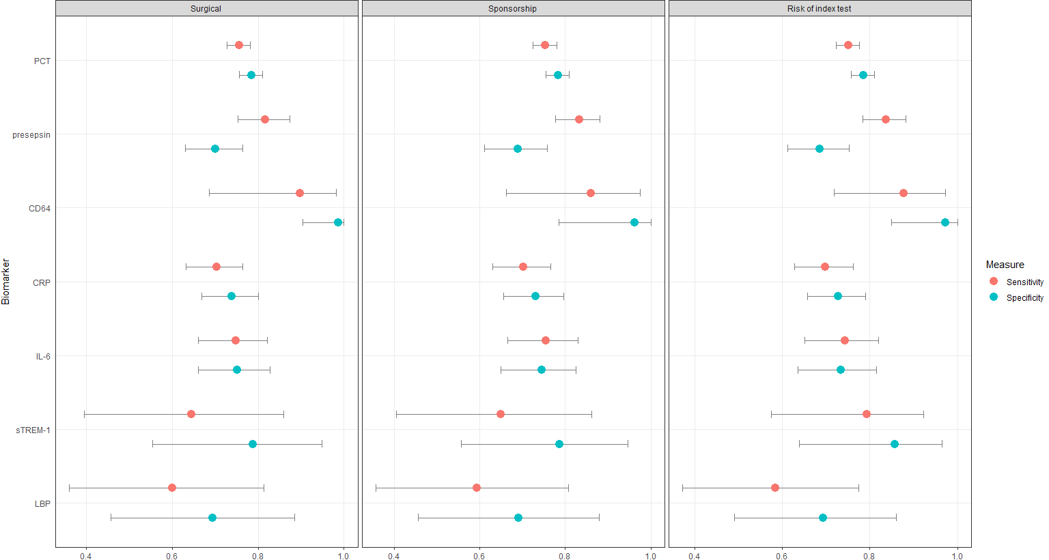
Note: PCT: procalcitonin, CRP: C-reactive protein, IL-6: interleukin-6, CD64: neutrophil CD64, sTREM-1: soluble triggering receptor expressed on myeloid cells 1, LBP: lipopolysaccharide-binding protein.
Sepsis-3 (Coefficients of univariable network meta-regression)
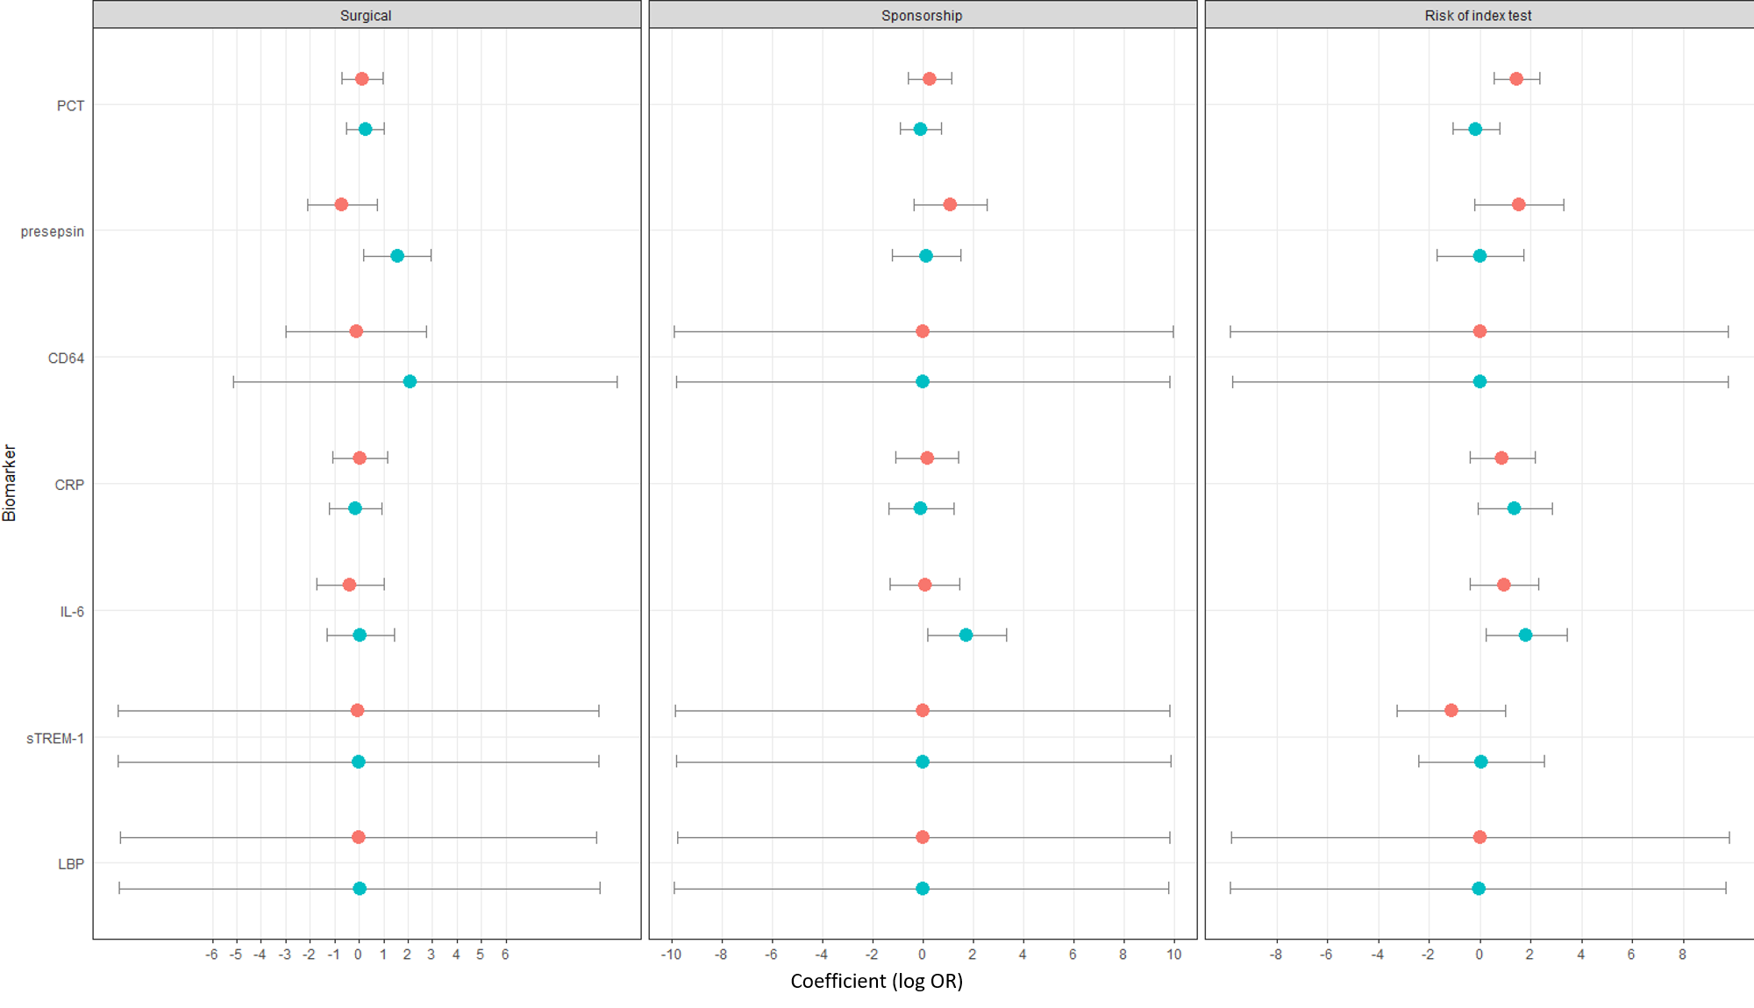
Note: PCT: procalcitonin, CRP: C-reactive protein, IL-6: interleukin-6, CD64: neutrophil CD64, sTREM-1: soluble triggering receptor expressed on myeloid cells 1, LBP: lipopolysaccharide-binding protein.
eFigure 8. Forest plots for the results from multivariable network meta-regression.
Sepsis-1 (Coefficients and Adjusted pooled results of multivariable network meta-regression)
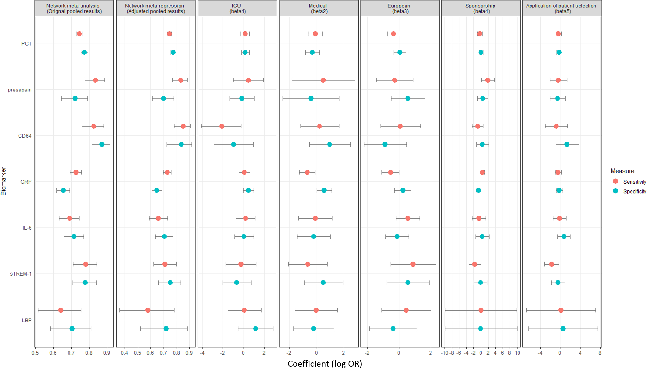
Note: PCT: procalcitonin, CRP: C-reactive protein, IL-6: interleukin-6, CD64: neutrophil CD64, sTREM-1: soluble triggering receptor expressed on myeloid cells 1, LBP: lipopolysaccharide-binding protein.
Sepsis-3 (Coefficients and Adjusted pooled results of multivariable network meta-regression)
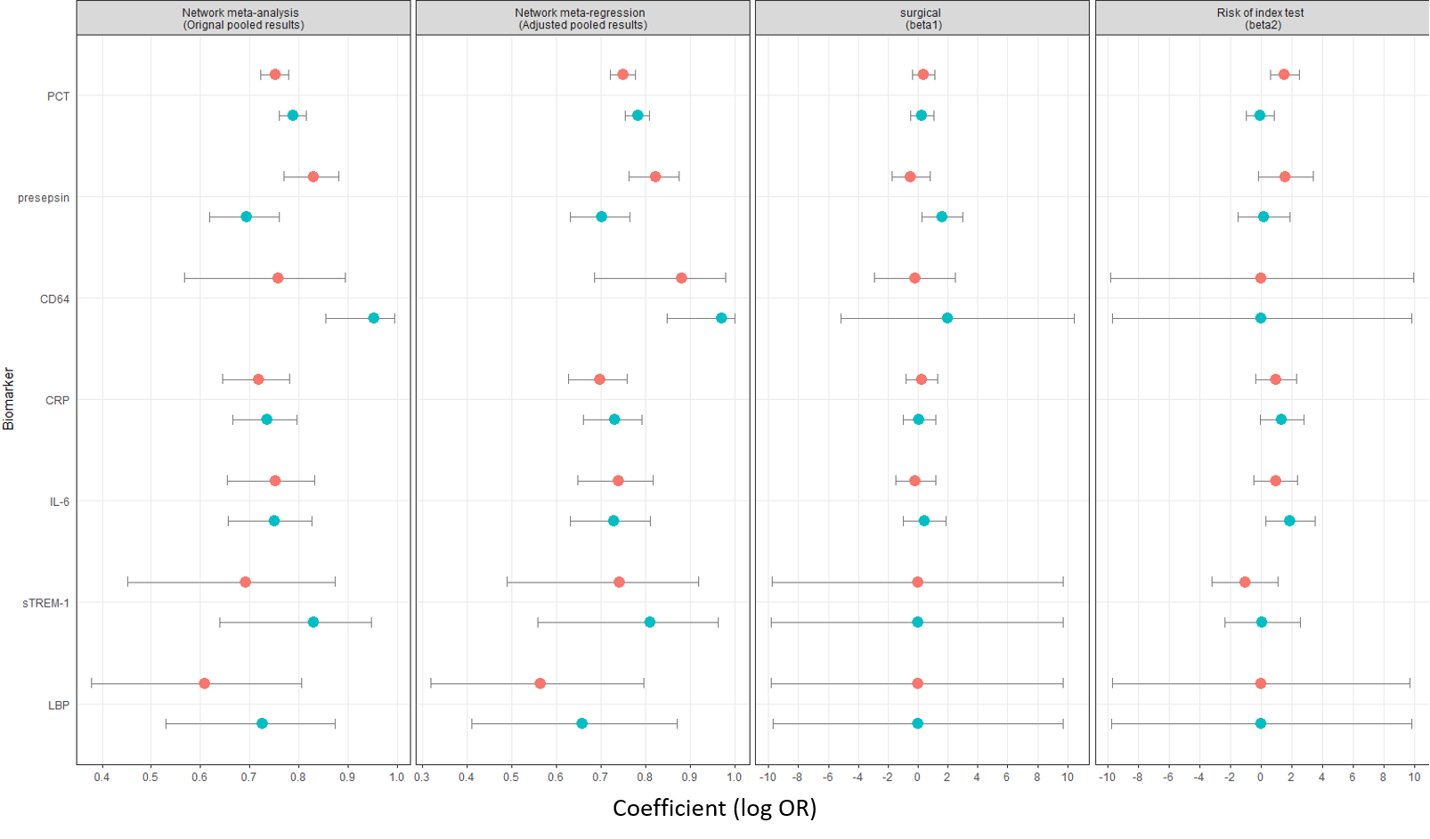
Note: PCT: procalcitonin, CRP: C-reactive protein, IL-6: interleukin-6, CD64: neutrophil CD64, sTREM-1: soluble triggering receptor expressed on myeloid cells 1, LBP: lipopolysaccharide-binding protein.

eFigure 9. Schematic for the node-splitting model.
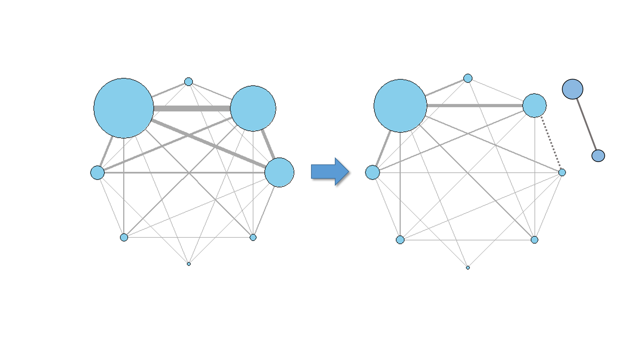

eTable 1. characteristics of included studies.
 | Sepsis-3 |  |  |  |  |  |  | Sepsis-1
 | Presepsin | PCT | CRP | IL-6 | sTREM-1 | CD64 | LBP | Presepsin | PCT | CRP | IL-6 | sTREM-1 | CD64 | LBP
Number of patients
<100 | 7 | 10 | 6 | 3 | 1 | 2 | 0 | 7 | 43 | 26 | 12 | 9 | 7 | 4
100-159 | 2 | 9 | 4 | 3 | 1 | 0 | 2 | 4 | 24 | 17 | 7 | 4 | 2 | 0
>=160 | 5 | 13 | 3 | 2 | 0 | 0 | 0 | 6 | 25 | 13 | 7 | 2 | 5 | 3
Country
Europe | 7 | 12 | 9 | 4 | 1 | 1 | 2 | 7 | 47 | 33 | 10 | 5 | 11 | 7
Asia | 6 | 16 | 3 | 4 | 1 | 1 | 0 | 9 | 38 | 19 | 15 | 7 | 1 | 0
America | 0 | 3 | 0 | 0 | 0 | 0 | 0 | 1 | 5 | 2 | 1 | 2 | 2 | 0
Africa | 1 | 1 | 1 | 0 | 0 | 0 | 0 | 0 | 1 | 2 | 0 | 1 | 0 | 0
Year
2016-2020 | 9 | 20 | 10 | 5 | 1 | 0 | 1 | 2 | 18 | 6 | 2 | 1 | 2 | 0
2012-2015 | 5 | 7 | 2 | 2 | 1 | 0 | 0 | 14 | 39 | 26 | 15 | 5 | 10 | 3
1996-2011 | 0 | 5 | 1 | 1 | 0 | 2 | 1 | 1 | 35 | 24 | 9 | 9 | 2 | 4
Setting
ED | 1 | 8 | 3 | 1 | 0 | 0 | 1 | 12 | 26 | 13 | 8 | 2 | 3 | 1
ICU | 12 | 20 | 10 | 5 | 2 | 2 | 1 | 7 | 54 | 39 | 14 | 13 | 10 | 4
Patient source
Surgical | 1 | 3 | 2 | 2 | 0 | 0 | 1 | 1 | 9 | 3 | 4 | 2 | 0 | 1
Medical | 3 | 3 | 0 | 0 | 0 | 1 | 0 | 2 | 12 | 7 | 5 | 1 | 1 | 0
Specimen type
plasma | 7 | 10 | 5 | 3 | 0 | 0 | 0 | 7 | 30 | 12 | 9 | 7 | 0 | 2
serum | 2 | 13 | 4 | 4 | 2 | 1 | 1 | 4 | 48 | 26 | 16 | 8 | 2 | 4
whole blood | 0 | 0 | 0 | 0 | 0 | 1 | 0 | 6 | 0 | 1 | 1 | 0 | 7 | 0
Total | 14 | 32 | 13 | 1 | 2 | 2 | 2 | 7 | 44 | 27 | 12 | 9 | 7 | 4
Total | 39 |  |  |  |  |  |  | 118
Note: Behnes M. et al. was divided into day 1, day 3, and day 8 groups. Dorizzi R.M. et al. was divided into medical and surgical groups. Lin S. et al. was divided into test and validate groups. Romano A. et al. was divided into frail and non-frail groups.

eTable 2. Detailed characteristics of included studies.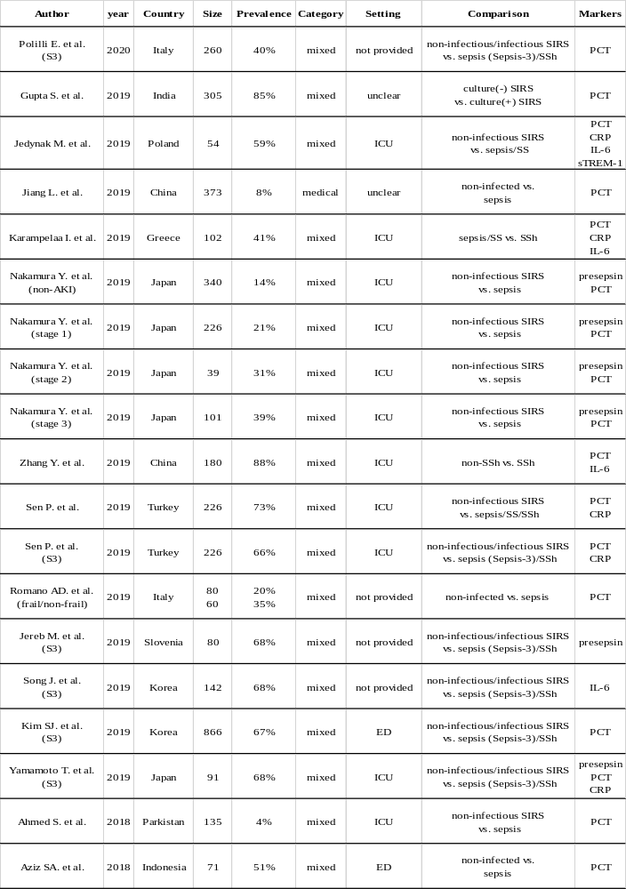
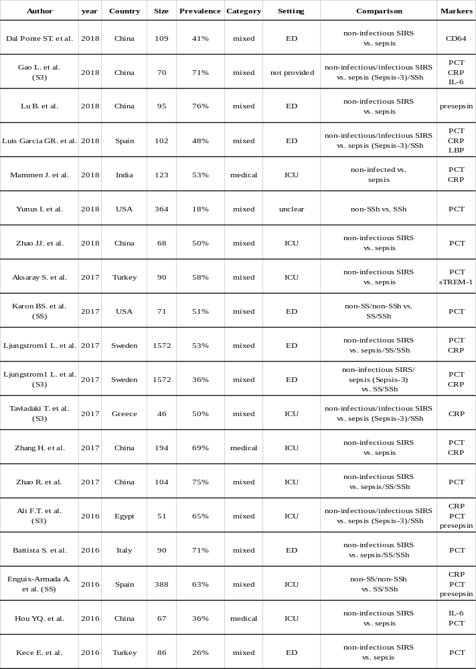

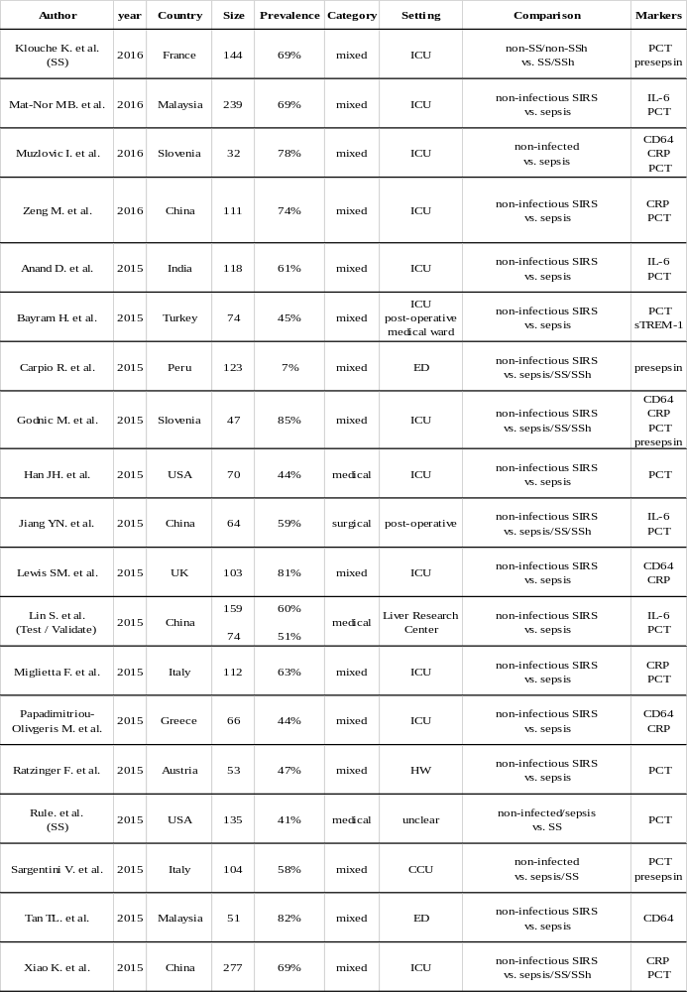
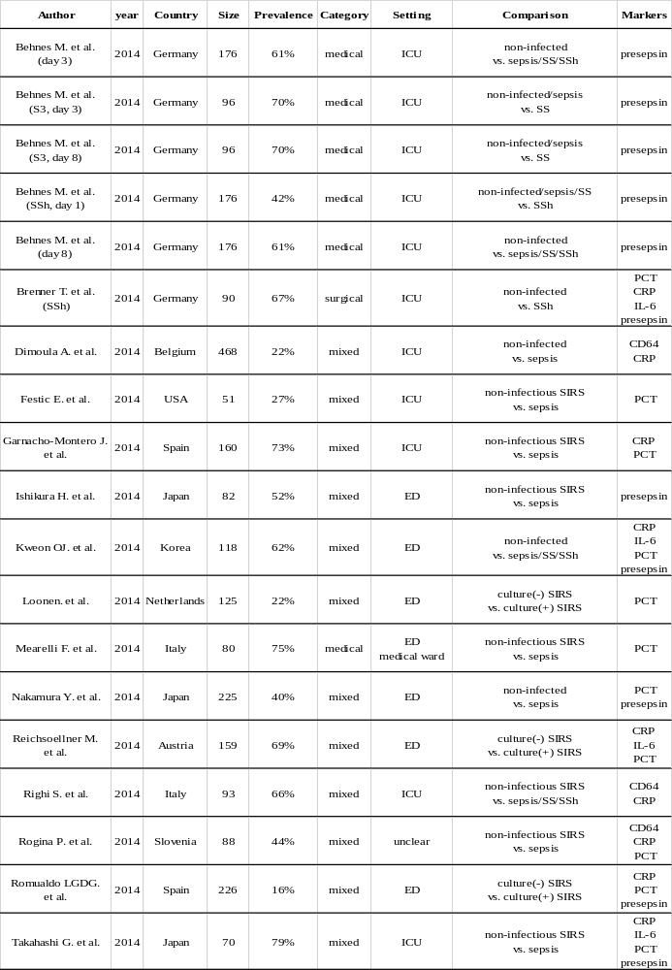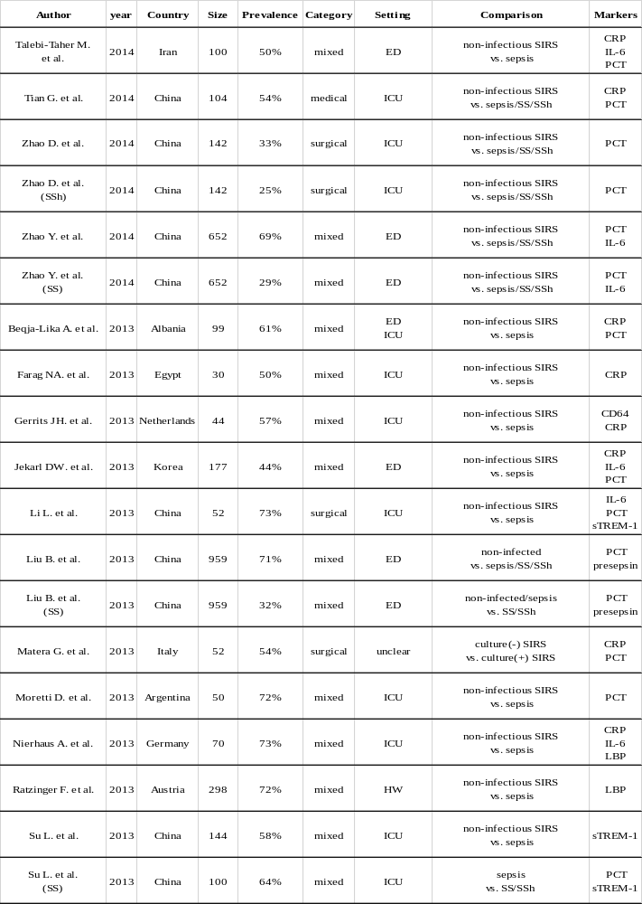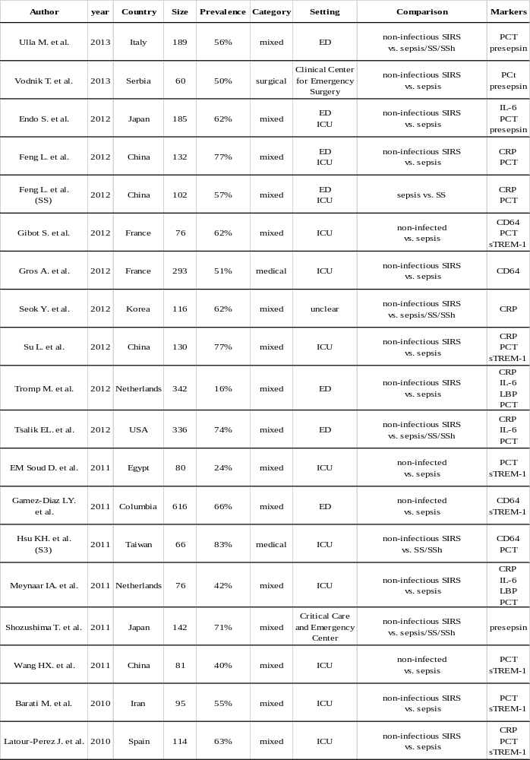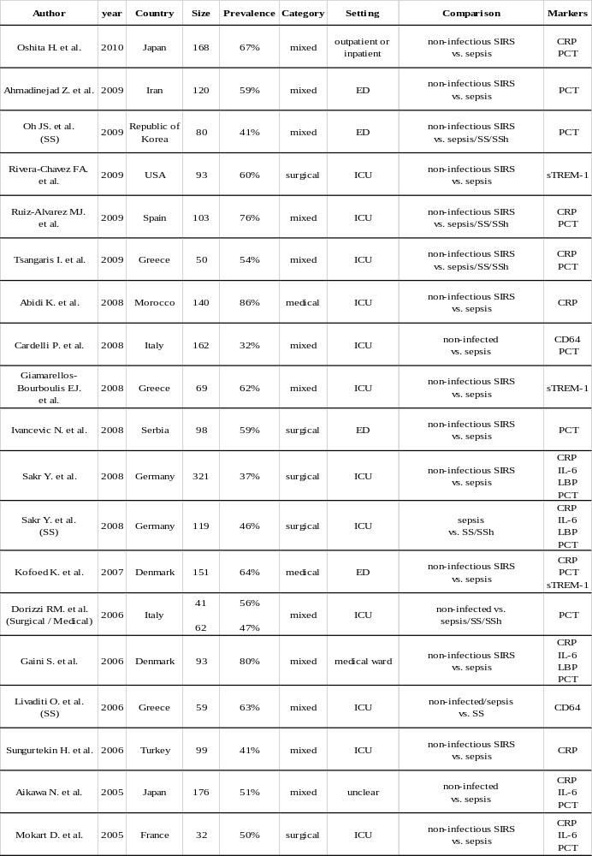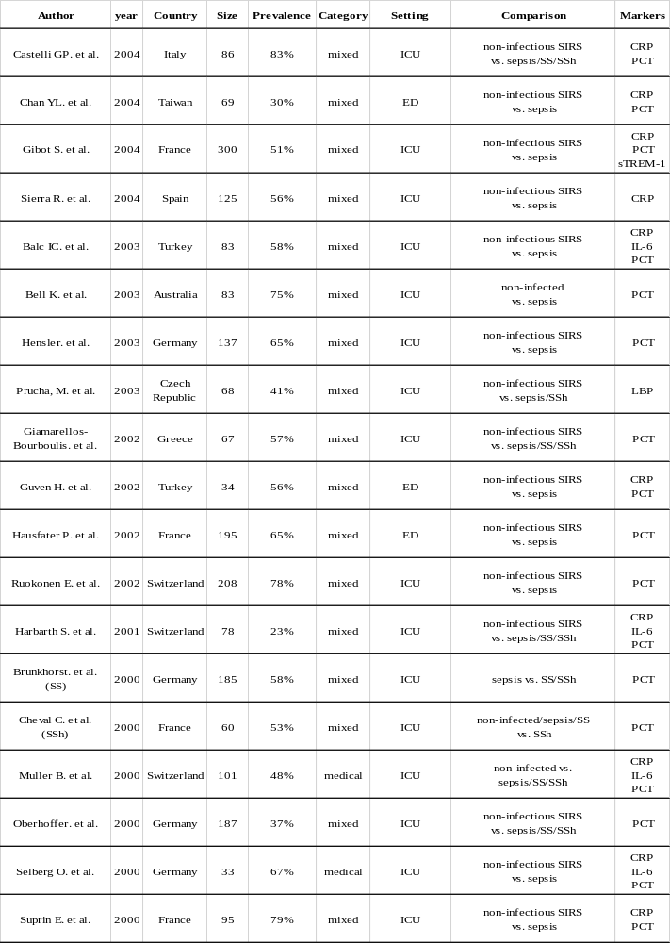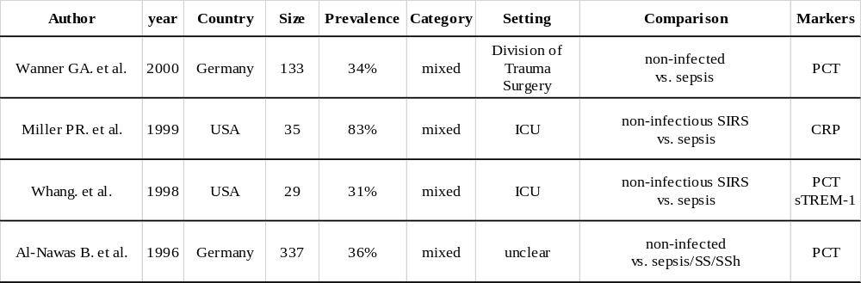
Note: Nakamura Y. et al. was divided into non-AKI, stage 1, stage 2, stage 3 groups.

eTable 3. Detailed diagnostic accuracies of included studies. 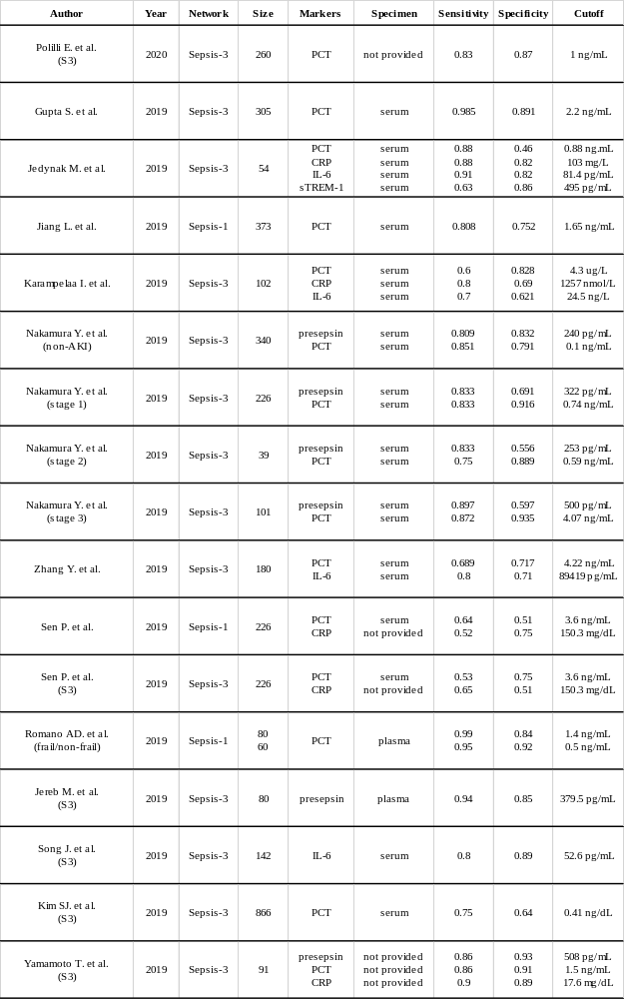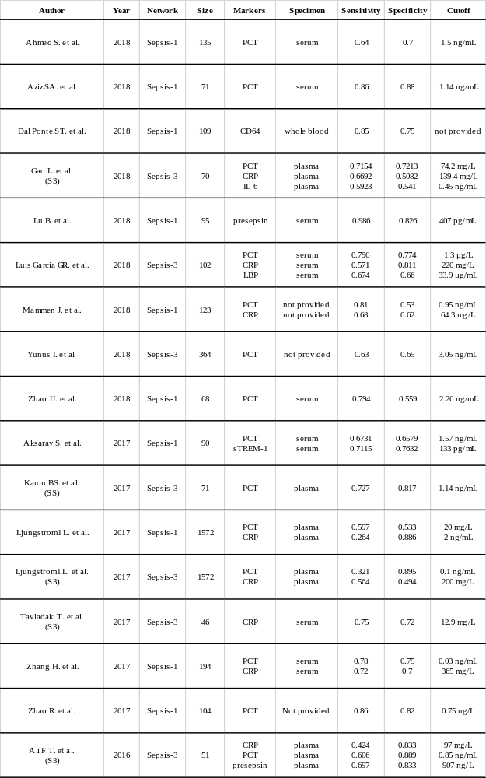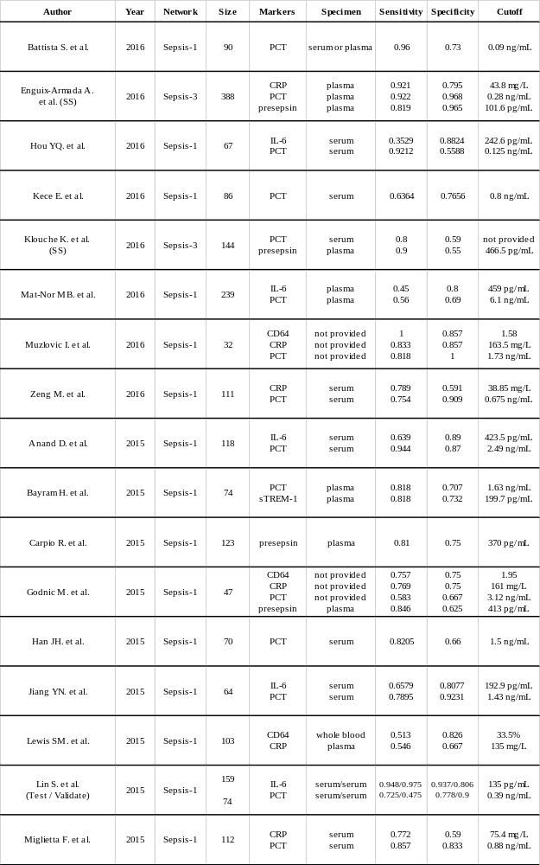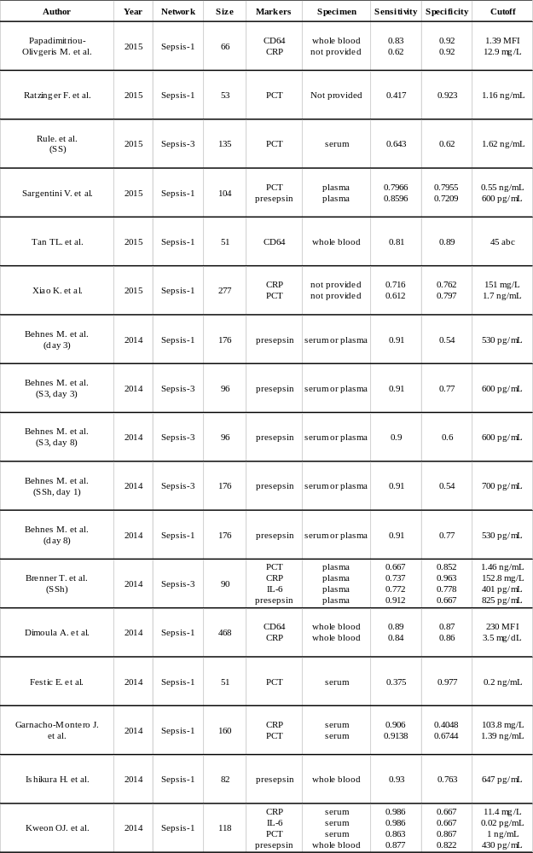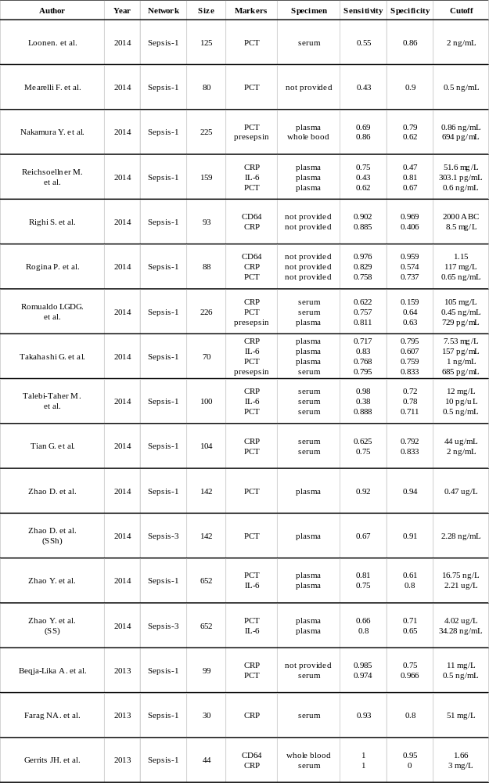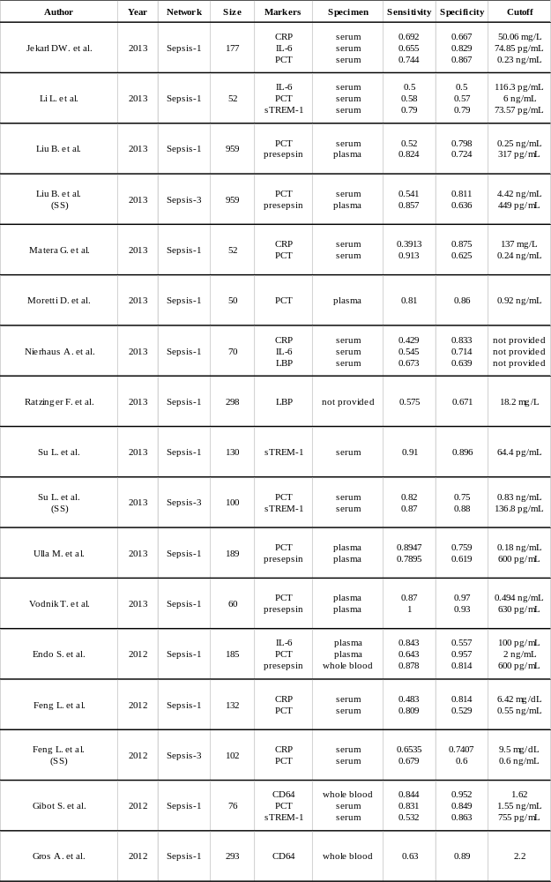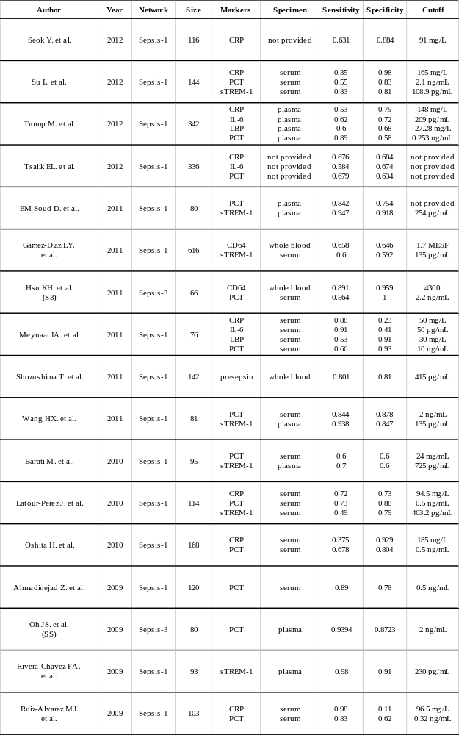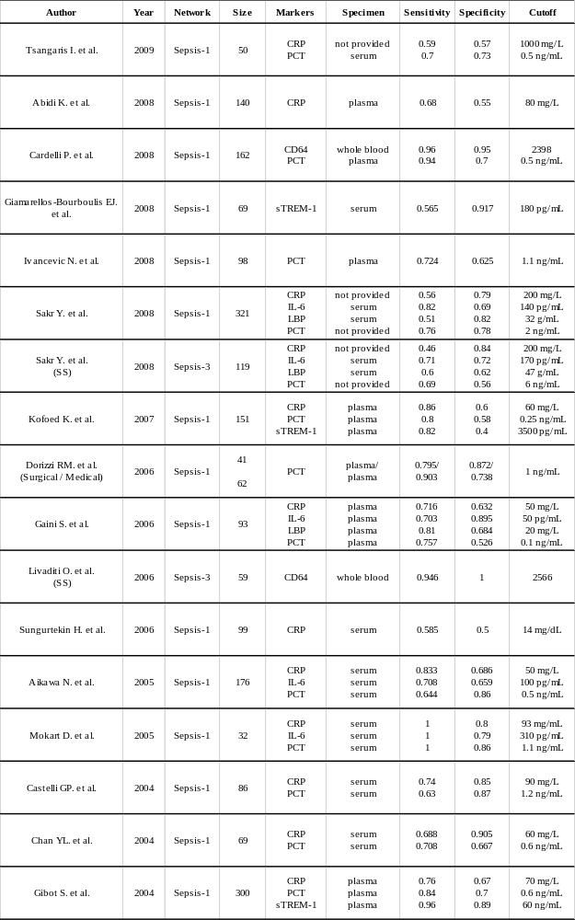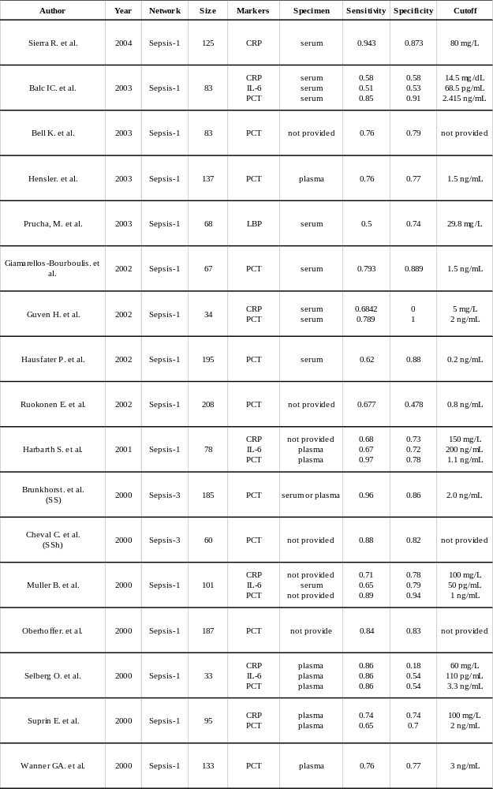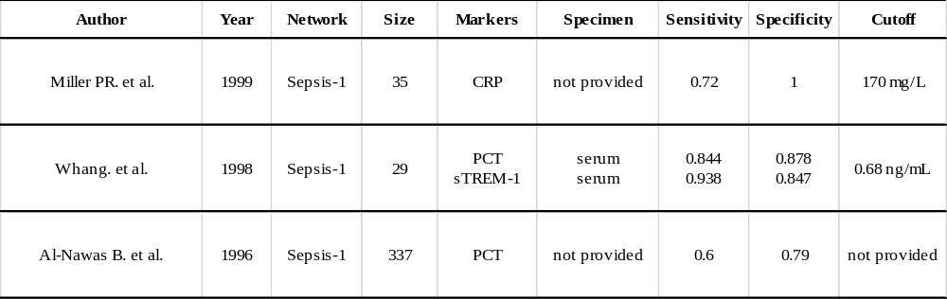

eTable 4. Cohen’s Kappa statistics for the consistency between opinion of reviewers to quality assessment.

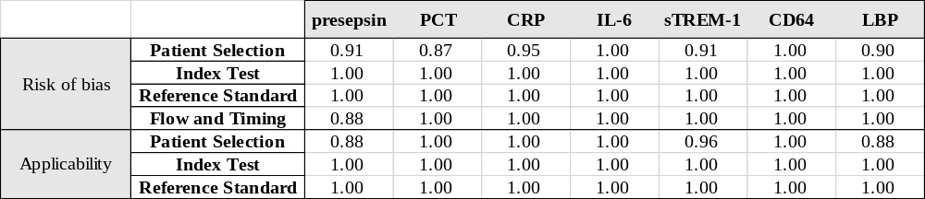
Note: PCT: procalcitonin, CRP: C-reactive protein, IL-6: interleukin-6, CD64: neutrophil CD64, sTREM-1: soluble triggering receptor expressed on myeloid cells 1, LBP: lipopolysaccharide-binding protein.

eTable 5. Detailed quality assessment of included studies.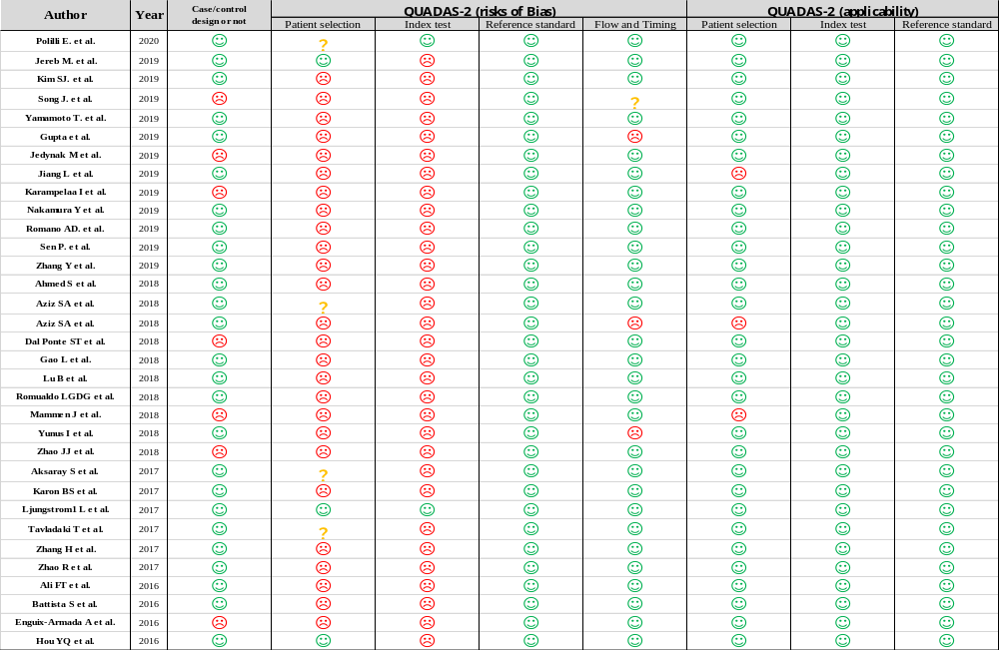 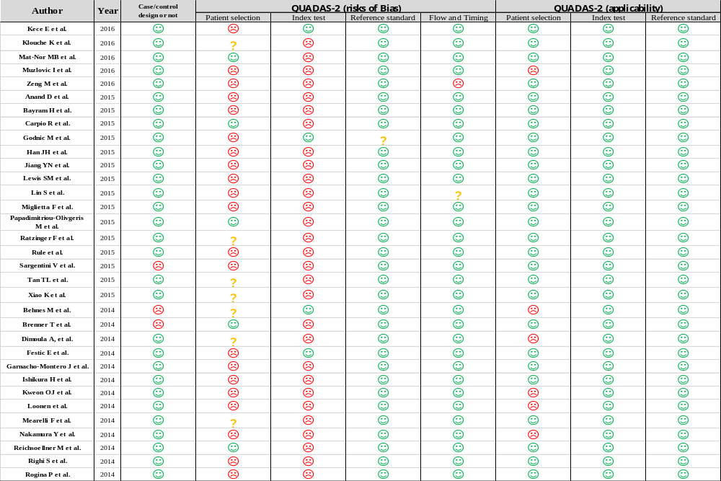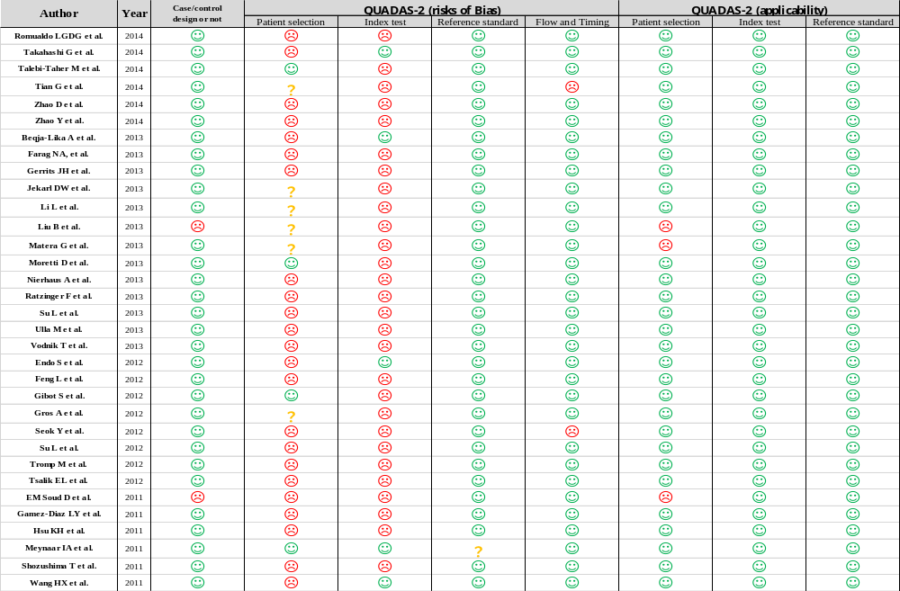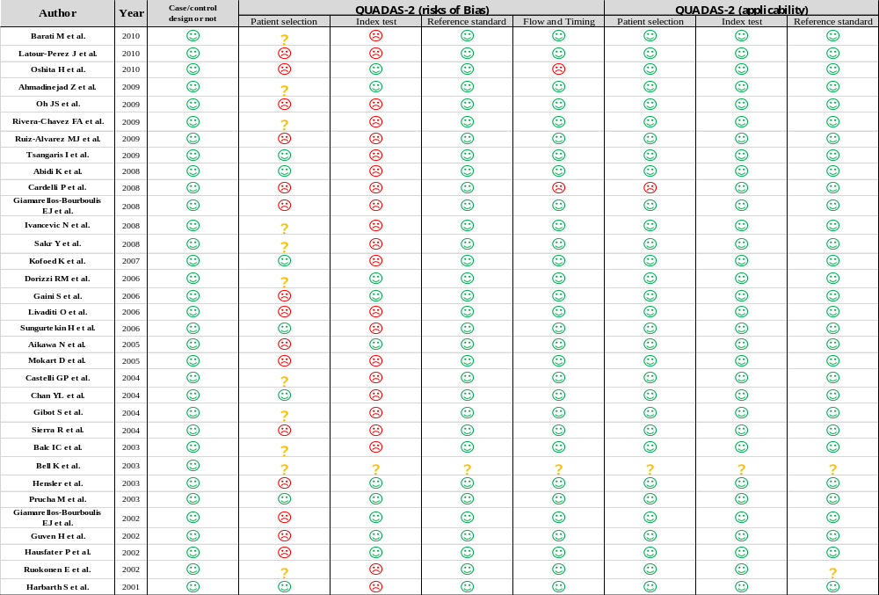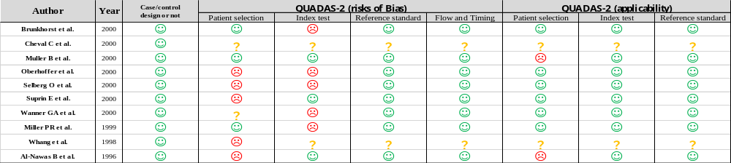

eTable 6. Inconsistency factors (IFs) for measuring the network inconsistency using the node splitting model.
Sepsis-3
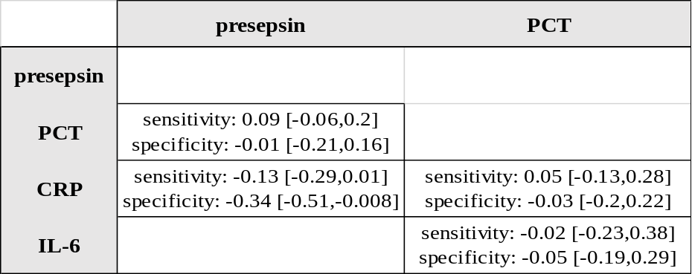

Sepsis-1
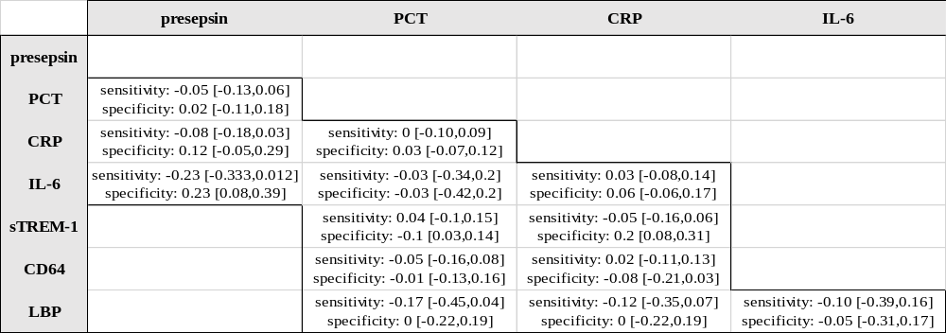
Note: PCT: procalcitonin, CRP: C-reactive protein, IL-6: interleukin-6, CD64: neutrophil CD64, sTREM-1: soluble triggering receptor expressed on myeloid cells 1, LBP: lipopolysaccharide-binding protein.

eTable 7. Statistics for heterogeneity.

Reference | Biomarkers | Number of studies | Threshold effect | I-square | Cochrane-Q
Sepsis-1 | Presepsin | 16 | -0.02 | 97 | 74.71
Sepsis-1 | PCT | 92 | -0.05 | 100 | 684.6
Sepsis-1 | CRP | 56 | -0.44 | 100 | 463.54
Sepsis-1 | IL-6 | 26 | -0.17 | 99 | 153.43
Sepsis-1 | sTREM-1 | 15 | 0.44 | 97 | 59.83
Sepsis-1 | CD64 | 14 | 0.69 | 91 | 21.06
Sepsis-1 | LBP | 7 | -0.68 | 42 | 3.46
Sepsis-3 | Presepsin | 14 | -0.72 | 97 | 63.2
Sepsis-3 | PCT | 32 | 0.2 | 100 | 498.41
Sepsis-3 | CRP | 13 | 0.32 | 94 | 33.1
Sepsis-3 | IL-6 | 8 | 0.69 | 0 | 1.676
Note: PCT: procalcitonin, CRP: C-reactive protein, IL-6: interleukin-6, CD64: neutrophil CD64, sTREM-1: soluble triggering receptor expressed on myeloid cells 1, LBP: lipopolysaccharide-binding protein.

eTable 8. Comparisons of the results between conventional and network meta-analysis.

Methods |  | Conventional meta-analysis |  | Network meta-analysis
Reference | Biomarkers | Pooled sensitivity  (95% confidence interval) | Pooled specificity  (95% confidence interval) | Pooled sensitivity  (95% credible interval) | Pooled specificity  (95% credible interval)
Sepsis-1 | Presepsin | 0.87 (0.83-0.91) | 0.74 (0.67-0.79) | 0.84 (0.78-0.89) | 0.72 (0.64-0.79)
Sepsis-1 | PCT | 0.77 (0.74-0.80) | 0.80 (0.77-0.82) | 0.75 (0.73-0.76) | 0.78 (0.76-0.79)
Sepsis-1 | CRP | 0.76 (0.70-0.80) | 0.67 (0.60-0.74) | 0.73 (0.69-0.76) | 0.66 (0.62-0.69)
Sepsis-1 | IL-6 | 0.73 (0.63-0.81) | 0.74 (0.68-0.78) | 0.69 (0.63-0.74) | 0.72 (0.66-0.77)
Sepsis-1 | sTREM-1 | 0.81 (0.71-0.89) | 0.81 (0.73-0.87) | 0.78 (0.71-0.84) | 0.78 (0.71-0.84)
Sepsis-1 | CD64 | 0.86 (0.77-0.92) | 0.90 (0.84-0.94) | 0.83 (0.76-0.88) | 0.87 (0.82-0.92)
Sepsis-1 | LBP | 0.61 (0.53-0.69) | 0.69 (0.61-0.77) | 0.64 (0.51-0.75) | 0.70 (0.58-0.81)
Sepsis-3 | Presepsin | 0.87 (0.84-0.90) | 0.74 (0.63-0.82) | 0.83 (0.77-0.88) | 0.69 (0.62-0.76)
Sepsis-3 | PCT | 0.78 (0.72-0.83) | 0.81 (0.76-0.85) | 0.75 (0.72-0.78) | 0.79 (0.76-0.81)
Sepsis-3 | CRP | 0.71 (0.60-0.79) | 0.75 (0.66-0.82) | 0.72 (0.64-0.78) | 0.74 (0.67-0.80)
Sepsis-3 | IL-6 | 0.75 (0.68-0.81) | 0.75 (0.65-0.83) | 0.75 (0.65-0.83) | 0.75 (0.66-0.83)
Sepsis-3 | sTREM-1 | ━ | ━ | 0.69 (0.45-0.87) | 0.83 (0.64-0.95)
Sepsis-3 | CD64 | ━ | ━ | 0.76 (0.57-0.89) | 0.95 (0.85-0.99)
Sepsis-3 | LBP | ━ | ━ | 0.61 (0.38-0.81) | 0.73 (0.53-0.87)
Note: PCT: procalcitonin, CRP: C-reactive protein, IL-6: interleukin-6, CD64: neutrophil CD64, sTREM-1: soluble triggering receptor expressed on myeloid cells 1, LBP: lipopolysaccharide-binding protein. ━: Not enough number of studies for the conventional method to analysis.

eTable 9. The results of sensitivity analyses after non-full text abstract and the outliers removed.

Methods |  | Network meta-analysis |  | Non-full text removed |  | The outliers removed
Reference | Biomarkers | Pooled sensitivity  (95% CrI) | Pooled specificity  (95% CrI) | Pooled sensitivity  (95% CrI) | Pooled specificity  (95% CrI) | Pooled sensitivity  (95% CrI) | Pooled specificity  (95% CrI)
Sepsis-1 | Presepsin | 0.84 (0.78-0.89) | 0.72 (0.64-0.79) | 0.85 (0.79-0.89) | 0.73 (0.66-0.80) | 0.84 (0.78-0.89) | 0.73 (0.65-0.79)
Sepsis-1 | PCT | 0.75 (0.73-0.76) | 0.78 (0.76-0.79) | 0.75 (0.73-0.77) | 0.77 (0.75-0.79) | 0.75 (0.72-0.77) | 0.78 (0.75-0.80)
Sepsis-1 | CRP | 0.73 (0.69-0.76) | 0.66 (0.62-0.69) | 0.73 (0.70-0.76) | 0.66 (0.62-0.69) | 0.72 (0.69-0.75) | 0.66 (0.62-0.69)
Sepsis-1 | IL-6 | 0.69 (0.63-0.74) | 0.72 (0.66-0.77) | 0.69 (0.63-0.75) | 0.72 (0.66-0.77) | 0.70 (0.64-0.75) | 0.71 (0.66-0.77)
Sepsis-1 | sTREM-1 | 0.78 (0.71-0.84) | 0.78 (0.71-0.84) | 0.78 (0.71-0.84) | 0.78 (0.71-0.84) | 0.77 (0.69-0.84) | 0.80 (0.73-0.87)
Sepsis-1 | CD64 | 0.83 (0.76-0.88) | 0.87 (0.82-0.92) | 0.83 (0.76-0.88) | 0.87 (0.81-0.92) | 0.82 (0.75-0.88) | 0.87 (0.81-0.91)
Sepsis-1 | LBP | 0.64 (0.51-0.75) | 0.70 (0.58-0.81) | 0.64 (0.52-0.75) | 0.70 (0.58-0.81) | 0.63 (0.50-0.75) | 0.69 (0.57-0.80)
Sepsis-3 | Presepsin | 0.83 (0.77-0.88) | 0.69 (0.62-0.76) | 0.83 (0.77-0.88) | 0.69 (0.61-0.75) | 0.85 (0.80-0.89) | 0.70 (0.63-0.77)
Sepsis-3 | PCT | 0.75 (0.72-0.78) | 0.79 (0.76-0.81) | 0.75 (0.72-0.78) | 0.78 (0.76-0.81) | 0.77 (0.73-0.80) | 0.76 (0.72-0.80)
Sepsis-3 | CRP | 0.72 (0.64-0.78) | 0.74 (0.67-0.80) | 0.70 (0.63-0.76) | 0.74 (0.66-0.80) | 0.70 (0.63-0.76) | 0.74 (0.67-0.80)
Sepsis-3 | IL-6 | 0.75 (0.65-0.83) | 0.75 (0.66-0.83) | 0.75 (0.66-0.82) | 0.76 (0.66-0.83) | 0.75 (0.67-0.82) | 0.75 (0.66-0.83)
Sepsis-3 | sTREM-1 | 0.69 (0.45-0.87) | 0.83 (0.64-0.95) | 0.68 (0.45-0.86) | 0.83 (0.63-0.95) | 0.71 (0.51-0.86) | 0.83 (0.64-0.94)
Sepsis-3 | CD64 | 0.76 (0.57-0.89) | 0.95 (0.85-0.99) | 0.90 (0.76-0.98) | 0.99 (0.92-1.00) | 0.91 (0.80-0.97) | 0.99 (0.91-1.00)
Sepsis-3 | LBP | 0.61 (0.38-0.81) | 0.73 (0.53-0.87) | 0.61 (0.40-0.79) | 0.72 (0.53-0.87) | 0.60 (0.41-0.77) | 0.72 (0.52-0.87)

Note1: PCT: procalcitonin, CRP: C-reactive protein, IL-6: interleukin-6, CD64: neutrophil CD64, sTREM-1: soluble triggering receptor expressed on myeloid cells 1, LBP: lipopolysaccharide-binding protein. CrI: Credible interval The outliers removed: mean that removed studies that cause publication bias (eFigure 2)

Note 2: Studies are defined as outliers when their 95 % confidence interval lies outside the 95 % confidence interval of the pooled effect.
Sepsis-1: PCT remove 19 studies, sTREM-1 remove 3 studies.
Sepsis-3: PCT remove 11 studies.

eTable 10. Results of influence analyses.
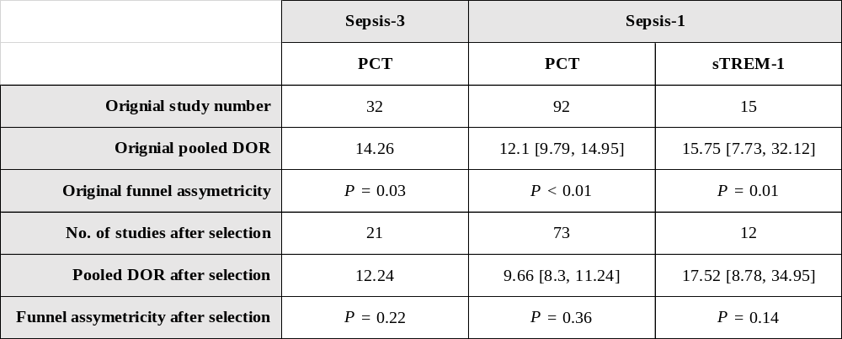

eTable 11. The results of subgroup analyses considered published year.

Methods |  | Network meta-analysis |  | Published before 2013 |  | Published after 2013
Reference | Biomarkers | Pooled sensitivity  (95% CrI) | Pooled specificity  (95% CrI) | Pooled sensitivity  (95% CrI) | Pooled specificity  (95% CrI) | Pooled sensitivity  (95% CrI) | Pooled specificity  (95% CrI)
Sepsis-1 | Presepsin | 0.84 (0.78-0.89) | 0.72 (0.64-0.79) | 0.81 (0.63-0.93) | 0.75 (0.51-0.92) | 0.84 (0.77-0.90) | 0.72 (0.64-0.79)
Sepsis-1 | PCT | 0.75 (0.73-0.76) | 0.78 (0.76-0.79) | 0.75 (0.73-0.78) | 0.76 (0.73-0.79) | 0.74 (0.71-0.76) | 0.79 (0.76-0.81)
Sepsis-1 | CRP | 0.73 (0.69-0.76) | 0.66 (0.62-0.69) | 0.70 (0.65-0.74) | 0.67 (0.62-0.72) | 0.76 (0.70-0.80) | 0.63 (0.58-0.68)
Sepsis-1 | IL-6 | 0.69 (0.63-0.74) | 0.72 (0.66-0.77) | 0.70 (0.62-0.78) | 0.66 (0.56-0.75) | 0.67 (0.59-0.75) | 0.76 (0.69-0.82)
Sepsis-1 | sTREM-1 | 0.78 (0.71-0.84) | 0.78 (0.71-0.84) | 0.76 (0.69-0.83) | 0.77 (0.68-0.84) | 0.80 (0.64-0.91) | 0.80 (0.66-0.90)
Sepsis-1 | CD64 | 0.83 (0.76-0.88) | 0.87 (0.82-0.92) | 0.79 (0.66-0.88) | 0.86 (0.74-0.94) | 0.85 (0.76-0.91) | 0.87 (0.80-0.92)
Sepsis-1 | LBP | 0.64 (0.51-0.75) | 0.70 (0.58-0.81) | 0.63 (0.49-0.75) | 0.72 (0.57-0.84) | 0.66 (0.39-0.87) | 0.63 (0.39-0.83)
Reference | Biomarkers | Network meta-analysis |  | Published before 2016 |  | Published after 2016
Sepsis-3 | Presepsin | 0.83 (0.77-0.88) | 0.69 (0.62-0.76) | 0.85 (0.77-0.90) | 0.69 (0.58-0.78) | 0.77 (0.69-0.84) | 0.71 (0.62-0.80)
Sepsis-3 | PCT | 0.75 (0.72-0.78) | 0.79 (0.76-0.81) | 0.77 (0.72-0.81) | 0.77 (0.72-0.82) | 0.75 (0.71-0.78) | 0.80 (0.76-0.83)
Sepsis-3 | CRP | 0.72 (0.64-0.78) | 0.74 (0.67-0.80) | 0.64 (0.51-0.76) | 0.76 (0.62-0.87) | 0.74 (0.68-0.80) | 0.70 (0.62-0.78)
Sepsis-3 | IL-6 | 0.75 (0.65-0.83) | 0.75 (0.66-0.83) | 0.72 (0.55-0.85) | 0.78 (0.62-0.90) | 0.75 (0.65-0.84) | 0.73 (0.60-0.84)
Sepsis-3 | sTREM-1 | 0.69 (0.45-0.87) | 0.83 (0.64-0.95) | 0.82 (0.54-0.96) | 0.84 (0.54-0.98) | 0.48 (0.23-0.75) | 0.77 (0.45-0.96)
Sepsis-3 | CD64 | 0.76 (0.57-0.89) | 0.95 (0.85-0.99) | 0.91 (0.76-0.98) | 0.98 (0.88-0.99) | ━ | ━
Sepsis-3 | LBP | 0.61 (0.38-0.81) | 0.73 (0.53-0.87) | 0.52 (0.23-0.80) | 0.78 (0.50-0.95) | 0.71 (0.46-0.88) | 0.63 (0.32-0.88)

Note: PCT: procalcitonin, CRP: C-reactive protein, IL-6: interleukin-6, CD64: neutrophil CD64, sTREM-1: soluble triggering receptor expressed on myeloid cells 1, LBP: lipopolysaccharide-binding protein. CrI: Credible interval. ━: no studies

eTable 12. The results of subgroup analyses considered sepsis proportion.

Methods |  | Network meta-analysis |  | Proportion lower than median (0.5833) |  | Proportion greater than median (0.5833)
Reference | Biomarkers | Pooled sensitivity  (95% CrI) | Pooled specificity  (95% CrI) | Pooled sensitivity  (95% CrI) | Pooled specificity  (95% CrI) | Pooled sensitivity  (95% CrI) | Pooled specificity  (95% CrI)
Sepsis-1 | Presepsin | 0.84 (0.78-0.89) | 0.72 (0.64-0.79) | 0.84 (0.74-0.92) | 0.71 (0.58-0.82) | 0.82 (0.74-0.88) | 0.74 (0.64-0.82)
Sepsis-1 | PCT | 0.75 (0.73-0.76) | 0.78 (0.76-0.79) | 0.76 (0.74-0.79) | 0.79 (0.76-0.81) | 0.72 (0.70-0.75) | 0.76 (0.73-0.79)
Sepsis-1 | CRP | 0.73 (0.69-0.76) | 0.66 (0.62-0.69) | 0.70 (0.64-0.75) | 0.65 (0.60-0.71) | 0.75 (0.71-0.78) | 0.66 (0.60-0.70)
Sepsis-1 | IL-6 | 0.69 (0.63-0.74) | 0.72 (0.66-0.77) | 0.66 (0.55-0.75) | 0.71 (0.61-0.80) | 0.71 (0.65-0.77) | 0.71 (0.64-0.78)
Sepsis-1 | sTREM-1 | 0.78 (0.71-0.84) | 0.78 (0.71-0.84) | 0.78 (0.66-0.87) | 0.77 (0.66-0.87) | 0.77 (0.69-0.85) | 0.78 (0.68-0.86)
Sepsis-1 | CD64 | 0.83 (0.76-0.88) | 0.87 (0.82-0.92) | 0.86 (0.77-0.92) | 0.89 (0.82-0.94) | 0.79 (0.68-0.87) | 0.83 (0.71-0.91)
Sepsis-1 | LBP | 0.64 (0.51-0.75) | 0.70 (0.58-0.81) | 0.56 (0.38-0.74) | 0.73 (0.56-0.86) | 0.75 (0.60-0.87) | 0.63 (0.43-0.81)
Reference | Biomarkers | Network meta-analysis |  | Proportion lower than median (0.5686) |  | Proportion greater than median (0.5686)
Sepsis-3 | Presepsin | 0.83 (0.77-0.88) | 0.69 (0.62-0.76) | 0.84 (0.76-0.90) | 0.64 (0.53-0.73) | 0.84 (0.76-0.90) | 0.74 (0.62-0.83)
Sepsis-3 | PCT | 0.75 (0.72-0.78) | 0.79 (0.76-0.81) | 0.73 (0.68-0.76) | 0.79 (0.75-0.82) | 0.79 (0.75-0.83) | 0.77 (0.71-0.81)
Sepsis-3 | CRP | 0.72 (0.64-0.78) | 0.74 (0.67-0.80) | 0.62 (0.51-0.72) | 0.71 (0.61-0.80) | 0.78 (0.68-0.85) | 0.73 (0.60-0.84)
Sepsis-3 | IL-6 | 0.75 (0.65-0.83) | 0.75 (0.66-0.83) | 0.76 (0.62-0.87) | 0.66 (0.50-0.80) | 0.75 (0.63-0.84) | 0.81 (0.69-0.90)
Sepsis-3 | sTREM-1 | 0.69 (0.45-0.87) | 0.83 (0.64-0.95) | ━ | ━ | 0.69 (0.47-0.86) | 0.83 (0.63-0.95)
Sepsis-3 | CD64 | 0.76 (0.57-0.89) | 0.95 (0.85-0.99) | ━ | ━ | 0.92 (0.77-0.98) | 0.98 (0.88-0.99)
Sepsis-3 | LBP | 0.61 (0.38-0.81) | 0.73 (0.53-0.87) | 0.58 (0.38-0.76) | 0.71 (0.51-0.86) | ━ | ━

Note: PCT: procalcitonin, CRP: C-reactive protein, IL-6: interleukin-6, CD64: neutrophil CD64, sTREM-1: soluble triggering receptor expressed on myeloid cells 1, LBP: lipopolysaccharide-binding protein. CrI: Credible interval. ━: no studies

eTable 13. The results of subgroup analyses considered the risk assessment by QUADAS-2.

Methods |  | Network meta-analysis |  | Application of patient selection (Low) |  | Application of patient selection (High)
Reference | Biomarkers | Pooled sensitivity  (95% CrI) | Pooled specificity  (95% CrI) | Pooled sensitivity  (95% CrI) | Pooled specificity  (95% CrI) | Pooled sensitivity  (95% CrI) | Pooled specificity  (95% CrI)
Sepsis-1 | Presepsin | 0.84 (0.78-0.89) | 0.72 (0.64-0.79) | 0.82 (0.68-0.91) | 0.69 (0.56-0.80) | 0.84 (0.77-0.90) | 0.75 (0.65-0.83)
Sepsis-1 | PCT | 0.75 (0.73-0.76) | 0.78 (0.76-0.79) | 0.78 (0.74-0.81) | 0.79 (0.75-0.82) | 0.74 (0.72-0.76) | 0.77 (0.75-0.79)
Sepsis-1 | CRP | 0.73 (0.69-0.76) | 0.66 (0.62-0.69) | 0.74 (0.63-0.83) | 0.73 (0.64-0.81) | 0.72 (0.69-0.76) | 0.64 (0.60-0.68)
Sepsis-1 | IL-6 | 0.69 (0.63-0.74) | 0.72 (0.66-0.77) | 0.79 (0.57-0.94) | 0.66 (0.44-0.84) | 0.68 (0.62-0.73) | 0.72 (0.65-0.77)
Sepsis-1 | sTREM-1 | 0.78 (0.71-0.84) | 0.78 (0.71-0.84) | ━ | ━ | 0.78 (0.71-0.84) | 0.78 (0.70-0.84)
Sepsis-1 | CD64 | 0.83 (0.76-0.88) | 0.87 (0.82-0.92) | 0.90 (0.76-0.98) | 0.86 (0.72-0.95) | 0.80 (0.72-0.87) | 0.87 (0.80-0.92)
Sepsis-1 | LBP | 0.64 (0.51-0.75) | 0.70 (0.58-0.81) | ━ | ━ | 0.63 (0.51-0.75) | 0.70 (0.57-0.81)
Reference | Biomarkers | Network meta-analysis |  | Risk of index test (Low) |  | Risk of index test (High)
Sepsis-3 | Presepsin | 0.83 (0.77-0.88) | 0.69 (0.62-0.76) | 0.82 (0.75-0.87) | 0.71 (0.63-0.79) | ━ | ━
Sepsis-3 | PCT | 0.75 (0.72-0.78) | 0.79 (0.76-0.81) | 0.77 (0.74-0.79) | 0.78 (0.76-0.81) | ━ | ━
Sepsis-3 | CRP | 0.72 (0.64-0.78) | 0.74 (0.67-0.80) | 0.71 (0.64-0.77) | 0.76 (0.69-0.82) | ━ | ━
Sepsis-3 | IL-6 | 0.75 (0.65-0.83) | 0.75 (0.66-0.83) | 0.76 (0.68-0.83) | 0.76 (0.67-0.83) | ━ | ━
Sepsis-3 | sTREM-1 | 0.69 (0.45-0.87) | 0.83 (0.64-0.95) | 0.69 (0.48-0.86) | 0.82 (0.63-0.94) | ━ | ━
Sepsis-3 | CD64 | 0.76 (0.57-0.89) | 0.95 (0.85-0.99) | 0.91 (0.77-0.98) | 0.99 (0.92-1.00) | ━ | ━
Sepsis-3 | LBP | 0.61 (0.38-0.81) | 0.73 (0.53-0.87) | 0.62 (0.42-0.80) | 0.73 (0.54-0.88) | ━ | ━

Note: PCT: procalcitonin, CRP: C-reactive protein, IL-6: interleukin-6, CD64: neutrophil CD64, sTREM-1: soluble triggering receptor expressed on myeloid cells 1, LBP: lipopolysaccharide-binding protein. CrI: Credible interval. ━: no sufficient studies

eTable 12. Brief review of meta-analyses for biomarkers of sepsis.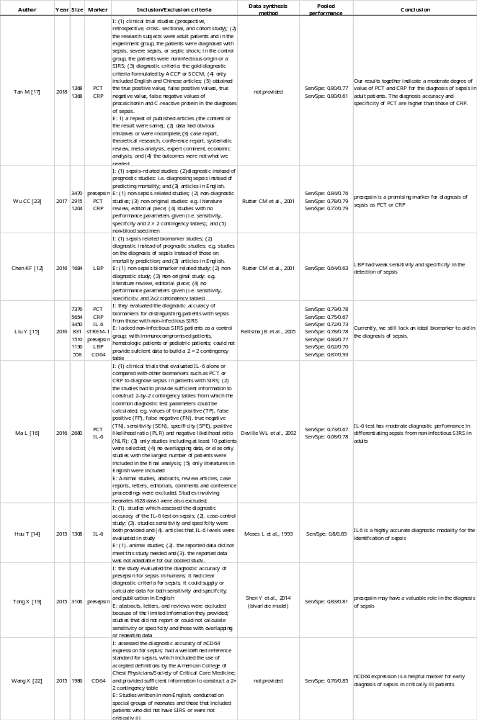
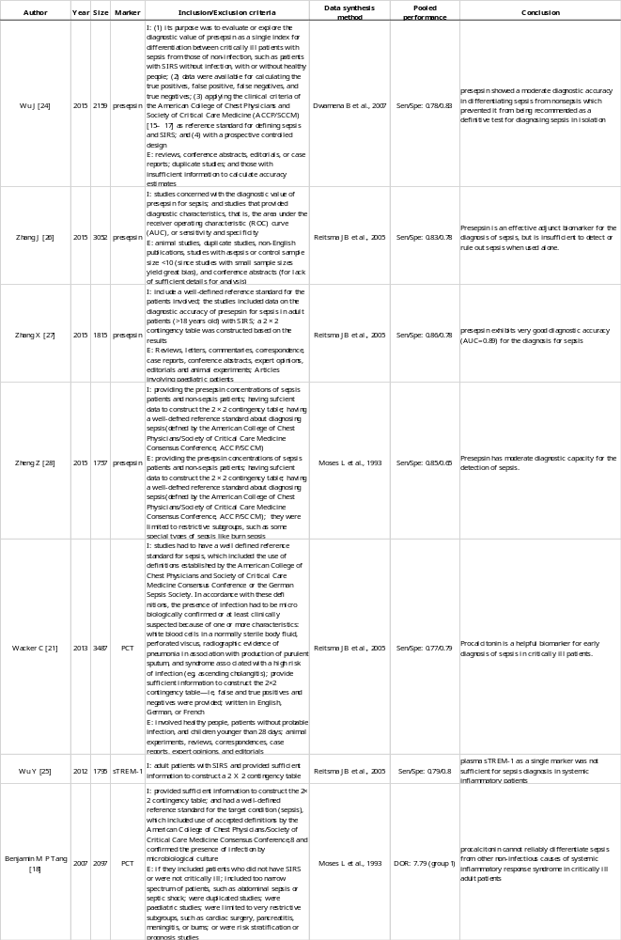
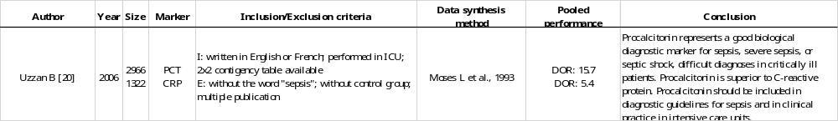
eReferences
1. Greenhalgh DG, Saffle JR, Holmes JHt, et al. American Burn Association consensus conference to define sepsis and infection in burns. J Burn Care Res 2007; 28(6): 776-90.
2. Reitsma JB, Glas AS, Rutjes AW, Scholten RJ, Bossuyt PM, Zwinderman AH. Bivariate analysis of sensitivity and specificity produces informative summary measures in diagnostic reviews. J Clin Epidemiol 2005; 58(10): 982-90.
3. Littenberg B, Moses LE. Estimating diagnostic accuracy from multiple conflicting reports: a new meta-analytic method. Med Decis Making 1993; 13(4): 313-21.
4. Higgins JG, S. Cochrane Handbook for Systematic Reviews of Interventions Version 5.1.0. The Cochrane Collaboration 2011; (Available from www.handbook.cochrane.org).
5. Rutter CM, Gatsonis CA. A hierarchical regression approach to meta-analysis of diagnostic test accuracy evaluations. Stat Med 2001; 20(19): 2865-84.
6. Harbord RM, Deeks JJ, Egger M, Whiting P, Sterne JA. A unification of models for meta-analysis of diagnostic accuracy studies. Biostatistics 2007; 8(2): 239-51.
7. Doebler P, Holling H, Bohning D. A mixed model approach to meta-analysis of diagnostic studies with binary test outcome. Psychol Methods 2012; 17(3): 418-36.
8. Menten J, Lesaffre E. A general framework for comparative Bayesian meta-analysis of diagnostic studies. BMC Med Res Methodol 2015; 15: 70.
9. Brooks SG, A. General Methods for Monitoring Convergence of Iterative Simulations. Journal of Computational and Graphical Statistics 1998; 7: 434-55.
10. Nyaga VN, Aerts M, Arbyn M. ANOVA model for network meta-analysis of diagnostic test accuracy data. Stat Methods Med Res 2018; 27(6): 1766-84.
11. Howell J. Stan Best Practices. stan-dev (Github) https://githubcom/stan-dev/stan/wiki/Stan-Best-Practices 2017.
12. Chen KF, Chaou CH, Jiang JY, et al. Diagnostic Accuracy of Lipopolysaccharide-Binding Protein as Biomarker for Sepsis in Adult Patients: A Systematic Review and Meta-Analysis. PLoS One 2016; 11(4): e0153188.
13. Hayashida K, Kondo Y, Hara Y, Aihara M, Yamakawa K. Head-to-head comparison of procalcitonin and presepsin for the diagnosis of sepsis in critically ill adult patients: a protocol for a systematic review and meta-analysis. BMJ Open 2017; 7(3): e014305.
14. Hou T, Huang D, Zeng R, Ye Z, Zhang Y. Accuracy of serum interleukin (IL)-6 in sepsis diagnosis: a systematic review and meta-analysis. Int J Clin Exp Med 2015; 8(9): 15238-45.
15. Liu Y, Hou JH, Li Q, Chen KJ, Wang SN, Wang JM. Biomarkers for diagnosis of sepsis in patients with systemic inflammatory response syndrome: a systematic review and meta-analysis. Springerplus 2016; 5(1): 2091.
16. Ma L, Zhang H, Yin YL, et al. Role of interleukin-6 to differentiate sepsis from non-infectious systemic inflammatory response syndrome. Cytokine 2016; 88: 126-35.
17. Tan M, Lu Y, Jiang H, Zhang L. The diagnostic accuracy of procalcitonin and C-reactive protein for sepsis: A systematic review and meta-analysis. J Cell Biochem 2019; 120(4): 5852-9.
18. Tang BM, Eslick GD, Craig JC, McLean AS. Accuracy of procalcitonin for sepsis diagnosis in critically ill patients: systematic review and meta-analysis. Lancet Infect Dis 2007; 7(3): 210-7.
19. Tong X, Cao Y, Yu M, Han C. Presepsin as a diagnostic marker for sepsis: evidence from a bivariate meta-analysis. Ther Clin Risk Manag 2015; 11: 1027-33.
20. Uzzan B, Cohen R, Nicolas P, Cucherat M, Perret GY. Procalcitonin as a diagnostic test for sepsis in critically ill adults and after surgery or trauma: a systematic review and meta-analysis. Crit Care Med 2006; 34(7): 1996-2003.
21. Wacker C, Prkno A, Brunkhorst FM, Schlattmann P. Procalcitonin as a diagnostic marker for sepsis: a systematic review and meta-analysis. Lancet Infect Dis 2013; 13(5): 426-35.
22. Wang X, Li ZY, Zeng L, et al. Neutrophil CD64 expression as a diagnostic marker for sepsis in adult patients: a meta-analysis. Crit Care 2015; 19: 245.
23. Wu CC, Lan HM, Han ST, et al. Comparison of diagnostic accuracy in sepsis between presepsin, procalcitonin, and C-reactive protein: a systematic review and meta-analysis. Ann Intensive Care 2017; 7(1): 91.
24. Wu J, Hu L, Zhang G, Wu F, He T. Accuracy of Presepsin in Sepsis Diagnosis: A Systematic Review and Meta-Analysis. PLoS One 2015; 10(7): e0133057.
25. Wu Y, Wang F, Fan X, et al. Accuracy of plasma sTREM-1 for sepsis diagnosis in systemic inflammatory patients: a systematic review and meta-analysis. Crit Care 2012; 16(6): R229.
26. Zhang J, Hu ZD, Song J, Shao J. Diagnostic Value of Presepsin for Sepsis: A Systematic Review and Meta-Analysis. Medicine (Baltimore) 2015; 94(47): e2158.
27. Zhang X, Liu D, Liu YN, Wang R, Xie LX. The accuracy of presepsin (sCD14-ST) for the diagnosis of sepsis in adults: a meta-analysis. Crit Care 2015; 19: 323.
28. Zheng Z, Jiang L, Ye L, Gao Y, Tang L, Zhang M. The accuracy of presepsin for the diagnosis of sepsis from SIRS: a systematic review and meta-analysis. Ann Intensive Care 2015; 5(1): 48.

