Additional file 1
Material Priority Engineered Metal-Polyphenol Networks: Mechanism and Platform for Multifunctionalities
Xinxiu Cheng, ^{§, 1} Yaxin Zhu,^{§, 1} Ruofei Lu,§ Xiaoqiang Zhang,§ Na Li† * and Xingjie Zan¶, §, †*
§Xinjiang Technical Institute of Physics and Chemistry, Chinese Academy of Sciences, Urumqi 830011, P.R. China.
¶School of Ophthalmology and Optometry, Eye Hospital, School of Biomedical Engineering, Wenzhou Medical University 270 Xueyuan Road, Wenzhou 325035, P.R. China.
†Oujiang Laboratory, Wenzhou Institute, University of Chinese Academy of Sciences, Wenzhou 325001, China.
¹Equally contributing authors.
*Corresponding authors. E-mail addresses: X. Zan, xjzan2000@hotmail.com; N. Li, lina0701@ucas.ac.cn.

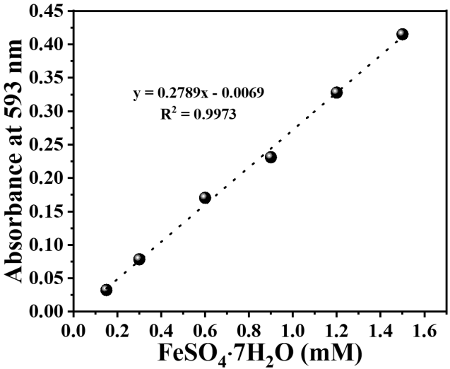
Fig. S1 The standard curve of antioxidant activity.

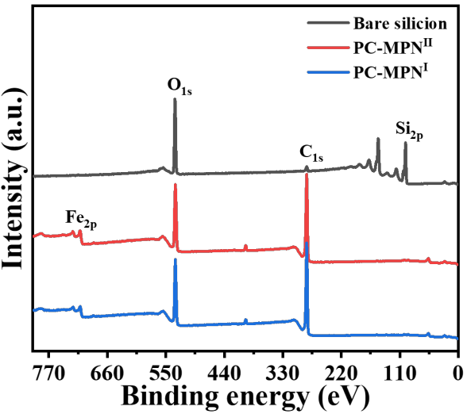
Fig. S2 XPS spectrum of PC-MPN^{Ⅰ} and PC-MPN^{Ⅱ} coatings with 100 deposition cycles.
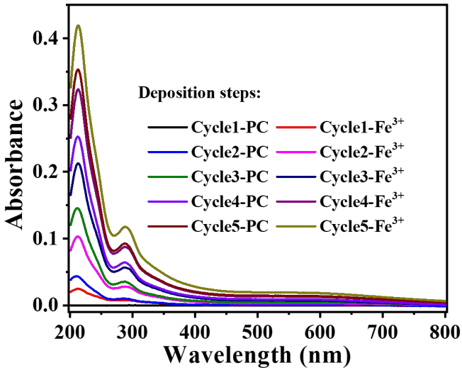
Fig. S3 The growth of PC-MPN^{Ⅰ} coating.
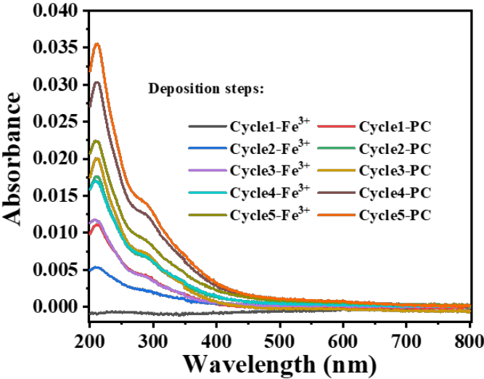
Fig. S4 The growth of PC-MPN^{Ⅱ} coating.
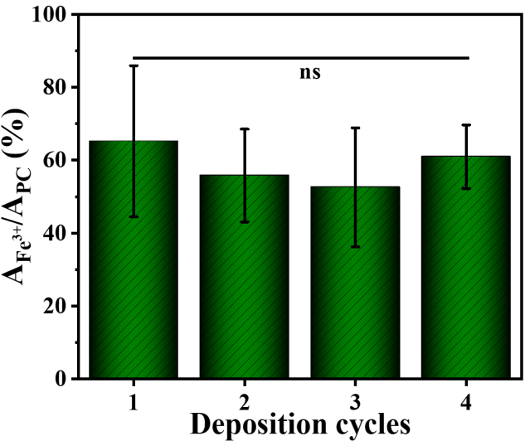
Fig. S5 The decomposition of the PC-MPN^{Ⅱ} coating: A_{Fe}³⁺ and A_{PC} are the decreased absorbance and increased absorbance in the same cycles, respectively.
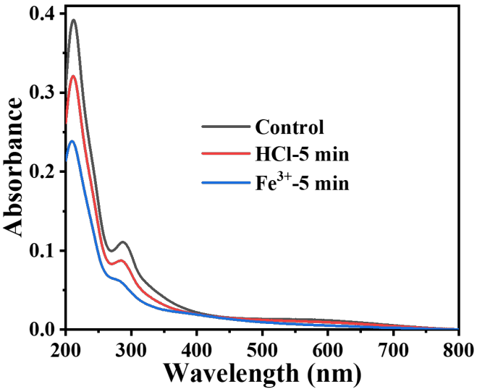
Fig. S6 UV-vis spectrum of PC-MPN^{Ⅰ} coating before and after immersing in to HCl and Fe(NO₃)₃ solutions.
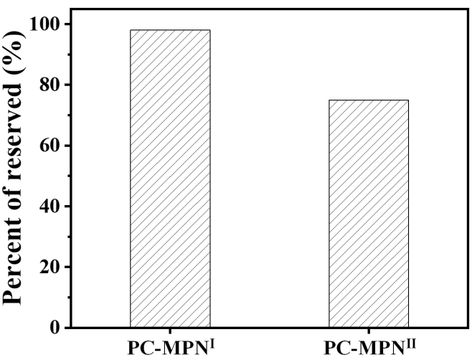
Fig. S7 The percent of reserved thickness of PC-MPN^{Ⅰ} and PC-MPN^{Ⅱ} coatings treated by immersing into in Fe(NO₃)₃ solution for 30 min.
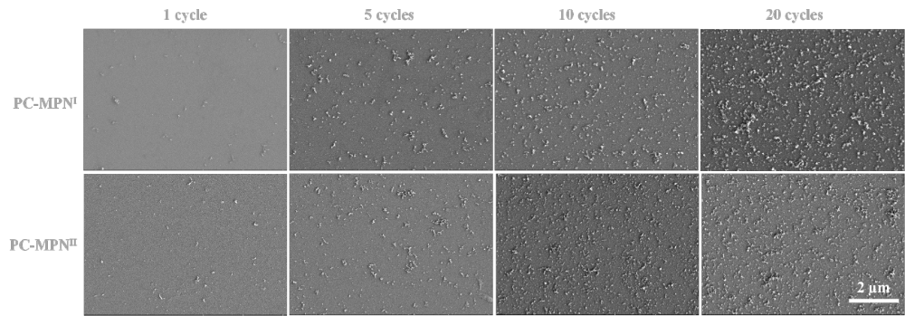
Fig. S8 SEM images of the PC-MPN^{Ⅰ} and PC-MPN^{Ⅱ} coatings in different deposition cycles.
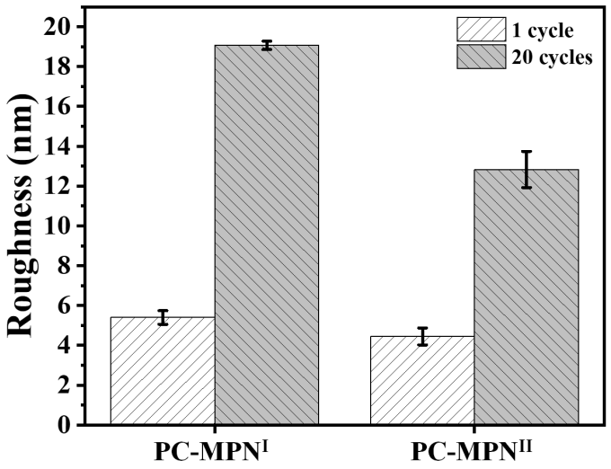
Fig. S9 Roughness of PC-MPN^{Ⅰ} and PC-MPN^{Ⅱ} coatings.

