Supplementary material
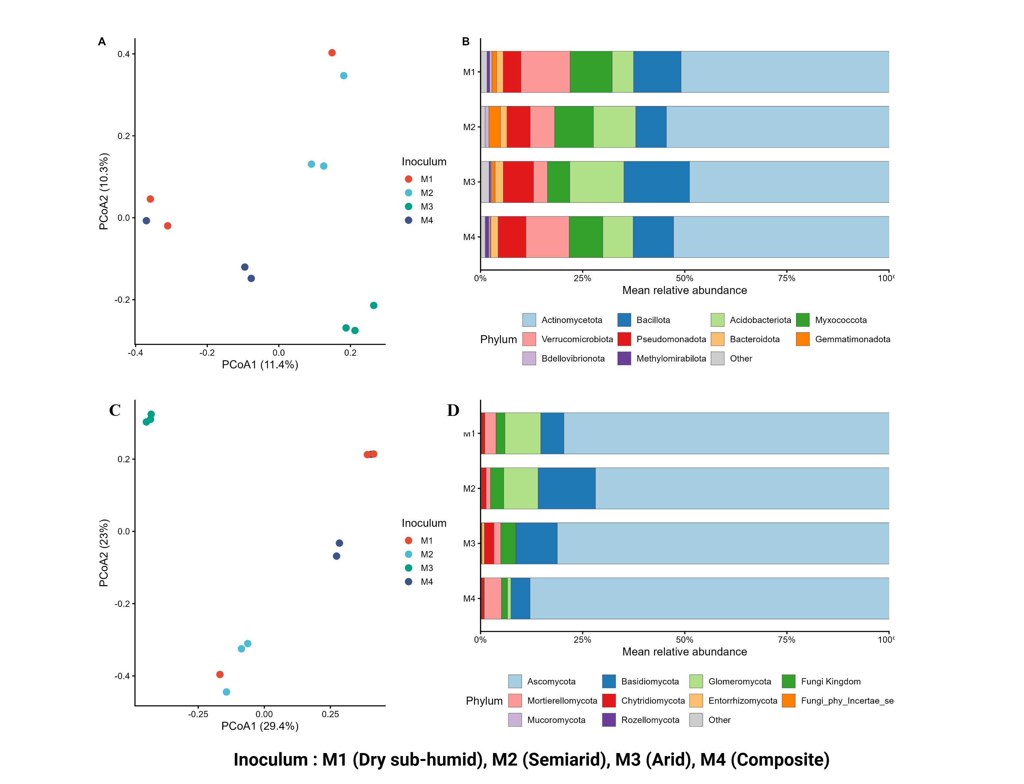
Figure S1. Structure and composition of the donor soil (M1-M4). Principal coordination analysis (PCoA) based on Bray-Curtis analysis of bacterial (A) and fungal (C) communities. Each point represents an individual sample, coloured by inoculum (n=3). The relative abundance of each inoculum of the 10 most abundant bacterial (B) and fungal (D) phyla is reported.

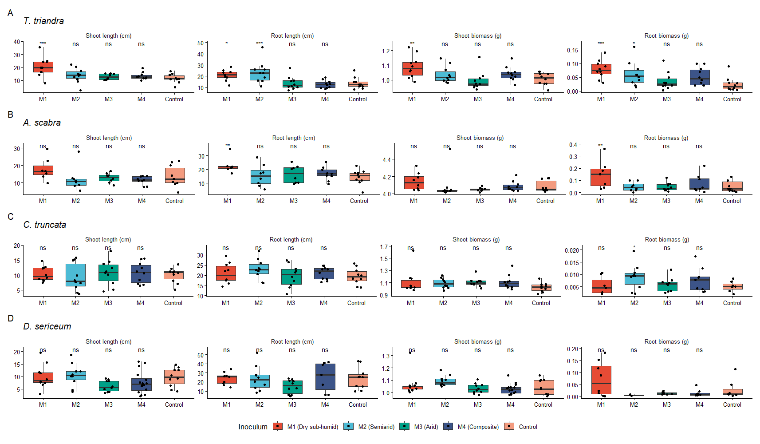
Figure S2. Effects of Themeda triandra-associated donor soil inocula (M1–M4) on growth traits of four native grass species. Panels are arranged with plant traits in columns and grass species in rows: (A) Themeda triandra, (B) Austrostipa scabra, (C) Chloris truncata, and (D) Dichanthium sericeum. Boxplots show the distribution of trait values across treatments. Significance is indicated as *** p < 0.001, ** p < 0.01, * p < 0.05, and ns, p ≥ 0.05.

Table S1. Results from linear mixed-effects models testing the effect of inoculum treatment on plant growth traits. Estimates represent differences between each inoculum treatment and the control. SE denotes the standard error of the estimate, t is the test statistic (estimate/SE), df denotes degrees of freedom, and p is the p value; significant (p < 0.05) values are in bold.
Species | Trait | Inoculum | Estimate | SE | t | df | p
T. triandra | Shoot length | M1 | 8.86 | 2.16 | 4.10 | 44 | <0.001
T. triandra | Shoot length | M2 | 2.33 | 2.16 | 1.08 | 44 | 0.286
T. triandra | Shoot length | M3 | 1.25 | 2.16 | 0.58 | 44 | 0.566
T. triandra | Shoot length | M4 | 1.89 | 2.22 | 0.85 | 44 | 0.399
T. triandra | Root length | M1 | 7.01 | 2.63 | 2.66 | 41 | 0.011
T. triandra | Root length | M2 | 9.52 | 2.63 | 3.62 | 41 | <0.001
T. triandra | Root length | M3 | -0.11 | 2.63 | -0.04 | 41 | 0.967
T. triandra | Root length | M4 | -1.13 | 2.63 | -0.43 | 41 | 0.670
T. triandra | Shoot biomass | M1 | 0.081 | 0.026 | 3.12 | 45 | 0.003
T. triandra | Shoot biomass | M2 | 0.027 | 0.026 | 1.04 | 45 | 0.304
T. triandra | Shoot biomass | M3 | -0.014 | 0.026 | -0.54 | 45 | 0.593
T. triandra | Shoot biomass | M4 | 0.033 | 0.026 | 1.27 | 45 | 0.211
T. triandra | Root biomass | M1 | 0.054 | 0.015 | 3.63 | 41 | <0.001
T. triandra | Root biomass | M2 | 0.037 | 0.015 | 2.45 | 41 | 0.019
T. triandra | Root biomass | M3 | 0.012 | 0.015 | 0.77 | 41 | 0.445
T. triandra | Root biomass | M4 | 0.028 | 0.015 | 1.89 | 41 | 0.066
A. scabra | Shoot length | M1 | 4.12 | 2.55 | 1.61 | 37 | 0.116
A. scabra | Shoot length | M2 | -1.59 | 2.46 | -0.65 | 37 | 0.522
A. scabra | Shoot length | M3 | -0.89 | 2.46 | -0.36 | 37 | 0.719
A. scabra | Shoot length | M4 | -2.34 | 2.38 | -0.98 | 37 | 0.332
A. scabra | Root length | M1 | 8.00 | 2.68 | 2.99 | 33.6 | 0.005
A. scabra | Root length | M2 | 0.84 | 2.56 | 0.33 | 33.2 | 0.745
A. scabra | Root length | M3 | 2.68 | 2.56 | 1.05 | 33.2 | 0.301
A. scabra | Root length | M4 | 2.87 | 2.47 | 1.16 | 33.1 | 0.254
A. scabra | Shoot biomass | M1 | 0.066 | 0.043 | 1.53 | 36 | 0.135
A. scabra | Shoot biomass | M2 | 0.008 | 0.042 | 0.20 | 35.9 | 0.844
A. scabra | Shoot biomass | M3 | -0.033 | 0.043 | -0.76 | 36 | 0.453
A. scabra | Shoot biomass | M4 | 0.001 | 0.040 | 0.02 | 35.7 | 0.980
A. scabra | Root biomass | M1 | 0.101 | 0.030 | 3.30 | 35.1 | 0.002
A. scabra | Root biomass | M2 | 0.000 | 0.029 | -0.01 | 34.3 | 0.994
A. scabra | Root biomass | M3 | -0.004 | 0.027 | -0.16 | 34 | 0.873
A. scabra | Root biomass | M4 | 0.021 | 0.029 | 0.72 | 34.3 | 0.477
C. truncata | Shoot length | M1 | 0.37 | 1.46 | 0.25 | 41 | 0.801
C. truncata | Shoot length | M2 | -0.74 | 1.46 | -0.51 | 41 | 0.614
C. truncata | Shoot length | M3 | 0.77 | 1.46 | 0.53 | 41 | 0.600
C. truncata | Shoot length | M4 | 0.74 | 1.46 | 0.51 | 41 | 0.614
C. truncata | Root length | M1 | 1.35 | 2.04 | 0.66 | 45 | 0.512
C. truncata | Root length | M2 | 3.49 | 2.04 | 1.71 | 45 | 0.094
C. truncata | Root length | M3 | 0.15 | 2.04 | 0.07 | 45 | 0.942
C. truncata | Root length | M4 | 1.44 | 2.04 | 0.71 | 45 | 0.484
C. truncata | Shoot biomass | M1 | 0.085 | 0.051 | 1.65 | 41 | 0.106
C. truncata | Shoot biomass | M2 | 0.066 | 0.051 | 1.28 | 41 | 0.206
C. truncata | Shoot biomass | M3 | 0.082 | 0.051 | 1.60 | 41 | 0.118
C. truncata | Shoot biomass | M4 | 0.088 | 0.051 | 1.71 | 41 | 0.094
C. truncata | Root biomass | M1 | 0.092 | 1.942 | 0.05 | 34.9 | 0.963
C. truncata | Root biomass | M2 | 3.615 | 1.749 | 2.07 | 33.8 | 0.046
C. truncata | Root biomass | M3 | 0.570 | 1.799 | 0.32 | 34.1 | 0.753
C. truncata | Root biomass | M4 | 2.314 | 1.799 | 1.29 | 34.1 | 0.207
D. sericeum | Shoot length | M1 | 0.28 | 1.82 | 0.15 | 51 | 0.878
D. sericeum | Shoot length | M2 | 0.89 | 1.82 | 0.49 | 51 | 0.627
D. sericeum | Shoot length | M3 | -3.53 | 1.82 | -1.94 | 51 | 0.058
D. sericeum | Shoot length | M4 | -2.09 | 1.64 | -1.27 | 51 | 0.208
D. sericeum | Root length | M1 | -0.45 | 5.23 | -0.09 | 41 | 0.932
D. sericeum | Root length | M2 | -0.32 | 5.09 | -0.06 | 41 | 0.950
D. sericeum | Root length | M3 | -9.24 | 5.09 | -1.82 | 41 | 0.077
D. sericeum | Root length | M4 | 1.38 | 5.61 | 0.25 | 41 | 0.807
D. sericeum | Shoot biomass | M1 | 0.025 | 0.026 | 0.96 | 49 | 0.344
D. sericeum | Shoot biomass | M2 | 0.052 | 0.026 | 1.99 | 49 | 0.052
D. sericeum | Shoot biomass | M3 | -0.010 | 0.026 | -0.38 | 49 | 0.704
D. sericeum | Shoot biomass | M4 | -0.011 | 0.024 | -0.46 | 49 | 0.647
D. sericeum | Root biomass | M1 | 0.043 | 0.022 | 1.98 | 27 | 0.058
D. sericeum | Root biomass | M2 | -0.024 | 0.034 | -0.71 | 27 | 0.486
D. sericeum | Root biomass | M3 | -0.016 | 0.023 | -0.72 | 27 | 0.479
D. sericeum | Root biomass | M4 | -0.015 | 0.022 | -0.69 | 27 | 0.497

Table S2. PERMANOVA results testing the effects of plant species and inoculum source on bacterial and fungal community composition, based on Bray–Curtis dissimilarities and 999 permutations. (a) Global model testing plant species, inoculum source and their interaction. (b) Separate one-way models testing inoculum source within each plant species. R² represents the proportion of variation explained by each term. Significant p-values (p < 0.05) are shown in bold.
Model term/  plant species | Bacteria |  |  | Fungi
Model term/  plant species | R² | Pseudo-F | p | R² | Pseudo-F | p
(a) Global model
Plant species | 0.053 | 3.50 | 0.001 | 0.097 | 6.84 | 0.001
Inoculum source | 0.071 | 1.57 | 0.001 | 0.092 | 2.17 | 0.001
Plant species * inoculum source | 0.070 | 1.54 | 0.001 | 0.056 | 1.32 | 0.038
(b) Inoculum effect within plant species
T. triandra | 0.163 | 2.01 | 0.001 | 0.193 | 2.47 | 0.001
A. scabra | 0.130 | 1.10 | 0.051 | 0.138 | 1.17 | 0.093

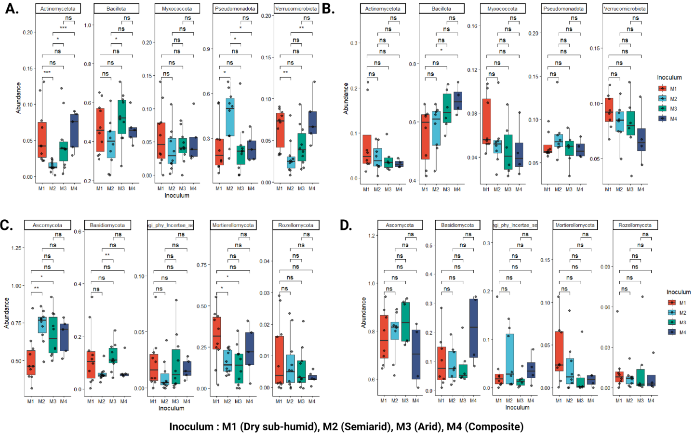
Figure S3. Relative abundance of top 5 bacterial and fungal phyla. Boxplots illustrating the relative abundance of bacterial and fungal phyla across various inocula (M1–M4) associated with T. triandra (A, C) and A. scabra (B, D). Statistical significance between groups is denoted as p < 0.05 (*), p < 0.01 (**), p < 0.001 (***), marginal significance p < 0.10 (.), and not significant p ≥ 0.05, n.s.

Table S3. Redundancy analysis (RDA) results and Pearson correlations between forward-selected microbial phyla and plant traits in Themeda triandra. Adjusted R² and p-values are shown for the global and final models. Asterisks indicate significant Pearson (r) correlations (p < 0.05).
Microbial group | Global model: adj. R² | Global model: p | Selected phylum | Final model: adj. R² | Final model: p | Shoot length (r) | Root length (r) | Shoot biomass (r) | Root biomass (r)
Bacteria | 0.115 | 0.049 | Pseudomonadota | 0.096 | 0.008* | −0.07 | 0.58* | 0.01 | 0.38*
Fungi | 0.121 | 0.042 | Mortierellomycota | 0.053 | 0.044* | 0.29 | 0.08 | 0.32 | 0.37*

