Extended Data Fig. 1 | Extended kinetic trace (1-30 s) that shows substrate turnover by reduced Mb-L29I/H64G/V68A (FerrElCat). Reaction was monitored using stopped-flow at pH 8.0 for 30 s at 25 °C with 140 µM of 5-NBI and 5 nM of FerrElCat.

Extended Data Fig. 2 | Catalytic parameters of Kemp eliminases evolved using directed evolution: k_{cat}/K_{M} values for the evolved enzymes (left) and improvement in k_{cat}/K_{M} achieved by directed evolution (right).

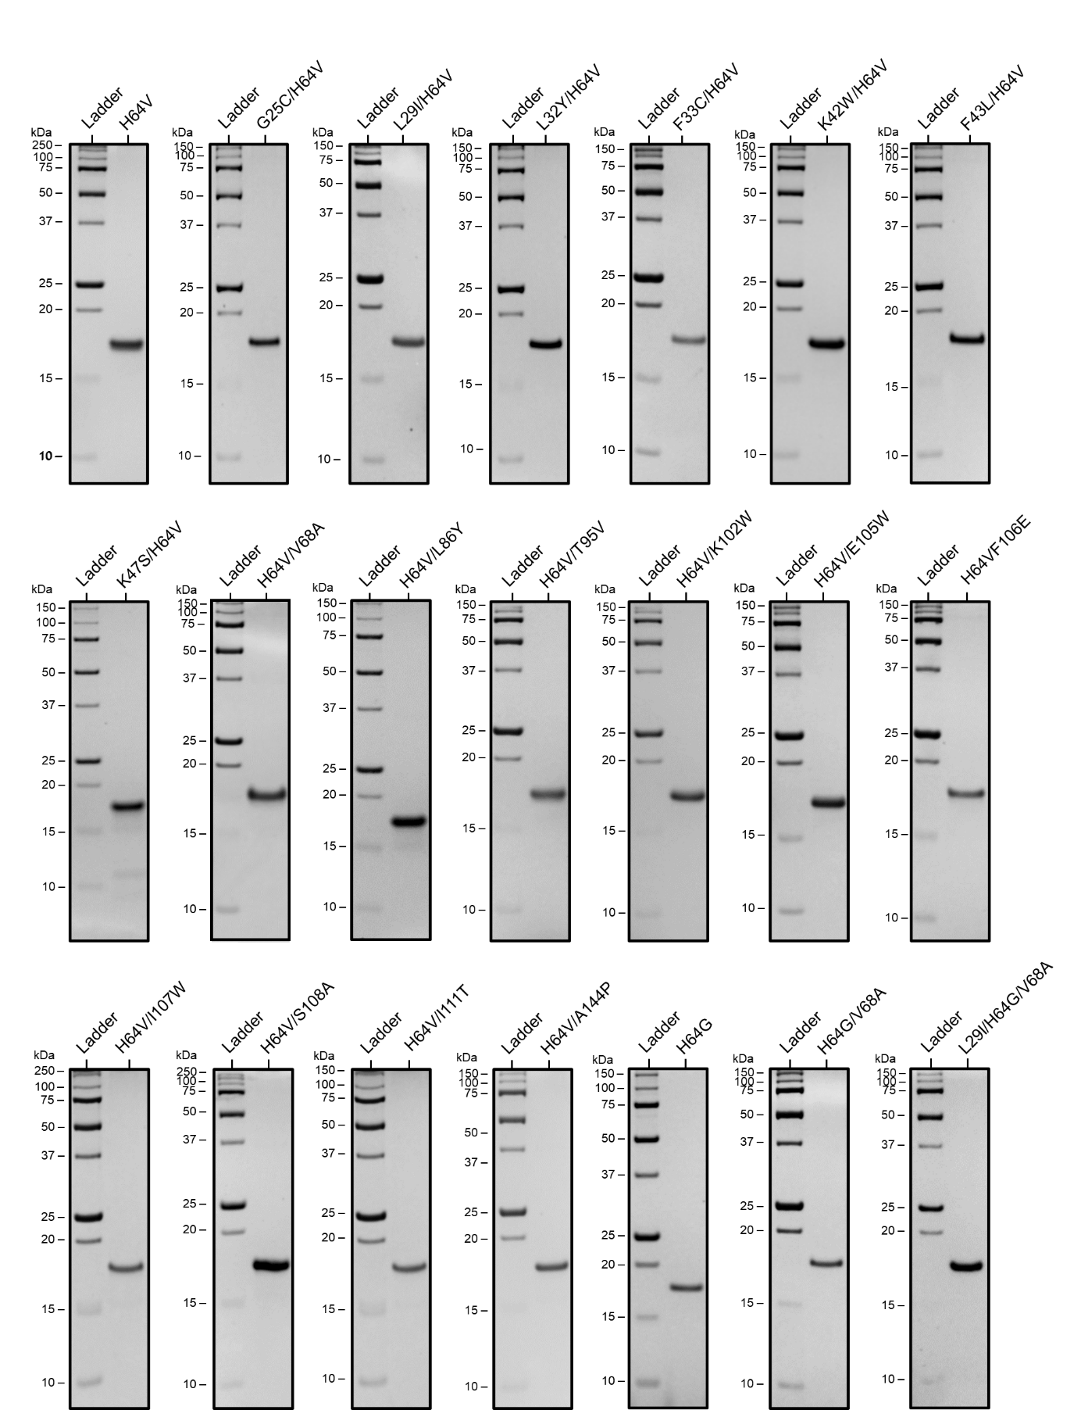

Extended Data Fig. 3 | SDS-PAGE (15%) analysis of myoglobin mutants used in this study.

Extended Data Fig. 4 | Absorbance spectra of Mb-H64V (left) and Mb-L29I/H64G/V68A (FerrElCat) (right) in the oxidized (black) and reduced (red) forms.

Extended Data Fig. 5 | Michaelis-Menten plots of Kemp elimination catalyzed by reduced (unless otherwise stated) myoglobin mutants. Final reaction mixtures contained 1 mM L-ascorbic acid, 0.1 µM SOD, 20 nM catalase, 140-840 µM substrate, 1.5% acetonitrile in 20 mM TRIS (pH 8.0). The protein concentration was 1 µM for Mb-H64V, 0.1 or 0.25 µM for Mb-H64V-based double variants, 5 nM for Mb-H64G or Mb-H64G-based double or triple variants (Extended Data Table S2).

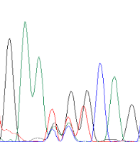  W7NNK  * * * | 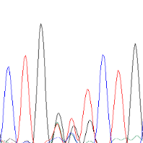  V10NNK  * * * | 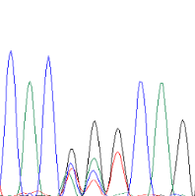  G25NNK  * * * | 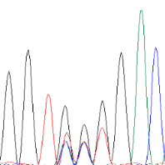  Q26NNK  * * * | 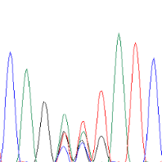  D27NNK  * * * | 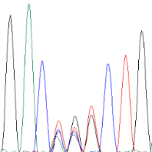  I28NNK  * * *
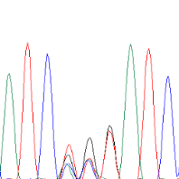  L29NNK  * * * | 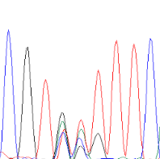  L32NNK  * * * | 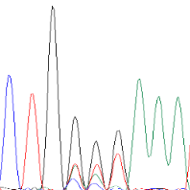  F33NNK  * * * | 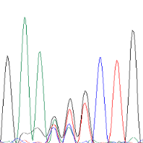  T39NNK  * * * | 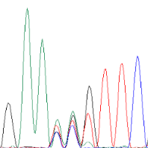  K42NNK  * * * | 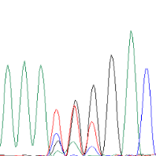  F43NNK  * * *
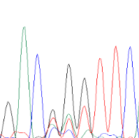  R45NNK  * * * | 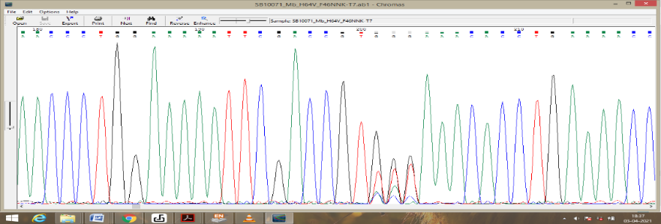  F46NNK  * * * | 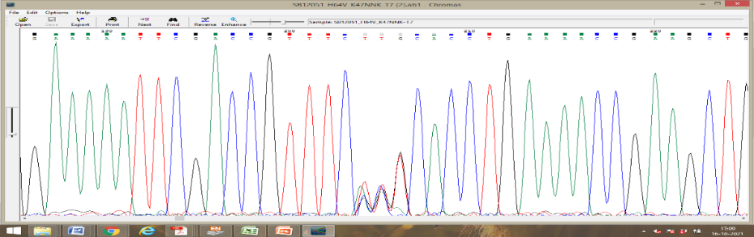  K47NNK  * * * | 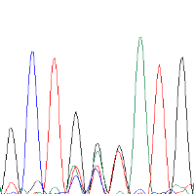  E54NNK  * * * | 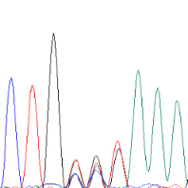  K62NNK  * * * | 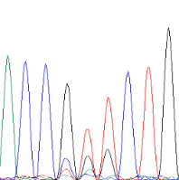  V68NNK  * * *
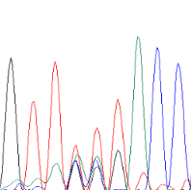  L69NNK  * * * | 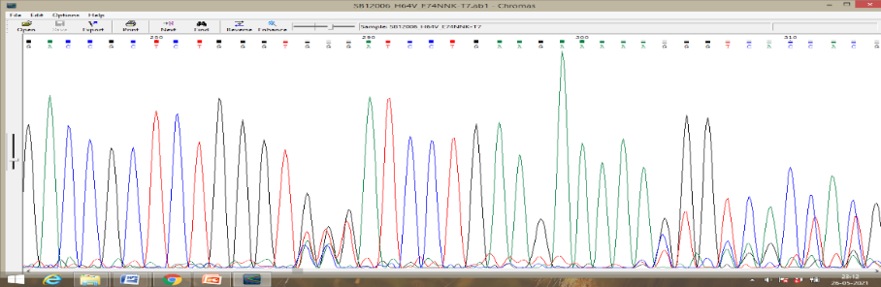  A74NNK  * * * | 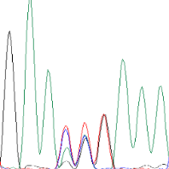  L86NNK  * * * | 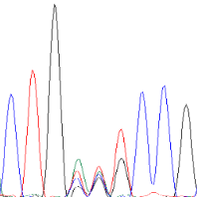  K87NNK  * * * | 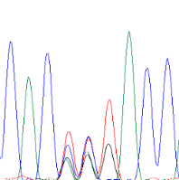  A94NNK  * * * | 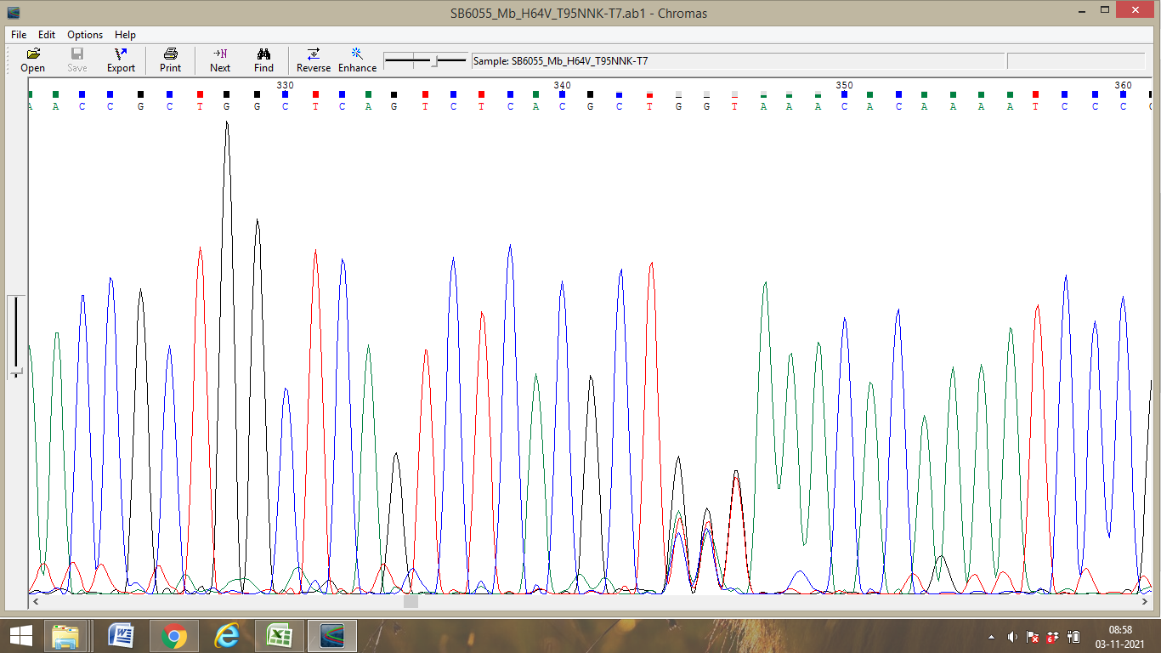  T95NNK  * * *
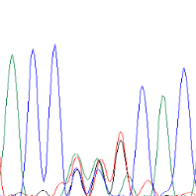  K96NNK  * * * | 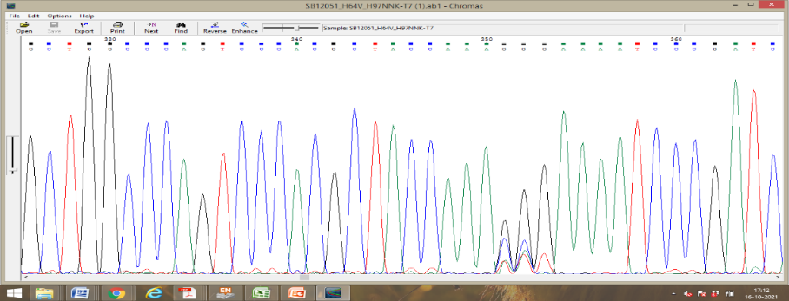  H97NNK  * * * | 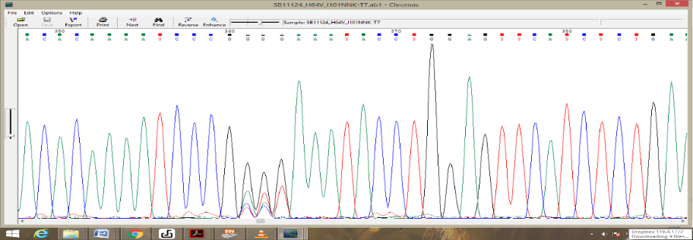  I101NNK  * * * | 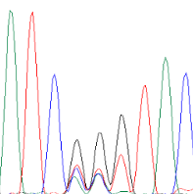  K102NNK  * * * | 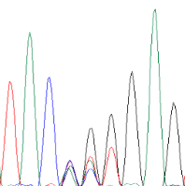  L104NNK  * * * | 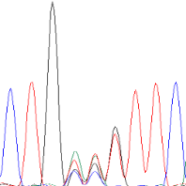  E105NNK  * * *
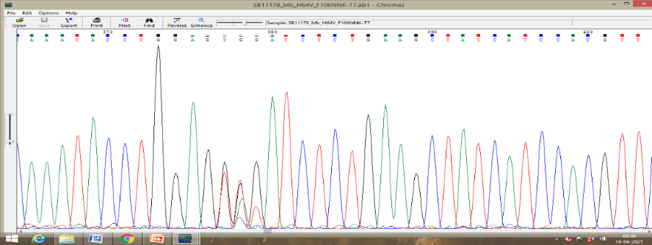  F106NNK  * * * | 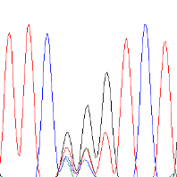  I107NNK  * * * | 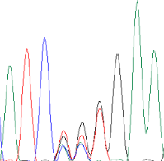  S108NNK  * * * | 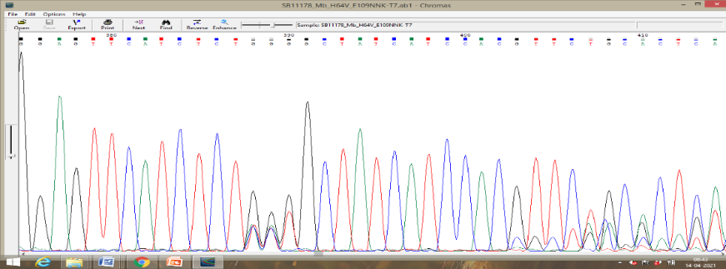  E109NNK  * * * | 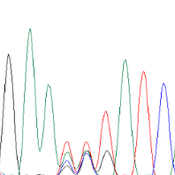  A110NNK  * * * | 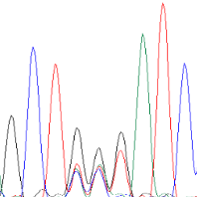  I111NNK  * * *
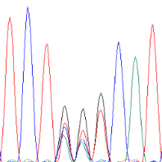  R118NNK  * * * | 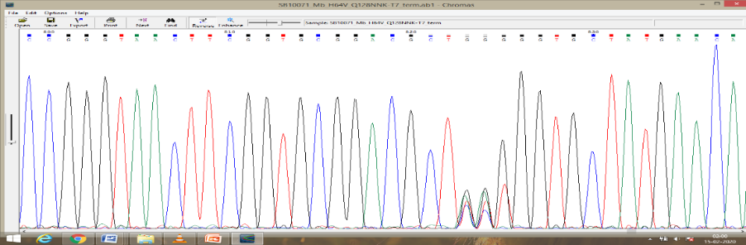  Q128NNK  * * * | 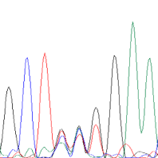  L135NNK  * * * | 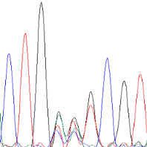  F138NNK  * * * | 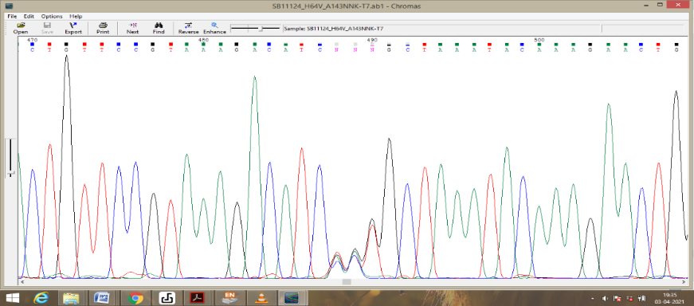  A143NNK  * * * | 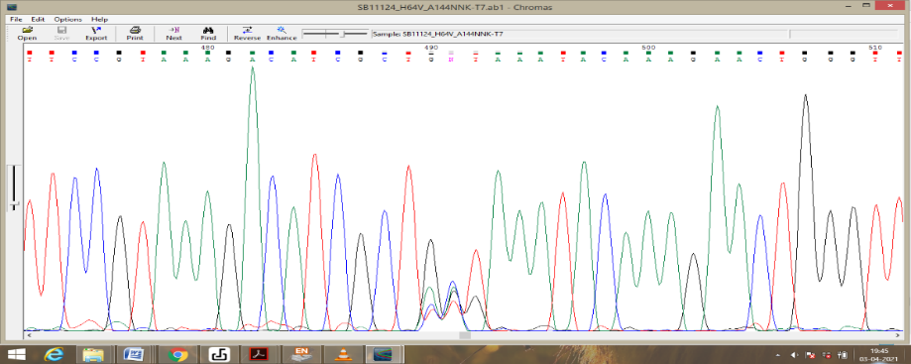  A144NNK  * * *
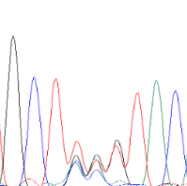  K145NNK  * * * | 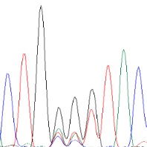  G150NNK  * * * | 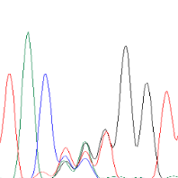  Q152NNK  * * * | 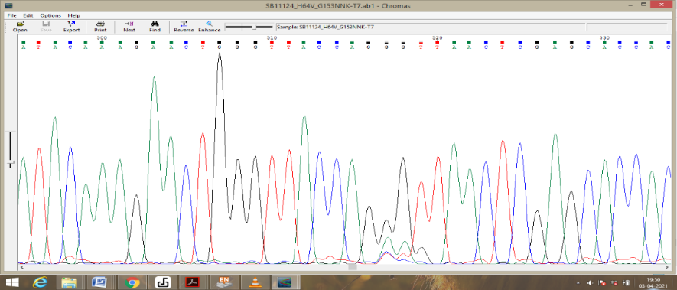  G153NNK  * * *

Extended Data Fig. 6 | Sequencing chromatograms of NNK-based libraries at specific positions in Mb-H64V. Nucleobases: A, green; C, blue; G, black, T, red. Randomized positions are marked with the asterisks.

Extended Data Fig. 7 | CD spectra for myoglobin mutants in oxidized (black) and reduced (red) forms at pH 8.0.

Extended Data Table 1 | Sequences of myoglobin mutants used in this study

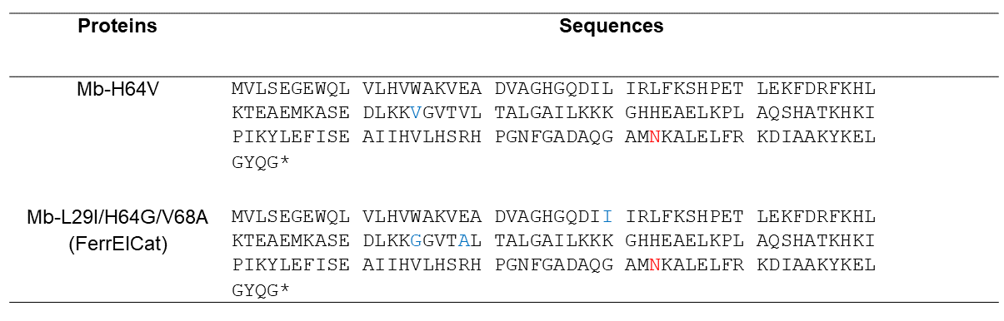

Extended Data Table 2 | Kinetic parameters for the Kemp elimination reaction catalyzed by myoglobin variants in the reduced state (unless otherwise stated)

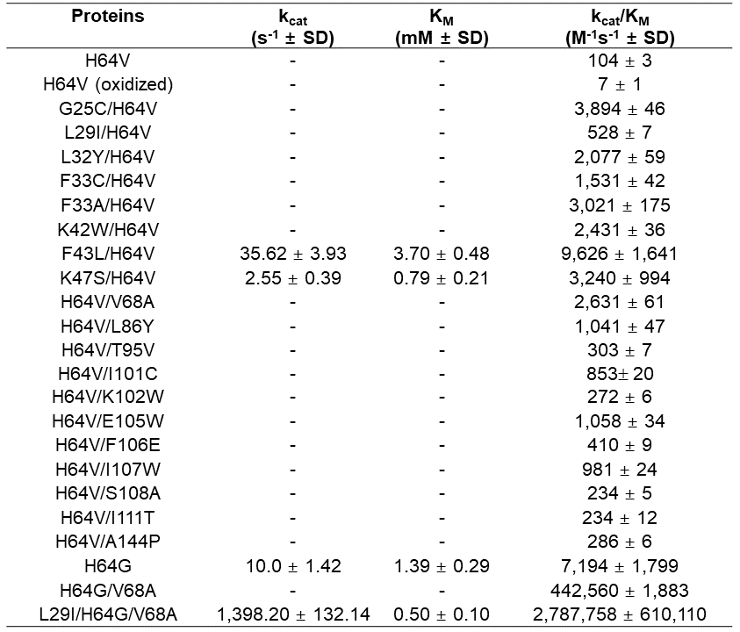

Extended Data Table 3 | Crystallographic data collection and refinement statistics for Mb-L29I/H64G/V68A (FerrElCat)
*Values in parentheses are for highest-resolution shell.

