Contents
Figures
Supplementary Fig. 1 | Multi view PA reconstructions of mouse abdomen.
Supplementary Fig. 2 | The reconstruction results of multi view in vivo rat liver with PA-SfM algorithm.
Supplementary Fig. 3 | The reconstruction results of PA-SfM multi-view in vivo data before and after the global differentiable pose fine-tuning.
Supplementary Fig. 4 | The comparison of PA-SfM multi-view reconstruction results and PA signals before and after the global differentiable pose fine-tuning.
Supplementary Fig. 5 | Freehand simulation geometry and acquisition overlap.
Supplementary Fig. 6 | Complete simulation comparison for Vessel 1.
Supplementary Fig. 7 | Complete simulation comparison for Vessel 2.
Supplementary Fig. 8 | Complete simulation comparison for Vessel 3.
Supplementary Fig. 9 | The comparison of joint reconstruction results with and without peripheral intensity compensation.
Notes
Supplementary Note 1 | Analytical expression for spherically symmetric photoacoustic sources: theoretical foundation for the differentiable acoustic radiation.
Supplementary Note 2 | Effect of global differentiable pose fine-tuning on in vivo PA-SfM reconstruction.
Supplementary Note 3 | Analysis of global differentiable pose fine-tuning in the simulation study.
Supplementary Note 4 | Multi-density freehand simulations and Image-based comparison.
Supplementary Note 5 | Effect of peripheral intensity compensation on expanded FOV freehand PA-SfM reconstruction.
Supplementary Note 6 | Computational efficiency.
Supplementary Note 7 | Usage instructions for the open-source PA-SfM automated workflow.
Tables
Supplementary Table 1 | Pose error, reconstruction quality and estimation time for Vessel 1.
Supplementary Table 2 | Pose error, reconstruction quality and estimation time for Vessel 2.
Supplementary Table 3 | Pose error, reconstruction quality and estimation time for Vessel 3.
Supplementary Table 4 | Results averaged across vascular samples and detector counts at each scan speed.
Movies
Supplementary Movie 1 | Video demonstration of the freehand hand imaging experiment procedure.
Supplementary Movie 2 | The PA-SfM joint reconstruction of the hand vessel.
Supplementary Movie 3 | Freehand scanning geometry and progressive field-of-view extension.
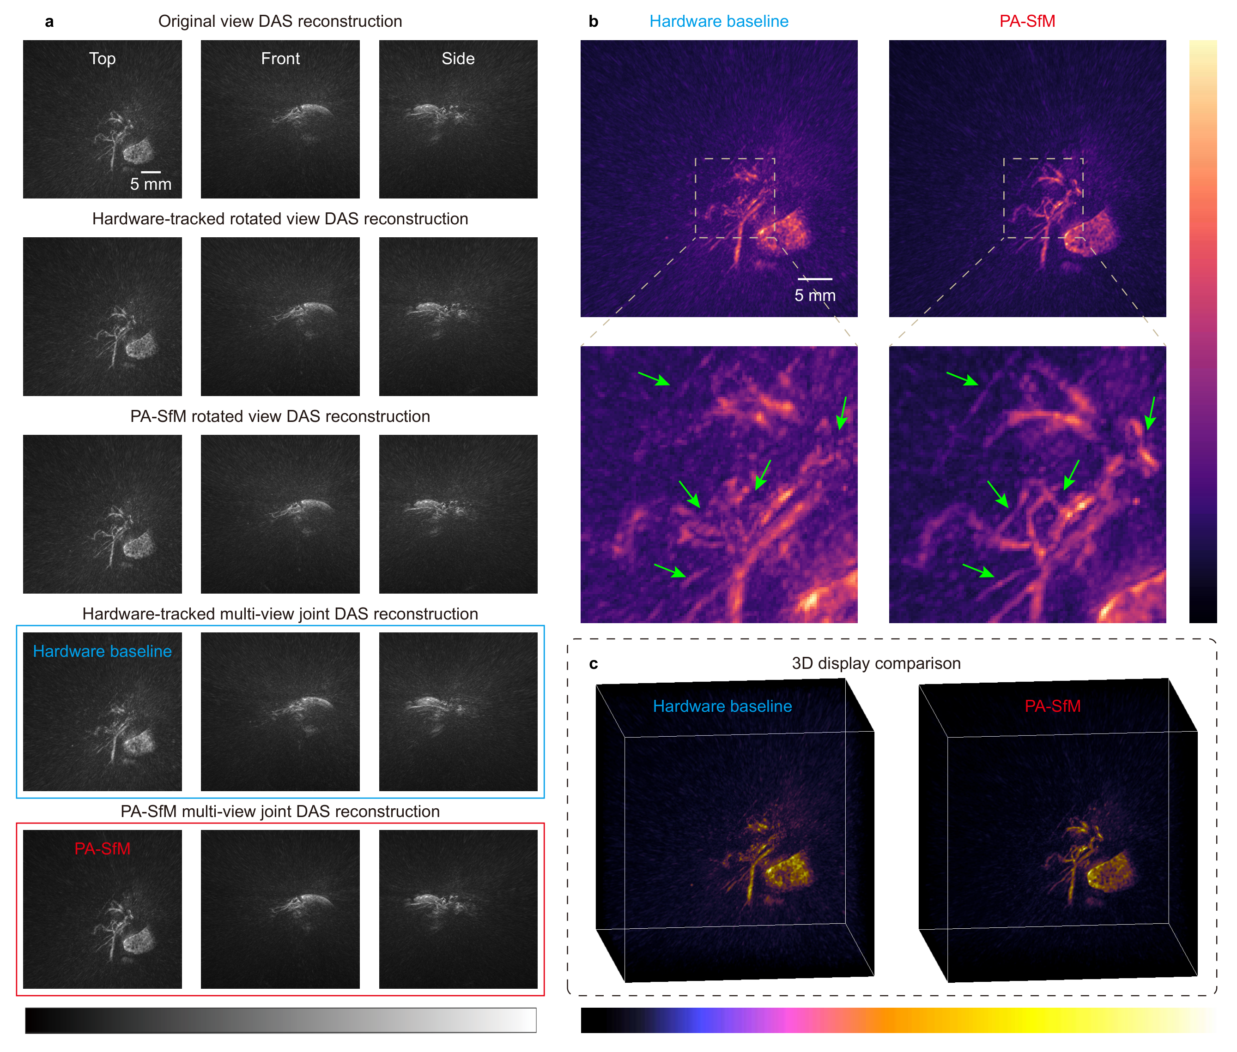
Supplementary Fig. 1 | Multi view PA reconstructions of mouse abdomen. a Top-, front-, and side view MAPs of reconstructions from single views (original, hardware-tracked and PA-SfM rotated) and multi views (hardware-tracked baseline, and PA-SfM result) (Scale: 5 mm; grayscale; reconstruction with DAS). b Locally magnified top view MAPs comparing the hardware-tracked baseline and PA-SfM fine tuned reconstruction (Scale: 5 mm; colormap: magma). c 3D display comparing hardware-tracked and PA-SfM reconstructions.
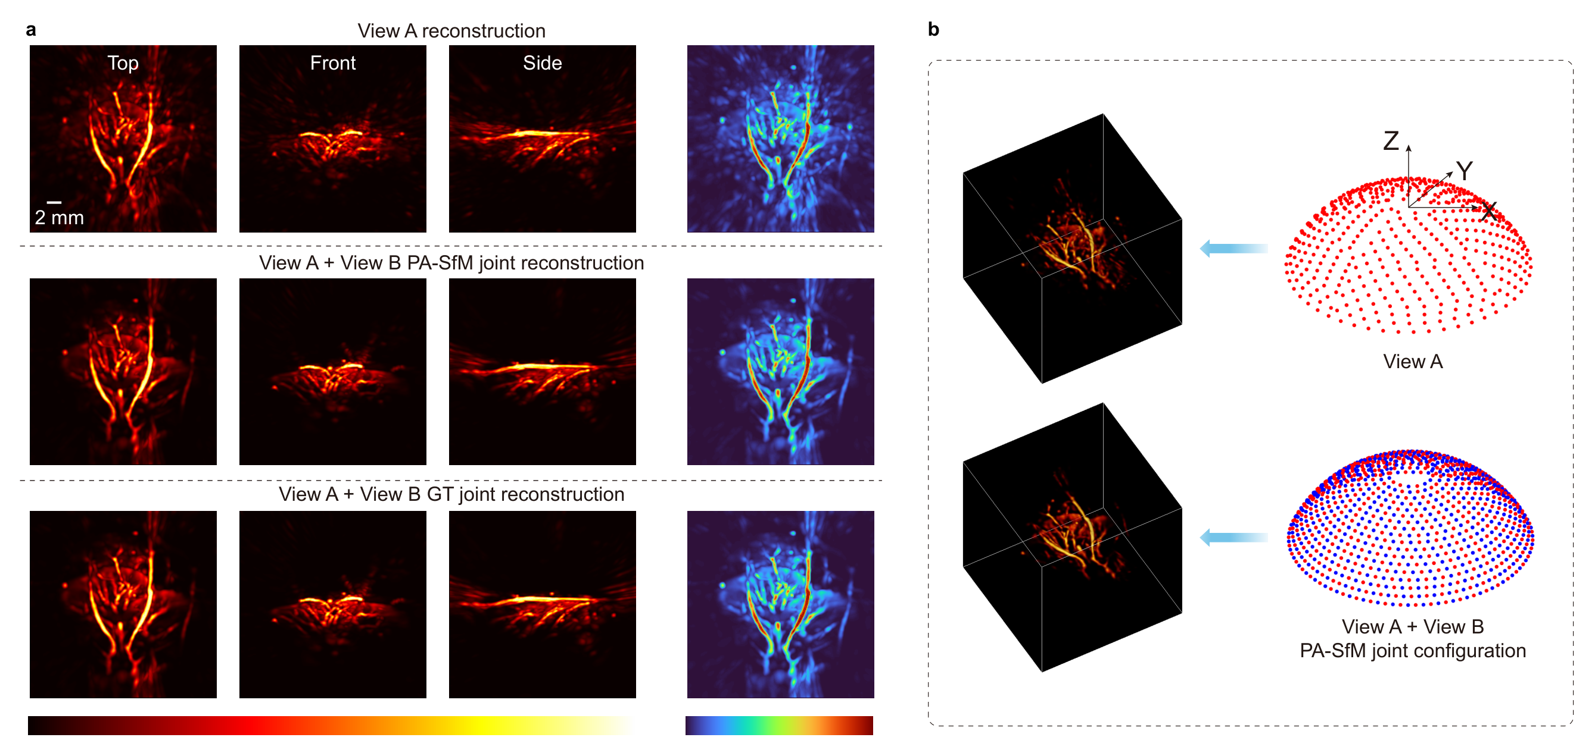
Supplementary Fig. 2 | The reconstruction results of multi view in vivo rat liver with PA-SfM algorithm. a The single view reconstruction, multi view reconstruction using the PA-SfM pose, and GT of the in vivo rat liver (Scale: 2 mm). b The 3D results of single view, and PA-SfM multi view reconstruction.
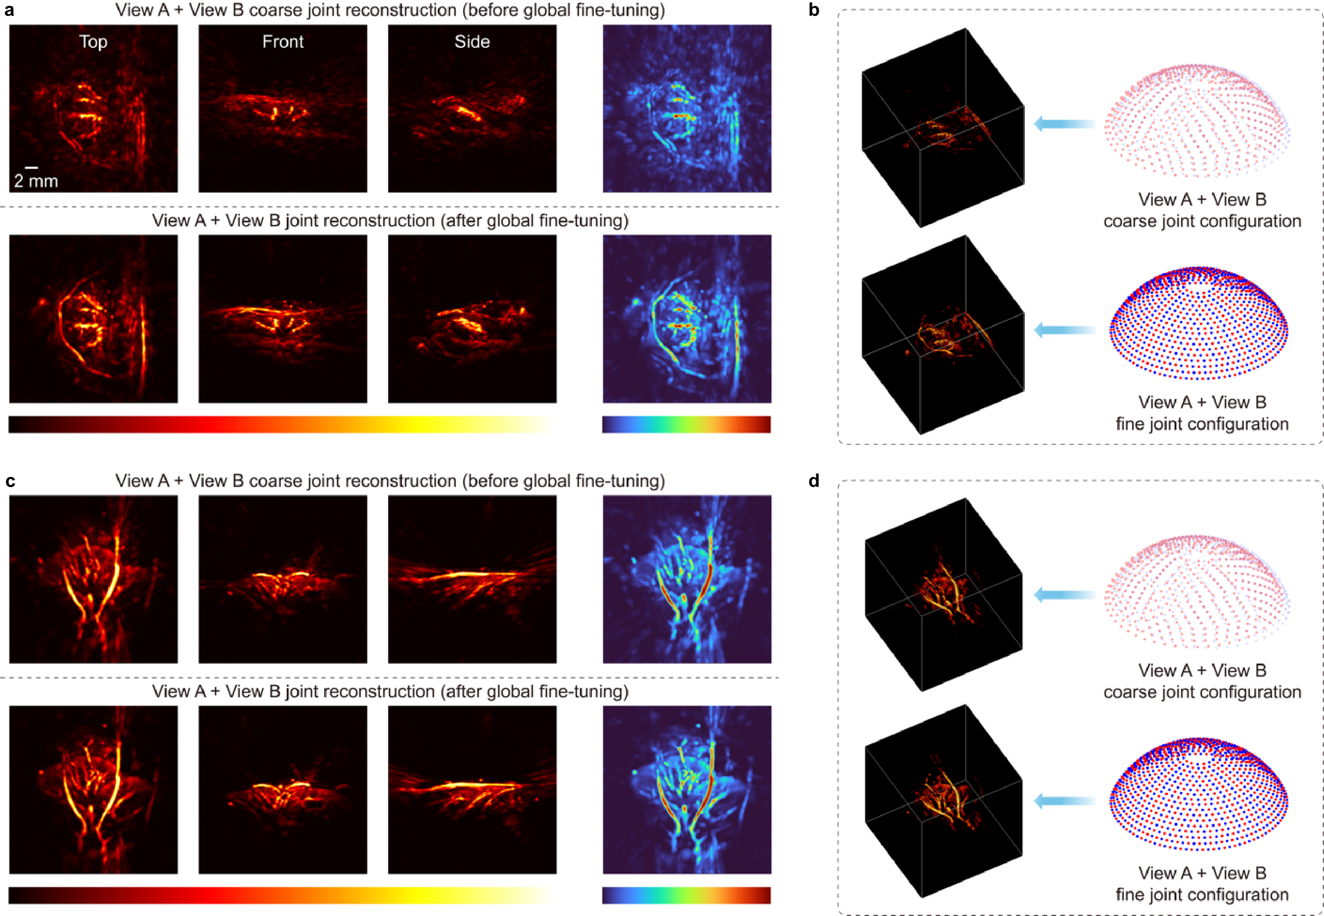
Supplementary Fig. 3 | The reconstruction results of PA-SfM multi-view in vivo data before and after the global differentiable pose fine-tuning. a The PA-SfM multi-view reconstruction of the in vivo rat kidney using the pose before and after global fine-tuning (Scale: 2 mm). b The 3D results of PA-SfM multi-view in vivo rat kidney reconstruction before and after the global differentiable pose fine-tuning. c The PA-SfM multi-view reconstruction of the in vivo rat liver using the pose before and after global fine-tuning (Scale: 2 mm). d The 3D results of PA-SfM multi-view in vivo rat liver reconstruction before and after the global differentiable pose fine-tuning.
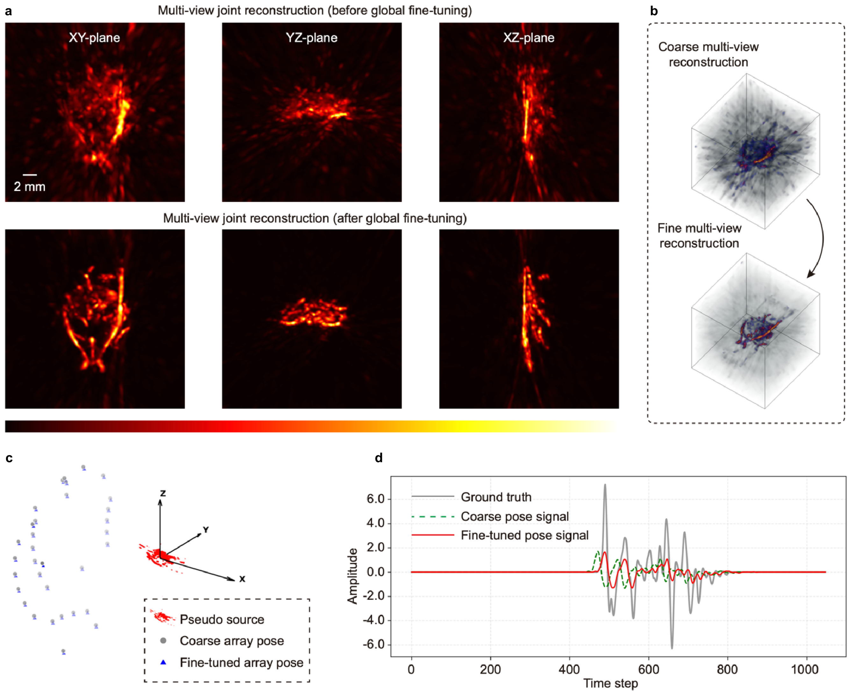
Supplementary Fig. 4 | The comparison of PA-SfM multi-view reconstruction results and PA signals before and after the global differentiable pose fine-tuning. a The PA-SfM multi-view reconstruction of the phantom liver using the pose before and after global fine-tuning (Scale: 2 mm). b The 3D results of PA-SfM multi-view reconstruction before and after the global differentiable pose fine-tuning. c Global differentiable pose fine-tuning of the new pose. d The PA signal of the target sensor before and after the global differentiable pose fine-tuning.
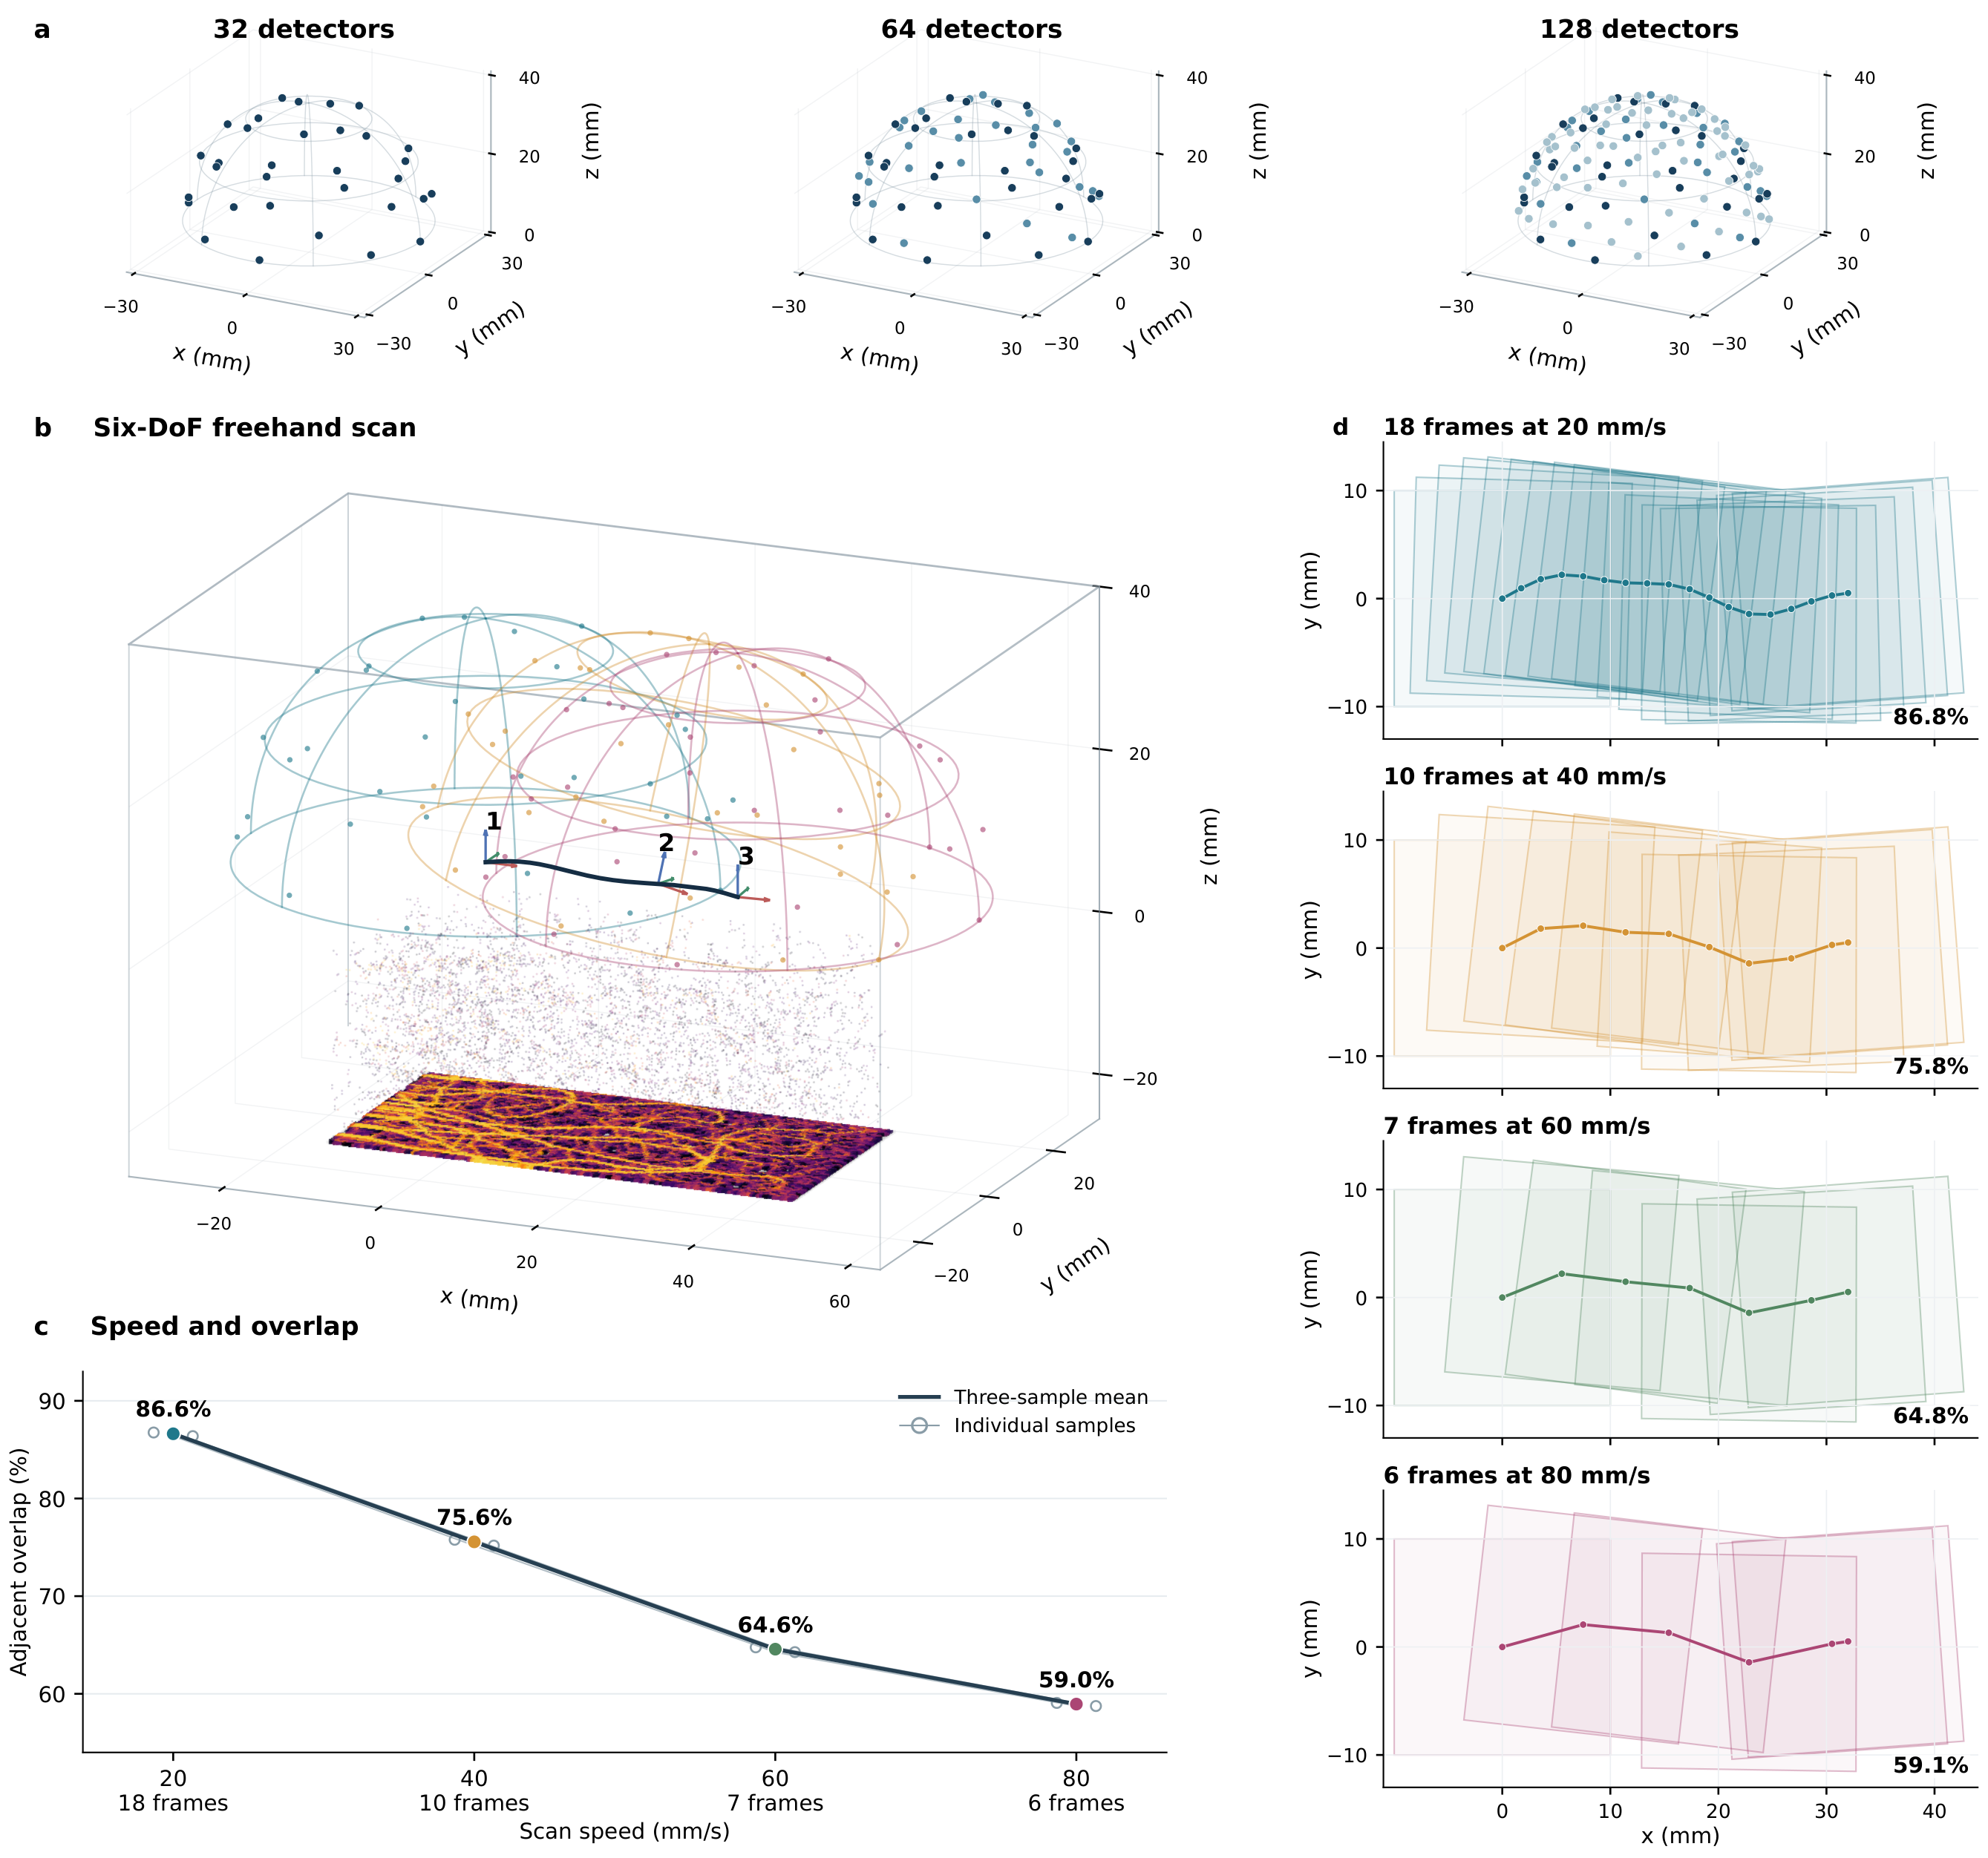
Supplementary Fig. 5 | Freehand simulation geometry and acquisition overlap. a Hemispherical arrays with 32, 64 and 128 detectors. b Six-degree-of-freedom scanning of a vascular phantom, showing the trajectory and three representative probe poses. c Adjacent-volume overlap at scan speeds of 20, 40, 60 and 80 mm/s. The solid curve shows the mean across three vessels, and open circles show individual vessels. d Top views of the trajectories and projected imaging footprints for Vessel 1, with 18, 10, 7 and 6 acquisition frames, respectively, at 10 Hz. The percentages in d give the mean adjacent-volume overlap for this vessel.
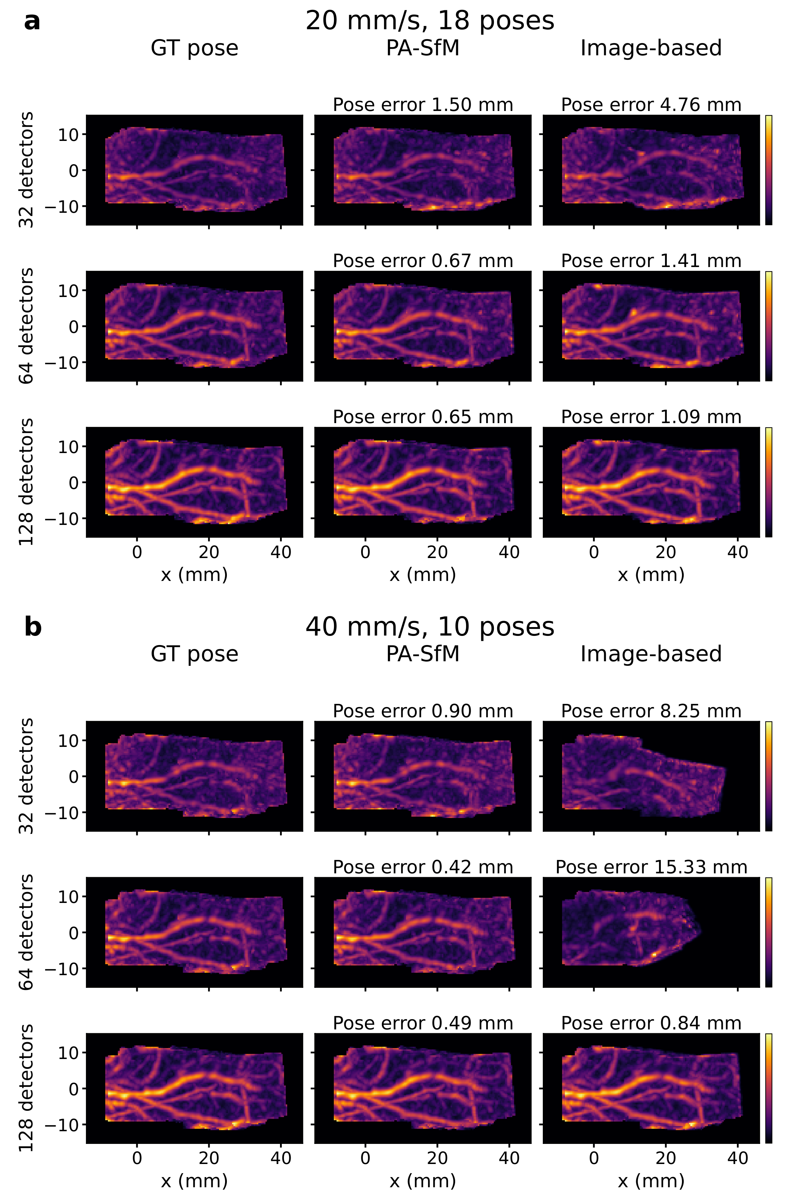
Supplementary Fig. 6 | Complete simulation comparison for Vessel 1. a,b XY maximum amplitude projections at 20 and 40 mm/s, respectively. Rows correspond to 32, 64 and 128 detectors; columns show reconstructions using ground-truth (GT) poses, PA-SfM and Image-based.
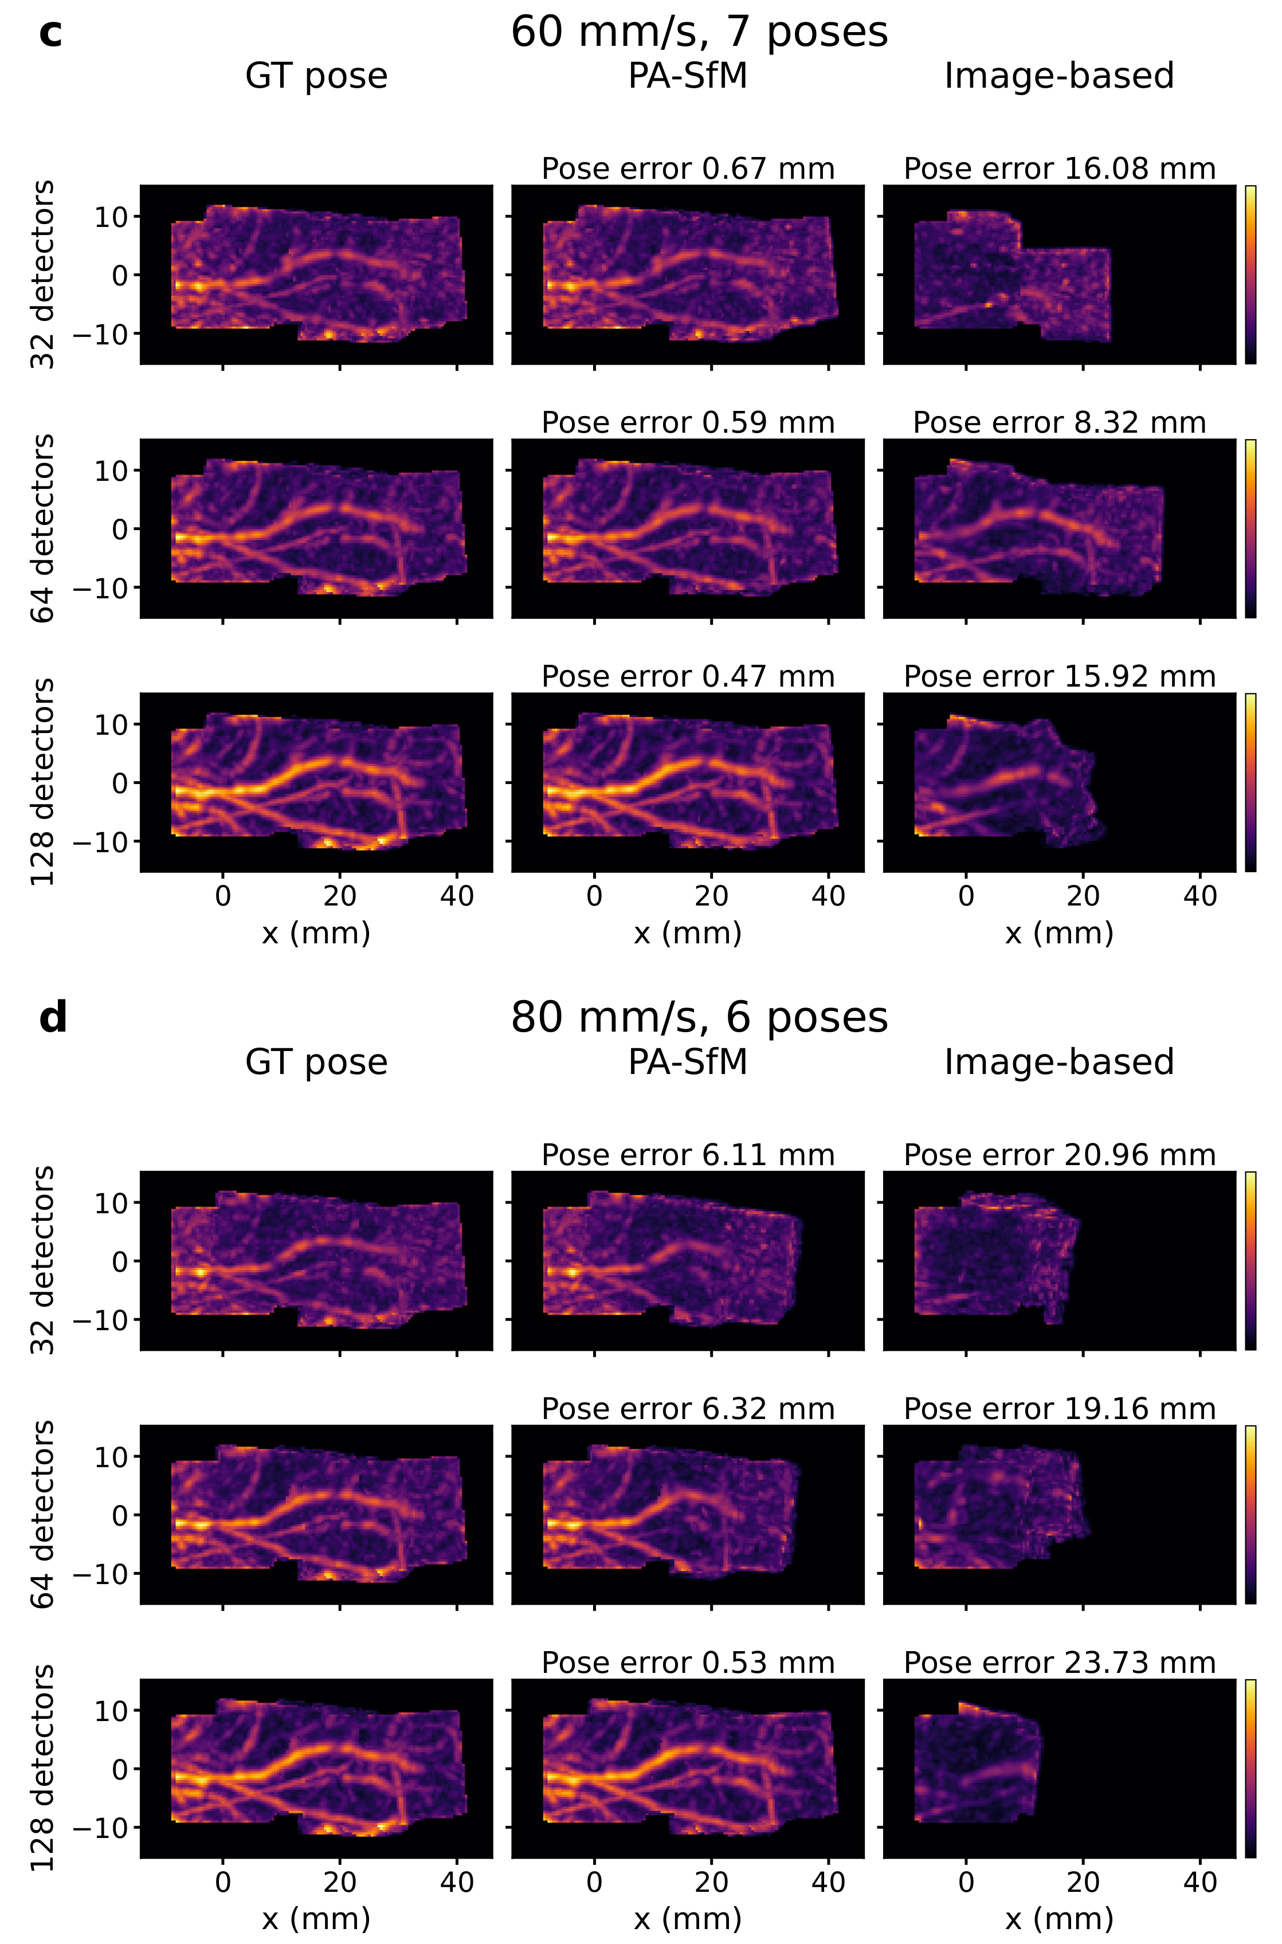
Supplementary Fig. 6 | Complete simulation comparison for Vessel 1 (continued). c,d XY maximum amplitude projections at 60 and 80 mm/s, respectively, with the same row and column order as in a,b.
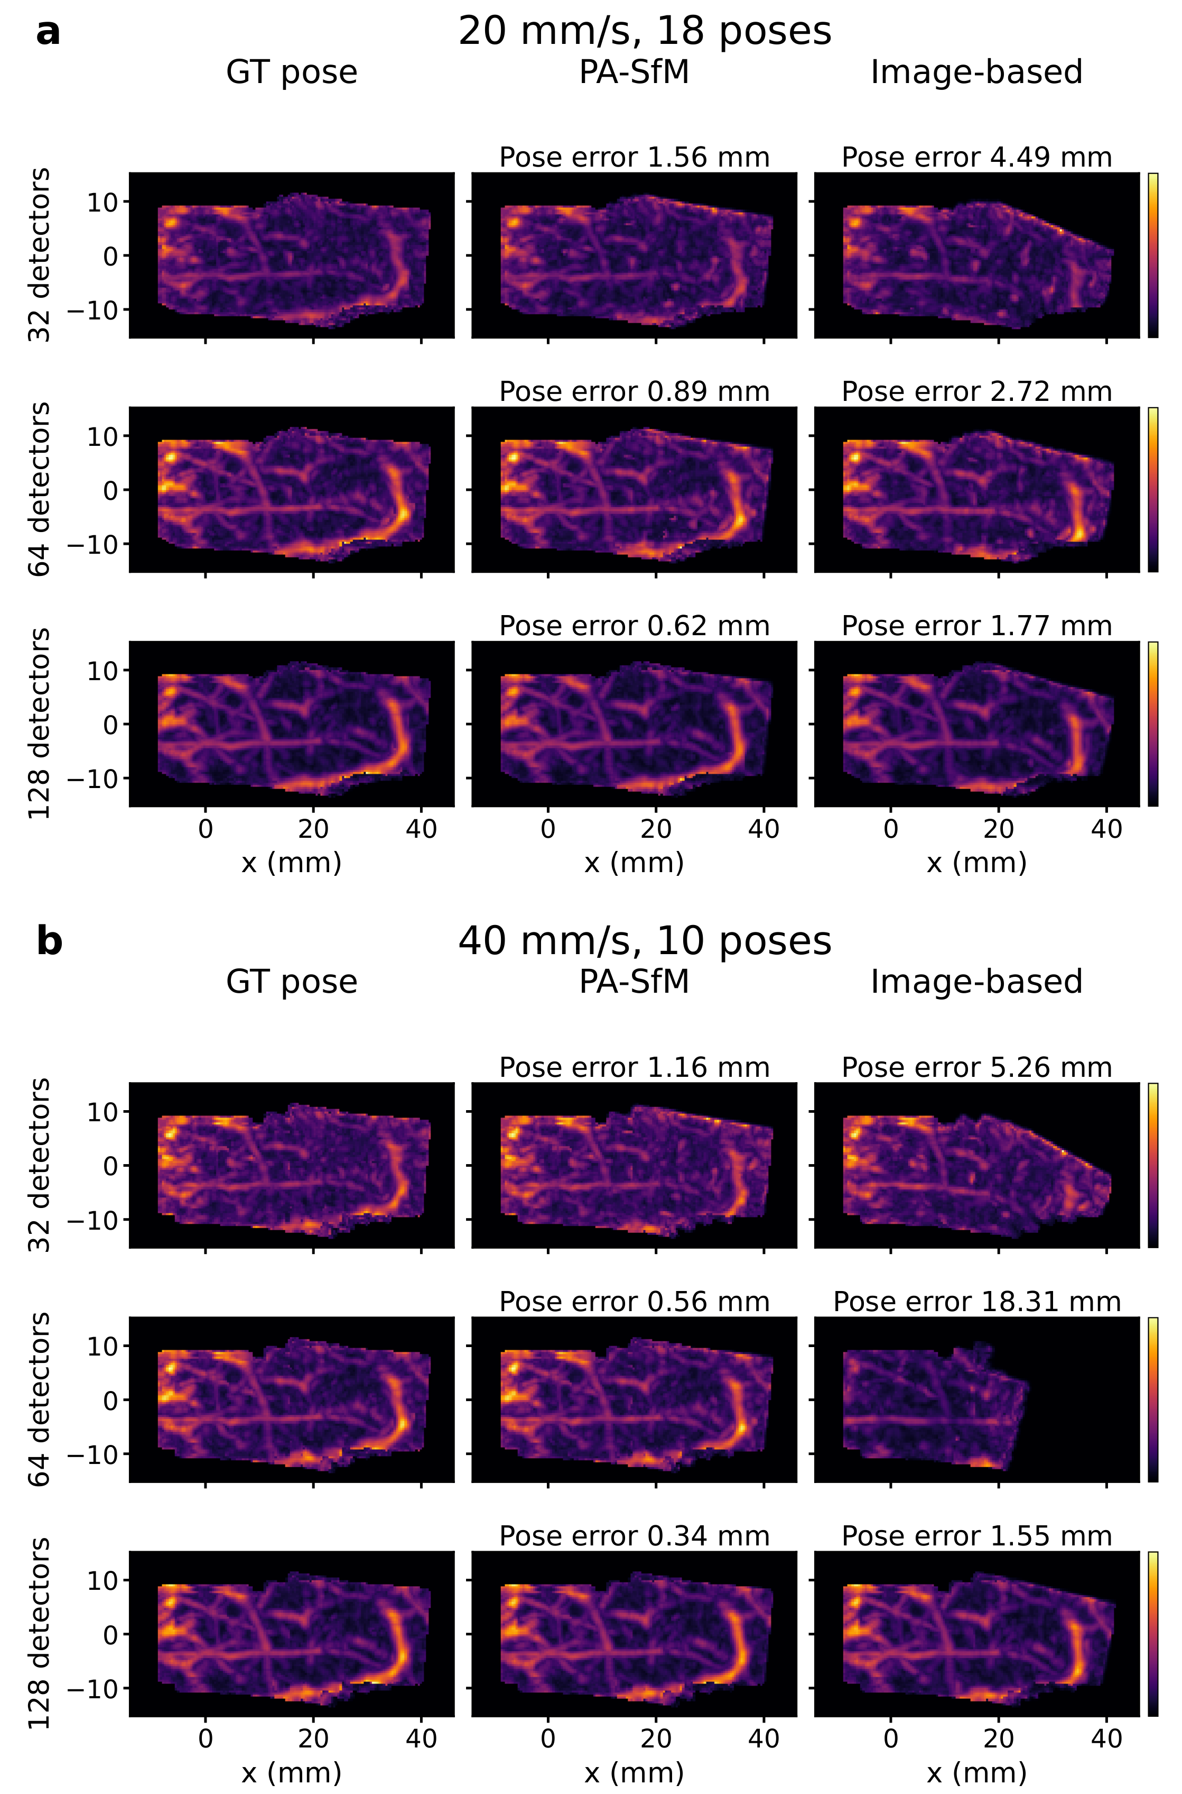
Supplementary Fig. 7 | Complete simulation comparison for Vessel 2. a,b XY maximum amplitude projections at 20 and 40 mm/s, respectively. Rows correspond to 32, 64 and 128 detectors; columns show reconstructions using ground-truth (GT) poses, PA-SfM and Image-based.
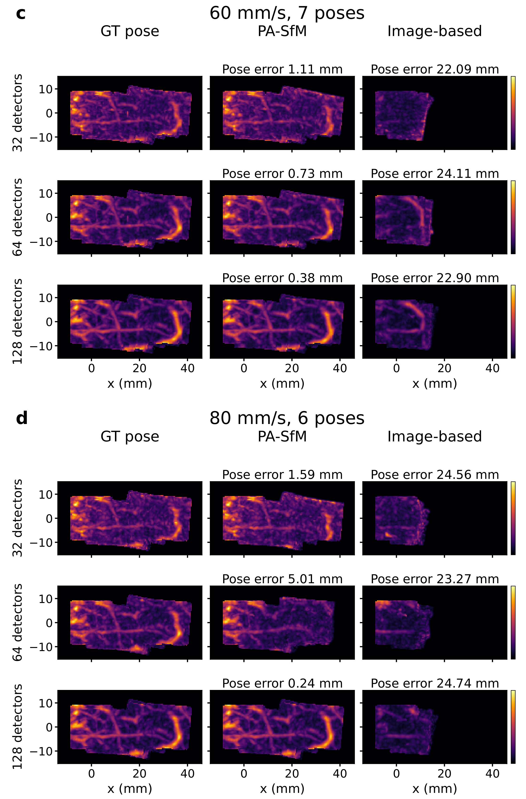
Supplementary Fig. 7 | Complete simulation comparison for Vessel 2 (continued). c,d XY maximum amplitude projections at 60 and 80 mm/s, respectively, with the same row and column order as in a,b.
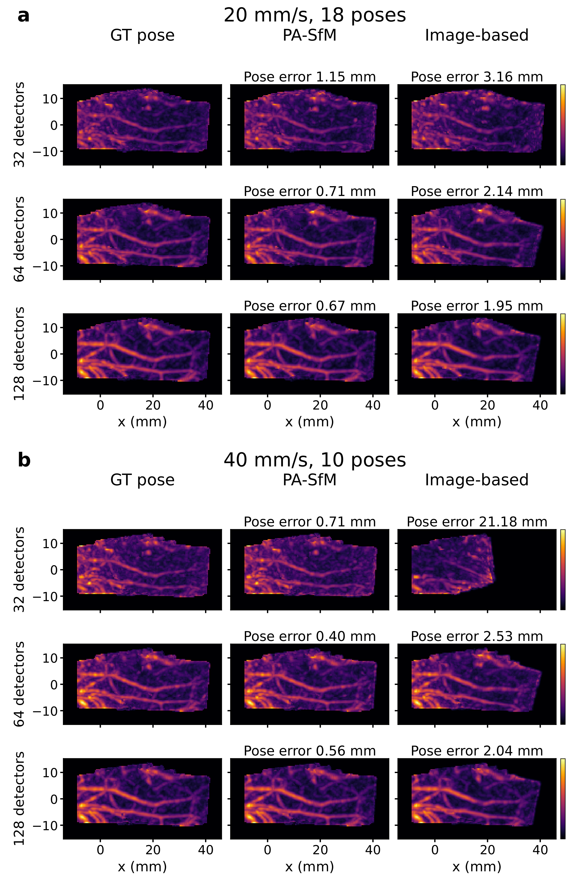
Supplementary Fig. 8 | Complete simulation comparison for Vessel 3. a,b XY maximum amplitude projections at 20 and 40 mm/s, respectively. Rows correspond to 32, 64 and 128 detectors; columns show reconstructions using ground-truth (GT) poses, PA-SfM and Image-based.
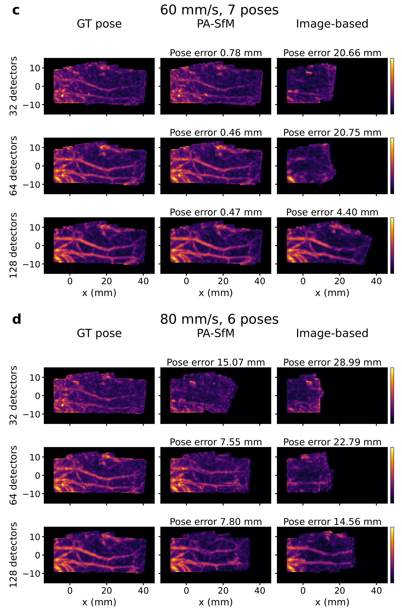
Supplementary Fig. 8 | Complete simulation comparison for Vessel 3 (continued). c,d XY maximum amplitude projections at 60 and 80 mm/s, respectively, with the same row and column order as in a,b.
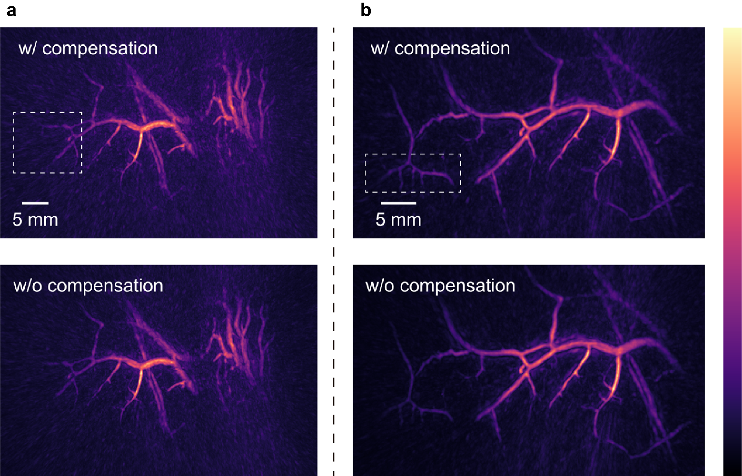
Supplementary Fig. 9 | The comparison of joint reconstruction results with and without peripheral intensity compensation. a Comparison of the compensated and uncompensated joint reconstruction results corresponding to Fig. 2e in the main text. (Scale: 5 mm). b Comparison of the compensated and uncompensated joint reconstruction results corresponding to Fig. 3c in the main text. (Scale: 5 mm).
Supplementary Note 1 | Analytical expression for spherically symmetric photoacoustic sources: theoretical foundation for the differentiable acoustic radiation.
In this supplementary text, we present the analytical derivation of the spatiotemporal acoustic pressure generated by spherically symmetric photoacoustic sources. This derivation provides the theoretical foundation for the differentiable acoustic radiation engine described in Methods section of the main text. We start from the photoacoustic wave equation, derive closed-form solutions for spherically symmetric initial pressure distributions, including the Gaussian model used in our framework, and formulate the far-field approximation used for the ultrafast GPU-accelerated forward simulation.
1.1 Theoretical background
1.1.1 Photoacoustic wave equation
The pressure wave generated by the photoacoustic effect satisfies the following wave equation:
$\left(∇^{2}-\frac{1}{v_{s}^{2}}\frac{∂^{2}}{∂t^{2}}\right)p\left(r,t\right)=-\frac{β}{C_{p}}\frac{∂H\left(r,t\right)}{∂t}$ (S1)
where $p\left(r,t\right)$ is the acoustic pressure, $v_{s}$ is the speed of sound, β is the thermal expansion coefficient, $C_{p}$ is the specific heat capacity, and $H\left(r,t\right)$ is the heating function. For instantaneous heating, the initial conditions are:
$p\left(r,0\right)=p_{0}\left(r\right),\frac{∂p}{∂t}\left(r,0\right)=0$ (S2)
1.1.2 Fundamental integral formula
The solution to the photoacoustic wave equation can be expressed using Green's function as:
$p\left(r,t\right)=\frac{1}{4πv_{s}^{2}}\frac{∂}{∂t}\left[\frac{1}{v_{s}t}∫dr^{'}p_{0}\left(r^{'}\right)δ\left(t-\frac{\left|r-r^{'}\right|}{v_{s}}\right)\right]$ (S3)
where $p_{0}\left(r^{'}\right)$ is the initial pressure distribution.
1.2 Derivation for spherically symmetric case
Assume the initial pressure distribution is spherically symmetric about the origin, $p_{0}\left(r^{'}\right)$ = $p_{0}\left(r^{'}\right)$, where $r^{'}=\left|r^{'}\right|$ and $r=\left|r\right|$. Using the scaling property of the delta function, $δ\left(t-\frac{\left|r-r^{'}\right|}{v_{s}}\right)=v_{s}δ\left(\left|r-r^{'}\right|-v_{s}t\right)$, and substituting it into eq. S3, we get:
$p\left(r,t\right)=\frac{1}{4πv_{s}^{2}}\frac{∂}{∂t}\left[\frac{1}{t}∫dr^{'}p_{0}\left(r^{'}\right)δ\left(\left|r-r^{'}\right|-v_{s}t\right)\right]$ (S4)
By transforming to spherical coordinates (r′, θ, φ) and applying the law of cosines $\left|r-r^{'}\right|=\sqrt{r^{2}+{r^{'}}^{2}-2rr^{'}cosθ}$, the delta function can be transformed (see section 1.6 below) as:
$δ\left(\left|r-r^{'}\right|-v_{s}t\right)=\frac{v_{s}t}{rr^{'}}δ\left(cosθ-\frac{r^{2}+{r^{'}}^{2}-{\left(v_{s}t\right)}^{2}}{2rr^{'}}\right)$ (S5)
Integrating over solid angles yields $∫dΩδ\left(⋯\right)=\frac{2πv_{s}t}{rr^{'}}$ under the condition $\left|r-v_{s}t\right|≤r^{'}≤r+v_{s}t$. Substituting this back into the pressure expression and simplifying yields:
$p\left(r,t\right)=\frac{1}{2v_{s}r}\frac{∂}{∂t}\left[\int_{\left|r-v_{s}t\right|}^{r+v_{s}t}{r^{'}p_{0}\left(r^{'}\right)dr^{'}}\right]$ (S6)
Applying Leibniz's rule for differentiating under the integral sign gives the unified analytical expression for the spherically symmetric case:
$p\left(r,t\right)=\frac{1}{2r}\left[\left(r+v_{s}t\right)p_{0}\left(r+v_{s}t\right)+\left(r-v_{s}t\right)p_{0}\left(\left|r-v_{s}t\right|\right)\right]$ (S7)
1.3 Analytical solutions for typical initial distributions
Based on eq. S7, explicit analytical solutions can be derived for several commonly encountered distributions:
(1) Uniform spherical source ($p_{0}\left(r\right)=p_{0}U\left(a_{0}-r\right)$): for an observation point outside the sphere ($r>a_{0}$), $p\left(r,t\right)=\left(\frac{p_{0}}{2r}\right)\left(r-v_{s}t\right)$ when $r-a_{0}≤v_{s}t≤r+a_{0}$, and 0 otherwise.
(2) Gaussian distribution ($p_{0}\left(r\right)=p_{c}exp\left(-r^{2}/2σ^{2}\right)$):
$p\left(r,t\right)=\frac{p_{c}}{2r}\left[\left(r+v_{s}t\right)e^{-\frac{{\left(r+v_{s}t\right)}^{2}}{2σ^{2}}}+\left(r-v_{s}t\right)e^{-\frac{{\left(r-v_{s}t\right)}^{2}}{2σ^{2}}}\right]$ (S8)
(3) Exponential distribution ($p_{0}\left(r\right)=p_{c}exp\left(-r/a\right)$):
$p\left(r,t\right)=\frac{p_{c}}{2r}\left[\left(r+v_{s}t\right)e^{-\left(r+v_{s}t\right)/a}+\left(r-v_{s}t\right)e^{-\left|r-v_{s}t\right|/a}\right]$ (S9)
(4) Power-law distribution ($p_{0}\left(r\right)=A/{\left(r^{2}+a^{2}\right)}^{ν},ν>1/2$):
$p\left(r,t\right)=\frac{A}{2r}\left[\frac{r+v_{s}t}{{\left({\left(r+v_{s}t\right)}^{2}+a^{2}\right)}^{ν}}+\frac{r-v_{s}t}{{\left({\left(r-v_{s}t\right)}^{2}+a^{2}\right)}^{ν}}\right]$ (S10)
1.4 Far-field approximations
Under far-field conditions ($r≫\text{characteristic source dimension},t≈r/v_{s}$), the first term in eq. S7, representing an inward converging wave, is exponentially or power-law suppressed. The dominant contribution comes from the second term, leading to the unified far-field approximation:
$p\left(r,t\right)≈\frac{1}{2r}\left(r-v_{s}t\right)p_{0}\left(\left|r-v_{s}t\right|\right)$ (S11)
Applying this to the Gaussian distribution yields the outward propagating Gaussian pulse:
$p\left(r,t\right)≈\frac{p_{c}}{2r}\left(r-v_{s}t\right)exp\left(-\frac{{\left(r-v_{s}t\right)}^{2}}{2σ^{2}}\right)$ (S12)
which provides the direct mathematical justification for the Gaussian kernel G defined in Eq. 1 of the main text.
1.5 GPU-accelerated forward simulation framework
Although the analytical expressions provide closed-form solutions, practical PA-SfM simulations involve a very large number of discrete source elements ($N_{s}$) and detector locations ($N_{d}$). To address this, we discretize the far-field approximation in eq. S11 to build the GPU-accelerated forward model. The acoustic pressure measured at a detector position $r_{d}$ becomes a superposition of outgoing waves emitted by all source elements $r_{k}$ with amplitudes $P_{c}^{\left(k\right)}$:
$p\left(r_{d},t\right)≈\sum_{k=1}^{N_{s}}{\frac{1}{2r_{k}}\left(r_{k}-v_{s}t\right)P_{c}^{\left(k\right)}K\left(\left|r_{k}-v_{s}t\right|\right)}$ (S13)
where $r_{k}=‖r_{d}-r_{k}‖$ and K(·) denotes the designated kernel function. Based on eq. S12, the Gaussian kernel is defined as $K_{G}\left(Δr\right)=exp\left(-\frac{{\left(Δr\right)}^{2}}{2σ^{2}}\right)$.
This discrete model exhibits two independent dimensions of parallelism: the detector index and the temporal sampling index. In our PyTorch-Triton implementation, a two-dimensional GPU execution grid is employed. Distances $r_{k}$ and time delays are computed on-the-fly, avoiding the explicit construction of large distance matrices. This design enables the efficient evaluation of $O\left(N_{s}×N_{d}×N_{t}\right)$ operations, seamlessly supporting bidirectional gradient flow for the PA-SfM framework. Open-source implementations for this generalized ultrafast forward simulation are also publicly available at https://github.com/JaegerCQ/PA-SfM.
1.6 Detailed delta function derivations
Starting from $δ\left(\sqrt{A}-R\right)$, where $A=r^{2}+{r^{'}}^{2}-2rr^{'}cosθ$ and $R=v_{s}t$. Let $g\left(A\right)=\sqrt{A}-R$; then $dg/dA=1/\left(2\sqrt{A}\right)$. At $A=R^{2}$, $\left|dg/dA\right|=1/\left(2R\right)$. Using the delta function transformation formula:
$δ\left(g\left(A\right)\right)=\frac{δ\left(A-R^{2}\right)}{\left|g^{'}\left(R^{2}\right)\right|}=2Rδ\left(A-R^{2}\right)$ (S14)
Next, let $h\left(cosθ\right)=r^{2}+{r^{'}}^{2}-R^{2}-2rr^{'}cosθ$. The zero point is $cosθ_{0}=\frac{r^{2}+{r^{'}}^{2}-R^{2}}{2rr^{'}}$ and the derivative is $\left|\frac{dh}{d\left(cosθ\right)}\right|=2rr^{'}$. Therefore:
$δ\left(h\left(cosθ\right)\right)=\frac{1}{2rr^{'}}δ\left(cosθ-\frac{r^{2}+{r^{'}}^{2}-R^{2}}{2rr^{'}}\right)$ (S15)
Combining these factors, we obtain:
$δ\left(\left|r-r^{'}\right|-R\right)=\frac{R}{rr^{'}}δ\left(cosθ-\frac{r^{2}+{r^{'}}^{2}-R^{2}}{2rr^{'}}\right)$ (S16)
1.7 Nomenclature
Symbol | Description
$$p\left(r,t\right)$$ | Acoustic pressure at position r and time t
$$p_{0}\left(r\right)$$ | Initial pressure distribution
$$v_{s}$$ | Speed of sound
β | Thermal expansion coefficient
$$C_{p}$$ | Specific heat capacity
r | Radial distance from origin
t | Time
δ(x) | Dirac delta function
σ | Gaussian width parameter
$$a_{0}$$ | Radius of uniform sphere
Supplementary Note 2 | Effect of global differentiable pose fine-tuning on in vivo PA-SfM reconstruction.
Global differentiable pose fine-tuning was evaluated in the rat kidney and liver reconstructions (Supplementary Fig. 3). In the kidney, the intermediate pose expanded the visible field of view by combining both views, but left blurring, vessel discontinuities and minor ghosting. Refinement reduced these artifacts and brought the vascular morphology closer to the GT reconstruction in the projections and 3D display (Supplementary Fig. 3a,b).
In the liver, fine-tuning reduced vessel fragmentation and background noise. Vessel continuity and the 3D branching pattern were more consistent with GT (Supplementary Fig. 3c,d).
The kidney reconstruction's PSNR and SSIM increased from 23.58 dB and 0.6098 before fine-tuning to 41.42 dB and 0.9864, respectively. For the liver, the corresponding values increased from 24.13 dB and 0.7900 to 44.31 dB and 0.9961.
Supplementary Note 3 | Analysis of global differentiable pose fine-tuning in the simulation study.
The simulation in Supplementary Fig. 4 starts from the intermediate relative pose obtained by differentiable single-sensor localization and rigid-constraint filtering. Single-sensor localization errors, sparse array sampling and local signal ambiguity can leave residual pose errors that affect alignment between views.
Global fine-tuning optimizes a common transformation for the entire sparse array by minimizing the difference between predicted PA signals and GT supervision signals (Supplementary Fig. 4c). The refined signals agree more closely with GT (Supplementary Fig. 4d). The mean and minimum Euclidean distance errors of sensor localization decreased from 1.213 mm and 0.265 mm to 0.751 mm and 0.113 mm, respectively.
The reconstruction comparison (Supplementary Fig. 4a,b) shows less boundary blurring and closer agreement with the phantom's 3D structure after fine-tuning. The multi-view reconstruction's PSNR and SSIM increased from 21.35 dB and 0.4552 with the intermediate pose to 41.14 dB and 0.9799 with the refined pose.
Supplementary Note 4 | Multi-density freehand simulations and Image-based comparison.
4.1 Simulation geometry and acoustic measurements
Three three-dimensional vascular volumes were used to simulate expanded FOV freehand acquisition with 32-, 64- and 128-detector hemispherical arrays at scan speeds of 20, 40, 60 and 80 mm/s, giving 36 conditions. The arrays had a radius of 30 mm. The 32- and 64-detector geometries were spatially dispersed, nested subsets of the 128-detector geometry. For each fixed vascular volume, the probe followed a smooth trajectory with lateral and axial drift and rotations about all three axes. The trajectory spanned 32 mm along the main scan direction. Sampling at 10 Hz produced 18, 10, 7 and 6 frames at the four speeds, respectively; the final path endpoint was included with a shorter last interval where needed. The simulation geometry and overlap are shown in Fig. 9, Supplementary Fig. 5 and Supplementary Movie 3.
The vascular volumes and reconstruction grids had an isotropic spacing of 0.4 mm. Each frame had a local excitation region of 20 × 20 × 24 mm³, with a uniform 16 × 16 × 20 mm³ interior and cosine-tapered edges. PA signals were generated in a homogeneous medium with a sound speed of 1,500 m/s. Each detector recorded 1,000 samples at 15 MHz. Additive Gaussian noise gave a signal-to-noise ratio of 30 dB. Detectors were modeled as ideal omnidirectional point receivers. Adjacent-volume overlap was calculated from regions with a normalized excitation weight of at least 0.5, as their intersection divided by the smaller volume. Increasing scan speed reduced the overlap while preserving the underlying path.
4.2 Image-based registration and common reconstruction
In Image-based registration, each local volume was enhanced using a multiscale Frangi filter and skeletonized using Lee thinning. The moving skeleton was aligned to the current panorama by rigid point-to-point iterative closest point (ICP) registration, followed by intensity registration of the vesselness volumes. Each new frame was initialized from the preceding estimated pose. Registered volumes were accumulated by inverse-distance weighting to form the panorama used by subsequent registrations.
Frangi scales were 0.4, 0.8 and 1.2 mm. Skeletonization used a threshold of 10% of the vesselness maximum and a minimum component volume of 0.02 mm³. ICP used at most 100 iterations. Vesselness refinement used a rigid Euler transform and the SimpleITK correlation metric, which minimizes negative squared Pearson correlation, with regular-step gradient descent. The three pyramid levels used shrink factors of 4, 2 and 1 and smoothing widths of 0.8, 0.4 and 0 mm. Refinement used at most 200 iterations per level, an initial step of 0.8 mm, a minimum step of 0.0002 mm and at most 200,000 samples per level. These numerical settings were held constant across conditions.
Image-based registration was evaluated using three known rigid transformations applied to a vascular volume. The RMS displacement error over 221 control points was 0.00394, 0.00132 and 0.00101 mm for the translation-only and two combined rotation–translation cases, respectively.
The final comparison used the same acoustic measurements, backprojection operator, 0.4 mm grid and three-dimensional evaluation mask for both methods; only the estimated poses differed. Signed backprojections were combined using the local excitation profile and clipped to nonnegative values after fusion. A reconstruction using the true acquisition poses provided the known-pose reference. The same illumination model was used for signal generation and reconstruction.
4.3 Evaluation and complete results
Target registration error (TRE) measured the displacement of 27 fixed control points under the estimated and true rigid poses. Their local coordinates were all combinations of x, y = {−8, 0, 8} mm and z = {−22, −12, −2} mm. The first frame defined the common coordinate system and was excluded from error averaging. For each condition, squared point displacements were pooled over the remaining frames and control points before taking the square root; no further rigid alignment was performed. This measure includes translation and rotation. A condition was counted as submillimeter when its pooled TRE was below 1 mm. The stricter all-frame criterion required the 27-point RMS error to be below 1 mm in every evaluated frame.
Reconstruction similarity was measured by normalized cross-correlation (NCC) with the known-pose reconstruction and area under the precision–recall curve (AUPRC) against the vascular foreground. Foreground voxels were defined at 10% of the peak true initial pressure within the common evaluation mask. AUPRC was computed as threshold-wise average precision, grouping equal reconstruction intensities. Both metrics used the same three-dimensional mask, defined as the union of regions with an illumination weight of at least 0.5 over all true acquisition poses. Within each condition, the reconstruction panels share a linear intensity range whose upper bound is the maximum across the three masked reconstructions. The mask was applied before maximum amplitude projection. The region enlarged in Fig. 10 spans x = 8–24 mm, y = −8–8 mm and z = −20 to −4 mm. Its intensity range and viewing direction are the same as in the full-volume display, without separate normalization.
Supplementary Figs. 6–8 and Supplementary Tables 1–3 include every condition. Across the 27 conditions at 20–60 mm/s, the mean TRE was 0.73 mm for PA-SfM and 9.41 mm for Image-based; all PA-SfM errors were below 2 mm. Across all 36 conditions, pooled TRE was below 1 mm in 24 PA-SfM conditions and one Image-based condition. The stricter all-frame criterion was met in 15 and zero conditions, respectively. Mean NCC was 0.7748 versus 0.4690, and mean AUPRC was 0.2599 versus 0.1460. At 80 mm/s, PA-SfM exceeded 2 mm in six of nine conditions, while Image-based exceeded this threshold in all nine. The speed-dependent means are given in Supplementary Table 4. Because faster scans contain fewer frames, the total trajectory error depends on both inter-frame displacement and the number of accumulated relative poses. A lower speed therefore need not give the smallest accumulated TRE.
Supplementary Note 5 | Effect of peripheral intensity compensation on expanded FOV freehand PA-SfM reconstruction.
In expanded FOV freehand PA-SfM imaging, the reconstructed volume is obtained by jointly integrating multiple array poses acquired over a relatively large spatial range. Because the optical illumination is not perfectly uniform across this enlarged field of view, array poses located near the periphery of the overall FOV may receive weaker illumination than those near the central region. Consequently, vascular structures reconstructed from peripheral poses can show relatively lower signal intensity after joint reconstruction, even when their spatial geometry is correctly recovered.
To account for this FOV-dependent intensity variation, peripheral intensity compensation was applied only to the expanded FOV freehand reconstruction results shown in Fig. 2e and Fig. 3c in the main text. Specifically, we multiplied the PA signals acquired at the initial and final array poses by a factor of 3 before joint reconstruction, because these two poses corresponded to the peripheral regions of the expanded FOV and exhibited relatively weaker signal amplitudes. This simple empirical compensation was sufficient to reduce the visible intensity drop near the FOV edges and improve the intensity consistency of the displayed expanded FOV reconstructions. Importantly, this compensation does not change the recovered pose relationship or introduce additional structural information; it only rescales the PA signal amplitude of the peripheral views before reconstruction.
Supplementary Fig. 9 compares the joint reconstruction results with and without peripheral intensity compensation. For the freehand reconstruction result corresponding to Fig. 2e in the main text, Supplementary Fig. 9a shows that the uncompensated reconstruction preserves the major vascular morphology but exhibits reduced signal intensity near the peripheral region, especially in the dashed box area. After compensation, the peripheral vessels become more visible and better balanced with the central vascular structures, while the overall vessel topology and spatial distribution remain unchanged.
A similar effect is observed for the sequential freehand reconstruction result corresponding to Fig. 3c in the main text. As shown in Supplementary Fig. 9b, the uncompensated result contains recognizable peripheral vessels, but their intensity is weaker than that of the central vessels. With peripheral intensity compensation, these edge region vessels are enhanced, improving the intensity uniformity and interpretability of the expanded FOV reconstruction. Future work may incorporate more physically accurate fluence correction strategies, such as Monte Carlo modeling of light transport in tissue, to quantitatively compensate for illumination heterogeneity.
Supplementary Note 6 | Computational efficiency.
6.1 Estimation time in the freehand simulation study
Trajectory estimation time includes source fitting, detector localization, rigid-array estimation and signal refinement for PA-SfM, and vessel enhancement, skeletonization, ICP, vesselness refinement and internal panorama fusion for Image-based. Input loading, initial local backprojection, metric evaluation and the final common reconstruction were excluded. Supplementary Tables 1–3 give the individual times, and Supplementary Table 4 gives the means across the nine conditions at each scan speed.
The mean trajectory estimation times at 20, 40, 60 and 80 mm/s were 31.74, 15.79, 10.62 and 8.98 s for PA-SfM, and 64.31, 39.68, 30.91 and 29.19 s for Image-based. These trajectories contained 18, 10, 7 and 6 frames, respectively. PA-SfM was implemented with PyTorch 2.5.1 and Triton 3.1.0 on a single NVIDIA A100-SXM4 40 GB; Image-based registration used SimpleITK 2.4.1 on an AMD EPYC 7742, with two registration threads.
6.2 Computation time for measured hand data
For the measured hand data, the complete two-view PA-SfM workflow required 287.8 s on a single NVIDIA A100-SXM4 40 GB. This included reference-view initialization, source fitting, detector localization, rigid refinement and joint reconstruction. Once the reference view was initialized, estimating the pose of one additional view and updating the joint reconstruction required 175 s.
The workflow used a 400 × 400 × 400 source-fitting grid, 100 source-fitting epochs per view, 4,096 coarse localization candidates, 15 localization starts, 600 localization iterations and 100 rigid-refinement epochs. Source fitting and detector localization were implemented in PyTorch 2.5.1 and Triton 3.1.0.
Supplementary Note 7 | Usage instructions for the open-source PA-SfM automated workflow.
The released PA-SfM code package (https://github.com/JaegerCQ/PA-SfM) contains the automated workflow used for the continuous 10-frame pose estimation and joint reconstruction example shown in Fig. 3c. The workflow is launched from the repository root using run_group3_pose_range.sh. In the default configuration, the script processes pose0 through pose9 (START_POSE=0 and END_POSE=9), uses pose0 as the common reference frame (TARGET_POSE=0), and reconstructs the dataset.
The released data should be placed in data/ with the expected filenames, including sensor_location_group03_pose000.txt and processed_signal_group03_pose000.txt through processed_signal_group03_pose009.txt. The default script was configured for one single NVIDIA A100 40 GB GPU; users can adapt the GPU list by editing GPU_IDS in run_group3_pose_range.sh. The default RUN_ID is stable, so logs, checkpoints and reconstruction outputs are written to deterministic directory names unless RUN_ID is manually changed.
For reproducible execution, create the supplied pinned Conda environment and launch the example as follows:
conda create -n PA_SfM --file locks/conda-explicit.txt
conda activate PA_SfM
python -m pip install \
--no-index \
--find-links locks/wheelhouse \
--require-hashes \
-r locks/requirements.pip-hash-lock.txt
chmod +x run_group3_pose_range.sh
nohup ./run_group3_pose_range.sh > main_group3_pose_range.log 2>&1 &
tail -f main_group3_pose_range.log
During execution, the script first optimizes the differentiable acoustic radiation embedding for each measured PA frame, then estimates the relative sensor array pose by single sensor localization, applies rigid array correction and differentiable pose refinement, maps later frames into the pose0 coordinate system, and performs incremental joint reconstruction after each added frame.
The main outputs are the per-pose logs, recovered sensor locations under each pose, and joint reconstruction volumes. Partial reruns can be performed by changing START_POSE and END_POSE in run_group3_pose_range.sh, provided that the required earlier checkpoints and pose files are already present.
Supplementary Table 1 | Pose error, reconstruction quality and estimation time for Vessel 1.
Speed  (mm/s) | Detectors | Method | TRE  (mm) | NCC | AUPRC | Time  (s)
20 | 32 | PA-SfM | 1.499 | 0.4807 | 0.1244 | 29.79
20 | 32 | Image-based | 4.757 | 0.3960 | 0.1043 | 61.31
20 | 64 | PA-SfM | 0.670 | 0.8105 | 0.2697 | 32.02
20 | 64 | Image-based | 1.409 | 0.4952 | 0.1522 | 60.59
20 | 128 | PA-SfM | 0.652 | 0.8206 | 0.3074 | 34.52
20 | 128 | Image-based | 1.092 | 0.7437 | 0.2467 | 66.33
40 | 32 | PA-SfM | 0.901 | 0.6188 | 0.1679 | 15.30
40 | 32 | Image-based | 8.247 | 0.3080 | 0.0899 | 31.53
40 | 64 | PA-SfM | 0.422 | 0.8923 | 0.3106 | 15.61
40 | 64 | Image-based | 15.332 | 0.2216 | 0.0877 | 47.98
40 | 128 | PA-SfM | 0.488 | 0.8569 | 0.3274 | 16.90
40 | 128 | Image-based | 0.843 | 0.8351 | 0.2992 | 36.47
60 | 32 | PA-SfM | 0.666 | 0.8029 | 0.2121 | 10.13
60 | 32 | Image-based | 16.084 | 0.1882 | 0.0725 | 24.44
60 | 64 | PA-SfM | 0.593 | 0.7479 | 0.2479 | 10.28
60 | 64 | Image-based | 8.316 | 0.2770 | 0.0929 | 30.54
60 | 128 | PA-SfM | 0.467 | 0.8650 | 0.3287 | 11.32
60 | 128 | Image-based | 15.918 | 0.3337 | 0.1090 | 29.27
80 | 32 | PA-SfM | 6.110 | 0.5830 | 0.1456 | 8.94
80 | 32 | Image-based | 20.955 | 0.2740 | 0.0789 | 28.93
80 | 64 | PA-SfM | 6.321 | 0.6387 | 0.1983 | 8.90
80 | 64 | Image-based | 19.161 | 0.2930 | 0.0924 | 24.12
80 | 128 | PA-SfM | 0.529 | 0.8754 | 0.3321 | 9.35
80 | 128 | Image-based | 23.735 | 0.3131 | 0.1020 | 33.90

TRE is pooled across 27 control points and all non-reference frames. NCC is measured against the known-pose reconstruction; AUPRC is measured against the true vascular foreground. Time is the complete trajectory estimation time, excluding input-volume backprojection and final common reconstruction (Supplementary Note 6). The sequences contain 18, 10, 7 and 6 frames at 20, 40, 60 and 80 mm/s, respectively.
Supplementary Table 2 | Pose error, reconstruction quality and estimation time for Vessel 2.
Speed  (mm/s) | Detectors | Method | TRE  (mm) | NCC | AUPRC | Time  (s)
20 | 32 | PA-SfM | 1.556 | 0.5175 | 0.1461 | 29.62
20 | 32 | Image-based | 4.494 | 0.4313 | 0.1182 | 62.50
20 | 64 | PA-SfM | 0.893 | 0.7466 | 0.2472 | 30.53
20 | 64 | Image-based | 2.717 | 0.4772 | 0.1466 | 63.93
20 | 128 | PA-SfM | 0.620 | 0.8645 | 0.3370 | 34.06
20 | 128 | Image-based | 1.767 | 0.6579 | 0.2172 | 71.47
40 | 32 | PA-SfM | 1.158 | 0.6498 | 0.1887 | 14.93
40 | 32 | Image-based | 5.264 | 0.4449 | 0.1254 | 37.20
40 | 64 | PA-SfM | 0.562 | 0.8841 | 0.3118 | 15.37
40 | 64 | Image-based | 18.309 | 0.3583 | 0.1209 | 41.48
40 | 128 | PA-SfM | 0.339 | 0.9538 | 0.3945 | 17.23
40 | 128 | Image-based | 1.547 | 0.6898 | 0.2358 | 43.52
60 | 32 | PA-SfM | 1.109 | 0.7399 | 0.2122 | 10.06
60 | 32 | Image-based | 22.094 | 0.2571 | 0.0834 | 35.07
60 | 64 | PA-SfM | 0.730 | 0.8401 | 0.2860 | 10.36
60 | 64 | Image-based | 24.112 | 0.3857 | 0.1211 | 34.68
60 | 128 | PA-SfM | 0.376 | 0.9398 | 0.3768 | 11.29
60 | 128 | Image-based | 22.898 | 0.4630 | 0.1597 | 33.25
80 | 32 | PA-SfM | 1.591 | 0.6655 | 0.1789 | 8.51
80 | 32 | Image-based | 24.556 | 0.3287 | 0.0953 | 22.00
80 | 64 | PA-SfM | 5.012 | 0.6161 | 0.1945 | 8.93
80 | 64 | Image-based | 23.274 | 0.3975 | 0.1221 | 23.83
80 | 128 | PA-SfM | 0.236 | 0.9770 | 0.3974 | 9.28
80 | 128 | Image-based | 24.742 | 0.3800 | 0.1314 | 37.82

TRE is pooled across 27 control points and all non-reference frames. NCC is measured against the known-pose reconstruction; AUPRC is measured against the true vascular foreground. Time is the complete trajectory estimation time, excluding input-volume backprojection and final common reconstruction (Supplementary Note 6). The sequences contain 18, 10, 7 and 6 frames at 20, 40, 60 and 80 mm/s, respectively.
Supplementary Table 3 | Pose error, reconstruction quality and estimation time for Vessel 3.
Speed  (mm/s) | Detectors | Method | TRE  (mm) | NCC | AUPRC | Time  (s)
20 | 32 | PA-SfM | 1.154 | 0.7341 | 0.1766 | 29.09
20 | 32 | Image-based | 3.158 | 0.5867 | 0.1327 | 65.07
20 | 64 | PA-SfM | 0.708 | 0.8594 | 0.2887 | 31.32
20 | 64 | Image-based | 2.137 | 0.6756 | 0.2065 | 63.48
20 | 128 | PA-SfM | 0.672 | 0.8841 | 0.3405 | 34.72
20 | 128 | Image-based | 1.949 | 0.7509 | 0.2630 | 64.09
40 | 32 | PA-SfM | 0.709 | 0.8010 | 0.2078 | 14.71
40 | 32 | Image-based | 21.179 | 0.4603 | 0.1031 | 45.70
40 | 64 | PA-SfM | 0.400 | 0.9469 | 0.3397 | 15.14
40 | 64 | Image-based | 2.527 | 0.6806 | 0.2148 | 36.76
40 | 128 | PA-SfM | 0.561 | 0.8907 | 0.3471 | 16.92
40 | 128 | Image-based | 2.043 | 0.7647 | 0.2698 | 36.48
60 | 32 | PA-SfM | 0.778 | 0.7809 | 0.1921 | 10.40
60 | 32 | Image-based | 20.659 | 0.3804 | 0.0948 | 29.66
60 | 64 | PA-SfM | 0.460 | 0.9344 | 0.3301 | 10.28
60 | 64 | Image-based | 20.752 | 0.5184 | 0.1323 | 32.04
60 | 128 | PA-SfM | 0.470 | 0.9205 | 0.3673 | 11.47
60 | 128 | Image-based | 4.400 | 0.7866 | 0.2767 | 29.24
80 | 32 | PA-SfM | 15.069 | 0.4355 | 0.0985 | 8.58
80 | 32 | Image-based | 28.991 | 0.4070 | 0.0881 | 25.85
80 | 64 | PA-SfM | 7.545 | 0.6469 | 0.1967 | 8.68
80 | 64 | Image-based | 22.786 | 0.3711 | 0.1016 | 29.68
80 | 128 | PA-SfM | 7.796 | 0.6716 | 0.2270 | 9.65
80 | 128 | Image-based | 14.558 | 0.5499 | 0.1672 | 36.59

TRE is pooled across 27 control points and all non-reference frames. NCC is measured against the known-pose reconstruction; AUPRC is measured against the true vascular foreground. Time is the complete trajectory estimation time, excluding input-volume backprojection and final common reconstruction (Supplementary Note 6). The sequences contain 18, 10, 7 and 6 frames at 20, 40, 60 and 80 mm/s, respectively.
Supplementary Table 4 | Results averaged across vascular samples and detector counts at each scan speed.
Speed  (mm/s) | Frames | Method | TRE  (mm) | NCC | AUPRC | TRE  <1 mm | Time  (s)
20 | 18 | PA-SfM | 0.936 | 0.7465 | 0.2486 | 6/9 | 31.74
20 | 18 | Image-based | 2.609 | 0.5794 | 0.1764 | 0/9 | 64.31
40 | 10 | PA-SfM | 0.615 | 0.8327 | 0.2884 | 8/9 | 15.79
40 | 10 | Image-based | 8.366 | 0.5293 | 0.1718 | 1/9 | 39.68
60 | 7 | PA-SfM | 0.628 | 0.8413 | 0.2837 | 8/9 | 10.62
60 | 7 | Image-based | 17.248 | 0.3989 | 0.1269 | 0/9 | 30.91
80 | 6 | PA-SfM | 5.579 | 0.6789 | 0.2188 | 2/9 | 8.98
80 | 6 | Image-based | 22.529 | 0.3683 | 0.1088 | 0/9 | 29.19

Each mean includes all nine combinations of three vascular samples and three detector counts at the stated speed. TRE is the arithmetic mean of the nine condition-level pooled TRE values. TRE <1 mm reports the number of conditions meeting this threshold. Time is the mean complete trajectory estimation time, with the same exclusions as Supplementary Tables 1–3.
Movies
Supplementary Movie 1: Video demonstration of the freehand hand imaging experiment procedure.
Supplementary Movie 2: The PA-SfM joint reconstruction of the hand vessel.
Supplementary Movie 3: Freehand scanning geometry and progressive field-of-view extension.

