Supplementary material
Blast percentage confounds transcriptome to drug-response associations in Beat AML: DHODH and sorafenib as a worked example
Cumhur Gokhan Ekmekci. Independent researcher, Istanbul, Turkey. ORCID 0000-0002-0967-172X
Four figures and three tables are collected here. Unless a row says otherwise, the extended model in these tables uses marrow blast percentage; the specimen-matched estimate appears only where it is named, and the panel-wide ranking was computed with marrow blast alone. The two calibration histograms and the pathway analyses are supporting rather than load-bearing, and the two tables that duplicate main-text figures are kept for readers who want the numbers behind them. Everything run under the base model is labelled as such, because those analyses carry the inflation the main text quantifies.
Supplementary figures
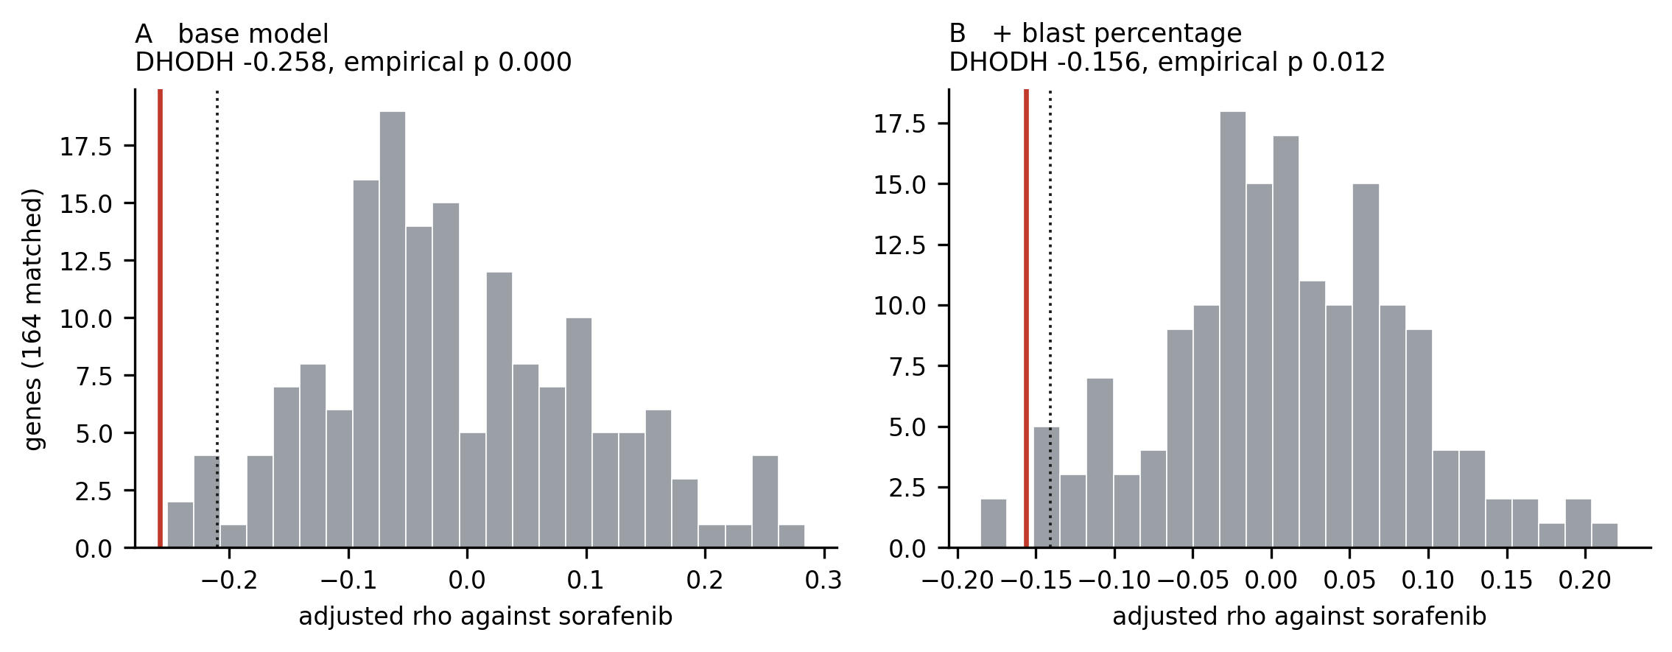
Supplementary Figure S1. Expression-matched genome-wide null under both models. Adjusted rho against sorafenib for 164 protein-coding genes sampled genome-wide and matched to DHODH on mean expression within 0.75 log2 units. Red line, observed DHODH value; dotted line, 2.5th percentile of the null. (A) Base model: DHODH falls outside the null, empirical p below 0.001. (B) With marrow blast percentage added: DHODH sits at the edge of it, empirical p 0.012. The calibration is computed under the same model as the estimate it calibrates; doing otherwise answers a different question.
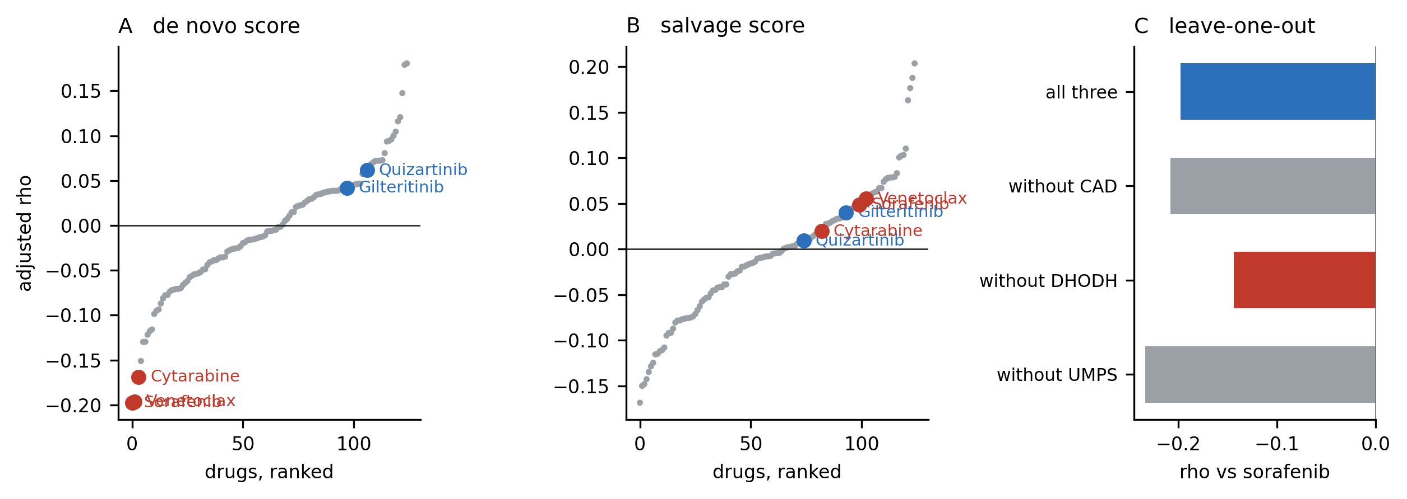
Supplementary Figure S2. Specificity of the de novo pyrimidine score, base model. (A) Adjusted rho for a score built from CAD, DHODH and UMPS against each of 125 drugs, ranked, with five compounds marked. Sorafenib first, venetoclax second, cytarabine fourth, the two licensed FLT3 inhibitors at ranks 107 and 98. (B) The same for a salvage-pathway score built from UCK1, UCK2, CDA, DCK, UPP1, NT5C2 and TK1, where the same three compounds sit at ranks 100, 103 and 83. (C) Leave-one-out analysis against sorafenib: removing DHODH (red) weakens the score, removing UMPS strengthens it. Run under the base model and therefore subject to the inflation quantified in the main text.
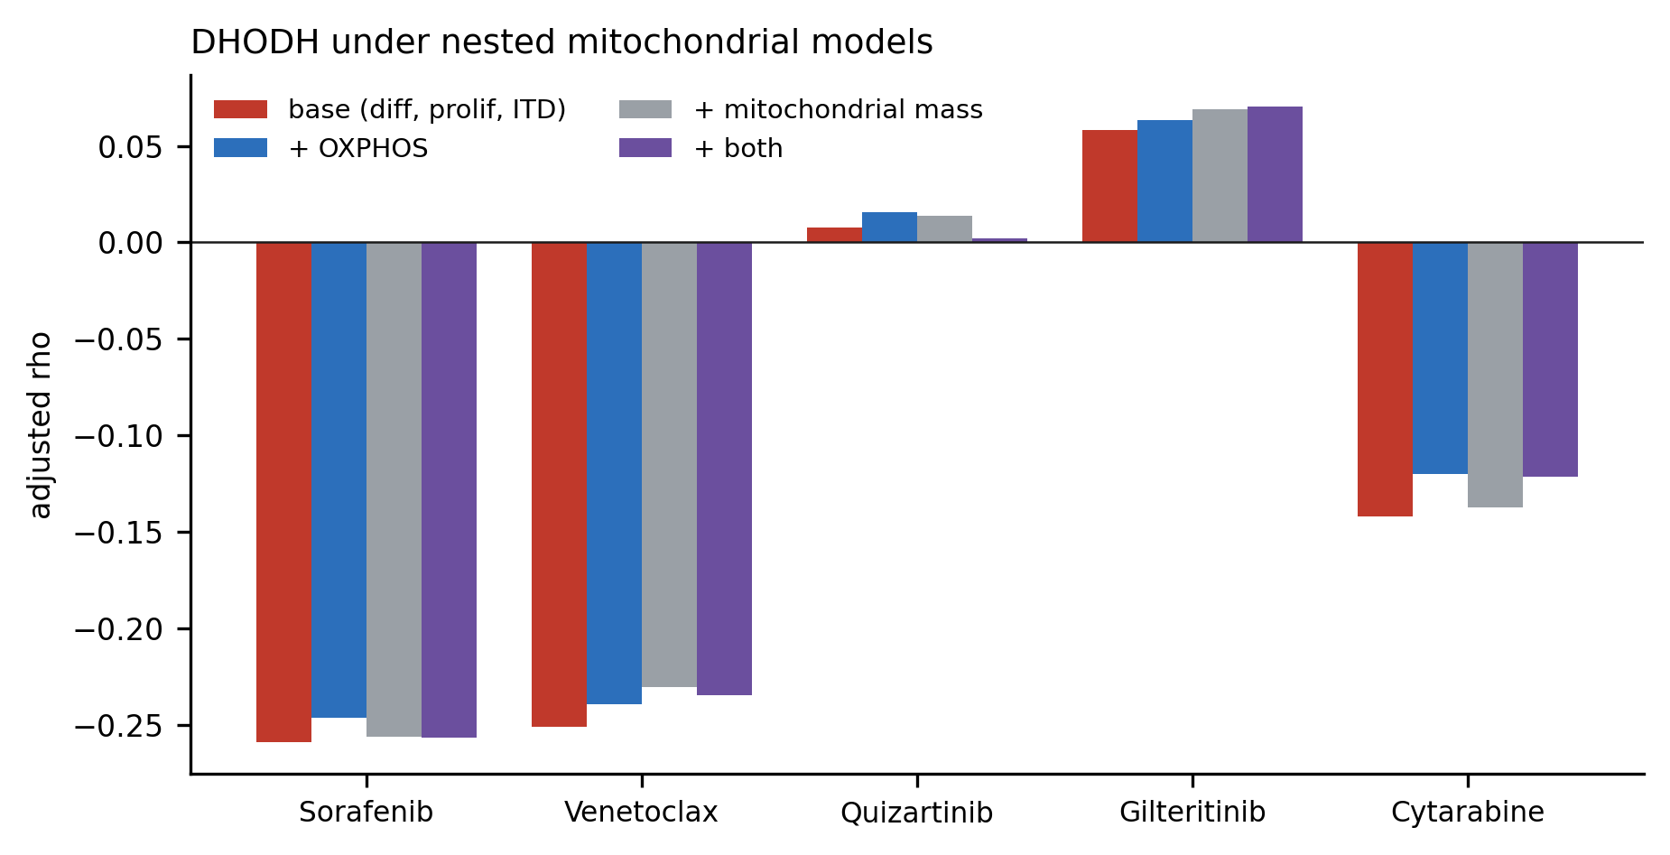
Supplementary Figure S3. DHODH under nested mitochondrial models. Adjusted rho for DHODH against five drugs under the base model and under the same model with a nuclear-encoded OXPHOS score, a mitochondrial mass score, or both added. DHODH sits on the inner mitochondrial membrane and venetoclax preferentially kills OXPHOS-dependent AML, so mitochondrial content was an obvious alternative explanation for both associations. It is not one: the estimates move in the third decimal place, which is why these covariates were not retained. Blast percentage, which does move them, is treated separately in the main text.
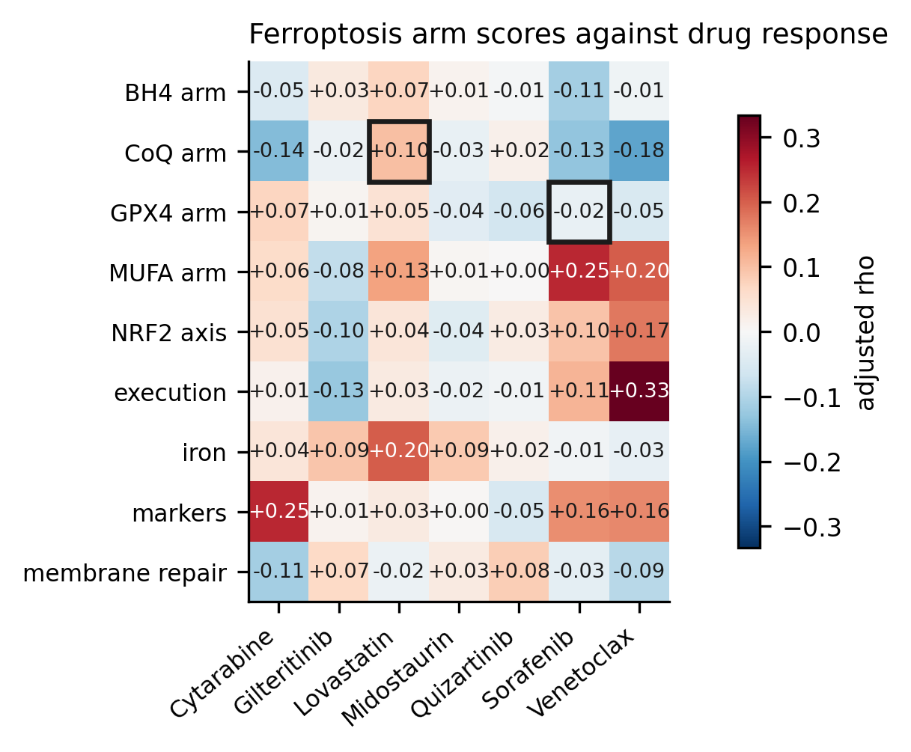
Supplementary Figure S4. The ferroptosis analysis that failed. Adjusted rho for nine ferroptosis arm scores against seven drugs, base model. Black outlines mark the two cells the hypothesis predicted: the GPX4 arm with sorafenib, on the proposal, since contested [12], that sorafenib inhibits system xc−, and the CoQ arm with lovastatin, on the reasoning that the mevalonate pathway supplies CoQ10. Neither held. The execution and MUFA arms track venetoclax and sorafenib in the direction opposite to the prediction, which their correlation with monocytic differentiation accounts for. The DHODH candidate came out of this scan, and the number of hypotheses tested around a result belongs in the record.
Supplementary tables
Supplementary Table S1. DHODH against FLT3-directed compounds under both models, overall and within FLT3-ITD strata. Stratified rows drop ITD status, which is constant within a stratum, and retain the remaining covariates including blast percentage. These are the numbers behind Figure 4 of the main text.
Comparison | Base rho (p) | Extended rho (p) | Extended n
Sorafenib, all patients | −0.259 (5.2e−9) | −0.155 (0.0026) | 376
Quizartinib | +0.008 (0.87) | +0.002 (0.96) | 350
Gilteritinib | +0.058 (0.33) | +0.103 (0.14) | 205
Midostaurin | +0.061 (0.19) | +0.150 (0.005) | 346
Crenolanib | +0.021 (0.66) | +0.075 (0.17) | 339
Sunitinib | −0.083 (0.067) | −0.057 (0.27) | 374
Ponatinib | −0.058 (0.32) | −0.064 (0.33) | 236
Sorafenib, ITD positive | −0.325 (2.6e−4) | −0.208 (0.048) | 91
Sorafenib, ITD negative | −0.233 (5.5e−6) | −0.134 (0.024) | 285
Quizartinib, ITD positive | −0.081 (0.39) | −0.055 (0.63) | 82
Quizartinib, ITD negative | +0.026 (0.62) | +0.005 (0.94) | 268
Gilteritinib, ITD positive | +0.083 (0.48) | +0.177 (0.22) | 50
Gilteritinib, ITD negative | +0.056 (0.43) | +0.092 (0.25) | 155

Supplementary Table S2. Robustness of the DHODH to sorafenib association, one model per objection. These are the numbers behind Figure 1C of the main text. Only the blast adjustment moves the estimate.
Model | n | rho | p
Base (all samples, residual AUC) | 494 | −0.258 | 5.6 × 10⁻⁹
One sample per patient | 454 | −0.246 | 1.1 × 10⁻⁷
Raw AUC, no general-sensitivity step | 494 | −0.212 | 2.0 × 10⁻⁶
+ specimen type | 494 | −0.259 | 5.0 × 10⁻⁹
+ relapse indicator | 494 | −0.260 | 4.4 × 10⁻⁹
+ marrow blast percentage | 376 | −0.156 | 0.0024
+ specimen-matched blast percentage | 414 | −0.186 | 1.4 × 10⁻⁴
All adjustments together | 376 | −0.157 | 0.0022

Supplementary Table S3. Pyrimidine pathway partners against sorafenib and venetoclax response, base model. DHODH is the mitochondrial step; the others are cytosolic. The partners move in the same direction and more weakly, which is what places the signal in the pathway while leaving the resolution with the gene.
Gene | Sorafenib rho | p | Venetoclax rho | p
DHODH | −0.259 | 5.2 × 10⁻⁹ | −0.251 | 1.1 × 10⁻⁶
CAD | −0.166 | 2.0 × 10⁻⁴ | −0.147 | 0.0047
UMPS | −0.124 | 0.0056 | −0.151 | 0.0036
CTPS1 | −0.164 | 2.6 × 10⁻⁴ | −0.256 | 6.8 × 10⁻⁷
CTPS2 | −0.145 | 0.0012 | −0.275 | 8.9 × 10⁻⁸
RRM1 | −0.125 | 0.0054 | −0.008 | 0.88
RRM2 | +0.041 | 0.36 | +0.101 | 0.053
TYMS | −0.029 | 0.53 | +0.058 | 0.27

Gene symbols used in the composite scores. Monocytic: LYZ, CD14, CD68, FCN1, VCAN, MAFB, CSF1R, CEBPB. Primitive: CD34, KIT, SPINK2, MSI2, PROM1, DNMT3B. Proliferation: MKI67, PCNA, TOP2A, CCNB1, AURKA. OXPHOS: NDUFA9, NDUFB8, NDUFS1, SDHA, SDHB, UQCRC1, UQCRC2, CYC1, COX5A, COX7B. Mitochondrial mass: TOMM20, TIMM23, VDAC1, CS, TFAM, PPARGC1A, MFN2, OPA1. De novo pyrimidine: CAD, DHODH, UMPS. Salvage: UCK1, UCK2, CDA, DCK, UPP1, NT5C2, TK1.

