Supplementary files to Wang et al., Construction and analysis of a Noccaea caerulescens TILLING population
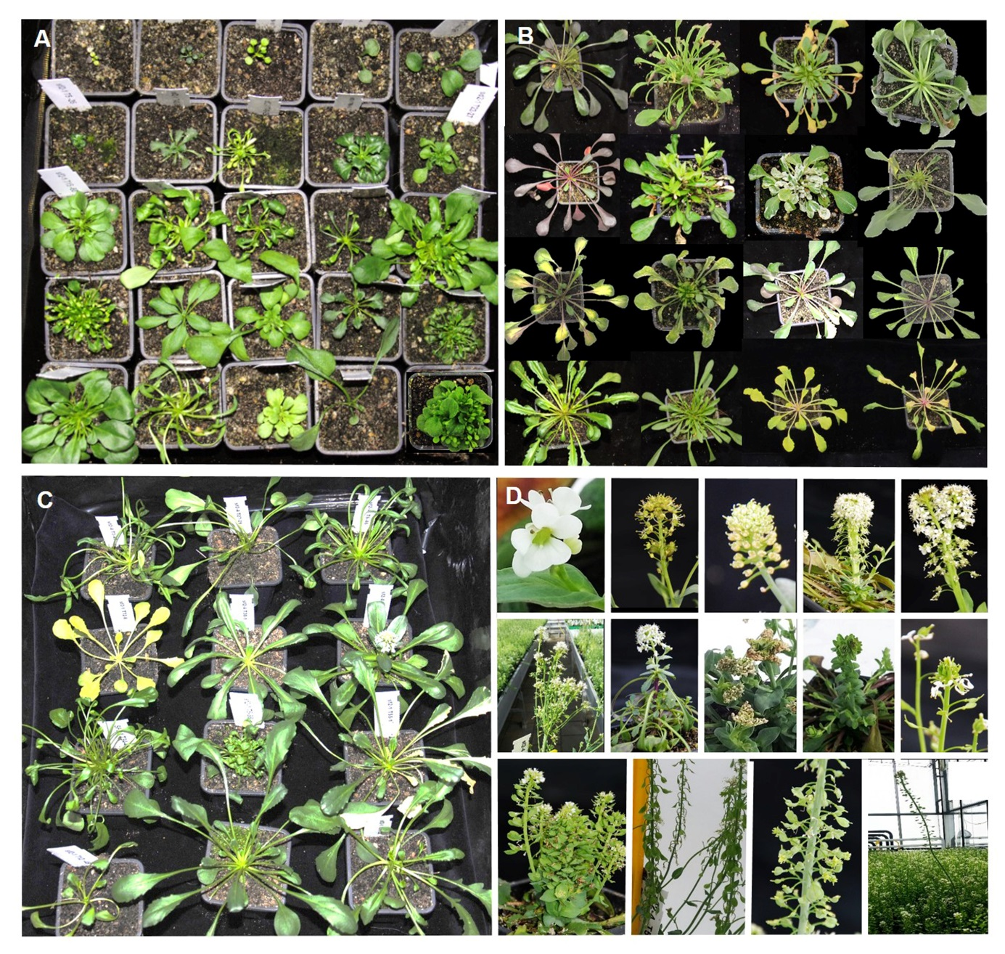
Figure S1
Figure S1 Additional morphological mutations identified in the M2 generation in vegetative growth stage. A: abnormal plant size and leaf shape; B: chlorophyII aberration; C: Plants with curly leaf petiole; D: abnormal organization of flowers, inflorescences, siliques and a super tall plant.
Figure S2
Figure S2. High Resolution Melting analysis of second round PCR products of 96 4x-fold pooled samples. The figure shows the analysis of the amplicons containing known point mutation (G-A) in flc-1. (A). the original total fluorescence for 96-samples captured by the light scanner. (B). normalizing curves by changing the black bars in figure A. (C). Normalized temperature-shifted curves, the black curves pointed by arrow containing flc1 mutants (G->A) in corresponding wells and (D) difference curves with G->A point mutations highlighted in black.
Table S1. Primer sequences used to optimize PCR and HRM.
Primer name | Gene |  | Primer sequences
Y1SP1F | NcFLC | Forward | AACATGCCGATGATCTTAAAGC
Y1SP1R | NcFLC | Reverse | GAACGAGGGAATCGACACTTAC
bzip19P1_F | NcbZIP19 | Forward | AAATCGTTCTCTACGTCCATGTCT
bzip19P1_R | NcbZIP19 | Reverse | TCAAAATCGACAATTTCTAAGAAGC
bzip19BP2_F | NcbZIP19 | Forward | GAGTACGGTTACTTTGTTGGTGGT
bzip19BP2_R3 | NcbZIP19 | Reverse | ATACTTTCGAACCGCTTCTCGATTC

