Supplementary Data
Material and Method
Delineating Quality Target Product Profile (QTPP) and Critical Quality Attributes (CQAs) as per ICH Q8 (R2) guidelines for product development
As the preliminary step towards the QbD-based product development of supersaturable preconcentrate isotropic mixture (SP-IM) of ATZ, the quality target product profile (QTPP) was defined; enlisting all the desired characteristics of the ATZ loaded SP-IM. The prepared formulation will be capable of keeping the drug in dissolved state irrespective of any pH condition, augmenting the ATZ targeting to lymph and subsequently into the systemic circulation for achieving enhanced therapeutic efficacy [1, 2]. Various key elements of QTPP, viz. dosage type and strength, its administration route, release profile, pharmacokinetics and stability requirements, are enlisted in Table S1. Table S2 enumerates the various CQAs and the degree of their plausible influence on varied biopharmaceutical attributes of the proposed ATZ-SP-IM.
An Ishikawa fishbone diagram was constructed by enlisting all the possible factors and delineating their likely influence on the drug product (Fig. S1). Further, the risks associated with each of the factors involved were best evaluated using Failure Mode Effect Analysis (FMEA) by assigning these with varying levels of risk, from low, medium to high (Table S3) [3, 4].
Factor screening studies
Screening design helps in more precise identification of the critical material attributes MAs and PPs with the help of statistical analysis. Based on the high risk factors identified from the FMEA, factor screening study was done for optimizing the process parameter (temperature condition (60 or 80˚C)) required for solubilizing ATZ into isotropic mixture (IM) by utilizing triangular prism design. Table S4 summarizes the design matrix constructed as per the 3 numeric variables i.e. Oil (X₁) (0.1-0.2 g), Surfactant (X₂) (0.5-0.6 g) and Co-Surfactant (X₃) (0.3-0.4 g) at 3 level and 1 categorical variable i.e. temperature (Z₄) required for solubilizing ATZ (60 or 80˚C) at 2 level; 12-runs.
Briefly, the ATZ loaded IM were prepared by simple admixture method. An amount of ATZ (50 mg) was first dissolved in the weighed amount of propylene glycol (at 60 or 80˚C) by stirring on a magnetic stirrer. Subsequently, the weighed amount of Tween 80 and corn oil: oleic acid (1:1) was further added as per the design matrix to form isotropic mixture (Table S4).
Characterization of the isotropic mixture prepared as per screening design
Determination of particle size (PS)(Y₁) and poly dispersity index (PDI) (Y₂)
The particle size and PDI of the globules were determined after 100-fold dilution of the isotropic mixture pre-concentrates with 0.1N HCl at 25˚C. An aliquot (0.1 mL) of each formulation was taken for globule size analysis. Droplet size and PDI of the emulsion formed was studied using photon correlation spectroscopy (PCS) with the help of a Malvern Zetasizer (Malvern Instruments, UK, Zetasizer Nano ZS90) [5]. The experiment was conducted in triplicate (n = 3) and results were reported as mean ± S.D.
Percentage Transmittance (%T) (λ_{max}, 560 nm) (Y₃)
An aliquot (0.1 mL) of IM pre-concentrates were diluted 100-folds with 0.1N HCl. Percentage transmittance were measured spectrophotometrically (Hitachi U-2900 spectrophotometer) at 560 nm using 0.1N HCl as a blank [6]. The experiment was conducted in triplicate (n = 3) and results were reported as mean ± S.D.
Drug Content (DC) (Y₄)
To determine the drug content, ATZ loaded IM pre-concentrates equivalent to 5 mg was accurately weighed and dissolved in 10 mL of methanol. The samples were vortexed for 5 min for the complete solubilization of IM, filtered by 0.45 µ membrane filter and analyzed by in house validated HPLC method [7]. The experiment was conducted in triplicate (n = 3) and results were reported as mean ± S.D.
Rheological studies
The changes in rheological behavior before and after addition of ATZ and PPI into the IM was studied using MCR-52 Rheometer (Anton Paar, Germany); parallel plate geometery PP50 (50 mm diameter) with a 0.5 mm measuring gap. The temperature of the sample was maintained by Anton Paar, peltier system. The shear rate sweep was conducted using a continuous ramp from 0.1-100 s⁻¹ while keeping the temperature of sample at 25°C. All measurements were performed in triplicates. The shear flow curves obtained in steady shear analysis were analyzed using different flow models such as Power law, Herschel-Bulkley, Casson and Bingham model [8]. The effect of temperature on the flow characteristics was also observed by carrying out temperature sweep test. The test was carried out in a range from 0˚C to 40˚C at a shear rate of 50 s⁻¹ according to the arrhenious mode [9].
Result and Discussion
Risk assessment study
Fig. S1 data represents the Ishikawa fish-bone diagram for the development of SP-IM depicting the cause-and-effect relationship among the potential formulation and process variables considerably affecting the performance of drug product. Table S2 illustrates the rationale justification of the critical quality attributes (CQAs) involved in formulating ATZ loaded SP-IM. Further, failure mode & effect analysis (FMEA) was carried out to screen the material attributes and process parameters on the basis of risk priority number (RPN) score (Table S3). The aforementioned tool has suggested that four factors namely concentration of oil, surfactant, co-surfactant and the temperature required for solubilizing the ATZ were found to be highly critical owing to the high risk associated with them on CQAs. While, the other process parameters involving medium risk were kept constant throughout the study.
Factor screening studies
The factor screening studies were carried out on the material attributes and the process parameters involving high risk by employing triangular prism design. The purpose of triangular prism design was to identify the significant main effects, rather than any interaction effects. As per the design matrix, each point on a triangular face representing a given temperature, can be defined in terms of its composition as a mixture of oil, surfactant and co-surfactant or alternatively as a mixture of the 3 pseudo components which have the mixture composition for each vertex of the simplex. Therefore, we wish to achieve a predictive screening model for the solubility of ATZ in components within this space. Thus, 12 formulations were prepared and were evaluated for various critical response variables (CQAs) namely % transmittance, particle size, drug content (indicates solubility of ATZ) and PDI (Table S4). The multiple linear regression analysis (MLR) was carried for all critical response variables to find out the intercept and coefficient for different response variables (Table S5). The outcome of MLR suggesting the positive effect of variable Z₄ in affecting the drug content, % Transmittance and PDI of ATZ loaded IM. However, no significant influence of Z₄ was observed on particle size while keeping other factors of simplex constant. Further, it was observed that to achieve higher CQAs (transmittance and drug content) and lowest particle size and PDI, solubilization of ATZ into oils, surfactant and co-surfactant at 80˚C was a crucial step. Therefore, maintaining 80˚C temperature has been screened for the preparation of ATZ loaded IM. The screened formulation from the combined optimal design has been taken further in the optimization design. While, the process parameters bearing medium risk has been kept constant throughout the study.
Rheological studies
The rheological performance of blank IM (Blank F₁), ATZ loaded IM (F₁), SP-IM without ATZ (Blank F_{ss}) and ATZ loaded SP-IM (F_{ss}) was carried out at controlled shear rate. The effect of increasing shear rate on viscosity at 25˚C has been illustrated in Fig. S4 A. The results suggested that all the samples except Blank F₁ exhibited a decrease in the value of viscosity with increasing shear rate which clearly depicts that all the samples exhibited a shear-thinning behavior. While the Blank F₁ sample showed a shear-thickening behavior. This shear-thickening behavior was evident by the fact that blank formulation without drug and polymer has not been provided any heating source to solubilize either of the component due to which the viscosity of the Blank F₁ sample was high as comparison to other samples. Further, to describe the flow characteristics of all the formulations, different models were applied. It was observed that all the formulations shown a typical newtonian low viscous Bingham flow type. Bingham fluids shows linear shear stress/shear rate dependence after initial threshold has been reached. The results obtained for all the samples are in agreement with those found by Milovic et al., when carbamazepine loaded SMEDDS formulated was analyzed for rheological investigation [10].
To study the effect of temperature on the flow characteristics, all the formulations were subjected to temperature sweep test from 0 to 40˚C. The rheogram showing the effect of temperature on the viscosity of the different formulations has been depicted in Fig. S4 B. The rheogram of all the formulation showed that by increasing the temperature of all the formulation, the viscosity of the sample decreases and follows arrhenious equation. The activation energy (E_{a}) of Blank F₁, F₁, Blank F_{ss} and F_{ss} formulations were found out to be 16.22 kJ/mol, 20.02 kJ/mol, 5.54 kJ/mol and 8.68 kJ/mol respectively. The above results suggested that all the formulations were found out to be stable at higher temperature.

Table S1: Quality target product profile (QTPP) postulated for the development of SP-IM of Atazanavir
QTPP Elements | Target | Justification
Dosage form | SP-IM | Selection of suitable excipients for the development of SP-IM which helps in the enhancement of biopharmaceutical attributes of BCS Class II drug (Atazanavir)
Dosage type | Immediate release | Faster onset of action leading to enhanced therapeutic efficacy
Dosage strength | 50 mg | Unit dose of Atazanvir that can be incorporated into a 1 g of SP-IM
Route of administration | Oral | Recommended route for the delivery of atazanavir
Dispersity | High dispersity of the globules after emulsification | Uniform size distribution is a crucial step for attaining the therapeutic effective concentration of ATZ
Pharmacokinetics | Higher C_{max} and AUC | For attaining the required therapeutic concentration in the systemic circulation
Stability | As per the conditions of ICH Q1A (R2) stability study | To maintain the therapeutic level of the drug during the shelf life
Container closure system | Air-tight glass bottle | To protect against the degradation of drug and lipids in the presence of atmospheric air
Contraindications | None | None

Table S2: Critical quality attributes (CQAs) involved in formulating SP-IM of Atazanavir and their justification
Quality attributes of the drug product | Target | Is this a CQA? | Justification
Physical attributes  (i) Color  (ii) Odor  (iii) Appearance | Acceptable to patients  No unpleasant odor  Acceptable to patients | No | Color, odor and appearance were not considered as CQA, as these are not directly associated with patient efficacy and safety.
Particle Size (nm) | <100 nm | Yes* | Nanoparticulate of smaller particle size allows ease in penetration across GI epithelial lining and paracellular pathways; therefore considered as highly critical.
Polydispersity index (PDI) | 0 to 0.3 | Yes* | Uniform size distribution of ATZ nanoparticulates formed after reconstitution is important for achieving the desired therapeutic efficacy; hence considered as highly critical.
Emulsification Time (s) | 0 to 60 s | Yes* | Lower values of emulsification time helps in ease of forming microemulsion after reconstitution; hence regarded as highly critical.
Drug Content (%) | High | Yes* | As SP-IM being the homogenous dispersions containing ATZ solubilized in the blend of oil, surfactant and co-surfactant. Hence, this variable was regarded as highly critical.
Percent Transmittance (%) | 90 to 100% | Yes* | Higher the values of % transmittance of SP-IM formed after reconstitution shows the stability of the microemulsion and in addition to it lower will be the particle size; hence considered as highly critical.

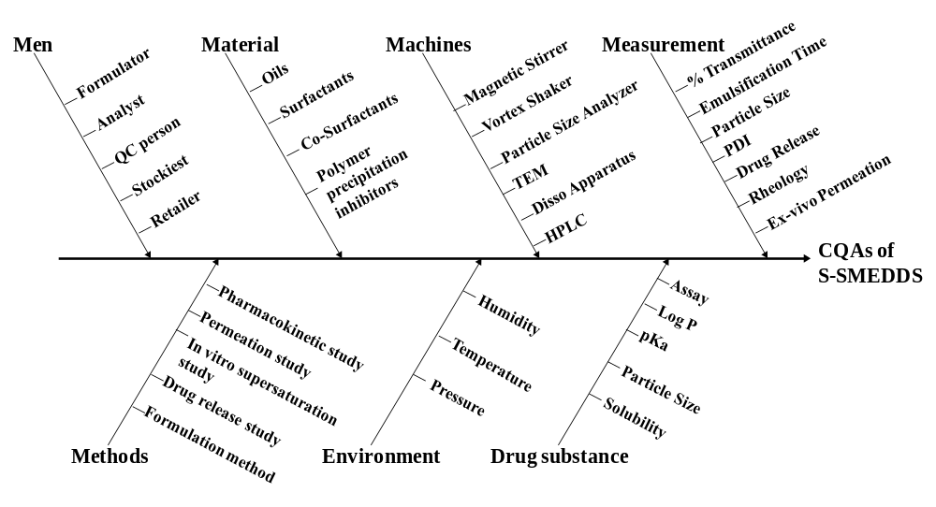
Fig. S1: Ishikawa fish-bone diagram depicting the cause-and-effect relationship among the formulation and process variables for the development of SP-IM
Table S3: FMEA matrix enlisting RPN scores for the material attributes and process parameters
S.No. | Failure Steps | Severity*  (S) | Occurrence* (O) | Detection* (D) | RPN Score | Risk Factor
Material Attributes
1. | Type of Oil | 5 | 5 | 5 | 125 | Low
2. | Type of Surfactant | 5 | 4 | 5 | 100 | Low
3. | Type of Co-Surfactant | 4 | 5 | 5 | 100 | Low
4. | Conc. of Oil | 8 | 8 | 7 | 448 | High
5. | Conc. of Surfactant | 8 | 6 | 8 | 384 | High
6. | Conc. of Co-Surfactant | 8 | 8 | 8 | 512 | High
Process Parameters
7. | Temperature required for solubilization of ATZ | 8 | 7 | 8 | 448 | High
8. | Order of Mixing | 7 | 6 | 7 | 294 | Medium
9. | Stirrer Type | 6 | 7 | 6 | 252 | Medium
10. | Stirring speed | 5 | 6 | 6 | 180 | Medium
11. | Stirring Time | 7 | 7 | 6 | 294 | Medium
12. | Humidity | 5 | 5 | 3 | 75 | Low
*Minimum value is assigned as 1; maximum value is assigned as 10
@ 0-125 Low risk 126-300 Medium risk 301-1000 High risk

Table S4: Traingular prism design for selecting the appropriate temperature required for the complete solubilization of ATZ into IM.
F.No. | (X₁)  Oil (CO:OA)  (1:1)  (g) | (X₂)  Surfactant  (T80)  (g) | (X₃)  Co-Surfactant  (PG)  (g) | (Z₄)  Temp.  (˚C) | % T | PS  (nm) | PDI | DC  (%)
1. | 0.1 | 0.55 | 0.35 | 60 | 99.4±0.4 | 12.7±0.6 | 0.098±0.004 | 66.1±1.9
2. | 0.1 | 0.55 | 0.35 | 80 | 99.5±0.3 | 13.1±0.4 | 0.493±0.02 | 82.3±1.4
3. | 0.15 | 0.5 | 0.35 | 80 | 99.5±0.2 | 15.4±0.7 | 0.194±0.009 | 81.5±1.2
4. | 0.15 | 0.5 | 0.35 | 60 | 98.8±0.6 | 14.4±0.3 | 0.04±0.002 | 69.1±1.4
5. | 0.1 | 0.6 | 0.3 | 60 | 99.4±0.3 | 13.1±0.5 | 0.045±0.002 | 54.3±1.1
6. | 0.15 | 0.55 | 0.3 | 60 | 99.1±0.5 | 14.4±0.6 | 0.034±0.001 | 26.5±0.7
7. | 0.1 | 0.60 | 0.3 | 80 | 99.6±0.2 | 12.9±0.5 | 0.246±0.01 | 90.1±2.1
8. | 0.15 | 0.55 | 0.3 | 80 | 99.4±0.4 | 14.7±0.7 | 0.097±0.003 | 73.8±1.7
9. | 0.2 | 0.5 | 0.3 | 80 | 99±0.6 | 44.7±2.1 | 0.456±0.02 | 85.8±2.2
10. | 0.1 | 0.5 | 0.4 | 80 | 99.5±0.2 | 13.2±0.4 | 0.63±0.03 | 87.6±1.8
11. | 0.1 | 0.5 | 0.4 | 60 | 99.2±0.5 | 12.8±0.6 | 0.091±0.003 | 23.5±0.7
12. | 0.20 | 0.5 | 0.3 | 60 | 99±0.4 | 69.7±3.1 | 0.297±0.01 | 71.6±1.4
*CO: Corn Oil; OA: Oleic Acid; T80: Tween 80; PG: Propylene Glycol; % T: Percent Transmittance; PS: Particle Size; PDI: Polydispersity Index; DC: Drug Content
Table S5: Multiple linear regression (MLR) analysis of various critical response variables (CRVs).
Variables | Intercept | B | Active variable
Particle Size | 8.89;  p = 0.072 | 36.09;  p = 0.0022 | X₁
Drug Content | 67.68;  p = 0 | 15.83;  p = 0.000038 | Z₄
% Transmittance | 99.51;  p = 0 | X₁ B = -0.520;  p = 0.002  X₃ = -0.160  p = 0.225  Z₄ B = 0.133;  p = 0.0095 | X₁, X₃ and Z₄
PDI | 0.277;  p = 0.0013 | X₂ B = -0.153;  p = 0.238  Z₄ B = 0.125;  p = 0.021 | X_{2,} Z₄

Fig. S2: 3D response surface plot correlating critical material attributes with (A) Particle size, (B) PDI, (C) % Transmittance, (D) Drug content, (E) Self-Emulsification Time and (F) Desirability plot.

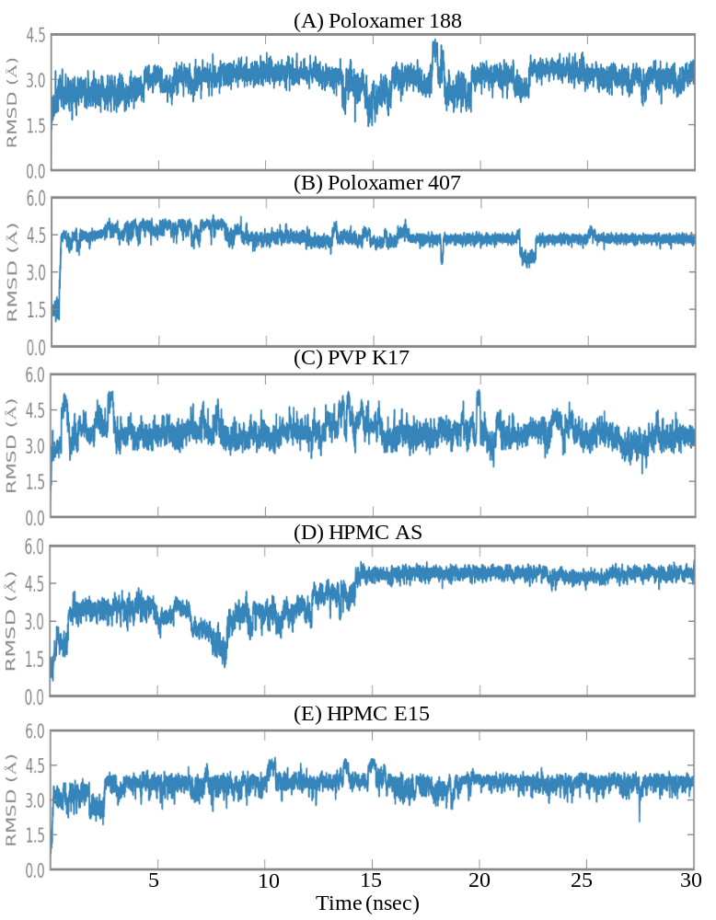
Fig. S3: Root mean-square deviation (RMSD) plot of various ATZ-PPIs complex
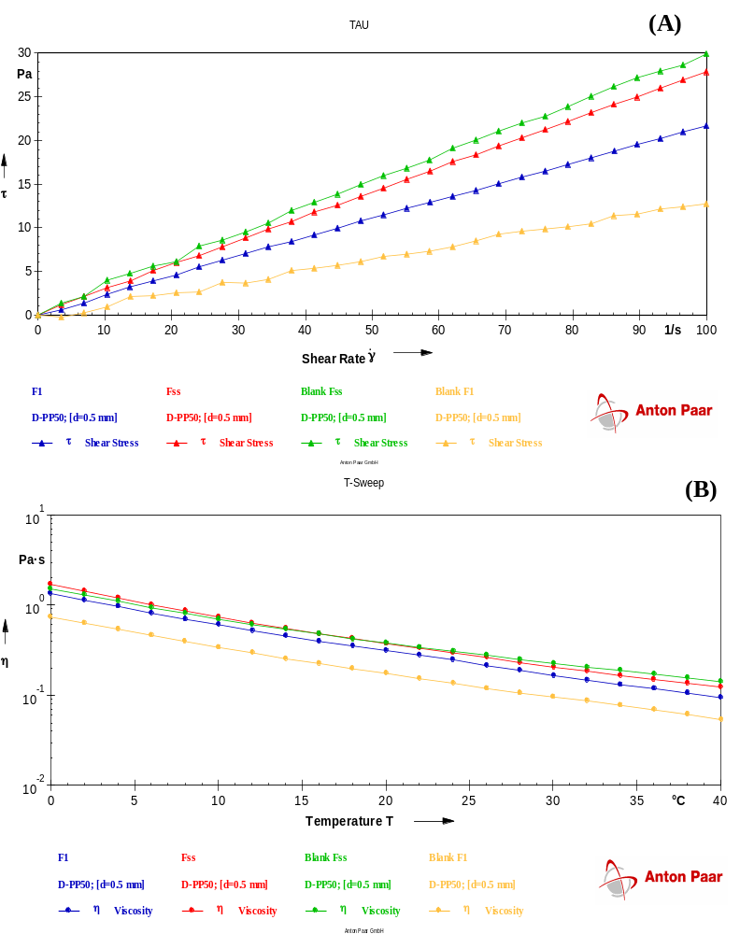
Fig. S4: Rheogram generated for different formulations at (a) controlled shear rate and (b) temperature sweep test from 0 to 40˚C.

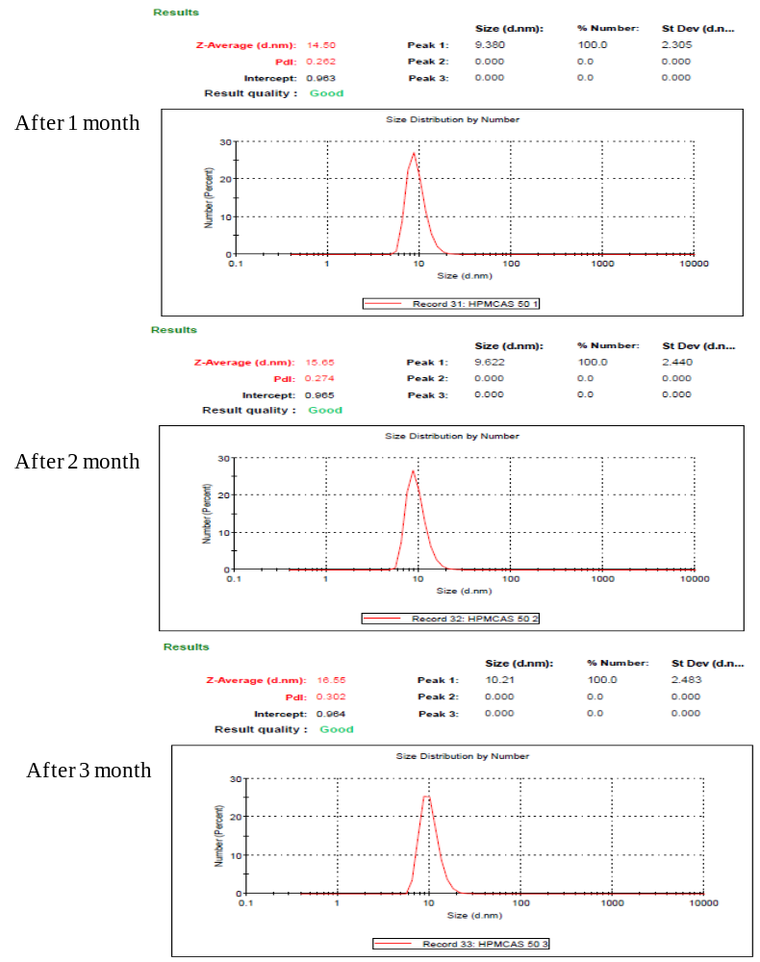
Fig. S5: Particle size and PDI analysis of SP-IM at different time intervals

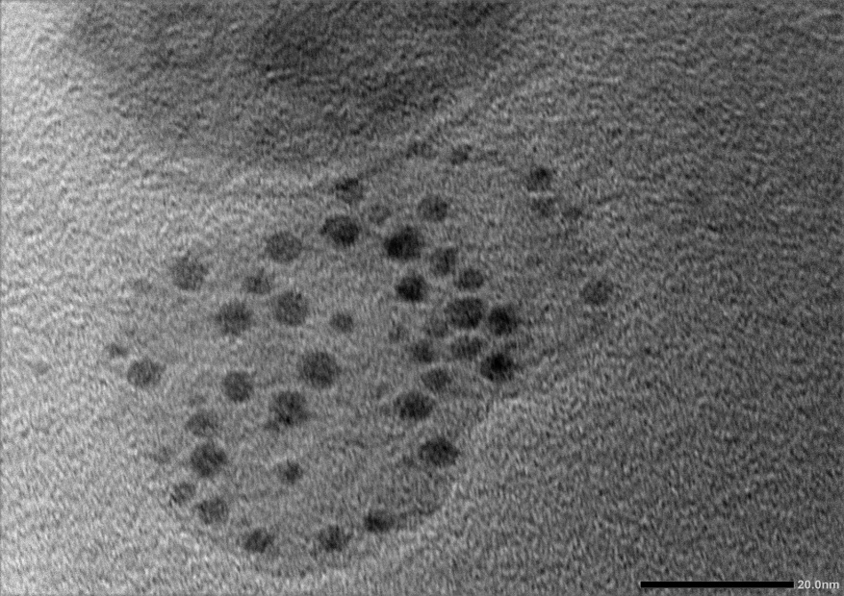
Fig. S6: TEM image of reconstituted SP-IM at low magnification.
Table S6: Ternary mixture prepared by varying ratio of Oil, Surfactant and Co-surfactant
Oils  (g) |  | Surfactant  (g) | Co-surfactant  (g) | Clarity and miscibility of excipients (after 24 hours) in ternary mixture |  | % Transmittance
Corn Oil | Oleic Acid | Tween 80 | Propylene Glycol | A | B | % Transmittance
0.05 | 0.05 | 0.8 | 0.1 | C | S | 98.1
0.05 | 0.05 | 0.7 | 0.2 | C | S | 98.8
0.1 | 0.1 | 0.6 | 0.2 | C | S | 96.5
0.05 | 0.1 | 0.75 | 0.1 | T | P | 57.4
0.05 | 0.1 | 0.65 | 0.2 | T | P | 55.6
0.1 | 0.05 | 0.75 | 0.1 | T | P | 54.2
0.1 | 0.05 | 0.65 | 0.2 | T | P | 54.1
0.05 | 0.15 | 0.7 | 0.1 | T | P | 36.3
0.05 | 0.15 | 0.6 | 0.2 | T | P | 35.2
0.15 | 0.05 | 0.7 | 0.1 | T | P | 33.4
0.15 | 0.05 | 0.6 | 0.2 | T | P | 33.8
*A-at the time of preparation and B-after 24 hours; C: Clear; T: Turbid; S: Stable; P: Phase Seperation

References:
[1] S. Beg, P.S. Sandhu, R.S. Batra, R.K. Khurana, B. Singh, QbD-based systematic development of novel optimized solid self-nanoemulsifying drug delivery systems (SNEDDS) of lovastatin with enhanced biopharmaceutical performance, Drug delivery, 22 (2015) 765-784.
[2] G. Kuruba, K.A.N. Reddy, S. Poli, C. Ramnarayanan, Quality by Design based development of Self Nano Emulsifying Drug Delivery System of Ritonavir, Journal of Young Pharmacists, 12 (2020) 215.
[3] B. Garg, S. Beg, R. Kaur, R. Kumar, O.P. Katare, B. Singh, Long-chain triglycerides-based self-nanoemulsifying oily formulations (SNEOFs) of darunavir with improved lymphatic targeting potential, Journal of drug targeting, 26 (2018) 252-266.
[4] S. Kamboj, S. Sethi, V. Rana, A spray dried nelfinavir mesylate particles for enhanced oral bioavailability: systematic formulation optimization and in-vivo performance, Colloids and Surfaces B: Biointerfaces, 176 (2019) 288-299.
[5] W. Wu, Y. Wang, L. Que, Enhanced bioavailability of silymarin by self-microemulsifying drug delivery system, European journal of pharmaceutics and biopharmaceutics, 63 (2006) 288-294.
[6] S.T. Bansode, S.J. Kshirsagar, A.R. Madgulkar, M.R. Bhalekar, M.M. Bandivadekar, Design and development of SMEDDS for colon-specific drug delivery, Drug development and industrial pharmacy, 42 (2016) 611-623.
[7] M.H. Patel, K.K. Sawant, Self microemulsifying drug delivery system of lurasidone hydrochloride for enhanced oral bioavailability by lymphatic targeting: in vitro, Caco-2 cell line and in vivo evaluation, European Journal of Pharmaceutical Sciences, 138 (2019) 105027.
[8] R. Sharma, V. Rana, Effect of carboxymethylation on rheological and drug release characteristics of Terminalia catappa gum, Carbohydrate polymers, 175 (2017) 728-738.
[9] S. Kamboj, S. Sethi, V. Rana, Lipid based delivery of Efavirenz: an answer to its erratic absorption and food effect, European Journal of Pharmaceutical Sciences, 123 (2018) 199-216.
[10] M. Milović, J. Djuriš, L. Djekić, D. Vasiljević, S. Ibrić, Characterization and evaluation of solid self-microemulsifying drug delivery systems with porous carriers as systems for improved carbamazepine release, International journal of pharmaceutics, 436 (2012) 58-65.

