Supplementary Material:
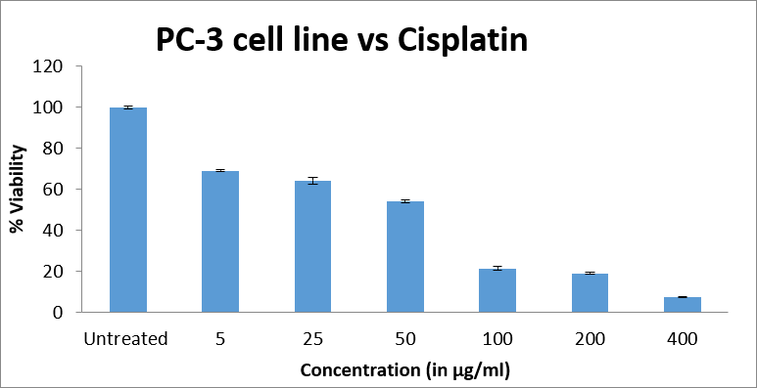
Figure S1. Dose–response analysis of cisplatin-induced cytotoxicity in PC-3 cells. PC-3 cells were exposed to cisplatin at concentrations ranging from 5 to 400 µg/mL, and cell viability was assessed following treatment. The dose–response profile demonstrates a concentration-dependent reduction in cell viability, with an estimated half-maximal inhibitory concentration (IC₅₀) of 30.447 µg/mL under the experimental conditions.

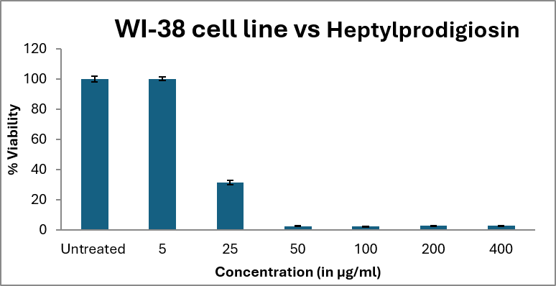
Figure S2. Cytotoxicity of heptylprodigiosin in WI-38 human fibroblasts. The cytotoxic effect of heptylprodigiosin on WI-38 cells was evaluated over a concentration range of 5–400 µg/mL. Cell viability decreased with increasing heptylprodigiosin concentration, and the estimated IC₅₀ was 16.27 µg/mL under the experimental conditions.
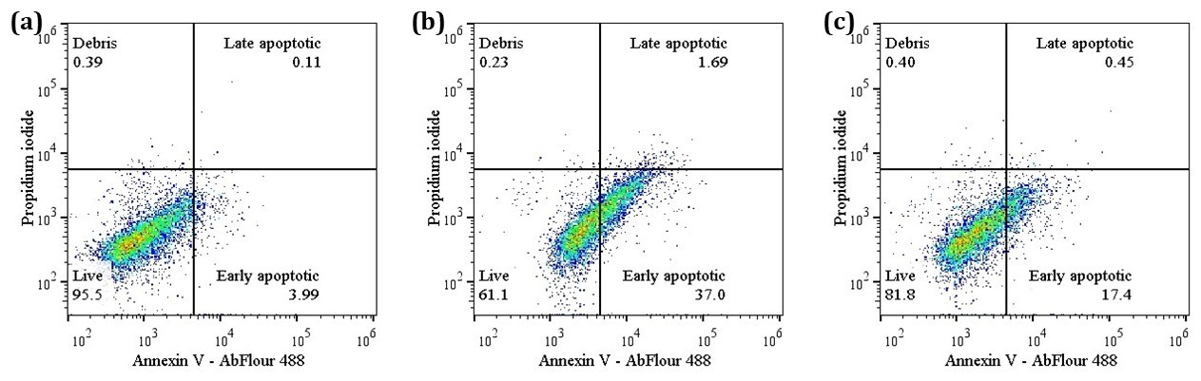
Figure S3: Flow cytometric profiling of apoptotic induction in human PC-3 prostate cancer cells. Representative quadrant plots following 24 h exposure to (A) untreated control, (B) Cisplatin (30.45 µg/mL), and (C) Heptylprodigiosin (9.00 µg/mL). Cell populations are categorized into live (lower left), early apoptotic (lower right), late apoptotic (upper right), and debris (upper left) based on Annexin V-AbFluor 488 and Propidium Iodide (PI) staining intensity.
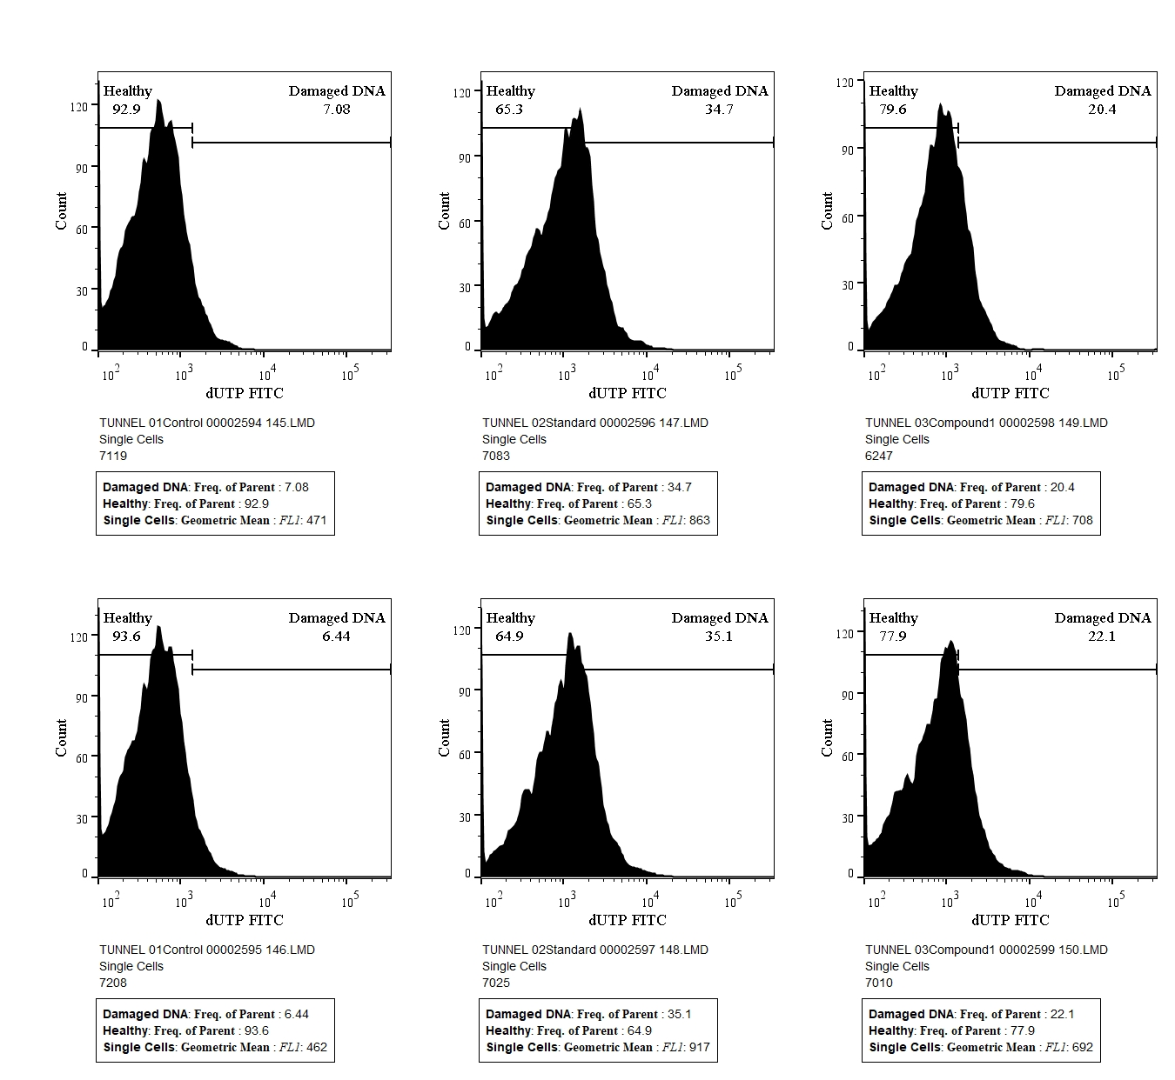
Figure S4. Flow cytometric analysis of heptyl prodigiosin-induced DNA fragmentation in human PC-3 cells using the TUNEL assay.

Table S1: ¹H NMR chemical shifts of heptylprodigiosin
Proton No. | Chemical Shift (ppm) | Proton No. | Chemical Shift (ppm)
2 | 7.24 (1H, br s) | 7" | 2.39 (3H, t, J=7.5 Hz)
3 | 6.33 (1H, t, J=3.0 Hz) | 8" | 1.55 (2H, m)
4 | 6.92 (1H, d, J=3.0 Hz) | 9" | 1.29 (6H, m)
4'-OMe | 4.0 (3H, s) | 12" | 1.33 (2H, m)
3" | 6.68 (1H, br s) | 13" | 0.89 (3H, t, J=7.0 Hz)
6" | 2.53 (3H, s) | - | -
Table S2: ¹³C NMR chemical shifts of heptylprodigiosin
Carbon No. | Chemical Shift (ppm) | Carbon No. | Chemical Shift (ppm)
2 | 127.08 | 3", 4" | 128.40
3 | 111.10 | 5" | 147.0
4 | 117.10 | 6" | 112.46
5 | 122.28 | 7" | 25.36
2' | 148.0 | 8" | 30.96
3' | 92.90 | 9" | 29.83
4' | 165.81 | 10" | 29.31
5' | 122.28 | 11" | 31.44
6' | 116.01 | 12" | 22.52
2" | 125.0 | 13" | 14.14

