Selective etching of silicon nitride over silicon oxide using ClF₃/H₂ remote plasma

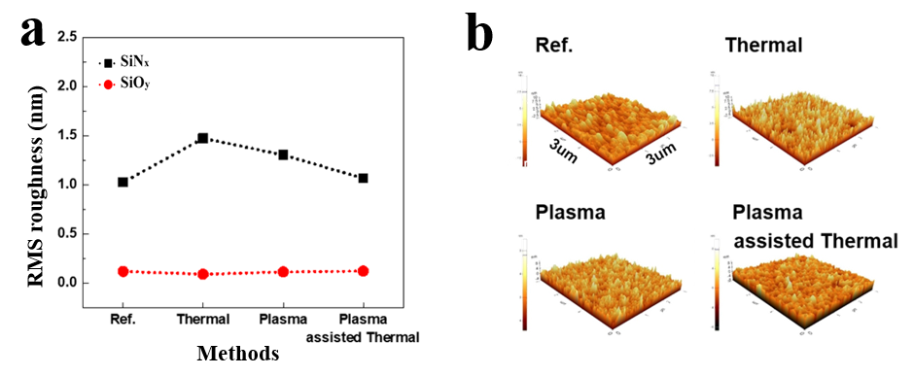
Figure S1. a) RMS surface roughness values and b) images of SiN_{x} and SiO_{y} after etching with ClF₃ plasma [same plasma conditions with figure 3a) in the manuscript].

Figure S1 a) and b) show the RMS surface roughness values and the images of surface roughness of SiN_{x} and SiO_{y} after the etching with the conditions in figure 3a), respectively. SiN_{x} and SiO_{y} were etched ~ 400 and ~ 20 nm, respectively. As shown in the figures, the surface roughness of etched SiN_{x} was the highest after the chemical etching with substrate temperature of 100 ℃ (1.5 nm) and it was followed by SiN_{x} after the remote plasma etching without substrate heating (1.3 nm). The lowest surface roughness which is similar to that of the reference SiN_{x} (~ 1 nm) was observed after the plasma etching at substrate heating with 100 ℃ (1.15 nm). Even though there were some differences in the surface roughness after the different etch methods, the differences are considered not significant. In the case of SiO_{y}, possibly due to small etch rates for all of the cases, no significant change in the surface roughness was also observed after the etching with the different methods.

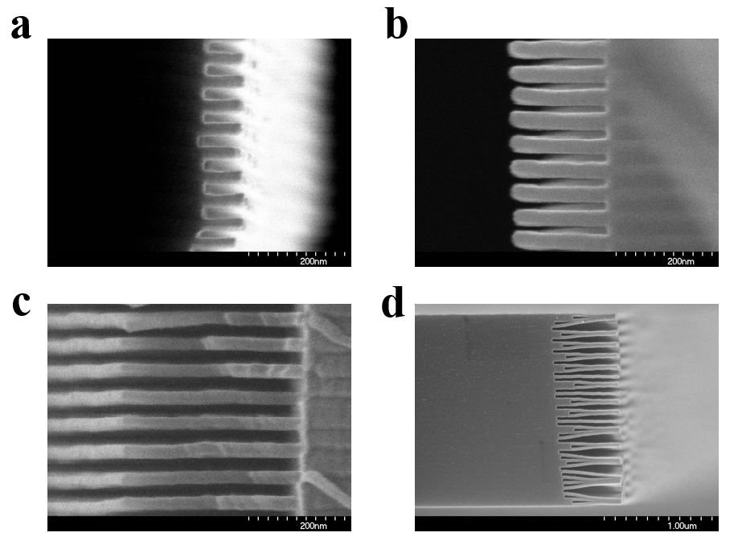
Figure S2. Cross-sectional SEM images of SiN_{x}/SiO_{y} stacks during the etching with ClF₃ plasma for a) 1, b) 3, c) 5, and d) 8 min, respectively.

During the process, the structure of SiN_{x}/SiO_{y} stack started to collapse over 4000 Å-width SiN_{x} etch depth as shown in figure S2 d) but no noticeable changes in the remaining SiO_{y} thickness were observed up to 8 min etching.

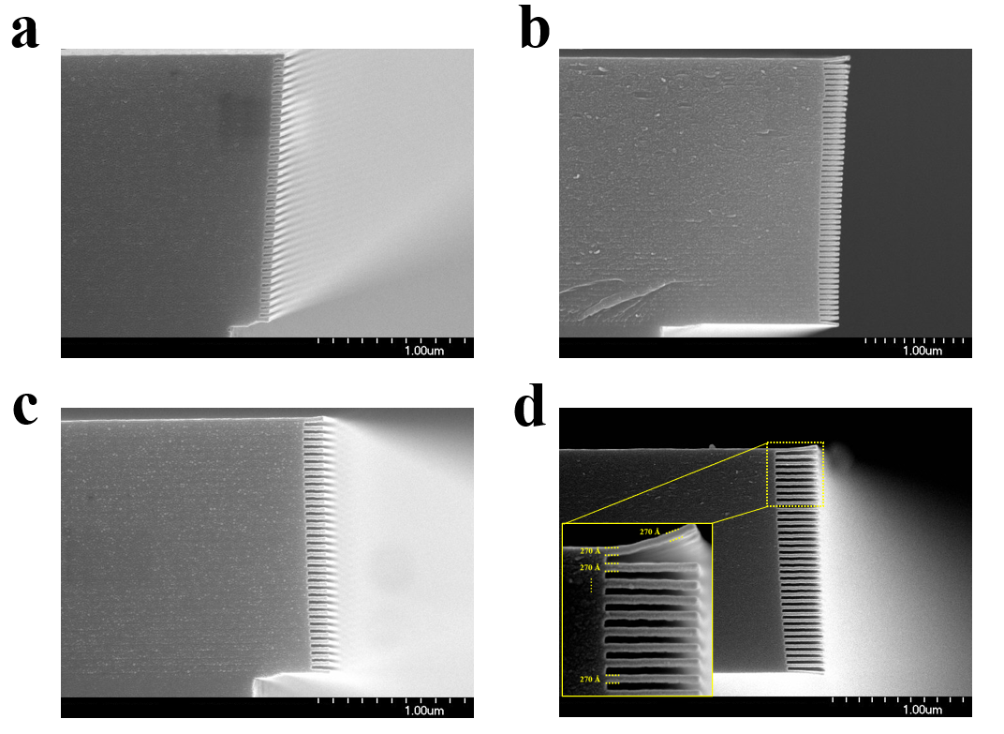
Figure S3. Cross-sectional SEM images of SiN_{x}/SiO_{y} stacks during the etching with ClF₃/H₂ (20 %) plasma for a) 1, b) 2, c) 3, and d) 10 min, respectively.

During the etching of SiN_{x}/SiO_{y} stack, the thickness of SiO_{y} was remaining unchanged and no significant change of SiO_{y} thickness between top (which was exposed to the ClF₃/H₂ remote plasma directly) and underneath layers was observed up to 10 min etching with ClF₃/H₂ (20 %) plasma (subset of figure d)

Sample | Atomic percentage (%)
Sample | Si | N | O | F | Cl | C
Ref. SiN_{x} | 35.3 | 38 | 19.5 | - | - | 7.2
SiN_{x} (ClF₃ only) | 33.9 | 33.3 | 12.1 | 15.6 |  | 5.1
SiN_{x} [ClF₃ & H₂ (20 %)] | 33.7 | 32.7 | 14.3 | 12.5 | - | 6.8
Ref. SiO_{y} | 32.9 | - | 61.9 | - | - | 5.2
SiO_{y} (ClF₃ only) | 31 | - | 59.5 | 5.9 | - | 3.6
SiO_{y} [ClF₃ & H₂ (20 %)] | 30.5 | - | 59.6 | 5.5 | - | 4.4
Table S1. Atomic composition of SiN_{x} and SiN_{y} for different ClF₃/H₂ etching conditions.

As shown in Table S1, the reference SiN_{x} deposited by PECVD, which is prepared for a stack layer of SiN_{x}/SiO_{y} of 3D NAND device, showed the N/Si ratio of 1.07, therefore, it was a Si-rich compound compared with the stoichiometric silicon nitride (Si₃N₄; 1.33) while the reference SiO_{y} deposited by PECVD showed O/Si ratio of 1.88 which is close to stoichiometric silicon oxide (SiO₂; 1:2)

