Supplemental Material

DETAILS ON COMPUTATIONAL METHODS
The particle swarm optimization (PSO) is a stochastic global optimization method, inspired by the choreography of a bird flock and can be seen as a distributed behavior algorithm that performs multidimensional search. According to PSO algorithm, the behavior for each individual is affected by either the best local or the best global individual to fly through a hyperspace. Moreover, an individual can learn from its part experiences to adjust its flying speed and direction. Therefore, all the individuals in the swarm can quickly converge to the global position and near-optimal geographical position by the behavior of the flock and their flying histories. Our research group has implemented the PSO algorithm on crystal structure prediction in crystal structure analysis by particle swarm optimization CALYPSO code.³⁴⁻³⁵ The global minimization method through CALYPSO code for predicting crystal structures comprises mainly four steps: (1) generation of random structures with the constraint of symmetry; (2) local structural optimization; (3) postprocessing for the identification of unique local minima by geometrical structure parameter; (4) generation of new structures by PSO for iteration.
The swarm-intelligence based CALYPSO structure prediction method³⁴⁻³⁵ requires only chemical compositions for given compounds to predict stable or metastable structures at any given pressure. In an attempt to investigate the stable and metastable structures of MH_{x} (x=2–24, and M stands for rare-earth/actinide metals, abbreviated as RE/An), we have performed structure searches of MH_{x} at 400 GPa using the CALYPSO code. We first searched the crystal structures of the ThH_{x} (x=2–24) series at 400 GPa with simulation cells containing 1–4 formula units up to 50 atoms per cell. Our structure searches found that ThH₁₈ holds the highest atomic hydrogen content among all known/predicted hydrides and its superconducting T_{c} is very high (the estimated T_{c} of ThH₁₈-Fmmm is in the range of 296-321 K at the pressure range of 400-600 GPa), which motivated us to focus on this chemical composition of MH₁₈. The other structures of MH_{x} stoichiometry are established by substituting the elements into the known structures of ThH_{x} (x=2, 4, 6, 9, 10, 12, 16, 17 and 18). Our searches found that MH₁₈ (M=Sc, Pr, Nd, Pm, Sm, Eu, Gd, Tb, Dy, Ho, Er, Tm, Yb, Lu, Pa, U, Np, Pu, Am, Cm, and Cf) are unstable in the pressure range of 0 to 700 GPa. We then performed further variable-stoichiometry structure searches that are able to explore the most stable structure among a broad range of stoichiometries selected for the stable MH_{x} (M= Y, La, Ce, and Ac; x=2-24) system at 400 GPa, and the results of these additional searches confirm the above identified stability of MH₁₈ (M=Y, La, Ce, Ac, and Th). Following established search protocols, in setting up the first generation of candidate structures, a population of structures belonging to certain space group symmetries is randomly constructed. Local optimizations of candidate structures are done using the conjugate gradients method implemented in the VASP code, with an energy convergence threshold of 1×10⁻⁵ eV per cell. Starting from the second generation, 60% of the structures in the previous generation with the lower enthalpy values are selected to produce the structures of the next generation by the PSO operators. The remaining 40% of the structures in the new generation are randomly generated. A structure fingerprinting technique of bond characterization matrix is employed to evaluate each newly generated structure so that identical structures are strictly forbidden. These procedures significantly enhance the diversity of the sampled structures during the evolution, which is crucial in driving the search into the global minimum. For most cases, the structure search for each chemical composition converges (evidenced by a lack of any additional structure with lower energy) after 1000∼1200 structures investigated (i.e., in about 20∼30 generations).
The energetic stability of MH_{10+x} (0<x≤14) is evaluated by their formation enthalpy (per atom) relative to those of the dissociated products into solid phases of MH₁₀ and H₂:
$$∆h=\frac{h[{MH}_{10+x}]-h({MH}_{10})-\frac{x}{2}h(H_{2})}{10+x} (1)$$
Here “h” represents the enthalpy of the examined systems, i.e., MH_{10+x}, MH₁₀ and H₂. The convex hull connects the phases that are lower in energy than any other phases or linear combination of other phases at any given composition. By extension, phases that lie on the convex hull are thermodynamically stable, whereas those above it are metastable or unstable. Phases lie between the zero line and convex-hull line are classified as metastable structures.
Structural optimization and computations of enthalpy, phonon, electronic structures, and spin-orbital coupling (SOC) were all performed in the framework of density-functional theory (DFT) as implemented in the VASP code.⁴⁶ The electron-phonon coupling (EPC) calculations were carried out using the QUANTUM ESPRESSO code.⁵⁰ Ultrasoft pseudopotentials for RE/An and H elements were used with a kinetic energy cutoff of 80 Ry. To reliably calculate the electron-phonon coupling in metallic systems, we have employed k-meshes of 2π×0.045 Å⁻¹ for the electronic Brillouin zone integration and q-meshes of 2π×0.09 Å⁻¹ for all the phonon calculations of MH₁₈ compounds. The key equations to be numerically solved in the Migdal-Eliashberg theory⁵¹ are:
$$Z\left(k,iω_{n}\right)=1+\frac{πT}{N_{F}ω_{n}}\sum_{k^{'}n^{'}}{\frac{ω_{n}^{'}}{\sqrt{ω_{n}^{'2}+∆^{2}\left(k^{'},{iω}_{n}^{'}\right)}}}λ\left(k,k^{'},n-n^{'}\right)δ\left(ϵ_{k^{'}}\right), (2)$$
$$Z\left(k,iω_{n}\right)∆\left(k,iω_{n}\right)=\frac{nT}{N_{F}}\sum_{k^{'}n^{'}}{\frac{∆\left(k^{'},{iω}_{n}^{'}\right)}{\sqrt{ω_{n}^{'2}+∆^{2}\left(k^{'},{iω}_{n}^{'}\right)}}}×\left[λ\left(k,k^{'},n-n^{'}\right)-N_{F}V(k-k^{'})\right]δ\left(ϵ_{k^{'}}\right), (3)$$
In these equations T is the temperature, and the functions Z and ∆ represent the renormalization function and superconducting gap, respectively, which form a coupled nonlinear equation system and can be solved self-consistently. N_{F} is the density of electronic states at the Fermi level, and δ(ϵ_{k}) is the Dirac delta function (the zero of energy is set to the Fermi level). k denotes the composite band and wavevector index, and $iω_{n}=i\left(2n+1\right)πT$(with n integer) are the fermion Matsubara frequencies. The quantity$λ\left(k,k^{'},n-n^{'}\right)$represents the electron-phonon coupling matrix and is given by:
$$λ\left(k,k^{'},n-n^{'}\right)=\int_{0}^{∞}{dω\frac{2ω}{{\left(ω_{n}-ω_{n}^{'}\right)}^{2}+ω^{2}}}α^{2}F\left(k,k^{'},ω\right), (4)$$
with $α^{2}F\left(k,k^{'},ω\right)$the Eliashberg electron-phonon spectral function:
$$α^{2}F\left(k,k^{'},ω\right)=N_{F}\sum_{v}{{\left|g_{mn,v}\left(k,q\right)\right|}^{2}}δ\left(ω-ω_{k-k^{'},v}\right). (5)$$
The notation $g_{kk^{'}v}$ stands for the electron-phonon matrix element, and here the band index has been incorporated inside the wave vector for convenience. The frequency $ω_{k-k^{'},v}$ corresponds to a phonon of branch index v and wavevector$q=k-k^{'}$.The static screened Coulomb interaction$V(k-k^{'})$ has been replaced by the standard Coulomb pseudopotential $μ_{c}^{*}$ .

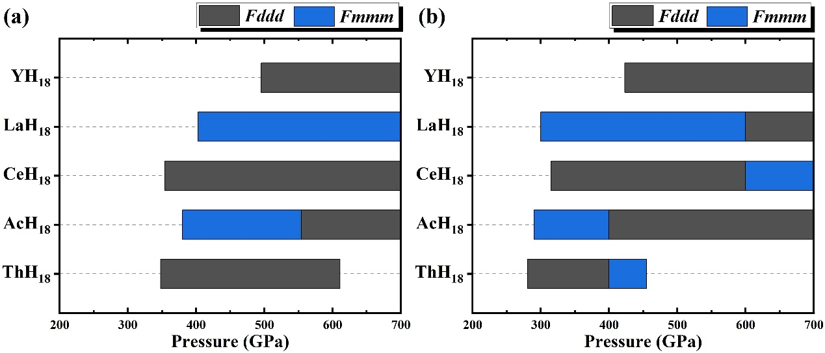
Supplementary Figure 1. Stable pressure ranges of the predicted series of extreme superhydrides MH₁₈ without (a) and with (b) inclusion of zero-point energy (ZPE) relative to known MH_{x} (x = 2, 4, 6, 9, 10, 12, 16 and 17) and Cmca–H₂. The ZPE of predicted compounds were obtained from lattice dynamic calculations as implemented the PHONOPY code. It is noted that ZPE lowers the threshold pressure for stable MH₁₈ compounds, quite significantly in some cases, e.g., LaH₁₈, AcH₁₈, and ThH₁₈, which become stable at 300 GPa, 290 GPa and 281 GPa, respectively, making it more favorable and feasible for experimental synthesis and characterization.

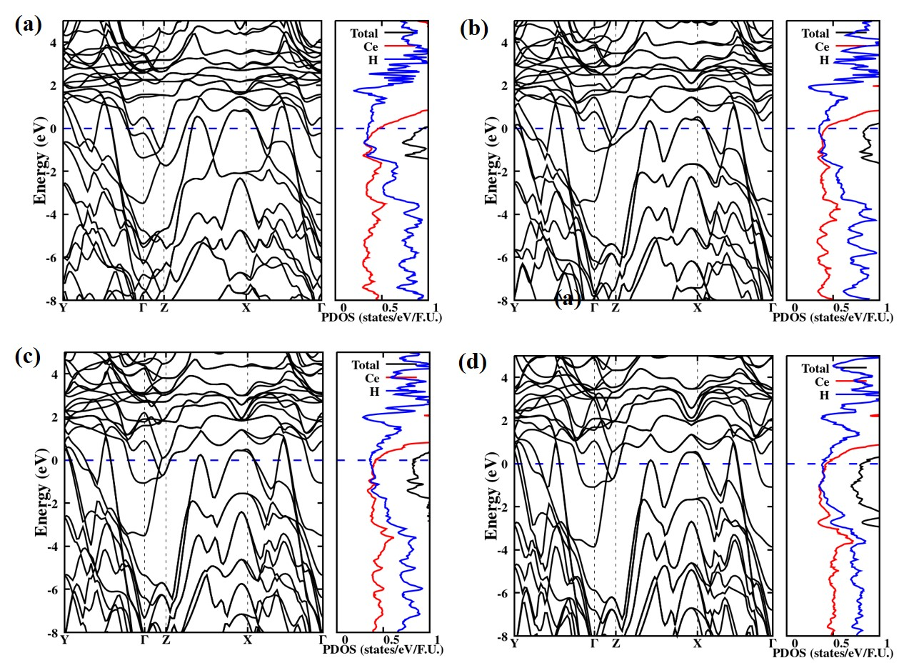
Supplementary Figure 2. Electronic band structure (left) and projected density of states (right) of CeH₁₈ at 300 GPa (a), 400 GPa (b), 500 GPa (c) and 700 GPa (d). The hole-bands at the X-point, along the Z-X path, and also at the Y-point move down with increasing pressure. The total DOS and PDOS on H atom slightly decrease with increasing pressure around the Fermi level.
Supplementary Table S1. The detailed structure information of two representative structures Fddd-CeH₁₈ and Fmmm-LaH₁₈ at 400 GPa.
Compound | Space Group | Lattice Parameters  (Å, ˚) | Atomic coordinates (fractional)  Atoms X Y Z
CeH₁₈ | Fddd | a = 14.608  b = 5.636  c = 3.249  α = β = γ = 90 | Ce (8a)  H (16e)  H (32h)  H (16e)  H (32h)  H (32h)  H (16e) | 0.125  0.431  0.663  0.686  0.755  0.733  0.938 | 0.125  0.125  0.455  0.125  0.534  0.206  0.125 | 0.125  0.125  0.612  0.125  0.388  0.883  0.125
LaH₁₈ | Fmmm | a = 7.122  b = 3.293  c = 5.685  α = β = γ = 90 | La (4a)  H (16n)  H (16n)  H (16j)  H (16l)  H (8g) | 0.000  0.717  0.925  0.250  0.119  0.621 | 0.000  0.000  0.000  0.250  0.250  0.000 | 0.000  0.672  0.339  0.915  0.250  0.000

Supplementary Table S2. The lattice parameters of several MH₁₈ compounds.
Compound | Space group | Pressure (GPa) | Lattice Parameters (Å, ˚)
YH₁₈ | Fddd | 500 | a = 13.785, b = 5.471, c = 3.141  α = β = γ = 90
LaH₁₈ | Fddd | 600 | a = 13.204, b = 5.531, c = 3.192  α = β = γ = 90
LaH₁₈ | Fmmm | 400 | a = 7.054, b = 3.348, c = 5.749  α = β = γ = 90
AcH₁₈ | Fddd | 400 | a = 14.124, b = 5.905, c = 3.410  α = β = γ = 90
AcH₁₈ | Fmmm | 400 | a = 7.099, b = 3.401, c = 5.894  α = β = γ = 90
ThH₁₈ | Fddd | 400 | a = 14.681, b = 5.770, c = 3.322  α = β = γ = 90
ThH₁₈ | Fmmm | 400 | a = 7.180, b = 3.357, c = 5.826  α = β = γ = 90
UH₁₈ | Fmmm | 700 | a = 6.223, b = 2.977, c = 5.925  α = β = γ = 90

