Supplementary methods and results

Methods
Participants
Two patients with severe and mild ischemic stroke participated in the whole-day monitoring session. The first was a 69-year-old male with right mild hemiparesis. The motor impairment was recorded as 20/25 in terms of the stroke impairment assessment set (SIAS) score [1]. The second was a 67-year-old male suffering from left hemiparesis, which was severe. The motor impairment was recorded as 2/25 in the SIAS score.

Procedure
For the whole-day measurement session, the ‘hitoe’ smart clothing system was used (see Material and Methods and Figure 1 in the main manuscript). The patients wore a ‘hitoe’ wear for consecutive 48 hours from 12:00 on day 1 to 12:00 on day 3. The heart rate and the trunk acceleration were measured with the ‘hitoe’ system. The data of 24-hour monitoring from 5:00 at day 2 to 5:00 at day 3 were extracted for analysis. The moving standard deviation of the acceleration value was used as an index for physical movement intensity. The time course of the values averaged for every 30 min were used for analysis. The accuracy of heart rate measurement of this system was reported previously [2].

Results
Whole-day patterns of heart rate and the MSD, which is an acceleration-based measurement index of movement intensity, in the patients with severe and mild paresis due to stroke are shown in Figure S2. Despite the high increase in heart rate during daytime in patients with severe paresis, the physical movement intensity was lower than the patients with mild paresis.
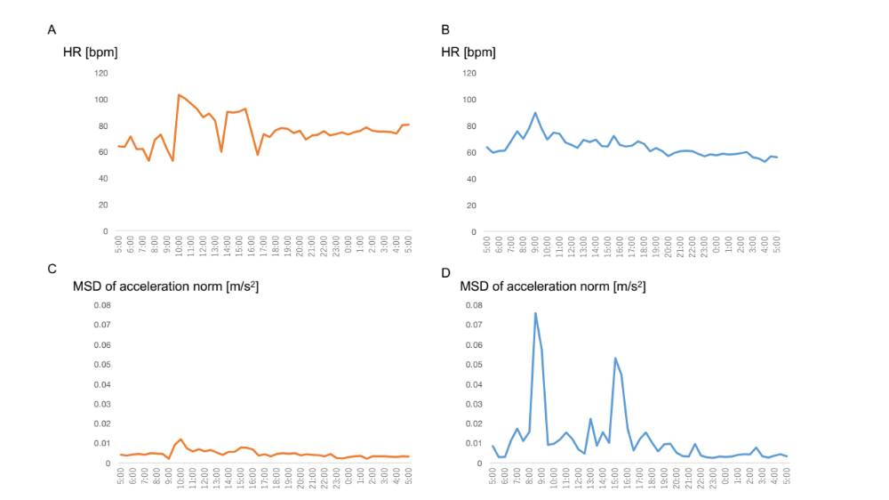
Figure S1. Difference in heart rate and movement intensity between patients with severe and mild motor impairment. (A, B) Whole-day pattern of heart rate in a patient with severe paresis (A) and mild paresis (B). (C, D) Whole-day pattern of moving standard deviation of trunk acceleration in a patient with severe paresis (C) and mild paresis (D). MSD; moving standard deviation.
1. Chino N, Sonoda S, Domen K, Saitoh E, Kimura A. Stroke Impairment Assessment Set (SIAS) a new evaluation instrument for stroke patients. Jap J Rehabil Med. 1994;31:119-25.
2. Tsukada S, Kasai N, Kawano R, Takagahara K, Fujii K, Sumitomo K. Electrocardiogram Monitoring Simply by Wearing a Shirt—For Medical, Healthcare, Sports, and Entertainment. NTT Tech Rev 2014;12:1-7

1. Chino N, Sonoda S, Domen K, Saitoh E, Kimura A. Stroke Impairment Assessment Set （SIAS） a new evaluation instrument for stroke patients. Jpn J Rehabil Med. 1994; 31:119-25.
2. Tsukada S, Kasai N, Kawano R, Takagahara K, Fujii K, Sumitomo K. Electrocardiogram Monitoring Simply by Wearing a Shirt—For Medical, Healthcare, Sports, and Entertainment. NTT Technical Review. 2014; 12:1-7.

