Supplementary Information
The Hidden Lifecycle of Public EV Charging Infrastructure in the United States

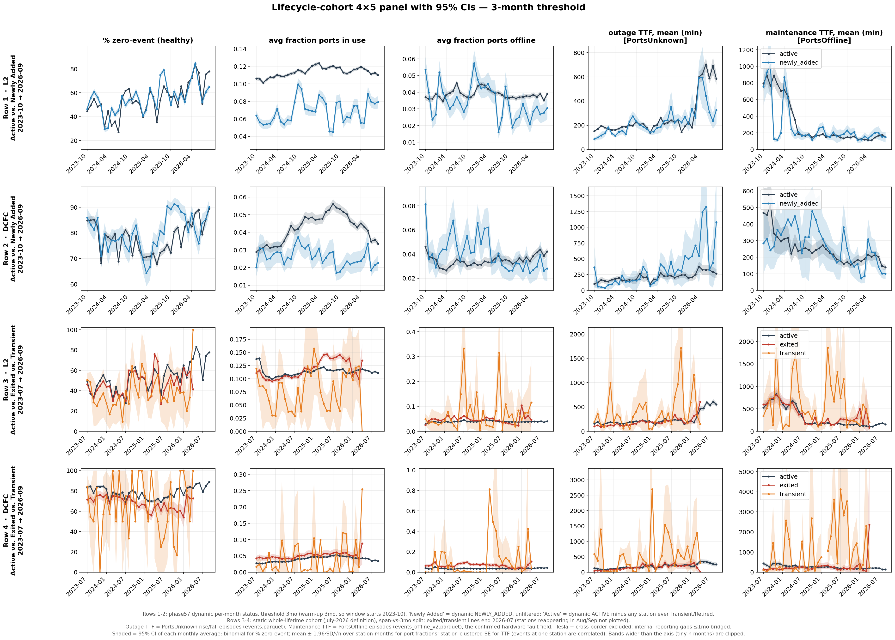
Supplementary Figure 1. Operational Performance by EV Charging-Station Lifecycle Cohort and Charger Type: 3-Month Threshold. Columns report the percentage of zero-event stations classified as healthy, average fraction of ports in use, average fraction of ports offline, mean outage-level time to fix (TTF) in minutes, and mean maintenance-level TTF in minutes. Rows 1–2 compare dynamically classified Active and Newly Added stations from July 2024 to July 2026, following a 12-month warm-up period. Rows 3–4 compare whole-lifetime Active, Exited, and Transient cohorts from July 2023 to July 2026 using a 12-month classification threshold. Note: Tesla stations are excluded because their operational data are not observed. Lines equal to monthly mean, and shaded areas are the 95% confidence interval.

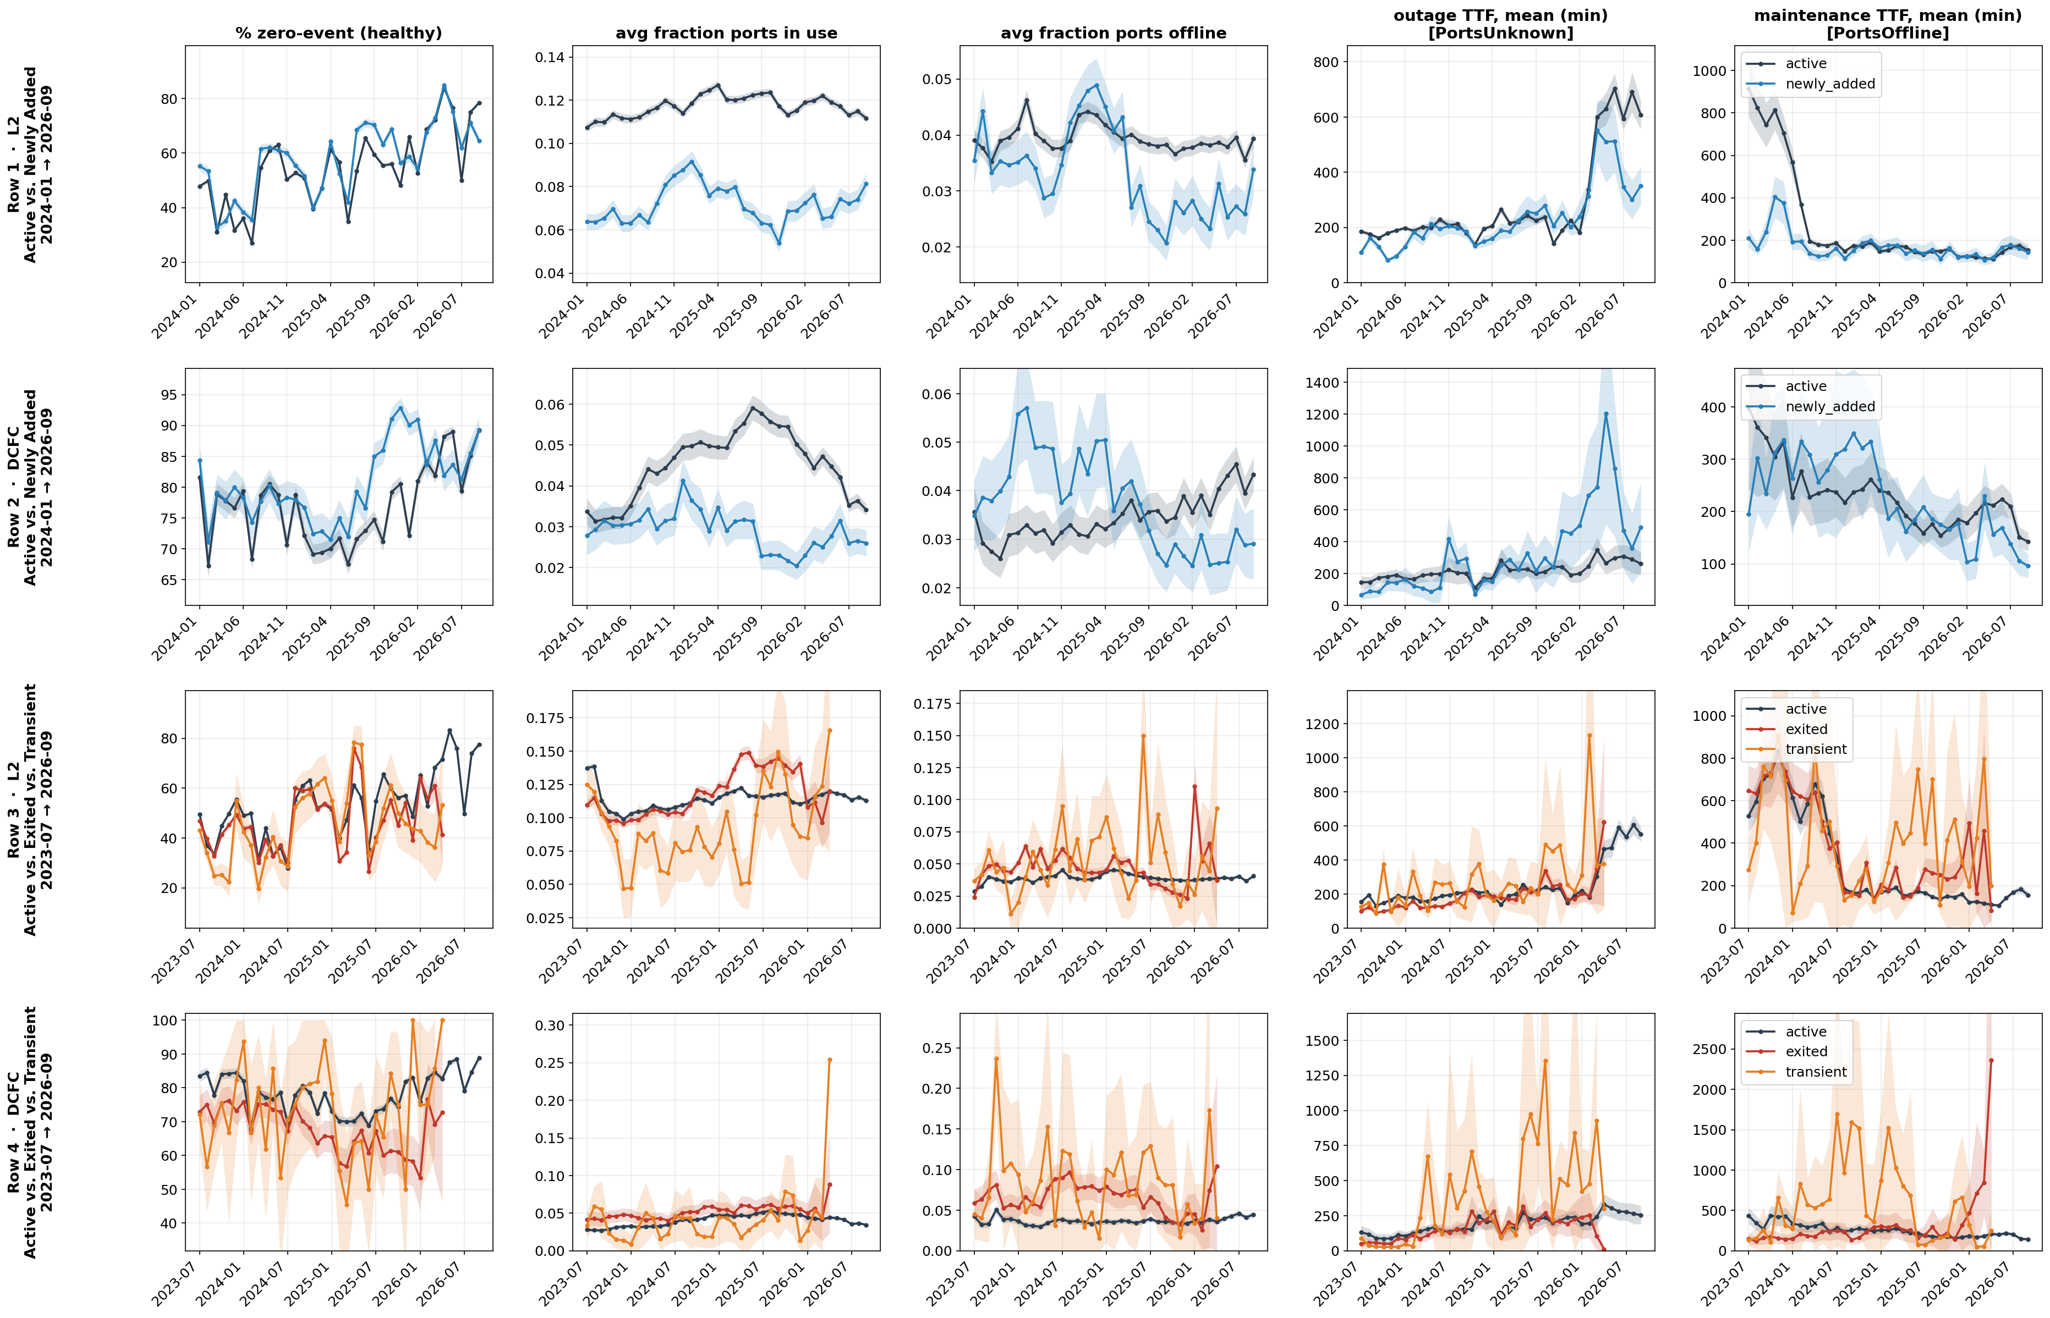
Supplementary Figure 2: Operational Performance by EV Charging-Station Lifecycle Cohort and Charger Type: 6-Month Threshold. Columns report the percentage of zero-event stations classified as healthy, average fraction of ports in use, average fraction of ports offline, mean outage-level time to fix (TTF) in minutes, and mean maintenance-level TTF in minutes. Rows 1–2 compare dynamically classified Active and Newly Added stations from July 2024 to July 2026, following a 12-month warm-up period. Rows 3–4 compare whole-lifetime Active, Exited, and Transient cohorts from July 2023 to July 2026 using a 12-month classification threshold. Note: Tesla stations are excluded because their operational data are not observed. Lines equal to monthly mean, and shaded areas are the 95% confidence interval.

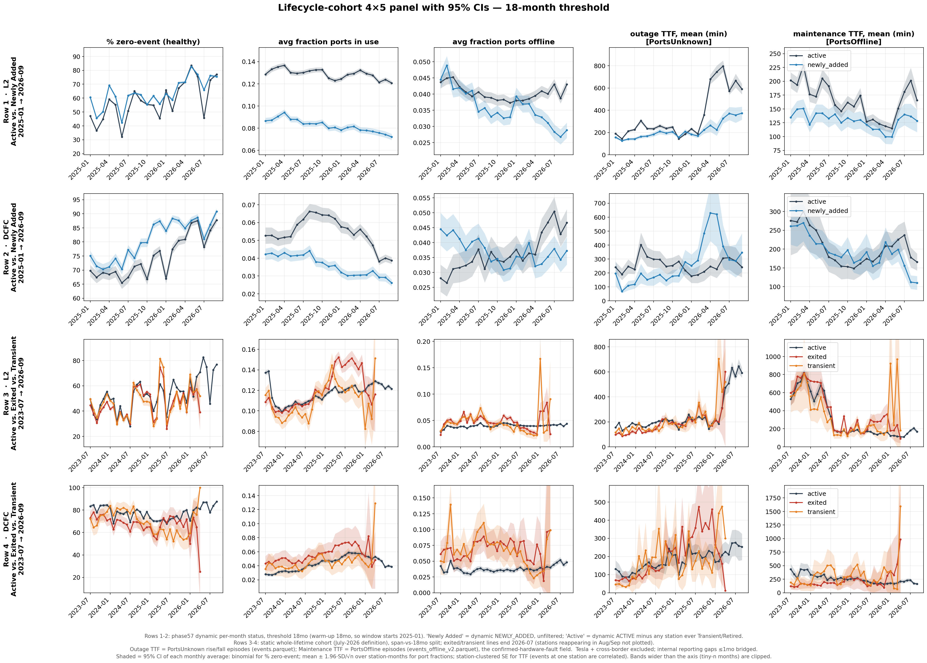
Supplementary Figure 3: Operational Performance by EV Charging-Station Lifecycle Cohort and Charger Type: 18-Month Threshold. Columns report the percentage of zero-event stations classified as healthy, average fraction of ports in use, average fraction of ports offline, mean outage-level time to fix (TTF) in minutes, and mean maintenance-level TTF in minutes. Rows 1–2 compare dynamically classified Active and Newly Added stations from July 2024 to July 2026, following a 12-month warm-up period. Rows 3–4 compare whole-lifetime Active, Exited, and Transient cohorts from July 2023 to July 2026 using a 12-month classification threshold. Note: Tesla stations are excluded because their operational data are not observed. Lines equal to monthly mean, and shaded areas are the 95% confidence interval.

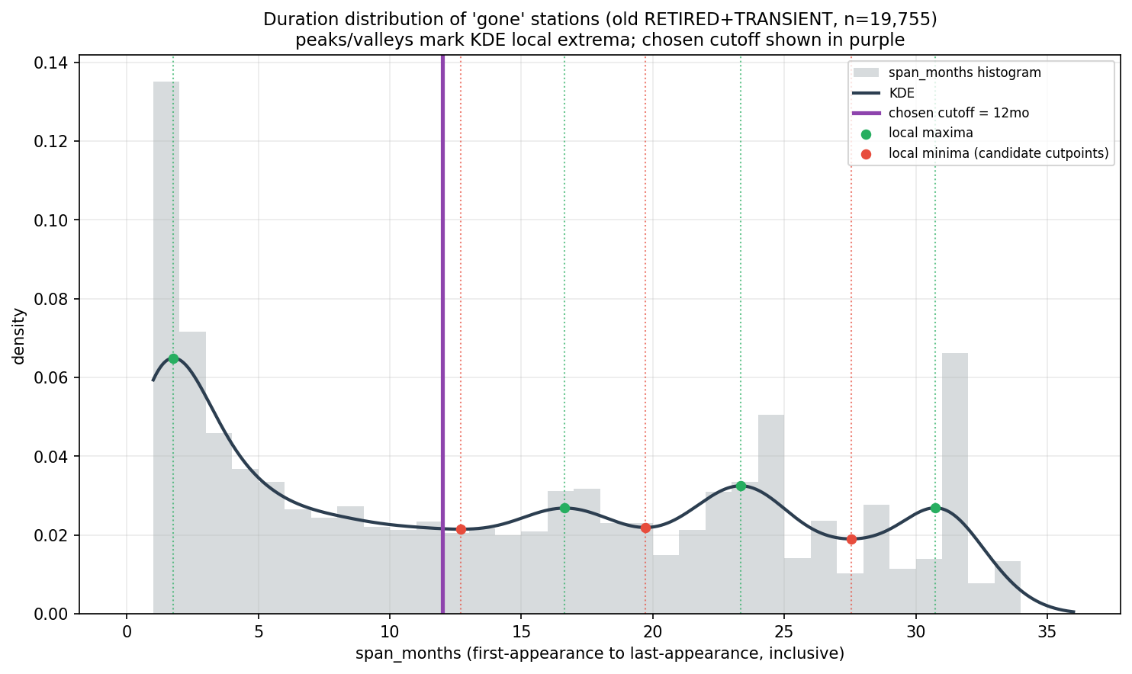
Supplementary Figure 4. Kernel-Density–Based Selection of the Station-Tenure Threshold. The figure shows the empirical distribution of observed tenure for 19,755 stations that disappeared from the dataset, where tenure is measured as the inclusive number of months between first and last observation. Gray bars represent the tenure histogram, the solid curve shows the kernel-density estimate, and the green and red markers identify local maxima and minima, respectively. The first local minimum, at approximately 12 months, is selected as the classification threshold because it provides the earliest clear separation between short-lived station churn and established stations that subsequently exit. Using a later minimum would risk grouping short-lived stations with the established exit population.

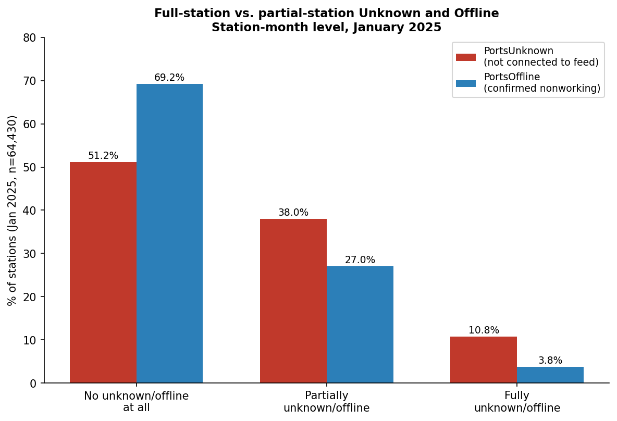
Supplementary Figure 5. Station-Level Distribution of Unknown and Offline Port Statuses, January 2025. The figure compares the percentage of stations with no affected ports, some affected ports, or all ports affected by unknown and offline statuses in January 2025 ($N=64,430$ station-months). Unknown status denotes ports not connected to the data feed, whereas offline status denotes ports reported as nonworking. Fully affected stations are more common under unknown status (10.8%) than offline status (3.8%), supporting the treatment of station-wide unknown-status events and port-level offline conditions as distinct dimensions of charging-station performance.

Supplementary Table 1. Statistical Summary of Dependent and Control Variables
Variable | Observations | Mean | Std. dev. | Minimum | Maximum
EV | 1,103,262 | 0.06 | 0.48 | 0.00 | 168.00
Median household income | 1,103,262 | 84,972.41 | 43,348.90 | 2,499.00 | 250,001.00
Population | 1,103,262 | 1,554.60 | 832.06 | 0.00 | 14,471.00
Housing units | 1,103,262 | 660.32 | 389.84 | 0.00 | 5,717.00
Per capita income | 1,103,244 | 39,417.25 | 19,796.31 | 1,706.00 | 339,683.55
Bachelor’s degree or higher (%) | 1,103,262 | 34.46 | 21.73 | 0.00 | 100.00
White alone (%) | 1,103,262 | 64.31 | 31.58 | 0.00 | 100.00
Black or African American alone (%) | 1,103,262 | 24.53 | 29.45 | 0.00 | 100.00
No vehicle available (%) | 1,103,262 | 8.57 | 12.72 | 0.00 | 100.00
Housing units in detached structures (%) | 1,103,262 | 63.07 | 33.85 | 0.00 | 100.00
Housing units in attached structures (%) | 1,103,262 | 17.34 | 25.01 | 0.00 | 100.00
Renter occupied (%) | 1,103,262 | 27.60 | 24.51 | 0.00 | 100.00
White, renter occupied (%) | 1,103,237 | 23.03 | 24.33 | 0.00 | 100.00
Black, renter occupied (%) | 1,103,262 | 31.37 | 36.54 | 0.00 | 100.00
Black, owner occupied (%) | 1,103,262 | 48.23 | 40.90 | 0.00 | 100.00
White, owner occupied (%) | 1,103,237 | 73.54 | 27.59 | 0.00 | 100.00
Housing occupancy status as occupied (%) | 1,103,262 | 89.00 | 13.17 | 0.00 | 100.00
Occupied housing units with White householder (%) | 1,103,262 | 389.40 | 257.03 | 0.00 | 2,836.00
Occupied housing units with Black householder (%) | 1,103,262 | 136.55 | 199.66 | 0.00 | 2,318.00
EV chargers per block | 1,103,262 | 0.01 | 0.13 | 0.00 | 27.00
EV chargers per block group | 1,103,262 | 0.19 | 1.01 | 0.00 | 44.00
EV chargers per tract | 1,103,262 | 0.46 | 1.66 | 0.00 | 44.00
Utility companies | 1,103,262 | 3.94 | 3.45 | 1.00 | 13.00
Note: Electric vehicle registrations are measured at the household level, and public EV chargers are recorded at the individual-address level. Values were aggregated to the block level for 1999–2024. Census ACS sociodemographic controls are measured at the block-group level. Some census block groups lack data, resulting in fewer observations than the EV and public-charger counts.

Supplementary Table 2: Estimated Coefficients from Discrete-Time Hazard Models of Public EV Charging-Station Exit
Reporting quality
NO_DATA share, t−1 | 0.589***
 | (0.033)
NO_DATA share, t−2 |  | 0.486***
 |  | (0.033)
NO_DATA share, t−3 |  |  | 0.616***
 |  |  | (0.036)
NO_DATA share, mean prior 3 months |  |  |  | 0.696***
 |  |  |  | (0.036)
NO_DATA share, mean prior 6 months |  |  |  |  | 0.531***
 |  |  |  |  | (0.034)
NO_DATA share, mean prior 12 months |  |  |  |  |  | 0.355***
 |  |  |  |  |  | (0.035)
NO_DATA share, mean prior 18 months |  |  |  |  |  |  | 0.255***
 |  |  |  |  |  |  | (0.035)
Power outage
Outage events per month, hundreds (prior 3 months) | −0.005 | −0.003 | −0.003 | −0.005 | −0.004 | −0.003 | −0.001
 | (0.043) | (0.043) | (0.043) | (0.043) | (0.043) | (0.043) | (0.043)
Log outage repair time, minutes (prior 3 months) | 0.054*** | 0.056*** | 0.056*** | 0.054*** | 0.056*** | 0.058*** | 0.058***
 | (0.006) | (0.006) | (0.006) | (0.006) | (0.006) | (0.006) | (0.006)
Has outage repair events (prior 3 months) | 0.026 | 0.006 | 0.021 | 0.038** | 0.003 | −0.031* | −0.046***
 | (0.017) | (0.017) | (0.017) | (0.017) | (0.017) | (0.017) | (0.018)
Maintenance
Fraction of ports offline (prior 3 months) | 0.274*** | 0.330*** | 0.274*** | 0.214*** | 0.344*** | 0.465*** | 0.520***
 | (0.049) | (0.050) | (0.052) | (0.051) | (0.050) | (0.050) | (0.050)
Maintenance events per month, hundreds (prior 3 months) | 0.122*** | 0.112*** | 0.121*** | 0.131*** | 0.110*** | 0.090*** | 0.081**
 | (0.033) | (0.033) | (0.033) | (0.034) | (0.033) | (0.032) | (0.032)
Log maintenance repair time, minutes (prior 3 months) | −0.043*** | −0.043*** | −0.043*** | −0.043*** | −0.043*** | −0.043*** | −0.043***
 | (0.006) | (0.006) | (0.006) | (0.006) | (0.006) | (0.006) | (0.006)
Has maintenance repair events (prior 3 months) | 0.120*** | 0.106*** | 0.116*** | 0.129*** | 0.103*** | 0.079*** | 0.068***
 | (0.013) | (0.013) | (0.014) | (0.013) | (0.013) | (0.013) | (0.013)
Station performance and characteristics
Fraction of ports in use (prior 3 months) | −0.187*** | −0.212*** | −0.186*** | −0.168*** | −0.206*** | −0.250*** | −0.273***
 | (0.054) | (0.054) | (0.054) | (0.054) | (0.054) | (0.054) | (0.054)
Station tenure (months) | 0.088*** | 0.089*** | 0.098*** | 0.091*** | 0.096*** | 0.095*** | 0.094***
 | (0.002) | (0.002) | (0.002) | (0.002) | (0.002) | (0.002) | (0.002)
Station tenure² ÷ 100 | −0.201*** | −0.203*** | −0.226*** | −0.211*** | −0.219*** | −0.215*** | −0.210***
 | (0.005) | (0.005) | (0.005) | (0.005) | (0.005) | (0.005) | (0.005)
Log total ports at station | −0.100*** | −0.100*** | −0.100*** | −0.101*** | −0.098*** | −0.096*** | −0.096***
 | (0.011) | (0.011) | (0.011) | (0.011) | (0.011) | (0.011) | (0.011)
Charger type: DCFC (reference: L2) | −0.142*** | −0.134*** | −0.135*** | −0.143*** | −0.130*** | −0.115*** | −0.109***
 | (0.018) | (0.018) | (0.018) | (0.018) | (0.018) | (0.018) | (0.018)
Charger type: mixed (reference: L2) | −0.102*** | −0.099*** | −0.101*** | −0.104*** | −0.099*** | −0.094*** | −0.091***
 | (0.022) | (0.022) | (0.022) | (0.022) | (0.022) | (0.022) | (0.022)
Socioeconomic and demographic characteristics
Log median household income | 0.103*** | 0.103*** | 0.102*** | 0.102*** | 0.102*** | 0.102*** | 0.103***
 | (0.022) | (0.023) | (0.023) | (0.023) | (0.023) | (0.023) | (0.023)
Log population density | 0.014*** | 0.014*** | 0.013*** | 0.013*** | 0.013*** | 0.013*** | 0.014***
 | (0.005) | (0.005) | (0.005) | (0.005) | (0.005) | (0.005) | (0.005)
Bachelor’s degree or higher (%) | −0.001 | −0.001 | −0.001 | −0.001 | −0.001 | −0.001 | −0.001
 | (0.001) | (0.001) | (0.001) | (0.001) | (0.001) | (0.001) | (0.001)
Non-Hispanic White population (%) | −0.003*** | −0.003*** | −0.003*** | −0.003*** | −0.003*** | −0.003*** | −0.003***
 | (0.000) | (0.000) | (0.000) | (0.000) | (0.000) | (0.000) | (0.000)
Hispanic population (%) | −0.001 | −0.001 | −0.001 | −0.001 | −0.001 | −0.001 | −0.001
 | (0.001) | (0.001) | (0.001) | (0.001) | (0.001) | (0.001) | (0.001)
EV registrations per 1,000 people | −0.048*** | −0.048*** | −0.051*** | −0.051*** | −0.050*** | −0.048*** | −0.047***
 | (0.004) | (0.004) | (0.004) | (0.004) | (0.004) | (0.004) | (0.004)
Residential electricity price (¢/kWh) | −0.006 | −0.005 | −0.004 | −0.005 | −0.005 | −0.005 | −0.006
 | (0.006) | (0.006) | (0.006) | (0.006) | (0.006) | (0.006) | (0.006)
Year-month fixed effects | Yes | Yes | Yes | Yes | Yes | Yes | Yes
State fixed effects | Yes | Yes | Yes | Yes | Yes | Yes | Yes
Standard errors clustered by station | Yes | Yes | Yes | Yes | Yes | Yes | Yes
Observations | 826,884 | 826,884 | 826,884 | 826,884 | 826,884 | 826,884 | 826,884
R² | 0.0121 | 0.0119 | 0.0122 | 0.0122 | 0.0118 | 0.0116 | 0.0115
Note: Notes: Each observation is a station-month. Shares range from 0 to 1; event counts are measured in hundreds per month; tenure is measured in months; repair-event indicators equal 0 or 1. Outages correspond to PortsUnknown, and maintenance corresponds to PortsOffline. All specifications include the same controls and differ only in the timing of NO_DATA exposure. Models (1)–(3) use individual monthly lags; Models (4)–(7) use means over the prior 3, 6, 12, and 18 months. Clustered standard errors are reported in parentheses. *** p<0.01, ** p<0.05, * p<0.10.

Supplementary Table 3. Out-of-sample prediction of station exit (L2 stations; models chosen on validation months, scored once on test months).
Model | Test AUC (95% CI) | PR-AUC | Brier | Top 10% capture | Top 20% capture
Monthly exit hazard (test: Jul–Sep 2025; 50,677 station-months, 335 exits)
Logistic regression | 0.751 (0.716–0.784) | 0.035 | 0.0065 | 53% | 62%
Firth logistic regression | 0.749 (0.715–0.783) | 0.035 | 0.0065 | 53% | 62%
Elastic-net logistic regression | 0.749 (0.715–0.783) | 0.035 | 0.0065 | 53% | 63%
Random forest | 0.760 (0.729–0.789) | 0.030 | 0.0065 | 54% | 65%
XGBoost | 0.766 (0.735–0.793) | 0.035 | 0.0065 | 53% | 64%
LightGBM | 0.752 (0.719–0.781) | 0.030 | 0.0065 | 49% | 63%
Constant base rate (reference) | 0.500 | 0.007 | 0.0066 | 10% | 20%
Exit within 3 months (test: May–Jul 2025; 50,943 station-months, 1,798 exits)
Logistic regression | 0.702 (0.685–0.719) | 0.097 | — | 32% | 47%
XGBoost | 0.735 (0.718–0.752) | 0.100 | — | 36% | 52%
Notes: AUC confidence intervals from 500 bootstrap replicates resampling whole stations. Capture = share of all test exits among the 10% / 20% highest-risk station-months. Training 705 exits (events per variable ≈ 34). Firth's estimates differ from the unpenalized logit by at most 0.03 in any coefficient, so small-sample bias is not a concern.

Supplementary Table 4. Charging station lifecycle status and charger composition
Group | N | % pure L2 | % pure DCFC | % mixed
All | 87,001 | 75.9% | 16.3% | 6.0%
Currently active | 67,246 | 74.4% | 17.9% | 6.3%
– Active across 3 years | 39,730 | 78.4% | 14.3% | 6.5%
– Newly added | 27,516 | 68.6% | 23.1% | 5.9%
No longer active | 19,755 | 80.9% | 10.8% | 5.2%
– Retired/exit | 11,582 | 83.3% | 8.1% | 5.8%
– Transient | 8,173 | 77.6% | 14.6% | 4.4%

Supplementary Table 5. States with at least 100 stations in the scored sample

State | Stations | High-risk stations | High-risk share | Exits | Exits among high-risk
CA | 3,330 | 330 | 9.9% | 80 | 36
NY | 1,696 | 88 | 5.2% | 29 | 7
TX | 1,061 | 142 | 13.4% | 28 | 11
MA | 1,010 | 41 | 4.1% | 12 | 5
FL | 962 | 173 | 18.0% | 34 | 21
CO | 711 | 50 | 7.0% | 10 | 6
PA | 543 | 57 | 10.5% | 15 | 10
WA | 515 | 86 | 16.7% | 20 | 10
OH | 512 | 36 | 7.0% | 9 | 1
NJ | 463 | 81 | 17.5% | 9 | 6
NC | 449 | 36 | 8.0% | 6 | 4
MD | 439 | 103 | 23.5% | 19 | 17
IL | 410 | 35 | 8.5% | 3 | 1
GA | 402 | 73 | 18.2% | 12 | 7
AZ | 388 | 62 | 16.0% | 8 | 4
OR | 376 | 46 | 12.2% | 5 | 3
MI | 362 | 15 | 4.1% | 4 | 1
MO | 321 | 15 | 4.7% | 1 | 0
CT | 310 | 31 | 10.0% | 5 | 3
MN | 279 | 23 | 8.2% | 3 | 0
VA | 268 | 34 | 12.7% | 12 | 8
UT | 244 | 19 | 7.8% | 3 | 0
TN | 229 | 15 | 6.6% | 3 | 0
WI | 203 | 5 | 2.5% | 2 | 2
IN | 186 | 13 | 7.0% | 8 | 0
KS | 161 | 3 | 1.9% | 0 | 0
IA | 131 | 6 | 4.6% | 1 | 0
NV | 129 | 27 | 20.9% | 2 | 1
VT | 122 | 5 | 4.1% | 1 | 0
RI | 107 | 8 | 7.5% | 5 | 0
ME | 105 | 3 | 2.9% | 1 | 0
SC | 104 | 11 | 10.6% | 0 | 0
NE | 103 | 0 | 0.0% | 0 | 0
Note: These 33 states meet the minimum sample-size threshold used for state-level mapping.

Supplementary Table 6. States with fewer than 100 stations in the scored sample

State | Stations | High-risk stations | High-risk share | Exits | Exits among high-risk
AR | 94 | 6 | 6.4% | 2 | 0
AL | 86 | 4 | 4.7% | 0 | 0
KY | 74 | 1 | 1.4% | 0 | 0
NM | 72 | 10 | 13.9% | 0 | 0
LA | 59 | 8 | 13.6% | 0 | 0
DE | 59 | 10 | 16.9% | 2 | 2
NH | 59 | 2 | 3.4% | 0 | 0
OK | 42 | 7 | 16.7% | 0 | 0
ID | 40 | 3 | 7.5% | 2 | 0
DC | 35 | 7 | 20.0% | 4 | 3
WV | 29 | 2 | 6.9% | 1 | 1
MT | 24 | 1 | 4.2% | 0 | 0
SD | 23 | 0 | 0.0% | 0 | 0
MS | 17 | 4 | 23.5% | 0 | 0
WY | 12 | 0 | 0.0% | 0 | 0
ND | 9 | 0 | 0.0% | 0 | 0
Note: These 16 states are hidden on the map because small samples produce unstable state-level high-risk percentages.

